Week 5: Comprehensive Project Report & Strategic Recommendations
NIFTY 50 Index: Data Preparation Through Predictive Modeling (2007-2026)
Author: Paras Nainwal
Date: August 2026
Tools: Python (Pandas, NumPy, Matplotlib, Seaborn, SciPy, Scikit-learn)

Executive Summary
This report synthesizes a four-week end-to-end data science project on the NIFTY 50 index, India's benchmark equity index, covering 4,554 trading days from September 2007 to April 2026. The project moved from raw data acquisition and cleaning (Week 1), through visual storytelling (Week 2) and formal statistical hypothesis testing (Week 3), to a predictive machine learning model (Week 4). The headline findings: the index delivered strong long-term growth (~430%) built on a genuine, statistically significant positive daily drift, but that growth came with sharply clustered volatility concentrated in a small number of crisis periods; no reliable calendar-based (weekday) trading edge exists; and next-day price direction could not be predicted meaningfully better than chance using standard technical features — a result consistent with market efficiency rather than a project shortfall. Strategic recommendations for different stakeholder types are provided in Section 6.

1. Introduction & Project Scope
The project's goal was to demonstrate the full data science lifecycle on a single, coherent dataset: acquisition and cleaning, exploratory and narrative visualization, statistical hypothesis testing, and predictive modeling. NIFTY 50 daily OHLCV data was chosen for its long history, real-world data quality issues, and direct relevance to Indian financial markets.

2. Methodology Summary Across Weeks
Week | Focus | Key Method(s)
1 | Data acquisition & cleaning, EDA | Missing-data audit, type correction, feature engineering
2 | Visualization & storytelling | Annotated trend, rolling volatility, drawdown, heatmap
3 | Statistical hypothesis testing | t-tests, Levene's test, ANOVA, Pearson correlation
4 | Predictive modeling | Logistic regression, decision tree, time-based validation

3. Week 1 Recap: Data Preparation & Exploratory Analysis
The raw dataset required correcting the Date field's data type, and — most importantly — recognizing that 29.3% of rows carried a Volume value of exactly 0, which was not genuinely zero trading activity but disguised missing data typical of index-level (rather than single-stock) feeds. These rows were reclassified as missing rather than left as misleading zeros. No exact duplicate rows were found, and all OHLC logical-consistency checks passed.
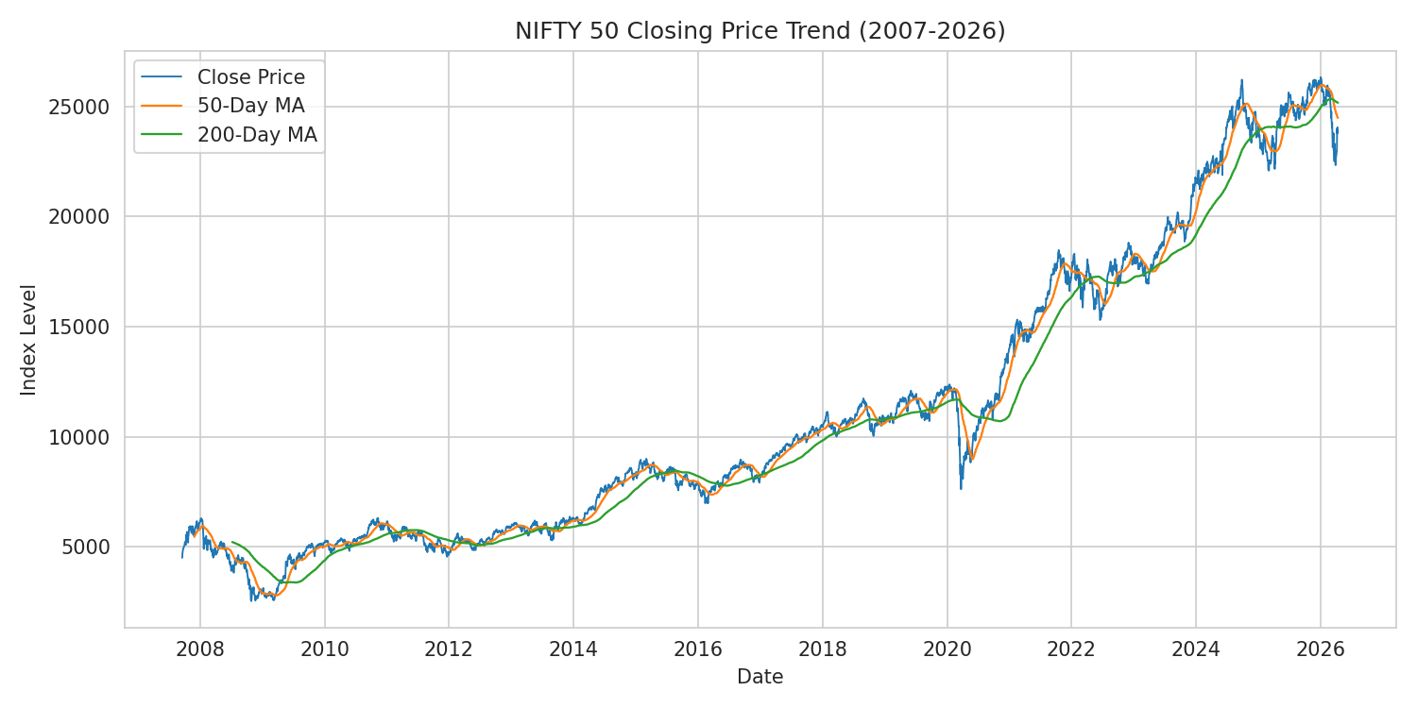
Figure 1: NIFTY 50 closing price with 50-day and 200-day moving averages
- The index grew approximately 430% over the full period
- Data quality on Volume improved substantially after 2013
- Price fields (Open/High/Low/Close) are near-perfectly correlated, so most modeling only needs Close

4. Week 2 Recap: Visual Storytelling
Six visualizations built a narrative from headline growth down to daily statistical behavior. The most consequential finding was that risk is highly clustered rather than steady over time, and that realized daily returns have meaningfully fatter tails than a normal distribution would predict.
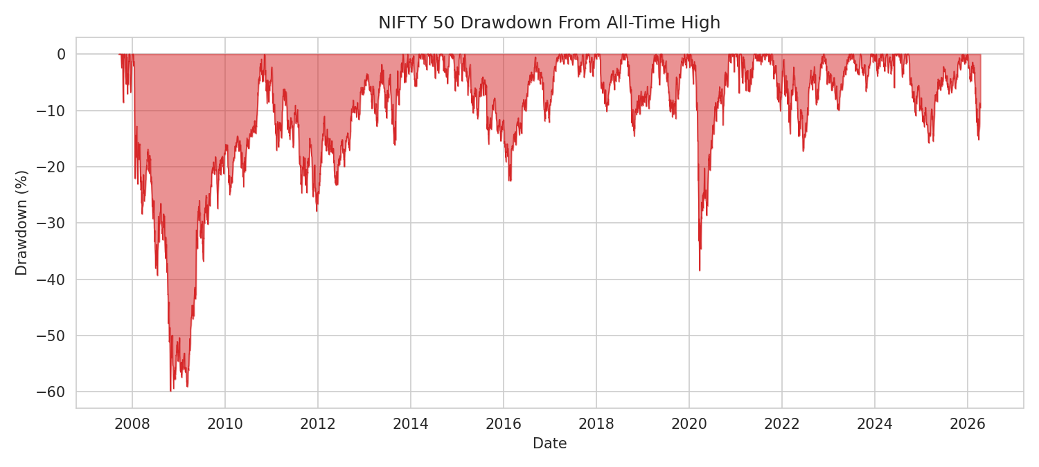
Figure 2: Drawdown from all-time high — the 2008 crisis (-59.9%) dwarfs the faster-resolving 2020 crash (-38.7%)
- 2008 produced the deepest and longest drawdown (-59.9%, multi-year recovery)
- 2020's COVID crash was nearly as deep (-38.7%) but resolved in months, not years
- No visually obvious seasonal (monthly) pattern emerged in the heatmap analysis

5. Week 3 Recap: Hypothesis Testing
Four hypotheses were tested formally at alpha = 0.05, moving the visual observations from Week 2 onto statistically rigorous footing.
Hypothesis | Result | p-value
Mean daily return ≠ 0 (drift exists) | Confirmed | 0.0195
Crisis years more volatile | Confirmed | < 0.001
Day-of-week effect exists | Not confirmed | 0.198
Volume correlates with volatility | Confirmed (weak-moderate) | < 0.001
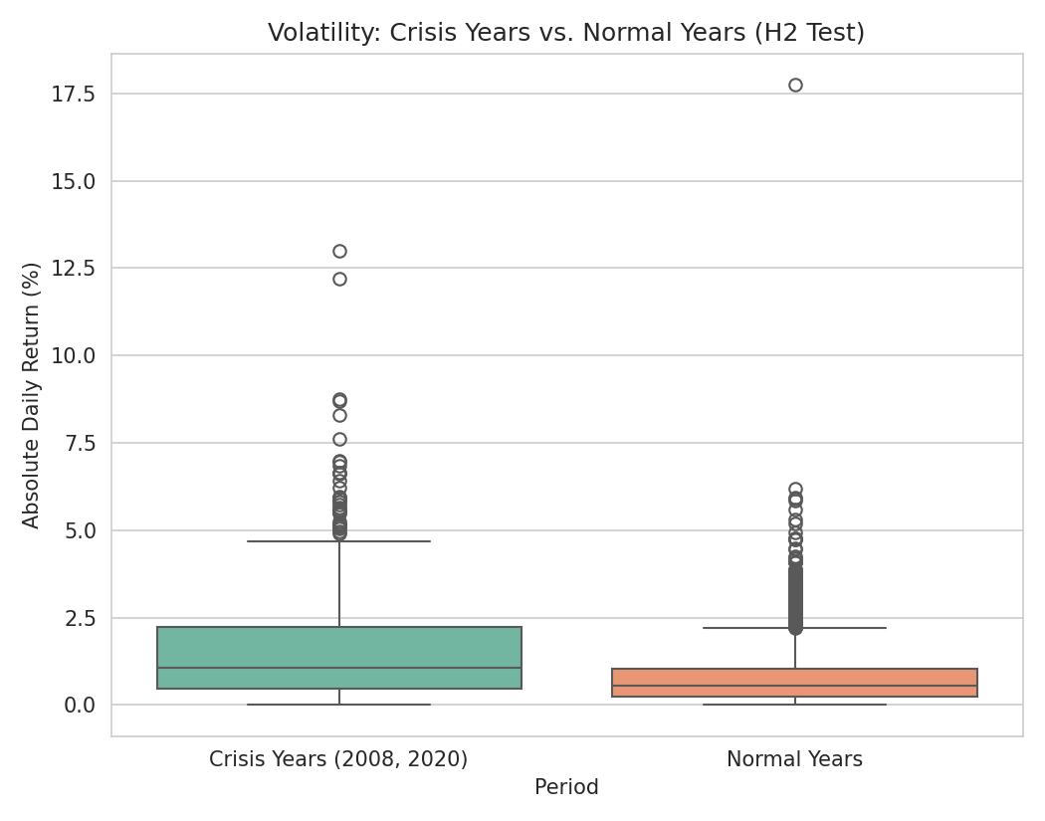
Figure 3: Statistically confirmed — crisis-year volatility is more than double normal-year volatility
Three of four hypotheses were statistically confirmed. The one rejected hypothesis (day-of-week effect) is an equally valid and useful finding: it closes off a commonly assumed market anomaly rather than representing an analytical gap.

6. Week 4 Recap: Predictive Modeling
A logistic regression and a decision tree were trained to predict next-day direction (Up/Down) using lagged returns, moving averages, and rolling volatility, with a chronological train/test split to avoid lookahead bias.
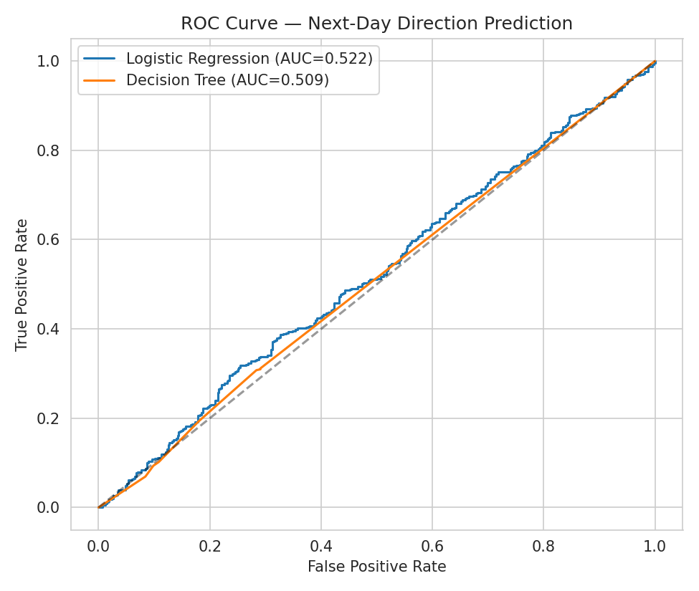
Figure 4: Both models perform only marginally above random chance (AUC ≈ 0.51-0.52)
Neither model meaningfully beat a naive majority-class baseline (54.1% accuracy). This null result is consistent with the weak-form Efficient Market Hypothesis: if simple technical features reliably predicted next-day direction in a liquid index, that edge would typically be arbitraged away by other market participants.

7. Integrated Insights
- Growth and risk are inseparable in this dataset: the same ~430% growth story that looks smooth zoomed out (Week 1) is revealed to be highly episodic and crisis-driven when zoomed in (Weeks 2-3).
- Statistically confirmed drift (Week 3, H1) explains why long-horizon buy-and-hold investing worked despite short-horizon unpredictability (Week 4) — the two findings are not in tension, they operate at different time scales.
- Volume, once properly cleaned of its disguised-missing-data problem (Week 1), turned out to carry a real, statistically significant relationship with volatility (Week 3, H4) — a good example of how a data-cleaning decision directly enabled a later analytical finding.
- The project's clearest 'negative' results — no weekday effect, no reliable next-day predictability — are as valuable as its positive findings, since they rule out commonly assumed but unfounded trading edges.

8. Strategic Recommendations

8.1 For Long-Term / Retail Investors
- The confirmed positive drift (Week 3) supports a long-horizon buy-and-hold approach; short-term direction is not reliably forecastable with these methods, so frequent short-term trading based on similar signals is unlikely to add value net of costs.
- Prepare psychologically and financially (e.g., via emergency-fund buffers) for drawdowns on the scale of the 2008 or 2020 events, since deep drawdowns are a demonstrated, recurring feature of this market, not a tail scenario that can be assumed away.

8.2 For Risk Managers / Portfolio Desks
- Adopt time-varying volatility models (e.g., GARCH-family) rather than static volatility assumptions, given the strong statistical evidence of volatility clustering (Week 2-3).
- Size tail-risk hedges using the actual fat-tailed return distribution (Week 2, Fig. 6 in that report) rather than a normal-distribution approximation, which understates extreme-move probability.

8.3 For Quant / Data Science Teams
- Treat this project's Week 4 result as a baseline, not a dead end: extend to longer prediction horizons, add cross-market and macro features, and use walk-forward validation before concluding no signal exists.
- If pursuing a trading strategy, evaluate future models on economically meaningful metrics (e.g., Sharpe ratio net of transaction costs) rather than classification accuracy alone, since the ~54% accuracy observed here is not obviously exploitable after costs even if statistically distinguishable from 50%.

9. Limitations & Future Work
- All analysis is index-level; no constituent-stock-level data was used, which could reveal which individual names drove specific drawdown or recovery periods.
- Statistical tests assume a level of independence between daily returns that volatility clustering (Week 2-3) technically violates, so p-values should be read as indicative rather than exact.
- The predictive model used only price/volume-derived features; incorporating macroeconomic indicators, global index co-movement, or news sentiment is a natural next step.
- Future work could extend Week 4's model to a longer forecast horizon, and pair it with the Week 3 findings by testing whether the same statistically confirmed relationships (e.g., volume-volatility) can be turned into engineered features that improve on the current near-baseline performance.

