Week 1: Data Acquisition, Cleaning & Exploratory Data Analysis
Domain: Financial Markets — NIFTY 50 Index Daily Historical Prices
Author: Paras
Date: August 2026
Tools: Python (Pandas, NumPy, Matplotlib, Seaborn)

1. Task Objective
This report documents the data preparation workflow for a data science project: acquiring a publicly available dataset, cleaning and preprocessing it, and performing exploratory data analysis (EDA) to surface trends, data quality issues, and insights. The chosen dataset is the daily historical price series of the NIFTY 50 index, India's benchmark stock market index.

2. Data Acquisition

2.1 Dataset Description
The dataset contains daily Open, High, Low, Close, Adjusted Close, and trading Volume figures for the NIFTY 50 index, spanning 17 September 2007 to 13 April 2026 (4,554 trading-day records).

2.2 Source
- Repository: kalilurrahman/NIFTY_50_STOCK_DATA (GitHub, public repository)
- File used: NIFTY50_stock_history.csv
- URL: https://github.com/kalilurrahman/NIFTY_50_STOCK_DATA
- Underlying provider: NSE (National Stock Exchange of India) index history, as redistributed via Yahoo Finance-style OHLCV format

2.3 Why This Dataset
- Publicly accessible with no authentication or API key required
- Long time span (18+ years) gives enough volume for meaningful trend and volatility analysis
- Realistic data quality issues (disguised missing values, as detailed in Section 3) that justify genuine cleaning decisions rather than a already-pristine dataset
- Domain relevance: builds directly on ongoing work with Indian financial market data
import pandas as pd
df_raw = pd.read_csv("NIFTY50_stock_history.csv")
print(df_raw.shape) # (4554, 7)
print(df_raw.dtypes) # Date is str, rest are numeric

3. Data Cleaning & Preprocessing
Each cleaning decision below was made only after inspecting the data, and is documented with its rationale so the process is reproducible and auditable.

3.1 Correcting Data Types
The Date column was read in as a plain string. It was converted to a proper datetime type so the data could be sorted, resampled, and plotted correctly as a time series.
df['Date'] = pd.to_datetime(df['Date'])

3.2 Duplicate Records
Checked for both exact duplicate rows and duplicate Date entries (which would indicate a data-collection error even if other fields happened to differ). None were found in this dataset — 0 exact duplicates and 0 duplicate dates — but the check and drop step were still included as standard practice for any real-world pipeline.
df = df.drop_duplicates()
df = df.drop_duplicates(subset='Date', keep='first')

3.3 Missing Values — Standard Check
A direct df.isnull().sum() check reported zero nulls across all columns. However, a dataset with zero nulls is not automatically a clean dataset — the next step looks for missing data disguised as valid-looking values.

3.4 Disguised Missing Data: Volume = 0
29.3% of all rows (1,334 of 4,554) had a Volume value of exactly 0, despite the index level clearly moving on those days. Because NIFTY 50 is an index rather than a directly-traded instrument, upstream data providers frequently back-fill Volume with 0 instead of leaving it blank, especially in the earlier years of the series. Treating these as real zero-volume trading days would badly distort any volume-based analysis, so they were reinterpreted as missing values (NaN) rather than left as misleading zeros.
zero_vol = (df['Volume'] == 0).sum() # 1334 rows, 29.3%
df['Volume'] = df['Volume'].replace(0, pd.NA)
This decision is the single most important cleaning step in this pipeline: it is a textbook example of why isnull() alone is not sufficient — missing data can hide inside a valid-looking numeric value.

3.5 Logical / Consistency Checks
Every row was validated so that High is the maximum and Low is the minimum of that day's Open/Close/High/Low quartet. Zero rows failed this OHLC consistency check, confirming the price fields themselves are internally reliable.

3.6 Sorting & Indexing
Rows were sorted chronologically by Date and the index was reset, guaranteeing correct behavior for all subsequent rolling-window and time-series operations.

3.7 Feature Engineering
Three derived columns were added to support the exploratory analysis in Section 4:
- Daily_Return_% — percentage change in Close price day-over-day
- MA_50 / MA_200 — 50-day and 200-day rolling averages of Close price, standard trend indicators in financial analysis
- Year — extracted from Date, used to group volatility and data-quality checks by year
df['Daily_Return_%'] = df['Close'].pct_change() * 100
df['MA_50'] = df['Close'].rolling(50).mean()
df['MA_200'] = df['Close'].rolling(200).mean()
df['Year'] = df['Date'].dt.year

4. Exploratory Data Analysis

4.1 Summary Statistics
Metric | Close | Volume | Daily Return % | High
Mean | 11,118.4 | 303,178 | 0.045% | 11,183.2
Std Dev | 6,507.5 | 182,110 | 1.30% | 6,529.5
Min | 2,524.2 | 100 | -12.98% | 2,585.3
Max | 26,328.6 | 1,811,000 | 17.74% | 26,373.2

4.2 Price Trend Over Time
The chart below plots the daily closing level alongside its 50-day and 200-day moving averages, which smooth out short-term noise and reveal the underlying multi-year trend.
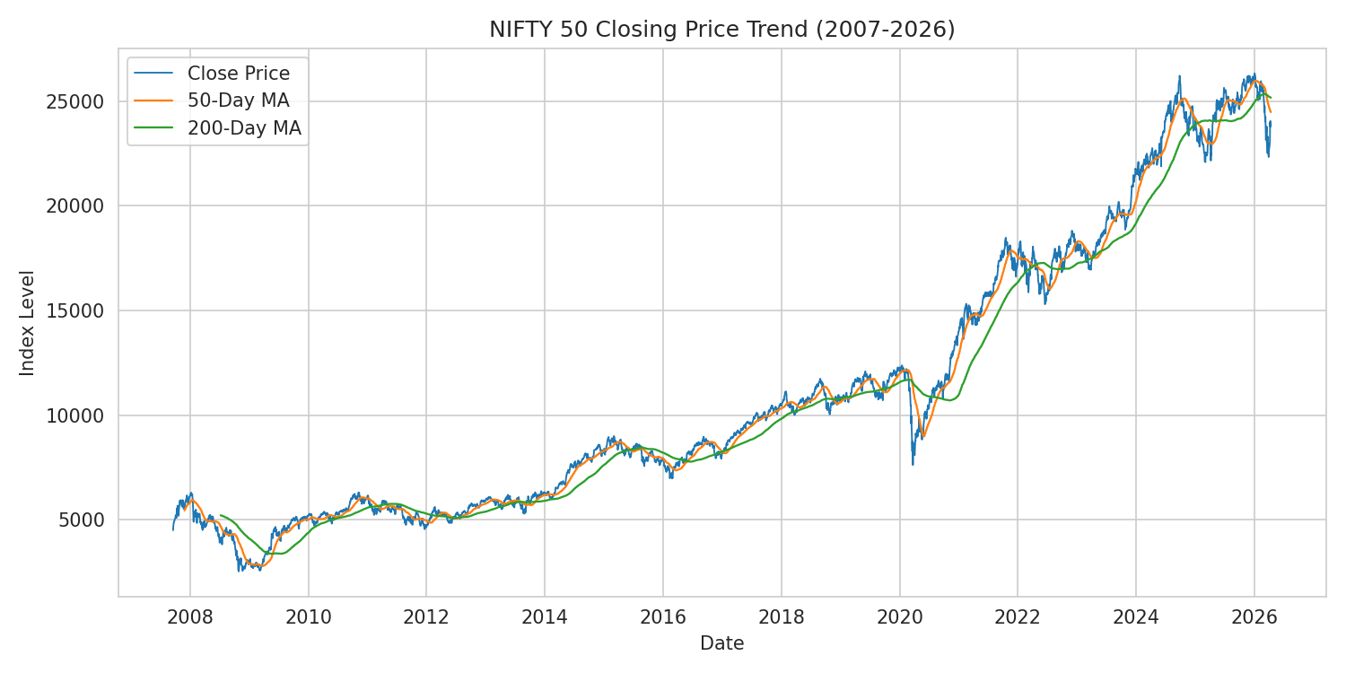
Figure 1: NIFTY 50 closing price with 50-day and 200-day moving averages (2007-2026)
The index rose roughly 430% over the full period, with two clearly visible drawdowns: the 2008 global financial crisis and the March 2020 COVID-19 crash, both followed by strong multi-year recoveries.

4.3 Missing Data Pattern by Year
Having reclassified Volume = 0 as missing, the chart below shows what share of trading days per year are affected — directly visualizing the cleaning decision made in Section 3.4.
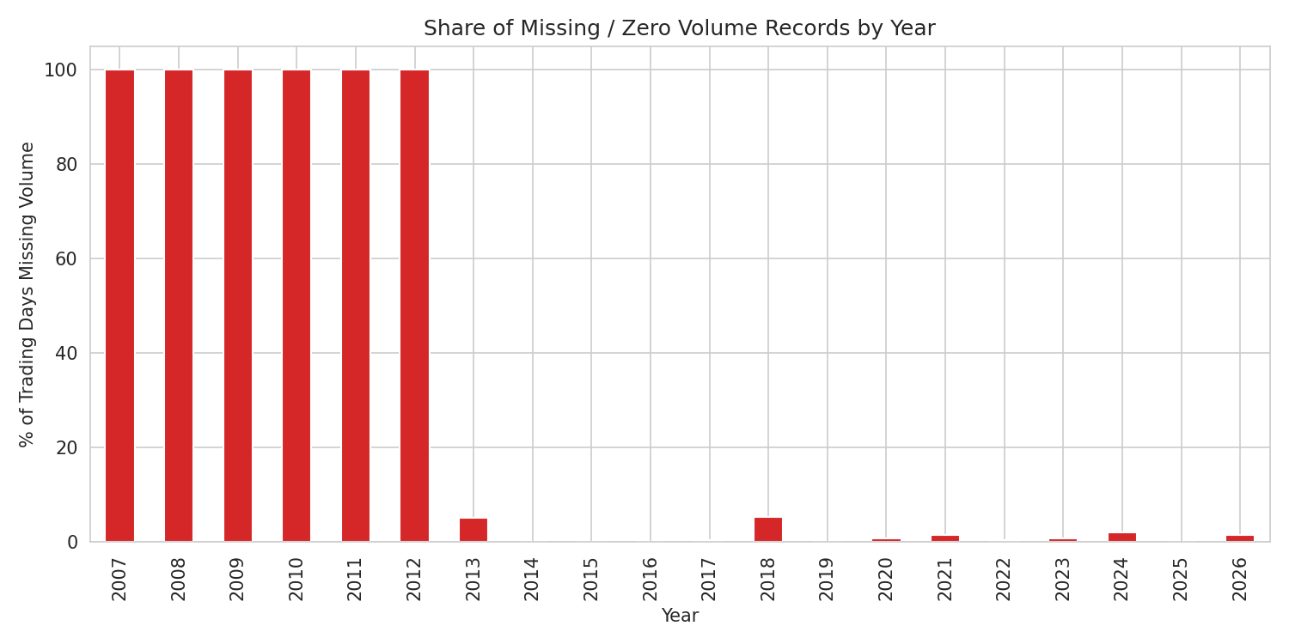
Figure 2: Percentage of trading days per year with missing (originally zero) Volume data
Missing volume data is heavily concentrated in the earlier years of the series (2007-2012) and becomes far less frequent from 2013 onward, consistent with index-level volume reporting maturing over time.

4.4 Correlation Between Variables
A correlation heatmap of the numeric fields shows expected patterns: the four price fields (Open, High, Low, Close) are almost perfectly correlated with each other, while Volume and Daily Return behave far more independently.
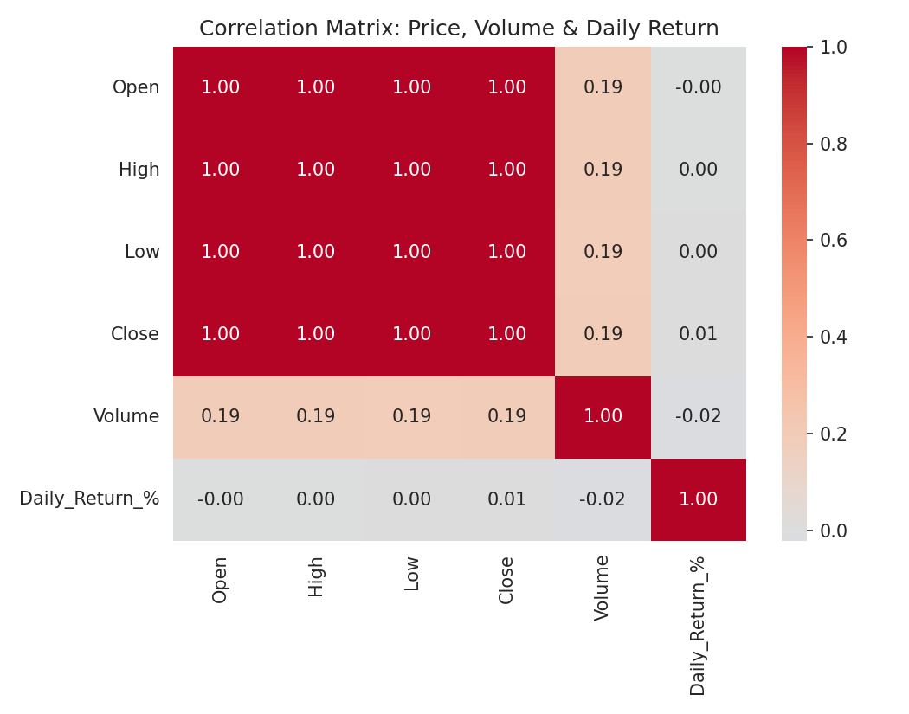
Figure 3: Correlation matrix of Open, High, Low, Close, Volume and Daily Return

4.5 Volatility by Year (Outlier Detection)
A box plot of daily returns grouped by year highlights both typical volatility ranges and extreme outlier days for each year.
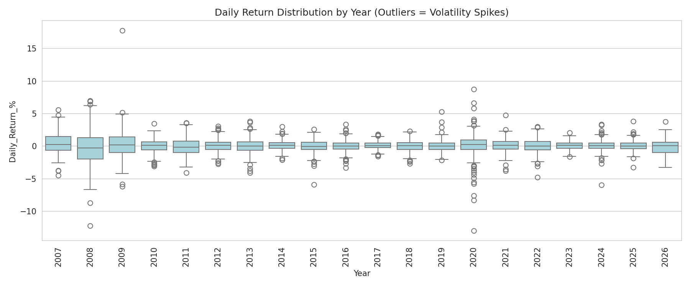
Figure 4: Distribution of daily returns by year; individual points beyond the whiskers are outlier trading days
2008 and 2020 stand out immediately, with visibly wider interquartile ranges and the most extreme outlier points — consistent with the global financial crisis and the COVID-19 market shock. The single worst trading day in the dataset was 23 March 2020 (-12.98%), and the single best was 18 May 2009 (+17.74%), both landmark events in Indian market history.

4.6 Distribution of Daily Returns
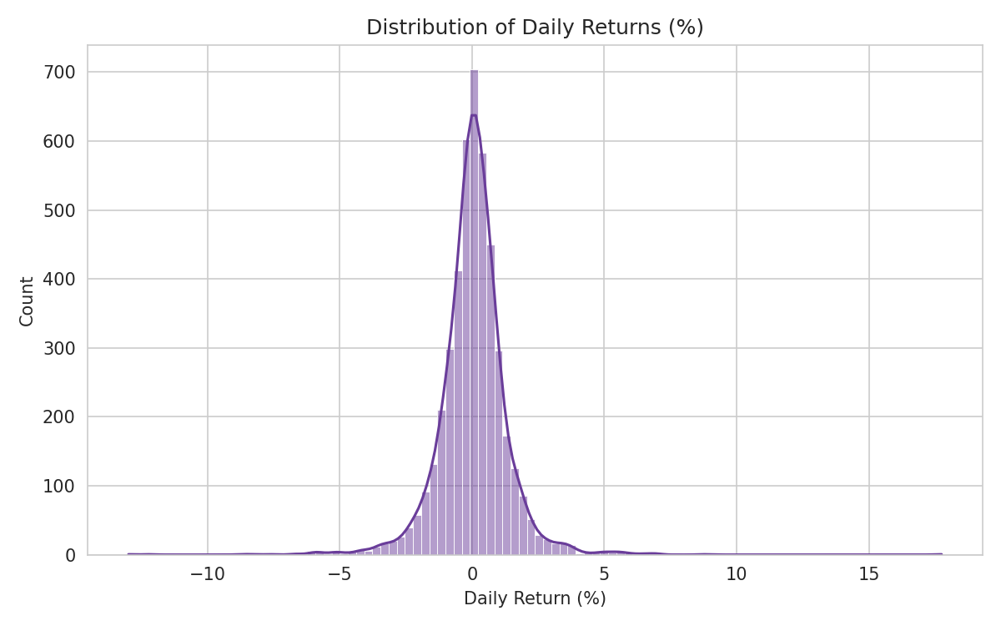
Figure 5: Histogram of daily returns with kernel density overlay
Daily returns are approximately centered around zero and roughly bell-shaped, but with visibly fatter tails than a true normal distribution — a well-documented property of financial return series, where extreme moves happen more often than a normal distribution would predict.

5. Summary of Insights
- The index grew approximately 430% over the ~18.5-year window, an annualized growth rate consistent with long-run Indian equity market performance.
- Annualized volatility across the full period is approximately 20.7%, but volatility is highly clustered rather than constant — 2008 and 2020 account for a disproportionate share of extreme daily moves.
- 29.3% of rows contained disguised missing data (Volume = 0) rather than genuinely missing values — a reminder that isnull() checks alone can miss real data quality issues.
- Data quality on the Volume field improves substantially after 2013, suggesting volume-based analysis should either exclude the pre-2013 period or be treated with additional caution.
- Price fields (Open/High/Low/Close) are near-perfectly correlated, as expected; this means for most modeling purposes only Close (or Adjusted Close) needs to be retained, reducing redundant features.
- Daily returns show fat-tailed, non-normal behavior — a consideration for any downstream risk modeling or forecasting work, since standard normal-distribution assumptions would understate tail risk.

6. Potential Areas for Further Analysis
- Compare NIFTY 50 volatility against a global benchmark (e.g., S&P 500) over the same period
- Build a volatility-clustering model (e.g., GARCH) using the daily return series
- Extend the per-stock files in the same repository (constituent-level history) to analyze which individual stocks drove index-level moves during the 2008 and 2020 crashes
- Join this index data with the news classifier project's sentiment output to test correlation between news sentiment and next-day index returns

