#### Feature correlation

[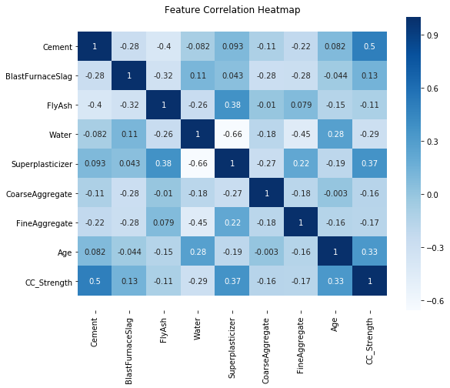](https://github.com/pranaymodukuru/Concrete-compressive-strength/blob/master/imgs/corr.png)

#### Feature importance

[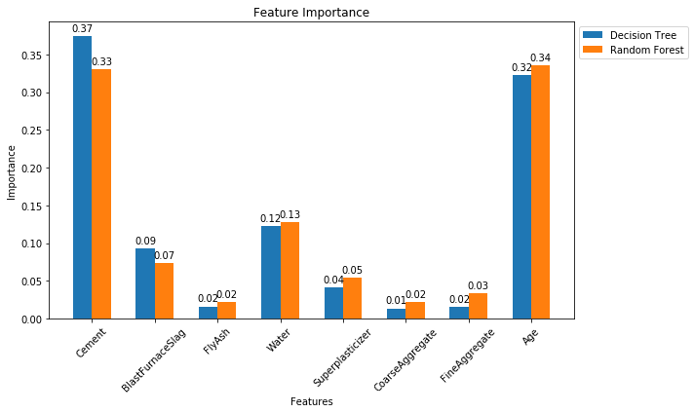](https://github.com/pranaymodukuru/Concrete-compressive-strength/blob/master/imgs/feat_imp.png)

#### Final Comparison

#### [Final Comparison](https://github.com/pranaymodukuru/Concrete-compressive-strength/blob/master/imgs/comparision.png)