**Atari Breakout**

It is a two player game which you and your friend can enjoy.

* We first started by importing the important modules required for developing this game.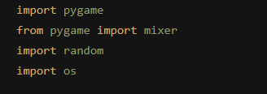

1. **Pygame** -> This module consists of computer graphics and sound that are used to design games in python programming language.
2. **Mixer form pygame** -> In order to play music/audio files in pygame we use this.
3. **Random** -> This module is used to produce random numbers or selecting random items from the list etc.
4. **Os** -> This module provides the functions for interacting with the operating system.

* Then to start with our code we initialized our modules.

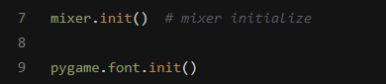

* Let's name our game **“Space Wars”** by setting the display captions using the pygame module.
* Now to create a window and for our game we started by setting the width and height of our screen by 1100 and 700 pixels.

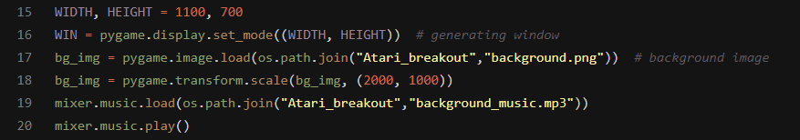

* Then we created a variable **WIN** that has our window with a given height and width.
* We imported our game background using pygame and with the help of the os module.
* We scaled the window according to our requirements.
* We imported the background music for the game using the mixer module and played it.
* Now we created some fonts that we will use later for the game.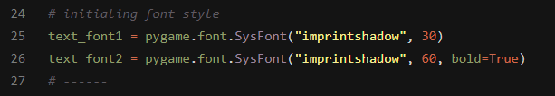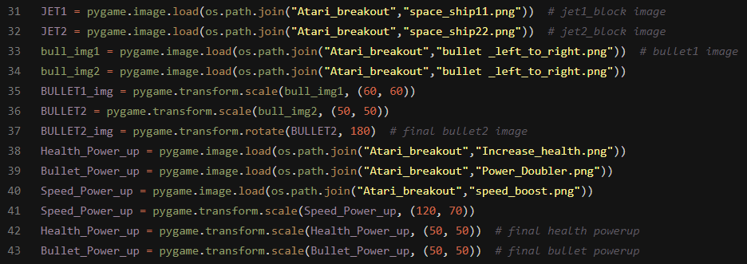
* Here comes the most important thing the surfaces we need on the screen for our game

1. First we import 2 Jets for our player in the game,
2. We scale and adjust them using the pygame module’s several functions.
3. We import the bullet images for both the jets and transform them accordingly too.
4. We import the power-up images for our game transform them.

* Then we set the FPS variable to 60 and we did this so that the game functions smoothly and its functionality doesn’t differ from system to system.
* Here comes some of the variables we are going to need during the development.

1. 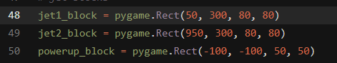

These are some of the Rectangle blocks that are created using the pygame module which define the rectangle’s x-coordinate , y-coordinate ,it's height and its width.

1. 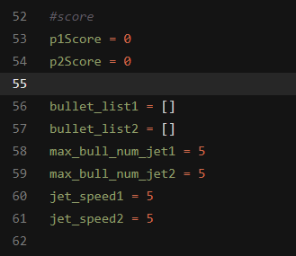

Now we have the score for each player, the list of bullets each player has, the max number of bullets each player can shoot at a time and speed for each player’s jet.

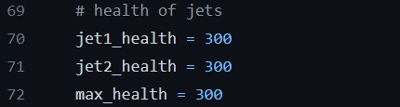

Here we set the health of each player’s jet to be 300.

* Now time for some action with our fire bullet function.

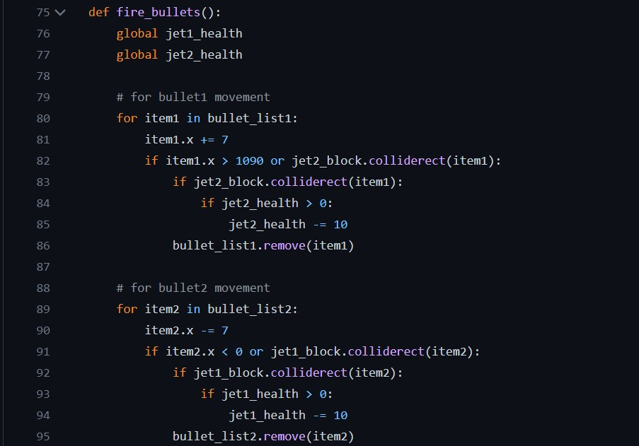

* Here the first line presents the declaration of a function named ‘fire_bullets’ , this function manages the movement of bullets.

1. The next two lines i.e line 73 and 74 has the health variables being declared as global.
   1. GLOBAL keyword allows the user to modify or give access to a variable outside of the current scope.
2. Next comes the “for loop” which lets the bullets move.
   1. There are two for loops with the same functionality .Both loops are present for both the space jets respectively.

* Now comes the most important function

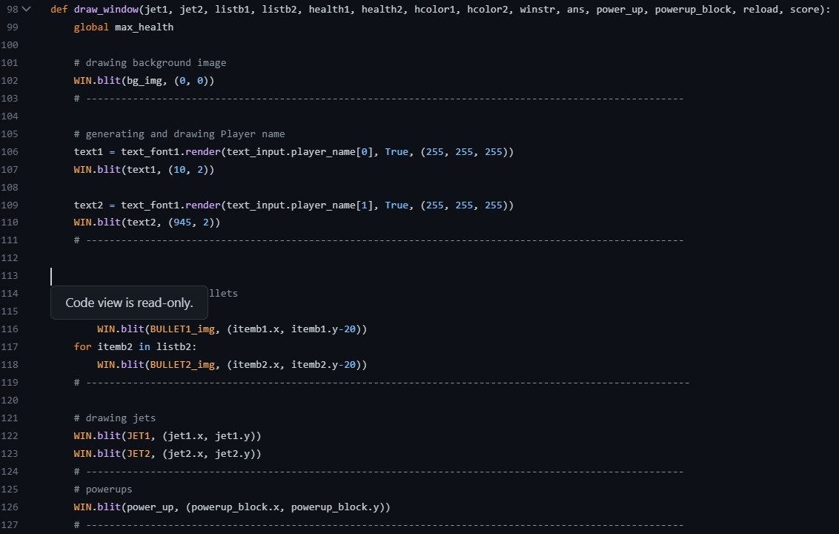

* In this fragment of code the first line , i.e. line no. 98 consists of the declaration of a function named “draw_window()” which draws or renders every image and text on the window .