Paras Patel-Day7 Assignment

Problem Statement: A large company named XYZ, employs, at any given point of time, around 4000 employees. However, every year, around 15% of its employees leave the company and need to be replaced with the talent pool available in the job market. The management believes that this level of attrition (employees leaving, either on their own or because they got fired) is bad for the company, because of the following reasons -

The former employees’ projects get delayed, which makes it difficult to meet timelines, resulting in a reputation loss among consumers and partners

A sizeable department has to be maintained, for the purposes of recruiting new talent

More often than not, the new employees have to be trained for the job and/or given time to acclimatise themselves to the company

Hence, the management has contracted an HR analytics firm to understand what factors they should focus on, in order to curb attrition. In other words, they want to know what changes they should make to their workplace, in order to get most of their employees to stay. Also, they want to know which of these variables is most important and needs to be addressed right away.

Since you are one of the star analysts at the firm, this project has been given to you.

Goal of the case study You are required to model the probability of attrition. The results thus obtained will be used by the management to understand what changes they should make to their workplace, in order to get most of their employees to stay.

Columns

EmployeeIDEmployee number/id

EnvironmentSatisfactionWork Environment Satisfaction Level

JobSatisfactionJob Involvement Level Job Involvement Level Job Involvement Level

WorkLifeBalanceWork life balance level

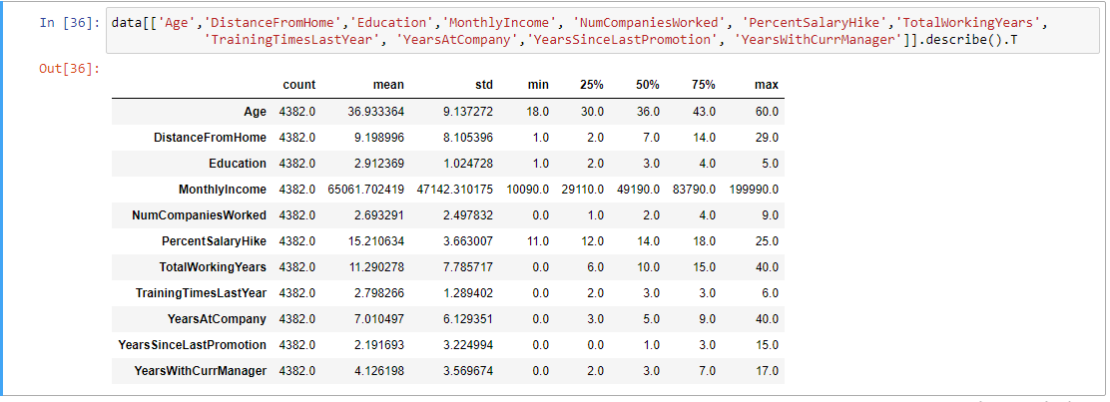

The average MonthlyIncome in the company is around 65000 i.e. the company gives much money to their employees. This shows that money can’t be a problem of leaving a job.

An employee on an average works for 11 years in this company which is a very good rate.

The average Salary hike is around 15% which is also good.

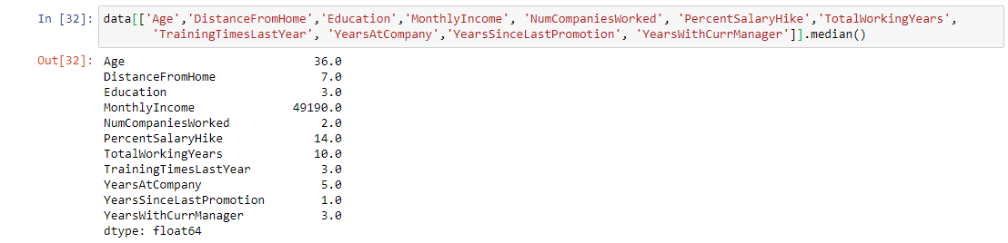

The median salary is around 49000 and maximum salary is around 2 lakh which signifies partiality of some employees.

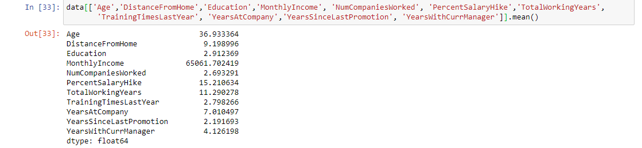

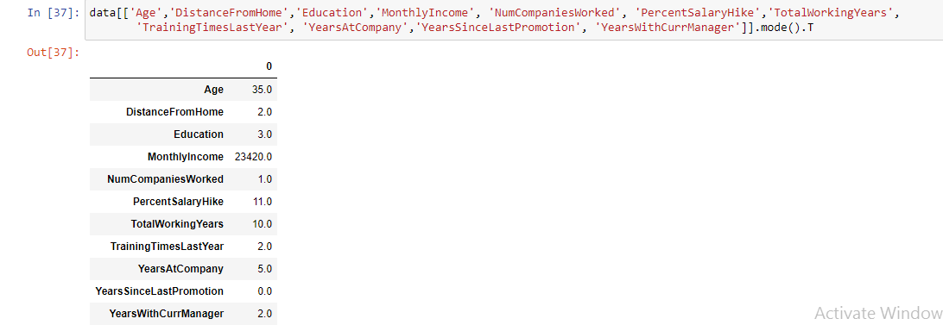

Most of the working professionals in this company are of 35 years which is quite significant and most of the professionals work for 10 years.

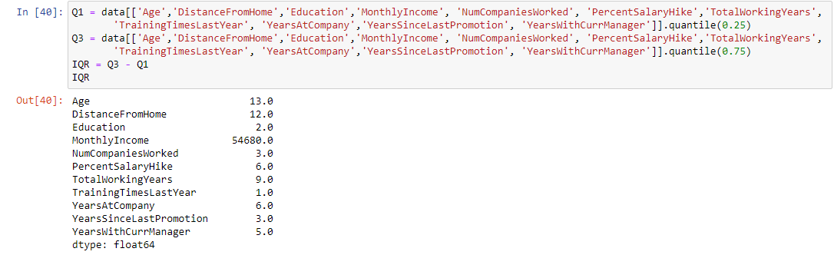

The IQR of Monthly Income is around 55000 which is very huge.

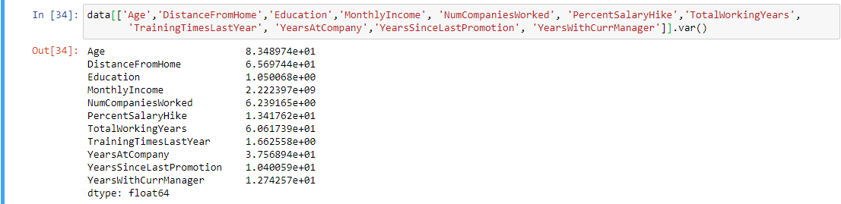

The Variance of Monthly Income is also a huge amount.

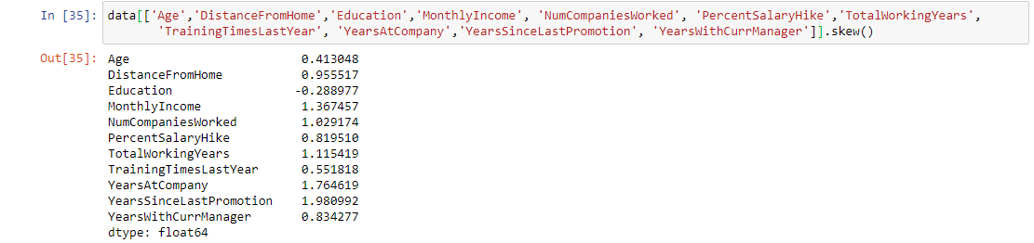

All the variables are positively skewed except Education which is negatively skewed.

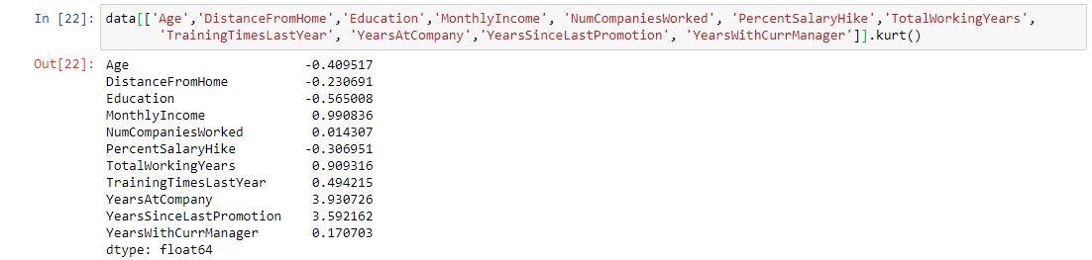

All the variables are Platykurtic except Age, DistanceFrom Home, Education and PercentSalaryHike.

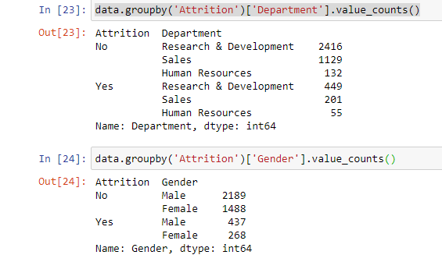

Most of the employees who left were in Research and Development Department followed by Sales and Human Resources. Most of the employees who left were Male.

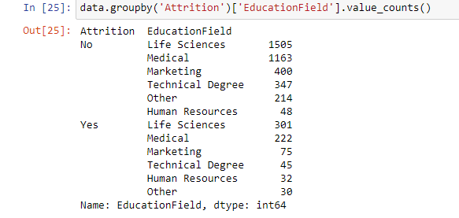

Most of the employees who left had done education in Life Sciences and Medical.

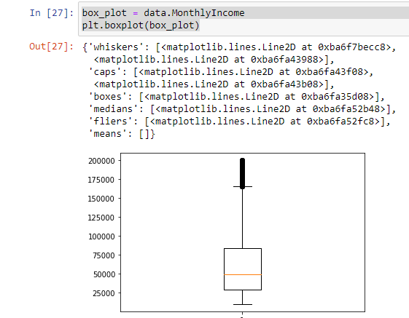

The distribution is positively skewed with lot of outliers.

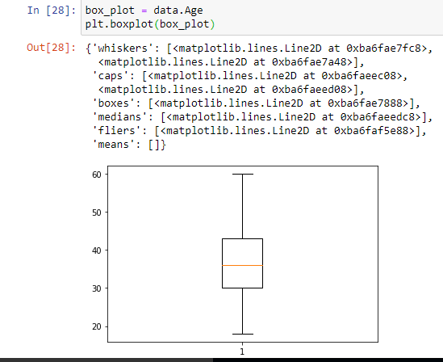

Age forms a normal distribution with no outliers.

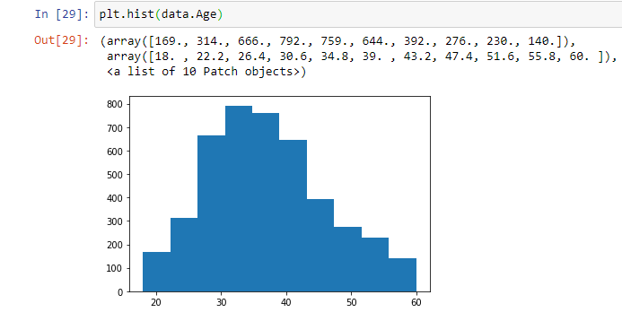

Age follows a normal distribution.

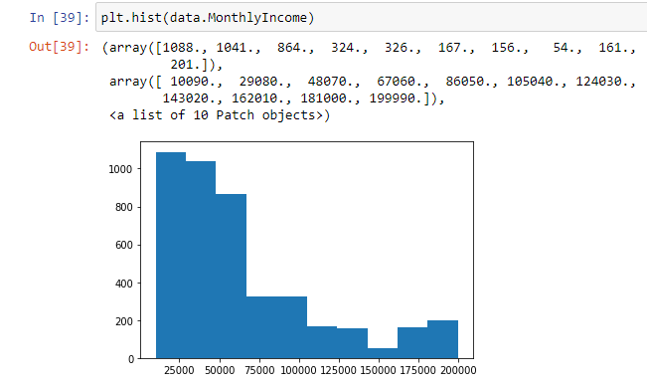

The monthly income is negatively skewed. Around 1100 employees receive salary of 10090 which might feel less to these employees and may be the reason to leave a job.