GAME DESIGN DOCUMENT

Ashes of Truth

1. Game Overview

Genre: Narrative Thriller / Investigation Adventure Game
Theme: “Women Empowerment”

Unlike traditional action-oriented games where strength is defined through physical power or combat dominance, ‘Ashes of Truth’ focuses on a female protagonist whose intelligence, persistence, judgment, courage and emotional resilience drive both the narrative progression and gameplay experience.
The game presents empowerment not through exaggerated heroism, but through:
- independent decision-making
- investigative determination
- moral courage
The protagonist is not portrayed as an unstoppable fighter or action hero. Instead, she represents an ordinary individual placed in extraordinary circumstances, gradually evolving through curiosity, fear, persistence and truth-seeking.
Her journey reflects:
- standing against corruption,
- surviving intimidation,
- uncovering hidden truths,
- and refusing to remain silent despite personal risk.
This grounded portrayal creates a more realistic and emotionally relatable interpretation of empowerment.

2. Theme Compliance

Unlike traditional action-oriented games where strength is defined through physical power or combat dominance, ‘Ashes of Truth’ focuses on a female protagonist whose intelligence, persistence, judgment, courage and emotional resilience drive both the narrative progression and gameplay experience.
The game presents empowerment not through exaggerated heroism, but through:
- independent decision-making
- investigative determination
- moral courage
- the willingness to confront powerful individuals despite overwhelming pressure.
The protagonist is not portrayed as an unstoppable fighter or action hero. Instead, she represents an ordinary individual placed in extraordinary circumstances, gradually evolving through curiosity, fear, persistence, and truth-seeking.
Her journey reflects:
- standing against corruption
- surviving intimidation
- uncovering hidden truths
- and refusing to remain silent despite personal risk.
This grounded portrayal creates a more realistic and emotionally relatable interpretation of empowerment.

3. Core Concept

Ashes of Truth follows a young female junior detective working within a news investigation department, struggling to prove herself in an environment where she is often ignored and underestimated.
After hearing news coverage about an unsolved case involving a partially burned mansion and a powerful businessman, she independently begins investigating the incident out of curiosity and ambition. During her first visit to the abandoned mansion, she discovers suspicious evidence connected to the case and secretly keeps it hidden.
What initially appears to be a forgotten tragedy slowly unfolds into a dangerous conspiracy involving corruption, hidden reports, mercenaries, intimidation and influential individuals attempting to erase the truth permanently.
As the investigation deepens, the protagonist must:
- explore dangerous locations
- gather evidence
- solve environmental clues
- survive attacks
- confront powerful enemies
- and ultimately expose the truth behind the incident.

4. Design Pillars

4.1 Narrative-Driven Progression
The story progression drives gameplay progression. Each clue naturally leads to another location, suspect, or revelation.

4.2 Limited but Immersive Scope
The game uses:
- a hybrid 2D + 3D structure,
- small explorable environments,
- and focused interactions.
This allows the project to feel larger while remaining achievable for the team.

4.3 Investigation Through Curiosity
The protagonist is not physically overpowering. Her strength comes from:
- observation
- persistence
- intelligence
- and decision-making.

4.4 Escalating Pressure
The story gradually shifts from:
- curiosity
- to suspicion
- to conspiracy
- to direct confrontation.

5. Target Experience

The primary experience goal of Ashes of Truth is to create:
- suspense
- curiosity
- tension
- emotional investment
- gradual narrative escalation.

The game is designed to make players feel uncertain about who to trust, pressured by hidden forces, emotionally connected to discoveries and progressively more determined to uncover the truth.
Rather than relying on constant action, the game builds engagement through:
- atmosphere
- pacing
- environmental storytelling
- narrative progression.

The overall experience aims to resemble a grounded investigative thriller where every discovered clue pushes the player deeper into danger.

6. Gameplay Structure

Core Gameplay Loop:
- Receive/Discover Lead
- Travel to Location
- Explore Environment
- Search for Clues/Evidence
- Collect Information
- Update Investigation
- Increase Story Tension
- Unlock Next Lead
- Repeat

7. Gameplay Systems

7.1 Movement System

Type: Basic first-person movement.

Features:
- Walk
- Look around
- Interact with objects
- Trigger dialogue/events

Purpose: Used inside 3D investigation environments.

7.2 Investigation System
The player explores environments searching for important clues.

Features:
- Interactable objects
- Highlight/shimmer effect on important evidence
- Evidence collection
- Dialogue-triggered clues

Purpose: Encourages exploration and observation.

7.3 Inventory System
The protagonist stores collected evidence and important items.

Features:
- Basic inventory UI
- Store evidence
- View collected items
- Possible clue descriptions

Purpose: Supports investigation progression.

7.4 2D Travel Map System
The player travels between major locations using a 2D map interface.

Purpose:
- Reduces development scope
- Avoids open-world complexity
- Maintains pacing
- Gives investigation progression feel

Possible Locations:
- News Office
- Mansion
- Slum Area
- Forest Area

7.5 Dialogue System
NPCs provide:
- story progression,
- clues,
- warnings,
- emotional interactions,
- and suspect information.

Features:
- Basic dialogue boxes
- Sequential conversations
- Optional choice-based responses (if achievable)

7.6 Suspect Investigation System
The player gradually uncovers individuals connected to the conspiracy.

Possible Features:
- Suspect profiles
- Clue notes
- Connection tracking
- Investigation board (optional)

Purpose: Makes the player feel like an investigator.

7.7 Combat / Confrontation System
Introduced later in the game during the mercenary confrontation.
Combat should feel:
- tense,
- survival-focused,
- and story-driven.
The protagonist is not intended to be a traditional action hero.

Possible Mechanics:
- Dodge
- Stun
- Escape
- Environmental interaction
- Basic melee interaction

Purpose: Represents escalation of danger.

8. World Structure

Hybrid World Design
The game uses:
- 2D travel/navigation,
- combined with selective 3D explorable environments.
This creates:
- immersion,
- manageable scope,
- and smoother development.

9. Main Environments (‘Under Progress’)

9.1 News Office (3D)
- Primary recurring location.

Features:
- Common workspace
- Player desk
- NPC interactions
- Story progression
- Intro/tutorial area

Important Areas:
- Player workstation
- Boss office
- Cafeteria

9.2 Boss Office (3D)
- Narratively important location.

Purpose:
- Suspicious interactions
- Story tension
- Authority pressure
- Secretive conversations

9.3 Mansion (2D)
- Main investigation location.

Purpose:
- First major exploration section
- Discovery of important artifact
- Story trigger point

9.4 Slum Area (2D Character Sprites in 3D Environment)
- Provides:
  - witness interactions,
  - hidden information,
  - and expansion of conspiracy.

9.5 Forest Area
- Later-game tension environment.

Purpose:
- Mini-boss confrontation
- Combat introduction
- Major revelation

10. Story Progression

Phase 1 — Introduction
  - Player introduced to office environment
  - Introduced to boss and coworker
  - Establishes protagonist as underestimated
  - Cafeteria TV news reveals old unresolved case

Mechanics Introduced:
  - Movement
  - Dialogue
  - Interaction

Phase 2 — Mansion Investigation
  - Protagonist secretly visits mansion
  - Searches environment
  - Finds important evidence/artifact
  - Stores artifact at home

Mechanics Introduced:
  - Exploration
  - Clue discovery
  - Inventory system

Phase 3 — Suspicion Begins
  - Mansion owner visits office
  - Boss behaves suspiciously
  - Protagonist warned to drop the case

Narrative Purpose:
Builds tension and mistrust.

Phase 4 — Second Investigation
  - Return to mansion
  - Discover half-burned note
  - Note references slums

Mechanics Introduced:
  - Lead progression
  - Evidence chain
  - Travel system

Phase 5 — Slum Investigation
  - Meet local NPCs
  - Discover hidden stories
  - Learn about old mercenary living in forest

Narrative Purpose:
Conspiracy expands beyond wealthy elites.

Phase 6 — Mercenary Confrontation
- Mercenary becomes mini-boss encounter
- Combat/confrontation mechanics introduced
- Major truth/reveal occurs

Narrative Purpose:
Story escalates from investigation to direct danger.

Phase 7 — Confrontation
- Return to the mansion using information gathered from archived case files.
- Locate the hidden cupboard containing the missing evidence.
- Discover the victim's personal notes and the complete photograph identifying the unknown third individual.
- Confront the final antagonist after they arrive at the mansion.
- Escape while protecting the collected evidence.
- Publicly expose the conspiracy and reveal the truth behind the victim's death.
Narrative Purpose:
Deliver the final mystery resolution, complete the protagonist's investigative journey and reinforce the theme that truth prevails through persistence, courage and refusal to remain silent.

11. Main Characters

11.1 Protagonist

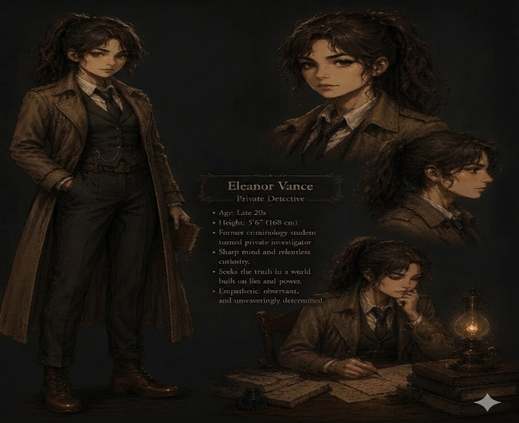
Role: Junior detective/investigator.

Traits:
- Curious
- Intelligent
- Persistent
- Courageous
- Underestimated

Character Arc: Grows from ‘ignored employee’ to

‘independent truth-seeker’.

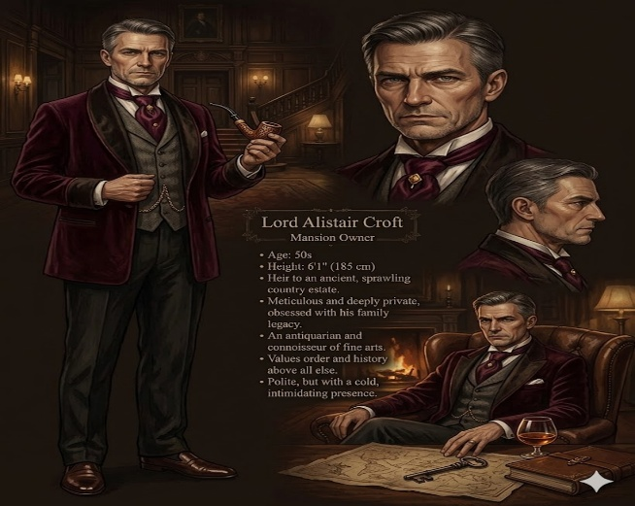
11.2 Boss Detective

Role: Authority figure.

Narrative Function:
- Suspicion
- Pressure
- Possible betrayal
- Internal corruption representation


11.3 Mafia Boss (Main Antagonist)

Role: Primary Antagonist / Crime Syndicate Leader

Narrative Function:
- Mastermind behind the mansion incident
- Source of conflict and danger throughout the investigation
- Symbol of corruption, power and influence


11.4 Rich Businessman

Role: Powerful suspect.

Narrative Function:
- External pressure
- Hidden agenda
- Connected to mansion and evidence


11.5 Mercenary

Role: Mini-boss / Enforcer.

Narrative Function:
- Physical danger
- Conspiracy cleaner/fixer
- Escalation point

12. Visual Style

Desired Tone:
- Thriller
- Dark mystery
- Grounded realism
- Slightly cinematic

Lighting:
- Indoor office lighting
- Dark mansion atmosphere
- Suspicious night-time environments

13. Audio Design

Music Direction:
- Suspenseful ambient music
- Investigation atmosphere
- Tension during important reveals

Sound Effects:
- Footsteps
- Door sounds
- UI clicks
- TV news audio
- Environmental ambience

14. UI Elements

Planned UI:
- Inventory panel
- Dialogue box
- Travel map
- Objective tracker
- Evidence notifications
- Suspect/evidence screen

15. Scope Management Strategy

Intentionally Avoided:
- Open world
- Advanced AI
- Large combat systems
- Complex branching narratives
- Large explorable city
- Heavy stealth mechanics

Focused Strengths:
- Strong story
- Controlled progression
- Atmosphere
- Investigation feel
- Simple but polished mechanics

16. Minimum Viable Product (MVP)

Required Features:
- Basic movement
- 2D travel map
- Explorable 3D environments
- Dialogue system
- Clue interaction system
- Inventory system
- Story progression
- One confrontation/combat sequence
- Beginning-to-ending playable build

17. Future Developments

Highest Priority:
- Dialogue progression
- Mansion investigation
- Inventory system
- Story flow
- Travel map

Secondary Priority:
- Suspect board
- Additional polish
- Expanded dialogue choices
- Visual effect

- Scene 9 — Forest Encounter

Narrative Event: The protagonist locates a retired mercenary living in isolation within the forest. Initially distrustful and unwilling to cooperate, the mercenary challenges the protagonist's intentions.
The player must navigate a dialogue sequence using collected evidence, including:
• The Burned Photograph
• The Burned Note
Successful dialogue choices convince the mercenary to continue speaking.
Aggressive or dismissive responses may result in a ‘fail state’ requiring the conversation to be restarted.
The mercenary recognizes the unidentified individual from the photograph and reveals that the person had connections to influential individuals involved in the original case.
Without fully revealing the truth, he suggests that the protagonist's boss possesses information that was never publicly disclosed.

18. Key Strengths of the Project

- Strong narrative hook
- Clear female protagonist agency
- Achievable scope
- Structured progression
- Memorable conspiracy-thriller tone
- Mechanics tied directly to narrative
- Evidence-driven storytelling that encourages player deduction rather than exposition
- Distinct and atmospheric locations that support world-building and narrative progression
- Consistent late-1990s investigative setting that reinforces immersion & mystery

19. Final Design Philosophy

The game focuses on:
- investigation,
- tension,
- progression through discovery,
- and a strong female protagonist driving the narrative.
Rather than becoming a large-scale action game, the experience is designed as a contained conspiracy thriller where intelligence and persistence are more important than physical power.

20. New Addition/Changes

- Core Mystery:
At the center of Ashes of Truth lies a single question:
"Who is the unidentified third person in the burned photograph?"

The protagonist's investigation gradually uncovers the connections between the mansion owner, his deceased brother, hidden case files, a former mercenary and an unknown individual whose identity appears repeatedly throughout the case.
Every major clue discovered throughout the game contributes to uncovering the identity of this individual and understanding their role in the original incident.
The mystery progresses through a chain of interconnected evidence:
• Burned Photograph
• Burned Note
• Witness Testimonies
• Mercenary Testimony
• Archived Case Files
• Victim's Personal Notes
• Final Photograph and Records
Each clue reveals a new piece of the conspiracy while directing the player toward the next investigation location.

- Level 2:

Scene — Discovery of First Evidence
Environment: Inside Mansion
Narrative Event: While exploring the abandoned mansion, the protagonist discovers a partially burned photograph hidden beneath debris that was likely overlooked during the original investigation.

The photograph contains:
• The mansion owner
• The mansion owner's deceased brother
• An unidentified third individual
The photograph appears intentionally damaged by fire, obscuring the identity of the third person.
Believing the photograph may be important, the protagonist secretly takes it home rather than reporting it immediately.
As she leaves the mansion, she briefly notices an unknown figure observing her from a distance before disappearing.

Mechanics Introduced:
• Inventory System
• Evidence Collection
• Evidence Inspection

- Updated Narrative Event:
The television broadcast discusses a famous unsolved mansion case that has remained unresolved for several years.
According to the report:
• The mansion owner's brother died during the incident.
• Autopsy records suggested the victim died before the fire began.
• The official investigation failed to determine the cause.
• The case was eventually closed due to insufficient evidence.
Already familiar with the case and eager to prove herself professionally, the protagonist becomes convinced that the abandoned mansion may still contain overlooked clues.
- Updated Slum Investigation:
The slum district acts as a dialogue-focused investigation area.
The protagonist gathers information from multiple local residents, each providing partial and often incomplete information.
Rather than receiving a direct answer immediately, the player gradually pieces together the next lead through several conversations.

- Example Information Chain:
NPC 1: Provides information regarding an individual connected to the original case.
NPC 2: Provides information regarding the individual's last known whereabouts.
NPC 3: Mentions a former mercenary who may possess additional knowledge.

Successfully completing these conversations unlocks the Forest location and advances the investigation.

- Scene 10 — Ambush Sequence
Narrative Event: As the protagonist leaves the mercenary's cabin, movement is detected outside. Moments later, gunfire erupts and a cabin window is shattered. The attack confirms that powerful individuals are monitoring the investigation and attempting to prevent further discoveries. The mercenary provides the protagonist with a firearm and urges her to defend herself.
Gameplay Purpose: Introduce the game's primary combat sequence and escalate narrative tension.

Mechanics Introduced:
• Target Shooting
• Time Pressure
• Combat Survival
Objective: Eliminate attackers and survive the ambush before time expires.

- Scene 13 — Boss Office Investigation
Narrative Event: Inside the office, the protagonist discovers archived investigation records connected to the original mansion case.
The files reveal:
• Evidence suppression records.
• References to an unidentified third individual.
• Reports indicating the victim possessed critical evidence before death.
• Confirmation that the evidence was never recovered.
Gameplay Mechanic: A timed search sequence is introduced while the coworker keeps watch outside.
Narrative Purpose: The files confirm that the investigation was incomplete and strongly suggest that the missing evidence remains hidden somewhere inside the mansion.

- Scene 14 — Final Mansion Exploration
Narrative Event: Using information gathered from the archived files, the protagonist returns to the mansion for a final investigation.
After locating a hidden key and unlocking a concealed cupboard, she discovers:
• A clear photograph identifying the unknown third individual.
• Personal diary pages belonging to the victim.
• Written records documenting threats received before the victim's death.
The victim's notes reveal that he had discovered information connecting influential individuals to illegal activities and had been attempting to expose them before his death.
Objective: Collect the final evidence and escape with it.

- Time Period & Setting:
‘Ashes of Truth’ is set around the late 1990’s. This period was intentionally selected to support the game's investigation-focused gameplay and grounded thriller atmosphere.
Physical evidence, archived files, printed photographs, witness testimony and on-site investigation remain essential tools for uncovering the truth. Modern technologies such as cloud storage, social media, and instant information sharing are not yet dominant, making hidden records and suppressed evidence more believable within the narrative.
This setting strengthens the mystery while encouraging exploration, evidence gathering and direct interaction with characters and locations.

