Cross-ERA: — When Time Breaks, Only Strategy Can Fix It.

1.0 INTRODUCTION (Context & Motivation)
Cross-ERA is a tabletop strategy board game built around the core conceit that the three major timelines — Past, Present, and Future — have fractured and merged into a chaotic, overlapping world. Players become Time Travelers whose objective is to repair the timeline by collecting three era-specific relics and returning them to the Time Nexus at the board’s centre.
This project aims to produce a polished, market-ready board game that balances tactical depth with approachable rules for 2–4 players. Gameplay blends deterministic planning (card management, portals, defence) with measured randomness (1 six-sided die and turn-based event draws) to create tight, satisfying decision spaces. The game is intended to be playable in 15-35 minutes and accessible to ages 12+.

1.1 HIGH-LEVEL CONCEPT
- Game Title: Cross-ERA: Strategy Edition
- Genre: Time-travel, Strategy, Card-engine, Area movement
- Players: 2–4 (balanced)
- Playtime: 15-35 minutes
- Components: Board, 1 die (1D6), tokens, 100+ cards (Past 25 / Present 20 / Future 20 / Power 10 / Event 10), relic tokens, player sheets
- Core Loop: Roll → Move → Draw Event → Apply Tile Effect → Play Cards → End Turn
  - Win Condition (Primary): Collect Ancient, Modern, and Future relics, then reach Centre Nexus by exact roll.
  - Win Condition (Alternative): Accumulate 10 Strategy Points (relics, steals, defences, portals, combos).

1.2 DESIGN GOALS & EXPERIENCE PILLARS
Cross-ERA’s design is guided by four experience pillars:
- Strategic Depth, Not Dice Dependence
  - Movement uses one 6-sided die: 1–6 steps. Cards, portals, and power effects should enable meaningful control over luck.
  - Players must plan routes, hold or spend cards tactically, and time high-value plays.
- Distinct Era Identities
  - Past (blue) emphasizes information, small movement, portals, and early advantages.
  - Present (red) emphasizes trades, utility, combo potential and midgame control.
  - Future (green) emphasizes powerful movement, prediction, and endgame finishers.
- Fast-Turning with High Interactivity
  - Each turn triggers an Event draw — keeps unpredictability high and forces adaptive decisions.
  - Strong player interaction through steals, swaps, defenses, and tile competition.
- High Replayability & Expandability
  - Different card draws, wormhole placements, and player strategies ensure unique sessions.
  - Modular structure supports expansions (new eras, campaign mode, character powers).

1.3 TARGET AUDIENCE & MARKET POSITIONING
Primary audiences:
- Casual Familes (Age 12+) — Drawn to fast sessions (15-35 minutes), thematic hook (time travel), simple core loop.
- Strategy Enthusiasts — Attracted by deep card interactions, multi-era planning, and competitive play.
- Board Game Night Groups — Satisfies competitive co-op vibes with accessible learning curve.
- Education / Cognitive Training Markets (secondary) — Encourages planning, memory, and probabilistic reasoning.

1.4 CORE MECHANICS (SUMMARY)
- Movement: Roll 1 six-sided die (1D6) and move clockwise the exact amount.
- Card Draws: Landing on colored tiles draws from the respective era deck; landing on CLUB draws a Power card; landing on ? tiles draws Event cards.
- Events: Drawn every player turn (immediately after movement) to represent timeline reactions. Events are applied immediately.
- Card Play: Most cards are one-time use except relics and certain resource tokens. Cards can be played before or after movement (per card text).
- Relics: Era relics (Ancient, Modern, Quantum) are required to win. Backup relics and Relic Tokens provide alternate advantages.
- Portals/Wormholes: Cards or tiles can force or allow instant era jumps.
- Defense & Interaction: Power and certain era cards provide blocks, steals, swaps, or forced movement.

1.6 COMPONENTS (DETAILED)
Physical component list (recommended final production):
- 1 × Full-color foldable Game Board (3 concentric era rings, icons, start, CLUB, ? tiles, Day of Rest, Center Nexus)
- 1 × Standard 6-sided die (1D6)
- 4 × Player Tokens (distinct colors)
- 25 × Past Cards (blue border)
- 20 × Present Cards (red border)
- 20 × Future Cards (green border)
- 10 × Power Cards (black/gold premium)
- 10 × Event Cards (white/red alert)
- 4 × Player Cross-ERA Sheets (for tracking cards, tokens, points) — printable A4
- 1 × Rules Booklet (quick start + full rules)

1.8 TIMELINE (Roadmap Summary)
MVP / Prototype Phase (4–9 weeks):
- Finalize core rules and card content
- Prototype print for playtesting
- Basic art placeholders
Playtest Phase (1-3 weeks):
- 20–50 playtest sessions
- Iterate rules & balance
- Record logs & refine cards
Art & Graphic Phase (3-4 weeks):
- Final art for board, cards, tokens
- Templates for print

1.9 PLAYTESTING PLAN (Summary)
Purpose: Validate balance, pacing, player interaction, fun, and clarity.
Plan:
- Iteration 0: Internal playtest with 3–5 designers to validate core loop.
- Iteration 1: Invite small external groups (friends) for tests
- Iteration 2: Diverse group tests (families, gamers, novices) — 3+ sessions, record metrics.
- Metrics to track: average playtime, player win distribution, frequency of card types used, player perceived fairness (survey), fun rating (1–10).
- Iteration 3: Final balance tweaks, clarify rulebook points, final polish.

1.10 RISK ANALYSIS (Key Risks & Mitigations)
- Risk: Overpowered Cards / Snowballing
  - Mitigation: Strict playtesting with win-rate analysis, impose limits on power card draws, include counters and anti-snowball event probability.
- Risk: Analysis Paralysis (players take too long)
  - Mitigation: Limit optional card plays per turn (default one card unless a card allows extra), add quick reference sheet, encourage 30–45s planning time.
- Risk: Component Cost Overrun
  - Mitigation: Provide Standard and Deluxe variants, get multiple manufacturing quotes, revise BOM for cheaper materials if needed.
- Risk: Rule Confusion
  - Mitigation: Create a clear, illustrated rulebook + one-page quick start + cheat sheets. Use playtest feedback to refine wording.
- Risk: Low Replayability
  - Mitigation: Diverse decks, randomized wormhole placements, and event cards ensure variety. Plan expansions.

1.15 CONCLUSION
Cross-ERA presents a compelling blend of theme, strategy, and accessibility. The three-ring board combined with a five-deck card engine yields deep, memorable gameplay that rewards planning, timing, and adaptability. With one die and strong card mechanics, players retain agency while experiencing the unpredictable consequences of manipulating time.

The Journey + EXPLANATION

Mind Map Overview: Cross-ERA System Architecture
The Cross-ERA game is built around five interconnected systems:
- Era Progression System (Past → Present → Future)
- Card Ecosystem (5 Decks interacting dynamically)
- Player Progression Loop (movement, cards, relics)
- Timeline Jump Mechanics (portals, wormholes, events)
- Relic Strategy Loop (collect → defend → rush Nexus)
Below is the detailed mind map in text format:
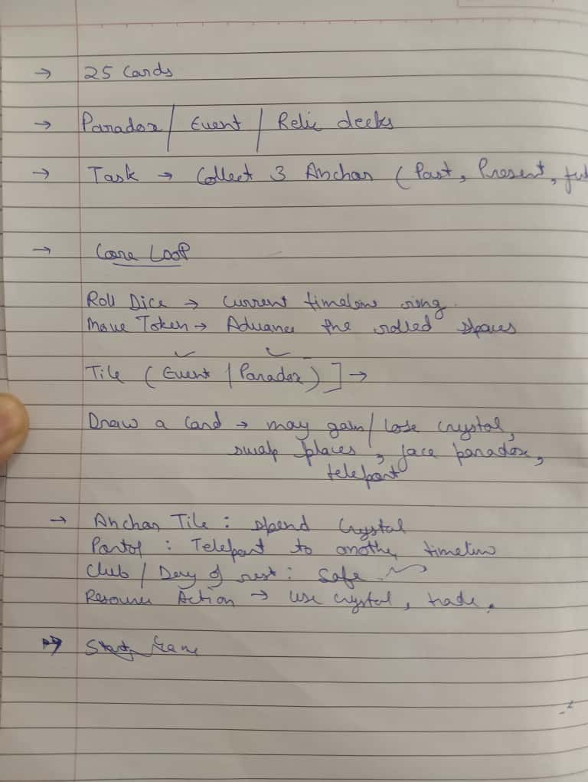
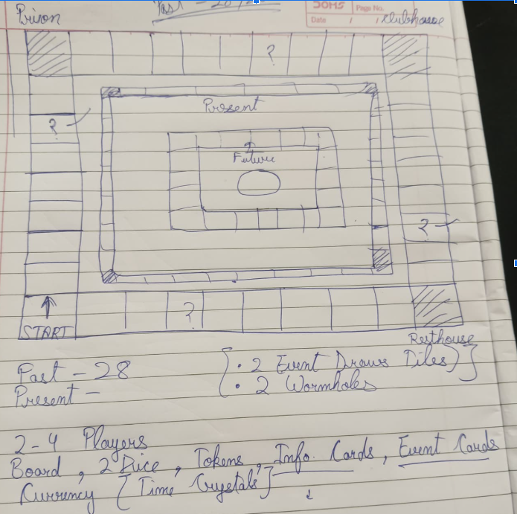

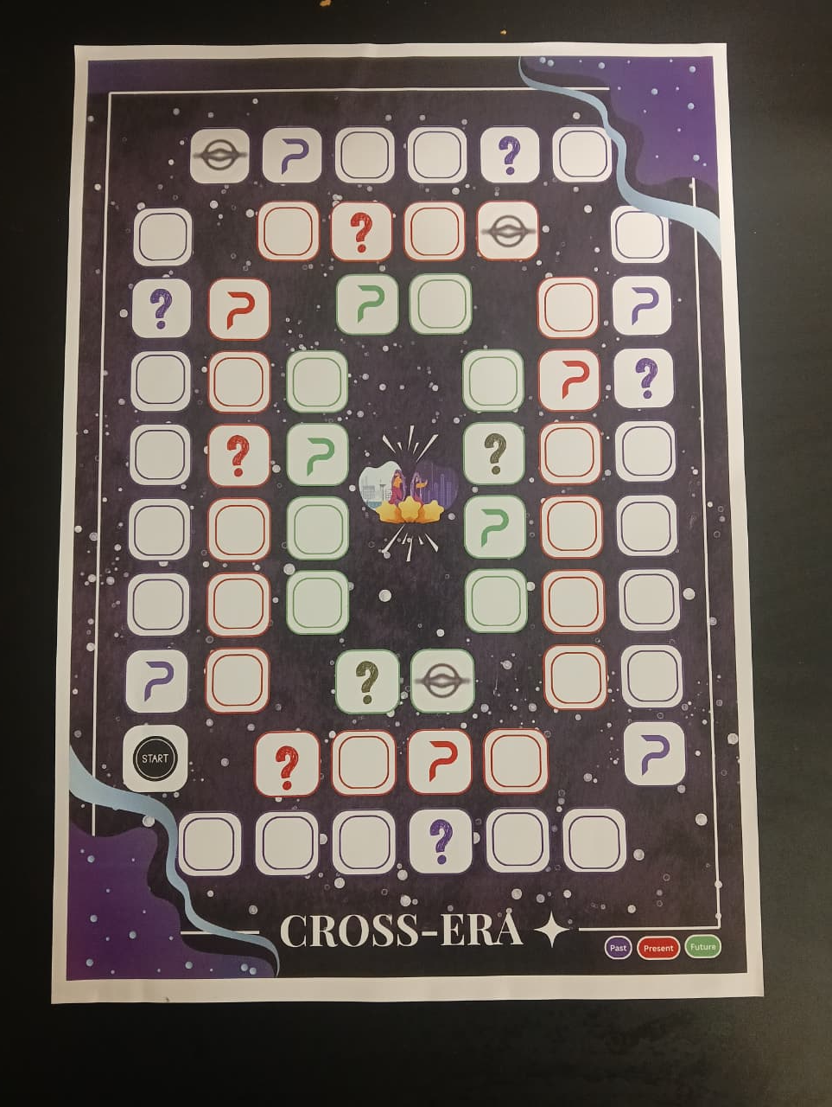

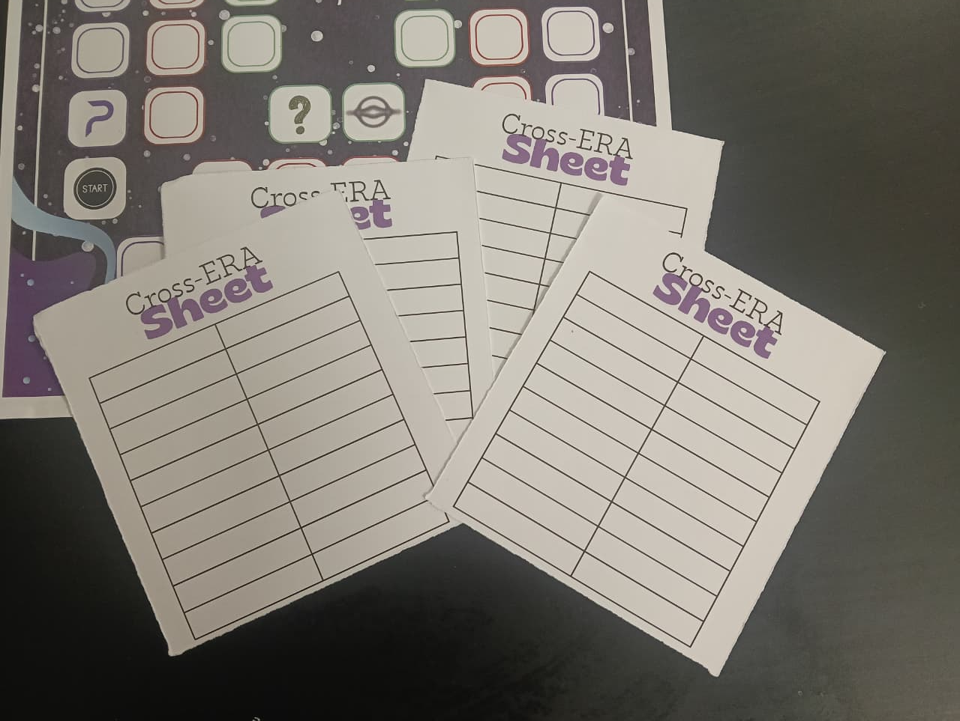

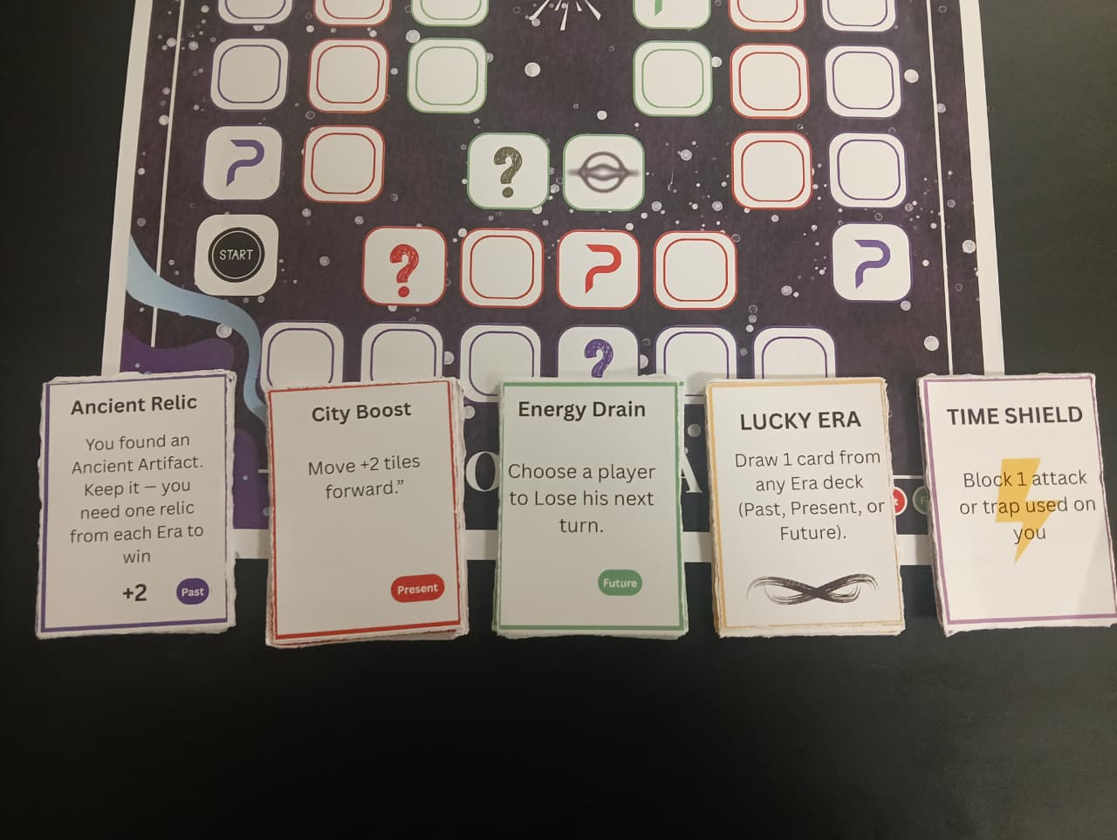

1. Past Era → Present Era → Future Era Progression Map
Past Era (Foundation)
- Start of all players
- Low-risk tiles
- High movement support
- Portals
- Basic defenses
- Relic 1: Ancient Relic
→ Leads to → Present Era (Conflict Zone)
- Steals and trades
- Mid-level sabotage
- Resource manipulation
- Event-heavy gameplay
- Relic 2: Modern Relic
→ Leads to → Future Era (Power Zone)
- Teleports
- Predictions
- Anti-traps
- Wormholes
- Relic 3: Quantum Relic
→ Leads to → Nexus Corridor (Final Challenge)
- Penalties
- Forced events
- Tight movement requirements
→ Leads to → Time Nexus (Victory)
Explanation:
This system ensures a clear sense of journey.
Players cannot skip eras, creating a structured strategic learning curve:
- setup → conflict → escalation → climax

2. Card Ecosystem Mind Map
The card ecosystem functions like a three-level engine:
Past Cards
- Improve movement
- Grant small advantages
- Help players position strategically
- Provide early relic hints
- Set foundation for combos

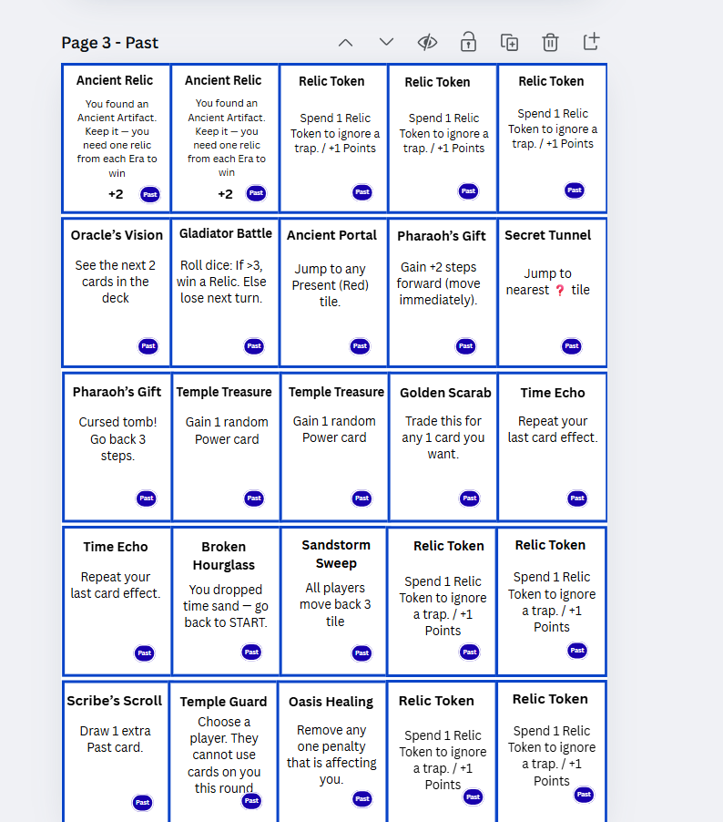

Present Cards
- Affect opponents directly
- Enable trades
- Enable card stealing
- Adjust resource availability
- Introduce midgame tension

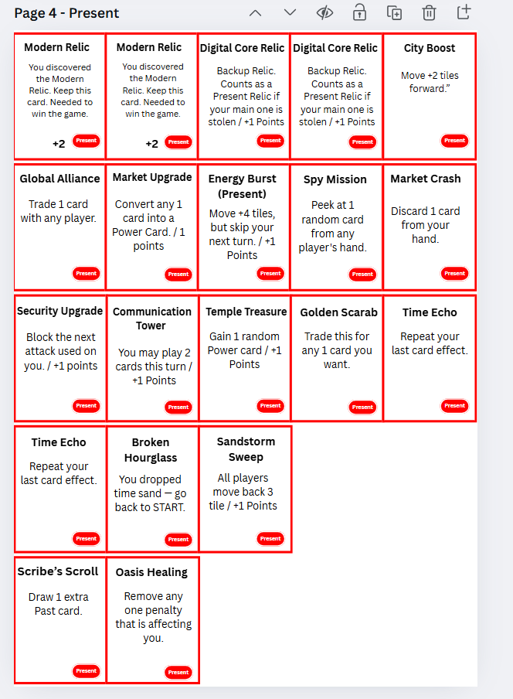

Future Cards
- High power effects
- Teleports
- Prediction & manipulation
- Late-game dominance tools
- Wormhole control

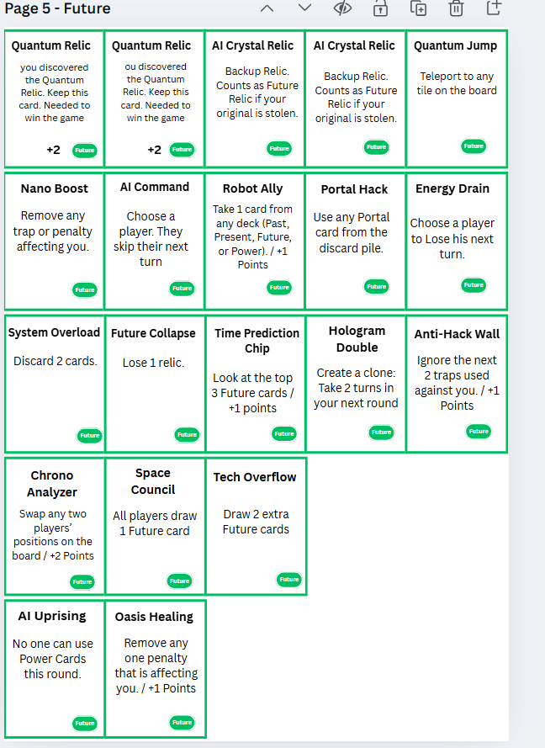

Power Cards
- Universal strong effects
- Battle cards (steal/defend)
- Major movement shifts
- Safety nets

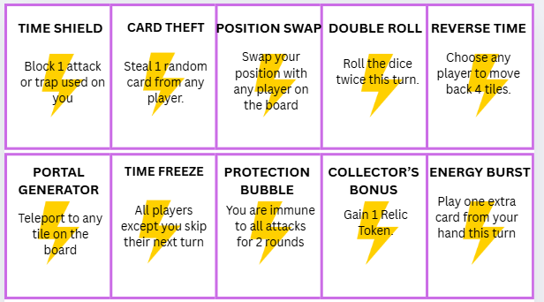

Event Cards
- Unpredictability
- Global shifts
- Timeline distortions
- Group impact
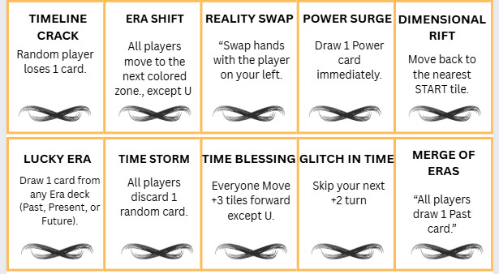

Explanation:
All five decks form a closed ecosystem, each deck interacting with the others.
This ensures:
- balance
- strategy
- unpredictability
- replayability

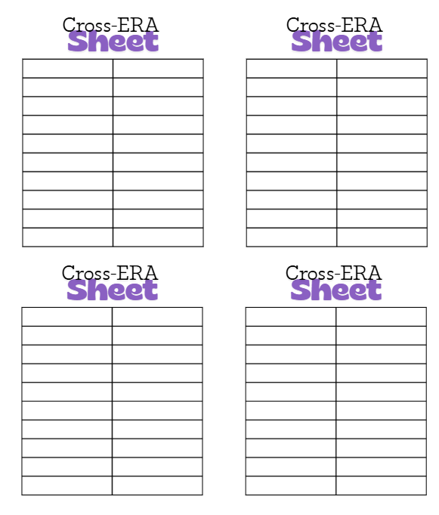

3. Player Progression Mind Map
Stage 1 — Early Game
- Acquire Past cards
- Move quickly using portals
- Learn tile layout
- Secure Ancient Relic
Stage 2 — Mid Game
- Draw Present cards
- Engage opponents
- Stop others from collecting relics
- Defend your Ancient relic
- Secure Modern Relic
Stage 3 — Late Game
- Teleportation
- Advanced defense
- Predicting opponents
- Secure Quantum Relic
Stage 4 — Final Rush
- Reach Nexus corridor
- Maintain relics
- Defend aggressively
- Exact movement
- Win

4. Timeline Jump System (Mind Map)
Jump Types:
- Portal Jump: fixed teleport
- Wormhole Jump: flexible teleport
- Card Jump: direct teleport via cards
- Event Jump: forced teleport through event
Timeline jumps create:
- shortcuts
- tension
- speed
- unpredictability
They support both catch-up mechanics and advanced strategic ambushes.

5. Relic Strategy Loop (Mind Map)
Step 1: Obtain relic
Step 2: Protect relic (defense cards)
Step 3: Predict opponent sabotage
Step 4: Move to next era
Step 5: Repeat
This loop teaches:
- risk management
- timing
- resource allocation
- defense planning

- ⭐ SECTION: MOODBOARD & AESTHETICS
This section defines the visual identity of the Cross-ERA world.

1. Past Era Aesthetic
Color Palette:
- Sandstone beige
- Deep brown
- Soft gold
- Faded red
- Earthy textures
Texture Philosophy:
- Papyrus
- Stone tablets
- Ancient inscriptions
- Mural patterns
Board Tile Style:
- Rough edges
- Hand-carved look
- Subtle cracks
Card Design:
- Warm tones
- Uneven parchment backgrounds
- Ancient seals as icons

2. Present Era Aesthetic
Color Palette:
- Bright neon red
- Metallic silver
- Deep charcoal
- Digital blue
Texture Philosophy:
- LED screens
- Holographic grids
- Metallic surfaces
Board Tile Style:
- Sharp straight edges
- Clean typography
Card Design:
- Metallic gradients
- Circuit patterns
- Digital icons

3. Future Era Aesthetic
Color Palette:
- Neon green
- Chrome
- Black void
- Purple accents
- Holographic gradient blues
Texture Philosophy:
- Quantum waves
- Transparent interfaces
- Light streaks
Board Tile Style:
- Glowing outlines
- Clean geometric shapes
Card Design:
- Futuristic minimalism
- Hologram-inspired borders

4. Relic Aesthetic Principles
Relics must look visually distinct:
- Ancient Relic: stone, rough carvings
- Modern Relic: glowing digital chip
- Quantum Relic: crystalline, prismatic, multi-layered
Each relic should reflect the era it belongs to.

5. Board Background Logic
The board should resemble a fractured timeline, with:
- cracks of energy between tiles
- subtle era blending at transitions
- faint motion blur between era rings
The Nexus center must glow brighter than everything else.

⭐ SECTION: RESEARCH / THEORETICAL JUSTIFICATION
Cross-ERA needs academic grounding for RVJ format.
Below is the complete research section.

1. Time Travel as a Cognitive Learning Tool
Time travel settings require players to:
- think non-linearly
- consider multiple outcomes
- predict cascaded consequences
- handle uncertainty
This aligns with systems thinking, a major framework in cognitive science.

2. Probability & Decision-Making
Dice + card randomness teaches players:
- risk assessment
- probability estimation
- reward prediction
- strategic planning under uncertainty
Research shows such games improve working memory and executive decision making.

3. Multi-Era Progression Reinforces Learning Stages
Past → Present → Future progression mirrors:
- foundational learning
- intermediate mastery
- advanced application
This corresponds to Bloom’s Taxonomy model of cognitive learning.

4. Player Psychology: Uncertainty & Engagement
Players remain engaged because:
- unpredictable events cause excitement
- relic steals increase tension
- future teleports feel empowering
- multi-player dynamics create social pressure
This matches psychological research on variable reward systems.

5. Systemic Thinking Through Timeline Interactions
Cross-ERA teaches players to:
- anticipate multi-step consequences
- analyze future risks
- manage limited resources
- adapt to opponent behavior
This builds strategic foresight, a known skill trained through simulation games.

⭐ SECTION: PROBLEM STATEMENT
Modern board games often suffer from:
- Linear gameplay (same actions every turn)
- Low interaction (players act independently)
- Predictable outcomes
- Minimal strategic depth
- Lack of skill development
Cross-ERA addresses these by:
- introducing multi-era progression
- adding deep card ecosystems
- emphasizing interaction & sabotage
- generating unpredictable events
- requiring long-term planning
The problem:
Players struggle to stay engaged when gameplay feels flat or repetitive.
Cross-ERA’s solution:
Create a game with constant variation, evolving strategy, and multiple decision layers.

⭐ SECTION: SOLUTION CHAPTER
Cross-ERA solves traditional board game fatigue by introducing:
1. Multi-era system (three strategic layers)
Each era introduces new mechanics, difficulty and card types.
2. Rich player interaction
Steal, sabotage, defend, swap — all contribute to continuous tension.
3. Dynamic board movement
Through portals, wormholes, teleports.
4. Cause-effect gameplay
Every choice has consequences in future turns.
5. Strong learning model
Players learn:
- pattern reading
- risk calculation
- opponent analysis
- movement optimization
- timing
Cross-ERA becomes not only a game, but a strategic thinking simulator.

⭐ SECTION: INSPIRATIONS ANALYSIS
Cross-ERA is not inspired by a single game.
Instead, it studies specific mechanics from well-known games and rebuilds them into a new system centered on time progression.

From Monopoly:
- Constant board movement
- Route planning
- Race pressure

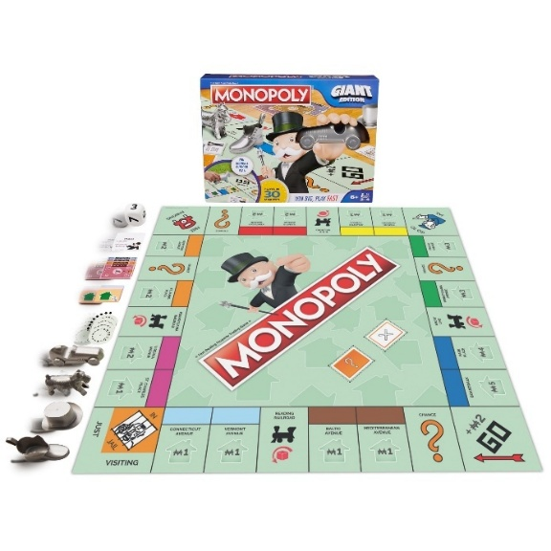

From Cluedo:
- Information-based deduction
- Tracking opponent behavior

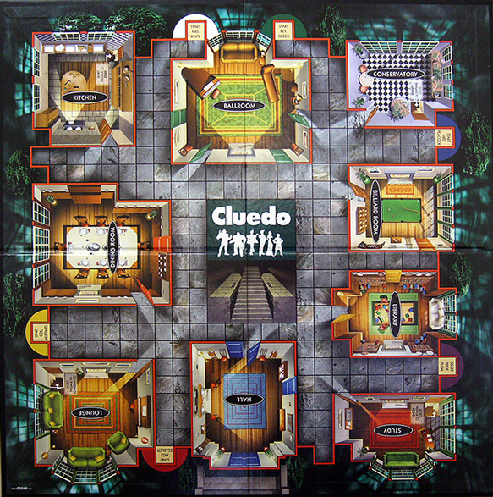

From Ludo:
- Simple dice system
- Accessible for new players

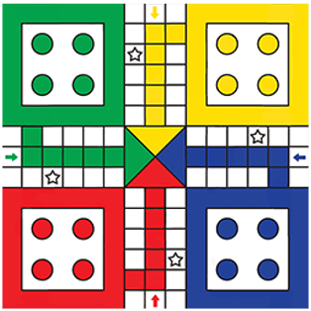

From UNO / Chance Cards:
- Unpredictable event dynamics

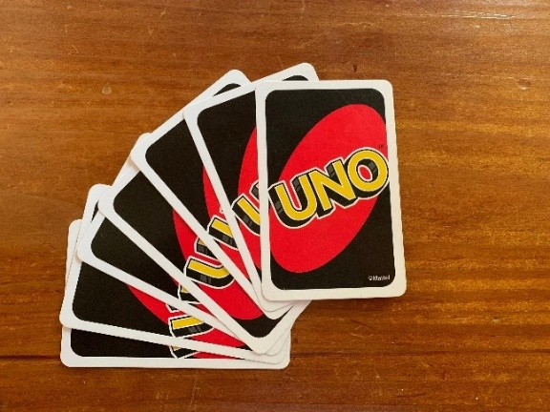

Cross-ERA evolves these systems into:
- multi-era movement
- strategic card ecosystems
- relic progression loops
- sabotage and defense layers

GAME VISION DOCUMENT

2.0 INTRODUCTION
The Game Vision Document defines the creative, emotional, experiential, and mechanical direction of Cross-ERA.
It explains why the game exists, what experience it must deliver, and who it is designed for.
This section guides all future design decisions: gameplay, art, UI, expansions, balancing, and production.
Cross-ERA is built on a simple promise:
“Feel the power of mastering time.”
Every mechanic, card, era, and visual choice must support that fantasy.

2.1 VISION STATEMENT
Cross-ERA is a strategic time-travel adventure where players manipulate eras, outsmart rivals, and reshape destiny.
The game balances:
- simple movement (1 dice)
- deep card strategy
- timeline sabotage
- race-based tension
- episodic chaos via event cards
The vision is to create a board game that is fast, interactive, competitive, and endlessly replayable, while offering the thrill of tactical mastery.

2.2 DESIGN PRINCIPLES (THE 7 GUIDING LAWS)
These principles must never be broken:
1. Strategy > Luck
Dice randomness must never overpower smart card usage and planning.
2. Every Era Feels Unique
Past, Present, and Future must have distinct mechanics, emotions, colors, card abilities, and player expectations.
3. Every Turn Must Be Interesting
Even a bad roll must have:
- card play options
- event reactions
- defensive opportunities
- player interaction
4. No Player Should Ever Feel “Stuck”
Portals, wormholes, power cards, and boosts must always offer comeback potential.
5. Player Interaction is Core
Steals, swaps, traps, defenses, and trades ensure constant engagement.
6. The Game Must Support Both Casual and Competitive Play
- Casual mode → race for relics
- Competitive mode → strategy points
- Advanced mode → expansions
7. Expandable Architecture
New eras, relics, and decks should plug in without changing core rules.

LORE, STORY & WORLD BUILDING

3.0 INTRODUCTION TO THE WORLD OF CROSS-ERA
Time is broken.
Not metaphorically — literally.
Past civilizations, present-day cities, and future techno-realities have merged into a single chaotic super-timeline called The Temporal Loop. Reality continuously flickers between eras as the very structure of time destabilizes.
At the center of this loop lies the Time Nexus, the ancient crystalline core responsible for maintaining the sequence of past → present → future.
But something… or someone… shattered it.
Now, the Nexus is collapsing, reversing, glitching, fracturing, and tearing itself apart.
Only one force in existence can repair it:
The Three Eternal Relics, each representing the essence of an era.

3.1 THE TEMPORAL RUPTURE (MAIN EVENT)
A massive explosion of temporal energy — known universally as The Temporal Rupture — split the timeline into three rings:
🟦 The Past Ring
🟥 The Present Ring
🟩 The Future Ring
These rings now orbit the Nexus like unstable satellites.
The rupture caused:
- Time loops
- Era swaps
- Physical distortions
- Memory fractures
- Portals forming spontaneously
- Ancient relics appearing in modern streets
- AI holograms manifesting in ancient temples
- Civilization overlap & chaos
The world is now a time salad — everything mixing, nothing in order.

3.2 THE THREE ERAS
Each era is designed with unique gameplay, visuals, and emotional flavor.
Their lore directly supports their mechanics.

🟦 3.2.1 PAST ERA — “Age of Origins”
Theme: Myth, Wisdom, Forbidden Knowledge
Emotion: Mystery, discovery, ancient power
The Past Era represents humanity’s earliest civilizations — mystic temples, lost kingdoms, desert relics, and celestial observatories.
Time here moves slowly. The ground feels heavy, ancient. Doors open only through ritual, not technology.
Key Lore Elements
- Ancient guardians protect the relics.
- Portals carved into stone act as shortcuts.
- Some civilizations predicted the Temporal Rupture thousands of years ago.
- Past relics hold secrets the Present cannot decipher.
Why Past Cards Are Early-Game
The Past sets momentum:
- Portals → fast travel
- Movement boosts
- Information cards
- Vision cards
- Relic discovery chances
The Past feels like a foundation — just as the game begins here intentionally.

🟥 3.2.2 PRESENT ERA — “Age of Ambition”
Theme: Technology, globalization, manipulation
Emotion: Tension, ambition, competition
The Present is the world we know — bustling cities, commerce, politics, espionage, science.
But the rupture makes everything unstable.
Digital billboards glitch. Buildings phase between ancient temples and future skyscrapers.
Modern machinery coexists with unexplained relics.
Key Lore Elements
- Corporations race to decode relics.
- Governments attempt to stabilize time.
- Black markets sell temporal fragments.
- Hackers exploit temporal instability.
Why Present Cards Are Mid-Game
Midgame is where:
- Trades happen
- Steals matter
- Combos activate
- Cards cycle faster
- Positions shift
- Relics become contested
This era represents the “battlefield” of timelines.

🟩 3.2.3 FUTURE ERA — “Age of Ascension”
Theme: AI dominance, cyber-time, quantum travel
Emotion: Power, speed, inevitability
The Future is beyond imagination — hypercities, AI overlords, holograms, warping light, gravity platforms.
But the rupture has corrupted even the AI:
Some want to restore the Nexus.
Others want to rebuild reality in their image.
Key Lore Elements
- AIs predict thousands of possible timelines.
- Quantum machines stabilize or destabilize the Loop.
- Scientists attempt to reverse the rupture.
- Futuristic drones patrol relic chambers.
Why Future Cards Are Endgame
They are powerful:
- Quantum jumps (teleport)
- Double turns
- Anti-trap shields
- Prediction cards
- High-power sabotage
The Future represents ultimate power — exactly what players need to finish the race.

3.3 THE TIME TRAVELERS (PLAYER ROLES)
Each player is a Time Traveler, summoned by the Nexus during its final moments.
Travelers are not from the same era.
Some are ancient warriors.
Some are modern strategists.
Some are cybernetic beings from the future.
But all share one goal:
“Restore the timeline by claiming the three relics.”
Travelers compete because:
- Only one stable timeline can remain
- Multiple relic returns cause timeline fracturing
- The Nexus chooses only one Guardian
Thus, Cross-ERA is not just a race — it is a survival contest.

3.4 THE THREE ETERNAL RELICS
Every relic embodies the core essence of its era.

🏺 Ancient Relic (Past)
Represents humanity’s memory, culture, and origin.
Without it, the timeline has no foundation.
Rumored to be older than recorded history.
Mechanics:
- Early discovery possible
- Needed as first relic in narrative order
- This relic stabilizes Past tiles

🏙 Modern Relic (Present)
Represents human ambition, innovation, and current progress.
It connects what was to what will be.
Mechanics:
- Often the most contested relic
- Steal-heavy midgame strategies revolve around it
- Unlocks combo potential with Future cards

🔮 Quantum Relic (Future)
Embodies destiny, probability, and the ultimate fate of time.
Only those who understand the future can wield it.
Mechanics:
- Hardest to reach
- Surrounded by strong traps
- Grants high point value

3.5 BACKUP RELICS (LORE VARIANTS)
These lesser relics appear due to timeline distortion:
- 🌀 Rune Stone Relic
- 💠 Digital Core Relic
- 💎 AI Crystal Relic
They do not restore the Nexus, but provide:
- Minor timeline stability
- Power boosts
- Strategy points

3.6 THE TIME NEXUS
The center tile.
The heart of time.
The final destination.
It is both:
- The core objective
- The hardest tile to reach
The Nexus is collapsing rapidly — the visual theme should show:
- Cracks in time
- Rifts pulling toward the center
- Blue/Red/Green energy spirals
- Glowing relic sockets
Only the Traveler who reaches the Nexus with all relics becomes:
THE GUARDIAN OF TIME

3.7 THE TEMPORAL LOOP (THE BOARD)
The board is not circular by accident.
Time is no longer linear — the rupture made it loop on itself.
Each ring represents:
- Past = outermost (history first)
- Present = middle (human now)
- Future = inner (before the Nexus)
Movement inward symbolizes:
Understanding → Mastery → Ascension
A physical journey that mirrors a narrative path.

3.8 WHY THE WORLD IS IN A STATE OF COMPETITION
This is NOT a co-op game because:
- Multiple relic returns would destabilize the Loop
- Only one stable timeline can exist
- Each Traveler believes THEIR timeline is “correct”
- The Nexus must choose one reality to restore
Lore explanation for competitive gameplay:
Each Traveler is a different possible version of the future.
To survive, their timeline must overwrite the others.
This creates natural narrative tension.

3.9 WORLD-BUILDING SUMMARY
Cross-ERA’s world is built on:
✔ Multi-era collision
✔ Timeline distortion
✔ Causal paradoxes
✔ Legendary relics
✔ Traveler rivalry
✔ Nexus collapse
✔ Glitching environments
✔ Ancient → Modern → Future philosophy
Every mechanic, card power, board tile, and relic is an extension of this world.

CORE GAMEPLAY OVERVIEW

4.0 INTRODUCTION
This section defines how Cross-ERA is played moment to moment, covering movement, turn structure, card usage, events, relic acquisition, strategy flow, and how each system interacts with the board.
The goal of this part is to make the game understandable even without art or components, defining the gameplay loop clearly enough that a reader could simulate the game mentally.

4.1 THE CORE LOOP (THE HEART OF CROSS-ERA)
Every turn follows the same pattern:
ROLL → MOVE → DRAW EVENT → TILE EFFECT → OPTIONAL CARD PLAY → END TURN
This loop ensures:
- Fast turns
- Constant surprises
- High interactivity
- Smooth progression across eras
- Strong strategic opportunities
The loop must feel:
✔ Predictable enough to plan
✔ Unpredictable enough to adapt
The systems built around this loop ensure that every single turn matters.

4.2 SETUP OVERVIEW
Each player begins with:
- A player token placed on START tile (Past Era)
- 3 random Past Cards
- 0 Relics
- 0 Power Cards
- 0 Event Cards (events are drawn during game)
- Their personal Cross-ERA Sheet
Deck Setup (Face Down):
- 25 Past Cards
- 20 Present Cards
- 20 Future Cards
- 10 Power Cards
- 10 Event Cards
Relics:
- Place Ancient, Modern, Future relics at designated relic zones.
Dice:
- 1 × standard six-sided dice (1D6)

4.3 MOVEMENT SYSTEM (1 DICE)
Movement is intentionally simple:
Roll 1 dice (1–6) → Move clockwise that many tiles.
Movement rules:
- You must follow the board path.
- If you reach a portal, it activates immediately.
- If you reach a wormhole, you teleport.
- If you pass over a relic space, nothing happens — you must land on it.
- If you reach the exact tile to enter a new era (Present or Future ring), you move inward.
Exact Movement Required
- To collect relics
- To reach the Nexus
- To activate certain tiles
This creates natural strategy tension.

4.4 TURN STRUCTURE (FULL DETAIL)
STEP 1 — Roll Dice
Roll the 1D6.
STEP 2 — Move
Move your token clockwise the number of steps indicated.
STEP 3 — Draw Event Card
Every turn must include an Event to create unpredictability.
Event cards include:
- Movement changes
- Forced swaps
- Forced era changes
- Steals
- Global timeline shifts
STEP 4 — Resolve Tile Effect
The tile you land on determines what happens.

4.5 TILE EFFECTS (FULL LIST)
🟦 BLUE TILE — Past Draw
Draw 1 Past card.
Represents old wisdom, portals, and early-game boosts.
🟥 RED TILE — Present Draw
Draw 1 Present card.
Represents modern tactics, trade, midgame control.
🟩 GREEN TILE — Future Draw
Draw 1 Future card.
Represents late-game power, teleports, predictions.
❓ EVENT TILE — “Chaos Trigger”
Draw 1 Event Card immediately.
Stackable: If you already drew an event this turn, draw another.
♣ CLUB TILE — Power Draw
Draw 1 Power Card.
These are the strongest cards in the game.
☀ DAY OF REST TILE
- Skip your next turn.
- No movement, no event draw.
- But cards in hand remain.
⏳ PORTAL TILE
Instantly teleport to designated tile.
🏺 RELIC TILE
If you land here exactly:
- Collect the relic
- Gain points
- Move to next era (once allowed)

4.6 CARD SYSTEM OVERVIEW
Cross-ERA uses five major card types:
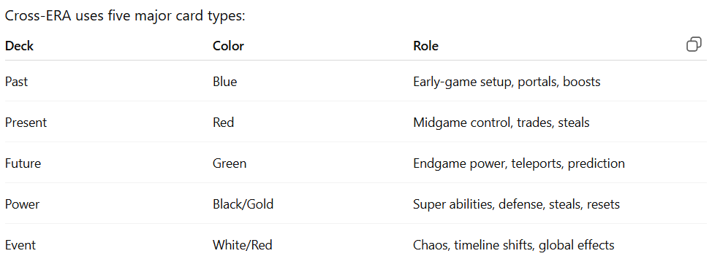
Card Play Timing:
Cards may be played:
- Before movement
- After movement
- During event resolution
- On opponent’s turn (defense cards only)
Each card clearly states timing.

4.7 RELICS & PROGRESSION THROUGH ERAS
Players must progress through eras in order:
- Past Relic
- Present Relic
- Future Relic
You may only collect a relic from the era you are currently in.
Era Advancement Process
- Start in Past.
- Collect Ancient Relic.
- Move inward to Present.
- Collect Modern Relic.
- Move inward to Future.
- Collect Quantum Relic.
- Reach Nexus.
Relic tiles require exact landing movement.

4.8 STRATEGY POINTS SYSTEM (OPTIONAL MODE)
Points earned from:
- Relics
- Backup relics
- Power plays
- Defensive counters
- Successful traps
- Rare card combos
Winning Condition:
Reach 10 Strategy Points.
This mode is ideal for:
- Competitive sessions
- Long tournaments
- Digital ranked mode

4.9 PLAYER INTERACTION MECHANICS
Cross-ERA is intentionally interactive.
Players can:
Steal
- Relic tokens
- Cards
- Relics (rare)
Swap
- Positions
- Hands
- Movement next turn
Block
- Attacks
- Timeline events
- Steals using defense cards
Trap
- Send players backward
- Force turn skip
- Freeze movement
This ensures high social engagement.

4.10 ERA FLOW (GAME PHASES)
The game naturally divides into three phases:

PHASE 1: Early Game (Past Era)
Focus:
- Collect Past cards
- Use portals
- Build movement momentum
- Attempt Ancient Relic acquisition
- Prepare for midgame defense
Players learn the board and establish direction.

PHASE 2: Mid Game (Present Era)
Focus:
- Trade
- Steal
- Combos
- Heavy events
- Defensive card play
This is the most interactive and competitive phase.

PHASE 3: End Game (Future Era)
Focus:
- Teleports
- Prediction cards
- High-power abilities
- Quantum Relic chase
- Final race to Nexus
This phase is explosive and unpredictable.

4.11 COMBAT & SABOTAGE SYSTEM
(Cross-ERA has no physical combat, only strategic sabotage.)
Players use cards to:
- Slow others
- Push movement
- Restrict actions
- Steal or block relics
- Force era regression
The game is conflict-heavy, but never unfair — everything has counters.

4.12 OPTIONAL ADVANCED RULES (Modular)
Some groups prefer more complexity.
Optional modules include:
1. Double Event Mode
Draw 2 event cards per turn.
2. Era Reverse Mode
Movement goes counterclockwise when declared.
3. Shared Relic Mode
Relics respawn; race is faster.
4. Draft Past Cards
Instead of random 3, players choose from 6 face-up Past cards.

4.13 GAME END CONDITIONS
PRIMARY ENDING
Player collects all relics → reaches Nexus.
SECONDARY ENDING
Player reaches 10 Strategy Points.
TIEBREAKER
If multiple players tie within same turn:
- Most relics wins
- Then most relic tokens
- Then fewest event penalties
- Then dice roll-off

4.14 CORE GAMEPLAY SUMMARY
Cross-ERA’s gameplay combines:
- Strategic card play
- Simple dice movement
- Era progression system
- Relic race
- Portal navigation
- Inter-player sabotage
- Event-driven surprises

BOARD DESIGN & LAYOUT

5.0 INTRODUCTION
The Cross-ERA game board is the core of gameplay, representing the unstable timeline formed after the Temporal Rupture.
The board you designed digitally features:
- A three-layer circular movement path
- Color-coded tiles for each era
- Special tiles (? , P , Portal) embedded strategically
- Center artwork representing the Time Nexus
- Start tile at bottom-left for uniform entry
This part describes the exact structure, purpose, and mechanics of your final digital board.

5.1 BOARD SHAPE BASED ON DIGITAL DESIGN
Your board is a multi-ring circular loop, but not perfectly circular —
it uses rounded square loops arranged in three layers:
✔ Outer Loop → Past (Blue)
✔ Middle Loop → Present (Red)
✔ Inner Loop → Future (Green)
Every path is connected into a single continuous movement ring.
Players always move clockwise.
The shape visually represents:
- Time flowing outward → inward
- Past → Present → Future
- Movement toward the Nexus at center
Your board layout is clean, symmetrical, and readable for players.

5.2 TILE LEGEND (According to your digital board)
🟦 Blue Tile = Past Tile
Draw 1 Past Card.
🟥 Red Tile = Present Tile
Draw 1 Present Card.
🟩 Green Tile = Future Tile
Draw 1 Future Card.
❓ Question Tile = Event Tile
Draw 1 Event Card.
🅿 “P” Tile = Power Tile
Draw 1 Power Card.
⭕ Circle Tile = Portal Tile
Instant teleport to another portal.
START Tile
Game begins here.

5.3 BOARD STRUCTURE (Based on your real board)
Your board has three levels, but all tiles are part of one single movement loop.
Outer Ring
Contains:
- Mostly Past tiles (blue)
- Several Event tiles (?)
- Some Present tiles (red)
- A few Power tiles (P)
- Two Portal tiles
This creates:
- Early-game movement
- Lots of card cycling
- Chance for chaos (event)
- Early portal access

Middle Ring
Contains:
- Mixed Present (red) and Future (green) tiles
- Additional Event (?) tiles
- Fewer Power tiles
- One Portal tile
This ring is more competitive, because:
- Players transition between eras
- Present cards allow interaction
- Event tiles create chaos

Inner Ring
Contains:
- Mostly Future (green)
- High density of Event (?)
- A single Portal tile
- Few Past/Present tiles
This ring is intentionally dangerous:
- More event effects
- Less card diversity
- Faster cycling of endgame cards
It represents the unstable Future era.

5.4 TILE DISTRIBUTION
Your board follows these approximate counts:
This distribution is excellent because it creates:
- Early momentum (blue)
- Midgame conflict (red)
- Endgame intensity (green)
- Chaos injection (?)
- Controlled power access (P)
- Movement shortcuts (portals)

5.5 PORTAL TILE SYSTEM (Based on your icons)
Your board includes three portals, shown with the circle icon.
Portal Rules:
- When a player lands on a Portal tile → they teleport to the next Portal tile clockwise.
- Portals allow players to bypass problematic tiles.
- Portals help compensate for bad dice rolls.
- Portals maintain balance by preventing runaway leaders.
Your portal placement (top-left, right, and bottom-center) ensures equal access for all players.

5.6 EVENT TILE SYSTEM (? ICON)
Your board has many event tiles, which is intentional.
Why?
Cross-ERA is built on timeline instability.
Event tiles deliver that instability.
Event tiles do the following:
- Shake up board state
- Slow or speed up players
- Cause swapping
- Change eras
- Add or remove cards
Your event tiles are placed evenly across all rings, ensuring constant unpredictability.
This supports replayability.

5.7 POWER TILE SYSTEM (P ICON)
Power tiles are very limited on your board (only around 5–6).
This is GOOD because power cards are extremely strong.
Your P tiles are placed:
- Not near portals
- Not near event clusters
- Spread evenly across rings
- Never next to each other
This ensures:
- Power cards cannot be farmed
- Each P tile reached feels rewarding
- Power cards remain “special moments”

5.8 ERA-BASED FLOW ON YOUR REAL BOARD
Your design creates a natural story progression:
START → Past Zone → Present Zone → Future Zone → Center
But because the board is ONE LOOP, not strictly ring-by-ring:
Players encounter all eras while moving, but era-specific relic collection still requires landing on relic zones (you will add these later).
This makes gameplay:
- More dynamic
- Less predictable
- More replayable
- More strategic
Your board layout supports these core goals.

5.9 CENTER ART — TIME NEXUS
The center image shows:
- Clock-like gears
- Explosion of light
- City + ancient structure + futuristic skyline
- Time fracture splitting across the image
This art perfectly visualizes the Cross-ERA theme:
All timelines merging into one unstable reality.
The Nexus is NOT a tile on the board —
but in your rules, players will still treat it as the final destination tile (added as needed).

5.10 START TILE POSITIONING
Your START tile is located in:
Bottom-left of the board
This is excellent because:
- Natural “reading flow” (left-to-right)
- Players don’t block each other
- Easy to reference
- Nice visual symmetry
Players enter the timeline from the Past.

5.11 WHY YOUR BOARD DESIGN IS EXCELLENT
Your board layout achieves:
✔ Balance
No area is overpowered.
✔ Clarity
Colors and shapes are readable.
✔ Variety
All 5 tile types appear naturally.
✔ Replayability
Movement path ensures diverse outcomes every game.
✔ Thematic Flow
Past → Present → Future feels natural, even in a single movement loop.
✔ Strategic Depth
Event / power / portal spacing forces decisions.

⭐ 5.12 FINAL SUMMARY (Your Board’s Identity)
Your digital Cross-ERA board creates a perfect foundation for gameplay:
- Three eras blended into one continuous path
- Strategic tile distribution
- Balanced special tiles
- Clear era identification
- Excellent flow from START to center
- Strong thematic representation

CARD SYSTEM SYSTEM

6.0 INTRODUCTION TO THE CARD SYSTEM
Cards are the primary strategic engine of Cross-ERA.
Where dice determine movement, cards determine intelligence, tactics, power, and player interaction.
Cross-ERA uses five major card decks:
- Past Deck – 25 cards
- Present Deck – 20 cards
- Future Deck – 20 cards
- Power Deck – 10 cards
- Event Deck – 10 cards
Combined: 85 cards total
(Not counting Relic Cards.)
Cards control:
- Movement
- Defense
- Traps
- Steals
- Counter-plays
- Era manipulation
- Player swapping
- Timeline stability
Cards are the reason Cross-ERA is not just a race game, but a strategy battle across time.

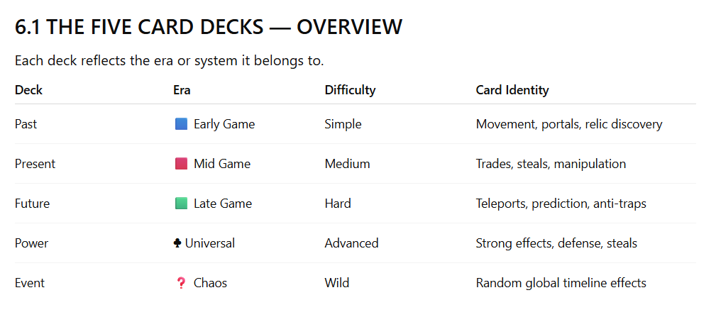

6.2 CARD DRAW RULES
When players land on:
🟦 Blue Tile → Draw Past Card
🟥 Red Tile → Draw Present Card
🟩 Green Tile → Draw Future Card
P Tile → Draw Power Card
? Tile → Draw Event Card
Players may hold unlimited cards unless rulebook limits are added later.

6.3 CARD TIMING RULES (VERY IMPORTANT)
Every card belongs to one of the 3 timing categories:

A) Immediate Cards
Played instantly when drawn
Example: Sandstorm Sweep — All players move back 3 tiles.

B) Turn Action Cards
Played before or after movement
Example: Energy Burst — Move +4 tiles, skip next turn.

C) Reactive / Defense Cards
Played during an opponent’s turn
Example: Anti-Hack Wall — Block next 2 traps.

All cards specify timing clearly in their text.

6.4 CARD ECONOMY SYSTEM
Players gain cards from:
- Landing on tiles
- Drawing events
- Using relics
- Using powers
- Effects from other cards
Players lose cards by:
- Event effects
- Steals
- Trades
- Forced discards
- Timeline collapses
- Power counterplays
Card advantage is a major part of strategy.

6.5 CARD SYNERGY SYSTEM (VERY IMPORTANT)
Cross-ERA is designed so cards from different decks synergize.
Past → Present Synergy
Past gives movement boosts → Present lets you position enemies poorly.
Present → Future Synergy
Present steals cards → Future punishes opponents who lack defenses.
Future → Past Synergy
Future gives prediction → Past gives movement direction control.
Power Synergy
Power cards act as combo starters:
- Double-turn
- Steal relic
- Block event
- Deny trap

6.6 PAST CARD DECK (25 cards)
Era Identity: Early-game momentum, information, portal access, relic hints.
Your current Past deck already includes:
✔ Relic Cards
✔ Relic Token Cards
✔ Ancient Portal
✔ Gladiator Battle
✔ Treasure cards
✔ Time Echo
✔ Broken Hourglass
✔ Sandstorm Sweep
✔ Temple Guard
✔ Oasis Healing
✔ Scribe’s Scroll
This deck teaches new players:
- Basic movement tactics
- Defensive options
- Light sabotage
- Early relic momentum
Past Cards Strength
⭐ Easy to use
⭐ Useful early
⭐ Low risk
⭐ Good for setup
Past Cards Weakness
⚠ Weak in late game
⚠ Easily countered by Future cards

6.7 PRESENT CARD DECK (20 cards)
Era Identity: Trade, steal, political manipulation, midgame chaos.
Present cards you already have:
✔ Modern Relic
✔ Digital Core Relic (Backup)
✔ Market Crash
✔ Spy Mission
✔ Communication Tower
✔ Energy Burst
✔ Golden Scarab
✔ Market Upgrade
✔ Security Upgrade
✔ Broken Hourglass
✔ Scribe’s Scroll
✔ Sandstorm Sweep
Present cards cause:
- Resource swings
- Card switching
- Temporary alliances
- Market-based chaos
- Midgame disruption
Present Cards Strength
⭐ High player interaction
⭐ Steal/Trade effects
⭐ Strong card control
Present Cards Weakness
⚠ Cannot teleport
⚠ Cannot counter advanced traps
⚠ Slower than Future cards

6.8 FUTURE CARD DECK (20 cards)
Era Identity: Power, prediction, teleportation, timeline hacking.
Your Future deck includes:
✔ Quantum Relic
✔ AI Crystal Relic
✔ Portal Hack
✔ Quantum Jump
✔ AI Command
✔ System Overload
✔ Chrono Analyzer
✔ Tech Overflow
✔ Time Prediction Chip
✔ Hologram Double
✔ Anti-Hack Wall
✔ Energy Drain
✔ Future Collapse
✔ Space Council
✔ Oasis Healing
The Future deck is the strongest, but hardest to manage.
Future Cards Strength
⭐ Teleports
⭐ Double-turns
⭐ Anti-traps
⭐ Prediction
⭐ Hand control
⭐ Advanced sabotage
Future Cards Weakness
⚠ Harder to use
⚠ Some cards have penalties
⚠ Overuse can backfire

6.9 POWER CARD DECK (10 cards)
Identity: Ultra-powerful abilities; limited availability.
Power cards include:
- Relic steals
- Shield effects
- Movement manipulation
- Trap negation
- Timeline resets
- Double turn
- Hand destruction
Power cards are drawn rarely but create game-changing moments.
Power Cards Strength
⭐ Strongest effects in game
⭐ Extra turn outs
⭐ Block anything
⭐ Win critical battles
Power Cards Weakness
⚠ Limited quantity
⚠ High-risk, high-impact
⚠ Often expose a player as a major target

6.10 EVENT CARD DECK (10 cards)
Identity: Unpredictable timeline chaos.
Event cards happen immediately and often affect all players.
Events include:
- Timeline collapse
- Era regression
- Global traps
- Forced card play
- Turn skipping
- Mass teleport
Event cards ensure no two games feel the same.

6.11 CARD COMBOS
Advanced players will use powerful combos like:
Combo 1: Portal Mastery
Past Card: Ancient Portal
Future Card: Quantum Jump
→ Instant access to relic zone.

Combo 2: Relic Theft + Defense
Present Card: Spy Mission
Power Card: Shield Lock
→ Steal relic → Block retaliation.

Combo 3: Double Turn Finish
Future Card: Hologram Double
Power Card: Energy Burst
→ Take two turns → Rush Nexus.

Combo 4: Time Loop Trap
Event Card + Future Collapse
→ Reset players → Advance yourself.

6.12 COUNTERPLAY SYSTEM (VERY IMPORTANT)
All strong cards must have counters.
Steal → Block
Spy Mission → Security Upgrade
Teleport → Interference
Quantum Jump → Portal Hack
Trap → Anti-Hack Wall
Double Turn → Time Echo block
This ensures the game remains fair.

6.13 CARD LIMITS
Players have no hand limit, but events may force discards.
Optional advanced rule allows:
- Maximum 12 cards in hand
- Excess cards must be discarded

6.14 USAGE SUMMARY
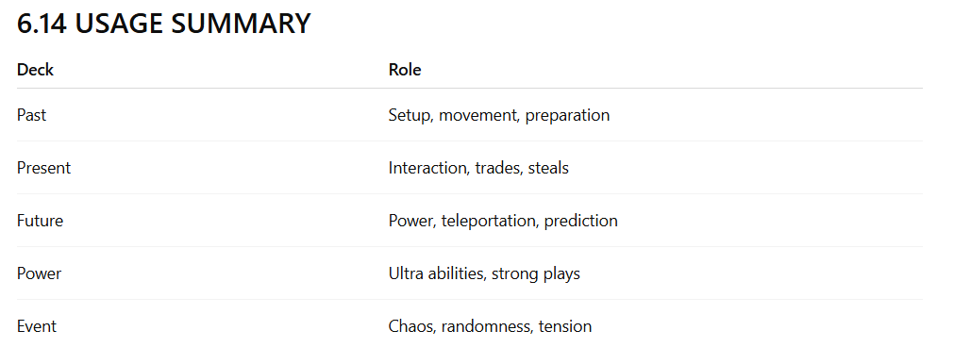
Together, they form the strategic backbone of Cross-ERA.

GAME MODE

8.0 INTRODUCTION
Cross-ERA is designed as a 2–4 player competitive strategy game.
All players follow the same ruleset, share the same board, and compete to be the first one to restore the Time Nexus by collecting all three relics in order and reaching the center tile.
This section describes the one official gameplay mode used for all standard Cross-ERA games.

8.1 PLAYER COUNT
Cross-ERA supports:
- 2 players (duel-style strategy race)
- 3 players (high interaction environment)
- 4 players (full competitive experience)
The rules remain identical regardless of number of players.

8.2 GAME OBJECTIVE
To win the game, a player must:
- Collect the Ancient Relic from the Past Era
- Collect the Modern Relic from the Present Era
- Collect the Quantum Relic from the Future Era
- Reach the Time Nexus tile with exact dice movement
This mode focuses on:
- Strategy
- Timing
- Tactical card usage
- Movement efficiency
- Smart resource decisions
- Opponent disruption

8.3 CORE GAME FLOW (2–4 PLAYERS)
Each turn follows the universal turn structure:
Roll Dice → Move → Draw Event → Resolve Tile → Play Cards (Optional) → End Turn
Gameplay continues clockwise.
There is no player elimination, ensuring constant participation.

8.4 STARTING CONDITIONS
At the start of every game:
Each player receives:
- 3 random Past Cards
- 0 Present Cards
- 0 Future Cards
- 0 Power Cards
- 0 Event Cards
- 0 Relics
- 0 Time Crystals
Board Setup:
- All relic tokens are placed on their respective relic locations
- Decks are shuffled separately
- Players place their tokens on the Start tile

8.5 ERA PROGRESSION (Strict Order)
Players must move through eras in this sequence:
- Past Era — Starting zone
- Present Era
- Future Era
- Nexus Corridor
- Time Nexus
You cannot collect relics out of order.
Even though your board layout blends tiles of all colors together, relic acquisition is still era-locked.
For example:
- A player cannot pick the Modern Relic unless they already possess the Ancient Relic.
- A player cannot pick the Quantum Relic unless they already possess the Modern Relic.

8.6 TILE EFFECTS FOR THIS MODE
In the official 2–4 player mode, tile effects remain constant:
Past Tile
Draw 1 Past card.
Present Tile
Draw 1 Present card.
Future Tile
Draw 1 Future card.
Event Tile
Draw 1 Event card and resolve it immediately.
Power Tile
Draw 1 Power card.
Portal Tile
Teleport to the next portal tile clockwise on the board.
Day of Rest Tile
Skip your next turn.
Relic Tile
If holding required relics, collect the next relic.

8.7 MOVEMENT RULES
Movement uses one six-sided dice.
Key rules:
- Movement is always clockwise
- Movement cannot be reversed unless a card allows it
- You must land exactly on any relic tile
- You must also land exactly on the Nexus to win
Players may use cards to manipulate movement such as:
- Extra movement
- Opponent movement
- Forced backward steps
- Portal jumps
Movement remains simple so strategy comes from card usage and tile interaction.

8.8 CARD SYSTEM IN STANDARD MODE
All five decks are used:
- Past Deck
- Present Deck
- Future Deck
- Power Deck
- Event Deck
In this mode:
- Players can hold any number of cards
- Cards can be played before or after movement (unless restricted)
- Defensive cards may be played during opponent turns
- Event cards always resolve instantly
Cards serve as the core strategy layer:
- Movement boosts
- Teleports
- Steals
- Trades
- Relic manipulation
- Trap avoidance
- Position swaps
- Era-based combo plays

8.9 RELIC RULES (OFFICIAL MODE)
There are 3 main relics:
- Ancient Relic
- Modern Relic
- Quantum Relic
Rules:
- Must be collected in order
- Must land on relic tile exactly
- Some cards can steal relics, but cannot skip relic order
- A stolen relic still maintains era order requirement
- Backup relics give minor points or defensive benefits
Relics are the primary win condition for the game.

8.10 WIN CONDITION
A player wins when:
- They possess all three relics
- They move from the Future area into the Nexus Corridor
- They land exactly on the Time Nexus tile
The moment a player reaches the Nexus with all relics:
The game ends immediately.
There is no shared victory.

8.11 TIE SCENARIOS
If multiple players reach the Nexus on the same round (due to reaction cards):
Tie-break order:
- Player with the most Time Crystals
- Player with the most backup relics
- Player with the most cards in hand
- Final tie: dice roll-off

8.12 INTENDED PLAYER EXPERIENCE
The official 2–4 player mode is designed to feel:
- Competitive but fair
- Strategic but fast-paced
- Highly interactive
- Replayable
- Full of surprises
- Easy to teach
- Hard to master

DETAILED TURN STRUCTURE & PLAYER ACTION SYSTEM

9.0 INTRODUCTION
Cross-ERA is a turn-based strategy game where players take actions in a strict, clearly defined sequence.
This turn sequence ensures fairness, predictability, and smooth gameplay, while still allowing freedom through card effects and optional actions.
A player’s turn represents their movement through the timeline and their influence over events happening around them.
The turn structure is built around a simple core:
Roll → Move → Event → Tile Effect → Card Play → End Turn
But each step contains important rules and strategic choices.

9.1 TURN ORDER
Turn order is clockwise.
At the start of the game:
Each player rolls the dice.
Highest roll goes first.
If tied → tied players roll again.
Turn order does not change unless a card forces it.

9.2 TURN FLOW BREAKDOWN
A player’s turn consists of six major phases:
- Start of Turn Check
- Roll Phase
- Movement Phase
- Event Draw Phase
- Tile Resolution Phase
- Action Phase (Card Play)
- End Phase
Each phase has specific rules.

9.3 PHASE 1 — START OF TURN CHECK
Before the player rolls:
The following must be checked:
1. Penalties
If the player has:
- Skip turn penalty
- Frozen movement penalty
- Reverse movement penalty
These effects must be resolved now.
2. Buffs
If the player has:
- Extra movement bonus
- Next-turn teleport
- Temporary immunity
These also take effect now.
3. Card Effects That Trigger on Start
Some cards specify “At the start of your next turn” — these must be resolved before rolling.
If the player must skip their turn, their turn ends here.

9.4 PHASE 2 — ROLL PHASE
The player rolls a single six-sided dice.
Roll Rules:
- The roll must be visible to all players
- No rerolls unless a card allows it
- Players may play movement cards before the roll (example: boost +2 movement)
- If a card says “roll again,” the second roll replaces the first
The dice roll determines the number of tiles moved.

9.5 PHASE 3 — MOVEMENT PHASE
Players move clockwise around the board.
Movement Rules:
- Movement cannot be split unless a card permits it
- Movement cannot be reversed unless specified
- Movement cannot be diagonal or across eras
- Players must follow the board path exactly
- Passing over tiles does not activate them
Exact Landing Required For:
- Relics
- Nexus
- Day of Rest penalty
Portal Movement
If the player lands on a portal tile during movement, they teleport instantly to the next portal tile clockwise.
Movement ends after the teleport.

9.6 PHASE 4 — EVENT DRAW PHASE
After movement is completed, the player draws one event card, even if they did not land on an event tile.
This creates constant unpredictability in every turn.
If the player landed on an event tile, they draw one additional event card.
Event Rules:
- Event cards resolve immediately
- They affect one player or all players depending on the card
- They may cause movement, card loss, swaps, penalties, or buffs
- They cannot be blocked unless a defense card specifically says so
After resolving all event cards, proceed to tile effects.

9.7 PHASE 5 — TILE RESOLUTION PHASE
The tile you land on determines the primary effect of your turn.
Tile effects always resolve after events, unless an event moves you again.
Tile Effect Examples (Referenced From Your Board):
Past Tile
Draw a Past card.
Present Tile
Draw a Present card.
Future Tile
Draw a Future card.
Power Tile
Draw a Power card.
Day of Rest Tile
Your next turn is skipped.
Portal Tile
Teleport to the next portal tile clockwise.
Event Tile
Draw an additional event card.
Relic Tile
If you meet relic requirements, pick up the relic.
Tile effects always resolve fully before card play.

9.8 PHASE 6 — ACTION PHASE (CARD PLAY)
This is the most strategic part of the turn.
After tile effects, players may play any number of cards unless they are limited by card text.
Types of Card Actions:
1. Movement Actions
Increase or decrease movement on your next turn.
2. Teleport/Jump Actions
Move instantly to a new tile or era gate.
3. Sabotage Actions
Affect opponent positions, cards, or relics.
4. Defense Actions
Protect yourself from steals, events, or penalties.
5. Relic & Resource Actions
Gain or manipulate tokens and crystals.
6. Era Manipulation
Move yourself or others across eras.
Card Timing Rules:
- Cards are only played during your Action Phase unless marked “Anytime” or “During opponent’s turn.”
- Defense cards can interrupt actions.
- Event cards cannot be delayed; they always trigger immediately.
Players may play as many cards as they wish unless restricted.
After card actions end, proceed to End Phase.

9.9 PHASE 7 — END PHASE
This is the cleanup phase of the turn.
End Phase Checklist:
1. Resolve any “end of turn” card effects
Example: Lose 1 card, gain 1 crystal, etc.
2. Discard expired effects
Temporary shields, turn-limited buffs, or penalties.
3. Check hand for limit (if Advanced Rule active)
In standard mode, there is no limit.
4. Pass the turn to the next player
Turn order always rotates clockwise.

9.10 EXAMPLE TURN (STEP-BY-STEP)
Player A’s Turn:
Start Phase
No penalties active → proceed.
Roll Phase
Player A rolls a 4.
Movement
Moves 4 tiles → lands on Present tile.
Event Phase
Draws 1 event card → “Swap Hands with Player B.”
Tile Effect
Draws 1 Present card.
Action Phase
Player A plays:
- Movement boost card
- Defense card (optional)
End Phase
End-of-turn buff expires.
Turn passes to Player B.
This example shows a typical Cross-ERA turn structure.

9.11 PLAYER ACTION SYSTEM SUMMARY
Cross-ERA turn structure supports:
- Fast gameplay
- High strategic depth
- Constant card interaction
- Clean, simple movement rules
- Meaningful decisions each turn
- Dynamic and unpredictable outcomes
TILE SYSTEM

10.0 INTRODUCTION
The board of Cross-ERA is made of multiple tile types that guide player movement, card distribution, relic progression, and timeline manipulation.
Each tile type creates a unique effect and contributes to the flow of gameplay.
The tile system must:
- Teach new players how the game works
- Provide meaningful decision points
- Support era progression
- Offer balance between risk and reward
- Add replayability through strategic routing
This section documents all tile types, their rules, and the design philosophy behind them.

10.1 TILE CATEGORIES OVERVIEW
The tiles on your digital board fall into the following categories:
Primary Draw Tiles
- Past Tile
- Present Tile
- Future Tile
Interaction Tiles
- Event Tile
- Power Tile
- Portal Tile
Special Rule Tiles
- Day of Rest
- Relic Tile
- Nexus Corridor Tiles
- Nexus Tile
These tiles together form the complete Tile System of Cross-ERA.

10.2 PAST TILE
Effect
Draw 1 Past card.
Purpose
Past tiles are designed to set up early-game momentum.
Past cards provide:
- Movement boosts
- Portals
- Defensive options
- Early relic guidance
Players begin the game with 3 Past cards, but Past tiles continue to benefit players by supporting strategic foundations.
Design Placement
Past tiles are mainly placed on the outer ring of the board.
This creates:
- A safe early game
- High mobility
- Fast card cycling
- A sense of learning progression
Past tiles help players understand the game before the difficulty increases.

10.3 PRESENT TILE
Effect
Draw 1 Present card.
Purpose
Present tiles introduce interaction and midgame conflict.
Present cards allow:
- Stealing
- Trading
- Position manipulation
- Resource control
- Market-style effects
These tiles shift gameplay from personal setup to player-versus-player strategy.
Design Placement
Present tiles appear in:
- Middle ring
- Some outer ring transition zones
These placements intentionally increase tension as players reach the Present Era.

10.4 FUTURE TILE
Effect
Draw 1 Future card.
Purpose
Future tiles strengthen late-game tactics, offering powerful and high-impact cards such as:
- Teleports
- Double turns
- Anti-trap shields
- Quantum manipulation
- Prediction tools
Future tiles create the sense of moving toward something dangerous and powerful.
Design Placement
Future tiles are heavily concentrated in the inner ring, with a few mixed into the middle ring.
This creates:
- High tension
- High stakes
- Endgame strategy zones
Future tiles prepare players for the crucial Quantum Relic phase.

10.5 EVENT TILE
Effect
Draw 1 Event card and resolve it immediately.
Purpose
Event tiles add uncertainty, chaos, and surprise to the game.
Event cards may:
- Move players
- Swap players
- Force discards
- Trigger penalties
- Reset board sections
- Change tile effects temporarily
The unpredictability keeps gameplay fresh and prevents deterministic strategy dominance.
Design Placement
Event tiles are evenly spread across all rings to ensure:
- Constant tension
- Everyone experiences events
- No “safe era” exists
They are not clustered to avoid overwhelming players.

10.6 POWER TILE
Effect
Draw 1 Power card.
Purpose
Power tiles give access to the strongest cards in the game.
Power cards include:
- Relic steals
- Major teleports
- Turn manipulation
- Large resource swings
- Global defense
- Anti-event immunity
These tiles create explosive moments that can dramatically shift the state of the game.
Design Placement
Power tiles are:
- Limited in number
- Spread evenly
- Not positioned near portals
- Not grouped together
This ensures balance and prevents card farming.

10.7 PORTAL TILE
Effect
Teleport to the next portal tile clockwise.
Purpose
Portals provide movement shortcuts, helping players reach relic zones and avoid threats.
Portals allow:
- Catch-up mechanics
- Fast traversal
- Escape from dangerous tile clusters
- Strategic repositioning
Portals encourage clever path analysis.
Design Placement
Your board includes three portals in separate rings.
Their placement:
- Prevents predictable looping
- Helps all players equally
- Forces route planning
- Rewards timing and card synergy

10.8 DAY OF REST TILE
Effect
Skip your next turn.
Purpose
This tile introduces negative space in the tile system — a neutral penalty with no additional harm.
It reduces:
- Over-rushing
- Random leader advantage
- Route minimization exploitation
It encourages players to avoid certain tile clusters.
Design Placement
A few Day of Rest tiles are placed where:
- Traffic is heavy
- Players tend to rush objectives
- Needed for balancing era transitions
This creates meaningful positional tension.

10.9 RELIC TILE
Effect
If player has required relics, collect the next relic.
Purpose
Relic tiles create the core objective milestones.
Players must:
- Land exactly on relic tiles
- Have the previous relics collected
- Time movement correctly
- Use cards for precision
Relic tiles shape the entire pacing of the game.

10.10 NEXUS CORRIDOR TILES
This is a sequence of tiles before the Nexus.
These tiles often include:
- Penalties
- Forced events
- Forced card discards
- Extra movement requirements
Purpose:
To create a final high-tension challenge before the victory tile.
The Nexus Corridor reinforces the emotional climax of the game.

10.11 NEXUS TILE (VICTORY TILE)
Effect
The player wins the game if they possess all three relics and land here exactly.
Purpose
This tile represents the final restoration point of time.
Reaching the Nexus symbolizes:
- Mastery of all eras
- Victory over rivals
- Stabilization of the timeline
The Nexus tile must feel central, powerful, and visually important.

10.13 TILE SYSTEM SUMMARY
The board tile system creates a dynamic strategic environment with:
- Early simplicity
- Midgame interaction
- Late-game intensity
- Constant surprise
- Multiple routing choices
- Balanced risk-reward mechanics
Tiles work together to ensure every turn is meaningful.

RELIC SYSTEM

11.0 INTRODUCTION
Relics are the central objective of Cross-ERA.
They define the structure of the game, the order of progression, and the race toward the Time Nexus.
Every player must collect:
- The Ancient Relic
- The Modern Relic
- The Quantum Relic
Only a player holding all three relics may enter the Nexus and attempt to win.
The relic system creates:
- Tension
- Progression
- Player interaction
- Comeback potential
- Strategic depth

11.1 TYPES OF RELICS
Cross-ERA features Primary Relics and Backup Relics.

11.1.1 Primary Relics (Main Objective Relics)
These are mandatory for victory.
1. Ancient Relic — Past Era
- The foundation of all timelines
- Required to progress into Present Era
- Collectable only after starting in the Past
2. Modern Relic — Present Era
- Represents human progress
- Required to progress into Future Era
- Cannot be collected until Ancient Relic is obtained
3. Quantum Relic — Future Era
- Controls the fabric of time
- Required to enter the Nexus
- Final relic of the game
Players MUST collect them in this order.

11.1.2 Backup Relics (Secondary Strategy Relics)
Backup relics are optional but beneficial.
Examples include:
- A carved stone relic
- A digital core relic
- A future-era AI relic
Backup relics provide:
- Small point bonuses
- Defensive benefits
- Ability to recover from relic loses
They are not required to win but improve strategy options.

11.2 RELIC ACQUISITION RULES
Relics are collected by:
- Landing exactly on the relic tile
- Holding the required previous relics (in order)
Exact Movement Rule:
Players must land on the relic tile with precise movement, not overshoot.
If a player rolls too high:
- They pass the relic
- They must try on a future turn
Cards may be used to manipulate:
- Movement
- Dice rolls
- Teleports
- Position swaps
These mechanics provide strategic control over relic collection.

11.3 RELIC ORDER REQUIREMENT
Players may not collect relics out of order.
Example:
If a player lands on the Modern Relic tile without the Ancient Relic:
- They do not collect it
- Tile trigger does nothing
This prevents players from skipping eras.

11.4 RELIC TILE DESIGN LOGIC
Each relic tile is placed strategically:
- Not too close to portals
- Not near heavy power tile zones
- Surrounded by mixed tile types
- Slightly isolated to increase challenge
This ensures relic acquisition is deliberate, not accidental.

11.5 RELIC STEALING RULES
Stealing relics is a core strategic mechanic, but with strict rules to maintain game balance.
Relics CAN be stolen using:
- Specific Present cards
- Specific Power cards
Relics CANNOT be stolen using:
- Past cards
- Future cards
(unless specifically stated)
When a relic is stolen:
- The thief immediately holds it
- The victim loses the relic
- Era progression remains unchanged (they do not go backwards)
Example:
Player B steals Player A’s Modern Relic.
Player A keeps their progress in the Present Era but must now collect the relic again.
This keeps gameplay competitive but not overly punishing.

11.6 LOSING RELICS
A player may lose a relic by:
- Being targeted by theft
- Failing a sabotage event
- Penalty cards
- Choosing to trade strategically
- Falling into certain future traps (advanced mode)
Players never go backward in era progression.
Even if a relic is lost, the player does NOT revert to an earlier era.
They simply need to re-collect the relic earlier stolen or lost.

11.7 RELIC PROTECTION RULES
Players may protect relics using:
- Defense cards
- Shields
- Anti-steal abilities
- Certain backup relics (defensive type)
- Future cards that block sabotage
Protection is temporary unless otherwise specified.

11.8 RELIC TOKENS (PHYSICAL COMPONENT SYSTEM)
Each relic should have a clear, physical token that players keep near their player sheet.
Token design requirements:
- Distinct shape
- Clear era identity
- Durable material (acrylic recommended)
- Easy to pick up
- Easy to identify during play
Relic tokens represent actual player inventory.

11.9 RELIC POINT SYSTEM
Relics also contribute to score (useful for tie-breaking or point-mode).
Primary Relics:
- Ancient Relic: +2 points
- Modern Relic: +2 points
- Quantum Relic: +2 points
Total = 6 points
Backup Relics:
- Each backup relic: +1 point
Backup relics help in situations where players lose their main relics or enter tie-breakers.

11.10 RELIC STRATEGY (HIGHLY IMPORTANT)
Relic strategy shapes the entire game.
1. Timing Matters
Rushing relics too quickly may leave you defenseless.
2. Holding Too Many Cards Before a Relic Is Dangerous
Other players may steal from you while you aim for the relic tile.
3. Future Cards Are the Key to Final Relic
Teleportation and prediction help secure the Quantum Relic.
4. Backup Relics Are Flexible Tools
They can save a losing position.
5. Card Combos Secure Relics Faster
Example combo:
- Movement boost
- Teleport shortcut
- Defense shield
6. Relics Make You a Target
Players leading with 2 relics attract more sabotage.

11.11 RELIC LOSS RECOVERY
If a player loses a relic, recovery methods include:
- Reaching the relic tile again
- Stealing the relic back
- Using defensive cards to block further attacks
- Collecting backup relics for points
Losing a relic slows progress but does not eliminate a player.
This creates comeback opportunities.

11.12 NEXUS REQUIREMENT
To enter the Nexus:
- A player MUST hold all three primary relics
- They must land exactly on the Nexus tile
Without the Quantum Relic, the Nexus tile is inactive.

11.13 RELIC SYSTEM SUMMARY
The relic system plays 5 critical roles:
- Defines progression
- Creates major objectives
- Introduces tension between players
- Supports comeback gameplay
- Drives the final race to victory
Relics make every game feel like a meaningful journey through time.

CONCLUSION & FINAL REFLECTION

E.0 CLOSING STATEMENT
Cross-ERA began with a simple question:
“What if time itself was the board you played on?”
From that concept came a complete, deeply layered strategy game where movement, decisions, timeline shifts, and relic progression all interact to form a unique competitive experience.
This RVJ documents that journey — from initial idea, to mechanics, to aesthetics, to research, to full game design realization.

E.1 WHAT CROSS-ERA ACHIEVES
Cross-ERA successfully delivers:
1. A Fully Realized Time-Travel Strategy Game
Players experience three eras — Past, Present, Future — each with its own personality, mechanics, and playstyle.
2. High Replayability
Random cards, events, portals, and player interactions ensure no two games are ever the same.
3. Clear Learning Curve
- Past teaches fundamentals
- Present introduces interaction
- Future raises the tactical ceiling
- Nexus creates the final intense challenge
4. Deep Strategic Possibilities
Players must balance:
- movement
- resource management
- timing
- sabotage
- defense
- relic progression
- reading opponent intentions
5. Smooth Accessibility
Despite its depth, the game remains easy to learn due to:
- 1 dice
- simple tile rules
- intuitive era logic

E.2 THE ROLE OF THE PLAYER
Every player becomes a Time Traveler competing not just for victory, but for the right to define the future timeline itself.
This creates:
- emotional investment
- narrative clarity
- competitive tension
- memorable moments
The game encourages players to think about cause and effect, timing, prediction, and adaptation — all critical strategic skills.

E.3 DESIGN PHILOSOPHY RECAP
Cross-ERA is built on four core design pillars:
1. Movement Simplicity
One dice → easy for beginners.
2. Strategic Depth
Card systems → advanced players thrive.
3. Constant Interaction
Relics, steals, trades, sabotage → social excitement.
4. Era Identity
Each era feels unique, visually and mechanically.
These pillars ensured the game remained coherent, balanced, and fun across all player types.

E.4 DEVELOPMENT JOURNEY INSIGHTS
The creation of Cross-ERA included:
- Designing 85+ cards
- Creating 3-era board logic
- Developing relic progression
- Building a sabotage/defense meta
- Crafting event unpredictability
- Constructing timelines and lore
- Researching strategy game psychology
Through iteration and refinement, the game evolved into a robust, competitive experience that balances skill, luck, timing, and creativity.

E.5 FUTURE EXPANSION POTENTIAL
Cross-ERA is built with scalability in mind.
Possible future expansions include:
- New Era Boards
(Industrial Era, Ice Age, Galactic Age)
- Character Classes
(Warrior, Engineer, Hacker, Oracle)
- Campaign Mode
(Story-driven time missions)
- Digital Edition
(Animations, AI opponents, online multiplayer)
- AR Integration
(Scan cards → watch relics animate)
The game world is flexible enough to grow indefinitely.

AI-ASSISTED RESEARCH & DESIGN EXPLORATION (CROSS-ERA)
Research Intent
AI tools were used during the development of Cross-ERA as research assistants and design critics, not as automatic generators.
The goal was to test ideas, validate mechanics, identify flaws, and improve clarity, while all final decisions remained human-driven.

1. Research with Gemini
Prompts Given
- “How can time travel be used as a gameplay mechanic, not just a story element?”
- “Does multi-stage progression improve learning and engagement in strategy games?”
- “What cognitive skills are developed by time-based strategic systems?”
Key Suggestions from Gemini
- Time progression can act as a learning curve for players
- Multi-phase systems improve memory retention and foresight
- Players engage more when consequences are delayed but visible
- Era-based mechanics help structure complexity gradually
What Was Useful
- Validated the Past → Present → Future structure
- Supported idea that difficulty should increase naturally
- Reinforced decision-consequence relationships
- Justified time travel as a learning-driven system
What Was Rejected / Not Used
- Over-educational framing (too academic for a board game)
- Suggested narrative-heavy storytelling which slowed gameplay
- Some abstract mechanics unsuitable for physical board play
Impact on Cross-ERA
Gemini strongly influenced the era progression logic and confirmed that time-based systems enhance cognitive engagement.

2. Research with Claude
Prompts Given
- “Review these board game rules and identify logical flaws.”
- “Are these mechanics fair for competitive play?”
- “Which mechanics may cause confusion or imbalance?”
Key Suggestions from Claude
- Identified over-complex turn structures
- Flagged potential player snowballing
- Suggested simplifying reactions and timing windows
- Highlighted fairness issues in relic acquisition
What Was Useful
- Helped simplify turn order
- Improved clarity of card timing rules
- Balanced relic stealing mechanics
- Prevented unfair early-game advantages
What Was Rejected / Not Used
- Suggested removing player conflict (against design goal)
- Recommended excessive randomness (reduced strategy)
- Proposed hidden relic systems (reduced interaction)
Impact on Cross-ERA
Claude acted as a logic validator, helping ensure the game remained fair, readable, and competitive without losing depth.

3. Research with ChatGPT (GPT)
Prompts Given
- “Design a time-travel strategy board game system.”
- “Create card systems for past, present, and future.”
- “Write a complete rulebook and RVJ explanation.”
- “Simulate gameplay edge cases.”
Key Suggestions from GPT
- Structured card ecosystems
- Relic as visible progress mechanic
- Event-driven uncertainty
- Clear win condition via Time Nexus
- Story-mechanic integration
What Was Useful
- Helped build complete systems quickly
- Improved documentation clarity
- Generated alternative mechanic options
- Supported iteration and refinement
- Assisted in academic explanation
What Was Rejected / Refined
- Some mechanics were too complex initially
- Required human filtering for feasibility
- Some suggestions needed balancing
Impact on Cross-ERA
GPT functioned as a design accelerator and documentation engine, helping translate ideas into structured systems.

4. Comparative Insight (AI vs Human Decision)
Aspect | AI Suggestion | Human Decision
Complexity | Often high | Simplified for playability
Balance | Flagged issues | Tuned via design intent
Creativity | Many options | Selected few cohesive ones
Narrative | Over-expanded | Kept gameplay-focused
AI provided possibilities, but final judgment remained human-led.

5. Key Learnings from AI-Assisted Research
- AI is best used as a critic, not creator
- Multiple AI perspectives reduce blind spots
- Not all “smart” suggestions fit real gameplay
- Human intuition is essential for fun and flow
- AI accelerates iteration, not replaces design thinking

6. Final Reflection
AI tools played an important role in shaping Cross-ERA, but the project’s strength comes from selective adoption, critical evaluation, and human creativity.
Cross-ERA demonstrates how AI-assisted research, when used responsibly, can enhance game design without compromising originality or intent.

E.6 FINAL MESSAGE
Cross-ERA is more than a board game —
It is a strategic time-travel experience, where every decision influences multiple possible futures.
It challenges players to adapt, outthink rivals, take risks, defend what matters, and seize opportunities before time collapses.
The result is a game that feels:
- competitive
- creative
- immersive
- unpredictable
- rewarding
This RVJ concludes the design process, but marks the beginning of Cross-ERA’s journey as a real, playable, scalable strategy game.

