The Last Resistance – AR Adaptation Design Document
Made By: Paras Garg
Roll No.: 2310992173

Overview

The Last Resistance is a narrative-driven, asymmetrical strategy board game set in an alternate-history Cold War scenario. The game places one player in the role of a powerful Soviet Leader, while three other players take on the roles of fragmented Rebel fighters attempting to reclaim their occupied city.

  - Board Game Foundation (Detailed Explanation):
The original board version is designed around asymmetry, morale-driven decision-making and spatial territory control. Unlike traditional war games that rely heavily on numerical superiority and resource management, this game emphasizes psychological state (morale), coordination and timing as core drivers of success.

- The board is vertically structured into three major regions:

Southern Sand Zone (Early Game): This is where Rebels begin the game. It represents low-risk, low-control territory with weaker Soviet presence. Players use this space to build morale, regroup, and prepare for future conflict. The design encourages exploration, cooperation, and early-game planning.
Central River (Transition Phase): The river acts as both a physical and psychological boundary. Crossing it signifies a shift from preparation to confrontation. Mechanically, it separates early-game safety from late-game danger, and narratively, it represents escalation in the conflict.
Northern Snow Zone (Late Game): This region is heavily fortified and controlled by the Soviet Leader. Strongholds here are harder to capture, and consequences of failure are more severe. The final objective, ‘Frosthold’, lies in this region, requiring coordinated Rebel effort to capture.

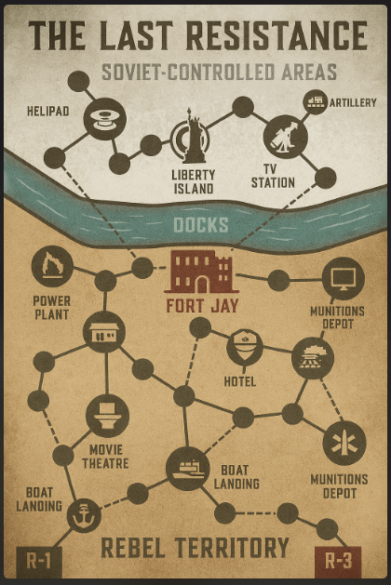
Fig. 1.1 Physical Game Board

- Core Systems in the Board Version:
Asymmetrical Roles: The Soviet Leader begins with superior strength, control over key strongholds, and access to systems like artillery and reinforcements. Rebels begin weak, scattered, and dependent on coordination.
Morale System: Each Rebel tracks an individual morale value (0–10), which directly affects their ability to act. Low morale restricts attacks, while high morale provides advantages. This system ensures that psychological state is as important as physical strength.
Territory & Strongholds: Each location on the board has a unique identity and gameplay function (e.g., Harbor for reinforcements, Artillery for long-range attacks, Rally Ground for recovery). Territories are not interchangeable, they shape strategy and narrative progression.
Turn-Based Structure: The Soviet Leader takes a powerful turn with multiple actions (movement, attacks, artillery), while Rebels take individual turns with limited actions. This reinforces the asymmetry between centralized authority and decentralized resistance.
Event Cards: Two separate decks (Rebel & Soviet) introduce controlled randomness. These cards influence morale, combat outcomes & strategic opportunities, ensuring variability across sessions.
Hidden Betrayal Mechanic: One Rebel is secretly designated as a potential traitor. When a specific stronghold is captured, this player switches sides, dramatically shifting game dynamics.
- Core Experience of the Board Game:

The board version is designed to create:
- Tension through asymmetry and uncertainty
- Hope through morale recovery and cooperation
- Urgency as Soviet pressure increases
- Climax during the final coordinated assault on ‘Frosthold’

Players are constantly balancing risk, trust and timing, ensuring that every decision carries both mechanical and emotional weight.

Design Philosophy

The AR adaptation of ‘The Last Resistance’ is guided by a principle of selective enhancement rather than full transformation. The goal is to preserve the strategic depth and social interaction of the board game while leveraging AR to amplify systems that benefit from visualization, automation and immersion.

2.1 Core Philosophy:
- Preserve the core identity of the game (asymmetry, morale, coordination, betrayal)
- Use AR only where it adds clarity, feedback or emotional impact
- Avoid over-digitization that removes physical engagement
- Reduce cognitive load by automating hidden or complex systems

2.2 System Classification: What Stays vs What Converts:
To ensure a meaningful adaptation, all game systems are divided into three categories:

A. Systems that remain Physical (Board Layer):
These systems are intentionally kept in the physical domain to preserve tactility, social interaction and spatial clarity.
- Board Layout (zones, river, strongholds)
- Player Tokens / Pawns
- Physical positioning and movement
- Basic turn-taking structure

Reasoning: Physical interaction reinforces player presence, spatial awareness, and strategic planning. Keeping the board tangible ensures that the game does not lose its identity as a tabletop experience.

B. Systems that convert to AR (Digital Layer)

These systems benefit from real-time visualization, automation and dynamic feedback:

- Morale System
Manual tracking reduces emotional impact and slows gameplay.
AR Implementation:
- Floating morale indicators above each Rebel unit
- Color-coded states (critical, normal, high)
- Real-time animated updates on gain/loss
Result: Players perceive morale instantly as a living system rather than a number.
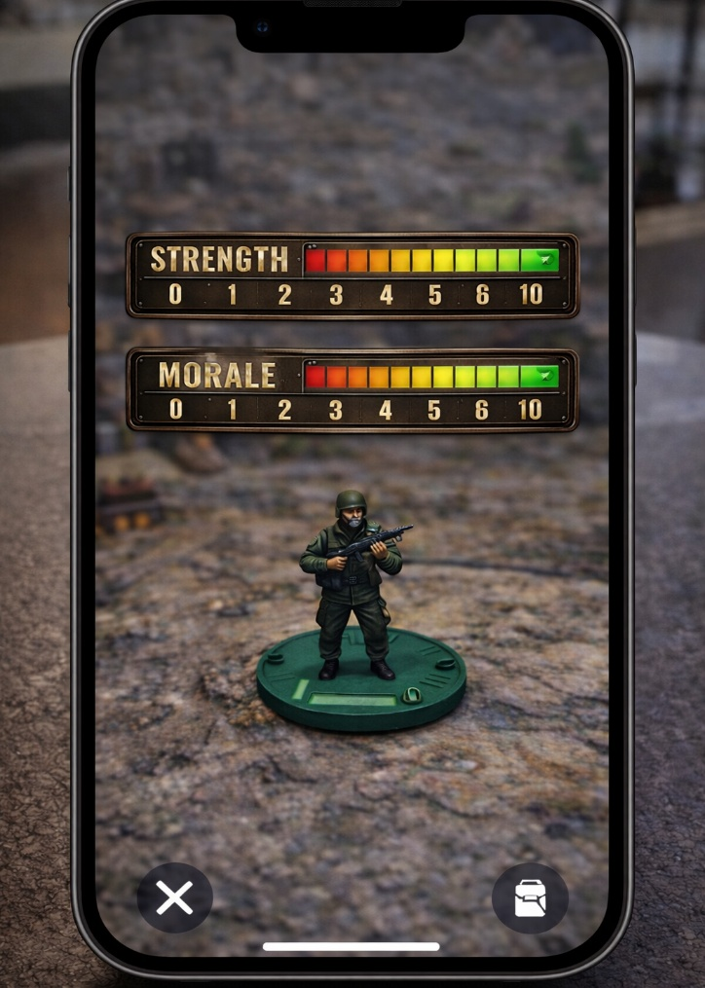
Fig. 2.1 Floating Meters in AR

- Hidden Betrayal Mechanic
Requires secrecy and controlled reveal, which AR can manage without human error.
AR Implementation:
- System tracks hidden identity internally
- No visual indication before trigger
- Cinematic reveal with visual transformation and UI shift
Result: Stronger narrative impact and elimination of accidental information leaks.

- Artillery System
Abstract mechanics lack clarity and tension.
AR Implementation:
- Targeting indicators projected onto board
- Warning visuals before impact
- Explosion effects and area feedback
Result: Improved fairness, anticipation, and engagement.

- Event Cards
Reduces rule-checking and improves pacing.
AR Implementation:
- Digital card display with contextual visuals
- Automatic resolution of effects
- Highlighting affected zones or players
Result: Faster gameplay and stronger narrative delivery.

- Strongholds & Territory States
Static visuals do not convey importance or state clearly.
AR Implementation:
- 3D structures overlaid on board locations
- Visual state changes (captured, damaged, fortified)
- Dynamic highlighting of key objectives
Result: Board becomes visually expressive and easier to read.

C. Hybrid Systems (Physical + AR Integration)

Some systems function best when combining both physical and digital elements:

1. Movement & Positioning
- Physical movement of tokens
- AR validates legal moves and highlights options
2. Combat Resolution
- Physical dice roll retained for tactile randomness
- AR calculates outcomes and applies effects (morale/strength changes)

3. Turn Guidance
- Physical turn order maintained
- AR provides UI prompts and action availability
Result: Maintains the feel of a board game while reducing friction and errors.

2.3 Design Outcome

By carefully dividing systems into physical, AR, and hybrid layers, the adaptation ensures:
- Preservation of the original gameplay identity
- Reduction of manual complexity and errors
- Enhanced clarity of hidden and dynamic systems
- Stronger emotional and narrative engagement
This approach transforms The Last Resistance into a hybrid tabletop experience, where AR acts as an invisible game master—handling complexity while allowing players to focus on strategy, cooperation, and decision-making.

3. AR Format Selection

Chosen Approach: Hybrid Tabletop + Marker-Based AR

Justification:
- Maintains strategic clarity of board layout
- Allows physical-digital hybrid gameplay
- Suitable for academic demonstration
- Technically feasible within limited development time

4. System Architecture

The AR adaptation of The Last Resistance is built on a layered hybrid architecture, where the physical board and digital AR systems work together as a single cohesive gameplay system. Instead of replacing the board, AR acts as an intelligent overlay and game manager, handling dynamic systems, hidden information, and feedback.

4.1 Architectural Overview
The system is divided into three tightly integrated layers:
- Physical Layer (Input & Spatial Anchor)
- AR Visualization Layer (Feedback & Representation)
- Game Logic Layer (Rules & State Management)
Each layer has a distinct responsibility, ensuring modular design and clarity in implementation.
4.2 Physical Layer (Real-World Interface)
This layer represents all tangible components of the game and acts as the input system for AR.
Components:
- Printed board (zones, strongholds, river)
- Player tokens / pawns
- Optional physical cards (markers or triggers)
Function:
- Provides spatial reference for AR tracking
- Captures player intent through physical movement
- Maintains the tactile, social nature of board gameplay
Technical Role:
- Acts as a tracking surface using image recognition or markers
- Defines coordinate system for AR object placement
Design Insight:
This layer ensures that players remain grounded in a shared physical space, preserving the core tabletop experience.

4.3 AR Visualization Layer (Dynamic Feedback System)
This layer is responsible for rendering all digital content on top of the physical board.

Components:
- UI overlays (morale bars, highlights, indicators)
- 3D models (strongholds, effects, environmental visuals)
- Animations (artillery strikes, betrayal reveal, state changes)
Function:
- Visualizes hidden or complex systems
- Provides immediate feedback for player actions
- Enhances narrative and emotional engagement
Examples:
- Morale displayed as floating, color-coded indicators
- Artillery shown with targeting zones and impact effects
- Strongholds visually changing state when captured

Technical Role:
- Uses AR camera feed + tracking data to anchor visuals
- Continuously updates visuals based on game state

Design Insight:
This layer transforms abstract mechanics into readable, intuitive visuals, reducing reliance on memory and manual tracking.

4.4 Game Logic Layer (Core System Controller)
This is the brain of the AR system, responsible for maintaining and updating the game state.
Responsibilities:
- Track all variables (morale, strength, control, roles)
- Enforce rules and constraints
- Process player actions and outcomes
- Handle hidden information (e.g., betrayal identity)
Key Systems Managed:
- Morale system (real-time updates)
- Turn validation (legal/illegal actions)
- Event resolution
- Combat outcomes
- Betrayal trigger and role switching
Technical Role:
- Central state machine or game manager in Unity
- Communicates with AR layer to update visuals
- Receives input from physical layer (via tracking/events)
Design Insight:
By centralizing logic, the system ensures consistency, fairness and automation, removing ambiguity from gameplay.
4.5 Data Flow Between Layers
The interaction between layers follows a continuous loop:
- Player Action (Physical Layer)
→ Player moves token or performs an action
- Input Detection (Tracking System)
→ AR detects position / marker / interaction
- Game Logic Processing (Game Logic Layer)
→ Validates action, updates state
- Visual Feedback (AR Layer)
→ Updates UI, animations and board state

4.6 Role of AR as “Invisible Game Master”
In this architecture, AR functions as an automated game master that:
- Tracks hidden states (morale, betrayal, triggers)
- Prevents illegal actions
- Resolves outcomes instantly
- Provides contextual guidance to players
This removes the need for manual rule enforcement while preserving player agency.

4.7 Scalability & Future Extensions
This architecture allows for future expansion:
- Multiplayer networked AR (shared state across devices)
- Additional maps or scenarios
- AI-driven Soviet behaviour (optional mode)
- Enhanced UI layers (player-specific views)

5. Core Mechanics Translation

This section defines how the core mechanics of the board version of The Last Resistance are translated into the AR environment. The goal is to preserve mechanical intent while enhancing clarity, feedback, and immersion through AR.
Each system is evaluated based on:
- Its role in gameplay
- Limitations in the physical version
- Opportunities for AR enhancement
5.1 Morale System → Real-Time Visual Feedback System
Board Version:
- Each Rebel tracks morale manually (0–10)
- Effects depend on thresholds (low, normal, high)
- Requires constant attention and updating
Limitations:
- Easy to forget or miscalculate
- Lacks emotional/visual impact
- Adds cognitive load during gameplay

AR Translation:
- Floating morale indicators above each Rebel unit
- Color-coded states:
  - Low (0–2): unstable / flickering
  - Normal (3–7): steady
  - High (8–10): glowing / enhanced
- Smooth animation for morale changes

Gameplay Impact:
- Instant readability of player condition
- Stronger emotional connection to outcomes
- Encourages strategic decisions based on visible state

5.2 Hidden Betrayal → System-Controlled Reveal Mechanic
Board Version:
- One Rebel secretly becomes a traitor at a trigger point
- Requires manual reveal and rule transition
Limitations:
- Risk of accidental information leaks
- Reveal depends on player honesty/timing
- Limited dramatic impact
AR Translation:
- Betrayal identity tracked entirely by system
- No visible indicators before trigger
- On trigger event:
  - Unit visually transforms
  - UI updates faction alignment
  - Global feedback (morale drop, visual shockwave)
Gameplay Impact:
- Ensures secrecy and fairness
- Creates a cinematic turning point
- Reinforces tension throughout gameplay

5.3 Artillery System → Telegraphed Area Control System
Board Version:
- Artillery targets are abstract or randomly determined
- Effects applied manually
Limitations:
- Low visual clarity
- Limited anticipation for players
- Feels detached from board state
AR Translation:
- Target zones highlighted directly on board
- Pre-impact warning indicators (pulse / radius)
- Impact animation with visible effect area
Gameplay Impact:
- Players can anticipate and react
- Increases tension and strategic positioning
- Makes Soviet power feel present and threatening

5.4 Event Cards → Contextual AR Event System

Board Version:
- Players draw cards and resolve effects manually
- Requires reading, interpretation, and tracking
Limitations:
- Slows pacing
- Breaks immersion
- Risk of rule misinterpretation

AR Translation:
- Digital card display with visual context
- Highlighting of affected zones/players
- Automatic application of effects
Gameplay Impact:
- Faster resolution of events
- Stronger narrative delivery
- Reduced rule-checking overhead

5.5 Territory & Strongholds → Dynamic Spatial Feedback System
Board Version:
- Static board representation
- Control indicated by tokens or markers
Limitations:
- Hard to distinguish importance of locations
- No visual differentiation of state (damaged, active, fortified)
AR Translation:
- 3D structures overlaid on each stronghold
- Visual state changes:
  - Captured
  - Damaged
  - Reinforced
- Key locations visually emphasized (scale, glow, effects)
Gameplay Impact:
- Improves spatial awareness
- Reinforces strategic importance of locations
- Makes board feel alive and reactive

5.6 Combat System → Assisted Resolution System
Board Version:
- Dice-based resolution
- Players manually calculate outcomes and apply effects
Limitations:
- Slows gameplay
- Risk of incorrect calculations
- Limited feedback beyond win/lose

AR Translation:
- Dice roll remains physical (to preserve tactility)
- AR calculates results instantly
- Visual feedback:
  - Damage indicators
  - Morale changes
  - Outcome highlights

Gameplay Impact:
- Maintains randomness and player engagement
- Eliminates calculation errors
- Enhances clarity of results

5.7 Movement & Turn System → Guided Interaction System
Board Version:
- Players manually determine valid moves and actions
Limitations:
- Requires rule recall
- Potential illegal moves
- Slower decision-making
AR Translation:
- Highlight valid movement paths
- Indicate available actions (attack, regroup, draw event)
- Disable invalid actions based on rules (e.g., low morale)
Gameplay Impact:
- Reduces confusion
- Speeds up gameplay
- Supports new players without simplifying depth
5.8 Escalation System → Environmental Feedback System
Board Version:
- Zone progression represented visually on board
Limitations:
- Limited dynamic feedback
- Escalation is understood, not felt

AR Translation:
- Environmental effects change across zones:
  - Sand → calm visuals
  - River → transition barrier
  - Snow → harsh, intense atmosphere
- ‘Frosthold’ emphasized as final objective

Gameplay Impact:
- Strengthens narrative progression
- Enhances emotional pacing
- Makes late-game feel significantly different

6. Zone-Based Escalation

The board of The Last Resistance is not just a spatial layout but a designed escalation system, where each zone represents a distinct phase of gameplay, both mechanically and emotionally. In the AR adaptation, this progression is enhanced through environmental feedback, visual tone, and intensity of effects, allowing players to feel the shift in difficulty and narrative stakes.

6.1 Sand Zone (Early Game – Preparation Phase)
Board Role: The Sand Zone represents the early stage of resistance, where Rebels are weak but relatively safe. It is designed to encourage exploration, regrouping, and morale-building.
AR Enhancement:
- Warm color palette (yellow/orange tones)
- Minimal visual clutter and soft lighting
- Subtle UI indicators with low animation intensity
- Calm ambient effects (stable environment, no heavy threats)
Design Intent: This zone creates a sense of safety and opportunity, allowing players to understand mechanics, coordinate with allies, and build confidence.

Gameplay Impact:
- Encourages strategic planning and cooperation
- Reduces early-game pressure
- Establishes baseline for later contrast

6.2 River (Transition Phase – Threshold of Conflict)

Board Role: The river acts as a mechanical and psychological boundary, separating early-game preparation from late-game confrontation.

AR Enhancement:
- Visual barrier such as fog, mist, or energy field
- Slight desaturation or color shift when approaching the boundary
- Audio transition (subtle tension-building cues)
- Highlighted crossing points to emphasize decision-making
Design Intent: Crossing the river is framed as a commitment point—a moment where players shift from survival to active resistance.

Gameplay Impact:
- Signals escalation clearly to all players
- Creates tension before entering high-risk zones
- Encourages coordinated movement before crossing

6.3 Snow Zone (Late Game – High-Risk Conflict Phase)

Board Role: The Snow Zone represents full Soviet control, with stronger defences and increased consequences for failure.
AR Enhancement:
- Cold color palette (blue/white tones)
- Increased visual intensity (sharper lighting, harsher contrasts)
- Environmental effects (snow particles, wind, visual distortion)
- More aggressive UI feedback (stronger animations, alerts)
Design Intent: This zone creates a sense of hostility and pressure, reinforcing that players are now deep within enemy territory.
Gameplay Impact:
- Increases emotional tension
- Forces careful, coordinated decision-making
- Punishes reckless actions more clearly
6.4 Frosthold (Final Objective - Climax Zone)
Board Role: ‘Frosthold’ is the ultimate Soviet stronghold and the final objective for Rebel victory.
AR Enhancement:
- Large-scale 3D structure dominating the board
- Distinct visual identity (glow, scale, animation)
- Persistent highlighting to indicate importance
- Pre-battle visual buildup (intensity increase as players approach)
Design Intent: ‘Frosthold’ is designed to feel like a final boss encounter, both visually and mechanically.

Gameplay Impact:
- Focuses all player attention on a single objective
- Reinforces the need for teamwork (multi-Rebel attack requirement)
- Delivers a strong narrative and gameplay climax

6.5 Overall Impact of AR-Based Escalation
By enhancing zones through AR, the game transforms escalation from a conceptual understanding into a sensory experience.
Key Transformations:
- Static → Dynamic environments
- Abstract progression → Visually communicated phases
- Passive awareness → Active emotional response
This ensures that players do not just understand progression - they experience it in real time, reinforcing pacing, tension, and narrative immersion.

7. Turn System (AR-Supported)

The turn system in The Last Resistance remains fundamentally unchanged in the AR adaptation to preserve the game’s asymmetrical structure and strategic depth. However, AR enhances the system by acting as an interactive guide and rule enforcer, ensuring clarity, reducing errors, and improving pacing.

7.1 Preservation of Core Turn Structure
Board Version:
- The game progresses in rounds
- Soviet Leader takes a powerful turn with multiple actions
- Rebels take individual turns with limited actions
AR Approach:
- No changes to turn order or action economy
- All original rules and constraints are preserved
Design Intent: To maintain the identity and balance of asymmetrical gameplay, ensuring that AR enhances the experience without altering core mechanics.

7.2 AR as Guided Interaction System
In the AR version, the system acts as a real-time guide, helping players understand what actions are available at any moment.
Key Features:
- Highlighting valid movement paths between connected zones
- Displaying available actions (attack, regroup, draw event, etc.)
- Context-sensitive prompts based on player state
Example:
- A Rebel in a neutral zone sees “Draw Event” highlighted
- Adjacent enemy strongholds are visually marked as attack options

Impact:
- Reduces confusion, especially for new players
- Speeds up decision-making
- Keeps players focused on strategy rather than rule recall

7.3 Rule Enforcement & Error Prevention
One of the key advantages of AR is its ability to enforce rules automatically, eliminating illegal actions and reducing disputes.

AR Implementation:
- Invalid actions are disabled or not selectable
- System validates conditions before allowing actions
Examples:
- A Rebel with morale between 0–2 cannot initiate an attack
- Frosthold cannot be attacked unless two Rebels are present
- Movement is restricted to connected zones only
Impact:
- Ensures fairness and consistency
- Prevents accidental rule violations
- Removes need for constant rule-checking

7.4 Targeting & Decision Clarity
AR enhances player decision-making by making targets and consequences more visible.
AR Implementation:
- Enemy units and strongholds are highlighted when in range
- Potential targets glow or display indicators
- Risk zones (e.g., artillery range) may be visualized
Impact:
- Improves situational awareness
- Helps players evaluate options quickly
- Supports more informed strategic decisions

7.5 Turn Feedback & Flow Enhancement
The AR system provides immediate feedback during and after actions, improving the overall flow of the game.
AR Feedback Includes:
- Visual confirmation of actions (movement, attack, regroup)
- Animated updates (morale changes, damage effects)
- Clear indication of turn transitions
Impact:
- Keeps gameplay smooth and continuous
- Reinforces player actions with visible outcomes
- Reduces downtime between turns

7.6 Role of AR in Turn System
In this system, AR functions as an “invisible facilitator”, ensuring that:
- Players always know what they can do
- Players cannot perform what they should not do
- The game progresses smoothly without interruptions

7.7 Overall Impact
The AR-supported turn system transforms gameplay from:
- Rule-dependent → System-guided
- Error-prone → Consistent and fair
- Slow-paced → Smooth and responsive
While the structure remains unchanged, the experience becomes significantly more intuitive, efficient, and engaging.

8. Visual Story Board
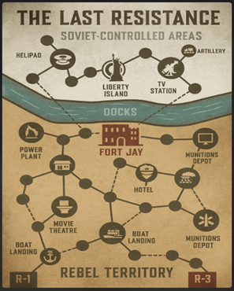
Fig. 8.1 Physical Game Board
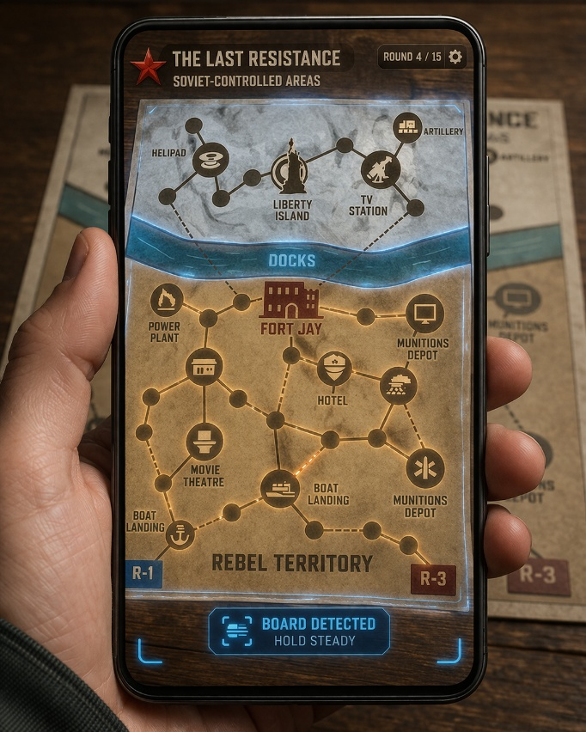
Fig. 8.2 Scanning Board through Phone


Fig. 8.3 Depiction of AR Board on the player phones
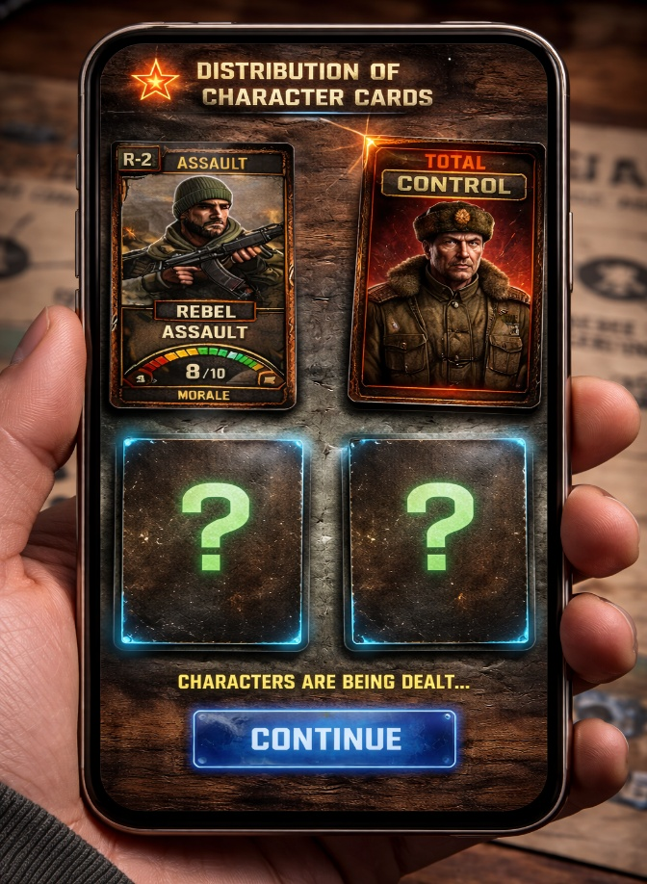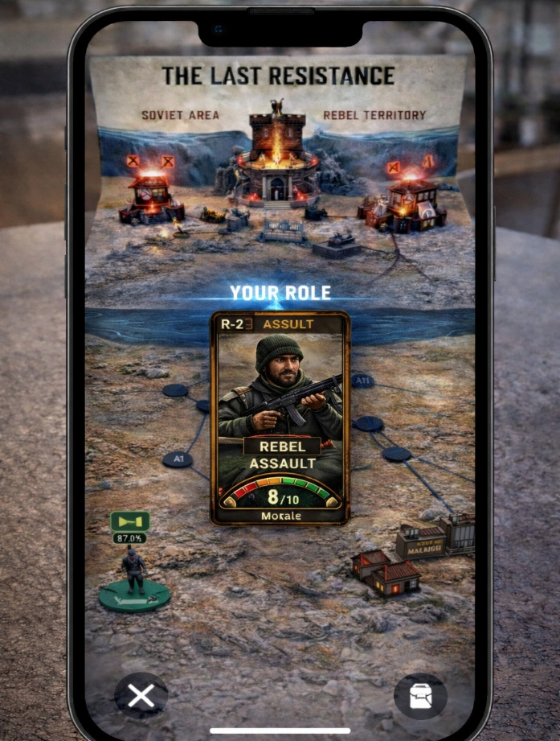
Fig. 8.4 Role Distribution
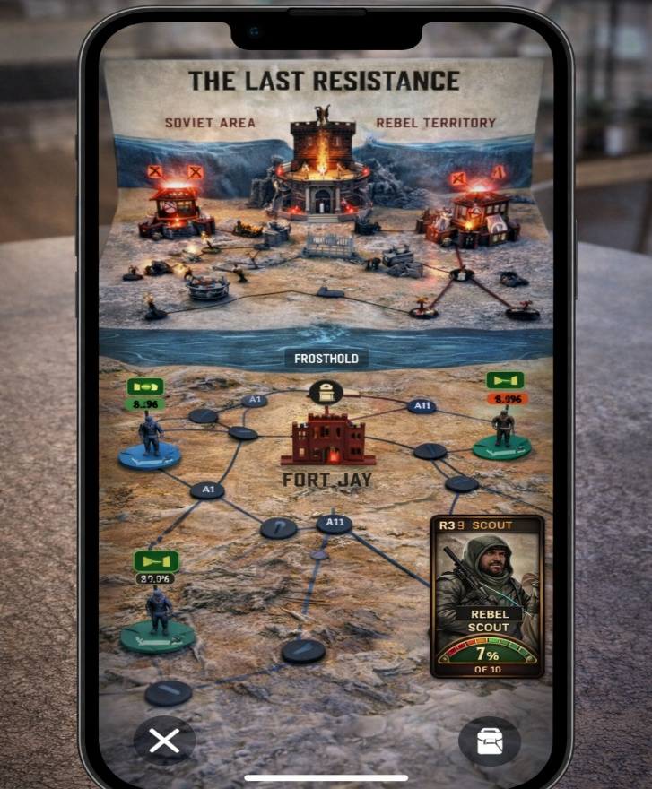
Fig. 8.5 Scene of one player screen
8. Player Experience Goals

The AR adaptation of The Last Resistance is designed not just to improve usability, but to reshape how players perceive, interpret, and emotionally respond to the game. While the board version delivers strong strategic depth, AR enhances the experiential layer by making hidden systems visible, abstract mechanics tangible, and progression emotionally felt.

8.1 Tension through Visual Feedback
In the board version, tension emerges from uncertainty and hidden information. However, much of this tension is conceptual rather than directly perceived.
In the AR version, tension is externalized through real-time visual feedback:
- Morale fluctuations are instantly visible
- Artillery threats are telegraphed spatially
- Strongholds visually reflect control and danger
This transforms tension from:
“I think something bad might happen”
into
“I can see the threat building right now.”
As a result, players experience anticipation, urgency, and pressure more intensely, leading to more deliberate and emotionally driven decisions.

8.2 Clarity through Automated Systems
The board version requires players to track multiple systems manually—morale, event effects, rule conditions—which increases cognitive load and can interrupt gameplay flow.
The AR system reduces this burden by:
- Automatically updating morale and status changes
- Enforcing rules (e.g., attack restrictions, movement limits)
- Resolving events instantly
By removing mechanical overhead, the game becomes more accessible, faster-paced and strategically focused, without reducing depth.

8.3 Immersion through Environmental Storytelling
In the board version, environmental storytelling is implied through visual design (sand, river, snow), but remains static.
AR transforms the board into a dynamic narrative space:
- Zones visually evolve in tone and intensity
- Environmental effects (lighting, particles, atmosphere) reflect danger levels
- Key locations gain visual identity and presence
This allows players to feel progression rather than just recognize it.
For example:
- The Sand Zone feels calm and controlled
- The Snow Zone feels hostile and oppressive
This creates a stronger sense of being inside a conflict, rather than observing it from above.

8.4 Emotional Impact through Real-Time Responses
One of the core goals of the game is to evoke emotional states such as hope, fear, betrayal, and urgency.
In the board version, these emotions rely heavily on player imagination and interpretation.
In the AR version, emotions are reinforced through immediate system feedback:
- Morale drops visibly reflect failure
- Victory moments are visually emphasized
- Betrayal is presented as a sudden, dramatic transformation
This ensures that:
- Success feels earned and rewarding
- Failure feels consequential and impactful
- Key moments feel memorable and cinematic
The game becomes not just strategic, but emotionally reactive.

9. Technical Considerations

The AR adaptation of The Last Resistance is designed using a modular and scalable technical approach, ensuring that the system remains feasible to implement while supporting real-time interaction, visual feedback, and rule management.

9.1 Recommended Tools
- Unity (Game Engine): Unity is used as the primary development platform due to its strong support for real-time rendering, cross-platform deployment, and integration with AR frameworks. It allows efficient handling of game logic, UI systems, and 3D visualization.

- AR Foundation (Cross-Platform AR Support): AR Foundation provides a unified framework for building AR applications compatible with both Android (ARCore) and iOS (ARKit). It enables plane detection, image tracking, and object placement, which are essential for aligning digital content with the physical board.

9.2 Core Systems Required
To implement the AR version effectively, several core systems are required:
1. Object Tracking System (Board Recognition & Alignment)
Function:
- Detects and tracks the physical board or markers
- Anchors AR elements accurately onto real-world positions
Implementation:
- Image tracking (printed board as reference)
- Marker-based tracking for specific zones or cards

Importance: Ensures that all AR visuals (units, UI, effects) remain stable, aligned, and believable.

2. UI Overlay System (Player Feedback Layer)
Function:
- Displays dynamic information such as morale, actions, and highlights
- Provides real-time visual feedback to players
Examples:
- Floating morale bars
- Highlighted movement paths
- Target indicators
Importance: Acts as the primary communication layer between the system and the player, improving clarity and usability.

3. State Management System (Game Logic Controller)
Function:
- Tracks all game variables:
  - Morale levels
  - Territory control
  - Player roles (including betrayal)
  - Event effects
- Processes player actions and updates game state
Implementation:
- Central game manager in Unity
- Event-driven architecture for updates
Importance: Maintains consistency, fairness, and rule enforcement throughout the game.

4. Animation & VFX System (Feedback & Immersion)
Function:
- Provides visual feedback for actions and events
- Enhances immersion through dynamic effects
Examples:
- Artillery explosions
- Morale change animations
- Stronghold state transitions
Importance: Transforms gameplay from static interactions into a visually engaging experience, reinforcing player actions.

9.3 System Integration Considerations
All systems must work together seamlessly:
- Tracking system → defines spatial context
- Game logic system → processes actions
- UI & VFX systems → present outcomes
This integration ensures a smooth flow from:
Player action → System processing → Visual feedback

9.4 Feasibility & Scope Control
The implementation is designed to remain practical within academic constraints by:
- Limiting the number of AR elements per interaction
- Reusing UI components across systems
- Prioritizing core mechanics over visual complexity

The technical design aims to create a system that is:
- Stable (accurate tracking and alignment)
- Responsive (real-time updates and feedback)
- Scalable (expandable for future features)
while supporting the core objective of enhancing gameplay without overcomplicating development.

10. Advantages of AR Adaptation

- Eliminates manual tracking errors
- Enhances understanding of complex systems
- Creates cinematic gameplay moments
- Bridges physical and digital gameplay

11. Conclusion

The AR adaptation of The Last Resistance preserves the original game’s strategic and narrative depth while enhancing clarity, immersion, and emotional engagement. By externalizing hidden systems such as morale, escalation, and betrayal, AR transforms the board into a dynamic and interactive battlefield.
This approach ensures that the game remains accessible, engaging, and academically relevant, while showcasing the potential of AR in modern game design.

