📖 Reflective Visual Journal (RVJ)

Project Title: The Last Resistance
Submitted By: Paras Garg
Course: Game Design

- Idea Generation

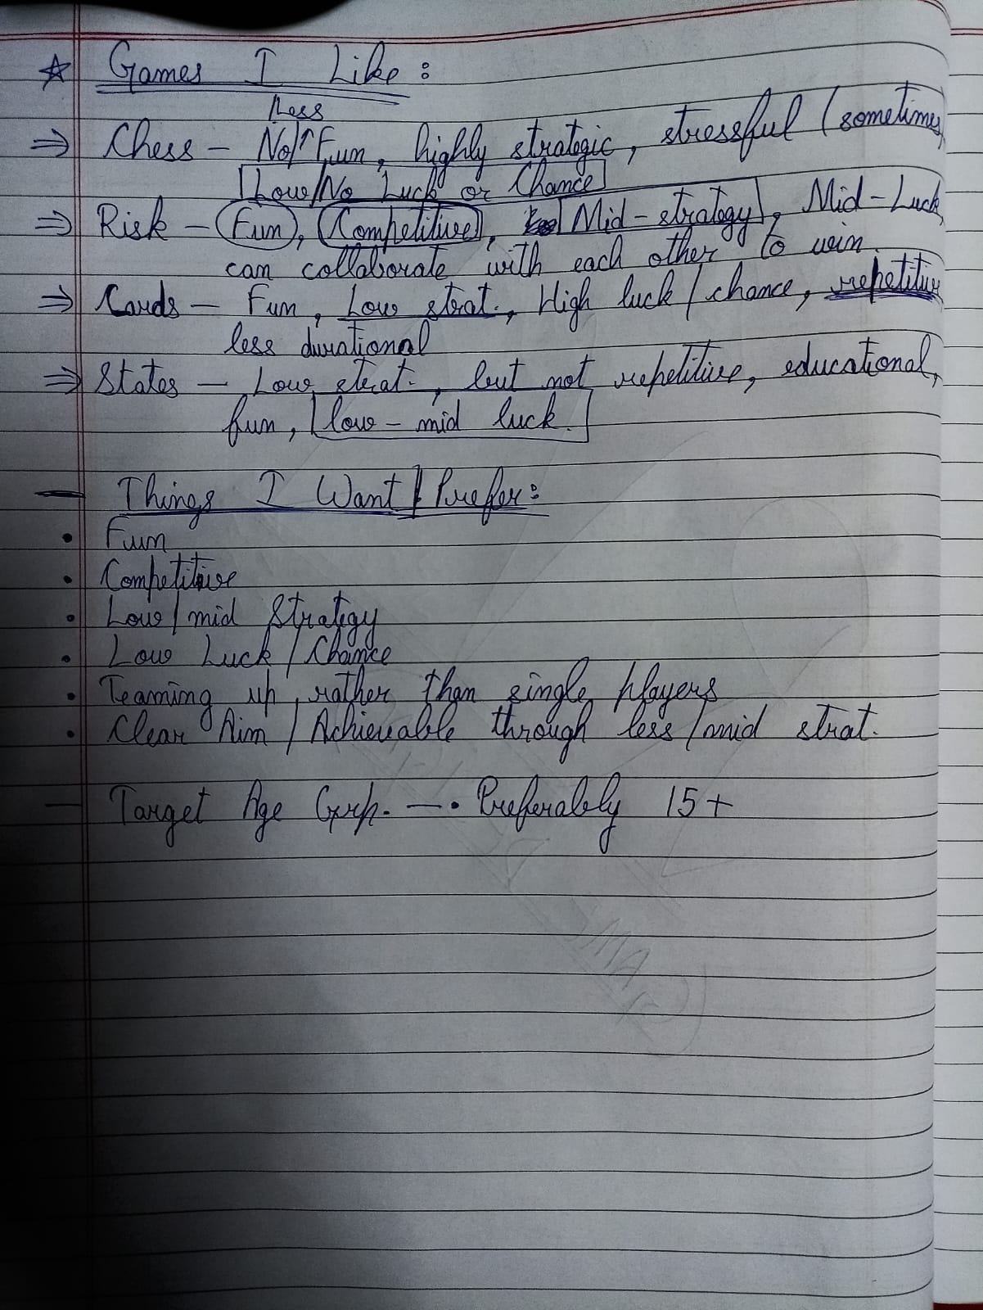

The seed for this project came from a strong personal connection to the 2003 video game Freedom Fighters. Having spent countless hours exploring its storyline and atmosphere, I was fascinated by its central idea.

The earliest sketches began as simple shapes. Circles represented neutral zones or ruins where random events might occur, and rectangles were placed as major landmarks under Soviet control. Fort Jay, a real landmark in New York, was chosen to act as the final and most fortified Soviet stronghold. The Soviet Leader would begin from the Harbor and Docks, while the Rebels emerged from three hidden hideouts at the far side of the board.

At this stage, the idea was still raw: how do Rebels win against such a powerful enemy? How do we balance gameplay so that the Soviets don’t crush the resistance too early? Slowly, through discussions, brainstorming, and critical feedback, the design evolved into a blend of narrative, history, and mechanics.

2. Inspirations

- Freedom Fighters (2003): This game gave the strongest foundation for the board game. The themes of resistance, hidden movements, betrayals and desperate morale matched the emotional tension I wanted players to feel.

- Risk: Risk inspired the concept of territory control. However, Risk is a long and complex game that can stretch for hours. I wanted something more compact: a game that resolves within 40–60 minutes while keeping the drama alive.

- UNO: From UNO, came the idea of simple, random event cards. Instead of just drawing for fun, these cards became thematically tied to “propaganda”, “reinforcements” or “unexpected support”, making each draw a tense moment.

- Historical Cold War & WWII: Real history also informed this project. Cold War proxy battles, Soviet artillery shelling, propaganda wars, and underground resistance all served as mechanics. While the board is fictional, the underlying inspirations remain grounded in history.

- Core Concepts

  - Central Design Vision

The core design vision of The Last Resistance is to create a narrative-driven, asymmetrical board game that simulates the psychological and strategic realities of resistance movements under military occupation. Unlike traditional war board games that focus purely on numerical superiority and territorial dominance, this game emphasizes morale, trust, and escalation as equally important factors in determining victory.
The game is designed to place players in situations where power is unevenly distributed from the beginning. The Soviet Leader starts with superior military strength, control over key infrastructure, and visible authority. In contrast, the Rebel players begin fragmented, weaker, and uncertain—not only of the enemy’s intentions but also of each other’s loyalty. This imbalance is intentional and forms the emotional and strategic foundation of the experience.
At its heart, The Last Resistance asks a simple but powerful question:
Can coordination, morale, and timing overcome raw military dominance?

3.2 Asymmetry as a Core Pillar

Asymmetry is the most important structural pillar of the game. Each faction operates under fundamentally different rules, strengths, and limitations, ensuring that no two players experience the game in the same way.

The Soviet Leader represents centralized authority and control. This player has:
- Higher starting strength
- Access to reinforcements via Harbor
- Long-range pressure through Artillery
- The ability to perform multiple attacks per turn

In contrast, the Rebel players represent decentralized resistance. They:
- Operate independently
- Track individual Morale meters
- Have limited attack opportunities
- Must rely on coordination and timing rather than brute force

This asymmetry creates constant tension. The Soviet Leader must decide where to apply overwhelming force, while the Rebels must choose when to hide, when to regroup and when to strike collectively.
Rather than attempting to “balance” both sides numerically, the game balances capability vs. flexibility - the Soviets dominate space while the Rebels dominate opportunity.

3.3 Morale as a Gameplay System

Morale is treated not as a thematic decoration but as a core gameplay system that directly governs player agency. Each Rebel player maintains an individual Morale meter ranging from 0 to 10, representing psychological readiness, civilian support and confidence.

Morale affects gameplay in three distinct states:

- Low Morale (0–2): The Rebel cannot initiate attacks and is forced into a defensive posture.
- Normal Morale (3–7): The Rebel can act freely but without bonuses.
- High Morale (8–10): The Rebel gains bonuses during attacks, representing heightened resistance momentum.

This system ensures that success and failure have lasting emotional consequences. Winning battles builds confidence, while losses compound pressure. Importantly, morale recovery is possible through cooperation, when allies regroup or support each other, reinforcing the theme that resistance is sustained collectively rather than individually.

3.4 Hidden Identity and Betrayal

One of the defining conceptual elements of ‘The Last Resistance’ is the hidden betrayal mechanic, inspired by real-world resistance movements where informants and double agents were common.
At the start of the game, one Rebel player is secretly designated as the ‘Corruptible Rebel’. This player appears identical to the other Rebels and operates under the same rules until a specific narrative trigger occurs: the capture of Tatarin’s Command Base.
When this event happens, the Corruptible Rebel reveals their true identity as General Bulba and permanently switches sides, gaining access to Soviet resources and objectives.
This mechanic is not intended to be a social deception game but a systemic shock. The betrayal immediately alters board control, morale states, and strategic planning. Rebels must therefore design their plans under uncertainty, knowing that cooperation is necessary but potentially dangerous.

3.5 Escalation and Phase-Based Progression

The game is structured around a clear escalation curve, represented both mechanically and visually through the board design.

The board is divided into two primary regions:

- Southern Zone (Sand/Ash): Represents early resistance efforts with weaker enemy presence and morale-building opportunities.
- Northern Zone (Snow/Ice): Represents full military occupation, heavy fortification, and high-risk engagement.

A horizontal river separates these zones, acting as a psychological and mechanical threshold. Crossing the river signals a shift from survival-oriented gameplay to decisive confrontation. Strongholds beyond this point are harder to capture and the consequences of failure are more severe.
This phased structure allows the game to build tension naturally, ensuring that early turns focus on preparation while later turns emphasize coordination and sacrifice.

3.6 Territory as Narrative, Not Just Space

Territories in The Last Resistance are not interchangeable spaces. Each stronghold and area on the board represents a meaningful narrative and mechanical function.
Examples include:
- Harbor: Controls Soviet reinforcements.
- Artillery: Enables long-range suppression.
- Power Plant: Provides system-wide advantages.
- Rebel Rally Ground: Allows Rebels to recover and regroup.
- Frosthold: The final fortress and ultimate objective.
By giving each location a unique identity and gameplay effect, territorial control becomes a storytelling device rather than a numerical race. Players do not merely capture spaces—they disrupt systems, shift momentum, and reshape the battlefield.

3.7 Player Agency Under Pressure

A key conceptual goal of the game is to ensure that players are always making meaningful decisions, even when losing.

Rebels with low strength can still:
- Defend key locations
- Support allies
- Influence morale dynamics
Similarly, the Soviet Leader must continuously decide where to focus power, as overextension can leave critical strongholds vulnerable.
This approach ensures that no player is ever fully “out of the game” until the final moments, preserving engagement and emotional investment.

3.8 Experience Goals

The Last Resistance is designed to evoke the following player experiences:
- Tension: From hidden betrayal and escalating difficulty.
- Hope: Through morale recovery and cooperation.
- Urgency: As Soviet systems tighten control.
- Climax: During the coordinated assault on Frosthold.

The ultimate goal is for players to walk away feeling that they did not simply win/lose a board game, but participated in a dramatic, evolving conflict shaped by their decisions.

- Creative Challenges

- Why should the Soviet Leader move?
At first, it seemed illogical. Why leave strongholds if he already has troops stationed everywhere?
The solution: the Harbor and Docks supply reinforcements. If Rebels threaten these routes, the Soviet Leader must move to defend them.

- Balancing morale
Without morale, Rebels would just throw numbers at Soviets. But with morale, victories feel rewarding and defeats dangerous.

- Not overcrowding the board
Using a single city map allowed me to keep the board large enough for strategy, but small enough for clarity.

- Betrayal twist fairness
The ‘Mr. Jones’ player draws Rebel cards until General Tatarin is defeated. At that moment, the betrayal is revealed and Mr. Jones joins the Soviets as ‘General Bulba’. This ensures balance and a cinematic turning point.

- Narrative Angle

The story is central. The U.S. has fallen to a Soviet invasion. Rebels, ordinary citizens, emerge from ruined parks, metro stations, and assembly grounds. They must take back their city one landmark at a time.

Each building represents a piece of the Soviet grip:
- Harbor/Docks: The lifeline of reinforcements.
- Helipad: Allows Soviet Leader to move faster.
- TV Station: Controls propaganda, lowering Rebel morale.
- Artillery Zone: Launches shelling on Rebel positions.
- Fort Jay: The ultimate stronghold and seat of Soviet power.

Victory is not just about numbers - it is about breaking the chains of oppression.

- Key Innovations

This game introduces mechanics that make each session feel alive, tense and unpredictable. Unlike traditional board games where turns are mostly tactical and predictable, these innovations add layers of psychology, asymmetry and suspense, keeping players fully engaged.

- Morale Meter - psychological stakes:
Most board games focus on resources, positions or points, but few simulate the mental state of characters or teams. The Morale Meter tracks how confident or stressed a team or character is. High morale can unlock special actions or bonuses, while low morale may limit options or force risky moves.
This mechanic adds tension beyond physical game pieces: players must manage not only their moves but also the mental and emotional state of their forces. It creates emergent drama - sometimes winning a skirmish feels hollow if morale collapses, making every decision weighty.

- Dual Decks - Rebel (blue) vs Soviet (red):
Many games use a single deck for everyone, creating symmetrical gameplay. Here, two distinct decks maintain asymmetry between sides, giving each faction unique tools, challenges and narrative flavour. The Rebel deck emphasizes improvisation, guerrilla tactics and creative problem-solving, while the Soviet deck emphasizes brute force, resource control and strict discipline. This asymmetry ensures re-playability and forces players to adapt strategies that work for one side but won’t work for the other, deepening tactical and narrative richness.

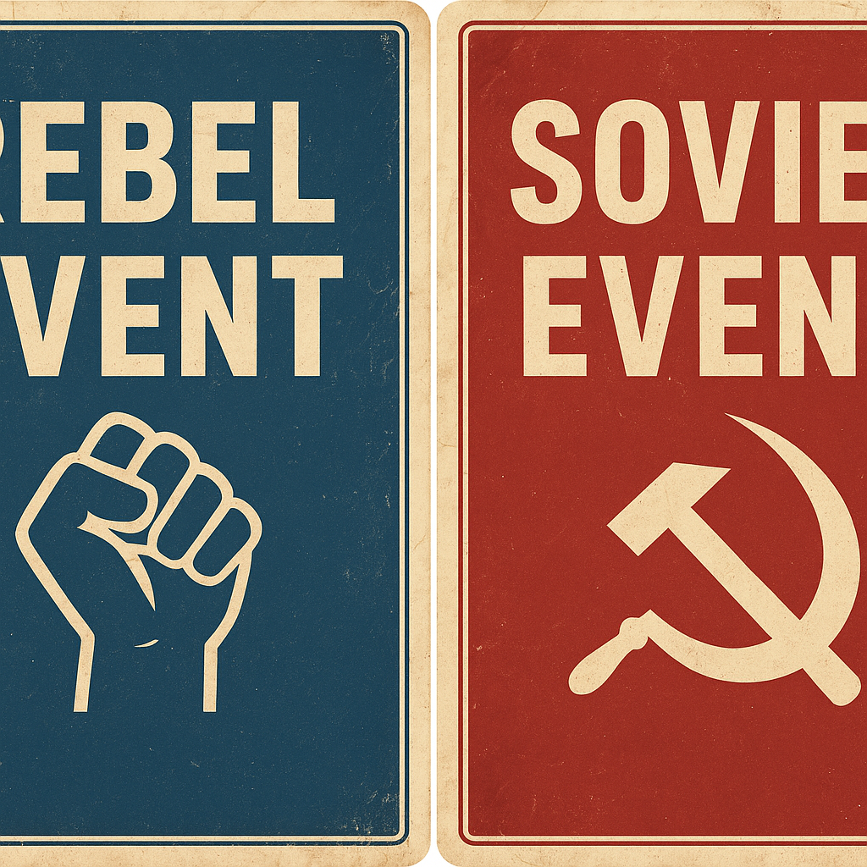

- Hidden Betrayal — the Mr. Jones twist:
Hidden roles in games often affect social dynamics or votes, but here, the Mr. Jones mechanic is woven directly into the core gameplay. One player secretly works against their own team, triggering unpredictable consequences when revealed. This ensures no two games unfold the same way and forces players to think beyond visible moves: they must weigh trust, anticipate deception, and adjust strategies on the fly. The hidden betrayal adds suspense and a sense of living story, making every session feel unique and dramatic.

- Why It’s Unique

- Unlike Risk - shorter, narrative-driven. Risk is about sprawling campaigns, armies and slow momentum. Victories are earned over many turns and the game can drag while players execute long-term strategies. This game compresses that scale into compact, high-stakes moments. Instead of continent-long slogging, each session feels like a chapter in a spy novel - fast setup, tight turns and story beats that escalate quickly. Players get the thrill of strategic tension without the marathon.

- Unlike UNO - card draws affect story, not just rules. UNO treats cards like rule modifiers (skip, reverse, draw two) with minimal narrative context. Here, cards are story engines. A draw can expose a secret, alter alliances, inject a moral choice or trigger a narrative twist, mechanically meaningful and narratively resonant at once. Cards don’t just change how you play; they change what happens in the world, so every draw feels like a line in the story.

- Unlike Axis & Allies - it avoids resource overload. Axis & Allies thrives on economies, production queues and long-term logistics. That depth comes at the cost of complexity and session length. We deliberately pare back resource systems so players focus on choices that matter now - tactical positioning, narrative decisions and the ripple effects of card play rather than managing an economy. The result is high decision density with low administrative friction.

8. Mind Map

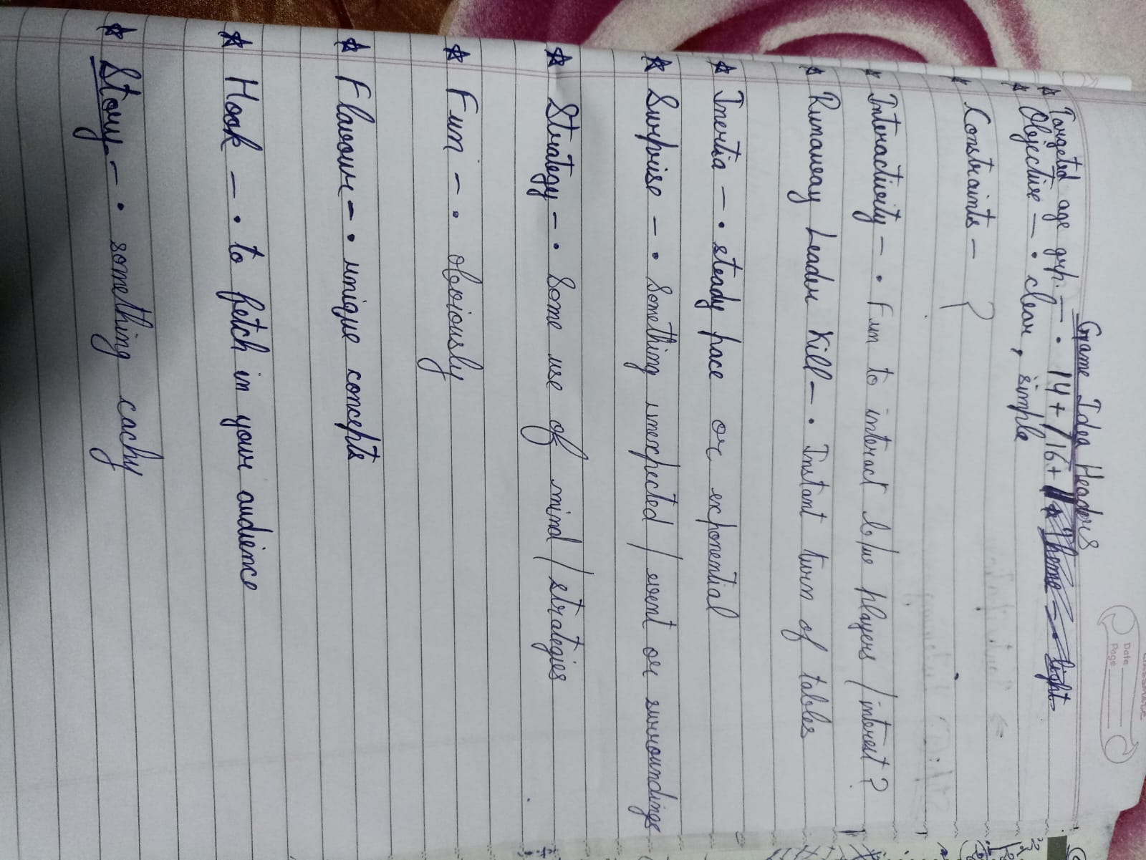

This is my research items’ list, about the important things to focus on while generating idea for my board game



The idea-generation process followed the “Attribute Listing” technique. I began by analyzing different games I personally enjoy, such as Chess, Risk, Cards and States. Each was broken down into its key features (e.g., level of strategy, role of luck, competitiveness, teamwork). From these attributes, I identified the qualities I preferred - fun, competitiveness, low-to-mid strategy, limited luck and collaborative play. By filtering and recombining these selected attributes, I was able to define the foundation of my own board game design.

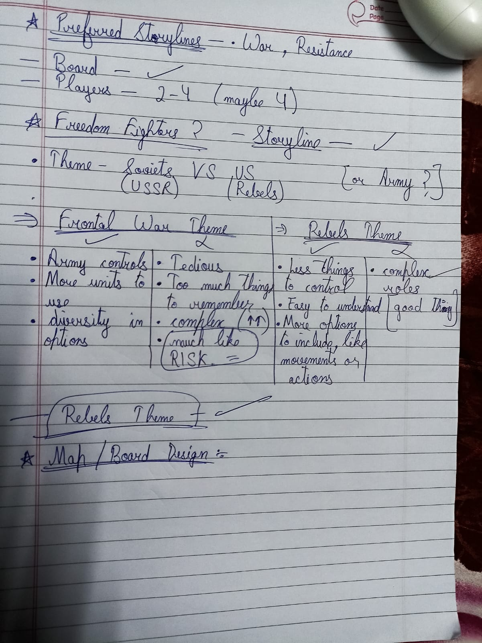

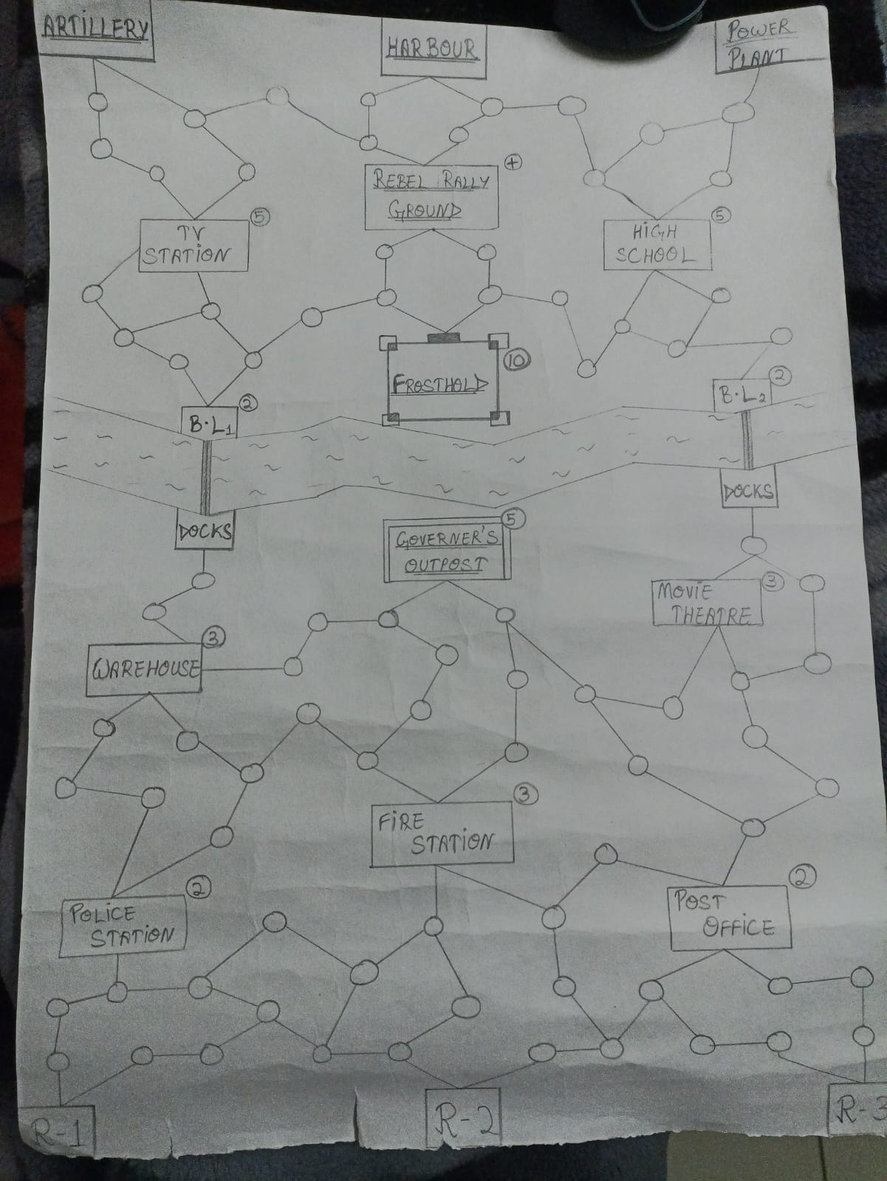
Fig. – Initial Hand-made map
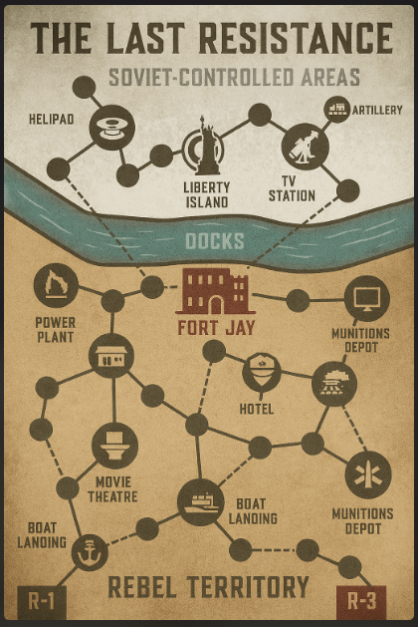
Fig. – Early Board design sample

9. Research Work

- Historical Cases: Soviet invasions of Hungary (1956), Czechoslovakia (1968), Afghanistan (1979).
- Psychology: Soldiers’ morale historically impacted entire battles.
- Game Design: Researching Risk, UNO and Axes & Allies for comparative mechanics.

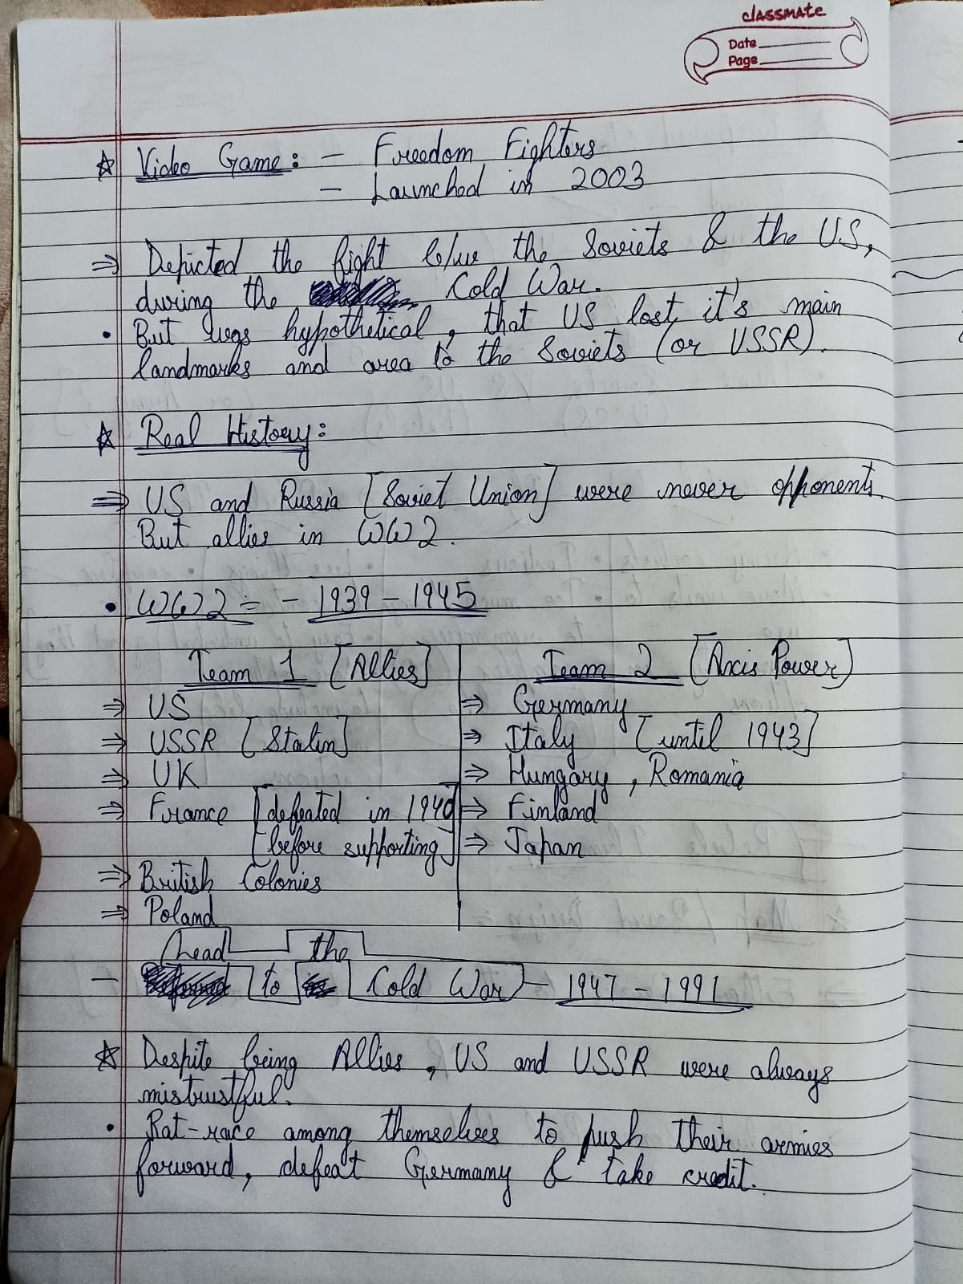

9.1 Purpose of Research in Game Design

Research played a critical role in shaping The Last Resistance, ensuring that the game was not only mechanically engaging but also historically grounded, psychologically meaningful, and structurally sound.

The research phase focused on three major domains:
- Historical research to ground the narrative and setting in real-world conflicts.
- Psychological research to understand morale, motivation, and group dynamics in warfare.
- Game design research to analyse existing board games and identify effective mechanics relevant to asymmetrical strategy gameplay.

In addition to traditional research methods, iterative discussions using Artificial Intelligence as a design support tool were also used to question assumptions, refine systems, and validate design logic. This hybrid research approach allowed for rapid ideation while maintaining authorial control over the final design decisions.

9.2 Historical Research: Cold War Conflicts & Soviet Expansion

9.2.1 Cold War Context

The narrative of The Last Resistance is inspired by the geopolitical tension of the Cold War (1947–1991), a period marked not by direct large-scale warfare between the United States and the Soviet Union, but by proxy conflicts, ideological dominance, and military interventions.
Although the video game Freedom Fighters presents a fictional scenario where the Soviet Union invades the United States, historical research was conducted to understand how similar invasions and suppressions occurred in reality—particularly in Eastern Europe and Central Asia.

9.2.2 Soviet Invasion of Hungary (1956)

The Hungarian Revolution of 1956 was a nationwide uprising against Soviet-imposed policies. Initially, Hungarian resistance forces gained control of key areas, similar to early-game Rebel success in The Last Resistance. However, the Soviet Union responded with overwhelming military force, crushing the rebellion.

Key insights drawn:
- Resistance movements often begin with high morale but limited resources.
- Superior military power eventually regains control through reinforcements and intimidation.
- Civilian support plays a major role in sustaining resistance temporarily.

These insights directly influenced:
- The early Rebel advantage in morale-building zones
- The Soviet reinforcement system via Harbor
- The concept that Rebels must strike decisively before being overwhelmed

9.2.3 Soviet Invasion of Czechoslovakia (1968)

The Prague Spring of 1968 represented an attempt to introduce political reforms within a socialist system. Despite limited violent resistance, Soviet forces invaded to restore control.
Design implications:
- Suppression does not always require direct battle; intimidation and presence are effective.
- Occupation forces often control communication and infrastructure first.
This research inspired:
- The inclusion of TV Station and Power Plant as key strongholds
- The idea that controlling systems can be more powerful than controlling territory alone
- Non-combat suppression mechanics in the Soviet event deck

9.2.4 Soviet-Afghan War (1979–1989)

The Soviet invasion of Afghanistan highlighted the limits of military superiority against guerrilla tactics.
Key observations:
- Rebels used terrain, tunnels, and mobility to counter artillery and air power.
- Long wars drain morale on both sides.
- Guerilla warfare thrives on unpredictability.
These findings directly influenced:
- Hidden routes between neutral areas
- Rebel mobility advantages despite low strength
- The long-term morale mechanics for Rebels

9.3 Psychology of Warfare: Morale and Group Dynamics

9.3.1 Importance of Morale in Combat

Historical and psychological studies consistently show that morale is a decisive factor in warfare. Armies with superior numbers have historically lost battles due to poor morale, leadership breakdown, or loss of belief in victory.
Examples from history include:
- Desertion during prolonged conflicts
- Collapse of resistance after symbolic defeats
- Sudden resurgence after inspirational victories
This research justified Morale as a core gameplay system, rather than a secondary modifier.

9.3.2 Individual vs Collective Morale

A key psychological insight was that morale does not function uniformly across a group. Individuals experience confidence, fear, and motivation differently.
This directly led to:
- Individual Morale meters for each Rebel
- The inability to attack when morale is critically low
- The ability for Rebels to support each other to recover morale

The design encourages empathy, cooperation, and strategic patience rather than reckless aggression.

9.3.3 Psychological Impact of Betrayal

Betrayal has a severe psychological effect on resistance movements. Historically, informants and defectors have caused disproportionate damage compared to their military strength.
This research influenced:
- The Corruptible Rebel mechanic
- The morale loss experienced by Rebels upon betrayal
- The late-game difficulty spike following the reveal of General Bulba
Rather than making betrayal a social deception gimmick, it was treated as a systemic shock that reshapes strategy.

9.4 Game Design Research: Comparative Analysis

9.4.1 Risk – Territory Control and Escalation

Risk (1957) was studied for:
- Area-based control
- Gradual escalation of conflict
- Dice-based uncertainty

Adopted concepts:
- Territory importance
- Multi-front pressure

Avoided elements:
- Long playtime
- Heavy randomness
- Pure numerical dominance

9.4.2 UNO – Event-Based Momentum Shifts

UNO was not studied for theme, but for event pacing and unpredictability.

Key takeaways:
- Simple cards can dramatically shift momentum
- Players remain engaged due to unpredictability
- Short-term chaos enhances long-term strategy

This inspired:
- The Rebel and Soviet Event Decks
- Controlled randomness instead of pure luck
- Immediate resolution of most events

9.4.3 Axis & Allies – Asymmetry and Scope Management

Axis & Allies demonstrated deep asymmetrical warfare but also revealed the risks of over-complexity.

Lessons learned:
- Too many resources can overwhelm players
- Long setup times reduce accessibility

Design response:
- Limited resource types
- Focus on morale and strength instead of economy
- Faster turns and clearer win conditions

9.5 Iterative Research Through Design Conversations (AI-Assisted)

In addition to traditional research, iterative discussions with an AI design assistant were used as a research and validation tool, not as a replacement for creativity.

These discussions were used to:
- Question core assumptions (e.g., “Why should the Soviet Leader move?”)
- Identify logical loopholes in mechanics
- Test balance implications through hypothetical scenarios
- Explore alternative designs before rejecting them

Crucially, all final decisions—mechanical, narrative, and structural—were made by the designer. The AI functioned similarly to a sounding board or peer reviewer, enabling faster iteration and deeper critical thinking.
This approach mirrors real-world industry practices where designers brainstorm collaboratively, conduct peer reviews, and test assumptions through discussion.

9.6 Research Outcomes and Design Integration

The research phase resulted in several key outcomes:
- A historically grounded narrative inspired by real resistance movements
- A morale system rooted in psychological realism
- An asymmetrical structure informed by successful and flawed board game designs
- A betrayal mechanic that is impactful but narratively justified
Rather than copying historical events directly, The Last Resistance abstracts these ideas into playable systems that preserve emotional authenticity while maintaining accessibility.

9.7 Conclusion of Research

The research conducted for The Last Resistance ensured that the game is not merely entertaining, but also thematically meaningful and strategically coherent. By combining historical case studies, psychological insights, comparative game analysis, and iterative design discussions, the game achieves a balance between realism and playability.
This research-driven approach strengthened both the mechanical integrity and narrative depth of the final design, ensuring that player decisions feel consequential and grounded within a believable conflict framework.

10. Utilizing AI as a Research & Development Partner:

A significant component of the research and development for ‘The Last Resistance’ involved leveraging Artificial Intelligence as a design partner. The AI was not used as a replacement for the creative process, but rather as a catalyst to accelerate ideation, analysis and prototyping.

The process can be broken down into several key functions:

- Early Concept Exploration: The initial concept started as a simple “Rebel vs Soviet clash” scenario. Through iterative sessions with AI, I was able to brainstorm more engaging directions. Instead of focusing only on brute-force combat, the AI helped me consider morale-based gameplay, psychological warfare and asymmetry between the two sides.

- Mechanics Expansion: The AI suggested several mechanics that shaped the game significantly—such as the Morale Meter, the Betrayal Twist (Mr. Jones → General Bulba) and the dual event decks for Rebels and Soviets. These additions gave the game layers of tension and replayability, making it more than just a territory-control board game.

- Alternative Scenarios & Testing: During brainstorming, the AI also generated alternative directions (like proxy war-inspired maps or Cold War espionage-based mechanics). While not all were adopted, these creative exercises challenged my assumptions and pushed the final design toward stronger storytelling.

- Prototyping & Balancing: With AI feedback, I was able to refine how strength, morale and reinforcements interact. This made it easier to avoid overpowering the Soviets while still making them a fearsome opponent. The AI acted as a “second designer”, testing hypothetical outcomes and ensuring that gameplay remained fair, tense, and narratively rich.

In summary, AI played the role of a research assistant, design challenger, and rapid prototyping partner. It allowed me to accelerate the creative process, explore wider possibilities, and ultimately focus my efforts on what made the game unique: the tension of resistance, the drama of betrayal, and the desperate fight for liberation.

11. Problem Statement & Solution

Problem: Traditional war games are often long, complex, and intimidating. They rely on heavy rulebooks, elaborate resource systems, and lengthy turn sequences, which can make gameplay slow and discourage casual or first-time players. While strategic depth is appealing, the experience can feel more like administration than action, with players spending more time managing pieces and resources than engaging in meaningful decisions. Additionally, most games treat characters and units as faceless pawns, with little connection to story or psychology, reducing immersion.

Solution: Our game addresses these issues with a streamlined design that balances strategy, narrative, and tension:

- Simplified Stats — strength + morale: By limiting Rebel units to only two key stats, players focus on what truly matters in the moment: tactical effectiveness (strength) and emotional/psychological readiness (morale). This keeps gameplay intuitive while still allowing strategic depth, as choices affect both physical and mental states.

- Asymmetry through Dual Decks: The Rebel (blue) and Soviet (red) decks create distinct playstyles, ensuring variety without adding complex rules. Each deck has unique cards that encourage different strategies, so players experience diversity in tactics while the rules remain compact.

- Strong Narrative Integration: Every mechanic - from the Morale Meter to Hidden Betrayal — ties directly into the story, giving players a sense of agency and drama. Instead of abstract points or meaningless moves, every decision shapes the narrative, making the game immersive and memorable.

12. Implementation

- Board drawn with landmarks, circles (event zones), for Rebel movement.
- Tokens representing armies.
- Morale meters for each Rebel (0–10).
- Role cards: Rebel Fighter, Rebel Leader, Hidden Betrayer (Mr. Jones), Soviet Leader.
- Decks: 20 Rebel event cards (blue), 20 Soviet event cards (red).

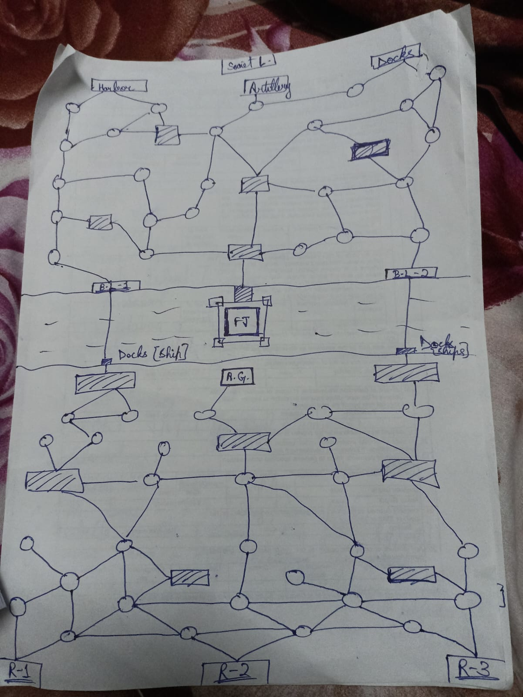

13. Game Mechanics (Detailed Playthrough)

Turn Sequence for Rebels:

- Draw Event Card (if on neutral ground): When a Rebel unit enters a neutral zone, the player draws an event card. These cards introduce unexpected situations - such as ambushes, civilian aid or resource gains - that affect morale and strategic options. This keeps the game unpredictable and encourages creative responses.

- Move up to one connected zone: Rebels can maneuver through connected zones on the board, positioning themselves for attacks, regrouping or reaching objectives. Movement is tactical - rebels must weigh risks of exposure versus rewards of gaining ground.

- Attack adjacent Soviet stronghold (if morale > 2): Attacks are only viable if morale is sufficiently high, emphasizing the importance of psychological readiness. Strength and morale interact to determine success - a daring Rebel assault can weaken Soviet control, shift the narrative and earn tactical advantages.

- Regroup with allies (combine strength, boost morale): Players can consolidate forces in the same zone, combining strength values and boosting morale. This mechanic reinforces teamwork and planning, providing a tangible reward for coordination while increasing the odds of success in subsequent turns.

Turn Sequence for Soviets:

- Move Soviet Leader or reinforce one stronghold: The Soviet player decides between repositioning their leader for strategic advantage or fortifying a stronghold. This reflects the dual focus on command presence and territorial control, forcing Rebels to anticipate multiple threats.

- Use artillery if active: Artillery provides area-of-effect attacks against Rebel positions, representing overwhelming firepower. Its activation is limited and conditional, adding a layer of tension: Rebels must weigh whether to risk exposure or retreat strategically.

- Attack one Rebel target with overwhelming force: The Soviet turn emphasizes decisive, high-impact strikes. When attacking, the combination of Soviet strength and planning can overwhelm Rebel units, enforcing the asymmetry and making careful Rebel play essential.

- Draw Event Card (if landing on neutral ground): Similar to Rebels, Soviet units may draw event cards when entering neutral zones. These events can either hinder or aid them, maintaining unpredictability and keeping players engaged in the narrative and tactical decision-making.

14. Design Iteration After Mid-Term Evaluation

- After the mid-term review, the game underwent significant structural and balancing refinements. The board layout was reoriented vertically to better communicate narrative progression, with Rebels starting in the southern zone and the Soviet Leader occupying the northern region. A central river was introduced to divide gameplay into two distinct phases, representing escalation from localized resistance to full-scale confrontation.

- Visual color zoning (sand, river & snow) was implemented to reinforce difficulty progression and environmental storytelling. Several strongholds were reclassified into early, mid and late-game objectives to improve pacing and player decision-making.

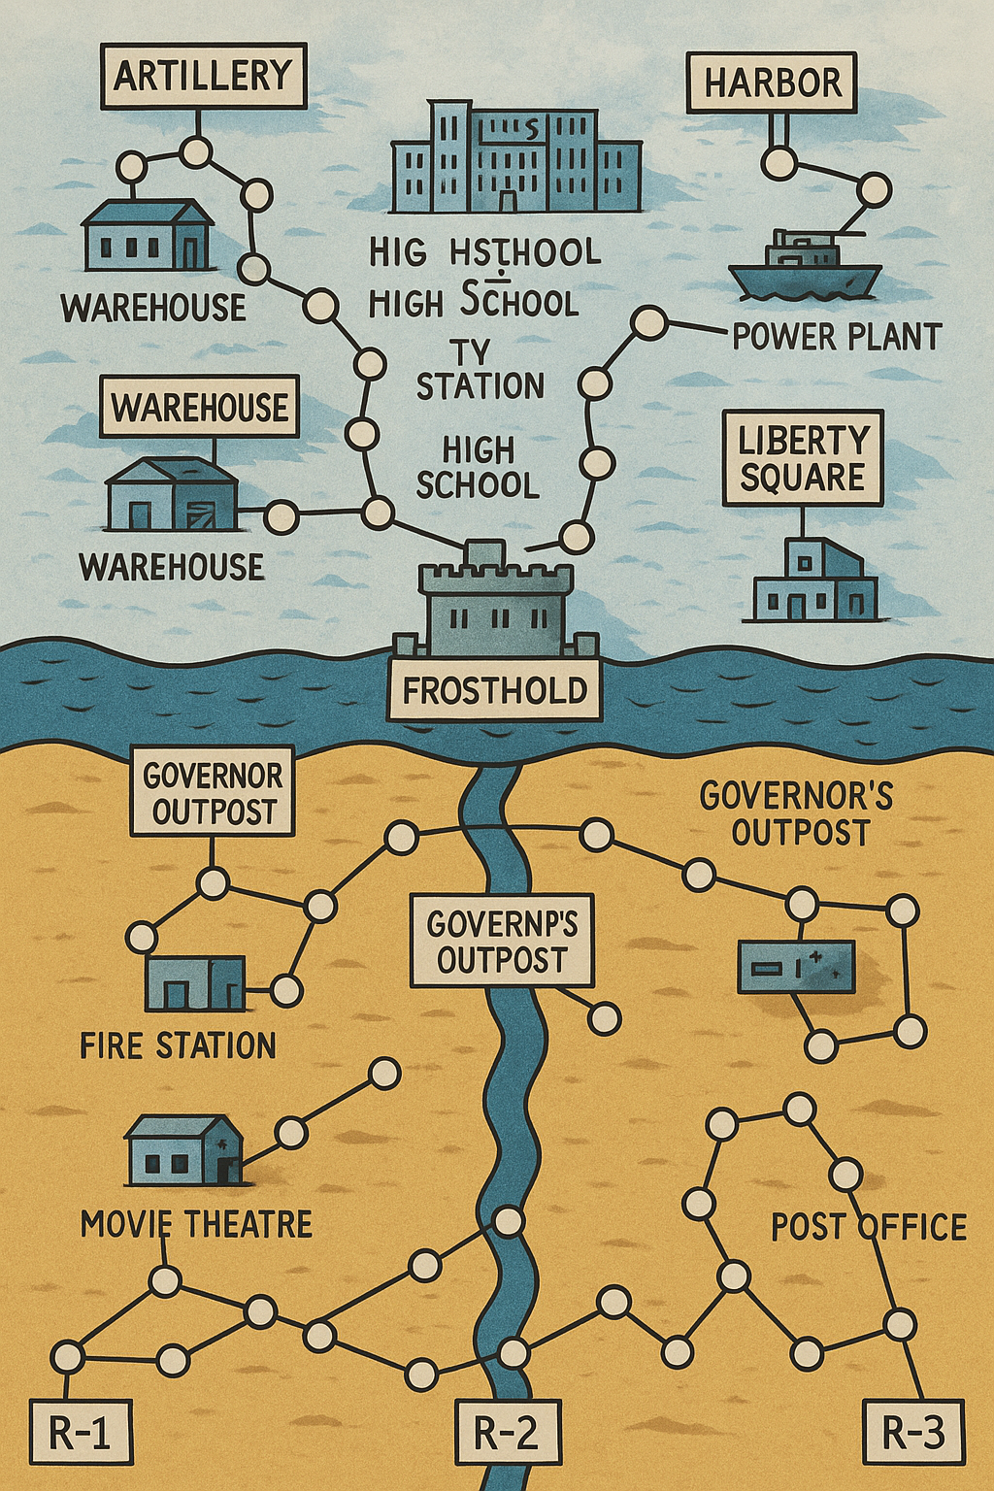

- The final Soviet stronghold was renamed from ‘Fort Jay’ to ‘Frosthold’, to better align with the snow-dominated northern territory and Cold War thematic tone. Additionally, a Rebel Rally Ground was introduced in the late-game zone to counterbalance the narrative betrayal mechanic and prevent excessive difficulty spikes after the Corruptible Rebel switches sides.

15. Conclusion

This project reflects the journey from a spark of inspiration into a fully developed board game concept. Through blending history, video game influence and board game mechanics, ‘The Last Resistance’ offers a unique mix of strategy, storytelling and social play.
The process taught me that simplicity creates strength - instead of overloading players with statistics, morale and strength were enough to carry the theme. The betrayal twist ensures replayability. And above all, it demonstrates how board games can retell alternate histories in a way that digital games cannot.

Future work could include expansions (new maps, different Cold War cities), or even a digital hybrid version where the board is physical but event cards are app-driven.

