**NPM ASSIGNMENT**

**Tasks to bee performed:-**

Setup NODEjs environment in your machine and install the following packages as global packages -  
  
  
1. Angular  
2. React  
3. Vue  
4. Ionic

**1) Setup NODE JS Environment**

sudo apt update {Command used to update the deb packages}

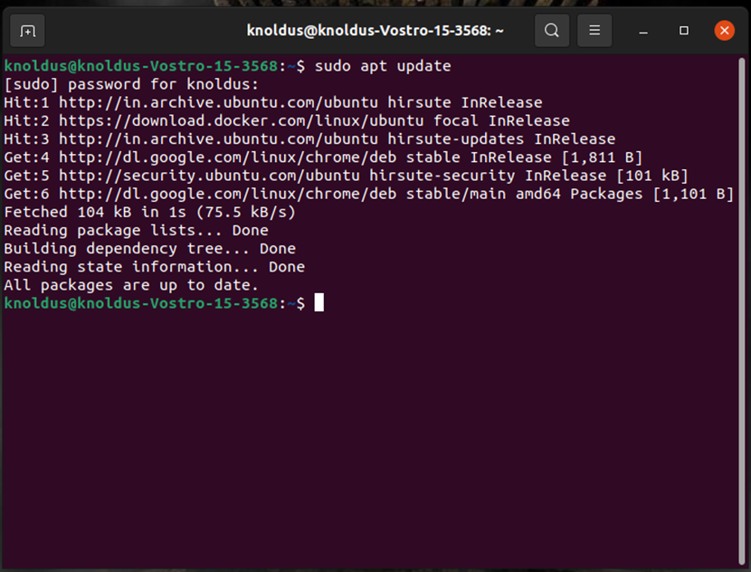

sudo apt install nodejs {command used to install the node}

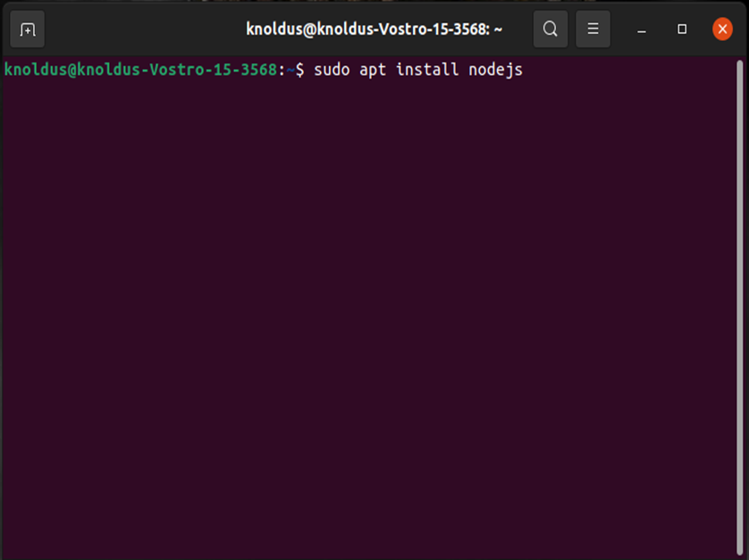

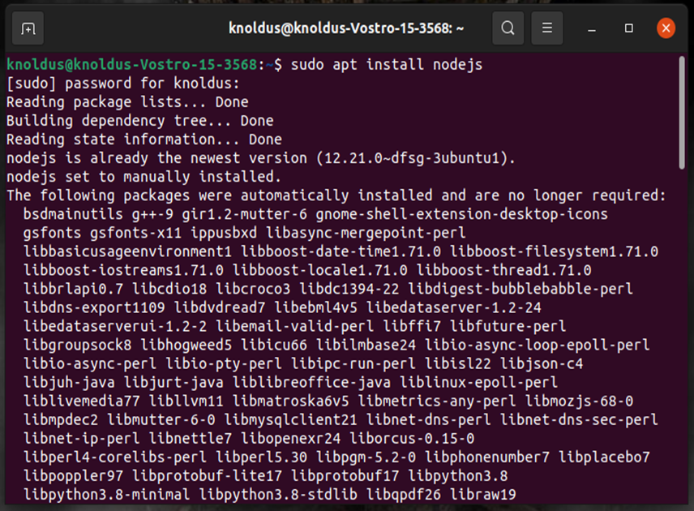

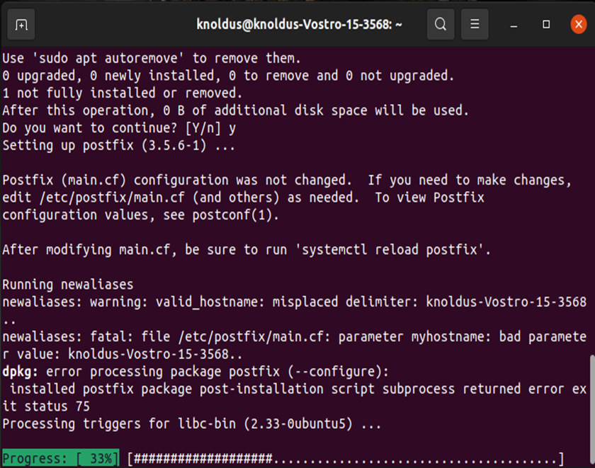

node -v {command to check the version of the node package installed}

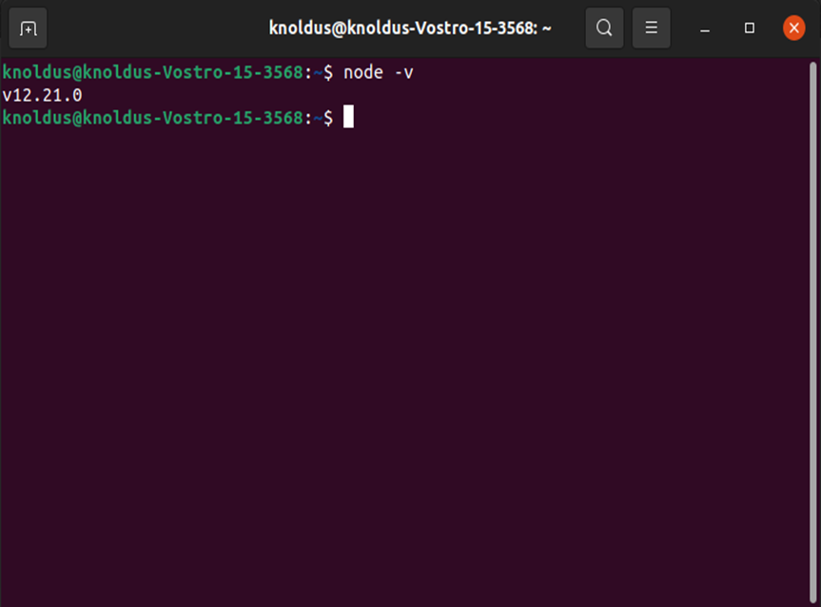

**2) Installation of Angular CLI**

sudo npm install -g @angular/cli {command used to install the Angular CLI}

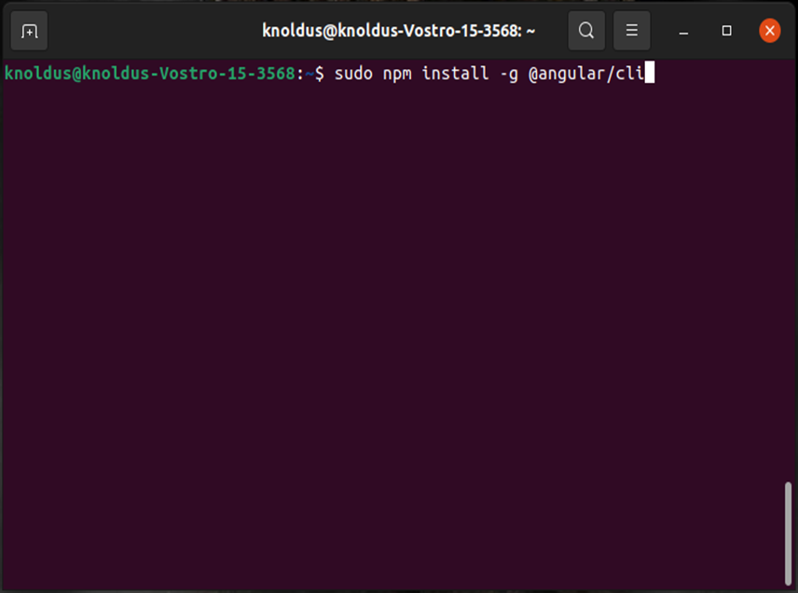

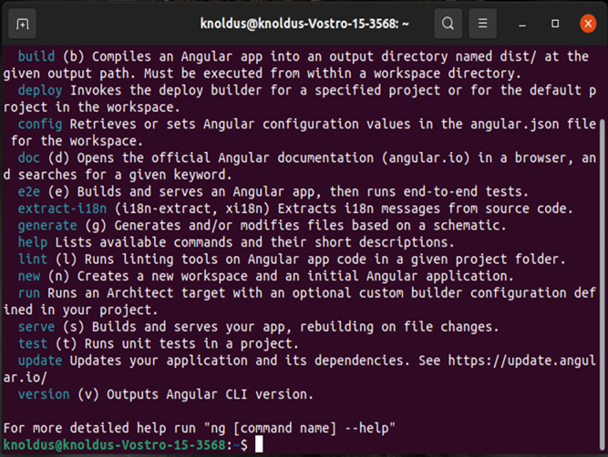

ng --version {command used to check the version of Angular CLI Installed}

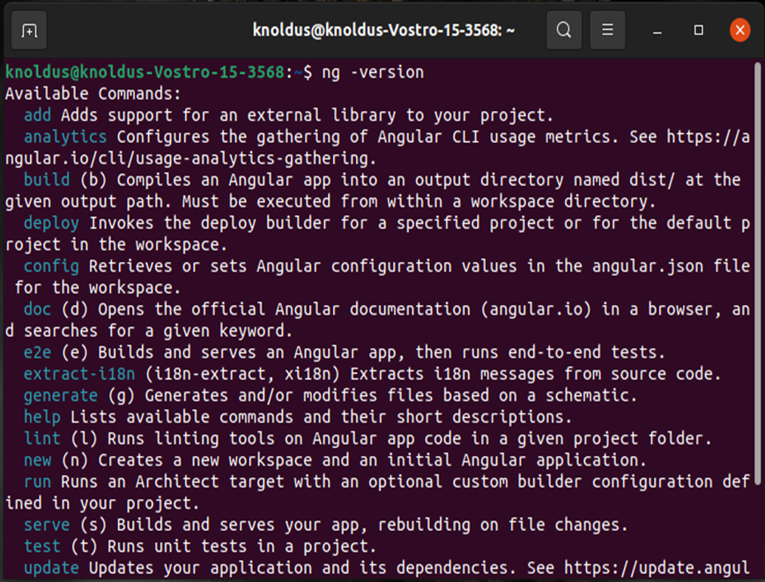

**3) Installation of Ionic CLI**

sudo npm i -g @ionic/cli {command used to install the Ionic CLI}

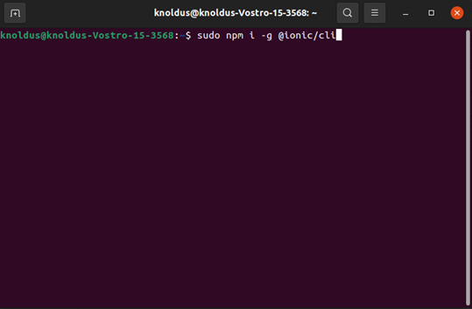

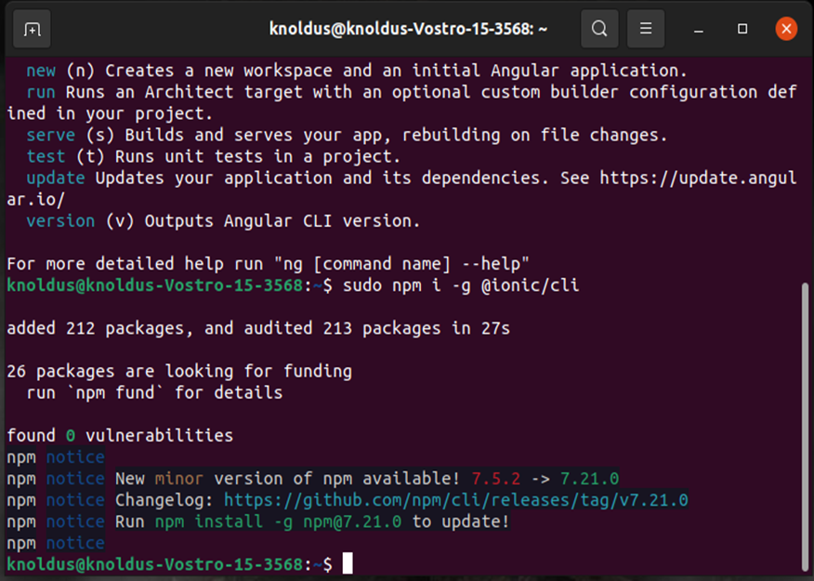

ionic -v {command used to check the version of Ionic CLI}

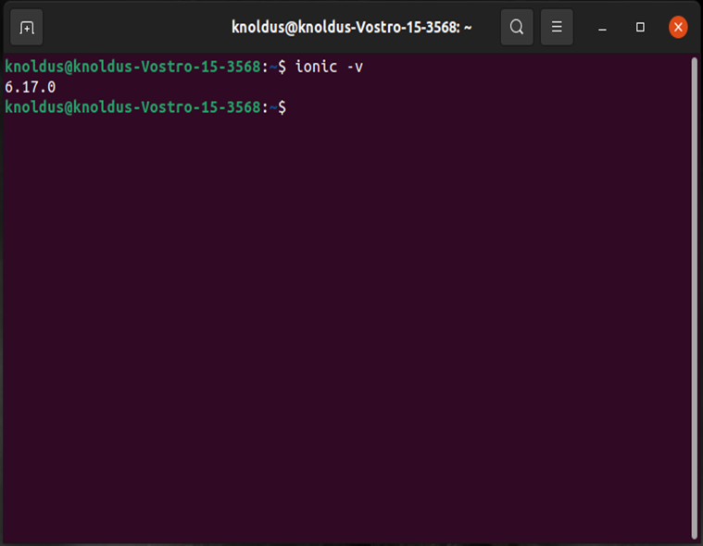

**4) Installation of Vue CLI**

sudo npm install -g @vue/cli {command used to install the Vue CLI}

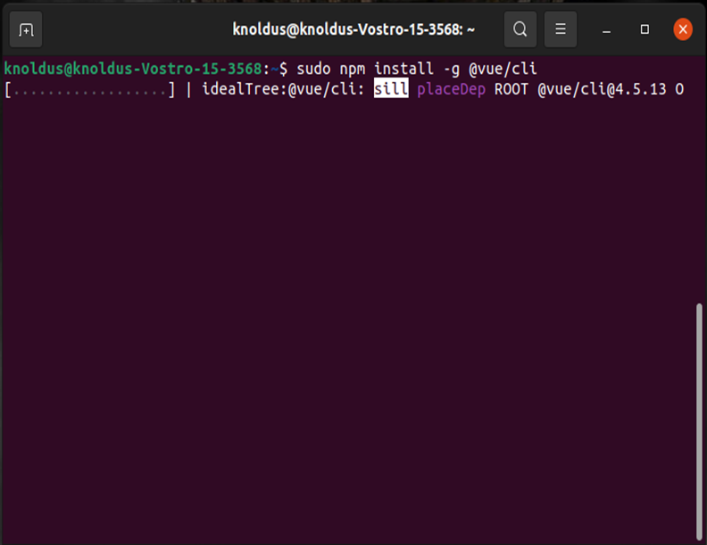

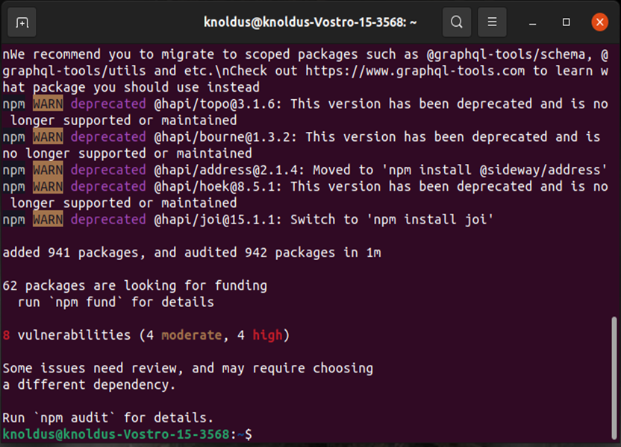

vue –version {command used to check the version of Vue CLI}

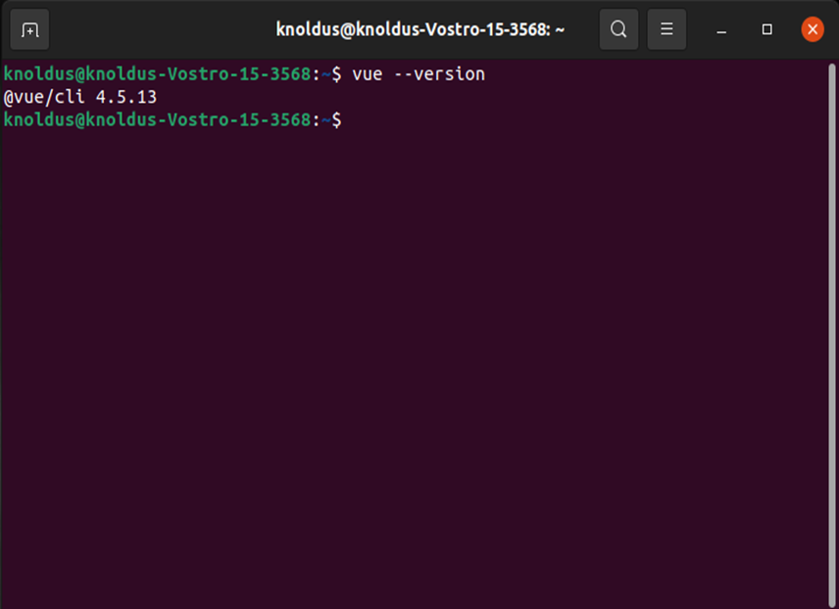

**5) Creation of New React-app**

sudo npm -g install create-react-app {command used to create a react-app}

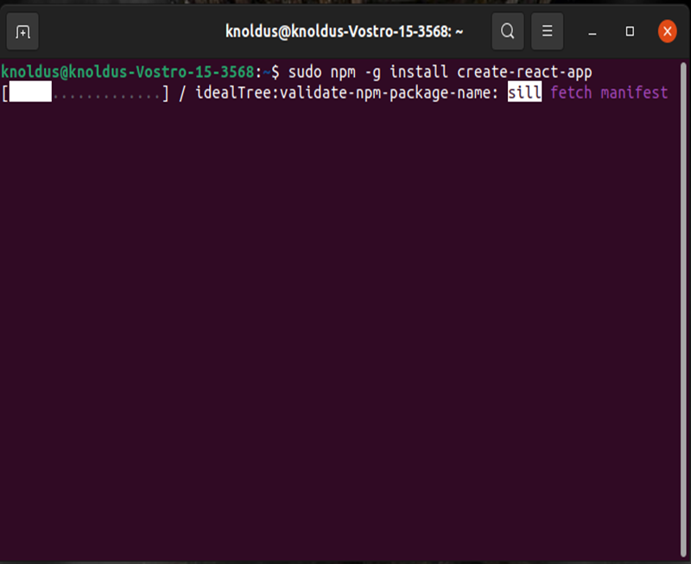

create-react-app –version {command used to check the version of created react-app}

