**PROGRAM-15**

**AIM :-** Write JSP program to implement form data validation.

**CODE:-**  
  
Let's create a database named "mysql_database" in MySQL. Now, create an employee table using below DDL script:

CREATE TABLE `employee` (

`id` int(3) NOT NULL,

`first_name` varchar(20) DEFAULT NULL,

`last_name` varchar(20) DEFAULT NULL,

`username` varchar(250) DEFAULT NULL,

`password` varchar(20) DEFAULT NULL,

`address` varchar(45) DEFAULT NULL,

`contact` varchar(45) DEFAULT NULL,

PRIMARY KEY (`id`)

) ENGINE=InnoDB DEFAULT CHARSET=utf8mb4 COLLATE=utf8mb4_0900_ai_ci;

SELECT * FROM mysql_database.employee;

Let's create an Employee JavaBean class which we will use in JSP action tags.

package net.javaguides.jsp.jdbc.bean;

import java.io.Serializable;

/**

JavaBean class used in jsp action tags.

@author Ramesh Fadatare

*/

public class Employee implements Serializable {

/**

*

*/

private static final long serialVersionUID = 1 L;

private String firstName;

private String lastName;

private String username;

private String password;

private String address;

private String contact;

public String getFirstName() {

return firstName;

}

public void setFirstName(String firstName) {

this.firstName = firstName;

}

public String getLastName() {

return lastName;

}

public void setLastName(String lastName) {

this.lastName = lastName;

}

public String getUsername() {

return username;

}

public void setUsername(String username) {

this.username = username;

}

public String getPassword() {

return password;

}

public void setPassword(String password) {

this.password = password;

}

public String getAddress() {

return address;

}

public void setAddress(String address) {

this.address = address;

}

public String getContact() {

return contact;

}

public void setContact(String contact) {

this.contact = contact;

}

}

Let's create EmployeeDao class which contains JDBC code to connect with MySQL database. Add the following code to an EmployeeDao class:

package net.javaguides.jsp.jdbc.database;

import java.sql.Connection;

import java.sql.DriverManager;

import java.sql.PreparedStatement;

import java.sql.SQLException;

import net.javaguides.jsp.jdbc.bean.Employee;

public class EmployeeDao {

public int registerEmployee(Employee employee) throws ClassNotFoundException {

String INSERT_USERS_SQL = "INSERT INTO employee" +

" (id, first_name, last_name, username, password, address, contact) VALUES " +

" (?, ?, ?, ?, ?,?,?);";

int result = 0;

Class.forName("com.mysql.jdbc.Driver");

try (Connection connection = DriverManager

.getConnection("jdbc:mysql://localhost:3306/mysql_database?useSSL=false", "root", "root");

// Step 2:Create a statement using connection object

PreparedStatement preparedStatement = connection.prepareStatement(INSERT_USERS_SQL)) {

preparedStatement.setInt(1, 1);

preparedStatement.setString(2, employee.getFirstName());

preparedStatement.setString(3, employee.getLastName());

preparedStatement.setString(4, employee.getUsername());

preparedStatement.setString(5, employee.getPassword());

preparedStatement.setString(6, employee.getAddress());

preparedStatement.setString(7, employee.getContact());

System.out.println(preparedStatement);

// Step 3: Execute the query or update query

result = preparedStatement.executeUpdate();

} catch (SQLException e) {

// process sql exception

printSQLException(e);

}

return result;

}

private void printSQLException(SQLException ex) {

for (Throwable e: ex) {

if (e instanceof SQLException) {

e.printStackTrace(System.err);

System.err.println("SQLState: " + ((SQLException) e).getSQLState());

System.err.println("Error Code: " + ((SQLException) e).getErrorCode());

System.err.println("Message: " + e.getMessage());

Throwable t = ex.getCause();

while (t != null) {

System.out.println("Cause: " + t);

t = t.getCause();

}

}

}

}

}

Let's create an EmployeeServlet class to process HTTP request parameters and redirect to the appropriate JSP page after request data stored in the database:

package net.javaguides.employeemanagement.web;

import java.io.IOException;

import javax.servlet.ServletException;

import javax.servlet.annotation.WebServlet;

import javax.servlet.http.HttpServlet;

import javax.servlet.http.HttpServletRequest;

import javax.servlet.http.HttpServletResponse;

import net.javaguides.employeemanagement.dao.EmployeeDao;

import net.javaguides.employeemanagement.model.Employee;

/**

@email Ramesh Fadatare

*/

@WebServlet("/register")

public class EmployeeServlet extends HttpServlet {

private static final long serialVersionUID = 1 L;

private EmployeeDao employeeDao;

public void init() {

employeeDao = new EmployeeDao();

}

protected void doPost(HttpServletRequest request, HttpServletResponse response)

throws ServletException, IOException {

String firstName = request.getParameter("firstName");

String lastName = request.getParameter("lastName");

String username = request.getParameter("username");

String password = request.getParameter("password");

String address = request.getParameter("address");

String contact = request.getParameter("contact");

Employee employee = new Employee();

employee.setFirstName(firstName);

employee.setLastName(lastName);

employee.setUsername(username);

employee.setPassword(password);

employee.setContact(contact);

employee.setAddress(address);

try {

employeeDao.registerEmployee(employee);

} catch (Exception e) {

// TODO Auto-generated catch block

e.printStackTrace();

}

response.sendRedirect("employeedetails.jsp");

}

}

Let's design employee registration HTML form with the following fields:

firstName

lastName

username

password

address

contact

<%@ page language="java" contentType="text/html; charset=ISO-8859-1"

pageEncoding="ISO-8859-1"%>

<!DOCTYPE html>

<html>

<head>

<meta charset="ISO-8859-1">

<title>Insert title here</title>

</head>

<body>

<div align="center">

<h1>Employee Register Form</h1>

<form action="<%= request.getContextPath() %>/register" method="post">

<table style="with: 80%">

<tr>

<td>First Name</td>

<td><input type="text" name="firstName" /></td>

</tr>

<tr>

<td>Last Name</td>

<td><input type="text" name="lastName" /></td>

</tr>

<tr>

<td>UserName</td>

<td><input type="text" name="username" /></td>

</tr>

<tr>

<td>Password</td>

<td><input type="password" name="password" /></td>

</tr>

<tr>

<td>Address</td>

<td><input type="text" name="address" /></td>

</tr>

<tr>

<td>Contact No</td>

<td><input type="text" name="contact" /></td>

</tr>

</table>

<input type="submit" value="Submit" />

</form>

</div>

</body>

</html>

After an employee successfully registered then this page show a successful message on screen:

<%@ page language="java" contentType="text/html; charset=ISO-8859-1"

pageEncoding="ISO-8859-1"%>

<%@page import="net.javaguides.employeemanagement.dao.*"%>

<!DOCTYPE html>

<html>

<head>

<meta charset="ISO-8859-1">

<title>Insert title here</title>

</head>

<body>

<h1>User successfully registered!</h1>

</body>

</html>

It's time to see a demo of the above development. Deploy this web application in tomcat server.

Employee Registration

Once you deploy this application successfully then hit this link into a browser - http://localhost:8080/jsp-servlet-jdbc-mysql-example/employeeregister.jsp

**OUTPUT:-**  
  
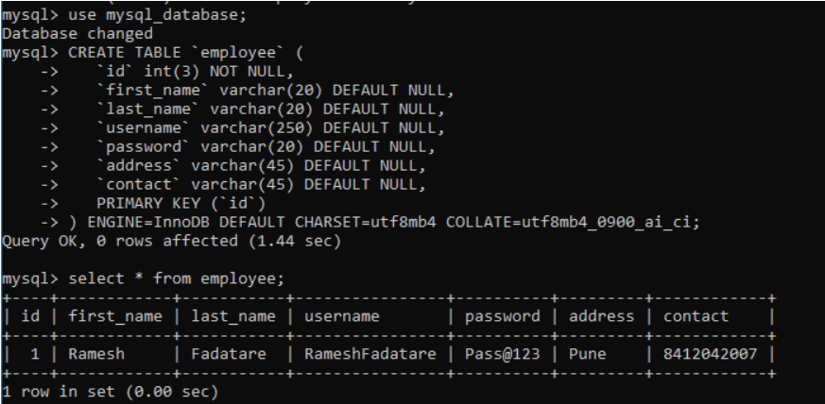

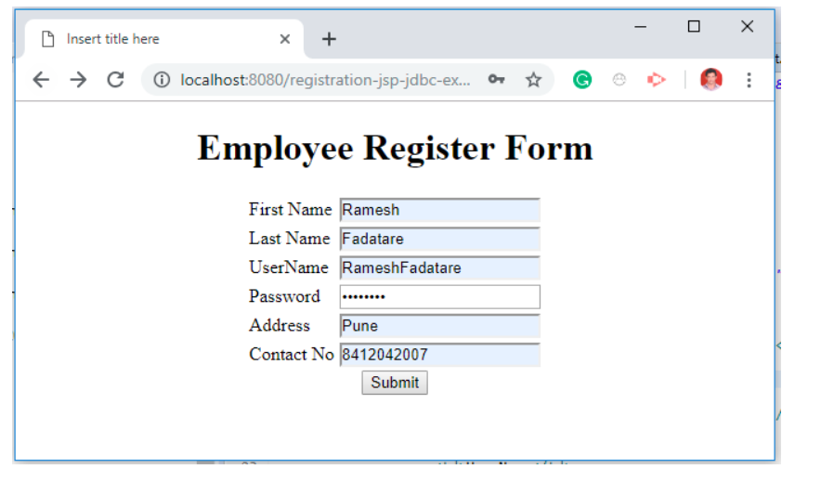

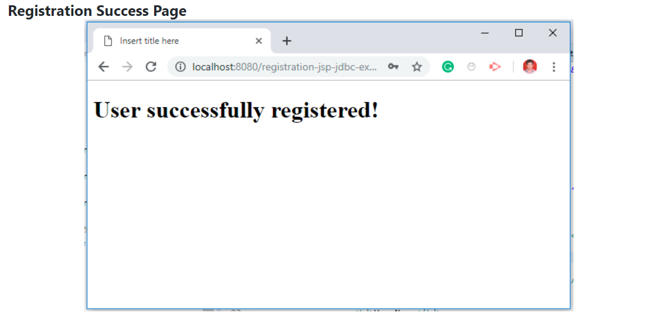

**PROGRAM-16**

**AIM :-** Write a Java program to show user validation using Servlet.

**CODE:-**  
<%@ page language="java" contentType="text/html; charset=ISO-8859-1"

pageEncoding="ISO-8859-1"%>

<html>

<head>

<meta http-equiv="Content-Type" content="text/html; charset=ISO-8859-1">

<title>Login Application</title>

<meta name="viewport" content="width=device-width, initial-scale=1">

<!-- css related code which we can have either in

same jsp or separately also in a css file -->

<style>

body {font-family: Arial, Helvetica, sans-serif;}

form {border: 3px solid #f1f1f1;}

input[type=text], input[type=password] {

width: 100%;

padding: 12px 20px;

margin: 8px 0;

display: inline-block;

border: 1px solid #ccc;

box-sizing: border-box;

}

button {

background-color: #04AA6D;

color: white;

padding: 14px 20px;

margin: 8px 0;

border: none;

cursor: pointer;

width: 100%;

}

button:hover {

opacity: 0.8;

}

.cancelbutton {

width: auto;

padding: 10px 18px;

background-color: #f44336;

}

.container {

padding: 16px;

}

span.psw {

float: right;

padding-top: 16px;

}

/* Change styles for span and cancel button

on extra small screens */

@media screen and (max-width: 300px) {

span.psw {

display: block;

float: none;

}

.cancelbutton {

width: 100%;

}

}

</style>

<!-- End of css related code which we can have either in

same jsp or separately also in a css file -->

<!-- Client side validations that need to be handled in javascript,

it can be handled in separate file or in same jsp -->

<script type="text/javascript">

function ValidateEmail(emailId)

{

var mailformat = /^\w+([\.-]?\w+)*@\w+([\.-]?\w+)*(\.\w{2,3})+$/;

if(emailId.value.match(mailformat))

{

document.getElementById('password').focus();

return true;

}

else

{

alert("You have entered an invalid email address!");

document.getElementById('emailId').focus();

return false;

}

}

</script>

<!-- End of client side validations that need to be handled

in javascript, it can be handled in separate file or in same jsp -->

</head>

<body>

<!-- We should have a servlet in order to process the form in

server side and proceed further -->

<form action="loginServlet" method="post" onclick="ValidateEmail(document.getElementById('emailId'))">

<div class="container">

<label for="username"><b>Email</b></label>

<input type="text" placeholder="Please enter your email" name="emailId" id = "emailId" required>

<label for="password"><b>Password</b></label>

<input type="password" placeholder="Please enter Password" name="password" id="password" required>

<button type="submit">Login</button>

<label>

<input type="checkbox" checked="checked" name="rememberme"> Remember me

</label>

</div>

<div class="container" style="background-color:#f1f1f1">

<button type="button" class="cancelbutton">Cancel</button>

<span class="psw">Forgot <a href="<%=request.getContextPath()%>/forgotpassword.jsp">password?</a></span>

</div>

</form>

</body>

</html>  
  
import java.io.IOException;

import javax.servlet.ServletException;

import javax.servlet.annotation.WebServlet;

import javax.servlet.http.HttpServlet;

import javax.servlet.http.HttpServletRequest;

import javax.servlet.http.HttpServletResponse;

import javax.servlet.http.HttpSession;

@WebServlet("/loginServlet")

public class LoginServlet extends HttpServlet {

private static final long serialVersionUID = 1L;

public LoginServlet() {

super();

// TODO Auto-generated constructor stub

}

// From login.jsp, as a post method only the credentials are passed

// Hence the parameters should match both in jsp and servlet and

// then only values are retrieved properly

protected void doPost(HttpServletRequest request, HttpServletResponse response)

throws ServletException, IOException {

// We can able to get the form data by means of the below ways.

// Form arguments should be matched and then only they are recognised

// login.jsp component names should match and then only

// by using request.getParameter, it is matched

String emailId = request.getParameter("emailId");

String password = request.getParameter("password");

// To verify whether entered data is printing correctly or not

System.out.println("emailId.." + emailId);

System.out.println("password.." + password);

// Here the business validations goes. As a sample,

// we can check against a hardcoded value or pass

// the values into a database which can be available in local/remote db

// For easier way, let us check against a hardcoded value

if (emailId != null && emailId.equalsIgnoreCase("admin@gmail.com") && password != null && password.equalsIgnoreCase("admin")) {

// We can redirect the page to a welcome page

// Need to pass the values in session in order

// to carry forward that one to next pages

HttpSession httpSession = request.getSession();

// By setting the variable in session, it can be forwarded

httpSession.setAttribute("emailId", emailId);

request.getRequestDispatcher("welcome.jsp").forward(request, response);

}

}

}  
  
<%@ page language="java" contentType="text/html; charset=ISO-8859-1"

pageEncoding="ISO-8859-1"%>

<html>

<head>

</head>

<body>

Welcome <%=session.getAttribute("emailId") %>

</body>

</html>  
<%@ page language="java" contentType="text/html; charset=ISO-8859-1"

pageEncoding="ISO-8859-1"%>

<html>

<head>

<meta http-equiv="Content-Type" content="text/html; charset=ISO-8859-1">

<title>Login Application</title>

<meta name="viewport" content="width=device-width, initial-scale=1">

<style>

body {font-family: Arial, Helvetica, sans-serif;}

form {border: 3px solid #f1f1f1;}

input[type=text] {

width: 100%;

padding: 12px 20px;

margin: 8px 0;

display: inline-block;

border: 1px solid #ccc;

box-sizing: border-box;

}

button {

background-color: #04AA6D;

color: white;

padding: 14px 20px;

margin: 8px 0;

border: none;

cursor: pointer;

width: 100%;

}

button:hover {

opacity: 0.8;

}

.cancelbutton {

width: auto;

padding: 10px 18px;

background-color: #f44336;

}

.container {

padding: 16px;

}

span.psw {

float: right;

padding-top: 16px;

}

/* Change styles for span and cancel

button on extra small screens */

@media screen and (max-width: 300px) {

span.psw {

display: block;

float: none;

}

.cancelbutton {

width: 100%;

}

}

</style>

</head>

</head>

<body>

<form action="forgotpassword" method="post">

<div class="container">

<label for="username"><b>Enter your email in order to check in our records</b></label>

<input type="text" placeholder="Please enter email" name="emailId" required>

<button type="submit">Search</button>

</div>

</form>

</body>

</html>

**OUTPUT:-**  
  
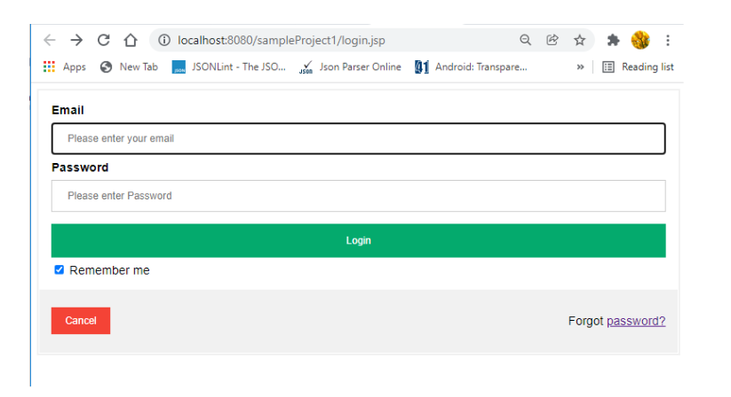

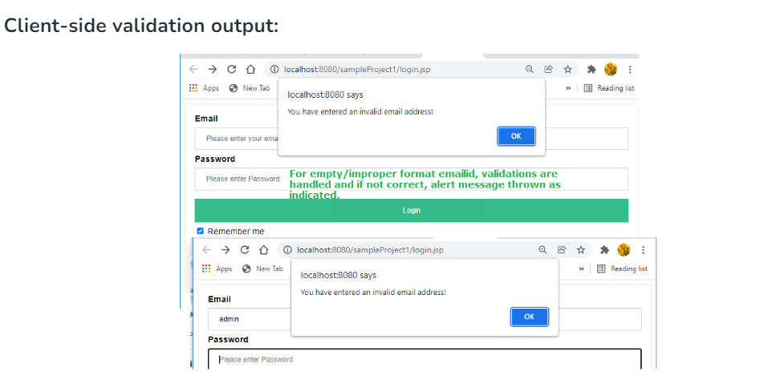

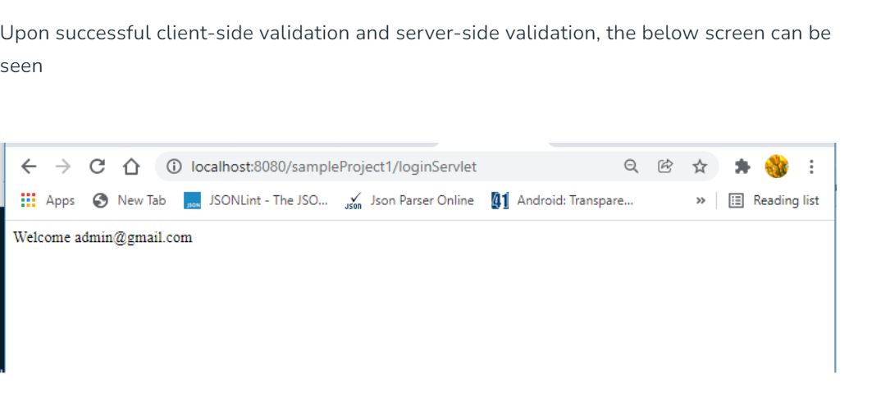

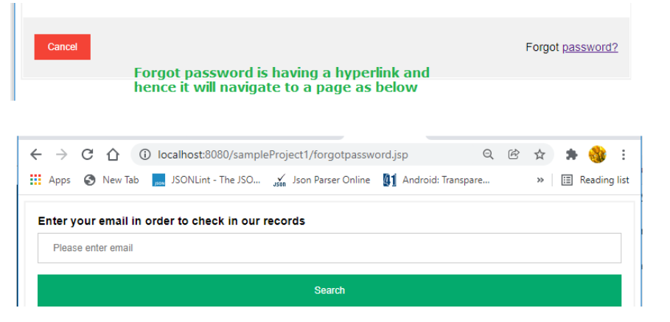

**PROGRAM-17**

**AIM :-** Write a program to set cookie information using Servlet.

**CODE:-**  
  
<!DOCTYPE html>

<html>

<head>

<title>TODO supply a title</title>

<!-- css-->

<link rel="stylesheet" href="https://maxcdn.bootstrapcdn.com/bootstrap/4.0.0/css/bootstrap.min.css"

integrity="sha384-Gn5384xqQ1aoWXA+058RXPxPg6fy4IWvTNh0E263XmFcJlSAwiGgFAW/dAiS6JXm"

crossorigin="anonymous">

<link rel="stylesheet" href="https://cdnjs.cloudflare.com/ajax/libs/font-awesome/4.7.0/css/font-awesome.min.css">

<meta charset="UTF-8">

<meta name="viewport" content="width=device-width, initial-scale=1.0">

</head>

<body>

<form action="servlet1" method="POST">

<div class="container-fluid ">

<div class="jumbotron">

<div class="container col-sm-4">

<h2>Enter your institute's name</h2>

<input type="text" name="name" style="font-size:30px;">

<br>

<br>

<!-- button to redirect to servlet1 -->

<button type="submit" style="font-size:20px;" class="center">

Go !

</button>

<br><br>

</div>

</div>

</div>

</form>

</body>

</html>  
  
import jakarta.servlet.*;

import jakarta.servlet.http.*;

import java.io.IOException;

import java.io.PrintWriter;

public class Servlet1 extends HttpServlet {

protected void

processRequest(HttpServletRequest request,

HttpServletResponse response)

throws ServletException, IOException

{

response.setContentType("text/html;charset=UTF-8");

try (PrintWriter out = response.getWriter()) {

out.println("<!DOCTYPE html>");

out.println("<html>");

out.println("<head>");

out.println("<title>Servlet Servlet1</title>");

out.println("</head>");

out.println("<body>");

// Creating a string to store the name

String name = request.getParameter("name");

out.println("<h1> Hello, welcome to " + name

+ " </h1>");

out.println(

"<h1><a href =\"servlet2\">Go to Servlet2</a></h1>");

// Creating a cookie

Cookie c = new Cookie("user_name", name);

response.addCookie(c);

out.println("</body>");

out.println("</html>");

}

}

}

import jakarta.servlet.*;

import jakarta.servlet.http.*;

import java.io.IOException;

import java.io.PrintWriter;

public class Servlet2 extends HttpServlet {

protected void

processRequest(HttpServletRequest request,

HttpServletResponse response)

throws ServletException, IOException

{

response.setContentType("text/html;charset=UTF-8");

try (PrintWriter out = response.getWriter()) {

out.println("<!DOCTYPE html>");

out.println("<html>");

out.println("<head>");

out.println("<title>Servlet Servlet2</title>");

out.println("</head>");

out.println("<body>");

// Fetching cookies(if found more than one)

// Array of Cookies

Cookie[] cookies = request.getCookies();

boolean f = false;

String name = "";

if (cookies == null) {

out.println(

"<h1>You are new user, go to home page and submit your institute's name");

return;

}

else {

for (Cookie c : cookies) {

String tname = c.getName();

if (tname.equals("user_name")) {

f = true;

name = c.getValue();

}

}

}

if (f) {

out.println("<h1> Hello, welcome back "

+ name + " </h1>");

out.println("<h2>Thank you!!</h2>");

}

else {

out.println(

"<h1>You are new user, go to home page and submit your institute's name");

}

out.println("</body>");

out.println("</html>");

}

}

}

**OUTPUT:-**  
  
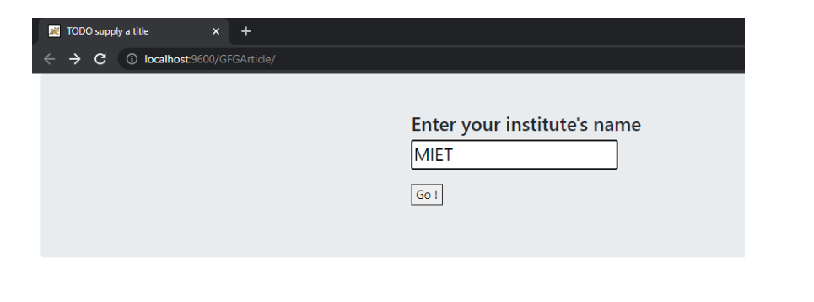  
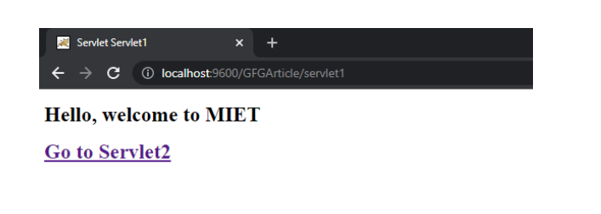  
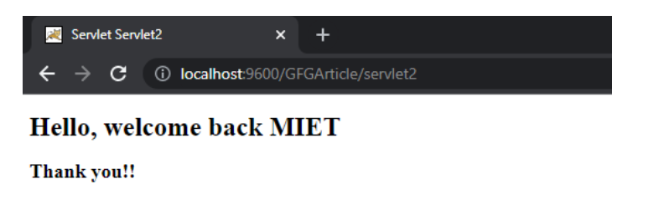  
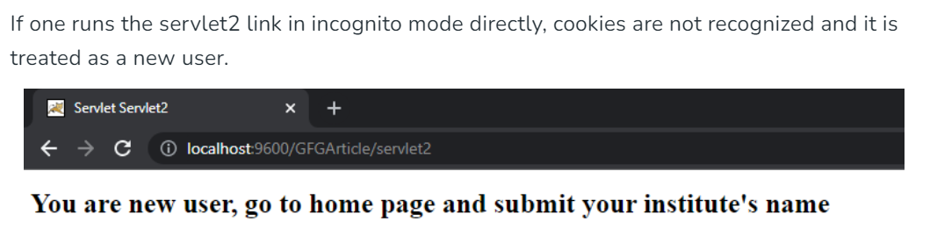

**PROGRAM-18**

**AIM :-** Design Servlet Login and Logout using Cookies

**CODE:-**  
<!DOCTYPE html>

<html>

<head>

<meta charset="ISO-8859-1">

<title>GFG</title>

</head>

<body>

<p>

<a href="login.html" style="font-size:25px;">Login |</a>

<a href="GFGLogoutServlet" style="font-size:25px;"> Logout |</a>

<a href="GFGProfileServlet" style="font-size:25px;"> Profile </a>

</p>

</body>

</html>  
  
<!DOCTYPE html>

<html>

<head>

<meta charset="ISO-8859-1">

<title>GFG</title>

</head>

<body>

<p>

<a href="login.html" style="font-size:25px;">Login |</a>

<a href="GFGLogoutServlet" style="font-size:25px;"> Logout |</a>

<a href="GFGProfileServlet" style="font-size:25px;"> Profile </a>

</p>

</body>

</html>  
<!DOCTYPE html>

<html>

<head>

<meta charset="ISO-8859-1">

<title>GFG</title>

</head>

<body>

<form action="GFGLoginServlet">

<pre>

User name: <input type="text" name="user_name" placeholder="Enter your name">

Password: <input type="password" name="password" placeholder="Enter password">

<button type="submit" value="login">Login</button>

</pre>

</form>

</body>

</html>  
// Java Program to Illustrate Login in Servlets

// Importing required classes

import java.io.IOException;

import java.io.PrintWriter;

import javax.servlet.ServletException;

import javax.servlet.annotation.WebServlet;

import javax.servlet.http.Cookie;

import javax.servlet.http.HttpServlet;

import javax.servlet.http.HttpServletRequest;

import javax.servlet.http.HttpServletResponse;

// Annotation

@WebServlet("/GFGLoginServlet")

// Class

// Extending HttpServlet class

public class GFGLoginServlet extends HttpServlet {

private static final long serialVersionUID = 1L;

protected void doGet(HttpServletRequest request,

HttpServletResponse response)

throws ServletException, IOException

{

PrintWriter out = response.getWriter();

request.getRequestDispatcher("link.html")

.include(request,

response); // This statement includes

// link.html in this servlet

String name = request.getParameter("user_name");

String password = request.getParameter("password");

if (password.equals("gfg")) {

out.println(

"<h1>Welcome " + name

+ ", you have successfully logged in!</h1>");

// creating cookie

Cookie c = new Cookie("username", name);

// attaching cookie to response object

response.addCookie(c);

}

else {

out.println(

"Sorry invalid username or password!");

request.getRequestDispatcher("login.html")

.include(request, response);

// Above statement includes login.html for the

// user to re-login if username or password is

// invalid.

}

}

protected void doPost(HttpServletRequest request,

HttpServletResponse response)

throws ServletException, IOException

{

// TODO Auto-generated method stub

doGet(request, response);

}

}  
import java.io.IOException;

import java.io.PrintWriter;

import javax.servlet.ServletException;

import javax.servlet.annotation.WebServlet;

import javax.servlet.http.Cookie;

import javax.servlet.http.HttpServlet;

import javax.servlet.http.HttpServletRequest;

import javax.servlet.http.HttpServletResponse;

@WebServlet("/GFGProfileServlet")

public class GFGProfileServlet extends HttpServlet {

private static final long serialVersionUID = 1L;

protected void doGet(HttpServletRequest request,

HttpServletResponse response)

throws ServletException, IOException

{

PrintWriter out = response.getWriter();

String name = "";

// request object will return an array of cookies

Cookie[] cookies = request.getCookies();

if (cookies == null) {

out.println(

"<h1> You are a new user, kindly login. </h1>");

request.getRequestDispatcher("login.html")

.include(request, response);

// Above statement includes login.html for the

// user to re-login if username or password is

// invalid.

}

else {

for (Cookie c : cookies) {

String tempName

= c.getName(); // For every cookie, add

// cookie name to the

// tempName.

if (tempName.equals("username"))

// If tempName and username (that we had set

// in the cookie c in GFGLoginServlet) are

// same, then this is an already logged in

// user and the request is not from a new

// user. So let the user access profile page.

{

name = c.getValue(); // From the (name,

// value) pair of

// cookie, fetch

// value

out.println(

"<a href='GFGLogoutServlet' style='font-size:25px;'>Logout </a>");

out.println(

"<h1>Welcome to your profile, "

+ name);

}

}

}

}

protected void doPost(HttpServletRequest request,

HttpServletResponse response)

throws ServletException, IOException

{

// TODO Auto-generated method stub

doGet(request, response);

}

}  
// Java Program to Illustrate Logout in Servlets

// Importing required classes

import java.io.IOException;

import java.io.PrintWriter;

import javax.servlet.ServletException;

import javax.servlet.annotation.WebServlet;

import javax.servlet.http.Cookie;

import javax.servlet.http.HttpServlet;

import javax.servlet.http.HttpServletRequest;

import javax.servlet.http.HttpServletResponse;

// Annotation

@WebServlet("/GFGLogoutServlet")

// Class

// Extending HttpServlet class

public class GFGLogoutServlet extends HttpServlet {

private static final long serialVersionUID = 1L;

protected void doGet(HttpServletRequest request,

HttpServletResponse response)

throws ServletException, IOException

{

PrintWriter out = response.getWriter();

request.getRequestDispatcher("link.html")

.include(request,

response); // This statement includes

// link.html in this servlet

// cookie with blank value is used to delete

// a cookie to sign out the user

Cookie c = new Cookie("username", "");

// setMaxAge will set the expiration of cookie.

// This cookie will expire in 0seconds

c.setMaxAge(0);

// Attach cookie to response

response.addCookie(c);

out.println("<h1>You have logged out!</h1>");

}

protected void doPost(HttpServletRequest request,

HttpServletResponse response)

throws ServletException, IOException

{

// TODO Auto-generated method stub

doGet(request, response);

}

}

**OUTPUT:-**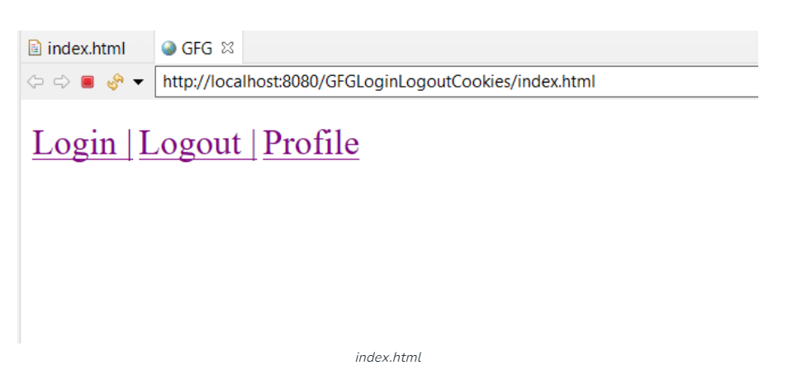  
  
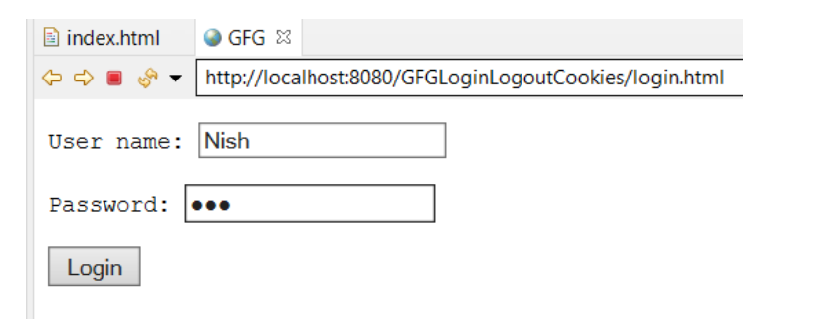  
  
  
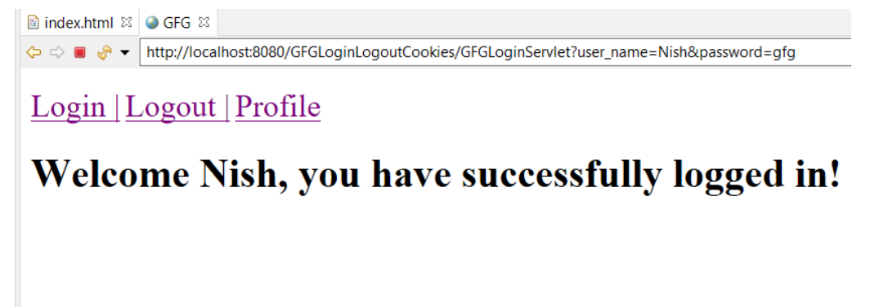

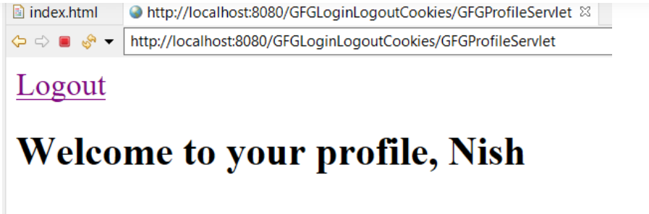

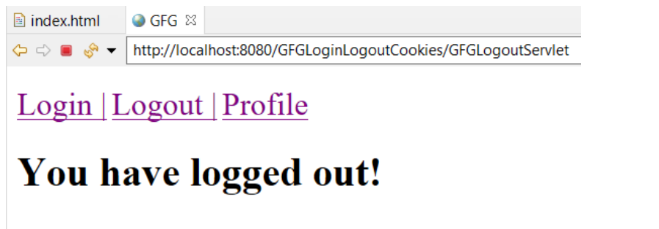

**PROGRAM-19**

**AIM :-** . Create a servlet that recognizes a visitor for the first time to a web application and responds by saying “Welcome, you are visiting for the first time”. When the page is visited for the second time, it should say “Welcome Back”.

**CODE:-**  
package com.ece.login.service;

import java.io.IOException;

import java.io.PrintWriter;

import javax.servlet.ServletException;

import javax.servlet.annotation.WebServlet;

import javax.servlet.http.HttpServlet;

import javax.servlet.http.HttpServletRequest;

import javax.servlet.http.HttpServletResponse;

import javax.servlet.http.HttpSession;

@WebServlet("/Session")

public class Session extends HttpServlet

{

private static final long serialVersionUID = 1L;

import java.sql.Date;

protected void doGet(HttpServletRequest request, HttpServletResponse response) throws ServletException, IOException

{

TODO Auto-generated method stub

//response.getWriter().append("Served at: ").append(request.getContextPath());

HttpSession session = request.getSession(true);

Date createTime = new Date(session.getCreationTime());

Date lastAccessTime = new Date(session.getLastAccessedTime());

String title = "Welcome Back";

Integer visitCount = new Integer(0);

String visitCountKey = new String("visitCount");

if (session.isNew())

{

title = "Welcome to my site"; }

else { visitCount = (Integer)session.getAttribute(visitCountKey);

visitCount = visitCount + 1;

} session.setAttribute(visitCountKey, visitCount);

response.setContentType("text/html")

; PrintWriter out = response.getWriter();

String docType = "<!doctype html public \"-//w3c//dtd html 4.0 " + "transitional//en\">\n";

out.println(docType + "<html>\n" + "<head><title>" + title + "</title></head>\n"+ "<body> "+visitCount+"</body></html>\n"); }}

**OUTPUT:-**

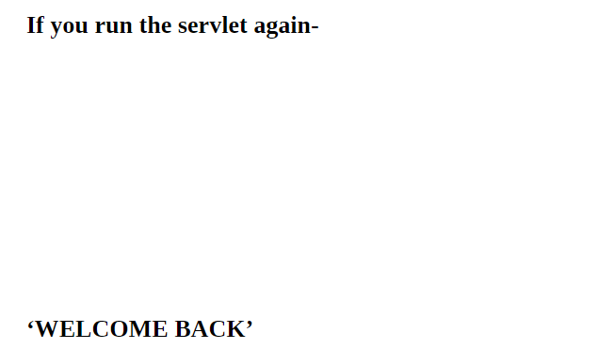

**PROGRAM-20**

**AIM :-** Develop a small web program using Servlets, JSPs with Database connectivity.

**CODE:-**  
  
<%@ page language="java" contentType="text/html; charset=ISO-8859-1"

pageEncoding="ISO-8859-1"%>

<!DOCTYPE html PUBLIC "-//W3C//DTD HTML 4.01 Transitional//EN" "http://www.w3.org/TR/html4/loose.dtd">

<html>

<head>

<meta http-equiv="Content-Type" content="text/html; charset=ISO-8859-1">

<title>Welcome Page</title>

</head>

<body>

<h2 align="center">Welcome to Student database management system</h2>

<br />

<table align="center">

<tr>

<td>To insert your details into the Database:</td>

<td><input type="button" value="Insert data"

onclick="window.location.href='Insert.jsp'" /></td>

</tr>

<tr>

<td>To delete your details from the Database:</td>

<td><input type="button" value="Delete data"

onclick="window.location.href='Delete.jsp'" /></td>

</tr>

<tr>

<td>To view your details from the Database:</td>

<td><input type="button" value="Select data"

onclick="window.location.href='Select.jsp'" /></td>

</tr>

</table>

</body>

</html>  
  
<%@ page language="java" contentType="text/html; charset=ISO-8859-1"

pageEncoding="ISO-8859-1"%>

<!DOCTYPE html PUBLIC "-//W3C//DTD HTML 4.01 Transitional//EN" "http://www.w3.org/TR/html4/loose.dtd">

<html>

<head>

<meta http-equiv="Content-Type" content="text/html; charset=ISO-8859-1">

<title>Insert Details</title>

</head>

<body>

<h2>Fill in the details</h2>

<form action="./InsertDetails" method="post">

<table>

<tr>

<td>ID:</td>

<td><input type="text" name="id" maxlength="6" size="7" /></td>

</tr>

<tr>

<td>Name:</td>

<td><input type="text" name="name" maxlength="30" size="25" /></td>

</tr>

<tr>

<td>Email Id:</td>

<td><input type="text" name="email" maxlength="40" size="35" /></td>

</tr>

<tr>

<td>Phone Number:</td>

<td><input type="text" name="phnum" maxlength="10" size="11" /></td>

</tr>

<tr />

</table>

<br /> <input type="submit" value="Insert Data" />

</form>

<br />

<input type="button" value="Return to Home"

onclick="window.location.href='Home.jsp'" />

</body>

</html>  
<%@ page language="java" contentType="text/html; charset=ISO-8859-1"

pageEncoding="ISO-8859-1"%>

<!DOCTYPE html PUBLIC "-//W3C//DTD HTML 4.01 Transitional//EN" "http://www.w3.org/TR/html4/loose.dtd">

<html>

<head>

<meta http-equiv="Content-Type" content="text/html; charset=ISO-8859-1">

<title>Delete Details</title>

</head>

<body>

<form action="./DeleteDetails" method="post">

<table>

<tr>

<td>Enter ID:</td>

<td><input type="text" name="id" maxlength="6" size="7" /></td>

</tr>

</table>

<br /> <input type="submit" value="Delete Data" />

</form>

<br />

<input type="button" value="Return to Home"

onclick="window.location.href='Home.jsp'" />

</body>

</html>  
  
<%@ page language="java" contentType="text/html; charset=ISO-8859-1"

pageEncoding="ISO-8859-1"%>

<!DOCTYPE html PUBLIC "-//W3C//DTD HTML 4.01 Transitional//EN" "http://www.w3.org/TR/html4/loose.dtd">

<html>

<head>

<meta http-equiv="Content-Type" content="text/html; charset=ISO-8859-1">

<title>Success Page</title>

</head>

<body>

<form action="Home.jsp">

<h3>

<%=request.getParameter("msg")%>

Successful

</h3>

<br /> <input type="submit" value="Return to Home page" />

</form>

</body>

</html>  
  
<%@ page language="java" contentType="text/html; charset=ISO-8859-1"

pageEncoding="ISO-8859-1"%>

<!DOCTYPE html PUBLIC "-//W3C//DTD HTML 4.01 Transitional//EN" "http://www.w3.org/TR/html4/loose.dtd">

<html>

<head>

<meta http-equiv="Content-Type" content="text/html; charset=ISO-8859-1">

<title>Select Details</title>

</head>

<body>

<form action="./SelectDetails" method="get">

<table>

<tr>

<td>Enter ID:</td>

<td><input type="text" name="id" maxlength="6" size="7" /></td>

</tr>

</table>

<br /> <input type="submit" value="View Data" />

</form>

<br />

<input type="button" value="Return to Home"

onclick="window.location.href='Home.jsp'" />

</body>

</html>  
  
<%@ page language="java" contentType="text/html; charset=ISO-8859-1"

pageEncoding="ISO-8859-1"%>

<!DOCTYPE html PUBLIC "-//W3C//DTD HTML 4.01 Transitional//EN" "http://www.w3.org/TR/html4/loose.dtd">

<html>

<head>

<meta http-equiv="Content-Type" content="text/html; charset=ISO-8859-1">

<title>Student Details - Result</title>

</head>

<body>

<h2>Details</h2>

<form>

<input type="hidden" name="stid"

value="<%=request.getParameter("id")%>">

<table>

<tr>

<td>ID:</td>

<td><%=request.getParameter("id")%></td>

</tr>

<tr>

<td>Name:</td>

<td><%=request.getParameter("name")%></td>

</tr>

<tr>

<td>Email Id:</td>

<td><%=request.getParameter("email")%></td>

</tr>

<tr>

<td>Phone Number:</td>

<td><%=request.getParameter("phone")%></td>

</tr>

<tr />

</table>

<br />

</form>

<br />

<input type="button" value="Update data" onclick="update()" />

<br />

<input type="button" value="Return to Home"

onclick="window.location.href='Home.jsp'" />

</body>

<script language="javascript" type="text/javascript">

function update() {

var sid = document.forms[0].elements['stid'].value;

window.location.href = "Update.jsp?id=" + sid;

}

</script>

</html>  
  
<%@ page language="java" contentType="text/html; charset=ISO-8859-1"

pageEncoding="ISO-8859-1"%>

<!DOCTYPE html PUBLIC "-//W3C//DTD HTML 4.01 Transitional//EN" "http://www.w3.org/TR/html4/loose.dtd">

<html>

<head>

<meta http-equiv="Content-Type" content="text/html; charset=ISO-8859-1">

<title>Update Details</title>

</head>

<body>

<h2>Fill in your details</h2>

<form action="./UpdateDetails" method="post">

<table>

<tr>

<td>ID:</td>

<td><input type="text" name="id"

value="<%=request.getParameter("id")%>" readonly="readonly">

</td>

</tr>

<tr>

<td>Name:</td>

<td><input type="text" name="name" maxlength="30" size="25" /></td>

</tr>

<tr>

<td>Email Id:</td>

<td><input type="text" name="email" maxlength="40" size="35" /></td>

</tr>

<tr>

<td>Phone Number:</td>

<td><input type="text" name="phnum" maxlength="10" size="11" /></td>

</tr>

<tr />

</table>

<br /> <input type="submit" value="Update Data" />

</form>

<br />

<input type="button" value="Return to Home"

onclick="window.location.href='Home.jsp'" />

</body>

</html>  
  
public class DbUtil {

public static String url = "jdbc:postgresql://localhost/postgres";

public static String user = "root";

public static String password = "root";

public static String driver = "org.postgresql.Driver";

}  
  
import java.io.IOException;

import java.sql.Connection;

import java.sql.DriverManager;

import java.sql.PreparedStatement;

import javax.servlet.ServletException;

import javax.servlet.annotation.WebServlet;

import javax.servlet.http.HttpServlet;

import javax.servlet.http.HttpServletRequest;

import javax.servlet.http.HttpServletResponse;

@WebServlet("/InsertDetails")

public class InsertDetails extends HttpServlet {

private static final long serialVersionUID = 1L;

protected void doPost(HttpServletRequest request, HttpServletResponse response)

throws ServletException, IOException {

// Jdbc Connection

try {

Class.forName(DbUtil.driver);

} catch (ClassNotFoundException e) {

System.out.println("Class not found " + e);

}

try {

Connection conn = DriverManager.getConnection(DbUtil.url, DbUtil.user, DbUtil.password);

System.out.println("connection successful");

// Query/statement to insert the values

PreparedStatement st = conn.prepareStatement("insert into studentdetails values(?, ?, ?, ?)");

// set values into the query

st.setInt(1, Integer.valueOf(request.getParameter("id")));

st.setString(2, request.getParameter("name"));

st.setString(3, request.getParameter("email"));

st.setString(4, request.getParameter("phnum"));

// Execute the query

st.executeUpdate();

st.close();

conn.close();

// Redirect the response to success page

response.sendRedirect("Success.jsp?msg=Insert");

} catch (Exception e) {

e.printStackTrace();

}

}

}  
import java.io.IOException;

import java.sql.Connection;

import java.sql.DriverManager;

import java.sql.PreparedStatement;

import javax.servlet.ServletException;

import javax.servlet.annotation.WebServlet;

import javax.servlet.http.HttpServlet;

import javax.servlet.http.HttpServletRequest;

import javax.servlet.http.HttpServletResponse;

@WebServlet("/DeleteDetails")

public class DeleteDetails extends HttpServlet {

private static final long serialVersionUID = 1L;

protected void doPost(HttpServletRequest request, HttpServletResponse response)

throws ServletException, IOException {

try {

Class.forName(DbUtil.driver);

} catch (ClassNotFoundException e) {

System.out.println("Class not found " + e);

}

try {

Connection conn = DriverManager.getConnection(DbUtil.url, DbUtil.user, DbUtil.password);

System.out.println("connection successful");

PreparedStatement st = conn.prepareStatement("delete from studentdetails where stuid=?");

st.setInt(1, Integer.valueOf(request.getParameter("id")));

st.executeUpdate();

st.close();

conn.close();

response.sendRedirect("Success.jsp?msg=Delete");

} catch (Exception e) {

e.printStackTrace();

}

}

}  
  
import java.io.IOException;

import java.sql.Connection;

import java.sql.DriverManager;

import java.sql.PreparedStatement;

import java.sql.ResultSet;

import javax.servlet.ServletException;

import javax.servlet.annotation.WebServlet;

import javax.servlet.http.HttpServlet;

import javax.servlet.http.HttpServletRequest;

import javax.servlet.http.HttpServletResponse;

@WebServlet("/SelectDetails")

public class SelectDetails extends HttpServlet {

private static final long serialVersionUID = 1L;

protected void doGet(HttpServletRequest request, HttpServletResponse response)

throws ServletException, IOException {

try {

Class.forName(DbUtil.driver);

} catch (ClassNotFoundException e) {

System.out.println("Class not found " + e);

}

try {

int id = 0;

String name = "", email = "", ph = "";

Connection conn = DriverManager.getConnection(DbUtil.url, DbUtil.user, DbUtil.password);

System.out.println("connection successful");

PreparedStatement st = conn.prepareStatement("select * from studentdetails where stuid=?");

st.setInt(1, Integer.valueOf(request.getParameter("id")));

ResultSet rs = st.executeQuery();

while (rs.next()) {

id = rs.getInt(1);

name = rs.getString(2);

email = rs.getString(3);

ph = rs.getString(4);

}

rs.close();

st.close();

conn.close();

response.sendRedirect("Result.jsp?id=" + id + "&name=" + name + "&email=" + email + "&phone=" + ph);

} catch (Exception e) {

e.printStackTrace();

}

}

}  
  
import java.io.IOException;

import java.sql.Connection;

import java.sql.DriverManager;

import java.sql.PreparedStatement;

import javax.servlet.ServletException;

import javax.servlet.annotation.WebServlet;

import javax.servlet.http.HttpServlet;

import javax.servlet.http.HttpServletRequest;

import javax.servlet.http.HttpServletResponse;

@WebServlet("/UpdateDetails")

public class UpdateDetails extends HttpServlet {

private static final long serialVersionUID = 1L;

protected void doPost(HttpServletRequest request, HttpServletResponse response)

throws ServletException, IOException {

try {

Class.forName(DbUtil.driver);

} catch (ClassNotFoundException e) {

System.out.println("Class not found " + e);

}

try {

Connection conn = DriverManager.getConnection(DbUtil.url, DbUtil.user, DbUtil.password);

System.out.println("connection successful");

PreparedStatement st = conn

.prepareStatement("update studentdetails set stuname=?, email=?, phonenum=? where stuid=?");

st.setString(1, request.getParameter("name"));

st.setString(2, request.getParameter("email"));

st.setString(3, request.getParameter("phnum"));

st.setInt(4, Integer.valueOf(request.getParameter("id")));

st.executeUpdate();

st.close();

conn.close();

response.sendRedirect("Success.jsp?msg=Update");

} catch (Exception e) {

e.printStackTrace();

}

}

}

**OUTPUT:-**  
  
