**GROUP-20-Q3 PROPOSAL**

*Abstract*

In this document, we propose analysing how gas consumption trends vary with changes in weather conditions in the Mueller neighbourhood of Autin, Texas, USA , which was the source of the data used in the Pecan Street project. With an in-depth analysis of the gas meter readings, we intend to examine whether weather conditions can account for an event predict consumption trends.

*Methodology*

Archived weather data for Austin can be found [here](https://rp5.ru/Weather_archive_in_West_Lake_Hills_(airport)) in rp5.ru, which is a website which archives weather data for locations all over the world. This data contains the temperature, pressure, and descriptions of cloudiness and visibility.

Using this data, simple visualizations such as temperature vs gas consumption per house can be made. These visualizations may yield useful insights into what drives fluctuations in gas consumption. Additionally, investigation of the ‘spikes’ in the data against various weather phenomena could further provide impetus to understand whether they are correlated with particular weather conditions that may prove useful in understanding the causes of the spikes.

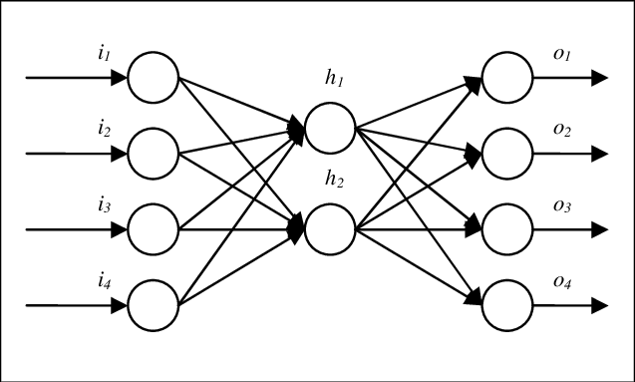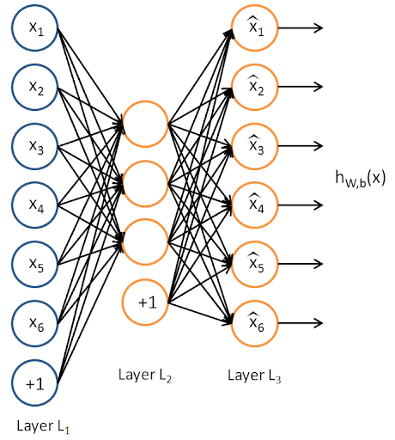Further, we intend to build a Neural Network model with the following architecture:

Prediction for gas consumption trend on the following day

Prediction Layer

Auto-encoder layer

Previous weather data + gas consumption data

The aim of this neural network will be to use weather data, house characteristics (if we can find this data), and preceding gas consumption trends to predict future consumption behaviour. Such insights may prove highly useful to the utility company since it will allow them to pro-actively ramp up or scale down the supply in anticipation of demand peaks and troughs.

**Please note** that we may add or remove data analyses and models as we progress with this line of work.