DATA SCIENCE
PROJECT REPORT
(Project Semester January-April 2025)
Crime Rate Analysis in 2024 - 2025
Submitted by
Paras Proach
Registration No: 12325159
B.Tech CSE – KM005
Course Code: INT217
Under the Guidance of
Baljeet Kaur
Assistant Professor, CSE
Lovely School of Computer Science and Engineering
Lovely Professional University, Phagwara

CERTIFICATE
This is to certify that Paras Proach bearing Registration no. 12325159 has completed Data Science project titled, “Crime Rate Analysis in 2024 - 2025” under my guidance and supervision. To the best of my knowledge, the present work is the result of his/her original development, effort and study.
Baljeet Kaur
Assistant Professor, CSE
School of Computer Science and Engineering
Lovely Professional University
Phagwara, Punjab.
Date: 2025-04-12

DECLARATION
I, Paras Proach, student of B.Tech CSE under CSE Discipline at Lovely Professional University, Punjab, hereby declare that all the information furnished in this project report is based on my own intensive work and is genuine.
Date: 2025-04-12

Paras Proach
Registration No. 12325159
Paras Proach

Table of Contents
1. Introduction
2. Source of Dataset
3. Dataset Preprocessing
4. Analysis on Dataset
5. Conclusion
6. Future Scope
7. References

4. Analysis on Dataset

iv. Visualizations
The following visualizations were used to present the analytical findings:

Crime Count by Place of Crime

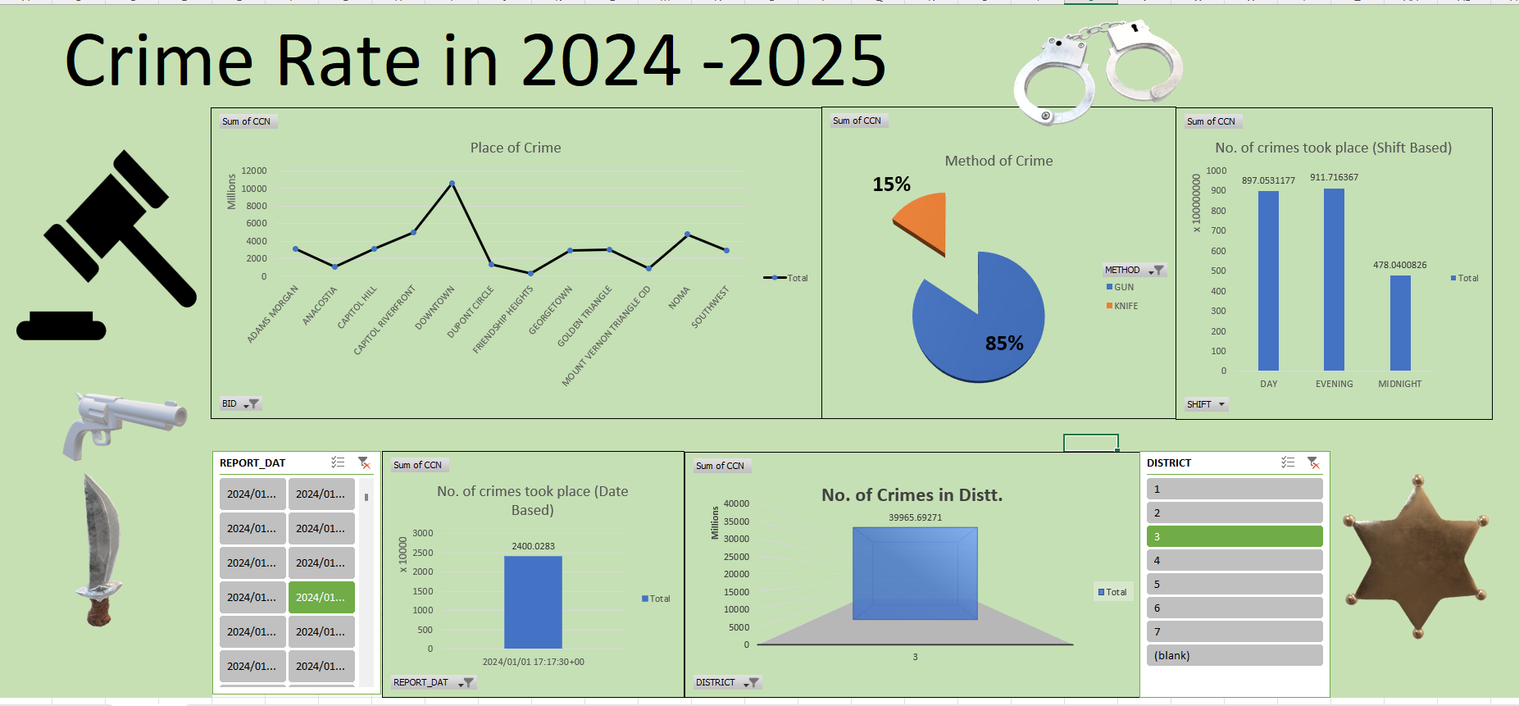

Distribution of Crime Methods (Gun vs Knife)



Crime Frequency by Shift



Date-wise Crime Trends



District-wise Crime Incidents



5. Conclusion
Through the crime rate analysis of 2024–2025, this project has uncovered significant patterns in the occurrence and distribution of crimes across different areas and time slots. Gun-related crimes dominate the statistics, and the majority of these incidents occur during the evening shift. Downtown areas and District 3 are especially vulnerable, indicating the need for enhanced policing and surveillance in these regions. This analysis offers an actionable foundation for public safety planning and crime prevention efforts.

6. Future Scope
This project lays the groundwork for several future enhancements:
- Incorporating demographic and economic data to examine deeper societal patterns behind crime.
- Developing predictive models using machine learning to forecast potential crime hotspots.
- Real-time integration with crime reporting systems for live updates and dashboard monitoring.
- Collaboration with law enforcement agencies for real-world deployment of insights and strategies.

7. References
[1] DC Government Open Data Portal, 'Crime Incidents in 2024'.
[2] Tableau Software, https://www.tableau.com/.
[3] Microsoft Excel Dashboard Tools.
[4] Python Data Analysis Libraries (Pandas, Matplotlib).

