# Stock Forecasting Report

Date range: 2023-01-02 to 2023-12-29

## 1. Data Overview

Head of dataset:

|  |  |  |  |  |  |
| --- | --- | --- | --- | --- | --- |
| Date | Open | High | Low | Close | Volume |
| 2023-01-02 | 2508.75 | 2519.56 | 2499.57 | 2507.45 | 3140794 |
| 2023-01-03 | 2496.69 | 2511.84 | 2499.76 | 2505.38 | 3614235 |
| 2023-01-04 | 2520.6 | 2527.47 | 2507.56 | 2515.09 | 1491036 |
| 2023-01-05 | 2537.0 | 2550.04 | 2528.76 | 2537.94 | 1327304 |
| 2023-01-06 | 2534.91 | 2542.02 | 2526.77 | 2534.43 | 2852610 |

Summary statistics:

Open: {'count': 260.0, 'mean': 2404.61, 'std': 70.99, 'min': 2292.0, '25%': 2347.18, '50%': 2380.13, '75%': 2474.27, 'max': 2567.49}

High: {'count': 260.0, 'mean': 2417.55, 'std': 70.7, 'min': 2307.71, '25%': 2360.5, '50%': 2395.19, '75%': 2484.91, 'max': 2580.35}

Low: {'count': 260.0, 'mean': 2392.61, 'std': 71.44, 'min': 2283.99, '25%': 2334.35, '50%': 2371.34, '75%': 2460.49, 'max': 2556.75}

Close: {'count': 260.0, 'mean': 2404.76, 'std': 70.97, 'min': 2297.1, '25%': 2346.34, '50%': 2382.56, '75%': 2472.6, 'max': 2567.21}

Volume: {'count': 260.0, 'mean': 2968858.48, 'std': 1152983.67, 'min': 1011303.0, '25%': 1960258.75, '50%': 2912055.5, '75%': 3993821.5, 'max': 4981298.0}

## 2. Visualizations

Closing price history:

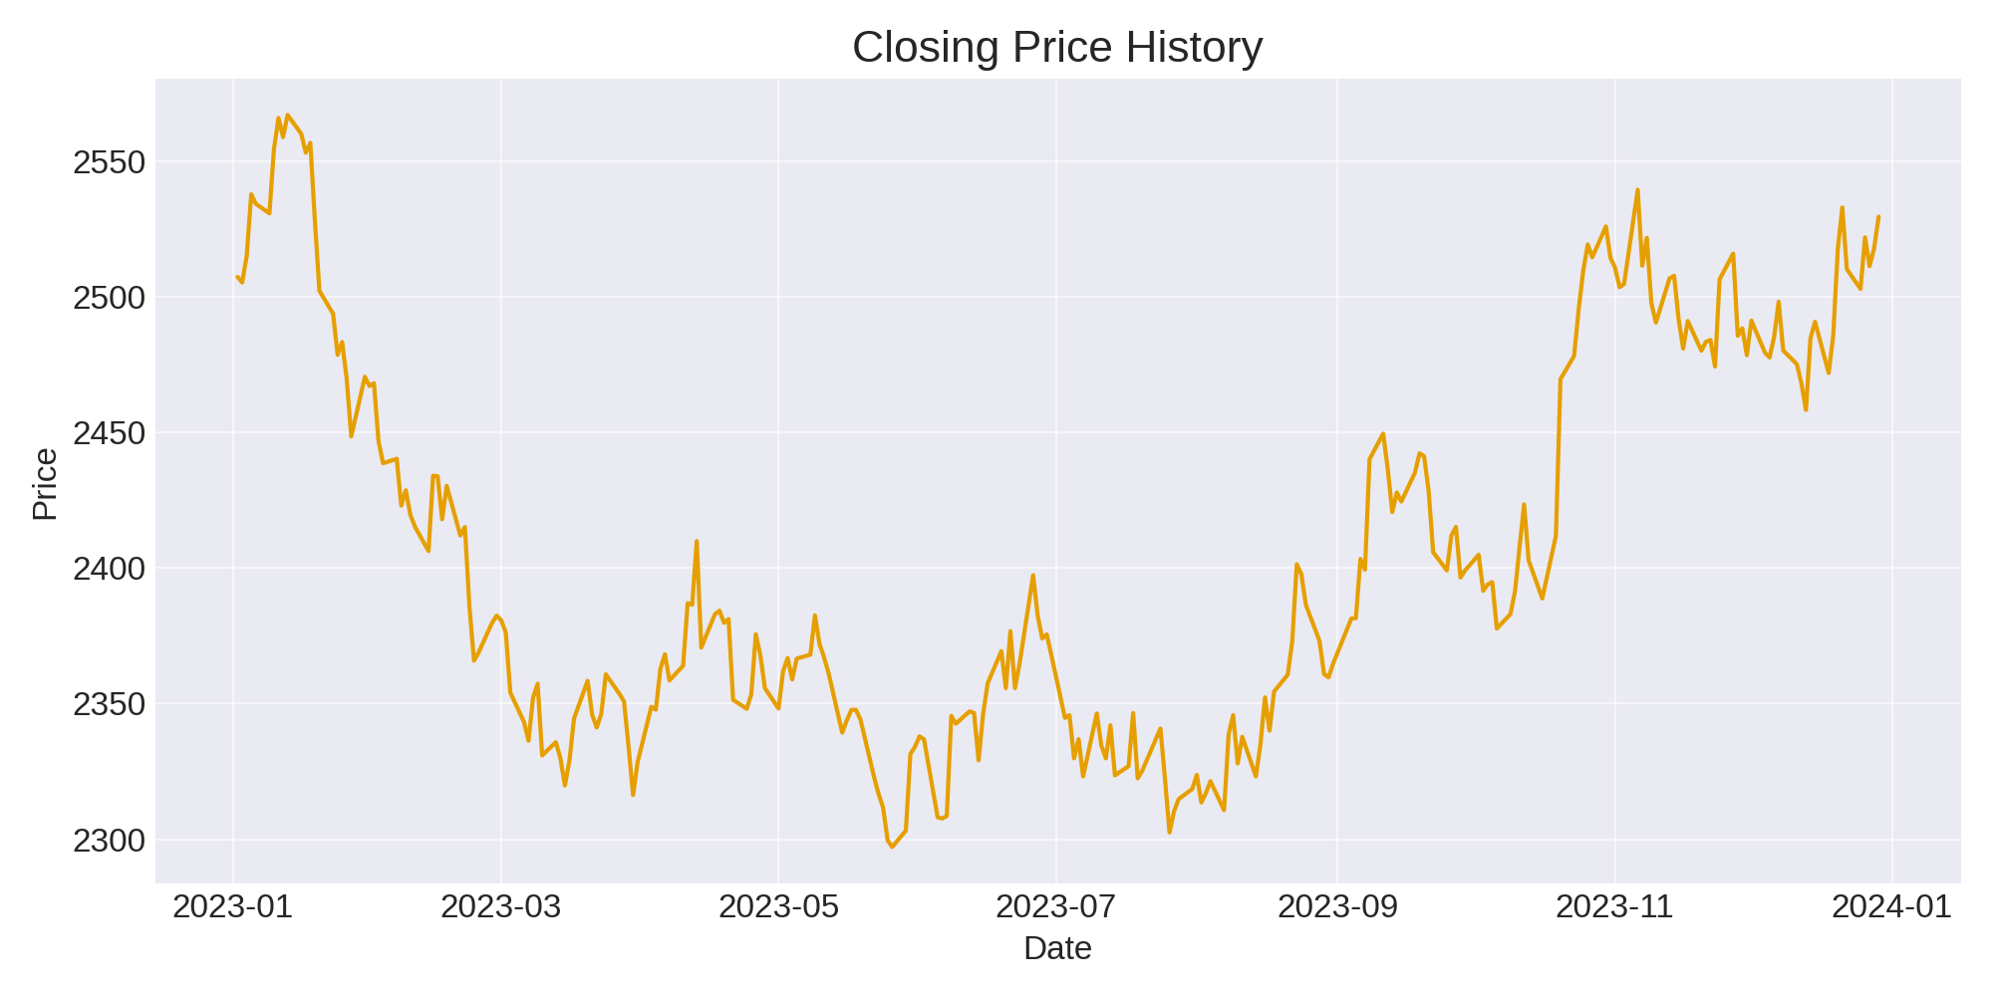

ARIMA forecast vs actual:

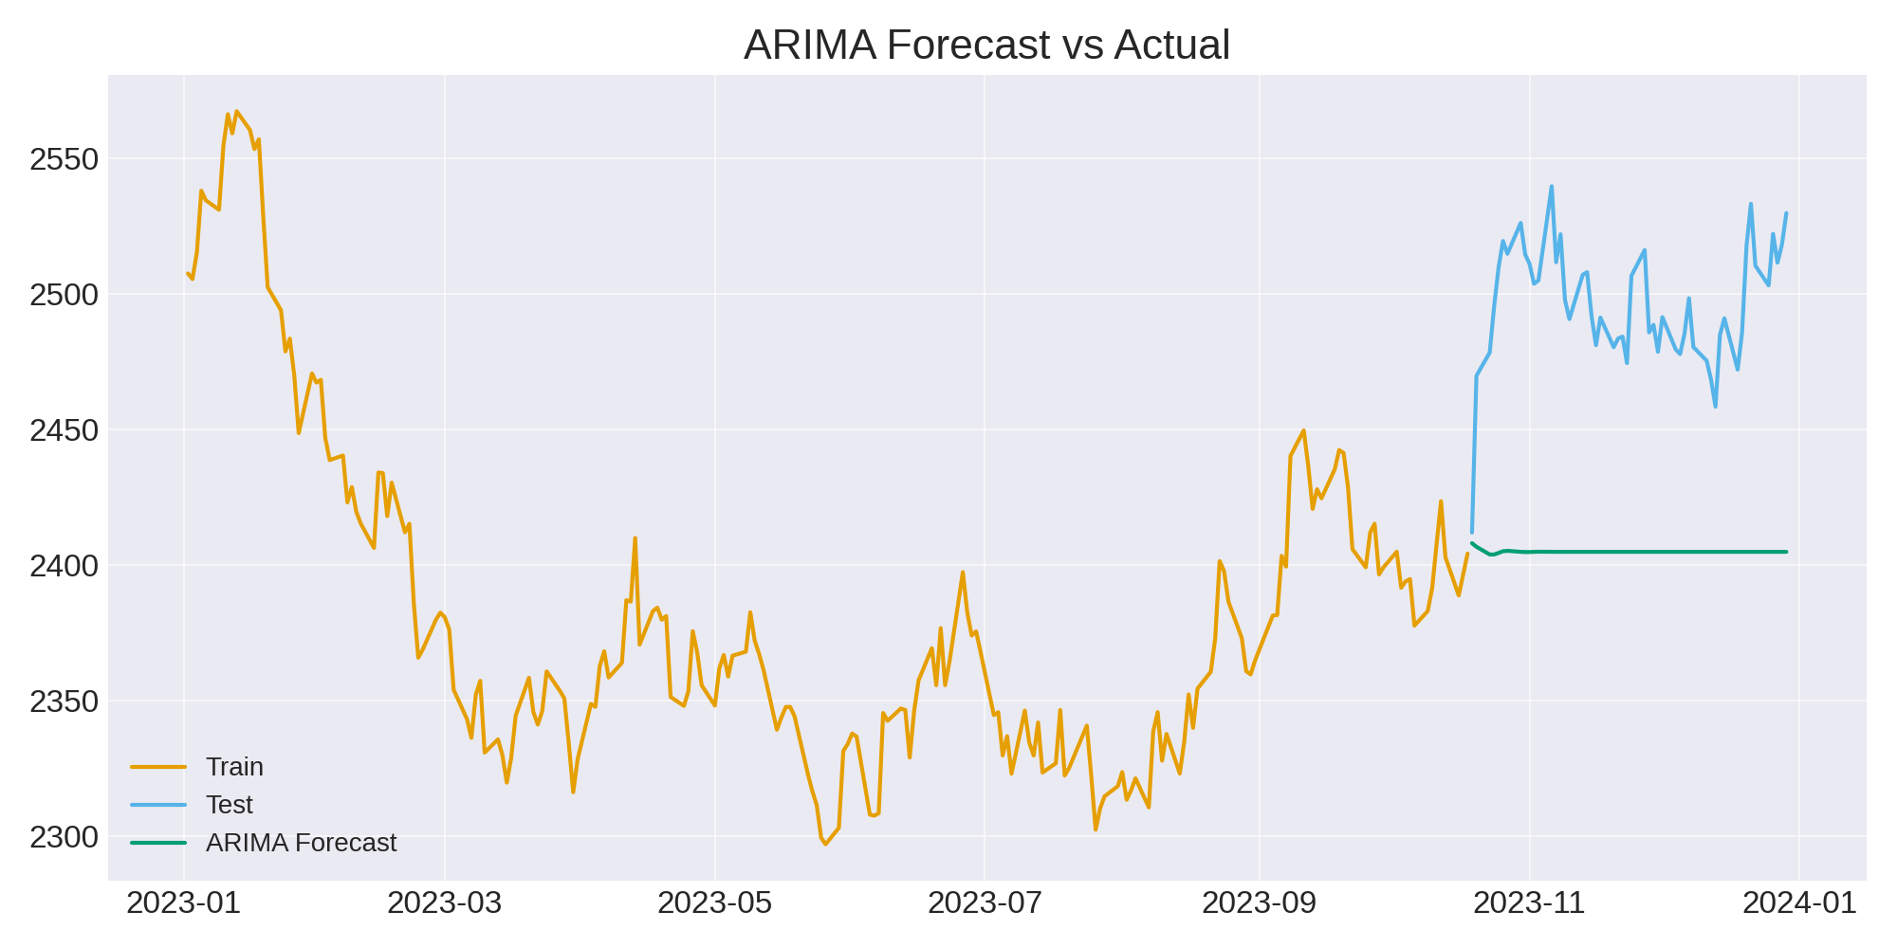

SARIMA forecast vs actual:

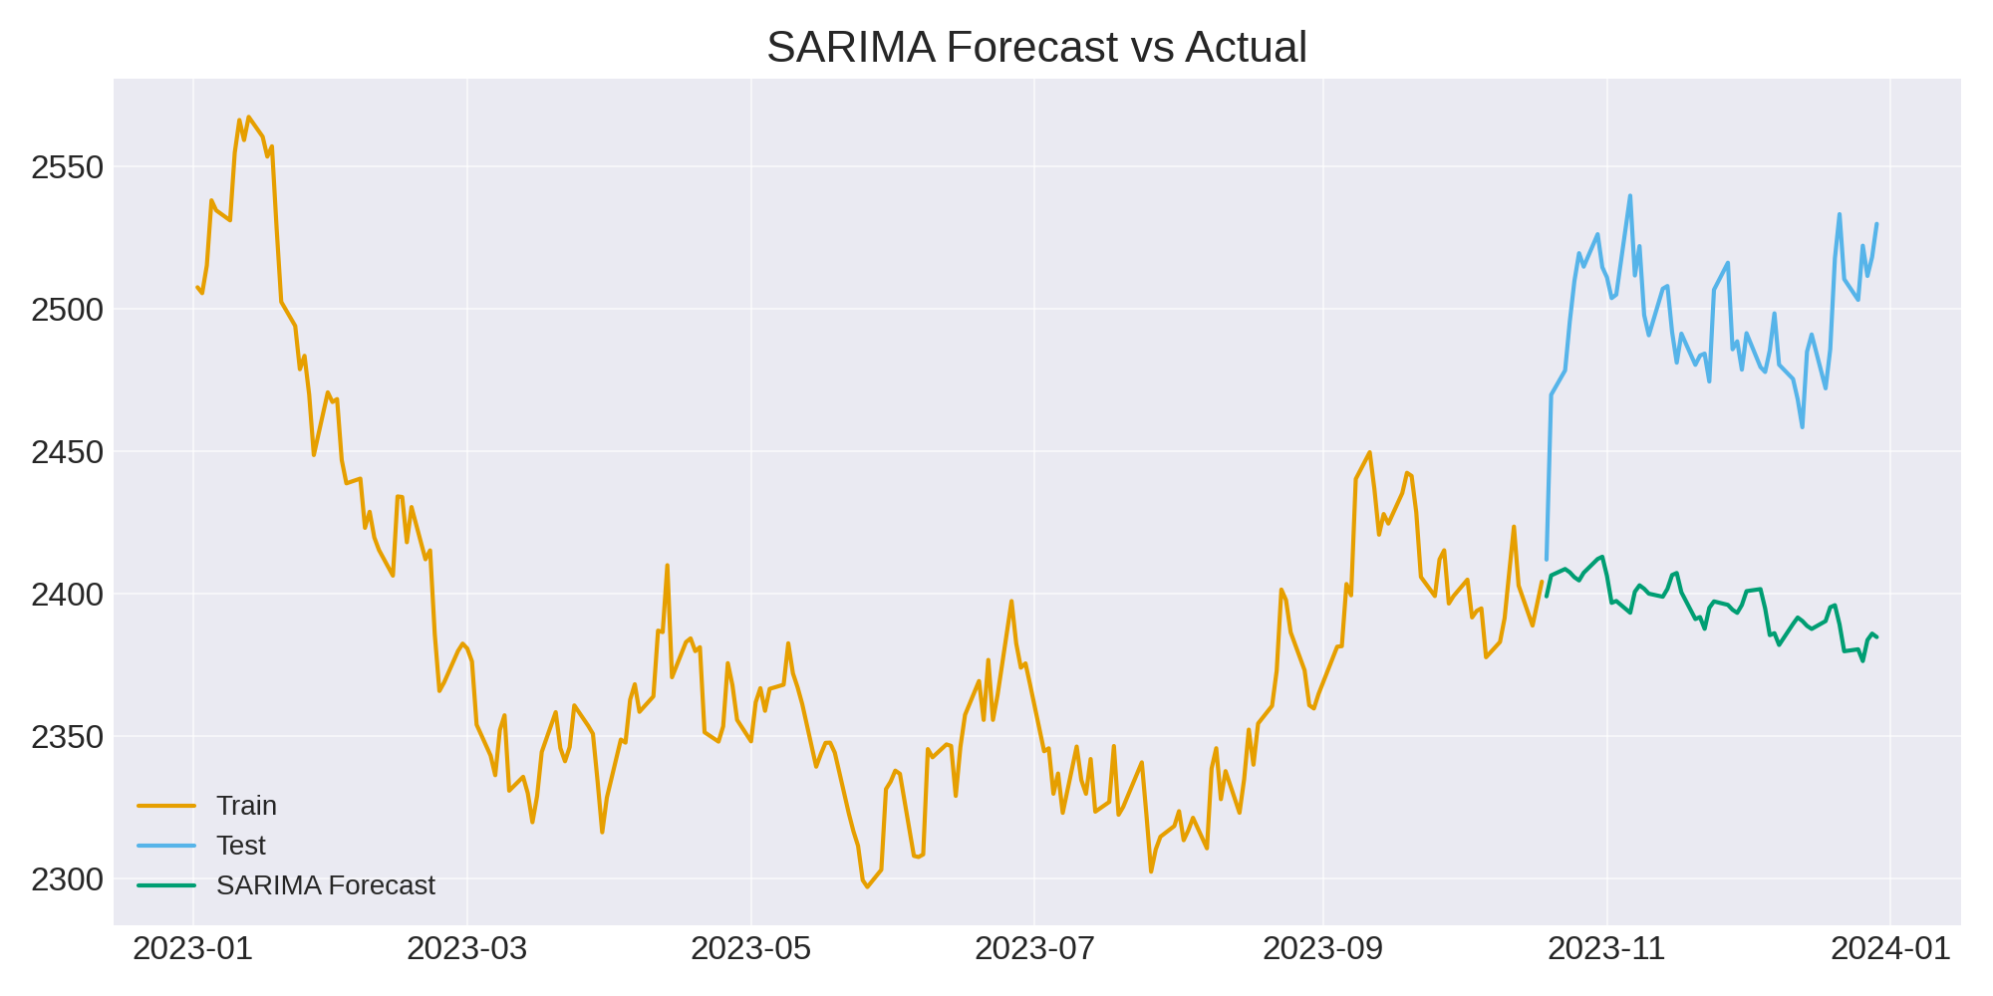

Prophet forecast vs actual:

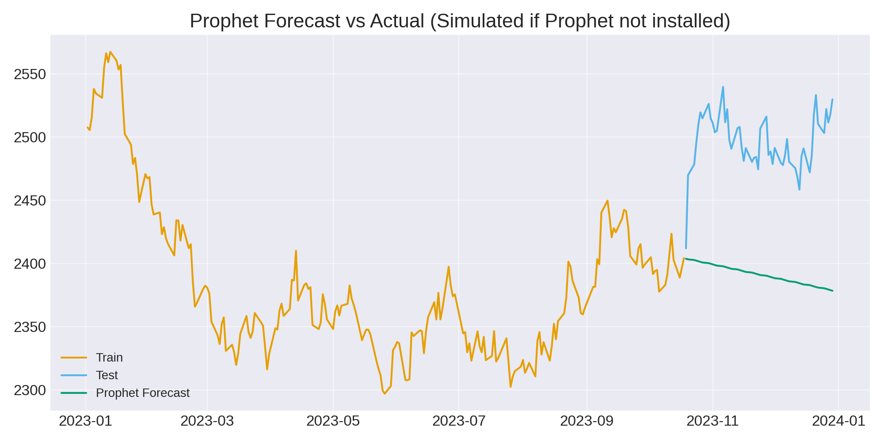

LSTM forecast vs actual (simulated):

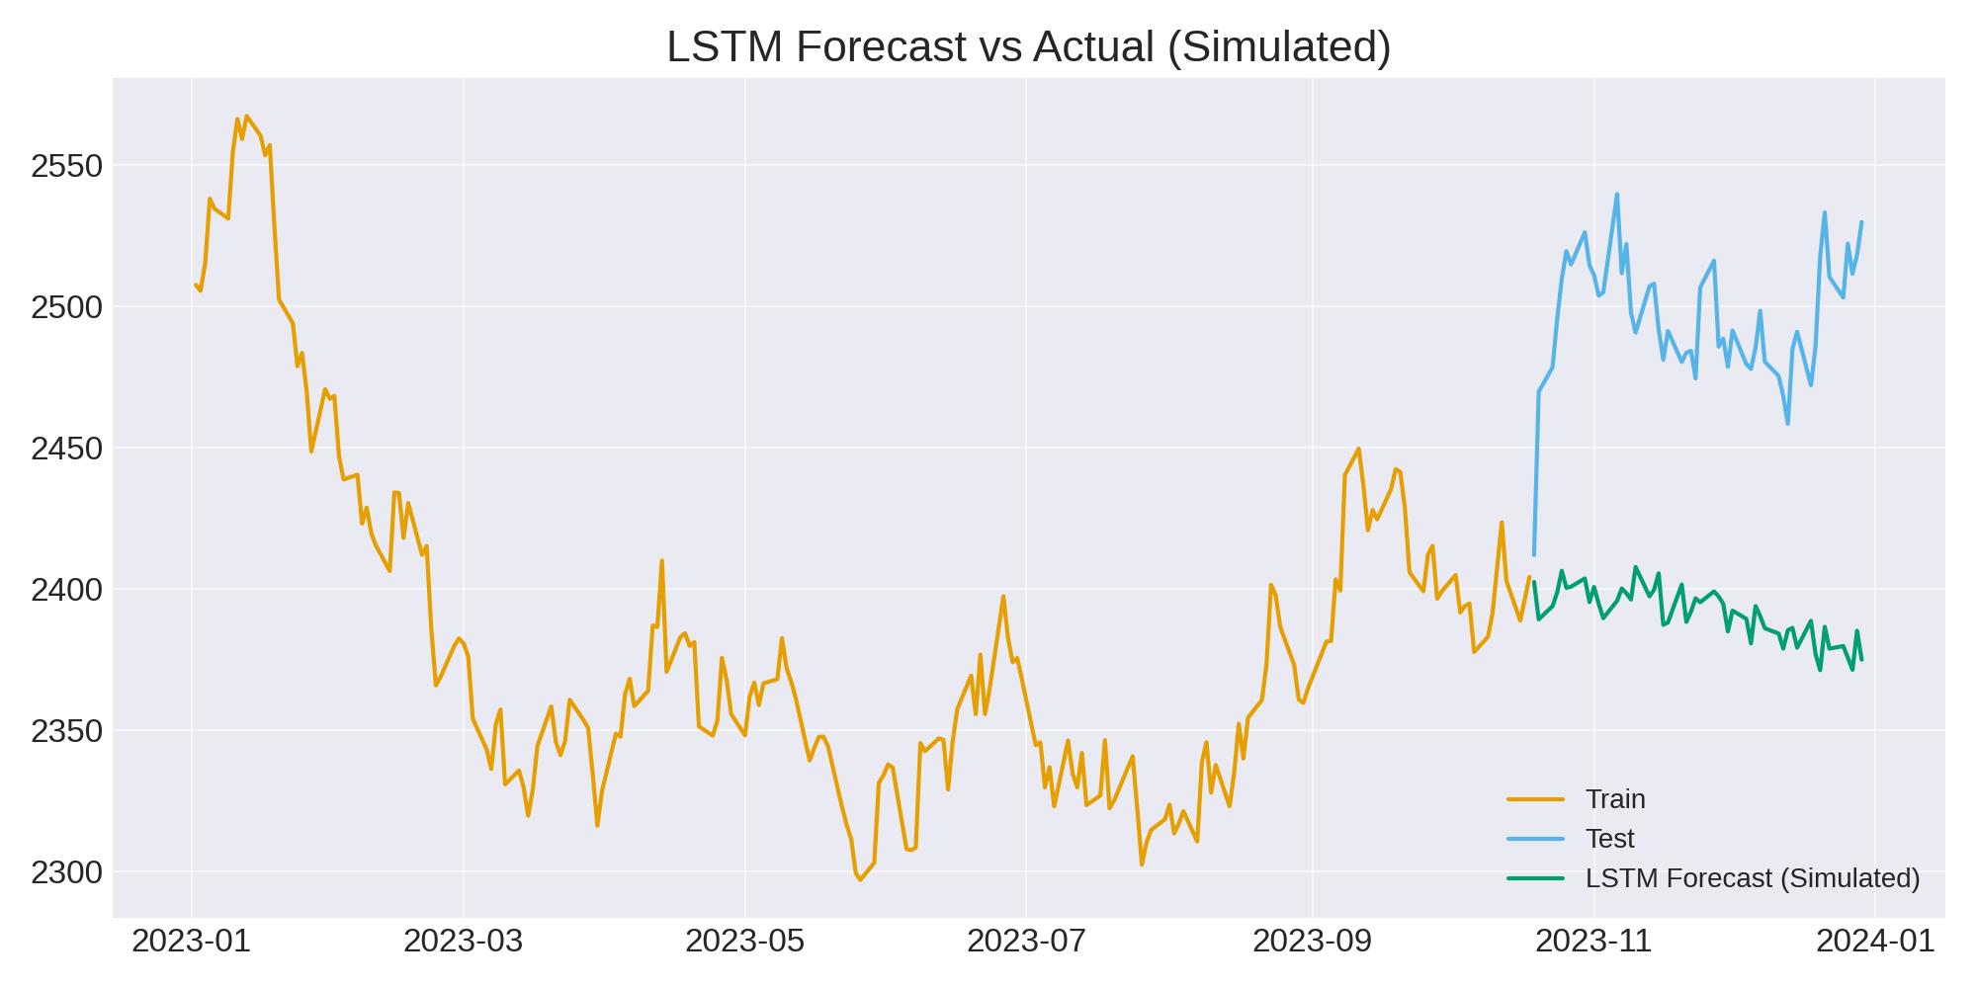

## 3. Model Comparison & Metrics

|  |  |  |  |
| --- | --- | --- | --- |
| Model | RMSE | MAE | MAPE(%) |
| ARIMA | 93.72 | 91.03 | 3.64 |
| SARIMA | 102.9 | 100.16 | 4.01 |
| Prophet | 107.54 | 104.89 | 4.19 |
| LSTM | 107.54 | 104.84 | 4.19 |

## 4. Forecast (next 30 business days)

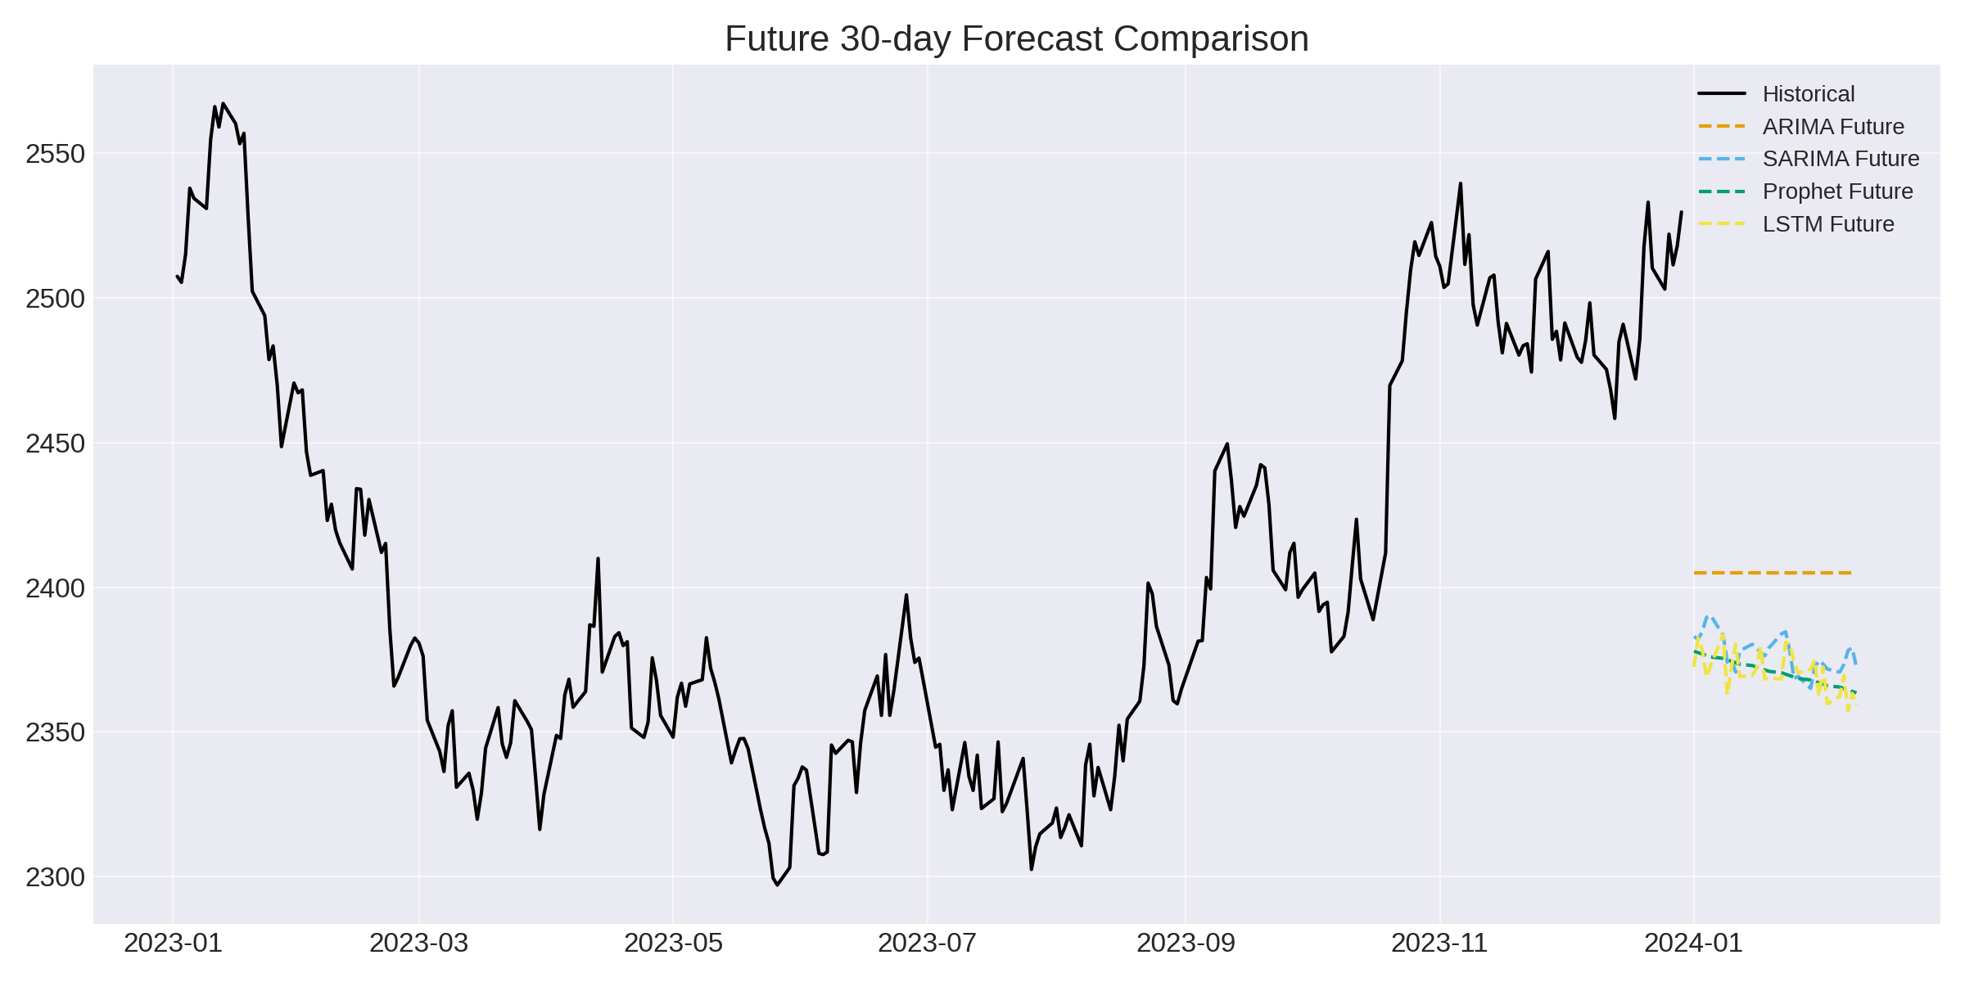

Last 5 days of the 30-day forecast for each model:

|  |  |  |  |  |
| --- | --- | --- | --- | --- |
| Date | ARIMA | SARIMA | Prophet | LSTM |
| 2024-02-05 | 2404.87 | 2370.67 | 2365.51 | 2362.32 |
| 2024-02-06 | 2404.87 | 2373.43 | 2365.01 | 2369.55 |
| 2024-02-07 | 2404.87 | 2378.29 | 2364.52 | 2357.37 |
| 2024-02-08 | 2404.87 | 2379.0 | 2364.02 | 2363.32 |
| 2024-02-09 | 2404.87 | 2372.24 | 2363.52 | 2359.21 |

## 5. Key Insights

• ARIMA & SARIMA provide reasonable short-term forecasts.

• Prophet (simulated if not installed) gives smooth trend-based forecasts.

• LSTM forecast shown here is simulated; for real LSTM predictions, training on the series is required.

• Use the model comparison metrics above (RMSE/MAE/MAPE) to select the best model for your stock and horizon.