1. **css3:**rounded cornors, shadows, text effects, transitions or animations, as well as new layouts like mlti-columns, flexible box etc  
   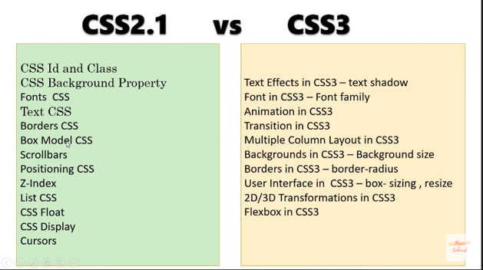
2. **box-sizing**:The CSS box-sizing property allows us to include the padding and border in an element's total width and height. If we need padding in div2 then it will use more space. Below we have padding 50px that creates uneven boxes  
   without box-sizing:  
   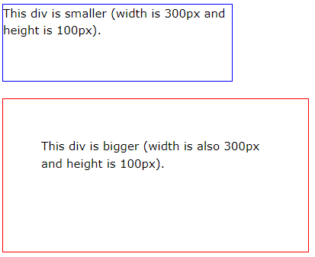  
   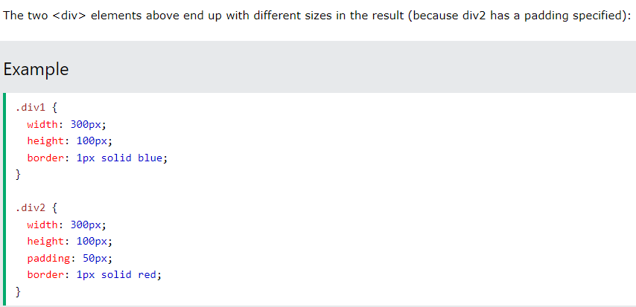  
   with box-sizing:  
   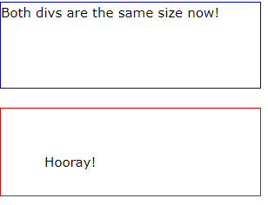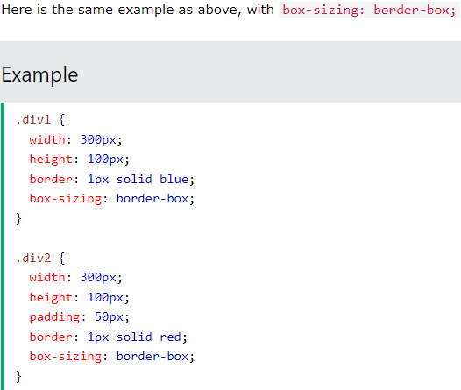
3. giving negative margin to main div and padding to child div for nice looks
4. **flex and flex wrap**
5. **justify-content**: The justify-content property aligns the flexible container's items when the items do not use all available space on the main-axis (horizontally).  
   properties of justify-content:  
   justify-content: flex-start,flex-end,center,space-bewteen,space-around,space-evenly  
   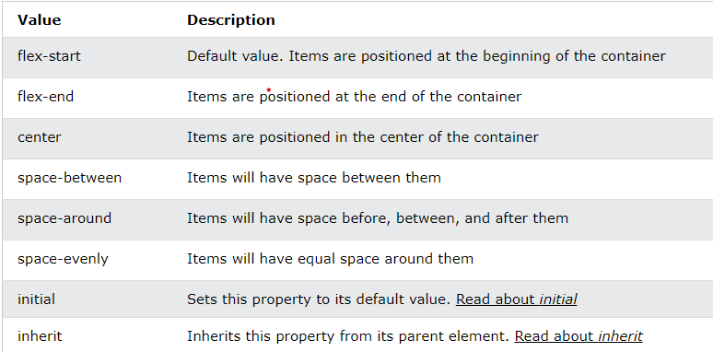

Tip: Use the align-items property to align the items vertically.

1. **align-items**align-items:center;  
   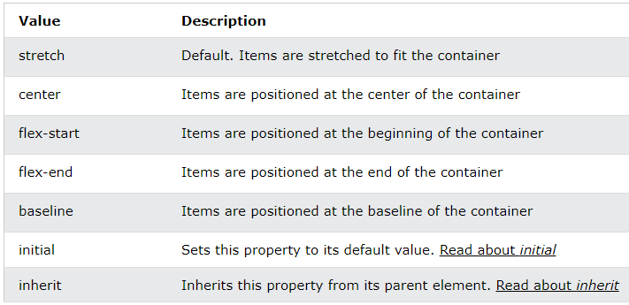
2. **navbar:**this navbar has one header, one container. Blue color is given to header. Inside container there is one row with 2 columns. First columns can use 70% space from main row for list and a tag. And 2nd column can use 30% for phone no

**  
