1. **css3: Introduction**rounded corners, shadows, text effects, transitions or animations, as well as new layouts like mlti-columns, flexible box etc jqery bata ni garko hune kam css3 ma sajilai garna milxa  
   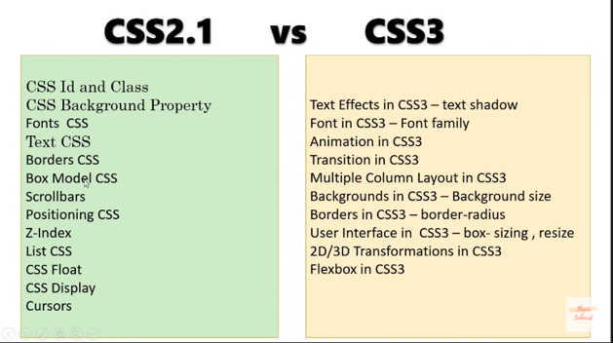
2. **Background-attachment:** The background-attachment property sets whether a background image scrolls with the rest of the page, or is fixed. 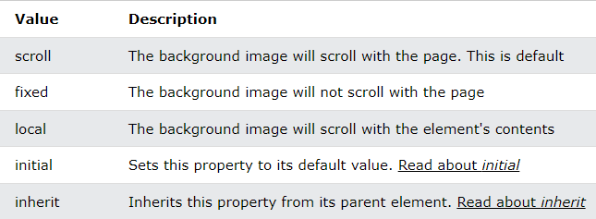
3. **Border**The border-style property specifies what kind of border to display.

The following values are allowed:

dotted - Defines a dotted border

dashed - Defines a dashed border

solid - Defines a solid border

double - Defines a double border

groove - Defines a 3D grooved border. The effect depends on the border-color value

ridge - Defines a 3D ridged border. The effect depends on the border-color value

inset - Defines a 3D inset border. The effect depends on the border-color value

outset - Defines a 3D outset border. The effect depends on the border-color value

none - Defines no border

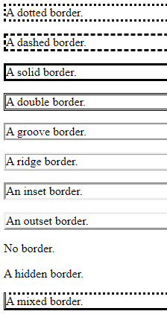

hidden - Defines a hidden border

The border-style property can have from one to four values (for the top border, right border, bottom border, and the left border).

1. **Media queries: making responsive website that supports all display and layout**css media queries is used to apply css only when a certain condition is true.for example:when resizing windows less than 800px, this will trigger another css automatically that will set background-color of body;

<html>  
<head>

<title>media queries</title>

<style>

.container{

background-color: red;

height: 34vh;

}

@media screen and (max-width:800px){

body{

background-color: brown;

}

}

</style>

</head>

<body>

<div class="container">

Lorem ipsum, dolor sit amet consectetur adipisicing elit. Iure magni, eum harum quidem et veniam repellat accusamus iusto labore odio vel, tenetur provident nesciunt consectetur vero fugiat magnam quod impedit.

</div>

</body>

</html>  
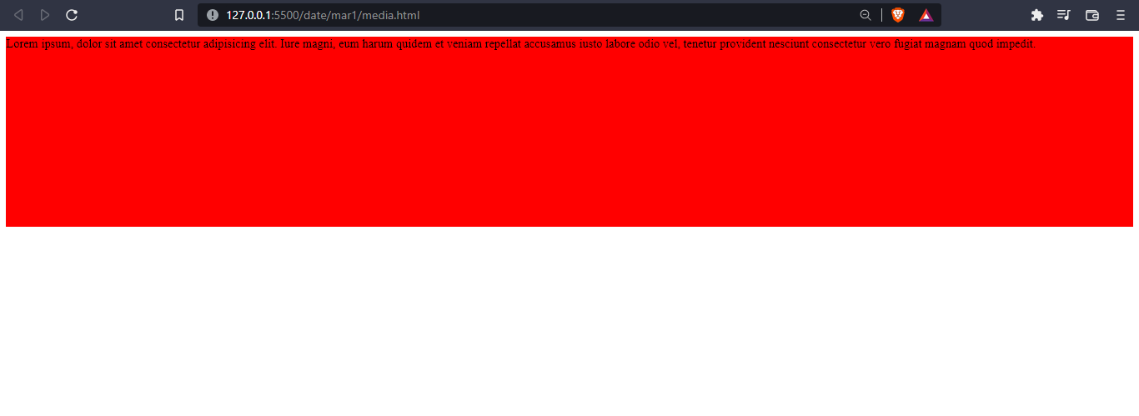

fig: when screen width is normal or greater than 800px

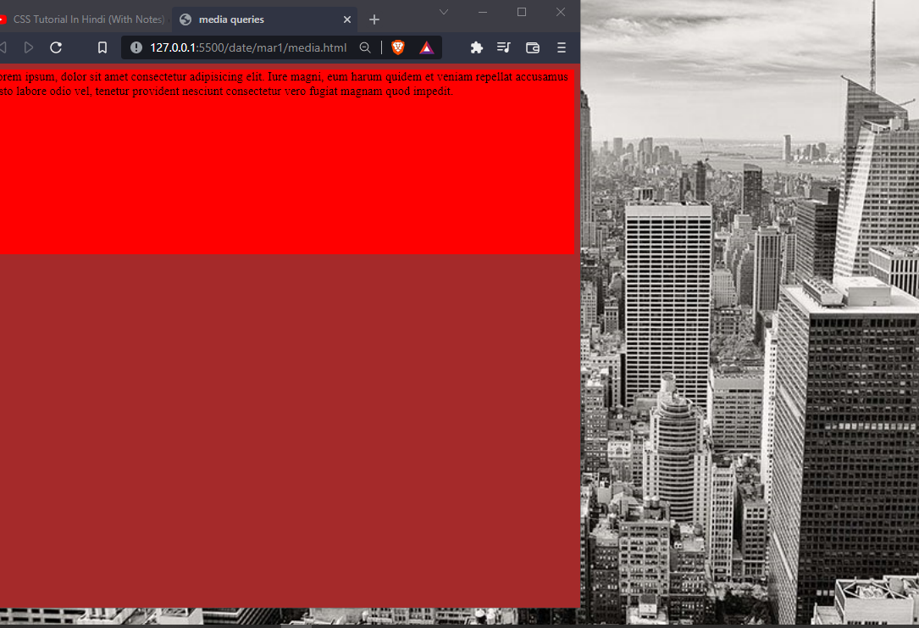

Fig: when you resize windows it will trigger media queries and set the background color to brown

1. **text shadow**
2. **font family**
3. **animation**
4. **transition**
5. **multi-column layout**
6. **backgrounds**
7. **borders**
8. **user interface**
9. **2d/3d Transformation(rotate)**
10. **flex box**