1. **Using external fonts using google font:**link: https://fonts.google.com/  
   Copy paste google font from website to <head> of html  
   eg.  
    <link rel="preconnect" href="https://fonts.googleapis.com">

<link rel="preconnect" href="https://fonts.gstatic.com" crossorigin>

<link href="https://fonts.googleapis.com/css2?family=Sofia&display=swap" rel="stylesheet">  
 **Use font using:**

font-family: 'Sofia', cursive;

1. Positioning: it is used to place item. With the help of CSS, you can put your HTML elements at the position of your choice.  
   here are five types of position property :

Static

relative

Absolute

fixed

Sticky

**Position: static;**

It is the default position of HTML elements.

**Position: relative;**

It is used when we need to position an HTML element relative to its normal position.

We can set the top, right, bottom, and left properties that will cause the element to adjust away from the normal position.

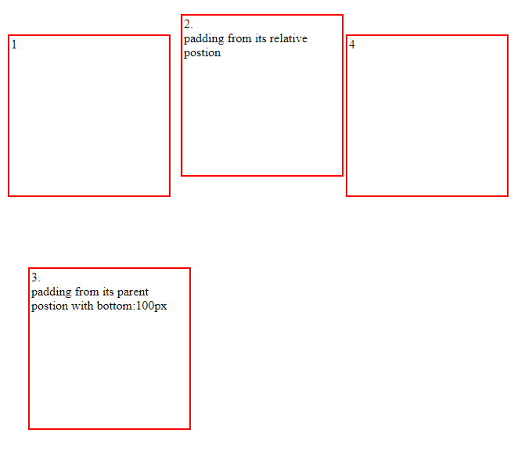  
item2 has position: relative, it means it has taken top:10px and left:5px from the postion where it was created at first.ja thiyo tei bata linxa  
item 3 has postion: absoulute, it means it has taken left:34px and bottom:100px corresponding to its parent div, suru bata linxa yesle  
**Postion:fixed:**

Item lai euta position ma fixed rakhne even when scrolling  
**Position: sticky:**item lai euta postion ma stick gardine

Fixed and sticky are both similar, but

If you make a particular element inside a container as fixed, then irrespective of container height, as we scroll, the element stays at the same position till you scroll to end of web page.

If you make an element as sticky and if its inside a container, then as you scroll, the element will be in the same position until the container height. While scrolling, if the container is also scrolled down, then the sticky element in the container will also move top with container.

i.e., sticky will be fixed only till the end of the container, But fixed will be fixed until the end of web page.