Lab-1
b) In this program we will see how to find the largest number from a block of bytes using 8085.

Problem Statement
Write 8085 Assembly language program to find the largest number from a block of bytes.

Discussion
In this program the data are stored at location 8001H onwards. The 8000H is containing the size of the block. After executing this program, it will return the largest number and store it at location 9000H.
Logic is simple, we are taking the first number at register B to start the job. In each iteration we are getting the number from memory and storing it into register A. Then if B < A, then we simply update the value of B with A, otherwise go for the next iteration. Thus we can find the smallest number in a block of bytes.

Input
Address | Data
... | ...
8000 | 06
8001 | 55
8002 | 22
8003 | 44
8004 | 11
8005 | 33
8006 | 66
... | ...

Flow Diagram
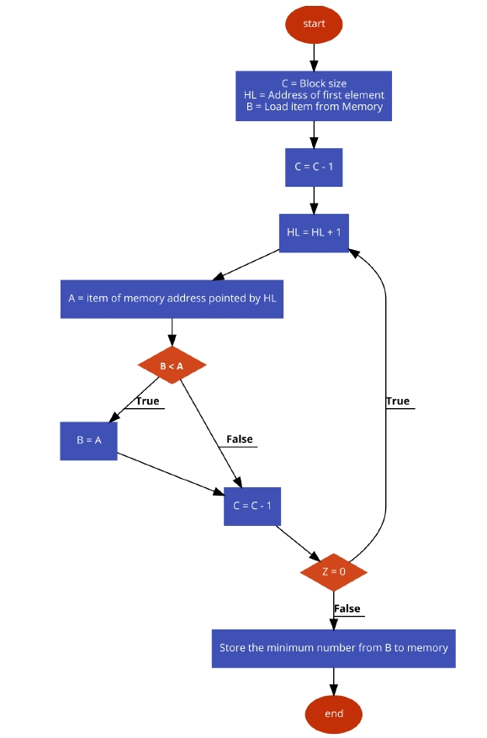

Program
Address | HEX Codes | Labels | Mnemonics | Comments
F000 | 21, 00, 80 |  | LXI H,8000H | Point to get array size
F003 | 4E |  | MOV C,M | Get the size of array
F004 | 23 |  | INX H | Point to actual array
F005 | 46 |  | MOV B,M | Load the first number into B
F006 | 0D |  | DCR C | Decrease C
F007 | 23 | LOOP | INX H | Point to next location
F008 | 7E |  | MOV A,M | Get the next number from memory to Acc
F009 | B8 |  | CMP B | Compare Acc and B
F00A | DA, 0E, F0 |  | JC SKIP | if B > A,then skip
F00D | 47 |  | MOV B,A | If CY is 0,update B
F00E | 0D | SKIP | DCR C | Decrease C
F00F | C2, 07, F0 |  | JNZ LOOP | When count is not 0, go to LOOP
F012 | 21, 00, 90 |  | LXI H,9000H | Point to destination address
F015 | 70 |  | MOV M,B | Store the minimum number
F016 | 76 |  | HLT | Terminate the program

Output
Address | Data
... | ...
9000 | 66

Lab-2:-
- We have different types of digital devices like computers, calculators that can perform a variety of processing functions like addition, subtraction, multiplication, division, etc. The most basic arithmetic operation that the ALU (arithmetic logic unit) of a computer performs is the addition of two or more binary numbers. To perform the operation of addition, a combinational logic circuit, named Adder is used.
Adders are classified into two types namely −
- Half Adder
- Full Adder
A half-adder is a combinational logic circuit that performs the addition of only two bits (binary digits). Whereas, a full-adder is a combination circuit that performs three bits (binary digits), where two are the significant bits and one is a carry from previous execution.

What is a Half-Adder?
A combinational logic circuit which is designed to add two binary digits is called as a half adder. The half adder provides the output along with a carry value (if any). The half adder circuit is designed by connecting an EX-OR gate and one AND gate. It has two input terminals and two output terminals for sum and carry. The block diagram and circuit diagram of a half adder are shown in Figure-1.
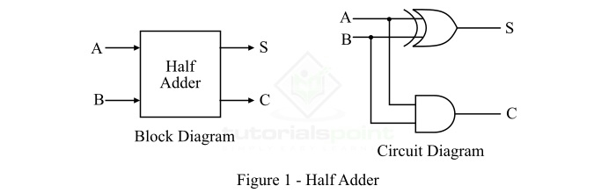
In the case of a half adder, the output of the EX-OR gate is the sum of two bits and the output of the AND gate is the carry. Although, the carry obtained in one addition will not be forwarded in the next addition because of this it is known as half adder.

Truth Table of Half Adder
The following is the truth table of the half-adder −
Inputs |  | Outputs
A | B | S (Sum) | C (Carry)
0 | 0 | 0 | 0
0 | 1 | 1 | 0
1 | 0 | 1 | 0
1 | 1 | 0 | 1

Characteristic Equations of Half-Adder
The characteristic equations of half adder, i.e., equations of sum (S) and carry (C) are obtained according to the rules of binary addition. These equations are given below −
The sum (S) of the half-adder is the XOR of A and B. Thus,
Sum,S=A⊕B=AB′+A′BSum,S=A⊕B=AB′+A′B
The carry (C) of the half-adder is the AND of A and B. Therefore,
Carry,C=A⋅BCarry,C=A⋅B

What is a Full Adder?
A combinational logic circuit that can add two binary digits (bits) and a carry bit, and produces a sum bit and a carry bit as output is known as a full-adder.
In other words, a combinational circuit which is designed to add three binary digits and produces two outputs (sum and carry) is known as a full adder. Thus, a full adder circuit adds three binary digits, where two are the inputs and one is the carry forwarded from the previous addition. The block diagram and circuit diagram of the full adder are shown in Figure-2.
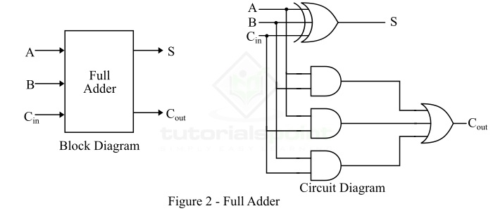
Hence, the circuit of the full adder consists of one EX-OR gate, three AND gates and one OR gate, which are connected together as shown in the full adder circuit in Figure-2.

Truth Table of Full Adder
The following is the truth table of the full-adder circuit −
Inputs |  |  | Outputs
A | B | C_{in} | S (Sum) | C (Carry)
0 | 0 | 0 | 0 | 0
0 | 0 | 1 | 1 | 0
0 | 1 | 0 | 1 | 0
0 | 1 | 1 | 0 | 1
1 | 0 | 0 | 1 | 0
1 | 0 | 1 | 0 | 1
1 | 1 | 0 | 0 | 1
1 | 1 | 1 | 1 | 1
Hence, from the truth table, it is clear that the sum output of the full adder is equal to 1 when only 1 input is equal to 1 or when all the inputs are equal to 1. While the carry output has a carry of 1 if two or three inputs are equal to 1.

Characteristic Equations of Full Adder
The characteristic equations of the full adder, i.e. equations of sum (S) and carry output (C_{out}) are obtained according to the rules of binary addition. These equations are given below −
The sum (S) of the full-adder is the XOR of A, B, and Cin. Therefore,
Sum,S=A⊕B⊕Cin=A′B′Cin+A′BC′in+AB′C′in+ABCinSum,S=A⊕B⊕Cin=A′B′Cin+A′BCin′+AB′Cin′+ABCin
The carry (C) of the half-adder is the AND of A and B. Therefore,
Carry,Cout=AB+ACin+BCinCarry,Cout=AB+ACin+BCin

What is a Subtractor?
The subtraction of two binary numbers can be performed by taking the 1’s or 2’s complement of the inputs. By this method, the subtraction operation becomes an addition operation, and thus can be performed by using the adder circuits. This results in the reduction of hardware and cost.
In the subtraction operation, each subtrahend bit (B) of the number is subtracted from its corresponding significant minuend bit (A) to obtain a difference bit.
Similar to adders, subtractors are also of two types −
- Half Subtractor
- Full Subtractor
Let us discuss the half-subtractor and full-subtractor in detail.

What is a Half-Subtractor?
A half-subtractor is a combinational logic circuit that have two inputs and two outputs (i.e. difference and borrow). The half subtractor produces the difference between the two binary bits at the input and also produces a borrow output (if any). In the subtraction (A-B), A is called as Minuend bit and B is called as Subtrahend bit. The block diagram and logic circuit diagram of the half subtractor is shown in Figure-3.
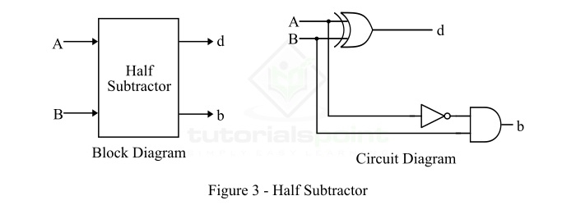
Hence, from the logic circuit diagram, it is clear that a half subtractor can be realized using an XOR gate together with a NOT gate and an AND gate.

Truth Table of Half Subtractor
The following is the truth table the half-subtractor −
Inputs |  | Outputs
A | B | d (Difference) | b (Borrow)
0 | 0 | 0 | 0
0 | 1 | 1 | 1
1 | 0 | 1 | 0
1 | 1 | 0 | 0

Characteristic Equation of Half Subtractor
The characteristic equations of the half subtractor, i.e. equations of the difference (d) and borrow output (b) are obtained by following the rules of binary subtraction. These equations are given below −
The difference (d) of the half subtractor is the XOR of A and B. Therefore,
Difference,d=A⊕B=A′B+AB′Difference,d=A⊕B=A′B+AB′
The borrow (b) of the half subtractor is the AND of A’ (compliment of A) and B. Therefore,
Borrow,b=A′BBorrow,b=A′B

What is a Full-Subtractor?
A full-subtractor is a combinational circuit that has three inputs A, B, bin and two outputs d and b. Where, A is the minuend, B is subtrahend, bin is borrow produced by the previous stage, d is the difference output and b is the borrow output.
Since, the half subtractor can only be used to find the difference of LSBs (Least Significant Bits) of two binary numbers. Thus, if there is any borrow during the subtraction of the LSBs, it will affect the subtraction of the next bits of numbers. To overcome this problem of the half subtractor, a full subtractor is realized. The block diagram and circuit diagram of a fullsubtractor is shown in Figure-4.
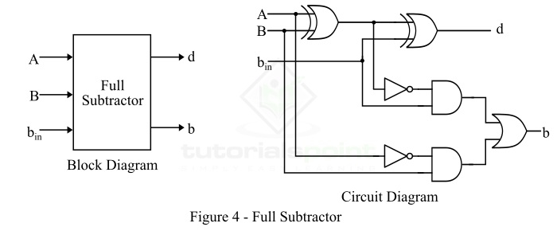
Therefore, we can realize the full-subtractor using two XOR gates, two NOT gates, two AND gates, and one OR gate.

Truth Table of Full-Subtractor
The following is the truth table of the full-subtractor −

Inputs |  |  | Outputs
A | B | b_{in} | d (Difference) | b (Borrow)
0 | 0 | 0 | 0 | 0
0 | 0 | 1 | 1 | 1
0 | 1 | 0 | 1 | 1
0 | 1 | 1 | 0 | 1
1 | 0 | 0 | 1 | 0
1 | 0 | 1 | 0 | 0
1 | 1 | 0 | 0 | 0
1 | 1 | 1 | 1 | 1

Characteristic Equations of Full Subtractor
The characteristic equations of the full subtractor, i.e. equations of the difference (d) and borrow output (b) are obtained by following the rules of binary subtraction.
b)
Assembly language program to find smallest number in an array

Problem Statement
Write 8085 Assembly language program to find the smallest number from a block of bytes.

Discussion
In this program the data are stored at location 8001H onwards. The 8000H is containing the size of the block. After executing this program, it will return the smallest number and store it at location 9000H.
Logic is simple, we are taking the first number at register B to start the job. In each iteration we are getting the number from memory and storing it into register A. Then if B > A, then we simply update the value of Bwith A, otherwise go for the next iteration. Thus we can find the smallest number in a block of bytes.

Input
Address | Data
... | ...
8000 | 06
8001 | 55
8002 | 22
8003 | 44
8004 | 11
8005 | 33
8006 | 66
... | ...

Flow Diagram
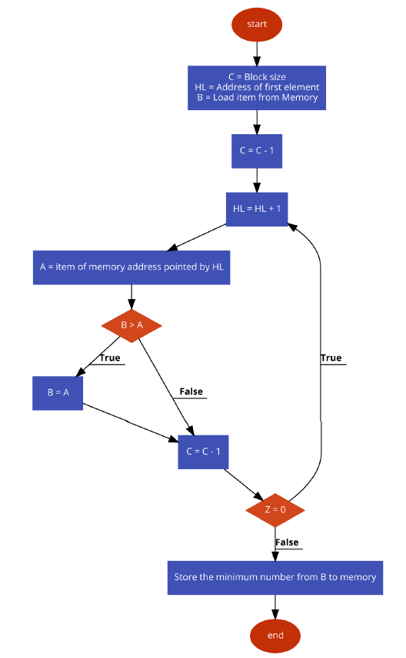

Program
Address | HEX Codes | Labels | Mnemonics | Comments
F000 | 21, 00, 80 |  | LXI H,8000H | Point to get array size
F003 | 4E |  | MOV C, M | Get the size of array
F004 | 23 |  | INX H | Point to actual array
F005 | 46 |  | MOV B, M | Load the first number into B
F006 | 0D |  | DCR C | Decrease C
F007 | 23 | LOOP | INX H | Point to next location
F008 | 7E |  | MOV A, M | Get the next number from memory to Acc
F009 | B8 |  | CMP B | Compare Acc and B
F00A | D2, 0E, F0 |  | JNC SKIP | if B <= A,then skip
F00D | 47 |  | MOV B, A | If CY is 1, update B
F00E | 0D | SKIP | DCR C | Decrease C
F00F | C2, 07, F0 |  | JNZ LOOP | When count is not 0, go to LOOP
F012 | 21, 00, 90 |  | LXI H,9000H | Point to destination address
F015 | 70 |  | MOV M, B | Store the minimum number
F016 | 76 |  | HLT | Terminate the program

Output
Address | Data
... | ...
9000 | 11

