STEP :1- Click on '+' button on the right top side.

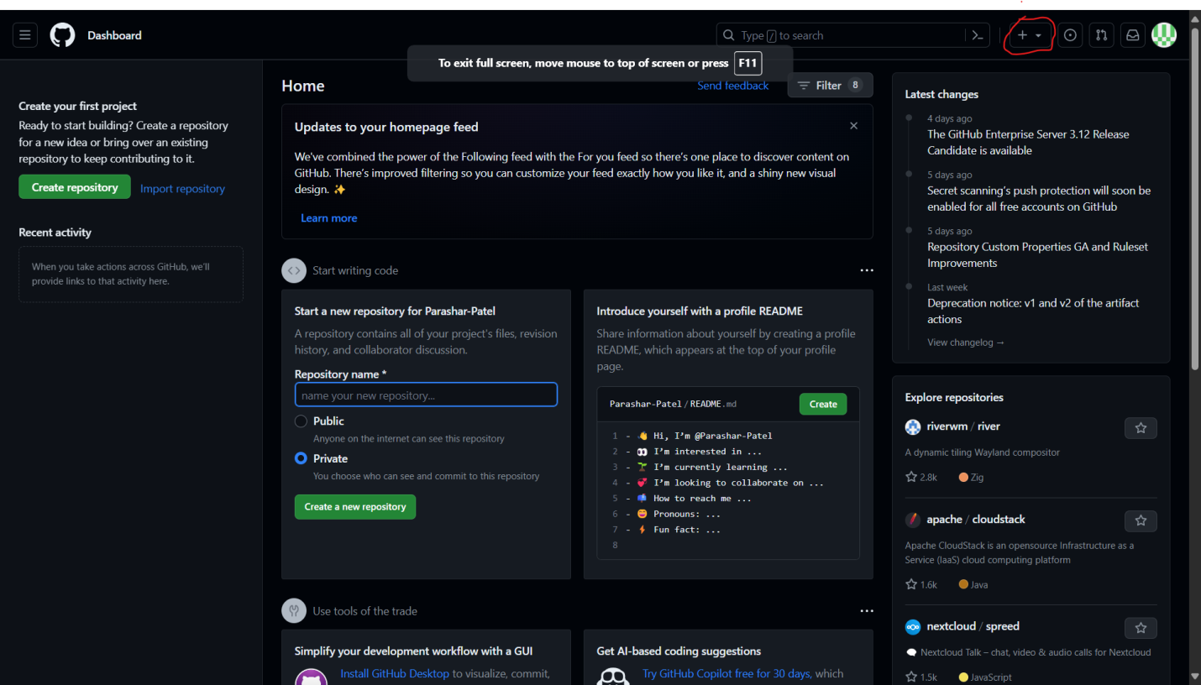

STEP :2-Click on 'New repository.

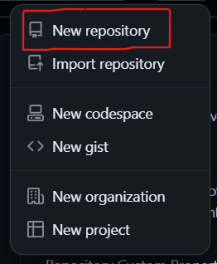

STEP :3-Name the repository "ENROLLMENT_NO" "2302030430078".

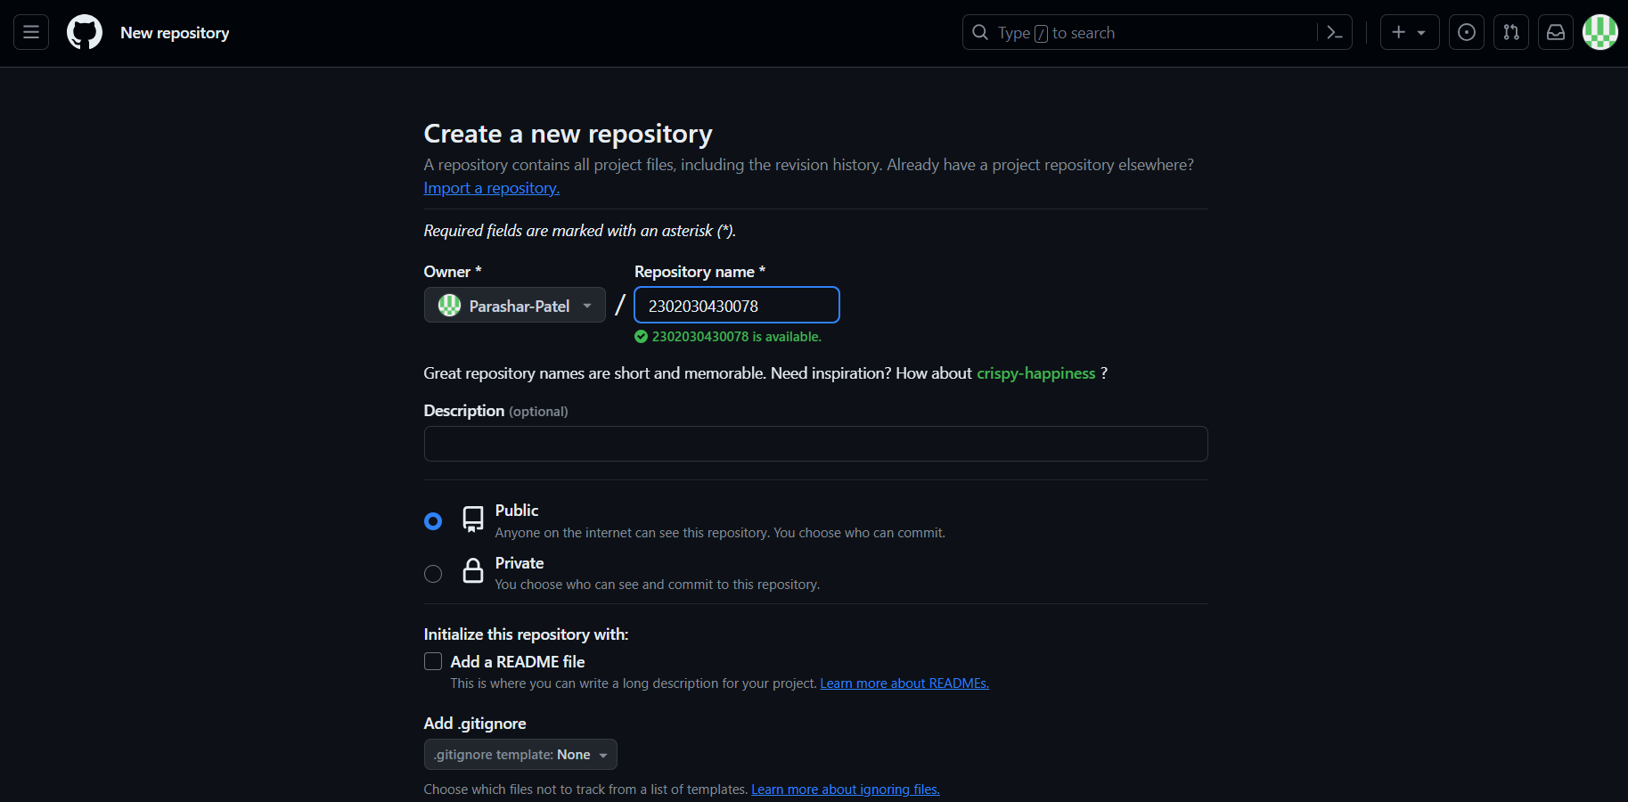

STEP :5-Click on "Create repository".

