**SMART DOOR LOCKING SYSTEM**

**IoT based System (UEC715)**

Submitted by

**Riya Khera** **102115019**

**Pratinav Batra** **102115004**

**Pulkit Garg**  **102115006**

**Varun Kashyap** **102115012**

**Paras Sharma 102115015**

Submitted to

**Dr. Amit Mishra**

Submitted On

**22nd Nov ‘24**



**DEPARTMENT OF ELECTRONICS AND COMMUNICATION ENGINEERING**

**THAPAR INSTITUTE OF ENGINEERING AND TECHNOLOGY**

**PATIALA, PUNJAB**

**INDIA**

**July-Dec 2024**

**TABLE OF CONTENTS**

|  |  |
| --- | --- |
| **ABSTRACT** | **3** |
| **LIST OF FIGURES** | **4** |
| **ABBREVIATIONS** | **5** |
| **NOTATION** | **6** |
| **CHAPTER 1- INTRODUCTION** | **7** |
| **CHAPTER 2- PROBLEM FORMULATION AND OBJECTIVES** |  |
| 2.1 Problem Formulation | **8** |
| 2.2 Objective | **8-9** |
| **CHAPTER 3- PROJECT DESIGN, RESULTS AND DESCRIPTION** |  |
| 3.1 Overview of the System Design | **10-11** |
| 3.2 Components Used and Their Descriptions | **11-13** |
| 3.3 User Interface (Arduino Bluetooth Controller) | **13-14** |
| 3.4 Results and Observations | **14-17** |
| **CHAPTER 4- OUTCOMES AND PROSPECTIVE LEARNING** |  |
| 4.1 Project Outcomes | **18** |
| 4.2 Challenges and How They Were Addressed | **18** |
| 4.3 Prospective Learning and Knowledge Gained | **19** |
| 4.4 Potential Advancements and Applications | **19** |
| **CHAPTER 5- CONCLUSION** | **20** |
| **REFERENCES** | **21** |

### 

**ABSTRACT**

The IoT Smart Door Locking System is an innovative solution designed to enhance home security and convenience by integrating modern IoT technology with traditional mechanical locking mechanisms. The system leverages a servo motor, Bluetooth module, and Arduino Uno microcontroller to automate the locking and unlocking of a door, eliminating the need for physical keys. Controlled via a user-friendly mobile application, the system provides seamless wireless communication for real-time access control within a defined range. Its compact, energy-efficient, and cost-effective design makes it ideal for residential and small-scale commercial applications.

This project focuses on addressing the challenges of integrating hardware components with precise mechanical operation. A metal wire mechanism connects the servo motor to the door latch, enabling accurate actuation. The Bluetooth module ensures reliable communication, while the Arduino processes commands and drives the servo motor. Rigorous testing validated the system’s functionality, ensuring smooth performance, stability, and durability under repeated use. The project also prioritizes energy efficiency, with power consumption optimized for long-term operation.

The IoT Smart Door Locking System not only demonstrates the practical application of IoT in daily life but also serves as a foundation for further innovation. Future enhancements could include cloud connectivity for remote access, biometric authentication for advanced security, and AI-driven analytics for predictive maintenance. This project illustrates the potential of IoT to transform conventional systems, combining convenience, security, and efficiency into a single, user-friendly solution.

|  |  |  |
| --- | --- | --- |
| **Roll No.** | **Name** | **Signature** |
| 102115019 | Riya Khera |  |
| 102115004 | Pratinav Batra |  |
| 102115006 | Pulkit Garg |  |
| 102115012 | Varun Kashyap |  |
| 102115015 | Paras Sharma |  |

**LIST OF FIGURES**

|  |  |  |
| --- | --- | --- |
| **Figure No.** | **Figure Name** | **Page No.** |
| Figure 2.1 | Mechanism showing Smart Door Locking System | 9 |
| Figure 3.1 | Flow Chart for Smart Door Locking System | 10 |
| Figure 3.2 | Bluetooth Module HC-05 | 11 |
| Figure 3.3 | Servo Motor MG996 | 12 |
| Figure 3.4 | Breadboard | 12 |
| Figure 3.5 | Jumper wires | 12 |
| Figure 3.6 | Door Latch | 13 |
| Figure 3.7 | Arduino Uno | 14 |
| Figure 3.8 | Interface from where we are controlling the locking and unlocking | 14 |
| Figure 3.9 | Circuit Diagram | 15 |
| Figure 3.10 | Code Snippet | 16 |
| Figure 3.11 | Output | 17 |

**ABBREVIATIONS**

|  |  |
| --- | --- |
| **Abbreviation** | **Full Name** |
| TIET | Thapar Institute of Engineering & Technology, Patiala |
| UI | User Interface |
| AI | Artificial Intelligence |
| IOT | Internet Of Things |
| GSM | Global System for Mobile Communication |
| MG996 | Metal Gear Servo Motor |
| PWM | Pulse Width Modulation |

**NOTATION**

|  |  |
| --- | --- |
| **Notation** | **Stands for** |
| % | Percentage |
| ° | Degree |
| V | Volts |
| kg | Kilogram |
| cm | Centimeter |
| sec | Seconds |

**CHAPTER 1- INTRODUCTION**

As technological advancements transform every aspect of human life, the need for secure, efficient, and intelligent systems in home and building management has become imperative. Among these, door locking mechanisms stand out as a fundamental aspect of security and convenience. Traditional mechanical locks have been a staple for centuries, but their vulnerabilities and limitations, including susceptibility to tampering, loss or duplication of keys, and lack of remote operability, highlight the need for smarter alternatives. In response, this project introduces a Smart Door Locking System that addresses these concerns by integrating modern engineering principles with Internet of Things (IoT) technologies.

This system is designed to provide a seamless locking and unlocking mechanism through the use of a servo motor operated by an Arduino microcontroller. A sturdy metal wire is used to manipulate the door latch, ensuring physical security. The lock is controlled wirelessly via a Bluetooth module connected to the Arduino, allowing users to manage access remotely using a smartphone application. By eliminating the dependence on physical keys and enabling real-time operability, this smart system offers a secure and convenient alternative to traditional locks.

The design of the Smart Door Locking System reflects the growing interest in home automation and IoT applications. Its compact and cost-effective structure ensures it can be deployed in various settings, including residential homes, office spaces, and hostels. Additionally, it addresses the dynamic requirements of shared spaces, where managing access for multiple users can be a logistical challenge.

The project demonstrates how advancements in electronics and computing can create solutions for real-world challenges. By utilizing open-source platforms like Arduino and widely available components, the system not only ensures affordability but also promotes accessibility and ease of replication. This alignment with contemporary technological trends makes the Smart Door Locking System an essential contribution to the ongoing evolution of smart living solutions.

**CHAPTER 2 - PROBLEM FORMULATION AND OBJECTIVES**

### **2.1 Problem Formulation**

Door locks have long been the cornerstone of personal and property security. Despite their widespread use, conventional locking mechanisms suffer from inherent limitations that compromise their effectiveness in modern contexts:

1. **Key-Related Vulnerabilities**: Keys can be misplaced, stolen, or duplicated without authorization, posing a direct threat to security.
2. **Limited Scalability**: Traditional locks are unsuitable for environments with multiple users, such as hostels or co-working spaces, where distributing and managing keys is inefficient.
3. **Lack of Technological Integration**: Traditional locks do not offer remote access or monitoring capabilities, which are essential in an increasingly connected world.
4. **Susceptibility to Tampering**: Physical locks are prone to tampering or forced entry, reducing their reliability in high-security scenarios.

The need for an intelligent and adaptable solution has become evident, particularly in light of the increasing adoption of IoT-enabled devices. The **Smart Door Locking System** addresses these challenges by introducing an innovative mechanism that integrates automation, remote control, and enhanced security measures.

**2.2 Objective**

The primary objective of the project is to design and develop a secure, cost-effective, and user-friendly locking mechanism leveraging modern technologies. The following specific objectives define the scope of the project:

1. **Enhancing Security:** Utilize a **metal wire mechanism** connected to a servo motor to provide a robust locking and unlocking function. This mechanism minimizes the risk of tampering and ensures physical reliability.
2. **Enabling Remote Control:** Implement a Bluetooth-based control system using an Arduino microcontroller, allowing users to manage the lock remotely through a smartphone application.
3. **Designing an Affordable Solution:** Leverage **readily available components** such as Arduino, servo motors, and Bluetooth modules to create an economically viable solution suitable for mass adoption.
4. **Facilitating Scalability:** Design the system in a modular fashion to support potential expansion, such as integrating additional locks or connecting to a broader smart home network.
5. **Promoting Energy Efficiency:** Optimize the power consumption of the system, ensuring reliable performance without excessive energy use, making it suitable for long-term operation.
6. **Ensuring Ease of Use:** Develop an intuitive interface for the smartphone application, allowing users of all technical backgrounds to operate the system without difficulty.
7. **Adapting to Diverse Applications:** Design the system to function across various environments, including residential homes, office spaces, and shared accommodations, making it a versatile solution for modern security needs.

The Smart Door Locking System aims to demonstrate how simple yet innovative solutions can enhance security while aligning with the principles of modern IoT design. By addressing the key limitations of traditional locks and embracing the capabilities of emerging technologies, this project seeks to contribute meaningfully to the field of home automation and smart systems.

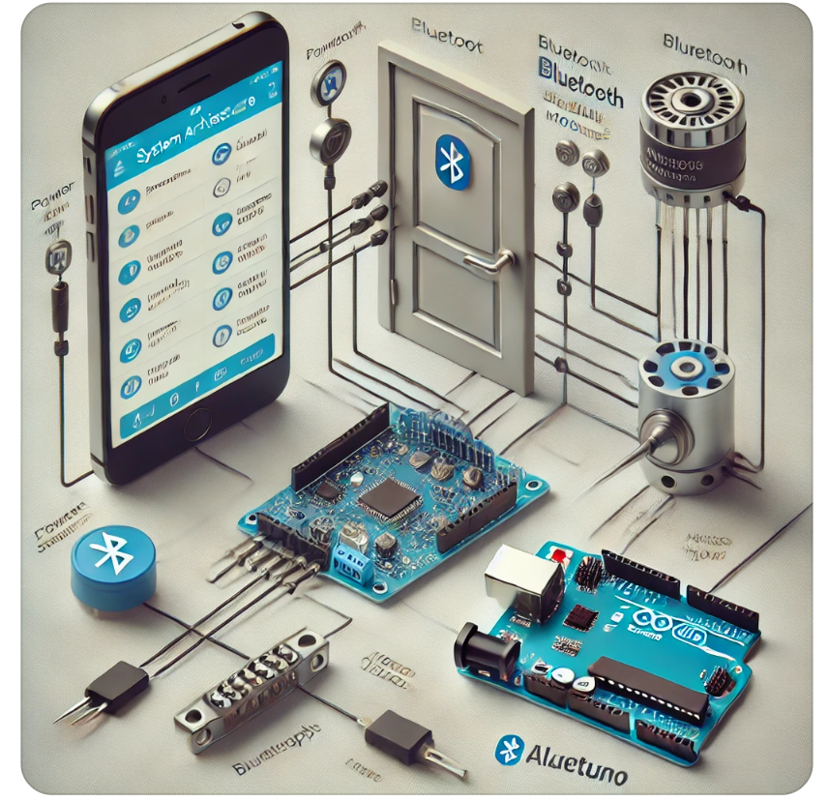

Fig 2.1 Mechanism showing Smart Door Locking System [1]

**CHAPTER 3 - PROJECT DESIGN, RESULTS AND DESCRIPTION**

**3.1 Overview of the System Design**

The Smart Door Locking System is an innovative IoT-based project designed to enhance home security by combining modern automation techniques with traditional locking mechanisms. It integrates a servo motor, a Bluetooth communication module, and a microcontroller to provide a reliable, efficient, and user-friendly solution for remotely locking and unlocking doors.

The primary mechanism employs a **metal wire linkage** that connects the servo motor to the door latch. This system enables precise mechanical actuation of the latch, controlled by commands sent from a smartphone app through Bluetooth. The project aims to eliminate the need for manual key-based door locking while ensuring ease of use and dependability.

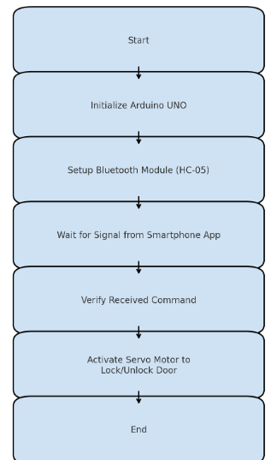

Fig 3.1: Flow Chart for Smart Door Locking System

Key design considerations included:

1. **Mechanism Development:** The development of a robust metal wire mechanism was prioritized to ensure the smooth and accurate operation of the door latch. The mechanism translates the rotary motion of the servo motor into linear motion for operating the latch and how servo motor works with Arduino Uno [2].
2. **Communication Integration:** The design incorporates a Bluetooth module that facilitates seamless communication between the Arduino microcontroller and a smartphone application. This allows real-time command transmission with minimal delay.
3. **Energy Optimization:** The system is designed to consume minimal power, leveraging efficient electronic components to ensure prolonged functionality even under continuous operation.
4. **User-Friendliness:** The mobile application’s interface was developed to be intuitive, featuring simple buttons for locking and unlocking the door. This ensures accessibility for users with minimal technical expertise.

**3.2 Components Used and Their Descriptions**

The Smart Door Locking System utilizes a combination of essential hardware and software components, as detailed below:

1. **Bluetooth Module (HC-05):** The HC-05 Bluetooth module is a key communication component in the system. It allows the Arduino Uno to establish a wireless connection with the mobile application. This module operates on Bluetooth 2.0 protocol and uses serial communication to exchange data. With a stable connectivity range of up to 10 meters, it ensures reliable and real-time transmission of commands. The HC-05 is compact and easy to integrate, making it an ideal choice for the project.

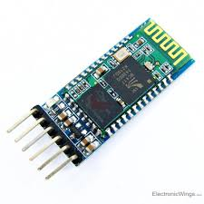

Fig 3.2: Bluetooth Module HC-05 [3]

1. **Servo Motor:** The **MG996 Servo Motor** is a high-torque digital servo known for its robust metal gears and reliability. It operates within a voltage range of 4.8V to 7.2V, delivering up to 11 kg/cm of torque at 6V, with a rotation range of 0° to 180°. Its quick response time (0.15 sec/60° at 6V) and PWM-based control ensure precise movements, while its sturdy design handles demanding applications effectively.

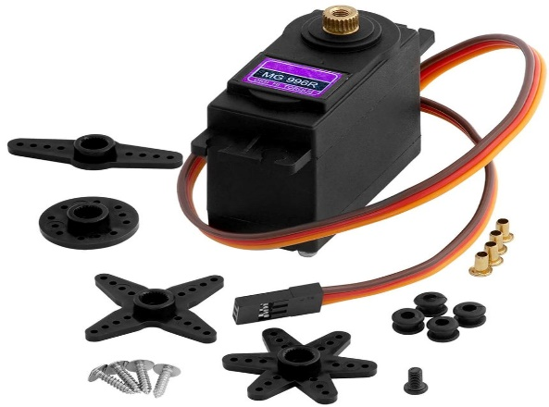

Fig 3.3: Servo Motor MG996 [4]

1. **Breadboard:** It consists of a grid of interconnected holes where electronic components and jumper wires can be inserted to create temporary connections. The layout typically includes **two power rails** for easy access to power and ground, and **interconnected rows of terminals** for connecting components.

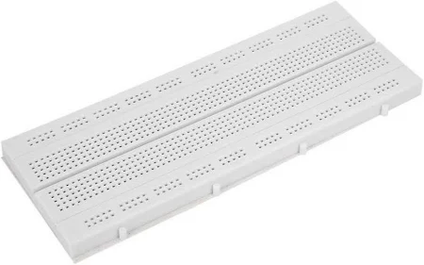

Fig 3.4: Breadboard [5]

1. **Jumper Wires:** Jumper wires are used to connect various electronic components on the breadboard, ensuring a modular and flexible setup. These components enable quick assembly and easy modifications during the development phase.

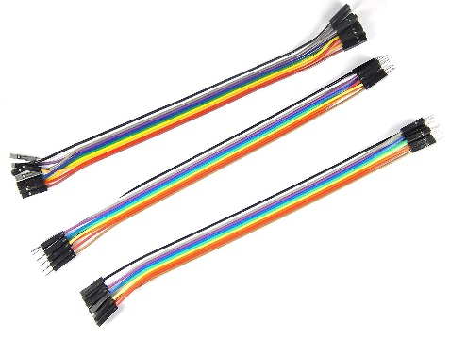

Fig 3.5: Jumper wires [6]

1. **Door Latch:** The door latch is a mechanical component integrated with the system. It works in conjunction with the servo motor and metal wire mechanism to physically lock or unlock the door. The latch is selected for its compatibility with the door's existing hardware and is robust enough to handle frequent operation.

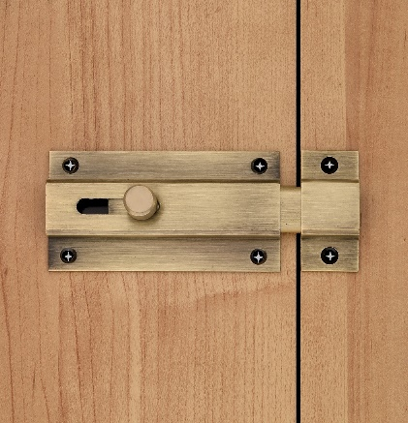

Fig 3.6: Door Latch [7]

1. **Arduino Uno:** The Arduino Uno microcontroller board acts as the central processing unit for the system. It processes signals received from the Bluetooth module and sends precise control commands to the servo motor. Its open-source nature and compatibility with various sensors and actuators make it a versatile choice for IoT applications.

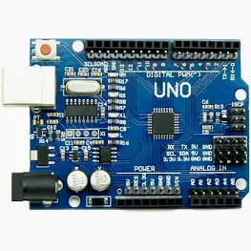

Fig 3.7: Arduino Uno [8]

* 1. **User Interface (Arduino Bluetooth Controller)**

1. **Wireless Operation:** Eliminates the need for physical connections, enabling seamless communication between the smartphone and the Arduino system.
2. **User-Friendly Interface:** Provides an intuitive layout, making it easy for users to send commands like "LOCK" or "UNLOCK" without technical expertise.
3. **Real-Time Control:** Allows immediate execution of commands, ensuring prompt locking or unlocking of the door latch.
4. **Security Through Pairing:** Restricts access to authorized devices via secure Bluetooth pairing, reducing risks of unauthorized control.
5. **Customizable Functionality:** Offers the ability to label or modify control buttons for a personalized user experience.
6. **Range Flexibility:** Operates within the Bluetooth range, enabling convenient remote operation for users nearby.
7. **Energy Efficiency:** Requires minimal power for operation, contributing to the overall efficiency of the IoT system.
8. **Integration with Arduino:** Communicates directly with the Arduino microcontroller to process commands and control the servo motor for door latch movement.

By acting as the central user interface, the Arduino Bluetooth Controller app is an integral part of the Smart Door Locking System, ensuring modernized, efficient, and secure access control.

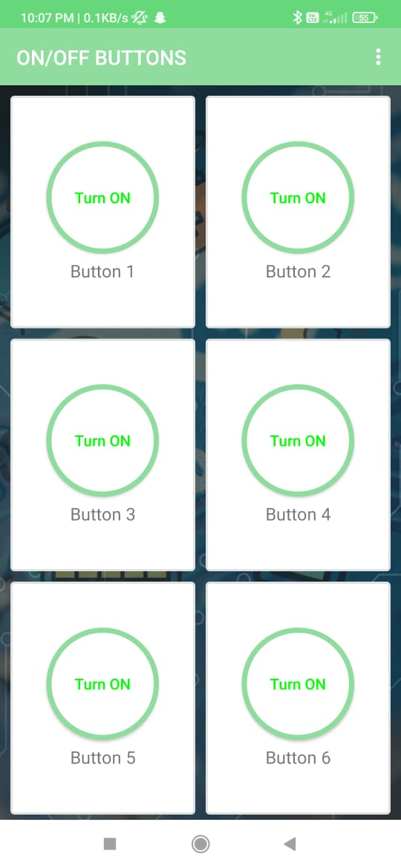

Fig 3.8: Interface from where we are controlling the locking and unlocking

**3.4 Results and Observations**

The project underwent extensive testing to evaluate its performance, functionality, and reliability under various conditions. The following results and observations were recorded:

* **Responsiveness:** The system demonstrated excellent responsiveness, with the servo motor actuating the door latch within a fraction of a second after receiving a command from the mobile app. This quick response ensures real-time control and user satisfaction.
* **Precision and Accuracy:** The metal wire mechanism operated seamlessly, accurately translating the servo motor's movements into the desired motion of the latch. The locking and unlocking positions were consistently achieved without any mechanical failure.
* **Connectivity Range:** The HC-05 Bluetooth module provided stable connectivity within a range of up to 10 meters, sufficient for most home and office environments. The connection remained robust, even in the presence of mild interference.
* **Energy Efficiency:** The system was designed to minimize power consumption. Testing revealed that the power draw remained low during standby and only increased momentarily during latch actuation. This efficiency makes the system suitable for long-term usage with minimal maintenance.
* **Reliability Under Stress:** The system was tested for durability by repeatedly locking and unlocking the door under varying environmental conditions. It maintained consistent performance, demonstrating reliability and robustness.

**CIRCUIT DIAGRAM:**

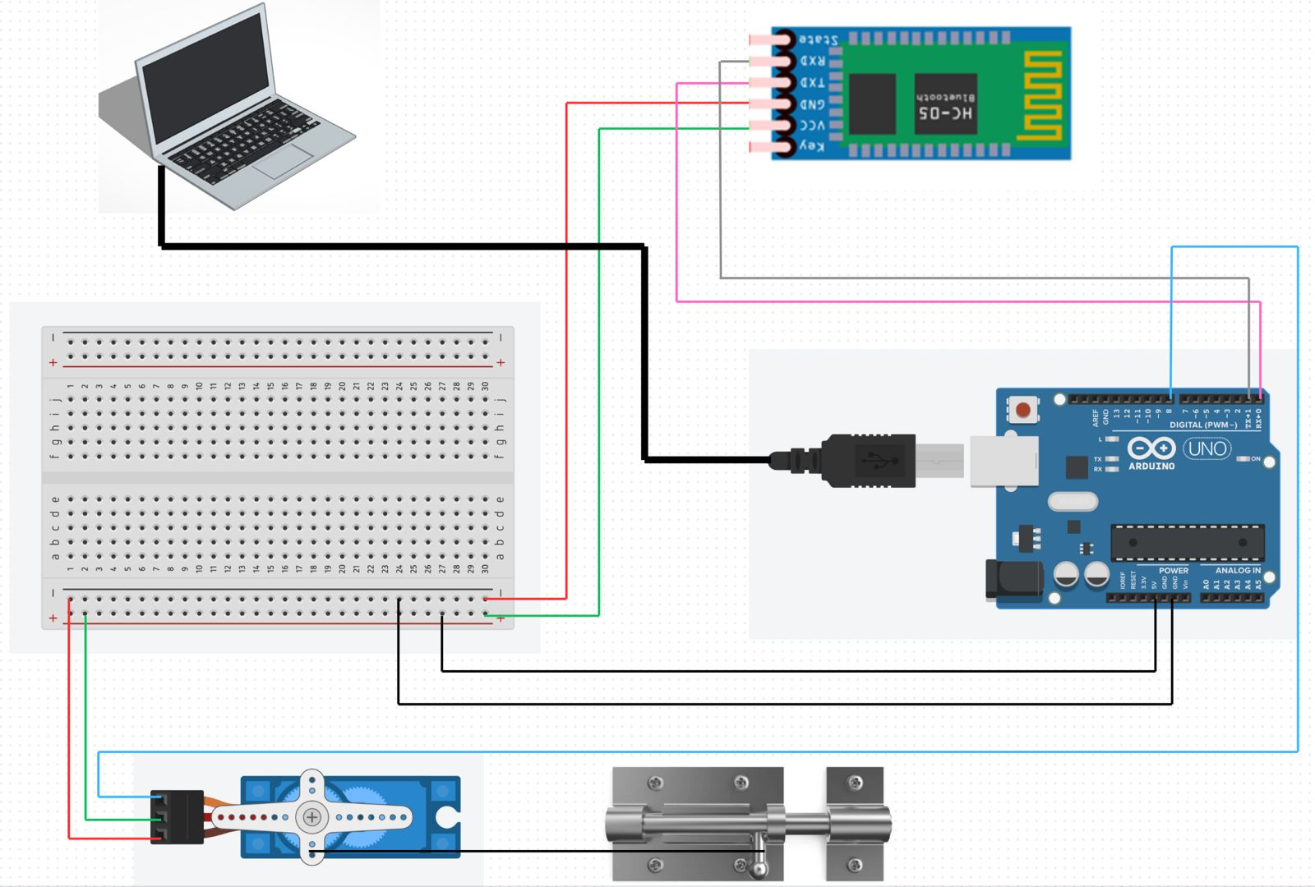

Fig 3.9: Circuit Diagram

**CODE:**

**OUTPUT:**

**CHAPTER 4 - OUTCOMES AND PROSPECTIVE LEARNING**

**4.1 Project Outcomes**

The IoT Smart Door Locking System successfully demonstrated the potential of integrating IoT with traditional locking mechanisms to enhance security and convenience. The project outcomes are summarized as follows:

* **Functional Automation:** The system effectively automated the door locking and unlocking process, reducing reliance on physical keys. The integration of a servo motor with the door latch provided precise and reliable actuation, ensuring that the door mechanism operated without manual intervention.
* **Seamless Connectivity:** The HC-05 Bluetooth module enabled real-time wireless communication between the mobile application and the Arduino Uno microcontroller. The system's responsiveness to user commands, even within its defined range, was highly efficient.
* **Energy Efficiency:** By optimizing power usage, the system maintained energy efficiency, consuming power primarily during active operation. This aspect makes it suitable for long-term deployment without frequent maintenance or battery replacements.
* **Cost-Effective Design:** Using widely available components such as the Arduino Uno, servo motor, and Bluetooth module ensured that the project remained cost-effective. The system demonstrated that advanced functionality could be achieved within budget constraints, making it viable for residential and small-scale commercial applications.

**4.2 Challenges and How They Were Addressed**

The development of the Smart Door Locking System presented several challenges, which were addressed through systematic analysis and problem-solving:

* **Precision in Mechanism Design:** Achieving precise coordination between the servo motor and the metal wire mechanism was critical to ensuring the accurate operation of the door latch. This challenge was addressed by carefully calibrating the servo motor's angular movement and using a high-strength wire for stability and durability.
* **Connectivity Stability:** Ensuring a stable connection within the operational range of the Bluetooth module was another significant challenge. Interference from nearby devices was mitigated by fine-tuning the Bluetooth settings and testing in various environments to optimize performance [9].
* **Durability Testing:** Repeated operation under varying conditions highlighted the need for robust materials and reliable components. By selecting high-quality parts and reinforcing critical connections, the system was made durable enough to withstand repeated usage.

**4.3 Prospective Learning and Knowledge Gained**

The completion of this project provided valuable learning experiences across multiple domains, fostering both technical and practical understanding:

* **Hands-On Experience with IoT Technology:** Working with the Arduino platform, Bluetooth communication, and servo motor control deepened knowledge of IoT hardware and its integration. This experience emphasized the importance of real-time data transmission and efficient device interaction.
* **System Design and Prototyping:** Designing a functional system from conceptualization to implementation provided insights into the iterative nature of prototyping. Challenges in hardware integration, circuit design, and mechanical assembly emphasized the importance of testing and optimization at every stage.
* **Interdisciplinary Knowledge:** The project required combining concepts from electronics, computer science, and mechanical engineering. This interdisciplinary approach enhanced problem-solving skills and underscored the value of integrating multiple fields for successful project execution.
* **Enhanced Programming Skills:** Programming the Arduino Uno to control the servo motor and interact with the Bluetooth module improved proficiency in microcontroller programming. Debugging real-world systems strengthened logical thinking and troubleshooting abilities.

**4.4 Potential Advancements and Applications**

The Smart Door Locking System presents a strong foundation for further development and broader applications. Prospective enhancements and learning opportunities include:

* **Integration with Cloud-Based Systems:** Extending the system to support cloud connectivity via Wi-Fi or GSM modules would allow remote access and real-time monitoring from anywhere in the world. This feature could be particularly valuable for users managing multiple properties [10].
* **Incorporation of Advanced Security Features:** Adding biometric verification, such as fingerprint scanning or facial recognition, could elevate the system's security capabilities. Implementing multi-factor authentication would ensure that unauthorized access is minimized.
* **Adaptation for Broader Applications:** The principles and design of the system could be adapted for use in other automated security solutions, such as smart safes, locker systems, and industrial gates. These adaptations could open avenues for learning about scalability and system customization.

**CONCLUSION AND FUTURE SCOPE**

The IoT Smart Door Locking System successfully integrates modern IoT technology with traditional locking mechanisms to enhance security and convenience. By automating the locking process through components like the servo motor, Bluetooth module, and Arduino Uno, the system provides a cost-effective, energy-efficient solution for remote door control via a mobile application.

The project highlights the seamless integration of existing hardware with innovative technologies, ensuring precise operation, stable connectivity, and long-term durability. Challenges, including mechanical precision and connectivity optimization, were effectively addressed, enhancing the team’s technical and problem-solving skills. The project’s interdisciplinary approach combined concepts from electronics, computer science, and mechanical engineering, fostering creativity and analytical thinking. This system serves as a foundation for future advancements, including cloud integration, biometric security, and AI-driven analytics. Such enhancements could expand its application to smart homes, industrial gates, and commercial security solutions.

In conclusion, the IoT Smart Door Locking System demonstrates how technology can simplify daily tasks while improving efficiency and security. It not only achieves its intended objectives but also lays the groundwork for innovative developments in IoT-based automation and security systems.

**Future Scope:**

1. **Integration with Advanced IoT Ecosystems:** Expand the system to connect with other smart home devices, such as security cameras, motion sensors, or lights, creating a fully integrated home automation network.
2. **Biometric Authentication:** Upgrade the system to include biometric authentication, such as fingerprint or facial recognition, for enhanced security and convenience.
3. **AI-Powered Security Monitoring:** Implement AI algorithms to analyze usage patterns and detect unauthorized access attempts, notifying the user in real time.
4. **Cloud Storage and Remote Monitoring:** Store access logs on cloud platforms for long-term record keeping, and allow users to monitor and control the door lock remotely via a dedicated app or website.
5. **Energy Efficiency Features:** Integrate energy-saving mechanisms such as automatic sleep mode for unused components or solar-powered locks for eco-friendly operation.
6. **Voice Assistant Compatibility:** Enable compatibility with popular voice assistants like Alexa, Google Assistant, or Siri, allowing users to control the lock with voice commands.
7. **Multi-Lock Synchronization:** Expand the system to control multiple locks in a building, synchronizing them for centralized management in offices or apartments.
8. **Emergency Features:** Add panic modes or emergency access settings, such as temporary access for first responders during emergencies.
9. **Enhanced Data Security:** Incorporate advanced encryption methods to safeguard data transmission between the Bluetooth module and the user's device.

**REFERENCES**

[1] https://how2electronics.com/password-based-security-system-arduino-keypad/

[2] Banzi, M., & Shiloh, M. (2014). Getting Started with Arduino. Maker Media, Inc.

[3] <https://www.electronicwings.com/sensors-modules/bluetooth-module-hc-05->

[4] https://www.casadarobotica.com/robotica/atuadores/servos/servo-digital-mg996r-15kg-alto-torque-metal-mg996

[5]https://www.flipkart.com/fedus-840-points-bread-board-solderless-piecesb-circuit-test-electronic-components-hobby-kit/p/itm5f21522a188c7?pid=EHKFJZ6MQ8GQTWZF&lid=LSTEHKFJZ6MQ8GQTWZFFADAD5&marketplace=FLIPKART&cmpid=content_electronic-hobby-kit_8965229628_gmc

[6]<https://www.amazon.in/ApTechDeals-Jumper-Female-breadboard-jumper/dp/B074J9CPV3>

[7] <https://materialdepot.in/door-latches>

[8]<https://robu.in/product/arduino-uno-r3-ch340g-atmega328p-devlopment-board/?gad_source=1&gclid=Cj0KCQiA0fu5BhDQARIsAMXUBOJ3cYS5WW8hQYtwUR0v7Y76t4dN4ZLrq1w_VSZCmm2LarPJxzIx1UQaAiWNEALw_wcB>

[9] Singh, N., & Nene, M. J. (2018). "A Review on Security and Privacy Challenges in IoT". International Journal of Computer Applications, 182(40), 1-7.

[10] Raj, P., & Raman, A. C. (2017). Internet of Things: Enabling Technologies, Security and Social Implications. CRC Press.