Files -> Preferences->Copy and paste->ok:

http://arduino.esp8266.com/stable/package_esp8266com_index.json

https://raw.githubusercontent.com/espressif/arduino-esp32/gh-pages/package_esp32_index.json

<https://www.pjrc.com/teensy/package_teensy_index.json>

Libraries  
  
espnowcam

Packages

Arduino esp32 boards

Esp32

Tools->board->board manager->AI thinker esp

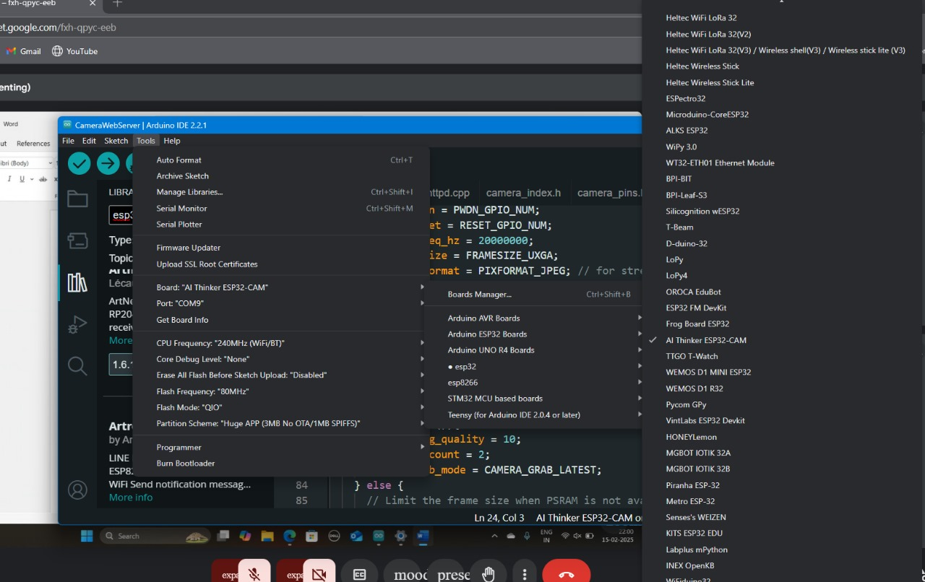

Files ->examples->esp->camera->camera webserver

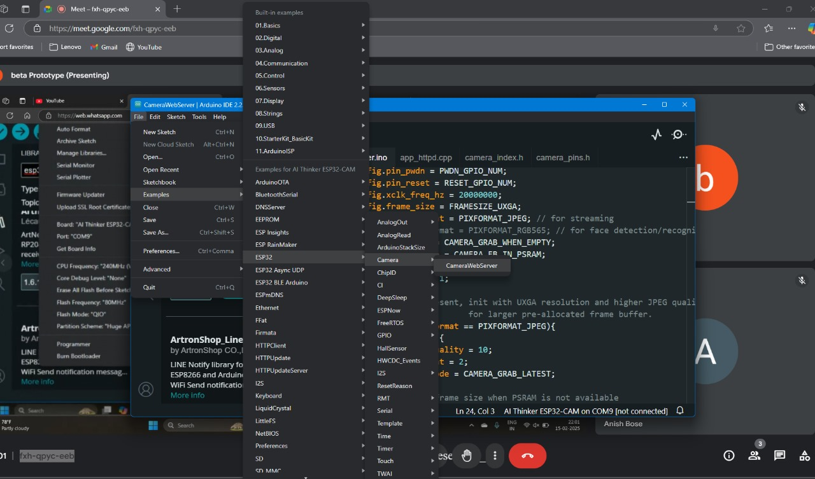

Baud rate 115200

In ui change 20 to 2 for camera