1.Running the Test ServerDouble-click the`datachannel_test_server.exe`file to launch it.The interface upon running is shown in the figure below.The`taskId`for the simulated application run is123456.During development,you can use this`taskId`for joint debugging and testing.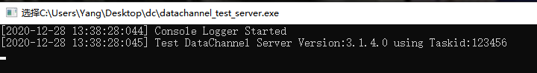
2.Documentation Directory Description
• `c++`Contains code snippets for C++development of the data channel,suitable for C++-based development scenarios.
• `webclient`Includes a web client demo,which is a front-end page with an iframe for testing purposes.It is recommended to use WebSDK in actual production environments.
• `unity`Contains the source code for the Unity test application of the data channel.After packaging,the application can be uploaded directly to the LarkXR backend and used for joint debugging and testing with the web client.
• `unreal`Contains the source code for the Unreal test application of the data channelrefer to theCSDN blog.After packaging,the application can also be uploaded to the LarkXR backend and used for joint debugging and testing with the web client.

