I Prerequisites for Using the Data Channel 2
II Using the Demo 2
2.1 Modify ConfigurationLocate 2
2.2 Effect After Running 2
III Instructions for Use 3
3.1 Listen for Messages 3
3.2 Send Messages 4

I Prerequisites for Using the Data Channel
- Enable the Data Channel Service in Authorization
- Integrate the Data Channel Plugin into the ApplicationData Channel Application Demo
https://home-oss.pingxingyun.com/test_appli/unity-datachannel.zip

II Using the Demo

2.1 Modify ConfigurationLocate
- Locate the`\datachannel\js\datachannel.js`file and make the following modifications
First Line
• `192.168.0.50`is the IP address of the management node.
• `8181`is the port for the LarkXR interface servicedefault is 8181,no need to modify.
Third Line
var config = {
server: "http://" + serverAddr + "/", // server
webclient: "http://" + serverAddr + "/webclient", // client
// webclient: "http://192.168.0.122:8080/", // debug client
testAppId: "745609250029436928",
}
`testAppId`is the ID of the application you want to test.The application ID can be viewed in the application overview in the backend,as shown in the figure belowApplication ID ExamplePlease replace with the actual screenshot link or path.
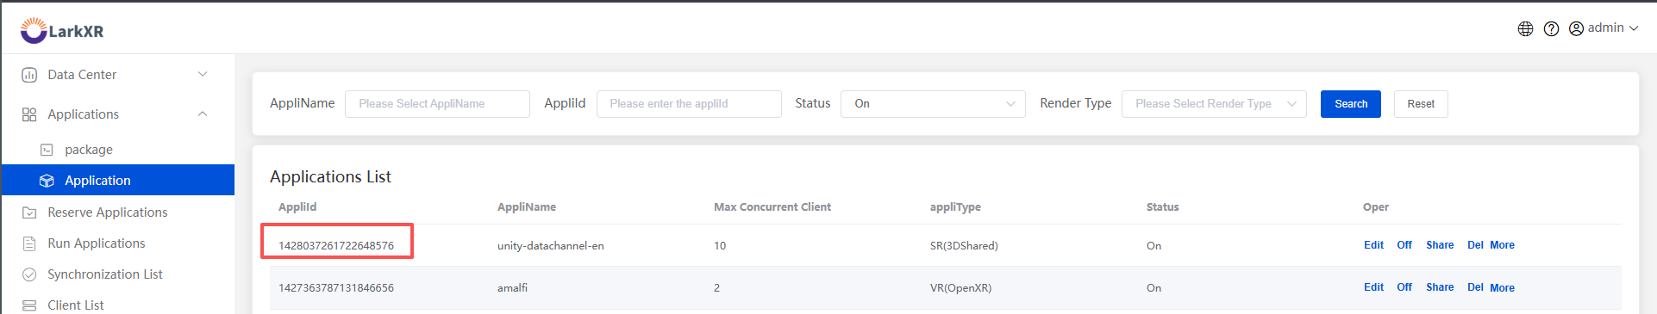
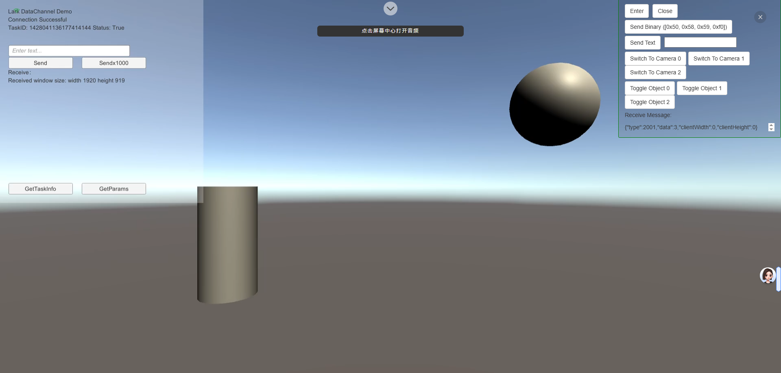

III Instructions for Use

3.1 Listen for Messages
var poster = new lark.iframePoster($("#iframe").get(0), {
onMessage: onMessage,
listenKeyboard: true,
});

// Listen for messages
function onMessage(e) {
switch (e.data.type) {
case 20200: // Channel Opened
console.log("Channel Opened", e.data.data);
$("#receive").text("Channel Opened");
break;
case 20201: // Channel Closed
console.log("Channel Closed", e.data.data);
$("#receive").text("Channel Closed");
break;
case 20202: // Received Byte Message
console.log("Received Byte Message", e.data.data);
$("#receive").text(e.data.data);
break;
case 20203: // Received Text Message
console.log("Received Text Message", e.data.data);
handleJsonCmd(e.data.data);
break;
default:
console.log("Unknown Message Type", e.data);
break;
}
}

3.2 Send Messages
// Send Text Message
function sendText(jsonStr) {
poster.sendTextToRenderSererAppDataChannel(jsonStr);
}

// Send Byte Message
function sendBinary(binary) {
poster.sendBinaryToRenderServerAppDataChannel(binary);
}

