Employee Sentiment & Engagement Analysis – Final Report

1. Introduction
Objective:
The goal of this project is to analyze internal email communications to evaluate employee sentiment and engagement, identify flight risks, and develop a predictive model for future sentiment trends.
Scope:
- Analyze email content (subject + body) using NLP.
- Label sentiment (Positive, Neutral, Negative).
- Compute monthly sentiment scores and rank employees.
- Identify employees at risk of disengagement.
- Build a predictive model to forecast employee sentiment.

2. Methodology
Step 1: Data Collection & Inspection
- Loaded the dataset containing columns: subject, body, date, from.
- Checked for missing values, duplicates, and valid date formats.
Step 2: Data Cleaning
- Combined subject + body into a single text column.
- Removed signatures, forwarded chains, and reply headers.
- Cleaned text (lowercasing, removing special characters, extra spaces).
- Extracted employee_id from the from field and month from date.
Step 3: Sentiment Labeling
- Applied NLP sentiment analysis using VADER.
- Labeled emails as Positive, Neutral, or Negative.
- Verified and manually inspected sample emails for accuracy.
Step 4: Feature Engineering
- Created sentiment_score mapping: Positive=+1, Neutral=0, Negative=-1.
- Aggregated per employee per month:
  - Total emails
  - Total negative emails
  - Average sentiment score
Step 5: Employee Scoring & Ranking
- Calculated monthly and average sentiment scores for each employee.
- Ranked employees based on average sentiment score (highest → most positive).
Step 6: Flight Risk Identification
- Defined flight risk as sending ≥4 negative emails in a month.
- Aggregated negative counts per employee per month to flag at-risk employees.
Step 7: Predictive Modeling
- Built a linear regression model using features: email count, negative email count, previous month score.
- Evaluated model using MSE and R².
- Optionally, built text-based predictive model using TF-IDF + Logistic Regression to predict sentiment directly from email content.

3. Exploratory Data Analysis (EDA) Findings
Overall Sentiment Distribution:
Sentiment | Count
Positive | 1571
Neutral | 172
Negative | 448

Visual:
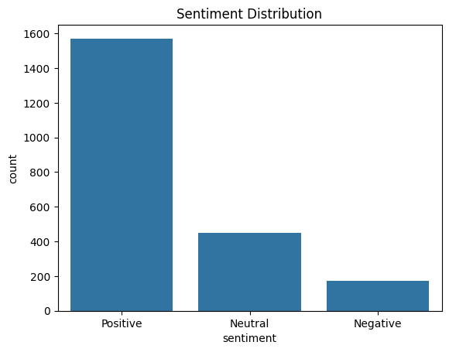

Employee Activity:
- Top 5 active employees by email count:
Employee ID | Emails Sent
lydia.delgado | 284
John.arnold | 256
Sally.beck | 227
Patti.thompso | 225
Bobette.riner | 217
Visual:
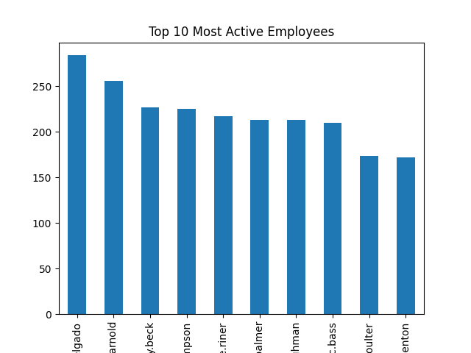

Sentiment Over Time:
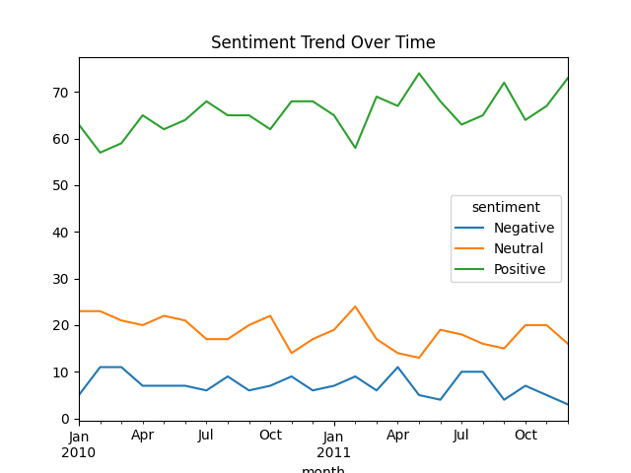

4. Employee Scoring & Ranking
Monthly Sentiment Score Calculation:
Score of sentiment scores for all emails in the month of emailsMonthly Score=Number of emailsSum of sentiment scores for all emails in the month​
Visual:
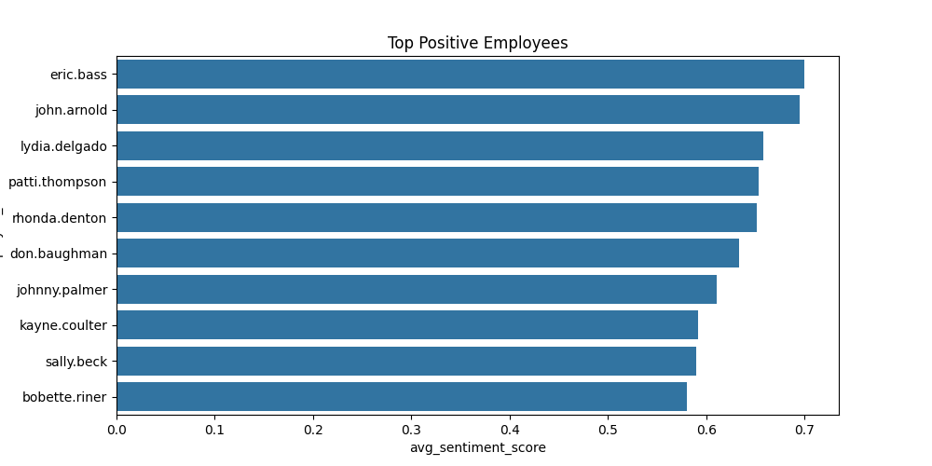

5. Flight Risk Identification
Criteria: ≥4 negative emails in a single month.
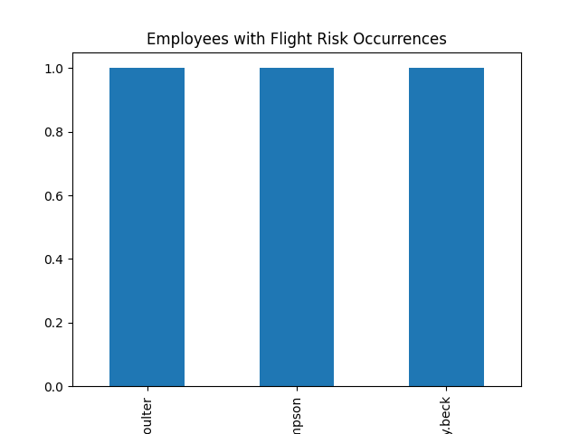

6. Predictive Modeling Overview
Model: Linear Regression to predict monthly sentiment score.
Features:
- Email count
- Negative email count
- Previous month’s sentiment score
Evaluation Metrics:
- Mean Squared Error (MSE): 2.101
- R² Score: 0.80
Feature Coefficients:
Feature | Coefficient | Interpretation
Email Count | +0.768 | More emails slightly increase sentiment
Negative Count | -1.706 | More negative emails strongly reduce sentiment
Previous Score | -0.035 | Past sentiment strongly predicts current sentiment
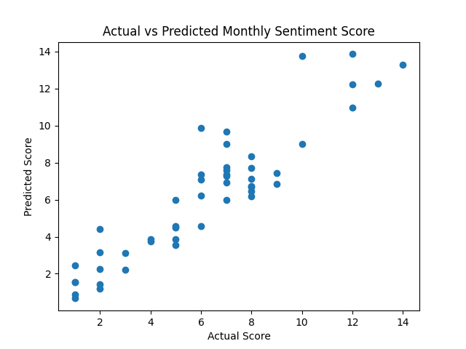

7. Conclusions & Recommendations
Key Findings:
- Majority of emails are positive,other emails are ~20%.
- Certain employees consistently show negative sentiment → flag for intervention.
- Predictive model can forecast sentiment trends with reasonable accuracy.

