PROJECT REPORT
ON
ADAPTIVE FAULT-TOLERANT
MULTI-SENSOR FUSION FOR
REAL-TIME AUTONOMOUS SYSTEMS
SUBMITTED IN PARTIAL FULFILMENT OF THE REQUIREMENTS FOR THE AWARD OF DEGREE OF
BACHELOR OF TECHNOLOGY IN
COMPUTER SCIENCE & ENGINEERING

Submitted By:
Name: | Sundram Kumar Ray | Arshiya | Parbinder Singh | Anupriya
Roll No. | 23BECSE52 | 23BECSE09 | 23BECSE35 | 23BECSE07
Group No. 23G15
Under the Supervision of: Prof. Dinesh Kumar, Professor
DEPARTMENT OF COMPUTER SCIENCE & ENGINEERING
CENTRAL UNIVERSITY OF JAMMU
Rahya-Suchani (Bagla), District Samba-181143, Jammu (J&K)
October 2026

Abstract
Reliable environmental perception under sensor degradation is a fundamental safety requirement for autonomous transportation systems. These systems combine RGB cameras, thermal infrared sensors and LiDAR because each fails under different conditions, yet most multi-sensor fusion networks weight every sensor the same way regardless of its state, so a silently failing sensor feeds corrupted features into the fused representation.
This project presents the Adaptive Fault-Tolerant Multi-Sensor Fusion (AFTMSF) framework, a deep learning system that integrates RGB, thermal and LiDAR-derived depth through confidence-gated cross-modal attention. A three-signal fault detector (autoencoder reconstruction error, feature variance and prediction entropy) estimates a confidence score for each sensor at runtime without fault labels, and the Adaptive Cross-modal Attention Fusion (ACAF) module uses those scores to weight each sensor's contribution. One network produces anchor-free (FCOS-style) detections and DeepLabV3+-style segmentation.
On the KAIST multispectral test set (131 images), AFTMSF reaches 89.14% mAP@0.5 and 44.28% mIoU, ahead of RGB-only (69.97%), early-fusion (70.66%) and late-fusion (77.89%) baselines built from the same components. Under complete RGB sensor dropout it keeps 63.85% mAP, whereas all three baselines fall to 0%. Inference-time ablations show that this robustness comes mainly from the cross-modal attention architecture and fault-injection training: removing the confidence gating changes accuracy by less than one percentage point. On KITTI (RGB + LiDAR depth) the same architecture reaches 21.53% mAP@0.5 and 22.55% mIoU without structural changes; on FLIR, detection is limited by very small objects (1.52% mAP) while segmentation reaches 16.34% mIoU. The model has 67.35M parameters and runs at 22.2–26.0 FPS on a 6 GB laptop GPU. All results in this report were re-measured from the trained models in October 2026.
Keywords: multi-sensor fusion, fault tolerance, cross-modal attention, autonomous driving, pedestrian detection, semantic segmentation, thermal imaging, LiDAR.

Acknowledgement
We express our sincere gratitude to our project supervisor Prof. Dinesh Kumar, Professor, Department of Computer Science & Engineering, Central University of Jammu, for his continuous guidance, encouragement and valuable suggestions throughout this project.
We thank the Department of Computer Science & Engineering, Central University of Jammu, for providing computational resources and academic support.
We also acknowledge the research community that made the KAIST, KITTI and FLIR datasets, as well as PyTorch, openly available for academic research.

Sundram Kumar Ray (23BECSE52)
Arshiya (23BECSE09)
Parbinder Singh (23BECSE35)
Anupriya (23BECSE07)

Group No. 23G15
Department of CSE
Central University of Jammu
October 2026

Contents
Abstract
Acknowledgement
Contents
Chapter 1: Introduction
1.1 Project Overview
1.2 Objectives of the Project
1.3 Problem Formulation
1.4 Existing System
1.5 Proposed System
1.6 Features of the Project
Chapter 2: Requirement Analysis
2.1 Feasibility Study
2.2 Software Requirement Specification
2.3 SDLC Model Used
Chapter 3: System Design
3.1 Product Perspective
3.2 Product Functions
3.3 User Characteristics
3.4 Constraints
3.5 Operational Data Flow
3.6 Data Storage Design
3.7 Configuration and Checkpoint Structure
3.8 ER Diagram
3.9 Assumptions and Dependencies
3.10 Specific Requirements
Chapter 4: Implementation
4.1 Project Directory Structure
4.2 Mathematical Formulation
4.3 Model Statistics
4.4 Training Results
Chapter 5: Results and Evaluation
5.1 Evaluation Metrics and Protocol
5.2 Comparison with Baselines
5.3 Relation to Published Methods
5.4 Fault Injection Results
5.5 Robustness Compared with Baselines
5.6 Ablation Study
5.7 Confidence Scores and Fusion Weights
5.8 Cross-Dataset Generalisation
5.9 Speed and Accuracy Trade-off
Chapter 6: Discussion and Conclusions
6.1 Key Findings
6.2 Limitations
6.3 Future Work
6.4 Conclusion
References
Appendix A: Installation and Reproduction Guide
A.1 Environment Setup
A.2 Training Commands
A.3 Evaluation and Experiment Commands
A.4 Final Achievements Summary

If page numbers are not shown, right-click the table of contents in Word and choose Update Field.

Chapter 1: Introduction

1.1 Project Overview
The rapid growth of autonomous systems, including self-driving vehicles, unmanned aerial vehicles, robotic platforms and intelligent industrial systems, has introduced a critical challenge: achieving reliable environmental perception under real-world conditions.
This project falls under research-based artificial intelligence and machine learning system development, with a focus on computer vision and autonomous perception. Such systems depend on heterogeneous sensors, namely RGB cameras, thermal infrared sensors and LiDAR, to capture complementary information. Individual sensors fail under adverse conditions such as low illumination, fog, rain, occlusion or hardware malfunction.
To address this, the project develops the Adaptive Fault-Tolerant Multi-Sensor Fusion (AFTMSF) system, which integrates RGB, thermal and LiDAR-derived depth data using confidence-gated cross-modal attention. The system was implemented and evaluated on three public benchmarks:
- KAIST Multispectral Pedestrian Dataset (RGB + thermal): a 1,374-image subset in YOLO early-fusion format, split 1,107 / 136 / 131 (train / validation / test) [3].
- KITTI Vision Benchmark (RGB + LiDAR): 7,481 training samples with Velodyne point clouds, of which 748 (10%) are held out for validation [5].
- FLIR ADAS v1.3 (RGB + thermal): 8,363 training and 1,257 validation image pairs [4].

1.2 Objectives of the Project
- Multi-modal fusion framework: design and implement a fusion framework integrating RGB, thermal and LiDAR depth data.
- Adaptive fusion mechanism: develop confidence-gated cross-modal attention that weights sensor modalities by estimated reliability.
- Fault detection and graceful degradation: implement a three-signal fault detector and keep useful performance when a sensor degrades or fails.
- Benchmark evaluation: evaluate on KAIST, KITTI and FLIR using mAP@0.5 and mIoU, against single-modality, early-fusion and late-fusion baselines, under systematic fault injection.

1.3 Problem Formulation
Individual sensors have specific weaknesses:
- RGB cameras fail under low light and glare.
- Thermal sensors lack texture and colour detail.
- LiDAR produces sparse data that degrades in rain and fog.
Most fusion systems assume that all sensors function correctly. In practice, sensor reliability varies over time. The problem addressed is: given N sensor inputs {x₁, …, x_N}, design a fusion function F that estimates a confidence cᵢ ∈ [0, 1] for each modality and maintains the highest possible detection and segmentation performance under partial sensor failure.

1.4 Existing System
Multi-sensor fusion approaches fall into three paradigms [1], [8]:
- Early fusion concatenates raw inputs; it is simple but sensitive to calibration errors and to failure of any one input.
- Late fusion combines per-sensor decisions; it misses feature-level interactions between modalities.
- Intermediate fusion integrates learned features and gives the best accuracy, but typically assumes all sensors are reliable.
Table 1.1: Research gap analysis
Work | Approach | Limitation addressed by this project
Zhang et al. [1] | Survey of fusion for driving | No adaptive runtime weighting
Li et al. [2] | Deep multimodal fusion review | Fault tolerance not addressed
Bijelic et al. [7] | Multimodal fusion in adverse weather | Performance drops when sensors degrade
TransFuser [10] | Transformer camera–LiDAR fusion | No explicit sensor reliability estimate
BEVFusion [11] | Bird's-eye-view fusion | High computational cost; fixed fusion
Wang et al. [12] | Sensor fault detection survey | Detection not integrated with fusion

1.5 Proposed System
AFTMSF addresses these limitations with four components (Figure 1.1):
- Modality encoders: ResNet-50 + FPN for RGB and thermal [13], [14]; a lightweight depthwise-separable CNN + FPN for LiDAR depth.
- Fault detector: a three-signal confidence estimate cᵢ for each modality.
- ACAF module: confidence-gated cross-modal attention at four feature scales.
- Task heads: FCOS-style detection [15] and DeepLabV3+-style segmentation [16].
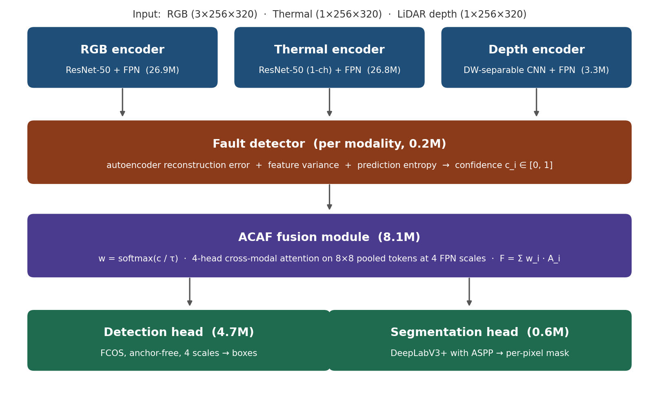
Figure 1.1: AFTMSF architecture. Each encoder produces 256-channel FPN features; the fault detector estimates a confidence per modality; ACAF fuses the features and feeds the detection and segmentation heads. Parameter counts are measured from the trained KAIST model.

1.6 Features of the Project
- Multi-modal sensor fusion of RGB, thermal and LiDAR depth in one architecture.
- Confidence-gated fusion: per-modality weighting from a three-signal reliability estimate.
- Graceful degradation: 63.85% mAP@0.5 under complete RGB dropout, where all baselines drop to 0%.
- Multi-task output: simultaneous object detection and semantic segmentation.
- Runs on a laptop GPU: 22.2–26.0 FPS on a 6 GB RTX 4050.
- Three-dataset evaluation: KAIST, KITTI and FLIR, with fault injection, baselines and ablations.
- Reproducible: code, configurations, results and figure scripts published at github.com/Parbinder29/ATMSF.
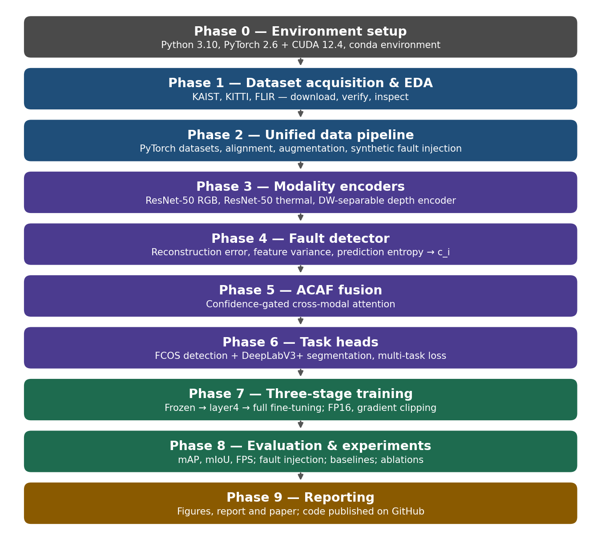
Figure 1.2: Project development pipeline, from environment setup to reporting.

Chapter 2: Requirement Analysis

2.1 Feasibility Study

2.1.1 Technical Feasibility
All required components are available and well supported: PyTorch 2.6.0 with CUDA 12.4, an NVIDIA RTX 4050 laptop GPU, public benchmark datasets and standard deep learning modules. The 6 GB GPU memory limit was handled with mixed-precision (FP16) training, gradient checkpointing, batch size 1 in the later training stages, and spatial pooling of attention to 8 × 8 tokens.

2.1.2 Operational Feasibility
The trained system runs at 22.2–26.0 frames per second on edge-class hardware. The fault detector needs no fault labels at inference time. The modular design allows individual components to be updated or replaced.

2.1.3 Economic Feasibility
All software is open source (Python, PyTorch, OpenCV) and all datasets are freely available for research. The main cost is GPU computation time, approximately 80 hours in total on a personal laptop. No commercial licences are required.

2.2 Software Requirement Specification

2.2.1 Functional Requirements
- Accept RGB (3-channel), thermal (1-channel) and depth (1-channel) inputs.
- Estimate a confidence score cᵢ ∈ [0, 1] for each modality.
- Fuse modality features with confidence-gated cross-modal attention.
- Output bounding-box detections and per-pixel segmentation maps.
- Flag a modality as faulty when cᵢ < 0.15.
- Run at ≥ 10 FPS on 6 GB GPU hardware.
- Log training metrics to TensorBoard.

2.2.2 Non-Functional Requirements
- Performance: mAP@0.5 ≥ 85% on KAIST (achieved: 89.14%).
- Reliability: no crash or collapse under complete dropout of one sensor (verified).
- Portability: any CUDA-capable NVIDIA GPU; Windows 11 or Linux.
- Scalability: the architecture accepts any subset of modalities without structural changes.

2.2.3 Hardware Requirements
Table 2.1: Hardware requirements and configuration used
Component | Minimum | Used
GPU | NVIDIA, 6 GB VRAM | RTX 4050 Laptop GPU, 6 GB
CPU | Intel i5 / Ryzen 5 | Intel Core i7, 13th generation
RAM | 8 GB | 16 GB DDR5
Storage | 200 GB free | 256 GB SSD + 256 GB HDD (datasets ≈ 51 GB)
Operating system | Windows 10 / Ubuntu | Windows 11
NVIDIA driver | Supports CUDA 12.x | 610.62

2.2.4 Software Requirements
Table 2.2: Software stack (versions in the current environment)
Software | Version | Purpose
Python | 3.10.22 | Core language
PyTorch | 2.6.0 + cu124 | Deep learning framework
torchvision | 0.21.0 + cu124 | ResNet-50, FPN, detection ops
CUDA runtime | 12.4 | GPU acceleration
OpenCV | 4.11.0 | Image processing
NumPy | 2.2.6 | Numerical computation
Matplotlib | 3.10.1 | Figures
Albumentations | 2.0.7 | Data augmentation
timm | 1.0.15 | Pretrained model utilities
einops | 0.8.1 | Tensor rearrangement
TensorBoard | 2.19.0 | Training monitoring
Open3D | 0.18.0 | Point-cloud support
Miniconda (conda) | 26.7.1 | Environment management
Git / GitHub | — | Version control and code publication
VS Code | Latest | Development environment

2.3 SDLC Model Used
The project follows the iterative and incremental development model, which suits research-based AI systems where requirements evolve as experimental results reveal new insights. The three-stage training curriculum mirrors three development iterations:
- Iteration 1 (Stage 1): encoders frozen — validates the fusion module design.
- Iteration 2 (Stage 2): last encoder block unfrozen — refines encoder features.
- Iteration 3 (Stage 3): full end-to-end training — final model.
A further iteration in October 2026 rebuilt the software environment, re-ran every evaluation from the saved models, made the fault experiments reproducible with fixed random seeds, and added baseline-robustness and ablation experiments. All numbers in this report come from that iteration.

Chapter 3: System Design

3.1 Product Perspective
AFTMSF is a standalone research prototype of a fault-tolerant perception module for autonomous systems. It accepts synchronised sensor images and outputs structured perception data (bounding boxes, segmentation maps and per-sensor confidence scores) for downstream planning modules. It builds on attention-based fusion [6], [10], [11] and adds runtime reliability estimation.

3.2 Product Functions
- Multi-modal feature extraction: independent 256-channel FPN features for each modality.
- Runtime reliability estimation: three-signal confidence scoring without external labels.
- Adaptive attention fusion: confidence-gated cross-modal attention at four scales.
- Object detection: anchor-free FCOS-style detection of pedestrians and vehicles at four FPN scales.
- Semantic segmentation: DeepLabV3+-style per-pixel labelling.

3.3 User Characteristics
- Autonomous-system engineers integrating the module into a vehicle stack.
- AI/ML researchers extending it to new sensors or fault models.
- Dataset evaluators running standard benchmarks for comparison.
Users need working knowledge of Python and deep learning, and access to a CUDA-capable GPU.

3.4 Constraints
- GPU memory: 6 GB requires batch size 1 in Stages 2–3 and attention pooled to 8 × 8 tokens.
- Resolution: images are processed at 256 × 320 instead of KAIST's native 512 × 640.
- FLIR detection: annotated objects average about 6 × 15 pixels at this resolution, smaller than the stride-4 feature map resolves well.
- Single GPU: no distributed training, which limits model size and training time.

3.5 Operational Data Flow
- Sensor images are captured and spatially aligned.
- Each modality is encoded independently into four-scale FPN features.
- The fault detector computes a confidence cᵢ for each modality from its highest-resolution features.
- ACAF computes fusion weights w = softmax(c / τ) and performs cross-modal attention at each scale.
- The detection head processes the four fused feature scales.
- The segmentation head processes the aggregated stride-4 feature.
- Detections, segmentation and confidence scores are passed to the planning module.

3.6 Data Storage Design
The project uses structured directories rather than a relational database:
- data/kaist/ — YOLO-format RGBA images (RGB + thermal) and labels.
- data/kitti/training/ — camera images, Velodyne point clouds and labels.
- data/flir/FLIR_ADAS_1_3/ — RGB and 8-bit thermal images with COCO-format JSON annotations.
- experiments/ — model checkpoints (.pth), TensorBoard logs, result files (JSON/YAML) and figures.

3.7 Configuration and Checkpoint Structure

3.7.1 Dataset Configuration (YAML)
Each configuration file (configs/kaist.yaml, kitti.yaml, flir.yaml) contains: dataset (name, root, modalities, number of classes, image size), preprocessing (normalisation mean and standard deviation), augmentation (flip and colour-jitter flags), dataloader (batch size, workers) and fault_injection (modes, probability, noise level).

3.7.2 Checkpoint Dictionary
Each .pth checkpoint stores: epoch (int), model (all weights), optimizer (AdamW state), loss (float) and config (training configuration).

3.8 ER Diagram
Not applicable: the system has no relational database. Data relationships are expressed through PyTorch dataset classes, collate functions and YAML configuration files.

3.9 Assumptions and Dependencies
Assumptions:
- Sensors are spatially calibrated before their images reach the fusion module.
- At least one modality keeps working (the system handles degradation, not total blackout).
- Ground-truth annotations are available for training; inference needs no labels.
Dependencies: PyTorch 2.6 with CUDA 12.x; an NVIDIA GPU with at least 6 GB of memory; ImageNet-pretrained ResNet-50 weights (downloaded automatically by torchvision).

3.10 Specific Requirements

3.10.1 Encoder Specifications
Table 3.1: Modality encoders (parameter counts measured from the model)
Encoder | Backbone | Parameters
RGB | ResNet-50 + FPN | 26,854,464
Thermal | ResNet-50 (1-channel input) + FPN | 26,848,192
Depth | Depthwise-separable CNN + FPN | 3,331,168

The thermal encoder adapts ResNet-50's first convolution from three input channels to one by averaging the pretrained RGB filters, which keeps the benefit of ImageNet pre-training.

3.10.2 Depth Encoder Layers
Table 3.2: Depth encoder, layer by layer (measured parameters)
Layer | Type | Output channels | Stride | Parameters
Sparse fill | Dilated convolutions (rates 2, 4) | 1 | 1 | 2,464
Stem | Conv 7×7 + max-pool | 32 | 4 | 1,632
Stage 1 | DW-separable × 2 | 64 | 4 | 9,632
Stage 2 | DW-separable × 2 | 128 | 8 | 35,648
Stage 3 | DW-separable × 2 | 256 | 16 | 136,832
Stage 4 | DW-separable × 2 | 512 | 32 | 535,808
FPN neck | Feature pyramid network | 256 | 4–32 | 2,609,152
Total |  |  |  | 3,331,168

3.10.3 ACAF Module Parameters
Table 3.3: ACAF module design
Parameter | Value
Attention heads | 4
Feature channels | 256 (matches FPN output)
Spatial tokens per modality | 8 × 8 = 64 (adaptive average pooling)
Temperature τ | learned; initialised 1.0, trained value 0.761
FPN scales | 4 (strides 4, 8, 16, 32)
Attention size, finest scale (KAIST) | 5,120 × 10,240 → 64 × 128 entries (6,400× smaller)
Parameters | 8,143,364

3.10.4 Training Configuration
Table 3.4: Training configuration (KAIST)
Parameter | Stage 1 | Stage 2 | Stage 3
Epochs planned / run | 10 / 10 | 10 / 4 | 30 / 36 (6 + 30 after resume)
Base learning rate | 1 × 10⁻³ | 5 × 10⁻⁴ | 1 × 10⁻⁴
Schedule | Cosine | Cosine | Cosine
Trainable encoders | None (frozen) | Last block (layer4) | All
Encoder learning rate | — | 0.1 × base | 0.1 × base
Batch size | 2 | 1 | 1
Precision | FP16 AMP | FP16 AMP | FP16 AMP
Gradient clipping (ℓ₂) | 10.0 | 10.0 | 10.0
Optimiser, weight decay | AdamW, 10⁻⁴ | AdamW, 10⁻⁴ | AdamW, 10⁻⁴
Fault injection (training) | p = 0.15 | p = 0.15 | p = 0.15

Chapter 4: Implementation

4.1 Project Directory Structure
aftmsf/
|-- configs/ kaist.yaml, kitti.yaml, flir.yaml
|-- data/ datasets (not in repository; see README)
|-- src/
| |-- datasets/ kaist_dataset.py, kitti_dataset.py, flir_dataset.py
| |-- models/
| | |-- encoders/ rgb_encoder.py, thermal_encoder.py, depth_encoder.py
| | |-- fault_detector.py, acaf_module.py
| | |-- detection_head.py, seg_head.py
| | |-- aftmsf_model.py (full model), baselines.py
| |-- losses/ multitask_loss.py, reliability_reg.py
| |-- experiments/ fault_experiment.py, baseline_experiment.py,
| | baseline_fault_experiment.py, ablation_experiment.py
| |-- train.py, train_kitti.py, train_flir.py
| |-- evaluate.py, evaluate_kitti.py, evaluate_flir.py
| |-- benchmark.py, visualize.py, visualize_all.py
|-- experiments/ checkpoints, TensorBoard logs, results, figures
|-- README.md, requirements.txt

4.2 Mathematical Formulation

4.2.1 Three-Signal Fault Detector
For each modality i, the fault detector uses the highest-resolution feature map fᵢ ∈ ℝ^(C×H×W).
Signal 1 — reconstruction error. A bottleneck autoencoder (256 → 64 → 256 channels) reconstructs the features; inputs unlike the training data reconstruct poorly:
s⁽¹⁾ᵢ = 1 − σ( 10 · ‖fᵢ − f̂ᵢ‖² / (CHW) ) (4.1)
Signal 2 — feature variance. Dropout gives near-zero variance and noise gives very high variance; the score peaks at moderate variance:
s⁽²⁾ᵢ = max( 0, 1 − 2 · | Var(fᵢ) / (Var(fᵢ) + 1) − 0.5 | ) (4.2)
Signal 3 — prediction entropy. A small classifier predicts a class distribution pᵢ from pooled features; uncertain predictions lower the score:
s⁽³⁾ᵢ = 1 − H(pᵢ) / log K, H(pᵢ) = −Σₖ pᵢₖ log pᵢₖ (4.3)
Combined confidence, with learned signal weights λ ∈ ℝ³:
cᵢ = Σₘ softmax(λ)ₘ · s⁽ᵐ⁾ᵢ (4.4)
After training, the signal weights are 0.23 / 0.51 / 0.26 for RGB and 0.35 / 0.31 / 0.34 for thermal (reconstruction / variance / entropy). The RGB detector relies mostly on feature variance.

4.2.2 ACAF Fusion
Confidence-gated weights, with learned temperature τ:
w = softmax(c / τ), Σᵢ wᵢ = 1 (4.5)
Cross-modal attention at scale s, on features pooled to 8 × 8 tokens, where each modality i attends to all modalities j:
A⁽ˢ⁾ᵢ = softmax( Q⁽ˢ⁾ᵢ [K⁽ˢ⁾ⱼ]ᵀ / √dₖ ) [V⁽ˢ⁾ⱼ] (4.6)
Fused feature (upsampled back to full feature resolution with a residual refinement convolution):
F⁽ˢ⁾ = Σᵢ wᵢ · A⁽ˢ⁾ᵢ (4.7)
Multi-task loss, where L_rel = MSE(cᵢ, c̃ᵢ) supervises the confidence with labels c̃ᵢ ∈ {0.1, 0.9} from the synthetic fault injector:
L = (L_focal + L_box + L_ctr) + (0.5 L_CE + 0.5 L_Dice) + 0.1 L_rel (4.8)

4.2.3 Forward Pass Algorithm
Algorithm 1: AFTMSF inference. Input: sensor images {xᵢ}; fault threshold 0.15. Output: detections D, segmentation map S, confidences c, fusion weights w.
- For each modality i: compute four-scale FPN features {f⁽ˢ⁾ᵢ} = Encoderᵢ(xᵢ).
- For each modality i: cᵢ = FaultDetector(f⁽⁰⁾ᵢ); flag modality i as faulty if cᵢ < 0.15.
- Compute w = softmax(c / τ).
- For each scale s ∈ {0, 1, 2, 3}: F⁽ˢ⁾ = Σᵢ wᵢ · CrossAttnᵢ⁽ˢ⁾(f⁽ˢ⁾ᵢ, {f⁽ˢ⁾ⱼ}).
- Aggregate scales: F_agg = ScaleAgg({F⁽ˢ⁾}) (bilinear upsampling to stride 4 and 1 × 1 convolution).
- D = FCOSHead({F⁽ˢ⁾}); S = DeepLabHead(F_agg).
- Return D, S, c, w.

4.3 Model Statistics
Table 4.1: AFTMSF parameter counts (measured from the model definition)
Module | KAIST (RGB + thermal) | KITTI (RGB + depth)
RGB encoder (ResNet-50 + FPN) | 26,854,464 | 26,854,464
Thermal encoder (ResNet-50 + FPN) | 26,848,192 | —
Depth encoder (DW-separable CNN + FPN) | — | 3,331,168
Fault detector (3 signals) | 197,002 | 197,132
ACAF fusion module | 8,143,364 | 8,143,364
Detection head (FCOS-style) | 4,736,522 | 4,738,827
Segmentation head (DeepLabV3+-style) | 570,498 | 570,563
Total | 67,350,042 | 43,835,518

The FLIR model (three classes) has 67,355,042 parameters; the difference from KAIST is only in the class-dependent output layers.

4.4 Training Results
Table 4.2: Training loss by dataset and stage (from TensorBoard logs and checkpoints)
Dataset | Stage | Epochs | Start loss | Final loss
KAIST | Stage 1 | 10 | 9.88 | 4.02 (best 3.98)
KAIST | Stage 2 | 4 | 3.60 | 2.03
KAIST | Stage 3 | 36 (6 + 30) | 1.59 | 0.559
KITTI | Stage 1 | 5 | 11.96 | 7.12
KITTI | Stage 2 | 5 | 6.95 | 5.81
FLIR | Stage 1 | 5 | 4.78 | 3.90
FLIR | Stage 2 | 5 | 3.22 | 2.76
FLIR | Stage 3 | 10 | 2.72 | 2.28

The KAIST total loss fell by 94.3% (9.88 → 0.559) over 50 epochs. Stage 2 was stopped after 4 of its 10 planned epochs once the loss had dropped sharply, and Stage 3 was interrupted after 6 epochs and resumed for 30 more, restarting its cosine schedule. For KITTI, a third stage was started but stopped after 3 epochs with a higher loss (7.53), so the Stage 2 model is used for all KITTI results.
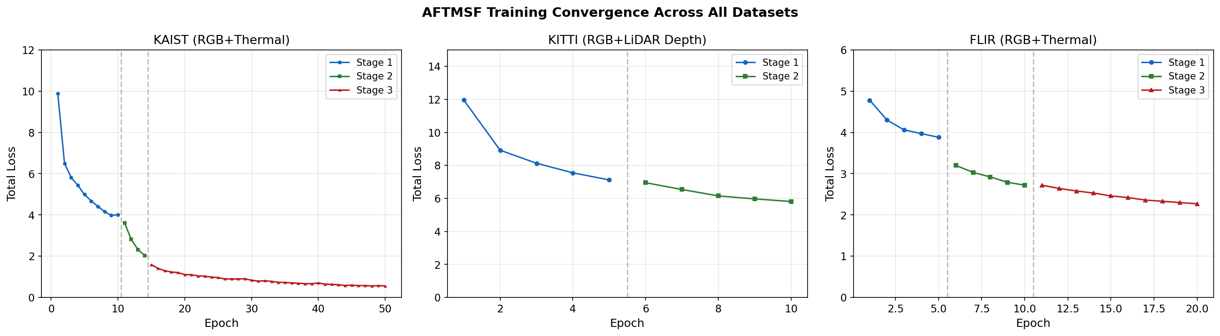
Figure 4.1: Training loss across datasets and stages. KAIST curves are read directly from the TensorBoard logs. Dashed lines mark stage boundaries.
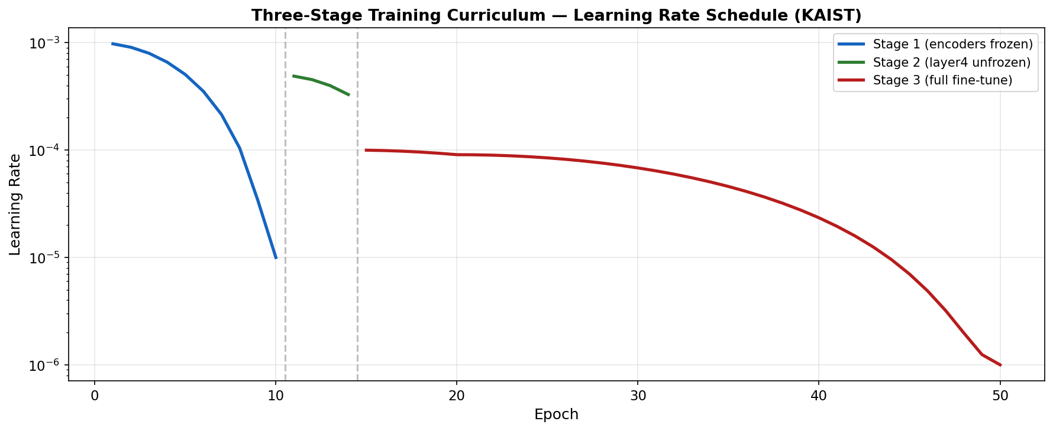
Figure 4.2: Logged learning-rate schedule for KAIST (log scale). Stage 2 ends after 4 epochs; Stage 3 shows the restart of the cosine schedule after resuming.

Chapter 5: Results and Evaluation

5.1 Evaluation Metrics and Protocol
- mAP@0.5: mean average precision at an IoU threshold of 0.5 (PASCAL VOC style); score threshold 0.3, NMS threshold 0.5.
- mIoU: mean intersection over union over the segmentation classes (including background), at stride-4 resolution.
- FPS: frames per second for the model forward pass on 256 × 320 inputs, batch size 1, FP32, on the RTX 4050 laptop GPU on mains power — median of five runs of 200 passes after 30 warm-up passes (src/benchmark.py).
- mAP drop (pp): percentage-point change from the clean result under fault injection.
All results were re-measured in October 2026 from the saved models. Fault experiments use a fixed random seed (0) so that the Gaussian-noise results are reproducible.

5.2 Comparison with Baselines
Three baselines were built from the same ResNet-50 + FPN components: RGB Only (single modality), Early Fusion (RGB and thermal concatenated into a 4-channel input) and Late Fusion (separate encoders with equal-weight feature averaging, no fault detection).
Table 5.1: KAIST test set (131 images)
Method | Parameters | mAP@0.5 | mIoU | FPS
RGB Only | 27.3M | 69.97% | 37.00% | 92.7
Early Fusion | 27.3M | 70.66% | 38.45% | 89.6
Late Fusion | 54.1M | 77.89% | 36.34% | 48.8
AFTMSF (ours) | 67.4M | 89.14% | 44.28% | 22.2

AFTMSF improves on RGB Only by 19.17 pp, Early Fusion by 18.48 pp and Late Fusion by 11.25 pp in mAP@0.5, and has the best mIoU. On the validation split it reaches 89.71% mAP@0.5 and 47.87% mIoU.
Important caveat: the baselines were trained for 5 epochs with ordinary training, while AFTMSF was trained for 50 epochs with the three-stage curriculum and synthetic fault injection. Part of the gap may therefore come from the larger training budget rather than the architecture alone; training the baselines with the same schedule is listed as future work.
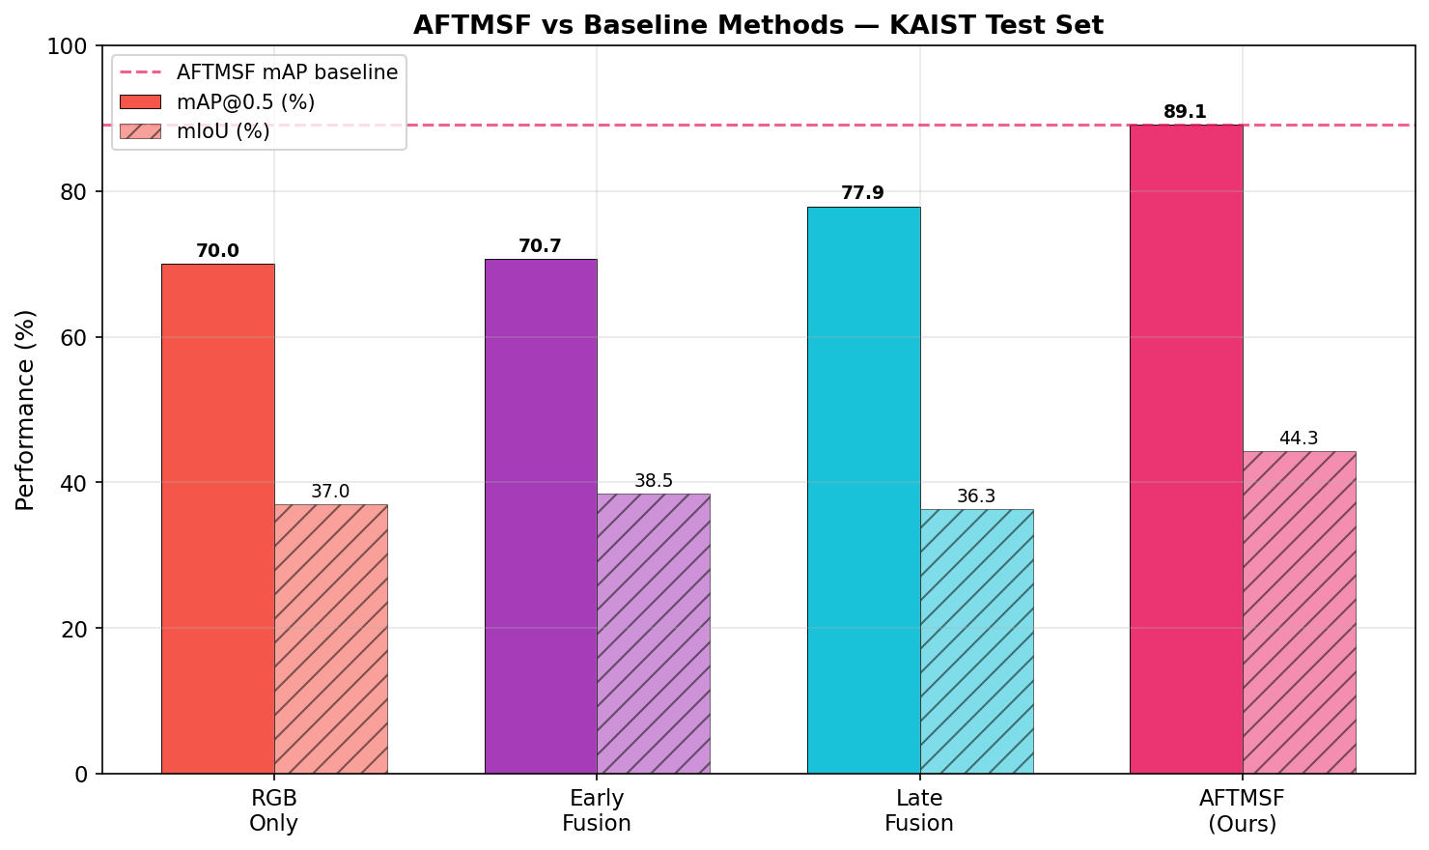
Figure 5.1: Detection (mAP@0.5) and segmentation (mIoU) on the KAIST test set.

5.3 Relation to Published Methods
Published multispectral and multi-sensor detectors report results on the full KAIST benchmark, usually as log-average miss rate, or on other datasets and tasks. This project uses a 1,374-image subset at reduced resolution and reports mAP@0.5, so its numbers are not directly comparable with published figures. Table 5.2 therefore compares capabilities rather than scores.
Table 5.2: Capability comparison with related methods
Method | Sensors | Fusion | Runtime sensor reliability
IAF R-CNN [19] | RGB + thermal | Illumination-weighted | Illumination only
CFT [20] | RGB + thermal | Cross-modality transformer | No
TransFuser [10] | Camera + LiDAR | Transformer | No
BEVFusion [11] | Camera + LiDAR | Bird's-eye view | No
Bijelic et al. [7] | Camera, LiDAR, radar, gated | Entropy-steered | Partial (entropy)
AFTMSF (ours) | RGB + thermal / depth | Confidence-gated attention | Yes (3 signals)

5.4 Fault Injection Results
Each fault is applied to 100% of the 131 test images for one modality: dropout (all zeros), blur (15 × 15 average filter), occlusion (a centred block covering 40% of each side) and Gaussian noise (σ = 0.3 on normalised inputs).
Table 5.3: AFTMSF under systematic fault injection (KAIST test, seed 0)
Modality | Fault | mAP@0.5 | Δ (pp) | mIoU
— | None (clean) | 89.14% | — | 44.28%
RGB | Dropout | 63.85% | -25.28 | 34.42%
RGB | Blur | 69.83% | -19.30 | 37.64%
RGB | Occlusion | 78.77% | -10.36 | 44.91%
RGB | Gaussian noise | 80.82% | -8.31 | 42.00%
Thermal | Dropout | 78.20% | -10.93 | 39.87%
Thermal | Blur | 79.41% | -9.73 | 38.86%
Thermal | Occlusion | 81.03% | -8.11 | 44.87%
Thermal | Gaussian noise | 80.61% | -8.52 | 40.47%

RGB faults hurt more than thermal faults, consistent with RGB carrying most of the information in KAIST's mainly daytime scenes. The worst case, complete RGB dropout, still leaves 63.85% mAP; every other condition stays above 69%. All four thermal faults cost between 8.1 and 10.9 pp.
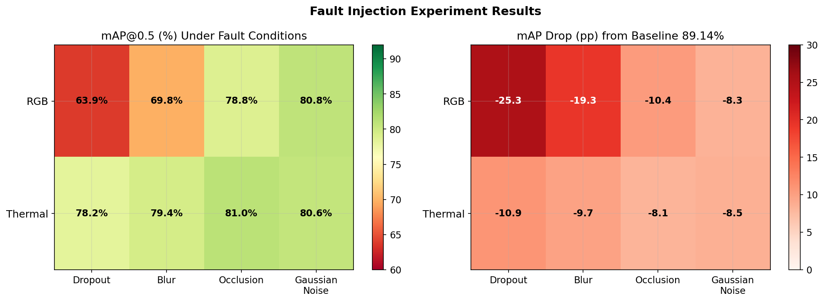
Figure 5.2: Fault injection heatmap. Left: mAP@0.5 under each fault. Right: drop from the clean result.

5.5 Robustness Compared with Baselines
The trained baselines were evaluated under exactly the same faults (Table 5.4, Figure 5.3).
Table 5.4: mAP@0.5 under faults — baselines vs AFTMSF (KAIST test, seed 0)
Fault | RGB Only | Early Fusion | Late Fusion | AFTMSF
None (clean) | 69.97 | 70.66 | 77.89 | 89.14
RGB dropout | 0.00 | 0.00 | 0.00 | 63.85
RGB blur | 0.00 | 18.18 | 18.18 | 69.83
RGB occlusion | 59.86 | 54.02 | 60.98 | 78.77
RGB gaussian noise | 68.34 | 70.61 | 75.59 | 80.82
Thermal dropout | n/a | 61.10 | 21.32 | 78.20
Thermal blur | n/a | 61.83 | 32.42 | 79.41
Thermal occlusion | n/a | 70.44 | 67.32 | 81.03
Thermal gaussian noise | n/a | 70.94 | 61.49 | 80.61

All three baselines collapse to 0% mAP under complete RGB dropout, and Early and Late Fusion fall to 18.18% under RGB blur; Late Fusion also drops to 21.32% under thermal dropout. AFTMSF keeps 63.85%, 69.83% and 78.20% in these cases and is the best method under every fault. (RGB Only has no thermal input, so thermal faults do not apply to it.) As in Section 5.2, the baselines were not trained with fault injection, which contributes to this difference.
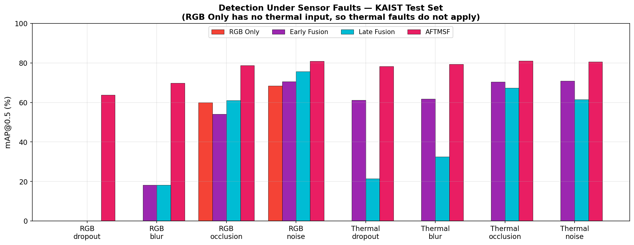
Figure 5.3: Detection under sensor faults for all methods.

5.6 Ablation Study
Two inference-time ablations were applied to the trained model (no retraining): without entropy removes the third signal from the confidence score, and without fault detector gives every modality the same confidence so that ACAF uses equal fusion weights.
Table 5.5: Fault detector ablation on clean KAIST test data
Configuration | mAP@0.5 | mIoU
AFTMSF (full) | 89.14% | 44.28%
Without entropy signal | 89.31% | 45.10%
Without fault detector (equal weights) | 89.20% | 45.55%

Table 5.6: mAP@0.5 under faults with and without the fault detector
Fault | With fault detector | Without | Difference (pp)
RGB dropout | 63.85% | 64.68% | -0.82
RGB blur | 69.83% | 69.92% | -0.09
RGB occlusion | 78.77% | 79.54% | -0.77
RGB gaussian noise | 80.82% | 80.93% | -0.11
Thermal dropout | 78.20% | 77.48% | +0.72
Thermal blur | 79.41% | 78.68% | +0.72
Thermal occlusion | 81.03% | 80.93% | +0.10
Thermal gaussian noise | 80.61% | 80.35% | +0.26

Removing the confidence gating changes mAP by less than one percentage point on clean data and under every fault: it helps slightly for thermal faults (up to +0.73 pp) and is slightly worse for RGB faults (up to −0.83 pp). The robustness of AFTMSF therefore comes mainly from the cross-modal attention architecture and the fault-injection training, not from the confidence weighting. Because these ablations remove components after training, a model retrained without the fault detector could behave differently; that experiment is left for future work.

5.7 Confidence Scores and Fusion Weights
Table 5.7: Mean confidence and resulting fusion weights (KAIST test)
Condition | c (RGB) | c (thermal) | w (RGB) | w (thermal)
Clean | 0.717 | 0.429 | 0.594 | 0.406
RGB dropout | 0.389 | 0.429 | 0.487 | 0.513
RGB blur | 0.359 | 0.429 | 0.477 | 0.523
RGB occlusion | 0.627 | 0.429 | 0.565 | 0.435
RGB gaussian noise | 0.688 | 0.429 | 0.585 | 0.415
Thermal dropout | 0.717 | 0.603 | 0.537 | 0.463
Thermal blur | 0.717 | 0.505 | 0.569 | 0.431
Thermal occlusion | 0.717 | 0.462 | 0.583 | 0.417
Thermal gaussian noise | 0.717 | 0.585 | 0.543 | 0.457

The fault detector responds correctly to RGB faults: RGB confidence drops from 0.717 to 0.389 under dropout and 0.359 under blur, shifting fusion weight towards thermal (RGB weight 0.59 → 0.49). For thermal faults the response is reversed: thermal confidence rises from 0.429 to between 0.462 and 0.603, giving the faulty thermal input slightly more weight. No confidence fell below the 0.15 fault threshold in any condition (minimum 0.359), so no modality was formally flagged as faulty; the system degrades through soft re-weighting rather than hard switching.
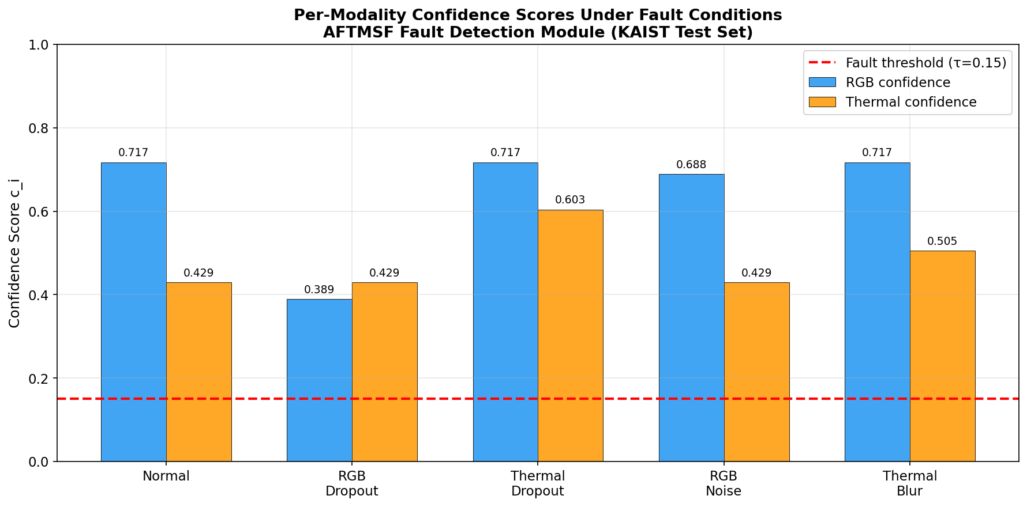
Figure 5.4: Measured per-modality confidence under five conditions. Red dashed line: fault threshold 0.15.
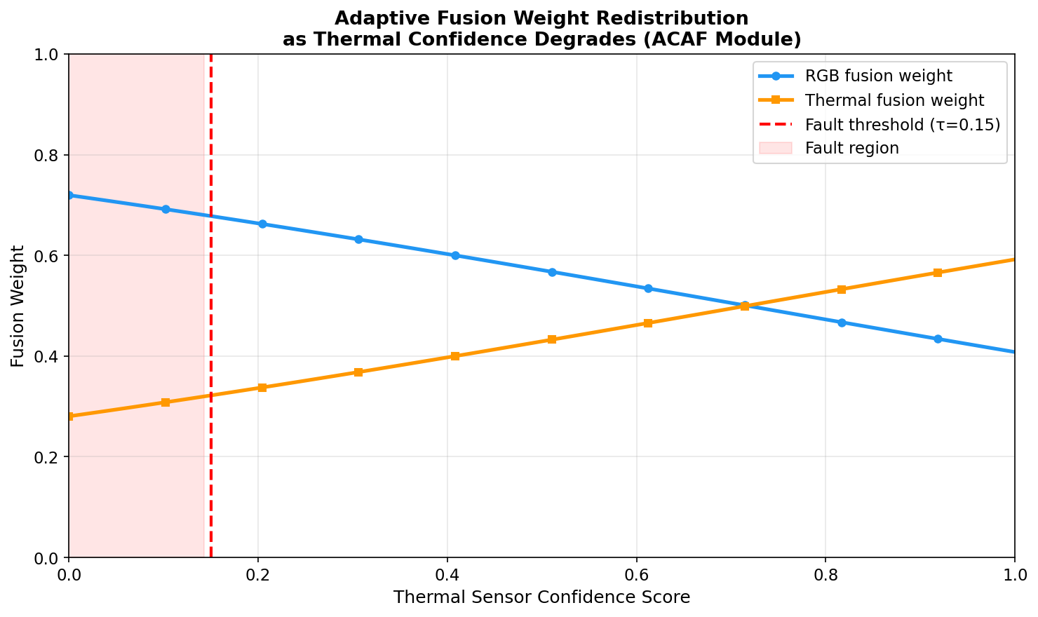
Figure 5.5: Fusion weights given by w = softmax(c / τ) with the learned τ = 0.761 and the measured clean RGB confidence (0.717), as thermal confidence varies. The RGB weight changes smoothly from about 0.72 (thermal confidence 0) to 0.41 (thermal confidence 1), with no hard switching.

5.8 Cross-Dataset Generalisation
Table 5.8: AFTMSF on three datasets
Dataset | Sensors | Classes | mAP@0.5 | mIoU | FPS
KAIST (test) | RGB + thermal | 1 | 89.14% | 44.28% | 22.2
KITTI (val, Stage 2 model) | RGB + LiDAR depth | 2 | 21.53% | 22.55% | 26.0
FLIR (val) | RGB + thermal | 3 | 1.52% | 16.34% | 23.3

The same architecture runs on RGB + LiDAR depth (KITTI) without structural changes, only by swapping the thermal encoder for the depth encoder. KITTI is a harder two-class problem with sparse depth and shorter training. FLIR detection is close to zero because its objects average about 6 × 15 pixels at 320 × 256, below what the stride-4 feature map resolves well; segmentation is less sensitive to object size and still reaches 16.34% mIoU.
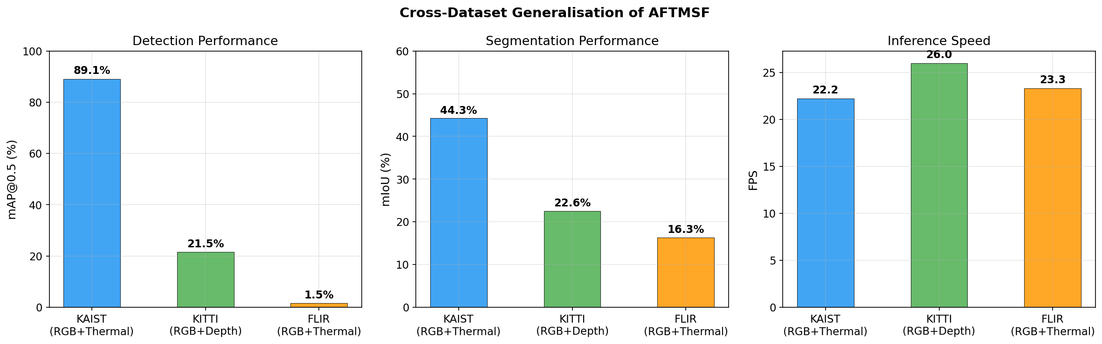
Figure 5.6: Detection, segmentation and speed across the three datasets.

5.9 Speed and Accuracy Trade-off
AFTMSF is the most accurate but also the slowest model (22.2 FPS on KAIST versus 48.8 for Late Fusion and about 93 for the single-encoder baselines). The two ResNet-50 encoders and the four-scale attention are the main costs. It meets the 10 FPS requirement on a laptop GPU but not the ~30 FPS typical for high-speed driving.
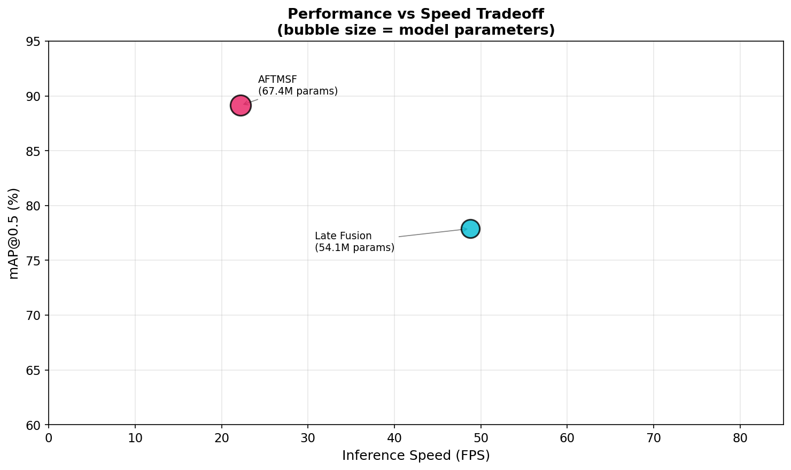
Figure 5.7: Speed against accuracy on KAIST. Bubble size is proportional to the number of parameters.

Chapter 6: Discussion and Conclusions

6.1 Key Findings
- Fusion improves accuracy: AFTMSF reaches 89.14% mAP@0.5 and 44.28% mIoU on KAIST, 11.25 pp above Late Fusion and 19.17 pp above RGB Only.
- Graceful degradation confirmed: under complete RGB dropout AFTMSF keeps 63.85% mAP, while all three baselines fall to 0%. It is the best method under all eight fault conditions.
- The source of robustness is the architecture and training, not the confidence gating: removing the fault detector or its entropy signal changes accuracy by less than 1 pp, clean or faulty.
- The fault detector responds to RGB faults but not to thermal faults: RGB confidence drops under RGB faults, but thermal confidence rises under thermal faults, and no condition crosses the 0.15 threshold.
- Sensor-agnostic design: the same architecture handles RGB + thermal and RGB + LiDAR depth without structural changes.
- Runs on a laptop GPU: 22.2–26.0 FPS on a 6 GB RTX 4050.

6.2 Limitations
- Confidence gating has little measurable effect and does not detect thermal faults; the reliability supervision (L_rel with weight 0.1) appears too weak to shape the confidence scores.
- Unequal baseline training: baselines had 5 epochs without fault injection versus 50 epochs with it for AFTMSF.
- KAIST subset: results use 1,374 images at 256 × 320 and are not directly comparable with published full-benchmark results.
- FLIR small objects: near-zero detection (1.52%) because objects are below the stride-4 feature resolution.
- KITTI training: only two stages were completed; more training should improve on 21.53%.
- Speed: below the ~30 FPS needed for high-speed driving; the dual ResNet-50 encoders are the bottleneck.
- Ablations are inference-time only: components were removed after training, not retrained without them.

6.3 Future Work
- Stronger reliability supervision: increase the weight of L_rel, add thermal-specific fault types to training, and calibrate the fault threshold so faults are actually flagged.
- Fair baselines and full ablations: train the baselines with the same schedule and fault injection, and retrain AFTMSF without each component.
- Small-object detection: add a stride-2 feature level and thermal super-resolution for FLIR-scale objects.
- Edge deployment: INT8 quantisation and TensorRT to reach > 30 FPS.
- More sensors and data: 4D radar for all-weather operation; full KAIST benchmark at native resolution; KAIST → FLIR domain adaptation.

6.4 Conclusion
This project designed, implemented and evaluated AFTMSF, a multi-sensor fusion system that integrates a three-signal fault detector with confidence-gated cross-modal attention for simultaneous detection and segmentation. The four objectives were met: (1) a multi-modal fusion framework was implemented and trained on three datasets; (2) an adaptive confidence-gated attention mechanism was developed; (3) a three-signal fault detector was implemented and evaluated systematically under eight fault conditions; and (4) the system was benchmarked on KAIST, KITTI and FLIR against three baselines, with fault injection and ablations.
The system achieves 89.14% mAP@0.5 on KAIST and degrades gracefully where conventional fusion collapses, keeping 63.85% mAP when the RGB camera fails completely. The re-evaluation also showed that the confidence gating itself contributes little and does not yet detect thermal faults, which sets a clear direction for the next stage of the work. All code, configurations, results and figure scripts are published at https://github.com/Parbinder29/ATMSF so that every number in this report can be reproduced.

References
[1] H. Zhang, F. Li, S. Zhao, and H. Ling, "Multisensor data fusion for autonomous driving: A survey," IEEE Trans. Intell. Transp. Syst., vol. 22, no. 7, pp. 3967–3984, 2020.
[2] S. Li, L. Liu, X. Lin, and B. Meng, "Deep learning for multimodal data fusion: A review," Inf. Fusion, vol. 76, pp. 284–301, 2021.
[3] S. Hwang, J. Park, N. Kim, Y. Choi, and I. S. Kweon, "Multispectral pedestrian detection: Benchmark dataset and baseline," in Proc. IEEE CVPR, 2015, pp. 1037–1045.
[4] FLIR Systems Inc., "FLIR thermal dataset for algorithm training (ADAS v1.3)," 2018. [Online]. Available: https://www.flir.com/oem/adas/adas-dataset-form/
[5] A. Geiger, P. Lenz, C. Stiller, and R. Urtasun, "Vision meets robotics: The KITTI dataset," Int. J. Robot. Res., vol. 32, no. 11, pp. 1231–1237, 2013.
[6] A. Vaswani et al., "Attention is all you need," in Proc. NeurIPS, 2017, pp. 5998–6008.
[7] M. Bijelic et al., "Seeing through fog without seeing fog: Deep multimodal sensor fusion in unseen adverse weather," in Proc. IEEE/CVF CVPR, 2020, pp. 11682–11692.
[8] Y. Feng, H. Wang, and J. Luo, "Deep multi-modal sensor fusion for autonomous driving: A review," IEEE Access, vol. 8, pp. 146876–146894, 2020.
[9] Z. Liu et al., "Swin transformer: Hierarchical vision transformer using shifted windows," in Proc. IEEE/CVF ICCV, 2021, pp. 10012–10022.
[10] K. Chitta et al., "TransFuser: Imitation with transformer-based sensor fusion for autonomous driving," IEEE Trans. Pattern Anal. Mach. Intell., vol. 45, no. 11, pp. 12878–12895, 2023.
[11] T. Liang et al., "BEVFusion: A simple and robust LiDAR-camera fusion framework," in Proc. NeurIPS, 2022.
[12] T. Wang et al., "Deep learning-based fault detection for sensor systems: A survey," IEEE Sensors J., vol. 22, no. 5, pp. 3989–4005, 2022.
[13] K. He, X. Zhang, S. Ren, and J. Sun, "Deep residual learning for image recognition," in Proc. IEEE CVPR, 2016, pp. 770–778.
[14] T.-Y. Lin, P. Dollár, R. Girshick, K. He, B. Hariharan, and S. Belongie, "Feature pyramid networks for object detection," in Proc. IEEE CVPR, 2017, pp. 2117–2125.
[15] Z. Tian, C. Shen, H. Chen, and T. He, "FCOS: Fully convolutional one-stage object detection," in Proc. IEEE/CVF ICCV, 2019, pp. 9627–9636.
[16] L.-C. Chen, Y. Zhu, G. Papandreou, F. Schroff, and H. Adam, "Encoder-decoder with atrous separable convolution for semantic image segmentation," in Proc. ECCV, 2018, pp. 801–818.
[17] A. Kendall and Y. Gal, "What uncertainties do we need in Bayesian deep learning for computer vision?" in Proc. NeurIPS, 2017, pp. 5574–5584.
[18] I. Loshchilov and F. Hutter, "Decoupled weight decay regularization," in Proc. ICLR, 2019.
[19] C. Li, D. Song, R. Tong, and M. Tang, "Illumination-aware faster R-CNN for robust multispectral pedestrian detection," Pattern Recognit., vol. 85, pp. 161–171, 2019.
[20] F. Qingyun, H. Dapeng, and W. Zhaokui, "Cross-modality fusion transformer for multispectral object detection," arXiv:2111.00273, 2021.

Appendix A: Installation and Reproduction Guide

A.1 Environment Setup
Run in the Anaconda Prompt (Windows) from the project folder:
git clone https://github.com/Parbinder29/ATMSF.git
cd ATMSF
conda create -n aftmsf python=3.10 -y
conda activate aftmsf
pip install torch==2.6.0 torchvision==0.21.0 torchaudio==2.6.0 \
--index-url https://download.pytorch.org/whl/cu124
pip install -r requirements.txt
pip install opencv-python-headless==4.11.0.86

Datasets go in data/ as described in the repository README; trained checkpoints go in experiments/.

A.2 Training Commands
# KAIST (three stages)
python -m src.train --config configs/kaist.yaml --stage 1
python -m src.train --config configs/kaist.yaml --stage 2 --resume experiments/stage1/last.pth
python -m src.train --config configs/kaist.yaml --stage 3 --resume experiments/stage2/last.pth

# KITTI (two stages)
python -m src.train_kitti --config configs/kitti.yaml --stage 1
python -m src.train_kitti --config configs/kitti.yaml --stage 2 --resume experiments/kitti_stage1/last.pth

# FLIR (three stages)
python -m src.train_flir --config configs/flir.yaml --stage 1
python -m src.train_flir --config configs/flir.yaml --stage 2 --resume experiments/flir_stage1/last.pth
python -m src.train_flir --config configs/flir.yaml --stage 3 --resume experiments/flir_stage2/last.pth

# Baselines
python -m src.experiments.baseline_experiment

A.3 Evaluation and Experiment Commands
python -m src.evaluate --config configs/kaist.yaml --checkpoint experiments/stage3/last.pth --split test
python -m src.evaluate --config configs/kaist.yaml --checkpoint experiments/stage3/last.pth --split val
python -m src.evaluate_kitti --checkpoint experiments/kitti_stage2/last.pth
python -m src.evaluate_flir --checkpoint experiments/flir_stage3/last.pth

python -m src.experiments.fault_experiment --checkpoint experiments/stage3/last.pth --seed 0
python -m src.experiments.baseline_fault_experiment
python -m src.experiments.ablation_experiment
python -m src.benchmark
python -m src.visualize_all # regenerates all figures from the result files

A.4 Final Achievements Summary
Table A.1: Project summary (re-measured October 2026)
Metric / deliverable | Result
KAIST mAP@0.5 / mIoU (test) | 89.14% / 44.28%
KAIST mAP@0.5 / mIoU (validation) | 89.71% / 47.87%
Improvement over best baseline (Late Fusion) | +11.25 pp mAP@0.5
mAP under complete RGB dropout | 63.85% (baselines: 0%)
KITTI mAP@0.5 / mIoU | 21.53% / 22.55%
FLIR mAP@0.5 / mIoU | 1.52% / 16.34%
Inference speed (RTX 4050, 6 GB) | 22.2 FPS (KAIST), 26.0 (KITTI), 23.3 (FLIR)
Model parameters | 67.35M (KAIST), 43.84M (KITTI)
Datasets | 3 (KAIST, KITTI, FLIR)
Experiments | Fault injection (8 conditions), baseline robustness, ablations, speed benchmark
Figures | 11 in this report
Source code | https://github.com/Parbinder29/ATMSF

