Maximum Margin Hyperplane in SVM
  - Student Notes | Explanation of the supplied SVM diagram
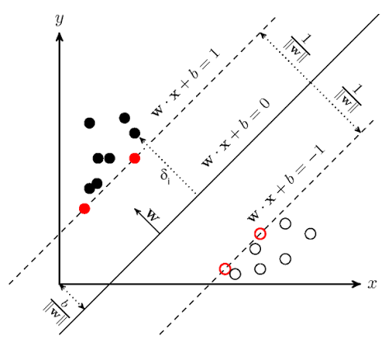
Figure 1. Decision boundary, margin boundaries, support vectors, weight vector and margin violations.

1. What does this diagram show?
Support Vector Machine (SVM) separates two classes by choosing a decision boundary with a large margin. The black filled circles represent one class (+1) and the hollow circles represent the other class (−1).

2. The three parallel lines
Equation | Meaning
w · x + b = 0 | Middle solid line: the decision boundary (hyperplane)
w · x + b = +1 | Upper dashed margin boundary, for class +1
w · x + b = −1 | Lower dashed margin boundary, for class −1
The line w · x + b = 0 divides the plane into two predicted classes. In two dimensions, a hyperplane is simply a line.

3. What are support vectors and the red points?
Support vectors are training points that influence the position of the SVM decision boundary. In the figure, red highlights identify support vectors: some lie on the dashed margin boundaries and others lie inside the margin. A point inside the margin is not necessarily misclassified; it is misclassified only when it crosses to the wrong side of the solid decision boundary.

4. What do w and b mean?
w is the weight vector, perpendicular to the three lines. It sets their orientation. b is the bias, which helps shift the lines. The shortest distance to a line is measured perpendicular to the line.

5. Why is the total margin 2 / ||w||?
The perpendicular distance from the middle line (0) to either dashed line (+1 or −1) is 1 / ||w||. Adding both halves gives:
Margin width = 1 / ||w|| + 1 / ||w|| = 2 / ||w||
Here ||w|| means the length (magnitude) of w. For example, if ||w|| = 2, the full margin is 1. If ||w|| = 1, the full margin is 2. Thus, a smaller ||w|| gives a wider margin, provided the classification constraints are respected.

6. What is δᵢ and what is a soft margin?
The segment marked δᵢ depicts a geometric margin violation for a highlighted point inside its margin. Standard soft-margin SVM usually writes the slack variable as ξᵢ (xi), with constraint:
yᵢ (w · xᵢ + b) ≥ 1 − ξᵢ, ξᵢ ≥ 0
Slack ξᵢ | Interpretation
0 | Correct side, on or beyond its margin boundary
Between 0 and 1 | Correctly classified but inside the margin
1 | Exactly on the decision boundary
Greater than 1 | On the wrong side of the decision boundary (misclassified)
When δᵢ denotes the perpendicular amount by which a point violates its own margin boundary, δᵢ = ξᵢ / ||w||.

7. How does C affect the soft margin?
C is the penalty (regularization) parameter. A small C tolerates more margin violations in exchange for prioritizing a wider margin. A large C penalizes violations more strongly, prioritizing correct training classifications; it may produce a narrower margin and can increase overfitting risk.

8. Classroom analogy
Imagine two groups of students standing on opposite sides of a corridor. The solid line is the centre divider; the dashed lines are safety boundaries. SVM tries to make the clear space between boundaries as wide as possible. Students closest to the boundary are support vectors. Soft-margin SVM tolerates some students entering this clear space, but applies a penalty.

Quick recap
- Solid line (0): decision boundary.
- Dashed lines (+1 and −1): margin boundaries.
- Distance between dashed lines: 2 / ||w||.
- w: perpendicular weight vector; b: bias.
- Red points: highlighted support vectors, including possible margin violators.
- C: penalty for margin violations in soft-margin SVM.

