Slack Variable in Soft-Margin SVM
  - Simple explanation with diagram, formula and classroom example

1. What is slack?
A slack variable measures how much a training point violates its margin requirement. It lets a soft-margin Support Vector Machine handle points that enter the margin or cross the decision boundary.
The symbol for slack is ξᵢ (Greek letter xi). Each training point has its own slack value.

2. Understand the diagram
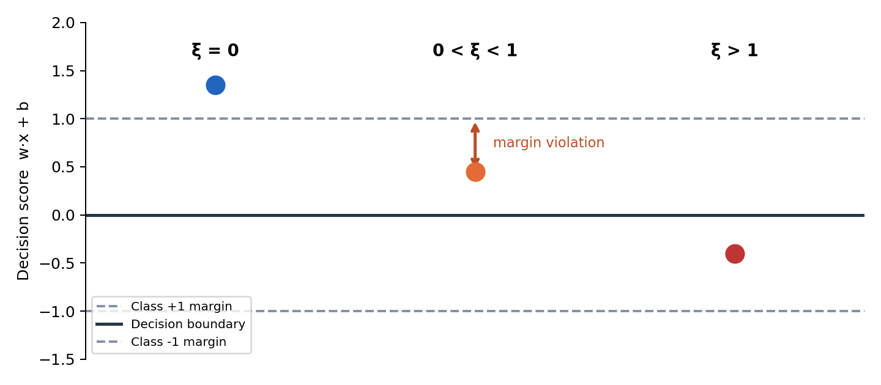
Illustration for points belonging to class +1. Positions are schematic, not real data.
Slack value | Meaning
ξᵢ = 0 | Correctly classified; on or beyond the correct margin boundary.
0 < ξᵢ < 1 | Inside the margin but still correctly classified.
ξᵢ = 1 | Exactly on the decision boundary.
ξᵢ > 1 | On the wrong side of the decision boundary (misclassified).

3. Mathematical formula
yᵢ (w · xᵢ + b) ≥ 1 − ξᵢ, ξᵢ ≥ 0
Here, yᵢ is the true class (+1 or −1), w is the weight vector, xᵢ is a training point, b is the bias, and ξᵢ is the amount of margin violation.

4. Slack and the parameter C
Slack tells us HOW MUCH a point violates the margin. C controls HOW STRONGLY those violations are penalized.
Small C: greater tolerance of violations, often favoring a wider margin. Large C: higher penalty for violations, encouraging better fit to the training points. Neither setting guarantees the best result on unseen data.

5. Classroom analogy
Imagine two groups of students separated by a marked safety zone. A student standing outside the safety zone on the correct side has zero slack. A student stepping into the zone has positive slack. A student crossing the central dividing line has slack greater than one.

6. One-line exam answer
A slack variable in soft-margin SVM measures violation of the margin constraint and allows the model to handle overlapping classes.

Quick check
Q1. Is a point with ξ = 0.5 misclassified? No: it is inside the margin but still on the correct side.
Q2. What does C control? The penalty for slack/margin violations.

