**QUESTION 1:**

CPU/Memory requirement for 500 Mbps, 1000 Mbps, and 5000 Mbps throughput for CSR

routers

500 Mbps 1 vCPU/4gb

1000Mbps 1,2 vcpu/4GB 2vcpu for AX

5000Mbps 1,2 & 8vCPU/4GB 1 for IPbase, 2for security and for all features 8gb

List three features of CSR for each of the follwoing: a) Networking, b)Security, c) Management

a) Virtual-machine creation and deployment

Provisioning and management

RESTful application programming interfaces

b) VPN: IPsec VPN, DMVPN, Easy VPN, FlexVPN, and GetVPN

Firewall: ZBFW

Access control: ACL, AAA, RADIUS, and TACACS+

c) Routing: BGP, OSPF, EIGRP

Hybrid cloud connectivity:OTV, VPLS, and Ethernet over MPLS (EoMPLS)

Application visibility, performance monitoring, and control: QoS and AVC

What would be per year cost to use two 1000 Mbps CSR in Amazon cloud

for the following package,Cisco Cloud Services Router (CSR) 1000V - Security Technology Package

it costs around 12,264$ for a year.

**QUESTION 2:**

1 VM Ip address and mac address :

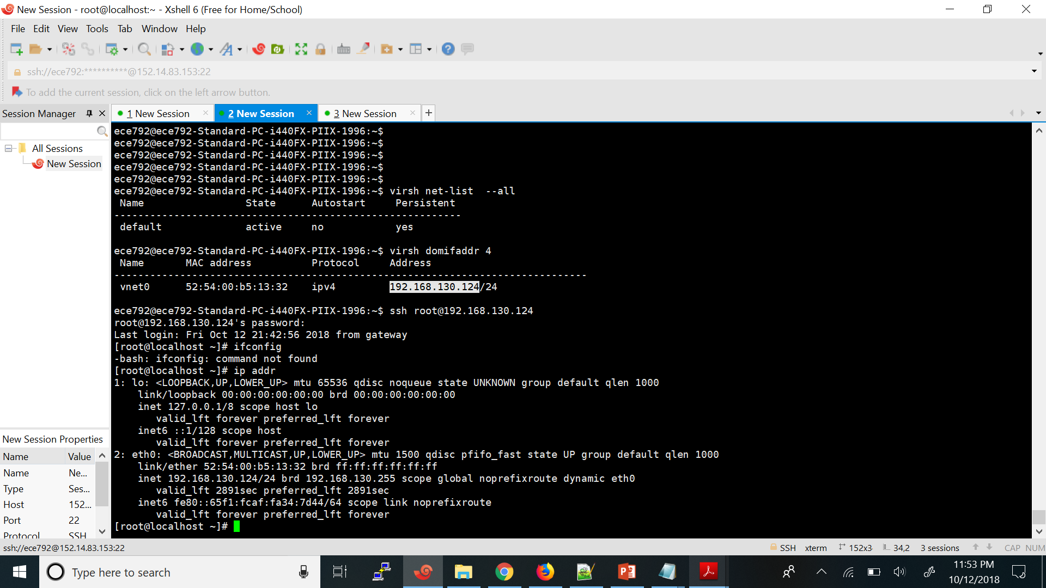

Hypervisor Ip address and Mac address :

As default gateway is connected through ens 3

The Ip address and mac address of ens3 – 192.168.122.66

HWaddr 52:54:00:a7:51:7a

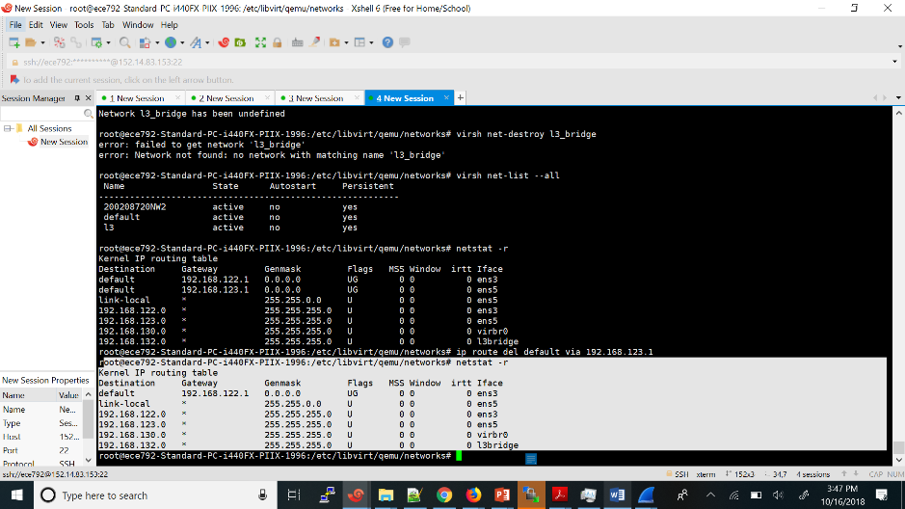

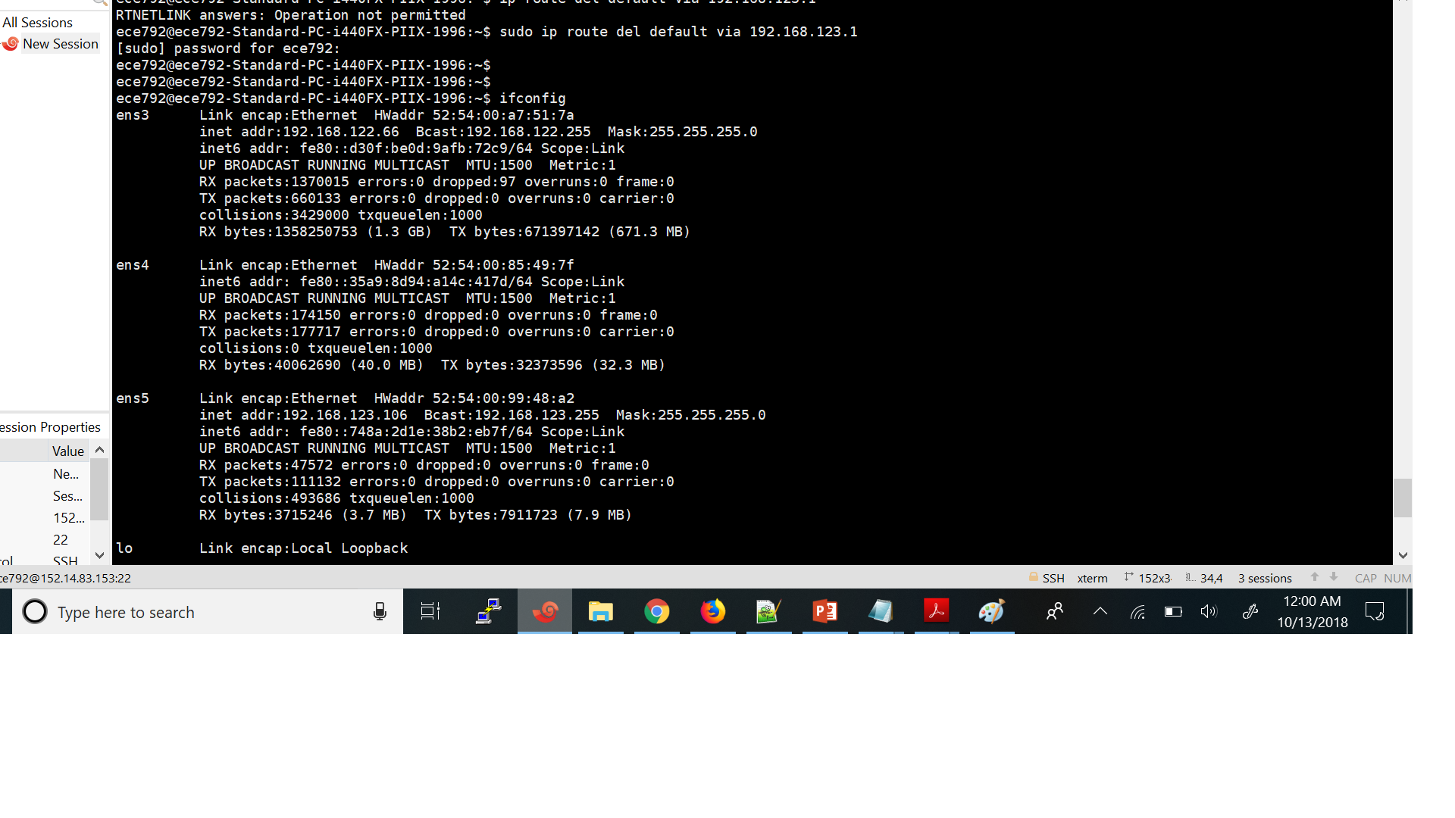

(2) the tuples captured at the VM interface and the Hypervisor interface are different

(srcIP, Dest IP, srcMAC and dest MAC)

Tuples Virtual Machine side(eth0)

(192.168.130.124 172.217.7.142 52:54:00:dd:70:c9 fe:54:00:dd:70:c9 )

The source mac address will be the mac address of eth0 and destination mac address will be the mac address of virbr0 interface ( default gateway for VM ) which will obtained from arp request and response.

Source IP address will be of the – eth0 interface

Destiantion Ip address will be of google server .

**Packet capture at the VM interface :**

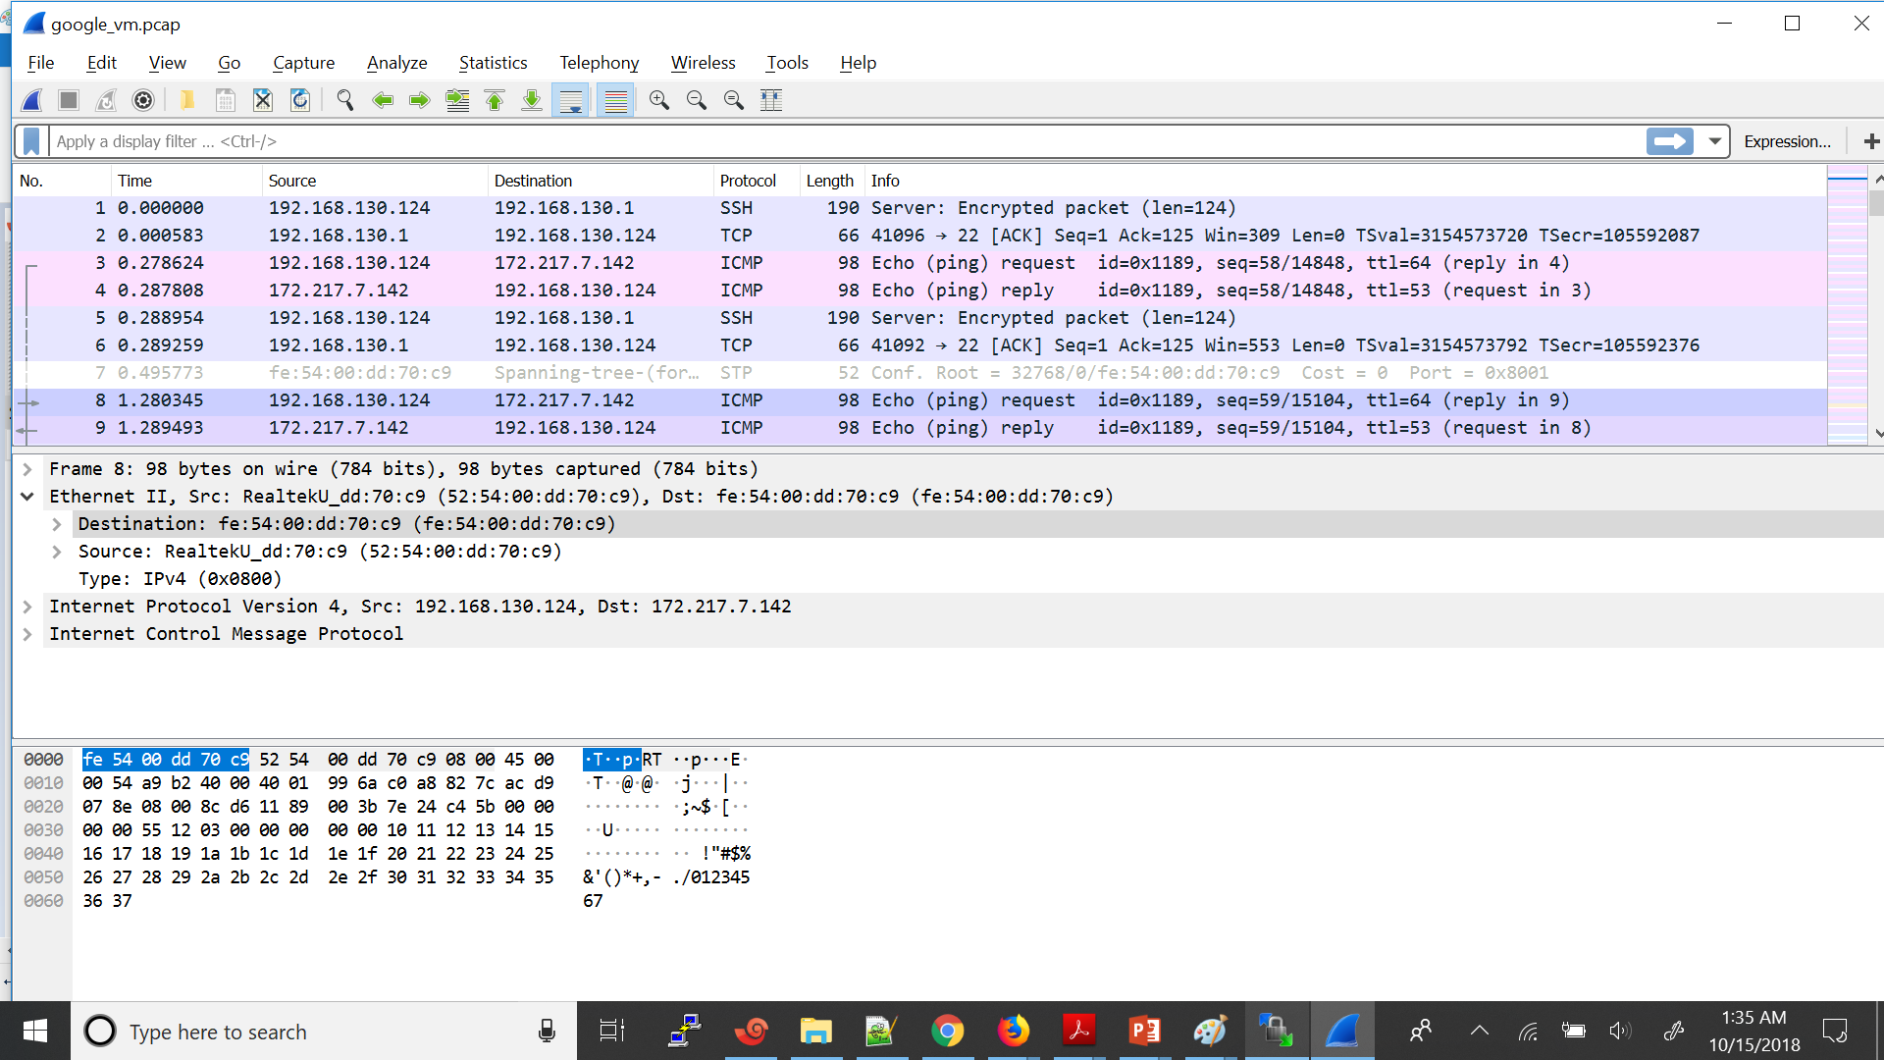

**Tuples for packet leaving from Hypervisor side (ens3)**

(192.168.122.66 172.217.7.142 52:54:00:a7:51:7a 52:54:00:85:2f:36)

Here the source ip will be the source ip of ens 3 and destination Ip address will be of google.com

The source ip address will be the ip address of the ens3 interface and destination mac address will be the next hop (default gateway ) mac address

**Packet capture at the Hypervisor interface :**

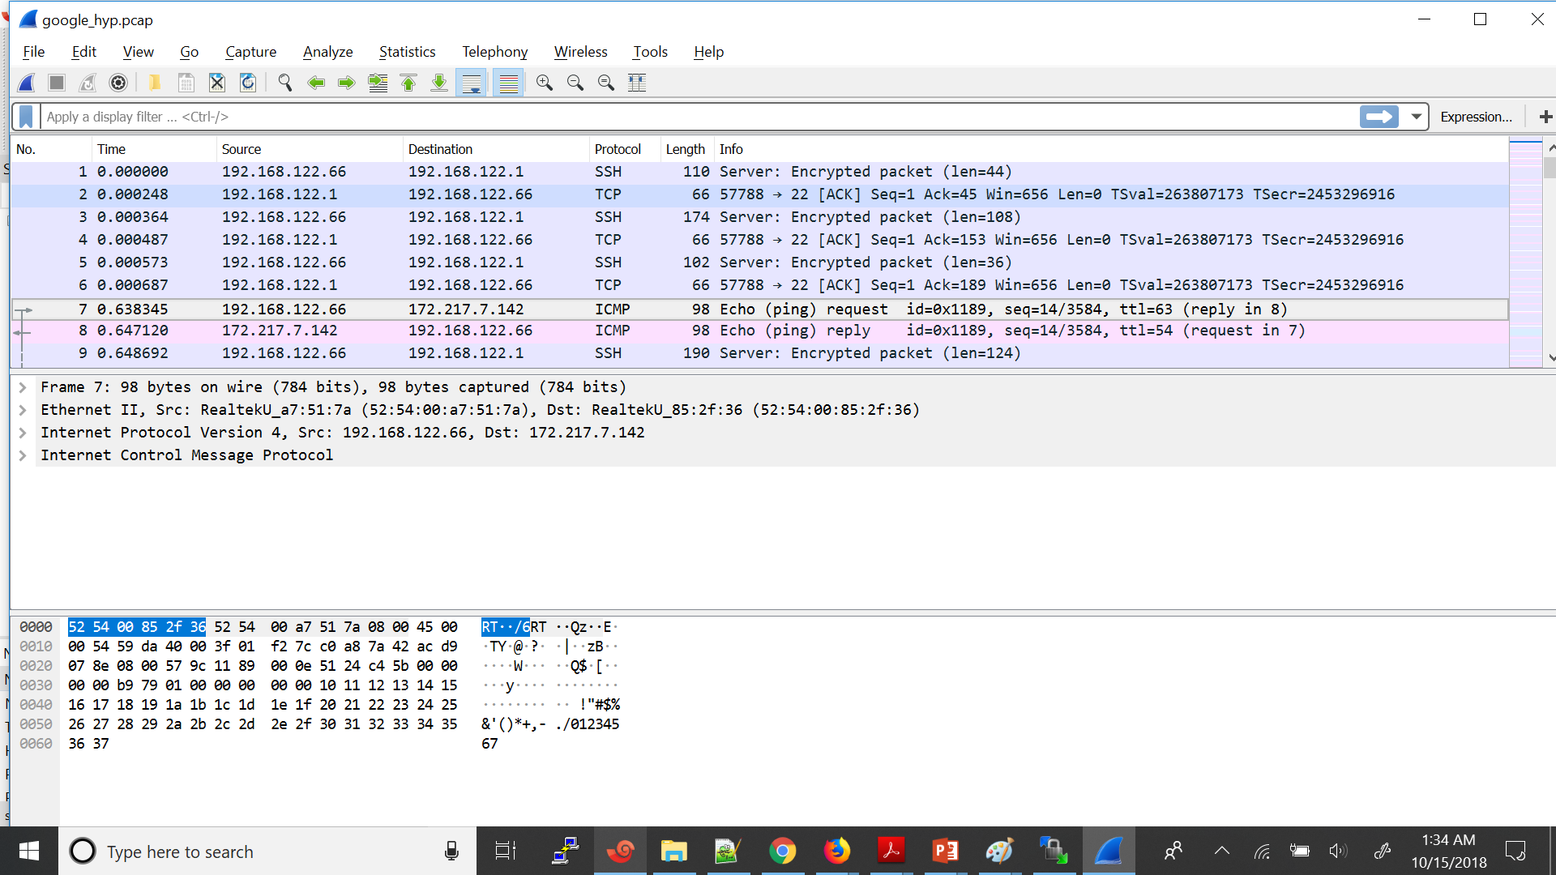

**QUESTION 3:**

1. Network addition in l2 mode :

The network 200208720NW2 has been added in the Host in the bridge mode :

BY creating the sw1 bridge and defining a 200208720NW2 network in bridge mode using the sw1 bridge

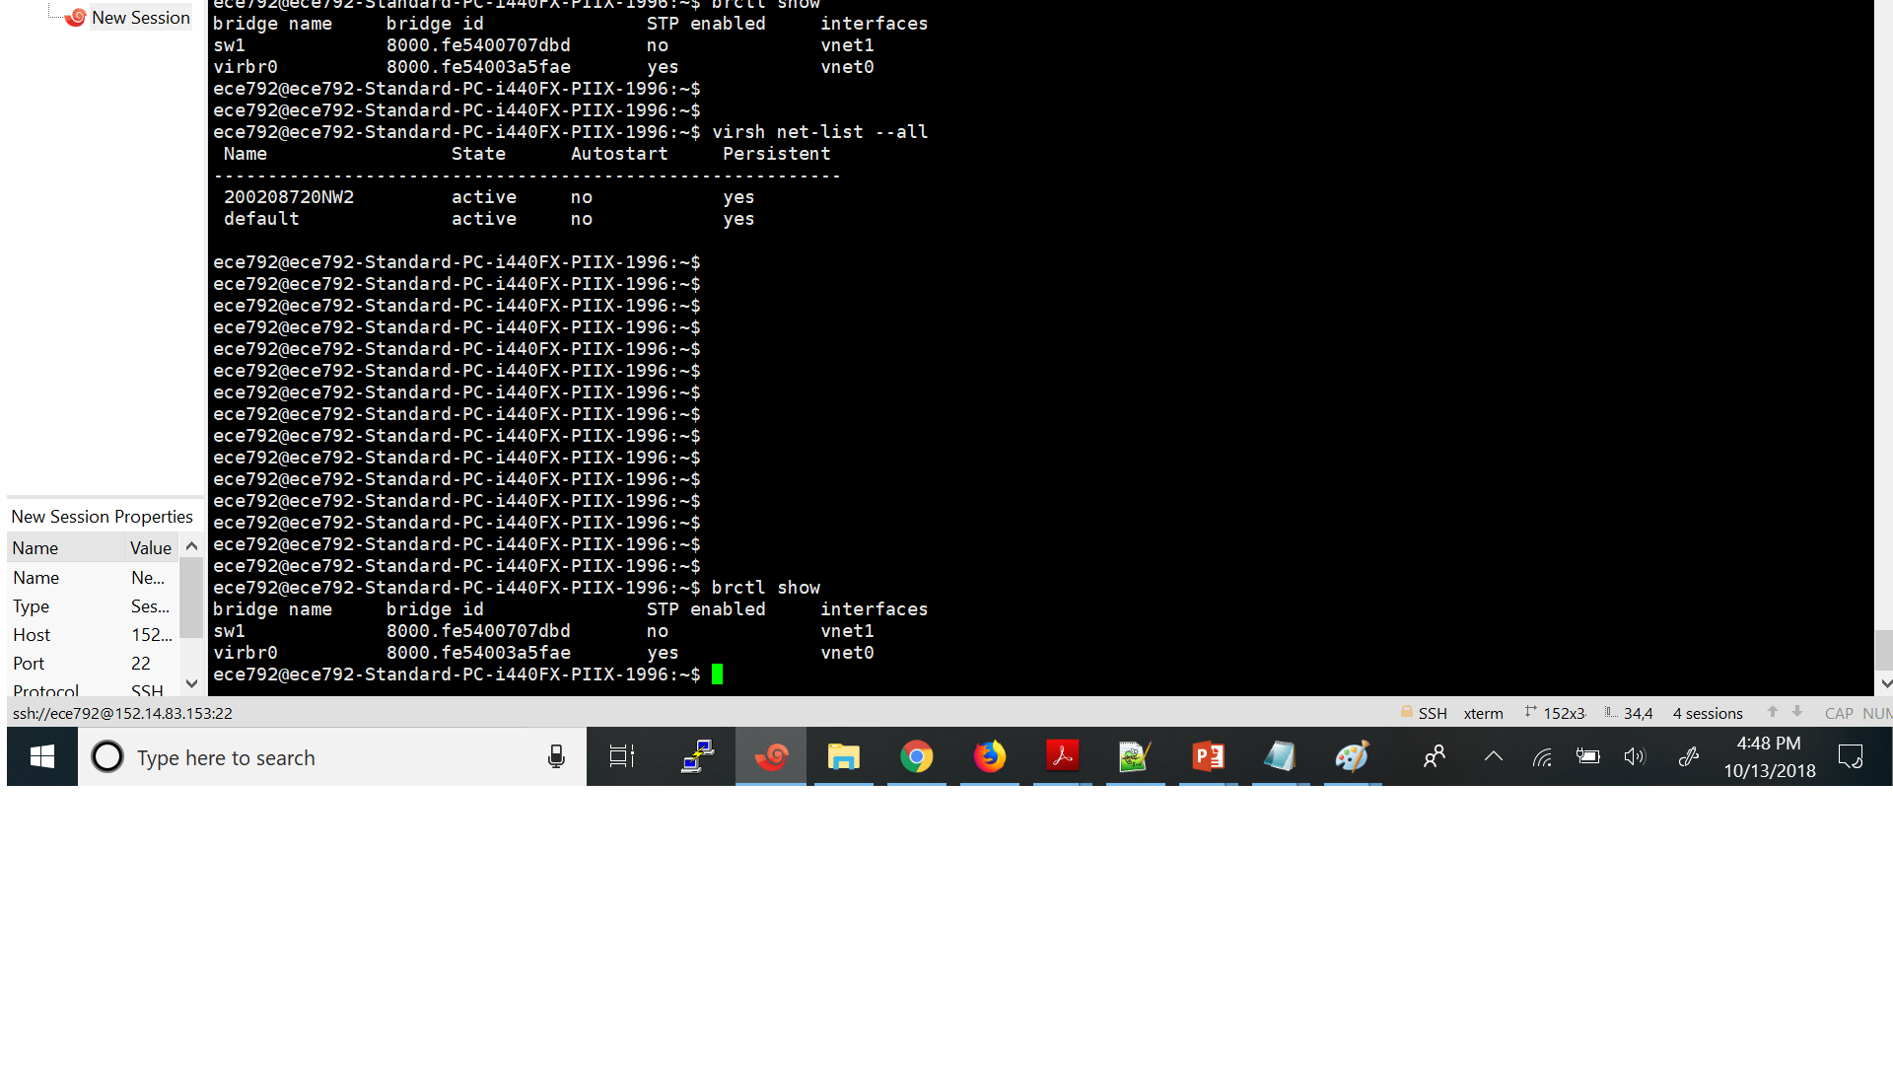

1. The interface eth2 in 200202780NW2 has been added to 200208720VM1 using the cli

virsh attach-interface --domain 200208720VM1 --type network --source 200208720NW2 --model virtio --config –live

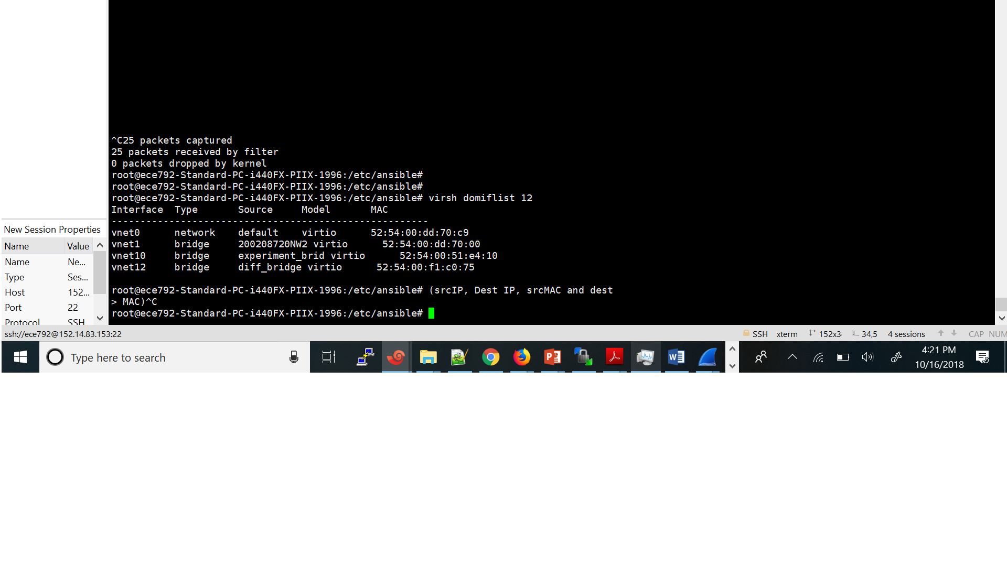

1. The VM “200208720lab2VM2” has been created using the cloning command

sudo virt-clone --original 200208720VM1 --name 200208720lab2VM2 --auto-clone

It has been cloned from the 200208720VM1

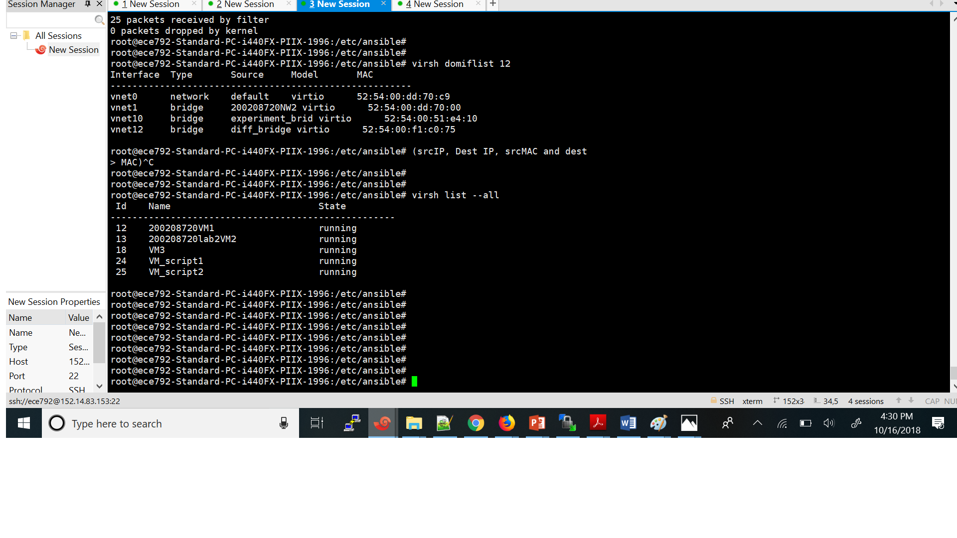

(d)

Listing the ip and mac adrees of all the VM

The 200208720VM1 interfaces and mac address details

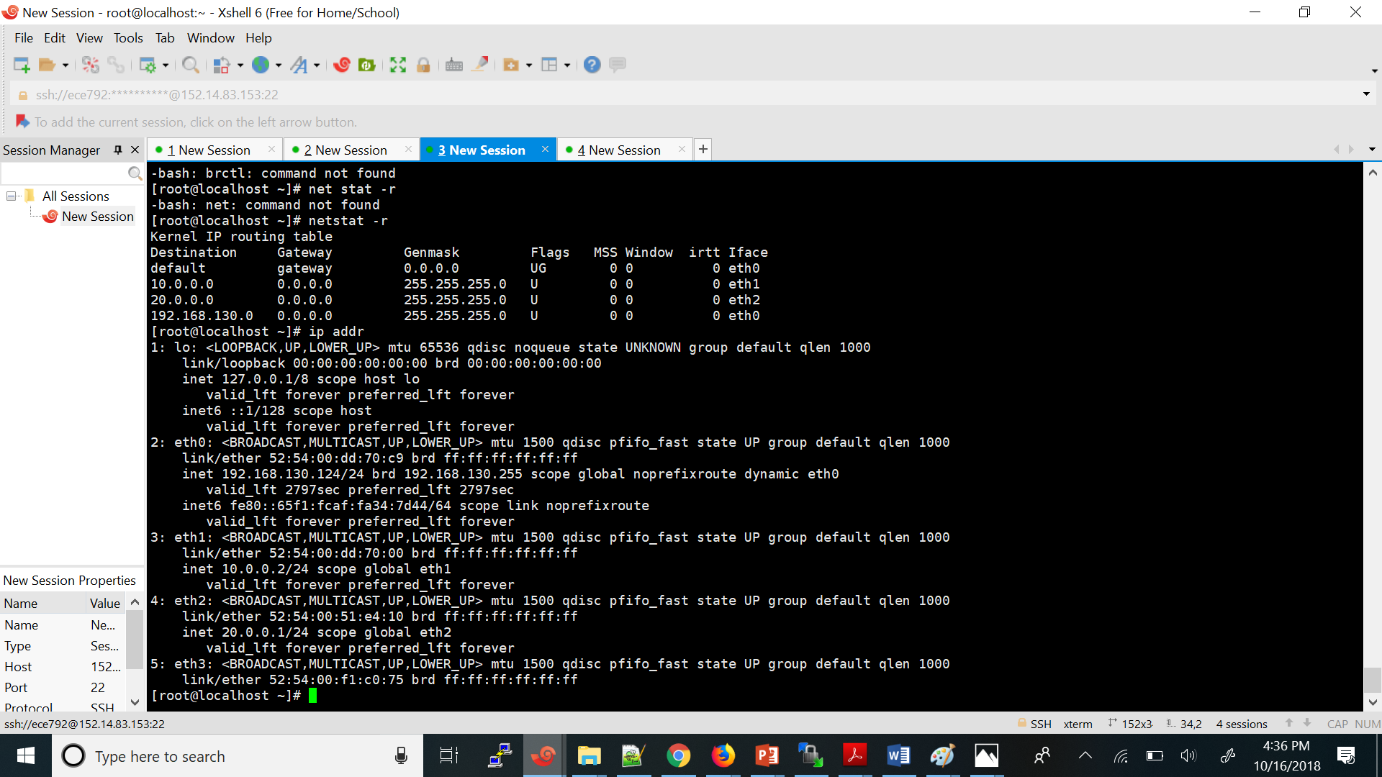

The VM 2 : 200208720lab2VM2 Mac addresses and the details

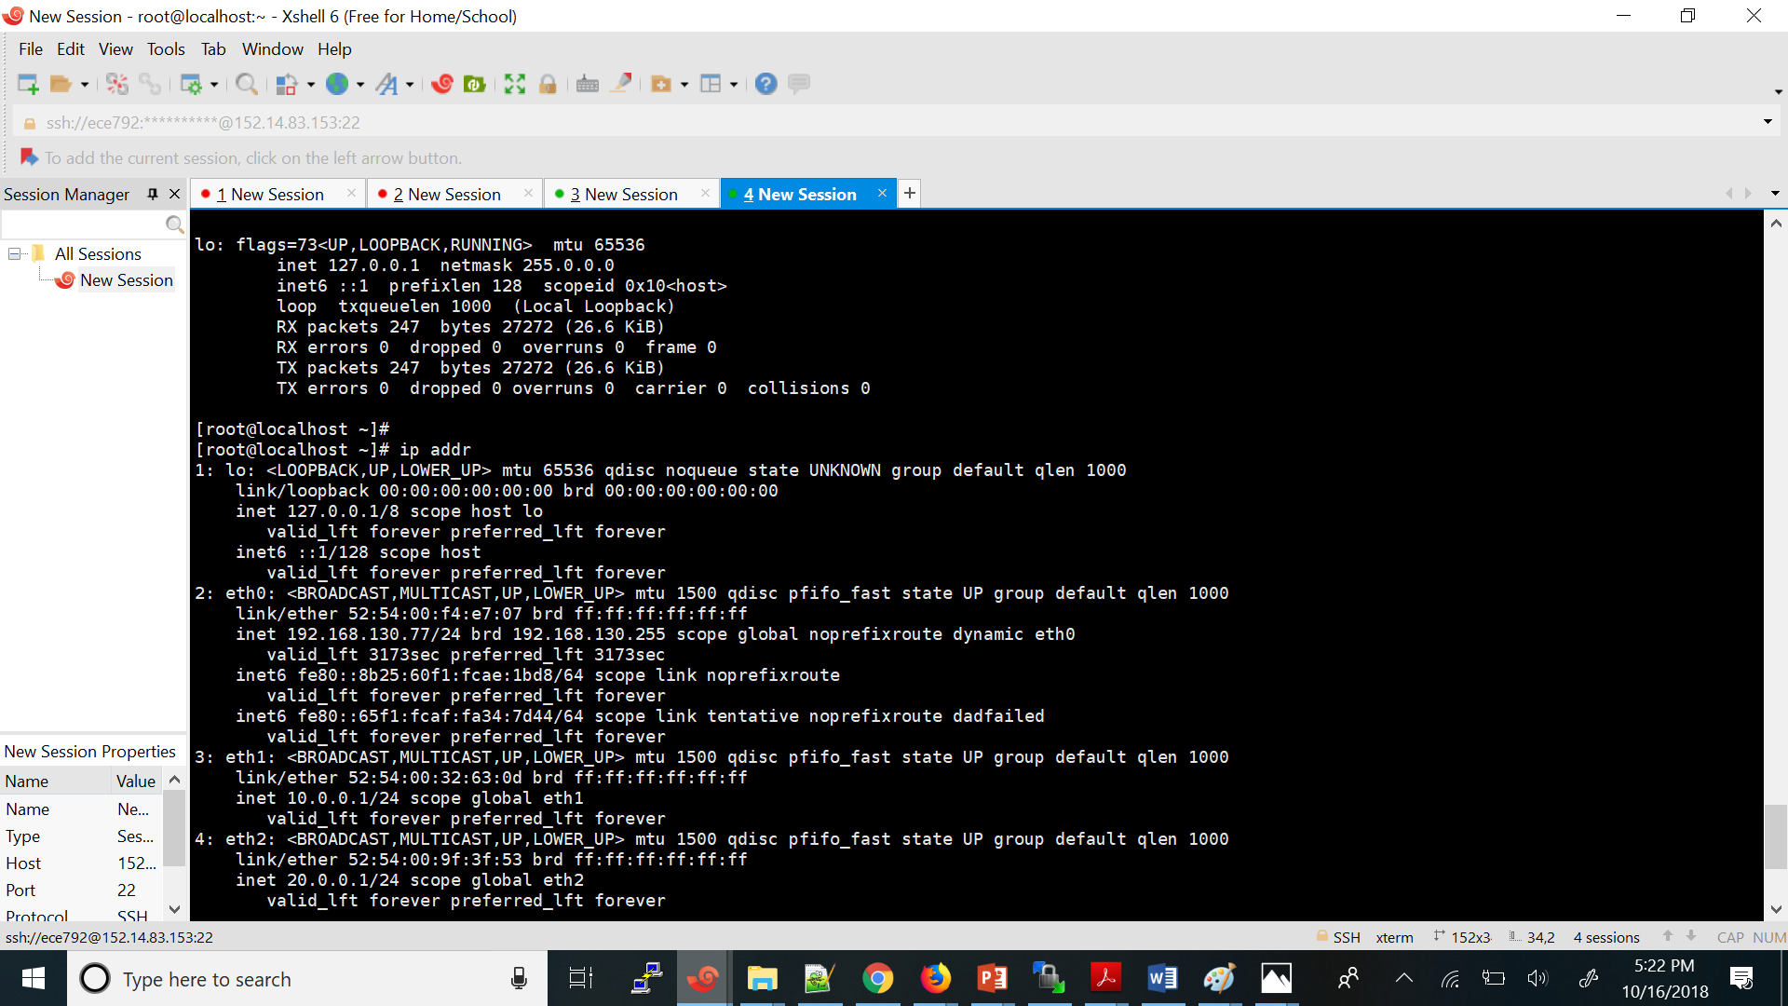

Part -5 :

When we ping from one Vm1 (10.0.0.2) to Vm2 (10.0.0.1)

The ip address of VM1 -10.0.0.2

The ip address of Vm2 – 10.0.0.1

Here is the tuple at the VM1 side :

(10.0.0.2 10.0.0.1 52:54:00:32:63:0d 52:54:00:dd:70:00 )

The tuple at the VM2 side is

(10.0.0.2 10.0.0.1 52:54:00:32:63:0d 52:54:00:dd:70:00)

Both must be the same as It is L2 connectivity the packet leaving from the First VM must be forwarded to the other VM

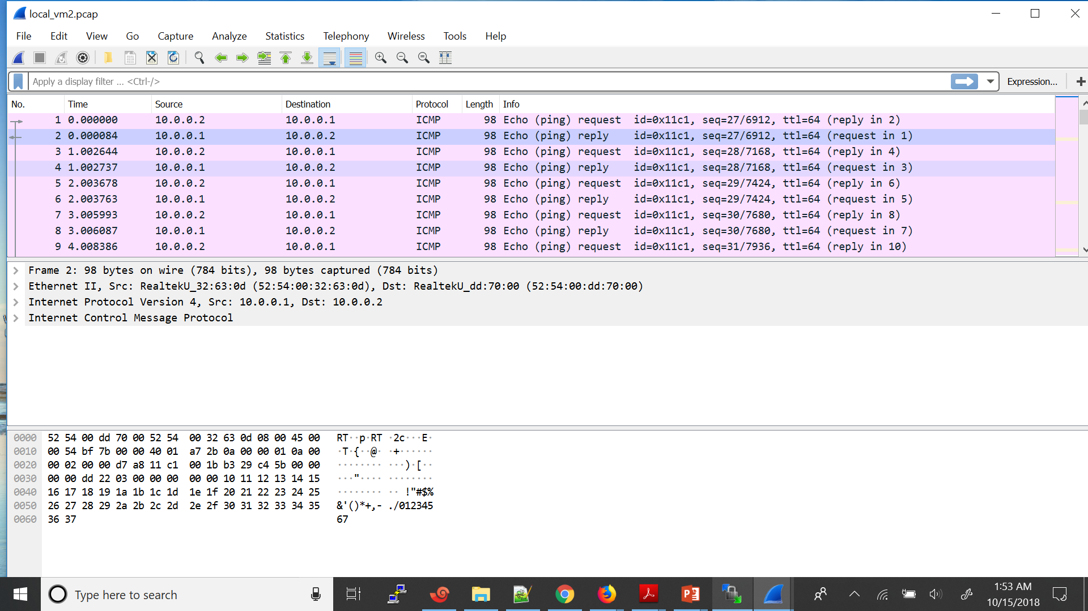

The packets captured on the other vm interface are also same

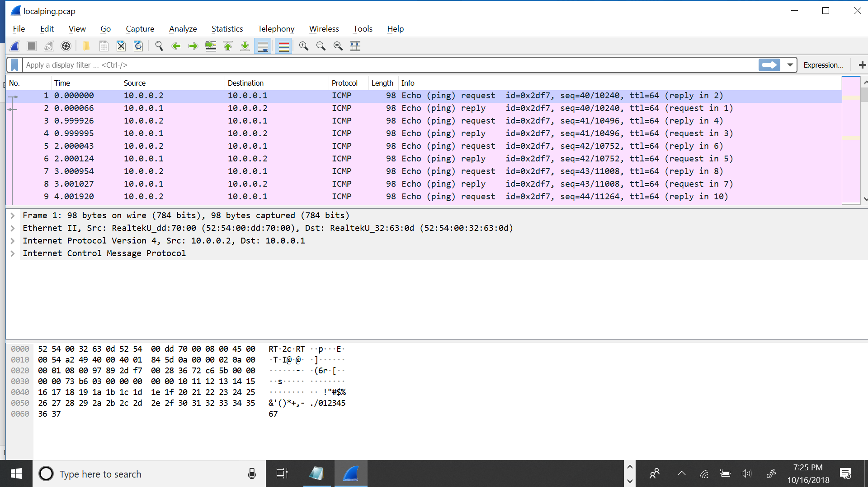

Soure Ip and destination Ip and the Mac address are same

If there would have been any routers then the packets sent and received would have different tuples

As there is only bridge between these two vms which doesn’t encapsulate or decapsulate as it just forwards or broadcast based on the mac table so the tuples obtained on both the interfaces are same.

**QUESTION 4: refer q4**

**QUESTION 5:referq5**

1)

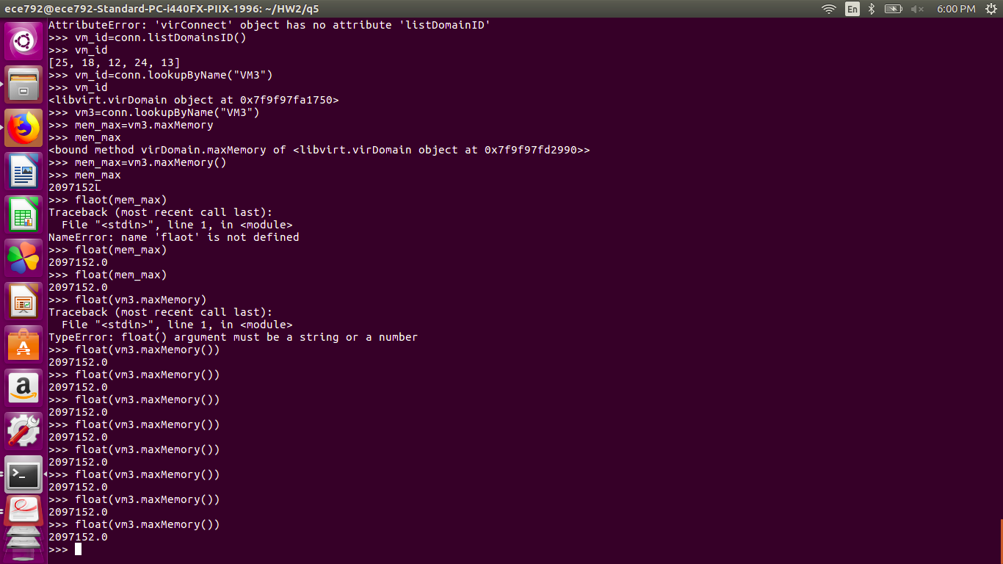

**2)**

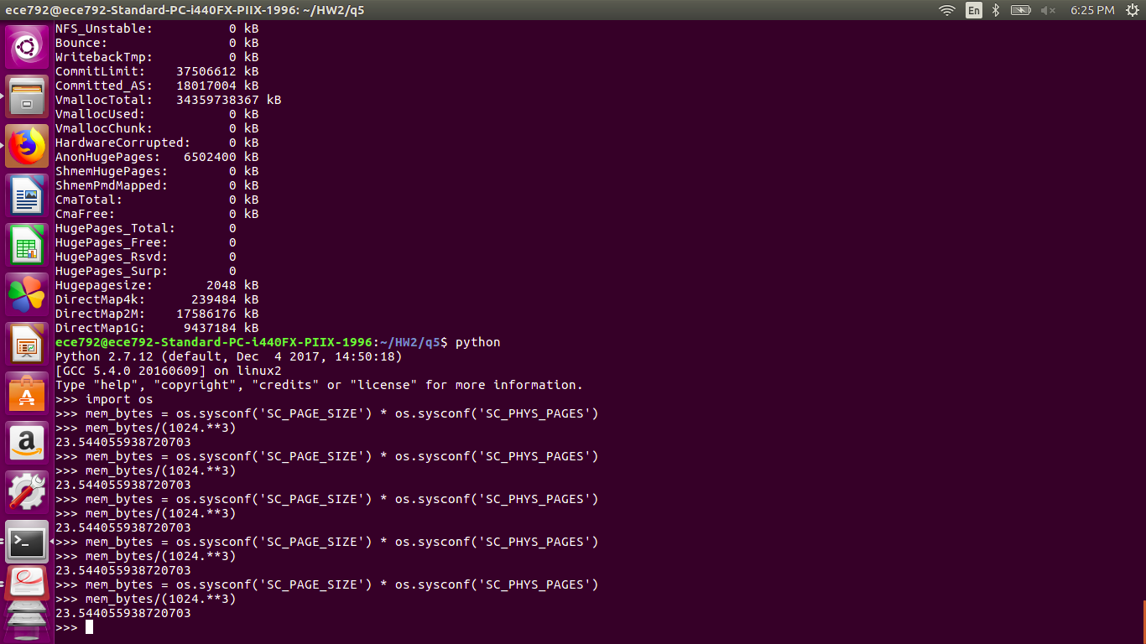

**QUESTION 6:**

A distributed switch like vDS can allow different hosts to use the switch unlike the Vswitches that are designed to support only one host. Vds also has features like Net flow and port mirror.

1)port mirror is a feature that allows debugging issue in virtual infrastructures

2)Vds can be used for blocking a virtual machine port

3)Net Flow helps to measure different application flows and their performance. This can help in planning the resources for different application.

4)Virtual distributed switch automates the virtual machine monitoring.

5)Eliminates the perhost configuration for each vsphere host.

6)virtual distributed switch provides centralized provisioning and monitoring.

**Question 7:**

**1st part : Two VMS connected to the same bridge**

Same mac different ip :

Both have the same mac address :52:54:00:9f:3f:53

Pinging 20.0.0.2 (eth2 interface )from 20.0.0.1 (eth2 inetrface )

Eth2(20.0.0.2) --------------------vnet10 (experiment_bridg)

Eth2(20.0.0.1) ------------------ vnet9 (experiment_brid)

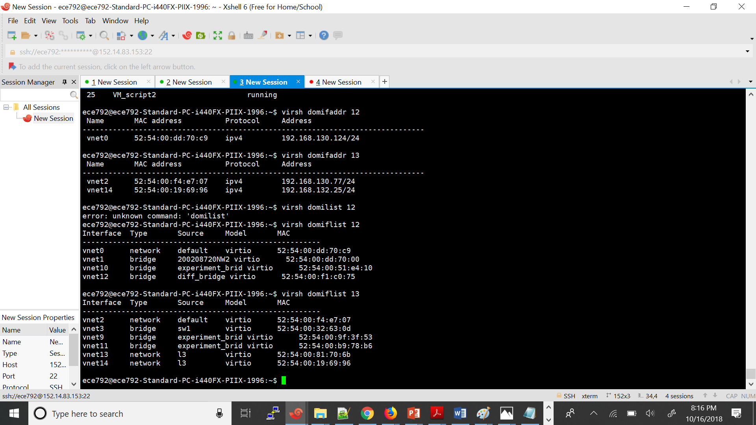

Eth2

Both have the same mac address :

Arp request is reaching the bridge(vnet10) and also the other VM (eth2) interface (10.0.0.2 ) other 20.0.0.2 interface is replying back to the arp request to the switch(Vnet9) .

The arp reply from (20.0.0.2) is not reaching the vnet9 interface so the ping between the 20.0.0.2 and

Packet capture at vnet9 interface (connected to 20.0.0.1 ) interface

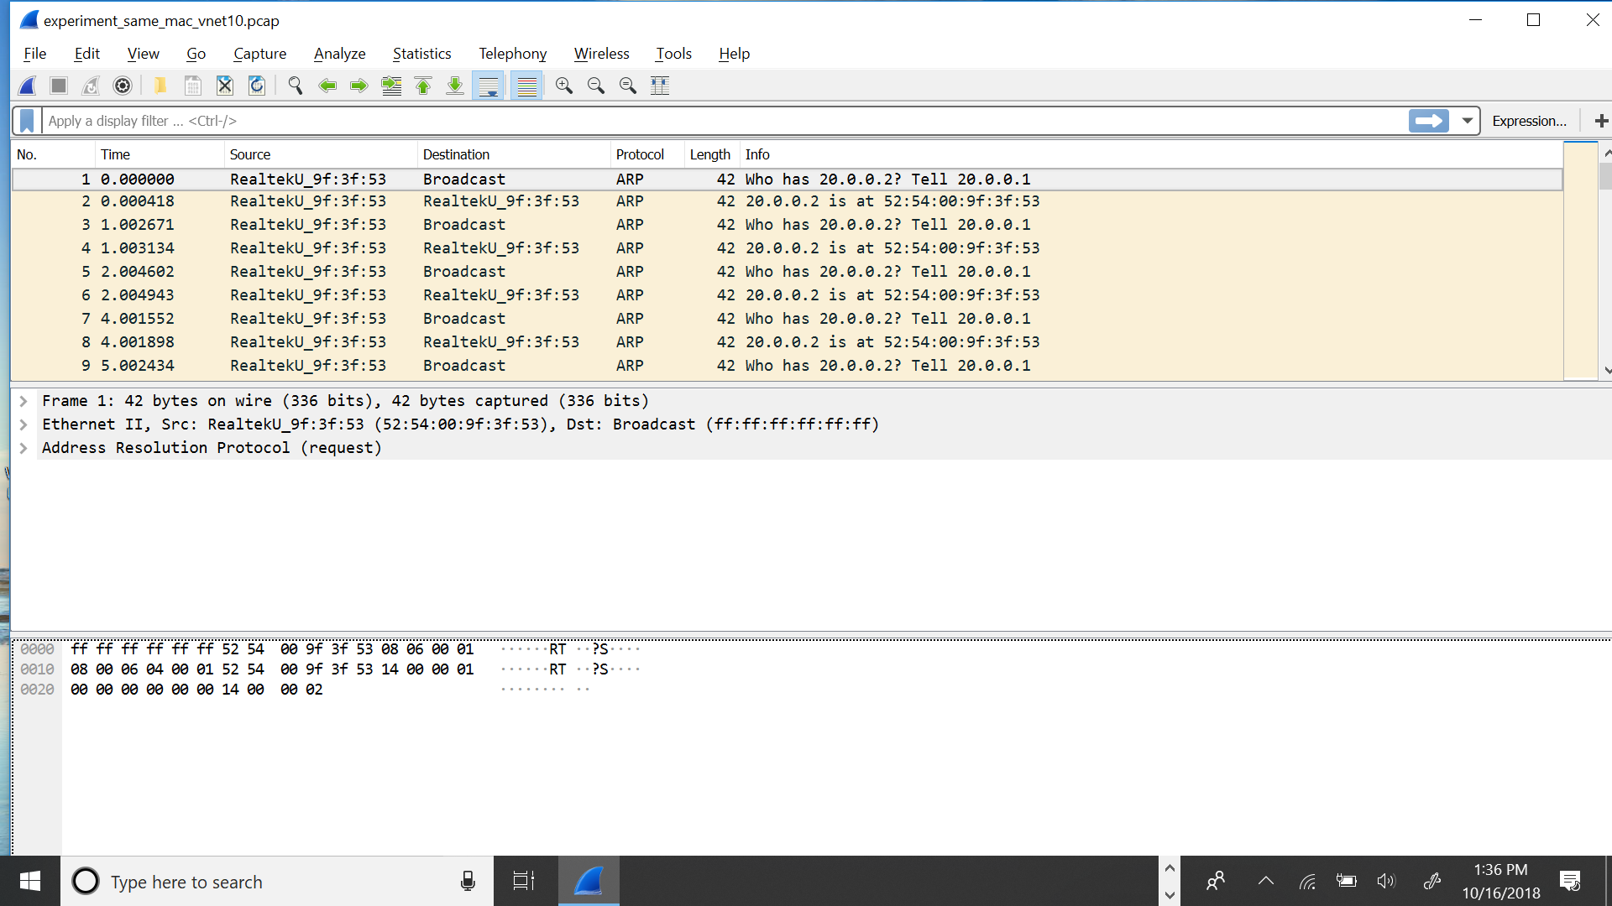

The packet capture at the Vnet10 interface (interface connected to 20.0.0.2) interface .

It is replying back to bridge with an arp reply but the source and destination are on the same interface

Vnet10. So the switch is not forwarding the packet to the vnet9 interface as this previous entry has been overridden by the arp reply from 10.0.0.2

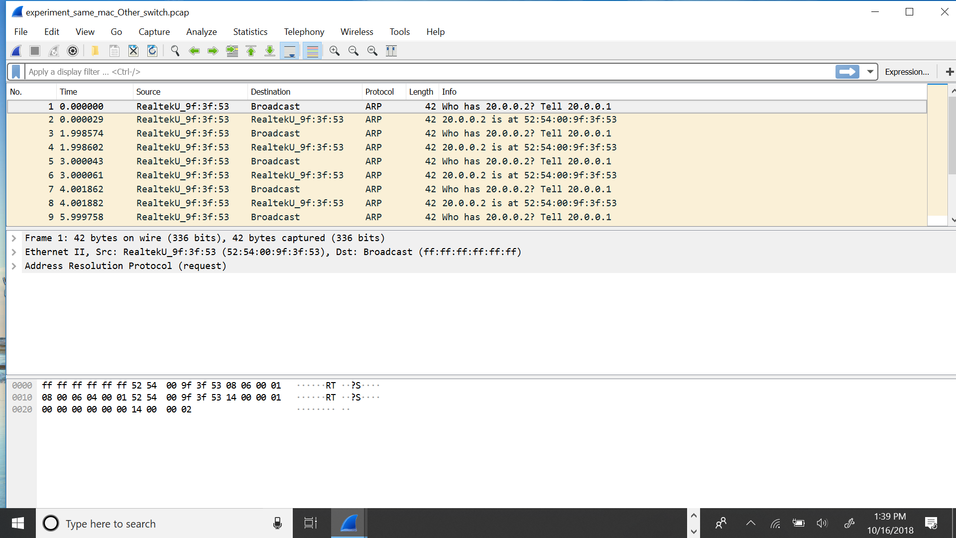

**Same Ip address but different mac address but connected to the same bridge :**

When the following command is executed

Arping _I eth2 20.0.0.2

Here is the snapshot of the packet capture at the vnet 9 interface(connected to VM1):

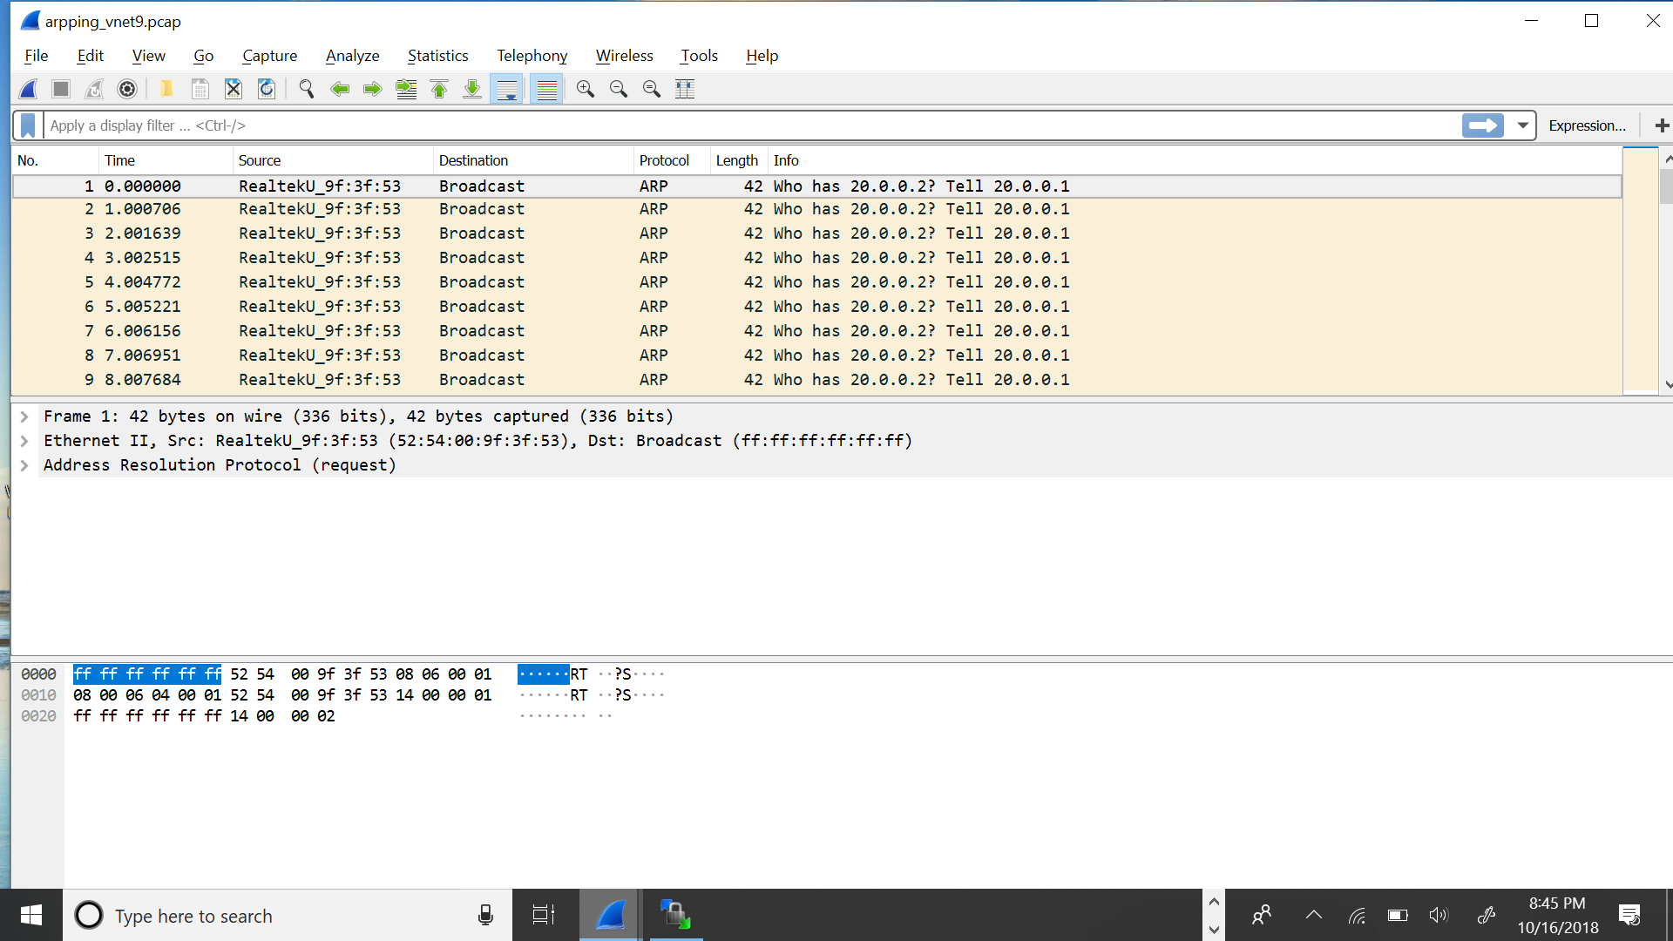

The snapshot of the packet capture at the VM2 interface(eth2) 20.0.0.1 .its receiving the arp request but not replying back.

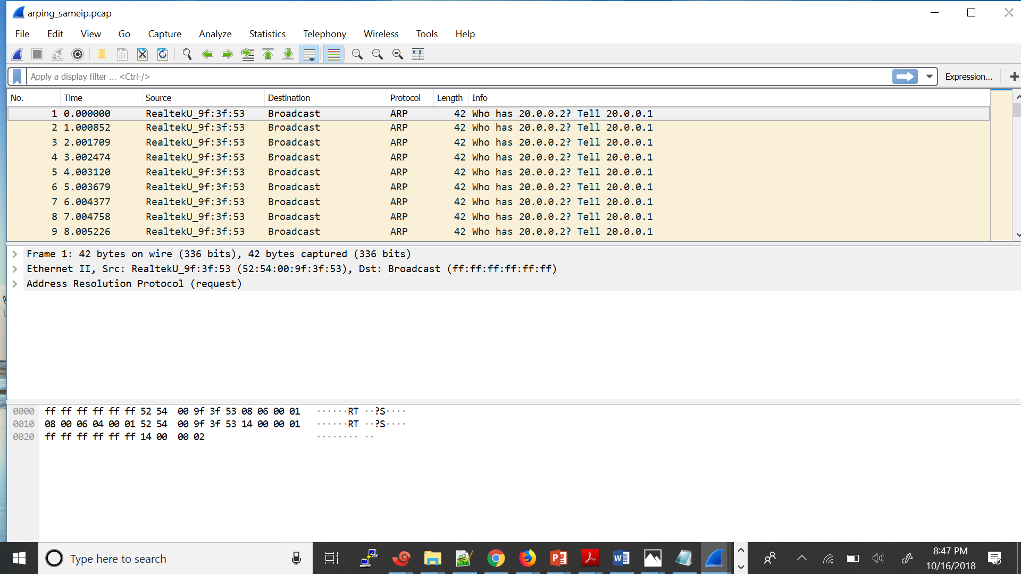

The packet capture at the vnet10 interface connected to the bridge (connected to VM2 ) :

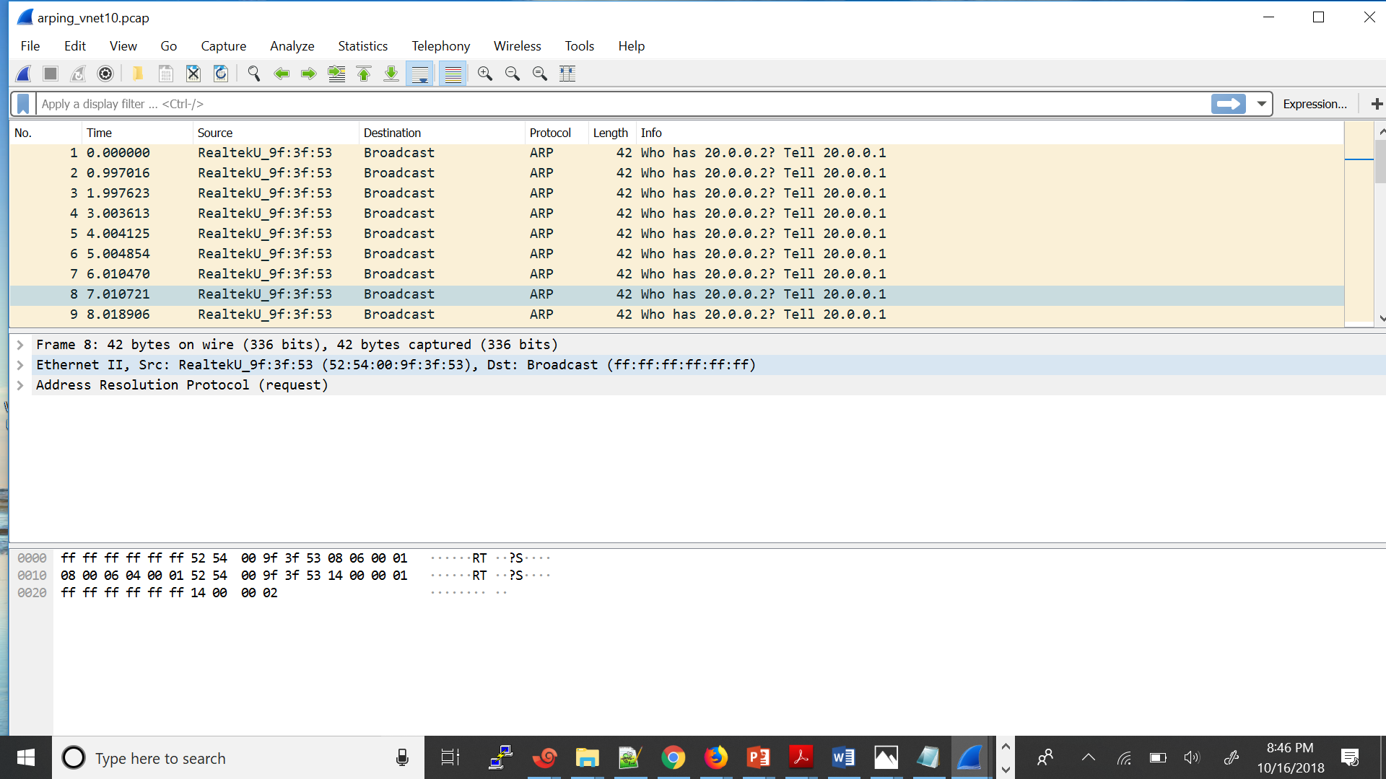

As the VM2 is not replying back to the Vm1 arp request so the arp process is not successful .

**Part 2 : Two VMs connected to two different bridges**

1. Same mac address and different ip addresses

If we ping from one vm to other vm the packets wont be reaching the other VM

As the two bridges aren’t interconnected so the packet will come to the bridge and it doesn’t have any path for further to proceed as it is only connected to the VM

So the data path for this is [ VM (eth3) ---- Bridge(vnet10) ] as there are no interconnections to this bridge.

1. same Ip address but different mac address

Ping is successful

In this case when both the VM are having the same Ip address ping is successful but it is not reaching to the other VM packets , ie it is self pinging (packets are travelling through the loopback interface and reaching the same VM ) self pinging.

**Part 3. Two VMS connected to different L3 bridges but having the same mac address:**

The topology is

200208720NW2 (eth4 )(192.168.134.152) interface ----- vnet 15 l3_net2 bridge(Routed)

200208720lab2VM2(eth 5) (192.168.132.25 )interface ---- vnet14 l3bridge (Routed)

By doing Arp -I eth5 192.168.134.152

The packets are reaching the vnet 14 interface but not reaching the vnet 15 interface as there is no connection between the two routed bridges so the arp process is not successful

Packet capture at vnet 14 interface:

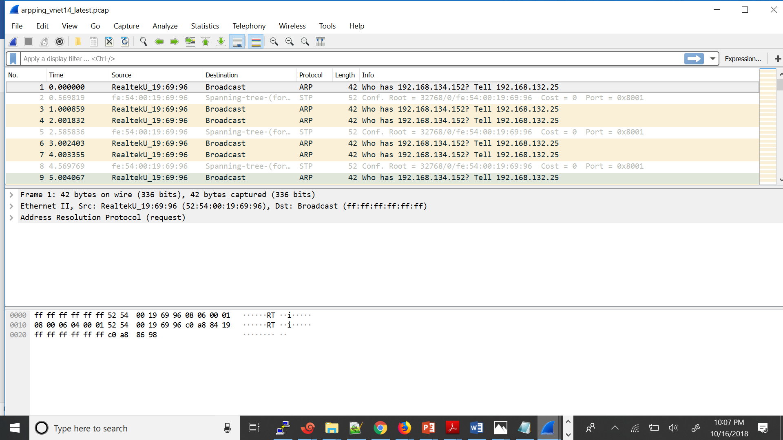

Packet capture at vnet 15 interface :

No packet is reaching here from the other l3 bridge to here

