Assignment 1: Neural Networks

Importing necessary libraries and modules for the IMDB dataset
import numpy as np
import matplotlib.pyplot as plt
from tensorflow.keras.datasets import imdb
from tensorflow.keras import models, layers, optimizers, losses, metrics, regularizers
from tensorflow.keras.models import Sequential
from tensorflow.keras.layers import Dense
- numpy is imported as np for numerical computations.
- matplotlib.pyplot is imported as plt for data visualization.
- From tensorflow.keras.datasets, the imdb dataset is imported, which will be used for this analysis.
- Various modules and classes from tensorflow.keras are imported, including models, layers, optimizers, losses, metrics, and regularizers.
- Specifically, Sequential model and Dense layer classes are imported from tensorflow.keras.models and tensorflow.keras.layers, respectively

Loading the IMDB dataset
(train_data, train_labels), (test_data, test_labels) = imdb.load_data(num_words=10000)
def vectorize_sequences(sequences, dimension=10000):
results = np.zeros((len(sequences), dimension))
for i, sequence in enumerate(sequences):
results[i, sequence] = 1.
return results
x_train = vectorize_sequences(train_data)
x_test = vectorize_sequences(test_data)
y_train = np.asarray(train_labels).astype('float32')
y_test = np.asarray(test_labels).astype('float32')
x_val = x_train[:10000]
partial_x_train = x_train[10000:]
y_val = y_train[:10000]
partial_y_train = y_train[10000:]

Neural Network Model Builder with Regularization and Dropout
def build_model(num_hidden_layers=2, num_hidden_units=16, activation='relu', loss='binary_crossentropy', dropout_rate=0.5, regularization=None, regularization_rate=0.01):
model = models.Sequential()
model.add(layers.Dense(num_hidden_units, activation=activation, kernel_regularizer=regularizers.l2(regularization_rate), input_shape=(10000,)))
for _ in range(num_hidden_layers - 1):
model.add(layers.Dense(num_hidden_units, activation=activation, kernel_regularizer=regularizers.l2(regularization_rate)))
model.add(layers.Dropout(dropout_rate))
model.add(layers.Dense(1, activation='sigmoid'))
model.compile(optimizer='rmsprop',
loss=loss,
metrics=['accuracy'])
return model
- activation='relu'
- loss = 'binary_crossentropy'
- droput_rate = 0.5
- l2 Regularization

Model Training and Evaluation Function
def train_and_evaluate_model(model, x_train, y_train, x_val, y_val, epochs=20, batch_size=512):
history = model.fit(x_train, y_train, epochs=epochs, batch_size=batch_size, validation_data=(x_val, y_val), verbose=0)
return history

Model Configuration Settings
configurations = [
{'num_hidden_layers': 1, 'num_hidden_units': 16},
{'num_hidden_layers': 3, 'num_hidden_units': 16},
{'num_hidden_layers': 1, 'num_hidden_units': 32},
{'num_hidden_layers': 3, 'num_hidden_units': 32},
{'num_hidden_layers': 1, 'num_hidden_units': 64},
{'num_hidden_layers': 3, 'num_hidden_units': 64},
]
results = []

Model Training and Evaluation
for config in configurations:
model = build_model(num_hidden_layers=config['num_hidden_layers'], num_hidden_units=config['num_hidden_units'])
history = train_and_evaluate_model(model, partial_x_train, partial_y_train, x_val, y_val)
loss, accuracy = model.evaluate(x_test, y_test)
results.append({'config': config, 'history': history, 'test_loss': loss, 'test_accuracy': accuracy})
782/782 [==============================] - 2s 3ms/step - loss: 0.4379 - accuracy: 0.8438
782/782 [==============================] - 2s 3ms/step - loss: 0.4585 - accuracy: 0.8707
782/782 [==============================] - 2s 3ms/step - loss: 0.4126 - accuracy: 0.8651
782/782 [==============================] - 3s 3ms/step - loss: 0.4543 - accuracy: 0.8708
782/782 [==============================] - 4s 5ms/step - loss: 0.4034 - accuracy: 0.8735
782/782 [==============================] - 3s 4ms/step - loss: 0.4424 - accuracy: 0.8709
- The provided code iterates over each configuration defined in the configurations list.
- For each configuration, it builds a neural network model using the build_model function with the specified number of hidden layers and units.
- The model is then trained and evaluated using the train_and_evaluate_model function, which takes training and validation data.
- After training and evaluating the model, the test loss and accuracy are computed using the test data.
- The results, including the configuration details, training history, test loss, and test accuracy, are appended to a list named results.

Results
model_configurations = []
model_test_loss = []
model_test_accuracy = []
for result in results:
print(f"Configuration: {result['config']}")
print(f"Test Loss: {result['test_loss']}, Test Accuracy: {result['test_accuracy']}")
model_configurations.append(str(result['config']['num_hidden_layers'])+":"+str(result['config']['num_hidden_units']))
model_test_loss.append(result['test_loss'])
model_test_accuracy.append(result['test_accuracy'])
Configuration: {'num_hidden_layers': 1, 'num_hidden_units': 16}
Test Loss: 0.437851220369339, Test Accuracy: 0.8438400030136108
Configuration: {'num_hidden_layers': 3, 'num_hidden_units': 16}
Test Loss: 0.4585479199886322, Test Accuracy: 0.8706799745559692
Configuration: {'num_hidden_layers': 1, 'num_hidden_units': 32}
Test Loss: 0.4125725030899048, Test Accuracy: 0.865119993686676
Configuration: {'num_hidden_layers': 3, 'num_hidden_units': 32}
Test Loss: 0.4543474316596985, Test Accuracy: 0.8708000183105469
Configuration: {'num_hidden_layers': 1, 'num_hidden_units': 64}
Test Loss: 0.4034256637096405, Test Accuracy: 0.8734800219535828
Configuration: {'num_hidden_layers': 3, 'num_hidden_units': 64}
Test Loss: 0.44235163927078247, Test Accuracy: 0.8708800077438354
plt.figure(figsize=(10, 6))
plt.bar(model_configurations, model_test_accuracy, color='lightgreen')
plt.title('Test Accuracies for Different Model Configurations')
plt.xlabel('Model Configurations')
plt.ylabel('Test Accuracy')
plt.ylim(min(model_test_accuracy)-0.005, max(model_test_accuracy)+0.005)
plt.xticks(rotation=45)
plt.grid(axis='y', linestyle='--', alpha=0.7)
plt.tight_layout()
plt.show()
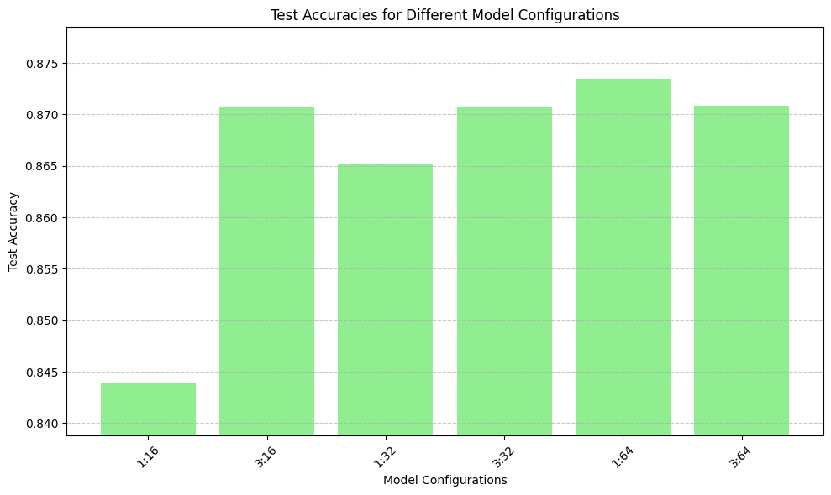
plt.figure(figsize=(10, 6))
plt.bar(model_configurations, model_test_loss, color='lightgreen')
plt.title('Test loss for Different Model Configurations')
plt.xlabel('Model Configurations')
plt.ylabel('Test Loss')
plt.ylim(min(model_test_loss)-0.05, max(model_test_loss)+0.05)
plt.xticks(rotation=45)
plt.grid(axis='y', linestyle='--', alpha=0.7)
plt.tight_layout()
plt.show()
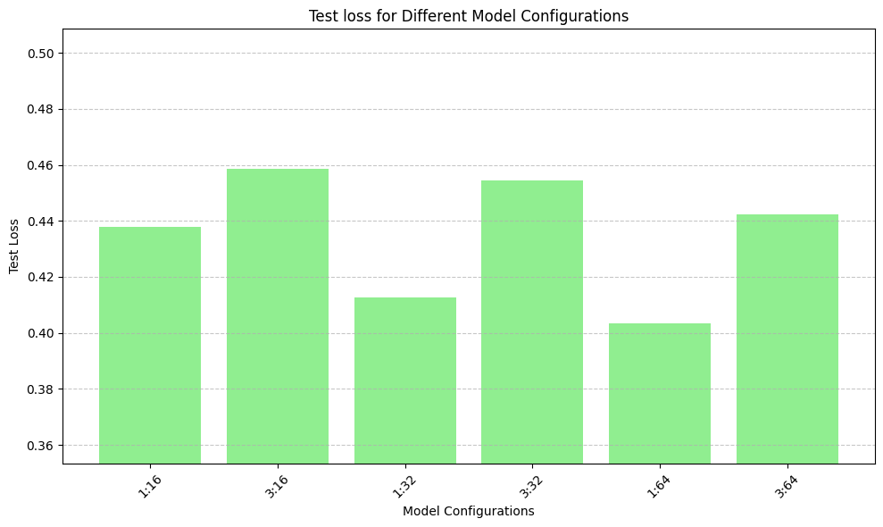

Neural Network Model Builder with Regularization and Dropout for tanh and mse
def act_build_model(num_hidden_layers=2, num_hidden_units=16, activation='tanh', loss='mse',dropout_rate=0.5, regularization=None, regularization_rate=0.01):
model = models.Sequential()
model.add(layers.Dense(num_hidden_units, activation=activation, kernel_regularizer=regularizers.l2(regularization_rate), input_shape=(10000,)))
for _ in range(num_hidden_layers - 1):
model.add(layers.Dense(num_hidden_units, activation=activation, kernel_regularizer=regularizers.l2(regularization_rate)))
model.add(layers.Dropout(dropout_rate))
model.add(layers.Dense(1, activation='sigmoid'))
model.compile(optimizer='rmsprop',
loss=loss,
metrics=['accuracy'])
return model
- activation='tanh'
- loss = 'mse'
- droput_rate = 0.5
- l2 Regularization
act_results = []

Model Training and Evaluation
for config in configurations:
model = act_build_model(num_hidden_layers=config['num_hidden_layers'], num_hidden_units=config['num_hidden_units'])
history = train_and_evaluate_model(model, partial_x_train, partial_y_train, x_val, y_val)
loss, accuracy = model.evaluate(x_test, y_test)
act_results.append({'config': config, 'history': history, 'test_loss': loss, 'test_accuracy': accuracy})
782/782 [==============================] - 2s 2ms/step - loss: 0.1320 - accuracy: 0.8683
782/782 [==============================] - 2s 2ms/step - loss: 0.1479 - accuracy: 0.8753
782/782 [==============================] - 3s 3ms/step - loss: 0.1519 - accuracy: 0.8345
782/782 [==============================] - 3s 4ms/step - loss: 0.1510 - accuracy: 0.8678
782/782 [==============================] - 3s 4ms/step - loss: 0.1410 - accuracy: 0.8573
782/782 [==============================] - 3s 4ms/step - loss: 0.1414 - accuracy: 0.8754

Results
act_model_configurations = []
act_model_test_loss = []
act_model_test_accuracy = []
for result in act_results:
print(f"Configuration: {result['config']}")
print(f"Test Loss: {result['test_loss']}, Test Accuracy: {result['test_accuracy']}")
act_model_configurations.append(str(result['config']['num_hidden_layers'])+":"+str(result['config']['num_hidden_units']))
act_model_test_loss.append(result['test_loss'])
act_model_test_accuracy.append(result['test_accuracy'])
Configuration: {'num_hidden_layers': 1, 'num_hidden_units': 16}
Test Loss: 0.13196450471878052, Test Accuracy: 0.8682799935340881
Configuration: {'num_hidden_layers': 3, 'num_hidden_units': 16}
Test Loss: 0.1479194611310959, Test Accuracy: 0.8752800226211548
Configuration: {'num_hidden_layers': 1, 'num_hidden_units': 32}
Test Loss: 0.1519286036491394, Test Accuracy: 0.8345199823379517
Configuration: {'num_hidden_layers': 3, 'num_hidden_units': 32}
Test Loss: 0.1509721428155899, Test Accuracy: 0.8678399920463562
Configuration: {'num_hidden_layers': 1, 'num_hidden_units': 64}
Test Loss: 0.14104266464710236, Test Accuracy: 0.8573200106620789
Configuration: {'num_hidden_layers': 3, 'num_hidden_units': 64}
Test Loss: 0.1413896530866623, Test Accuracy: 0.8753600120544434
plt.figure(figsize=(10, 6))
plt.bar(act_model_configurations, act_model_test_accuracy, color='lightgreen')
plt.title('Test Accuracies for Different Model Configurations')
plt.xlabel('Model Configurations')
plt.ylabel('Test Accuracy')
plt.ylim(0.82, 0.89)
plt.xticks(rotation=45)
plt.grid(axis='y', linestyle='--', alpha=0.7)
plt.tight_layout()
plt.show()
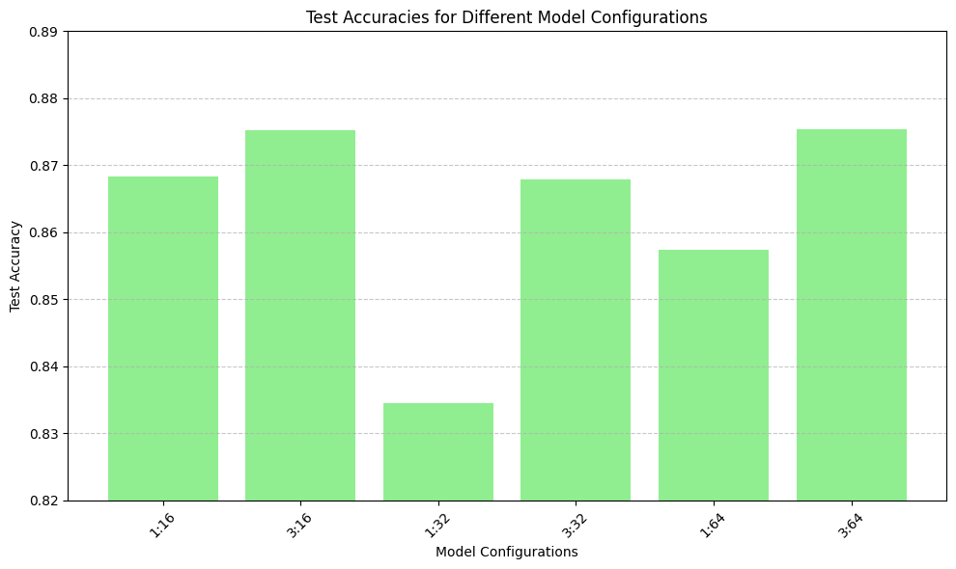
plt.figure(figsize=(10, 6))
plt.bar(act_model_configurations, act_model_test_loss, color='lightgreen')
plt.title('Test loss for Different Model Configurations')
plt.xlabel('Model Configurations')
plt.ylabel('Test Loss')
plt.ylim(0.12, 0.16)
plt.xticks(rotation=45)
plt.grid(axis='y', linestyle='--', alpha=0.7)
plt.tight_layout()
plt.show()
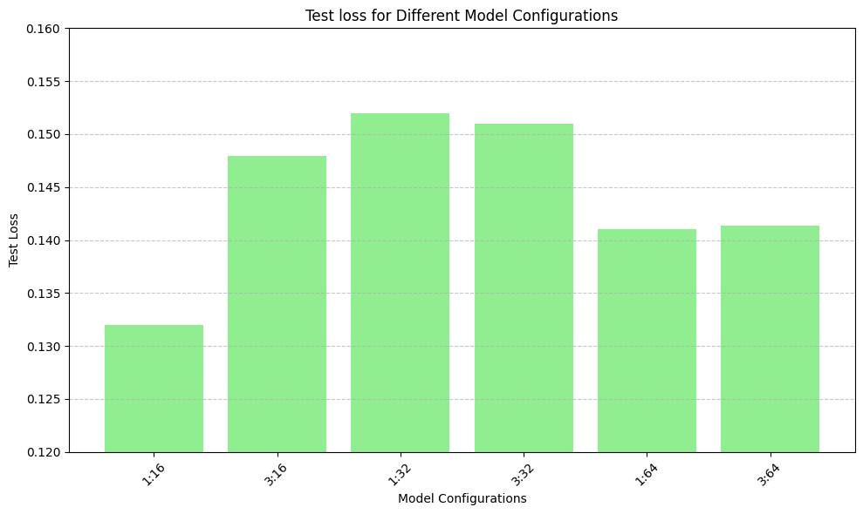
- Model with Relu Activation and Binary Crossentropy Loss:
- Test Loss: Varies between approximately 0.403 and 0.458
Test Accuracy: Varies between approximately 0.843 and 0.874
- Model with Tanh Activation and MSE Loss:
- Test Loss: Varies between approximately 0.131 and 0.152
Test Accuracy: Varies between approximately 0.834 and 0.875
- Differences:
- Loss Function: The first model uses binary crossentropy loss, while the second model uses mean squared error (MSE) loss. Activation Function: The first model uses ReLU activation, while the second model uses hyperbolic tangent (tanh) activation.
- Comparison:
- Test Loss: The model with tanh activation and MSE loss generally achieved lower test loss values compared to the model with ReLU activation and binary crossentropy loss. Lower test loss values indicate better agreement between the model's predictions and the actual labels in the test data.
Test Accuracy: The test accuracy varies for both models, but there is no consistent trend indicating one activation and loss combination is consistently better in terms of accuracy across all configurations.
- Conclusion:
- Overall, based on the test loss values, the model with tanh activation and MSE loss appears to perform slightly better than the model with ReLU activation and binary crossentropy loss

