SPICE ROUTE KITCHENS · MONTHLY OPERATIONS REVIEW
21 Jul – 17 Aug 2026
Prepared for Anjali Menon, Head of Operations, and the area management team · 20 outlets · compared against 23 Jun – 20 Jul 2026 · live detail at spice-route-ops.onrender.com
THE MONTH IN ONE LINE

Compliance held; follow-up did not.
Stores filed slightly more of their routine paperwork than last month and hygiene audits improved sharply. But the work those checks generate is not being closed: 79 of 83 open tickets are past their deadline, 53 of them by more than a month, and 71% of high-priority tickets raised this period missed their 24-hour target. The chain is good at spotting problems and poor at finishing them.
CHECKLIST COMPLETION  76.0%  ▼ 0.1pt vs last period · 269 runs missed | HYGIENE AUDITS DONE  67.5%  ▲ 11.3pt vs last period · 26 store-weeks missed | AVG COMPLIANCE SCORE  82.0%  ▼ 0.8pt vs last period · 39% below threshold | TICKETS PAST DUE  79  of 83 open · median age 43 days

WHAT CHANGED, AND WHAT IT MEANS

Four things worth your attention
1 The ticket backlog has become structural, not seasonal
53 of the 83 open tickets are more than 30 days old and the oldest is 91 days. Escalations have risen every period (10 → 12 → 16), which tells us escalation is being used as a filing cabinet rather than a trigger. Safety is the single largest category in the backlog (16 open tickets), which is the part I would not let run another month.
2 Closing a ticket is not the same as fixing the problem
Reading the free-text issue reports rather than the tick-boxes: 61 times this quarter a store reported the same fault in the same words it had already reported before, and in 41 of those cases the earlier ticket had already been marked Closed. Median time to recurrence is 22 days. Delhi – Connaught Place has reported the same grill igniter fault four separate times. We are paying to reopen problems we believe we solved.
3 The chain average hides a two-speed estate
Chain completion moved 72.4% → 76.0% across the quarter, which reads like slow progress. It is not: the eight healthiest stores average 91% completion while seven at-risk stores average 54%, and that gap has not narrowed in three months. Those seven stores generate 63% of every missed checklist in the chain. This is a seven-store problem being reported as a twenty-store average.
4 Hygiene audits are the one clear win — and it was coachable
Weekly audit completion went 56.2% → 67.5%, the largest single improvement of the quarter, driven mostly by Bhopal – MP Nagar (+34 points on checklists) after its area manager started reviewing the missed-audit list weekly. That is the intervention worth copying to the other six.

DECISIONS NEEDED FROM YOU

Three of the five actions need your call, not ours
ACTION | WHY | OWNER | BY
Set the high-priority SLA at 24 or 48 hours. If it stays at 24 it needs on-call cover funded; if not, move it to 48 and the breach number becomes real again. | Today we breach 55% of the time, so the target no longer changes anyone's behaviour. | VP Operations | This month
Approve a refrigeration and ice-machine condition survey at the six worst outlets. | Two of the three most-failed checks chain-wide are equipment, not discipline. | Maintenance | 4 weeks
Agree the seven at-risk stores get a named 30-day plan with their area manager. | They produce 63% of all missed checklists; the Bhopal playbook already worked once. | Area managers | Starts Monday

CHAIN PERFORMANCE

Thirteen weeks at a glance
Daily checklist completion has been flat in the mid-70s since mid-June. The volatility in the audit line is the story worth watching — audits are done by exception rather than by routine, so the line swings between 40% and 80% depending on who chased them.
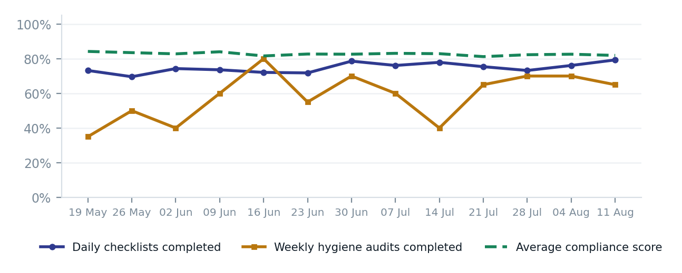
Weekly, all 20 outlets. Compliance score is the average of the scored checklist and audit submissions filed that week; it stays high because the stores that skip filing are also the stores that would have scored badly — a survivorship effect worth remembering whenever compliance looks reassuring.

DISTRIBUTION, NOT AVERAGE

Where each store started the quarter, and where it is now
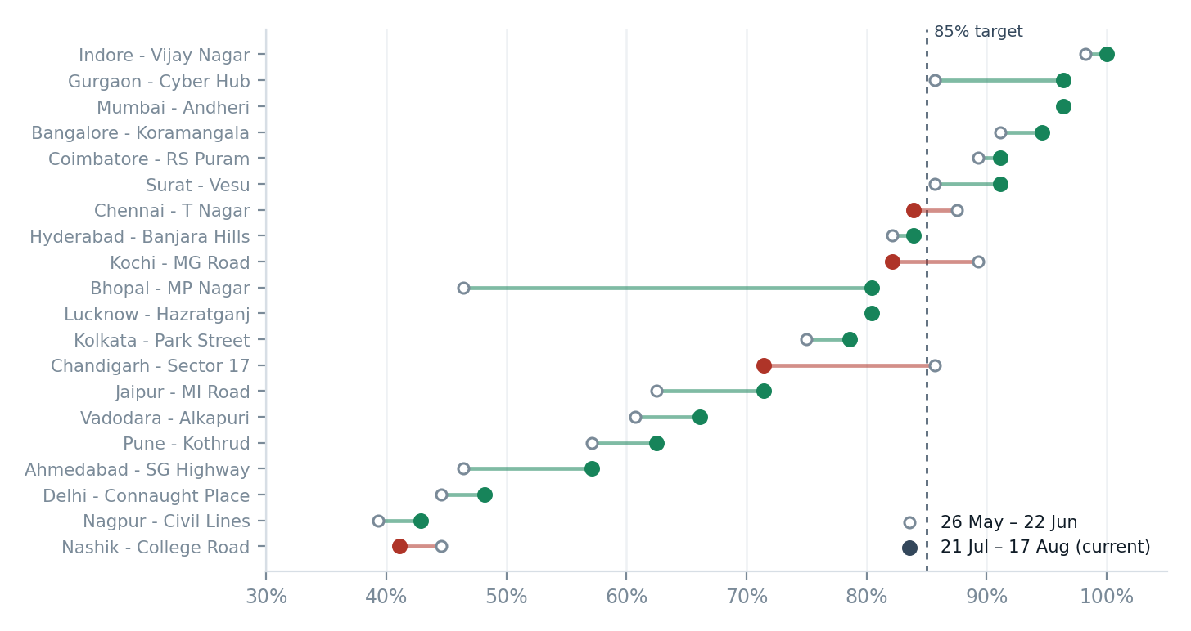
Hollow marker = 26 May – 22 Jun, solid = 21 Jul – 17 Aug. Green means the store improved, red means it slipped. Nine stores now clear the 85% completion target; four have sat below 50% for the entire quarter. Nagpur is the one to act on: it is not just the lowest performer, it is the fastest-declining one. Chandigarh matters for a different reason — it was a healthy store a month ago and nobody has flagged it yet.

STORE SCORECARD

All 20 outlets, quarter to date
Rating is a 0–100 roll-up of what the store itself controls: completion (35), audits (15), compliance score (30) and failed checks (20). Ticket lateness sits in its own column because it is owned by the area manager, not the store.
STORE | RATING | CHECKLISTS | AUDITS | AVG SCORE | CHECKS FAILED | TICKETS LATE
Indore - Vijay Nagar  Dev Reddy | 94 Good | 98.4% | 92.3% | 90.8% | 9.3% | 5
Surat - Vesu  Dev Reddy | 92 Good | 90.7% | 84.6% | 95.1% | 5.2% | 6
Bangalore - Koramangala  Mohit Iyer | 91 Good | 95.1% | 100.0% | 86.0% | 14.3% | 2
Mumbai - Andheri  Mohit Iyer | 89 Good | 96.7% | 84.6% | 85.4% | 14.5% | 2
Coimbatore - RS Puram  Vinod Patel | 89 Good | 90.7% | 69.2% | 94.0% | 6.1% | 4
Gurgaon - Cyber Hub  Vinod Patel | 88 Good | 89.0% | 61.5% | 94.7% | 5.3% | 1
Kochi - MG Road  Dev Reddy | 85 Good | 85.7% | 76.9% | 87.5% | 12.6% | 6
Hyderabad - Banjara Hills  Mohit Iyer | 85 Good | 83.0% | 76.9% | 88.9% | 11.0% | 0
Chandigarh - Sector 17  Priya Nair | 83 Watch | 80.8% | 76.9% | 86.0% | 14.1% | 3
Kolkata - Park Street  Priya Nair | 76 Watch | 78.0% | 53.8% | 81.7% | 18.4% | 3
Chennai - T Nagar  Priya Nair | 75 Watch | 81.9% | 46.2% | 78.0% | 21.8% | 1
Jaipur - MI Road  Priya Nair | 73 Watch | 69.8% | 61.5% | 78.0% | 22.0% | 4
Lucknow - Hazratganj  Dev Reddy | 72 Watch | 74.7% | 38.5% | 80.8% | 19.0% | 6
Vadodara - Alkapuri  Vinod Patel | 69 At risk | 64.8% | 46.2% | 79.4% | 20.7% | 4
Bhopal - MP Nagar  Vinod Patel | 69 At risk | 64.8% | 30.8% | 84.1% | 16.2% | 6
Pune - Kothrud  Mohit Iyer | 69 At risk | 65.9% | 61.5% | 72.4% | 27.5% | 5
Nashik - College Road  Vinod Patel | 53 At risk | 41.8% | 30.8% | 66.9% | 33.4% | 5
Ahmedabad - SG Highway  Priya Nair | 52 At risk | 50.5% | 38.5% | 57.6% | 42.2% | 4
Nagpur - Civil Lines  Dev Reddy | 50 At risk | 44.0% | 23.1% | 62.6% | 36.4% | 7
Delhi - Connaught Place  Mohit Iyer | 46 At risk | 47.8% | 15.4% | 54.8% | 45.3% | 5
Good ≥ 85, Watch 70–84, At risk below 70. “Checks failed” is the share of yes/no questions answered No. “Tickets late” is open tickets already past their deadline as at 17 Aug 2026.

WHAT IS ACTUALLY FAILING

The same six checks, month after month
Across 29,236 answered questions this quarter, 4,213 checks came back No. They are not spread evenly — a handful of checks account for most of them, and the top two are equipment problems rather than discipline problems.
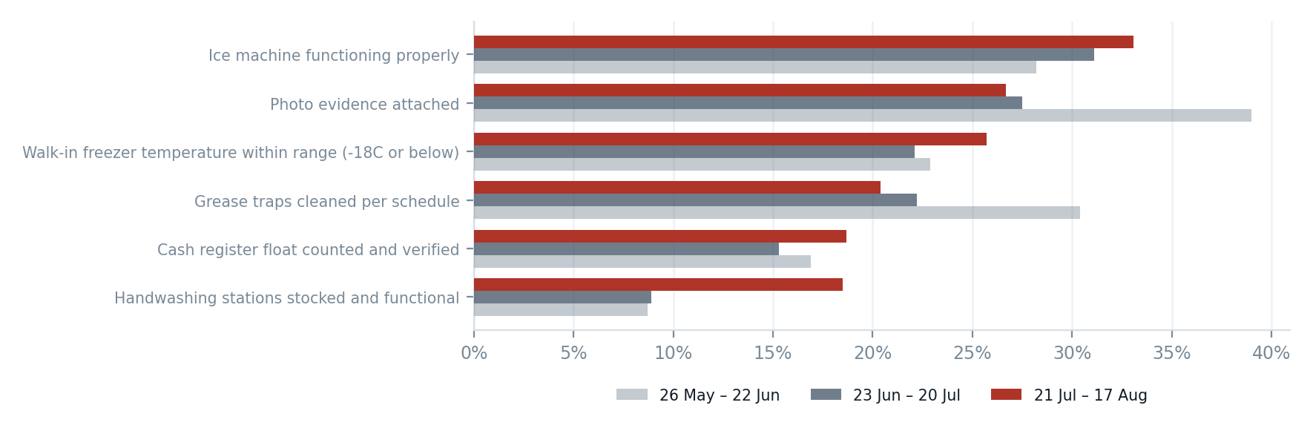
Share of submissions answering No, by period. Only checks asked at least 25 times in the current period are shown.

The ice machines are the single biggest failing check in the business
“Ice machine functioning properly?” has failed on roughly a third of all opening checklists, and the rate has climbed across the quarter — 27.3% in May to 33.7% so far in August. Crucially it fails at good stores too: even the outlet with the fewest ice failures in the chain still answers No 19.5% of the time. That is an asset problem, not a compliance problem. The free-text reports point the same way: “ice machine leaking water onto the floor, stopped using it” has been filed repeatedly at Ahmedabad alone. Walk-in freezer temperature is the same pattern at a lower level (23.4% failing, also rising).

What I would do with this
Two of the top three failing checks are refrigeration and ice. Rather than coach twenty store managers on the same check, it is cheaper to commission a condition survey of the ice machines and walk-in units at the six worst outlets and decide replace-versus-service with actual numbers. I can produce the per-asset failure history from Linemate in an afternoon if you want it costed.

TIMELINESS

A third of openings are logged late
454 of 1,366 opening checklists this quarter (33%) were filed at or after 09:00, which for a store opening at 08:00 usually means the checklist was completed from memory rather than walked through. It correlates almost perfectly with the at-risk group. It is worth a conversation before it becomes a food-safety incident, because a back-filled temperature check is not a temperature check.

FOLLOW-THROUGH

Where the operating model is leaking
This is the section I would spend the meeting on. Reporting works. Resolution does not, and the pattern is consistent enough that it is a process design issue rather than an effort issue.
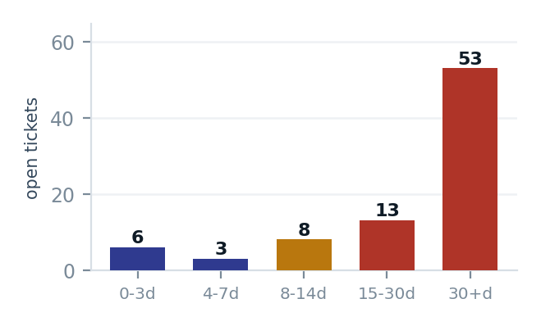
Open tickets by age. The bar on the right is the problem: 53 tickets older than 30 days, 42 of them formally escalated and still open.
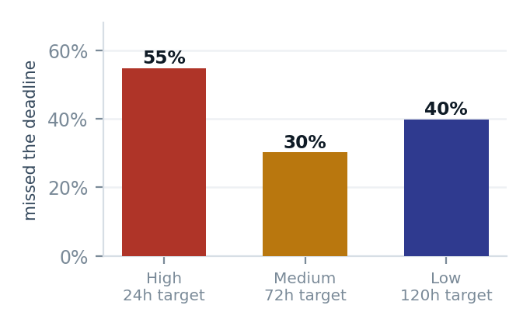
Share of tickets that missed their deadline, by priority, quarter to date. The inversion is the finding: the more urgent the ticket, the more likely we miss it.
The 24-hour high-priority SLA is not real
High-priority tickets breach 55% of the time against a 24-hour target, with a median resolution of 22 hours — sitting almost exactly on the deadline, which is what a target nobody has resourced looks like. In the current period it reached 71%. Either we staff for 24 hours or we set the target at 48 and stop generating breach noise that everyone has learned to ignore.
Roughly one in five reported issues never becomes a ticket
244 store issue reports were filed this quarter; 198 (81%) generated a ticket. The other 46 — including 10 marked High severity — went nowhere. Separately, 32% of issue reports have no photo attached, which is the single biggest reason maintenance vendors come back for a second visit.

Faults reported more than once at the same store
STORE AND FAULT | TIMES
Delhi - Connaught Place  Grill igniter not working, had to relight manually all day. | 4
Ahmedabad - SG Highway  Ice machine leaking water onto the floor, stopped using it. | 3
Ahmedabad - SG Highway  Packaging supplies delayed, using backup stock. | 2
Nashik - College Road  Walk-in cooler door seal is torn, cooler struggling to hold temperature. | 2
Bangalore - Koramangala  Packaging supplies delayed, using backup stock. | 2
61 recurrences across 17 stores; 41 came back after the earlier ticket had been closed.

RECOMMENDATIONS

Five decisions, with owners
ACTION | WHY | OWNER | BY
Clear the 30-day backlog. Triage all 53 tickets older than a month: fix, re-scope or close with a reason. Safety category first. | 16 open safety tickets, median age 43 days. | Area managers | 2 weeks
Re-baseline the high-priority SLA to 48 hours or fund on-call cover for the 24-hour target. Pick one. | 55% breach makes the current target meaningless. | VP Operations | This month
Auto-raise a ticket from any issue report of Medium severity or above, and make the photo field mandatory on High. | Closes the 46-report leak, including 10 High-severity ones. Configuration change, no headcount. | Linemate admin | 1 week
Commission a refrigeration and ice-machine condition survey at the six worst outlets; decide service versus replace on the failure history. | Two of the top three failing checks chain-wide, and rising every month. | Maintenance | 4 weeks
Put the seven at-risk stores on a named 30-day plan using the Bhopal playbook: weekly missed-audit review with the store manager. | They generate 63% of all missed checklists. Bhopal moved +34 points with exactly this. | Area managers | Starts Monday

WHAT LINEMATE CAUGHT THIS QUARTER

The counterfactual
None of the above is visible without the platform. Over 13 weeks across 20 outlets:
CHECKS ANSWERED  29,236  across 3,143 submissions | FAILED CHECKS LOGGED  4,213  each one a defect found and recorded rather than missed | HIGH-SEVERITY ISSUES  68  of 244 issues reported from the floor | TICKETS CLOSED  221  of 304 raised · 73% resolution rate
Put plainly: 4,213 things were wrong in our kitchens this quarter and we know what each one was, which store it was in and who found it. Not knowing used to be the hard part of running twenty kitchens; that part is now solved. The remaining problem — and the reason this report exists — is that we close 73% of tickets but fix fewer than that, and until the recurrence number comes down we are measuring activity rather than resolution. Next month's edition will track exactly that: repeat faults per store, and the age of the oldest open safety ticket.
About this report.
Issued monthly, first working day, covering the trailing 28 days so every edition is comparable. Sent as PDF and Word to the VP of Operations and the four area managers, with the live dashboard linked for anyone who wants to drill into a specific store, day or submission. Generated from Linemate data through 17 Aug 2026.

