**Problem Statement 1**

A company manufactures LED bulbs with a faulty rate of 30%. If I randomly select 6 chosen LEDs, what is the probability of having 2 faulty LEDs in my sample? Calculate the average value of this process. Also evaluate the standard deviation associated with it.

**Solution 1:** Let X be the random variable representing faulty bulbs in a sample

1. $X \sim Bin(6, 0.3)$, therefore the probability is given by
$$P\left(X=2\right)= \left({n \atop x}\right)*p^{x}*{\left(1-p\right)}^{n-x}$$

$$=\left({6 \atop 2}\right)*{0.3}^{2}*{\left(1-0.3\right)}^{6-2}$$

$$=15*0.09*0.2401=0.324135$$

2. The average value is given by $E\left(X\right)=n p=6*0.3=1.8$
3. The standard deviation associated with it is given by $s=\sqrt{Var\left(X\right)}=n p\left(1-p\right)$

$$=\sqrt{6*0.3*\left(1-0.3\right)}$$

$$=\sqrt{1.8*0.7}=1.122 (to 3dp)$$

**Problem Statement 2:**

Gaurav and Barakha are both preparing for entrance exams. Gaurav attempts to solve 8 questions per day with a correction rate of 75%, while Barakha averages around 12 questions per day with a correction rate of 45%. What is the probability that each of them will solve 5 questions correctly? What happens in cases of 4 and 6 correct solutions? What do you infer from it? What are the two main governing factors affecting their ability to solve questions correctly? Give a pictorial representation of the same to validate your answer.

Solution 2:

1. $G \sim Bin(8, 0.75)$, therefore the probability is given by
$$P\left(G will get 5 correct\right)= \left({8 \atop 5}\right)*p^{x}*{\left(1-p\right)}^{n-x}$$

$$=\left({8 \atop 5}\right)*{0.75}^{5}*{\left(1-0.3\right)}^{8-5}$$

$$=0.2076$$

2. $B \sim Bin(12, 0.45)$, therefore the probability is given by

$$P\left(B will get 5 correct\right)= \left({12 \atop 5}\right)*p^{x}*{\left(1-p\right)}^{n-x}$$

$$=\left({12 \atop 5}\right)*{0.45}^{5}*{\left(1-0.45\right)}^{12-5}$$

$$=0.2224$$

*What happens in cases of 4 and 6 correct solutions?*

In cases of 4 and 6 probabilities of getting 6 correct is much higher than that of getting 4 correct

*What are the two main governing factors affecting their ability to solve questions correctly?*

* Number of trials
* Probability of correction

**Pictorial View**

$$G \sim Bin(8, 0.75)$$

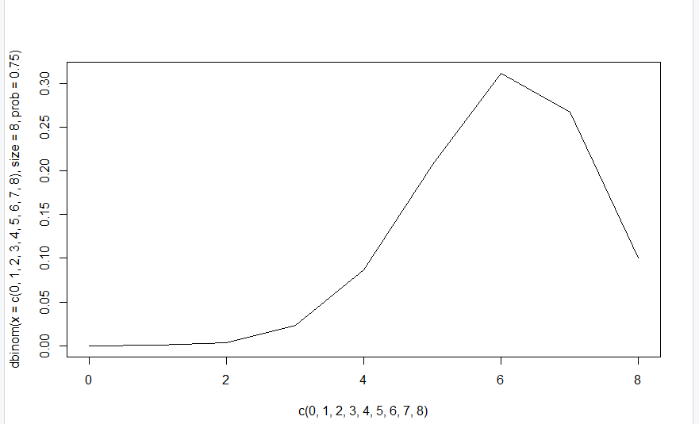

$$B \sim Bin(12, 0.45)$$

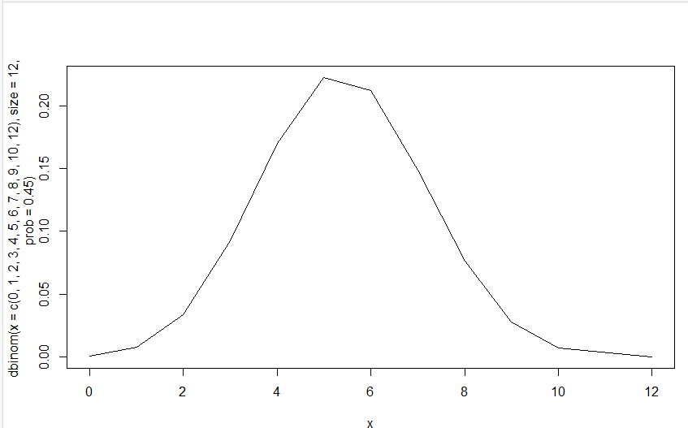

**Problem Statement 3:**

Customers arrive at a rate of 72 per hour to my shop. What is the probability of customers arriving in 4 minutes? a) 5 customers, b) not more than 3 customers, c) more than 3 customers. Give a pictorial representation of the same to validate your answer.

**Solution 3:** Let X be the random variable that represents the number of customers who arrive at a shop. $μ=\left(\frac{72}{60}\right)*4=4.8$, thus $X \sim Po(4.8)$




$P\left(X=5\right)= \frac{e^{-μ}*μ^{x}}{x!}=\frac{e^{-4.8}{* 4.8}^{5}}{5!}=0.1747$

$P\left(X≤3\right)=P\left(X=0\right)+P\left(X=1\right)+P\left(X=2\right)+P\left(X=3\right)$

$= \frac{e^{-4.8}{* 4.8}^{0}}{0!}+\frac{e^{-4.8}{* 4.8}^{1}}{1!}+\frac{e^{-4.8}{* 4.8}^{2}}{2!}+\frac{e^{-4.8}{* 4.8}^{3}}{3!}=0.2942$

$P\left(X>3\right)=1- P\left(X≤3\right)=1-0.2942=0.7058$

2. The pictorial view of this is given by

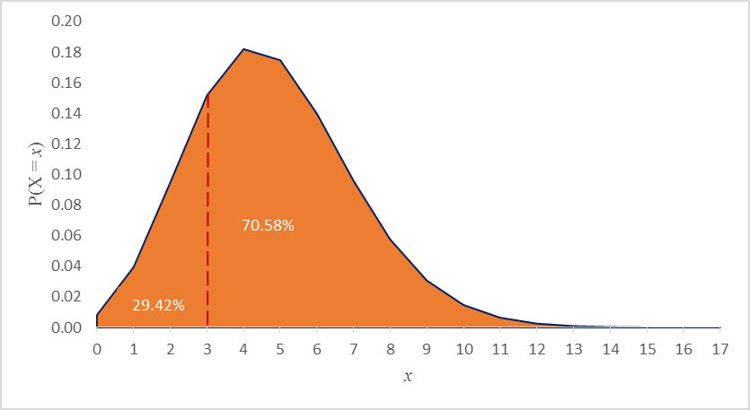

**Problem Statement 4**

I work as a data analyst in Aeon Learning Pvt. Ltd. After analysing data, I make reports, where I have the efficiency of entering 77 words per minute with 6 errors per hour. What is the probability that I will commit 2 errors in a 455-word financial report? What happens when the no. of words increases or decreases (in case of 1000 words, 255 words)? How is the affected? How does it influence the PMF? Give a pictorial representation of the same to validate your answer.

Solution 4:

At 77 words per minute, it means in an hour the analyst will type 4260 words, in which he is susceptible to 6 errors. Let $X$ be the randon variable that represents the number of errors in an hour at 77 words per minute (4260 per hour)

Thus $X \sim Po(6)$

1. For a 455 word document, the error rate becomes lower i.e. $μ=\frac{455}{4260}*6=0.591$, thus $X \sim Po\left(0.591\right)$

$P\left(X=2\right)=\frac{e^{-0.591}{* 0.591}^{2}}{2!}=0.0964$

1. For a 1000 word document, the error rate becomes $μ=\frac{1000}{4260}*6=\frac{100}{77}=1.299$, thus $X \sim Po(1.299)$
$$P\left(X=2\right)=\frac{e^{-1.299}{* 1.299}^{2}}{2!}= 0.2301$$

2. For a 255 word document, the error rate becomes $μ=\frac{255}{4260}*6=0.359$, thus $X \sim Po(0.359)$

$$P\left(X=2\right)=\frac{e^{-0.359}{* 0.359}^{2}}{2!}= 0.045$$

The likelihood of making 2 errors increases as the number of words increases and decreases as the number of words in a document decreases.

How does it influence the PMF?

255 words 455 word

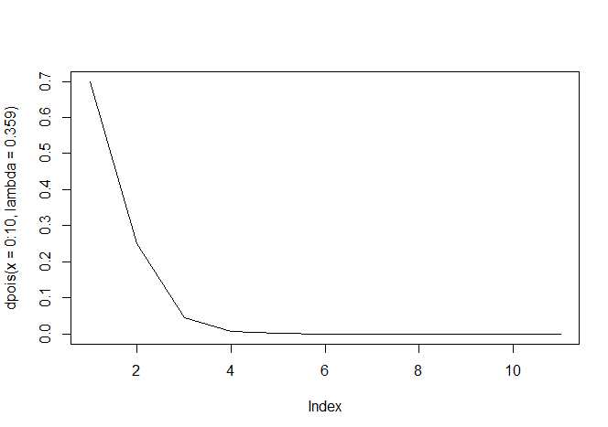 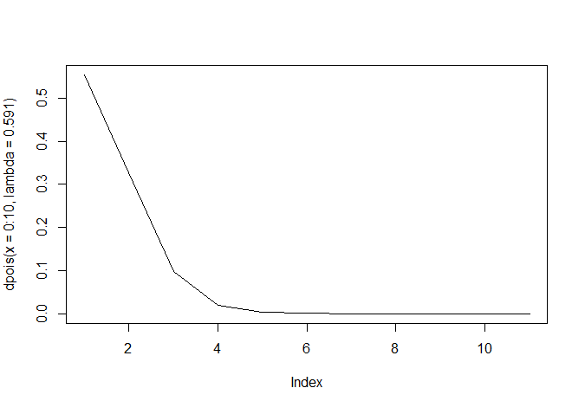

1000 words

