**Problem Statement 1:**

**A test is conducted which is consisting of 20 MCQs (multiple choices questions) with every MCQ having its four options out of which only one is correct. Determine the probability that a person undertaking that test has answered exactly 5 questions wrong.**

**Solution 1:** Let X be the random variable representing number of questions answered wrong in a given MCQs test

$X \sim Bin(20, 0.75)$, therefore the probability is given by

$$P\left(X=5\right)= \left({n \atop x}\right)*p^{x}*{\left(1-p\right)}^{n-x}$$

$$=\left({20 \atop 5}\right)*{0.75}^{5}*{\left(1-0.75\right)}^{20-5}$$

$$=15504*0.2373*{\left(0.25\right)}^{15}=0.00000342$$

**Problem Statement 2:**

**A die marked A to E is rolled 50 times. Find the probability of getting a “D” exactly 5 times.**

**Solution 2:** Let X be the random variable representing number of questions answered wrong in a given MCQs test

$X \sim Bin(50, 0.2)$, therefore since n is large, the distribution is approximated to the normal distribution $X \sim N(10, 8)$, (*with continuity correction*)

$$P\left(X=5\right)= P\left(Z=\frac{x-μ}{σ}\right)$$

$$=P\left(\frac{4.5-10}{\sqrt{8}}≤Z≤ \frac{5.5-10}{\sqrt{8}}\right) =0.0299$$

**Problem Statement 3:**

**Two balls are drawn at random in succession without replacement from an urn containing 4 red balls and 6 black balls. Find the probabilities of all the possible outcomes.**

**Solution 3:**

These are independent events, below is a tree diagram to represent the scenario

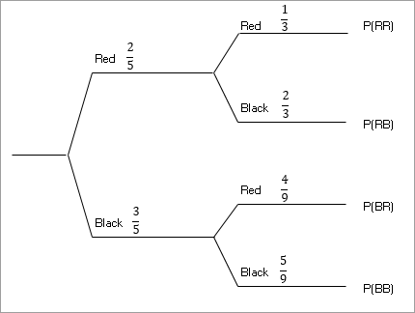

**Outcome 1: $P\left(two red balls\right)= \frac{2}{5}×\frac{1}{3}=\frac{2}{15}$**

**Outcome 2: $P\left(red ball first and black ball second\right)$**

$$=\frac{2}{5}×\frac{2}{3}=\frac{4}{15}$$

**Outcome 3: $P\left(black ball first and red ball second\right)$**

$$=\frac{3}{5}×\frac{4}{9}=\frac{4}{15}$$

**Outcome 4: $P\left(two black balls\right)= \frac{3}{5}×\frac{5}{9}=\frac{1}{3}$**