**Problem Statement 1:**

A company manufactures LED bulbs with a faulty rate of 30%. If I randomly select 6 chosen LEDs, what is the probability of having 2 faulty LEDs in my sample? Calculate the average value of this process. Also evaluate the standard deviation associated with it.

**Solution 1:** Let X be the random variable representing faulty bulbs in a sample

1. $X \sim Bin(6, 0.3)$, therefore the probability is given by
$$P\left(X=2\right)= \left({n \atop x}\right)*p^{x}*{\left(1-p\right)}^{n-x}$$

$$=\left({6 \atop 2}\right)*{0.3}^{2}*{\left(1-0.3\right)}^{6-2}$$

$$=15*0.09*0.2401=0.324135$$

2. The average value is given by $E\left(X\right)=n p=6*0.3=1.8$
3. The standard deviation associated with it is given by $s=\sqrt{Var\left(X\right)}=n p\left(1-p\right)$

$$=\sqrt{6*0.3*\left(1-0.3\right)}$$

$$=\sqrt{1.8*0.7}=1.122 (to 3dp)$$

**Problem Statement 2**

Gaurav and Barakha are both preparing for entrance exams. Gaurav attempts to solve 8 questions per day with a correction rate of 75%, while Barakha averages around 12 questions per day with a correction rate of 45%. What is the probability that each of them will solve 5 questions correctly? What happens in cases of 4 and 6 correct solutions? What do you infer from it? What are the two main governing factors affecting their ability to solve questions correctly? Give a pictorial representation of the same to validate your answer.

Solution 2:

1. $G \sim Bin(8, 0.75)$, therefore the probability is given by
$$P\left(G will get 5 correct\right)= \left({8 \atop 5}\right)*p^{x}*{\left(1-p\right)}^{n-x}$$

$$=\left({8 \atop 5}\right)*{0.75}^{5}*{\left(1-0.3\right)}^{8-5}$$

$$=0.2076$$

2. $B \sim Bin(12, 0.45)$, therefore the probability is given by

$$P\left(B will get 5 correct\right)= \left({12 \atop 5}\right)*p^{x}*{\left(1-p\right)}^{n-x}$$

$$=\left({12 \atop 5}\right)*{0.45}^{5}*{\left(1-0.45\right)}^{12-5}$$

$$=0.2224$$

*What happens in cases of 4 and 6 correct solutions?*

In cases of 4 and 6 probabilities of getting 6 correct is much higher than that of getting 4 correct

*What are the two main governing factors affecting their ability to solve questions correctly?*

* Number of trials
* Probability of correction

**Pictorial View**

$$G \sim Bin(8, 0.75)$$

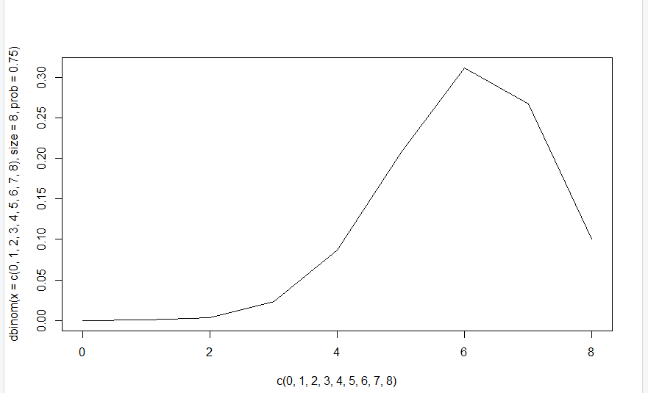

$$B \sim Bin(12, 0.45)$$

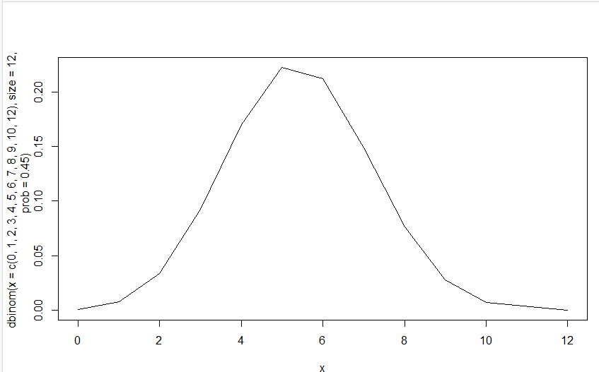

**Problem Statement 3**

Customers arrive at a rate of 72 per hour to my shop. What is the probability of k customers arriving in 4 minutes? a) 5 customers, b) not more than 3 customers, c) more than 3 customers.

Give a pictorial representation of the same to validate your answer.

**Solution 3:** Let X be the random variable that represents the number of customers who arrive at a shop. $μ=\left(\frac{72}{60}\right)*4=4.8$, thus $X \sim Po(4.8)$




$P\left(X=5\right)= \frac{e^{-μ}*μ^{x}}{x!}=\frac{e^{-4.8}{* 4.8}^{5}}{5!}=0.1747$

$P\left(X≤3\right)=P\left(X=0\right)+P\left(X=1\right)+P\left(X=2\right)+P\left(X=3\right)$

$= \frac{e^{-4.8}{* 4.8}^{0}}{0!}+\frac{e^{-4.8}{* 4.8}^{1}}{1!}+\frac{e^{-4.8}{* 4.8}^{2}}{2!}+\frac{e^{-4.8}{* 4.8}^{3}}{3!}=0.2942$

$P\left(X>3\right)=1- P\left(X≤3\right)=1-0.2942=0.7058$

2. The pictorial view of this is given by

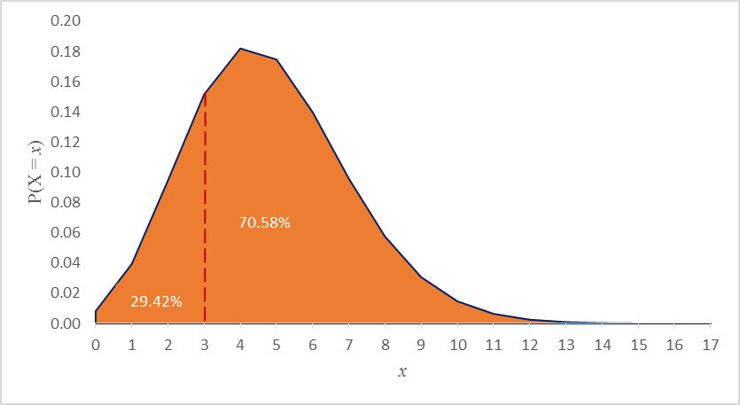

**Problem Statement 4**

I work as a data analyst in Aeon Learning Pvt. Ltd. After analysing data, I make reports, where I have the efficiency of entering 77 words per minute with 6 errors per hour. What is the probability that I will commit 2 errors in a 455-word financial report? What happens when the no. of words increases (in case of 1000 words) or decreases (255 words)? How is the λ affected? How does it influence the PMF? Give a pictorial representation of the same to validate your answer.

Solution 4:

At 77 words per minute, it means in an hour the analyst will type 4260 words, in which he is susceptible to 6 errors. Let $X$ be the randon variable that represents the number of errors in an hour at 77 words per minute (4260 per hour)

Thus $X \sim Po(6)$

1. For a 455 word document, the error rate becomes lower i.e. $μ=\frac{455}{4260}*6=0.591$, thus $X \sim Po\left(0.591\right)$

$P\left(X=2\right)=\frac{e^{-0.591}{* 0.591}^{2}}{2!}=0.0964$

1. For a 1000 word document, the error rate becomes $μ=\frac{1000}{4260}*6=\frac{100}{77}=1.299$, thus $X \sim Po(1.299)$
$$P\left(X=2\right)=\frac{e^{-1.299}{* 1.299}^{2}}{2!}= 0.2301$$

2. For a 255 word document, the error rate becomes $μ=\frac{255}{4260}*6=0.359$, thus $X \sim Po(0.359)$

$$P\left(X=2\right)=\frac{e^{-0.359}{* 0.359}^{2}}{2!}= 0.045$$

The likelihood of making 2 errors increases as the number of words increases and decreases as the number of words in a document decreases.

How does it influence the PMF?

255 words 455 words

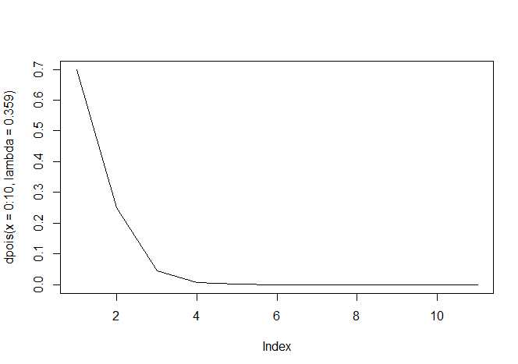 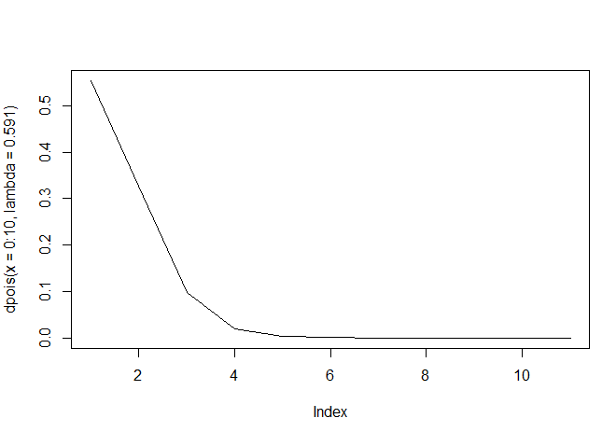

1000 words

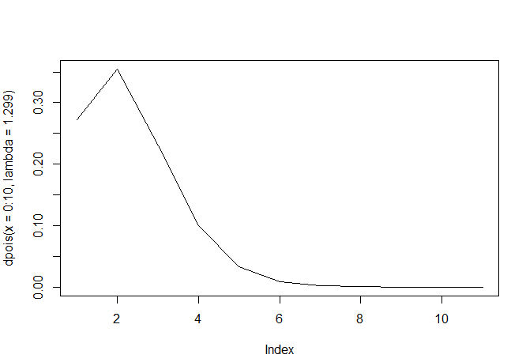

**Problem Statement 5**

*The current measured in a copper wire is modelled by a continuous random variable (is in mA.) Assume that the range of X is [0, 20mA]. The probability density function is given by $f(x ) = 0.05 for 0 ≤x ≤ 20$. What is the probability that a current measurement is less than 10 milliamperes? Draw the PDF and the CDF diagrams as well.*

a)

$$P\left(X<10\right)= \int_{0}^{10}{0.05}dx=0.05x|\begin{matrix}10 \\ 0\end{matrix}=0.05\left(10\right)-0.05\left(0\right)=0.5$$

b)

The PDF diagram is as follows c) The CDF diagram is given below

