PROJECT REPORT OF CO-OP Project at Industry (Module-2)
ON
Umess
submitted in partial fulfilment of the requirements for the award of degree of

BACHELOR OF ENGINEERING
In
COMPUTER SCIENCE AND ENGINEERING

Submitted by: Supervised By:
Pardume Sharma Dr. Rajat Takkar
2210990638 Supervisor
Chitkara university


DEPARTMENT OF COMPUTER SCIENCE AND ENGINEERING

CHITKARA UNIVERSITY INSTITUTE OF ENGINEERING AND TECHNOLOGY
CHITKARA UNIVERSITY, PUNJAB, INDIA


DECLARATION

I hereby certify that the work which is being presented in the project report entitled “Title of the Project” in partial fulfilment of requirement for the award of the degree of Bachelor of Engineering (Computer Science and Engineering) submitted in the department of Computer Science and Engineering at Chitkara University Institute of Engineering and Technology, Chitkara University, Punjab, India, is an authentic record of my own work carried out under the supervision of <Name of the Mentor>. The matter presented in this project report has not been submitted in any other university/institute for the award of any degree.

Place: Rajpura Pardume Sharma
Date:29-04-2026 University Roll No 2210990638

This is to certify that the above statement made by the candidate is correct to the best of my knowledge and belief.

Dr. Rajat Takkar
Professor
Department of Computer Science and Engineering
Chitkara University Institute of Engineering and Technology,
Chitkara University, Punjab, India



ACKNOWLEDGEMENT

It is my pleasure to be indebted to various people, who directly or indirectly contributed in the development of this work and who influenced my thinking, behavior and acts during the course of study.

I express my sincere gratitude to all for providing me an opportunity to undergo Integrated Project as a part of the curriculum.

I am thankful to Dr. Rajat Takkar for his support, cooperation, and motivation provided to us during the training for constant inspiration, presence and blessings.

I also extend my sincere appreciation to Dr. Rajat Takkar who provided his valuable suggestions and precious time in accomplishing our Integrated project report.

Lastly, I would like to thank the almighty and our parents for their moral support and friends with whom I shared my day-to-day experience and received lots of suggestions that improve my quality of work.

Pardume Sharma
2210990638



Table Of Content

Sr. No | Topics | Page No.
1. | Abstract | 5
2. | Introduction | 6
3. | Problem Statement | 7
4. | Objectives | 8
5. | Project Scope | 9
6. | Solution | 11
7. | Features | 12
8. | Flow of the System | 18
9. | References | 19



Abstract

The Mess Management System (MMS) is an innovative digital platform designed to transform the conventional, paper-based processes prevalent in university mess operations into a streamlined, secure, and smart solution. In many universities across India, mess facilities continue to rely on physical mess cards—often made of paper or plastic—which not only pose challenges in terms of maintenance and authenticity but are also prone to misuse and manipulation. Students frequently face issues like lost cards, unauthorized usage by others, and the lack of a proper mechanism to register genuine feedback or access important real-time updates from the mess administration.
The MMS project leverages modern web technologies and cloud infrastructure, utilizing the powerful MERN stack (MongoDB, Express.js, React.js, Node.js) for robust development, alongside Cloudinary for secure QR code and media storage, Vercel for front-end deployment, and Render for scalable backend services. This combination ensures high performance, secure data handling, and scalable architecture suitable for handling the diverse needs of educational institutions.
At its core, the Mess Management System is not just a software solution—it is a digitally-driven ecosystem tailored to meet the operational, logistical, and feedback-related demands of student dining systems. The system introduces QR code-based authentication, generated uniquely for each student and stored on the cloud, eliminating the risk of impersonation or card sharing. Students can simply scan their unique QR code at the mess counter to avail their meals, ensuring that only authorized users are served.
Additionally, MMS empowers students by providing them with a user-friendly portal to access real-time mess menus, receive instant notifications about changes or alerts, and submit anonymous feedback directly visible to higher-level administrators such as the Director or Warden. This feedback loop fosters accountability and encourages mess staff to maintain higher standards in terms of hygiene, service, and food quality.
From the administrative perspective, MMS offers a sophisticated suite of tools and dashboards designed to streamline mess management and improve operational efficiency. The system supports role-based access control, ensuring that different stakeholders, including Directors, Wardens, Guards, and Mess Staff, have access to the specific features and data relevant to their responsibilities..
\

Introduction

The Mess Management System (MMS) is an innovative digital platform designed to transform the conventional, paper-based processes prevalent in university mess operations into a streamlined, secure, and smart solution. In many universities across India, mess facilities continue to rely on physical mess cards—often made of paper or plastic—which not only pose challenges in terms of maintenance and authenticity but are also prone to misuse and manipulation. Students frequently face issues like lost cards, unauthorized usage by others, and the lack of a proper mechanism to register genuine feedback or access important real-time updates from the mess administration.
The MMS project leverages modern web technologies and cloud infrastructure, utilizing the powerful MERN stack (MongoDB, Express.js, React.js, Node.js) for robust development, alongside Cloudinary for secure QR code and media storage, Vercel for front-end deployment, and Render for scalable backend services. This combination ensures high performance, secure data handling, and scalable architecture suitable for handling the diverse needs of educational institutions.
At its core, the Mess Management System is not just a software solution—it is a digitally-driven ecosystem tailored to meet the operational, logistical, and feedback-related demands of student dining systems. The system introduces QR code-based authentication, generated uniquely for each student and stored on the cloud, eliminating the risk of impersonation or card sharing. Students can simply scan their unique QR code at the mess counter to avail their meals, ensuring that only authorized users are served.
Additionally, MMS empowers students by providing them with a user-friendly portal to access real-time mess menus, receive instant notifications about changes or alerts, and submit anonymous feedback directly visible to higher-level administrators such as the Director or Warden. This feedback loop fosters accountability and encourages mess staff to maintain higher standards in terms of hygiene, service, and food quality.
From the administrative perspective, the system supports role-based access control for Directors, Wardens, Guards, and Mess Staff, ensuring that every stakeholder has access to tailored dashboards and tools. Admins can track meal consumption trends, analyze food wastage through interactive graphs, and download daily Excel reports of food consumption for accountability and analysis.

\

Problem Statement
The traditional mess management system in universities faces multiple challenges, making it inefficient, prone to misuse, and lacking in transparency.

1. Physical Mess Cards:
- Problem: Students rely on physical, paper-based mess cards which are easily lost, damaged, or misused.
  - The management of lost cards requires manual intervention, creating additional workload for administrators.

2. Lack of Anonymous Feedback:
- Problem: Traditional feedback systems often discourage students from providing honest reviews.
  - Students are reluctant to give genuine feedback due to fear of identification or backlash.
  - Underutilization of feedback means administrators cannot gauge the quality of food and service effectively.

3. Inefficient Food Wastage Management:
- Problem: Without real-time tracking, mess operations often over-prepare meals to avoid food shortages.
  - This results in significant food wastage, as the food prepared may not match the demand.

4. Poor Communication Regarding Menu and Notices:
- Problem: Traditional systems fail to provide real-time communication about:
  - Important notices like meal timings, special events, or health guidelines.Students are often unaware of these updates, leading to confusion or missed meals.


Objectives

The Mess Management System was designed to address the aforementioned challenges through a set of key objectives aimed at enhancing efficiency, transparency, and student satisfaction.

1. Prevent Misuse of Mess Cards

QR Code-Based Authentication: Replace physical mess cards with digital QR codes that uniquely identify students, ensuring only the intended student can avail food.

2. Enable Anonymous Feedback Collection

Feedback Submission: Students can submit their opinions about food quality and services anonymously, which is crucial for gathering honest insights.

Real-Time Review Processing: Feedback is immediately accessible to mess administrators for quick action and improvements.

3. Real-Time Menu and Notice Updates

Dynamic Menu: Mess administrators can update the menu in real-time, ensuring that students are always informed about available meals.

Instant Notices: Important notices regarding schedule changes, health precautions, or events are displayed in real-time.

4. Track and Minimize Food Wastage

Food Consumption Monitoring: Using QR code scans, administrators can track meal consumption and reduce over-preparation, thereby minimizing food wastage.

Wastage Analytics: A built-in tool provides insights into food wastage, allowing for better planning and optimization.

5. Improve Administrative Efficiency

Role-Based Access Control: Different levels of access are given to various administrators (e.g., Director, Wardens, Guards) to manage mess operations effectively.

Reports and Dashboards: The system offers automated reports on student food availment, wastage, and feedback for easy monitoring and decision-making.

\

Project Scope
The Mess Management System extends across several domains, providing benefits for students, administrators, and mess staff alike. The project scope includes:

1. User Authentication and Security
- Login System: Students log in using their unique roll number and password, ensuring a secure and personalized experience.
- QR Code Generation: Each student’s login credentials are linked to a unique QR code, stored on Cloudinary for easy retrieval.

2. QR Code-Based Food Availment
- Students scan their QR code to avail food. This system prevents any misuse of mess cards and ensures accurate tracking of food consumption.
- The system records which student has availed which meal, keeping track of meal types and the number of meals served.

3. Real-Time Menu Updates and Notices
- Menu Updates: Mess staff can instantly update the menu and notify students of any changes, whether due to availability or special items.
- Notice Board: Administrators can post critical messages regarding mess timings, health updates, or upcoming events, which are automatically visible to all students.

4. Feedback Collection
- Anonymous Feedback: Students can submit feedback without revealing their identity, ensuring honest reviews.
- Review Management: Admins can view, analyze, and take action based on the feedback provided by students.


5. Food Wastage Tracking
- Tracking and Reporting: The system tracks meal consumption by scanning QR codes and generates detailed reports on food wastage.
- Optimization Recommendations: Based on this data, the system provides suggestions to reduce wastage, such as adjusting meal portions or rethinking food preparation quantities.

6. Role-Based Access and Admin Management
- Role-Specific Permissions: Each type of admin (Director, Warden, Mess Staff) has different levels of access to the system.
- Dashboard Features: Admins can manage food availment, menu updates, notices, and feedback directly through an interactive dashboard.

\

Solution
The Mess Management System provides a digital alternative to the outdated paper-based system, ensuring better food distribution management, real-time updates, and a more effective feedback system.

Key Technological Solutions Used:
- MERN Stack: MongoDB, Express.js, React, Node.js

- Cloudinary: For storing and managing the unique QR codes for each student.

- Vercel and Render: For deploying the application in a cloud environment, ensuring scalability and security.

Key Benefits:
- Reduced Food Waste: By tracking meal consumption in real time.
- Improved Transparency: Real-time updates about the menu and notices ensure everyone is on the same page.
- Enhanced User Experience: Students enjoy seamless access to food availing, feedback submission, and menu details.

\

Features

1. Student

Login and Authentication
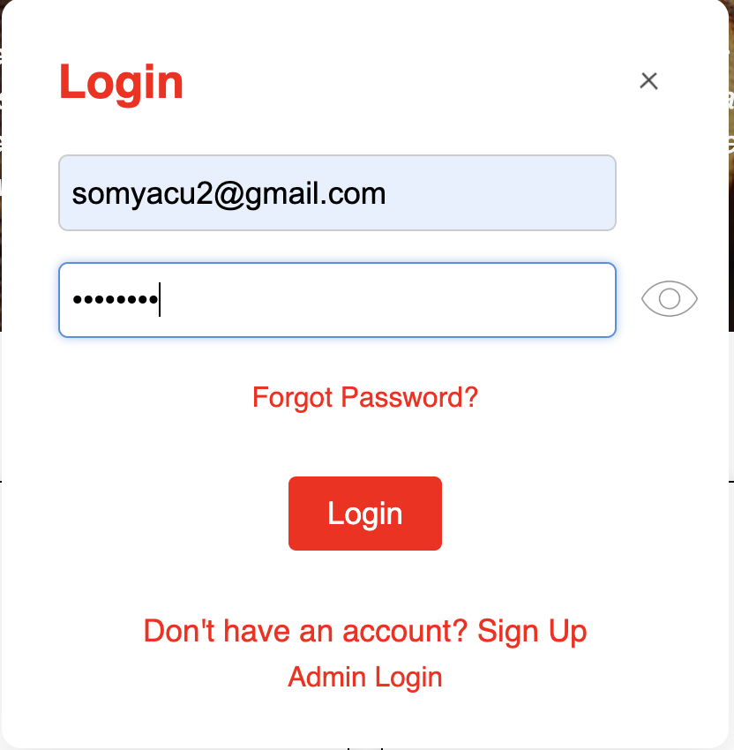
- Students log in with their unique roll number and password.
- The system generates a QR code linked to the student's ID, stored on Cloudinary.

Food Availment
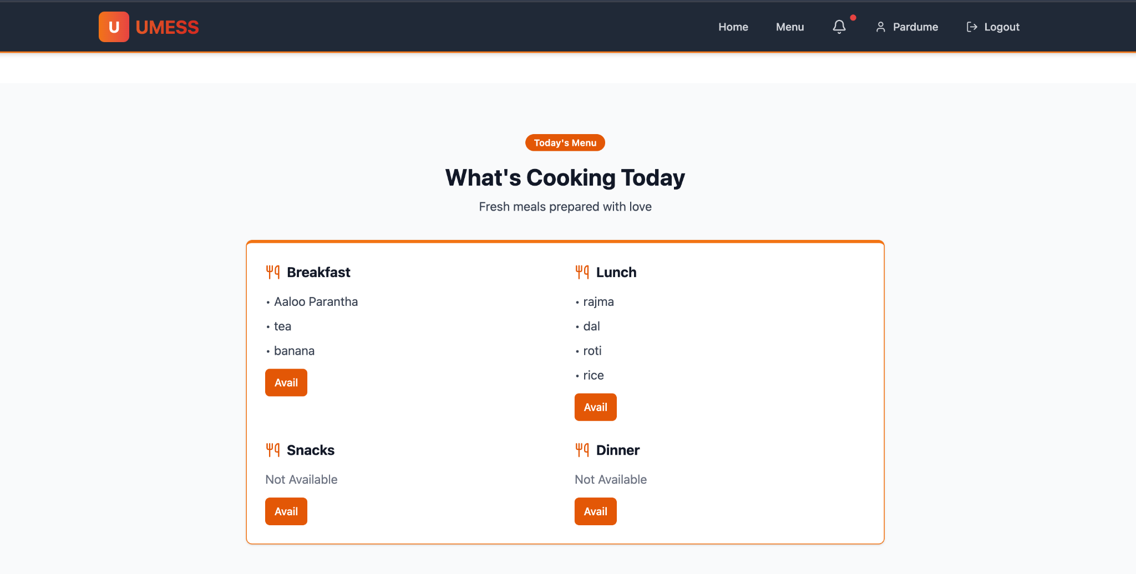
- QR Code Scan: At the mess counter, students scan their QR code to avail food.
- The system logs the meal and prevents any misuse by another student.


Real-Time Menu and Notices
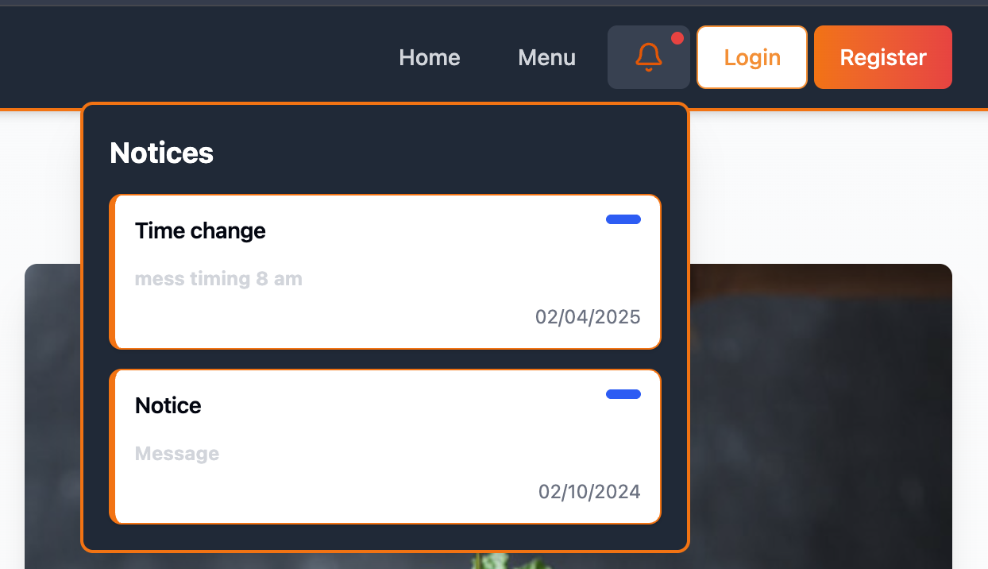
- Students have access to the updated menu for each meal (breakfast, lunch, dinner).
- Real-time notices are displayed about important updates, such as changes in the schedule or new meal items.

Anonymous Feedback
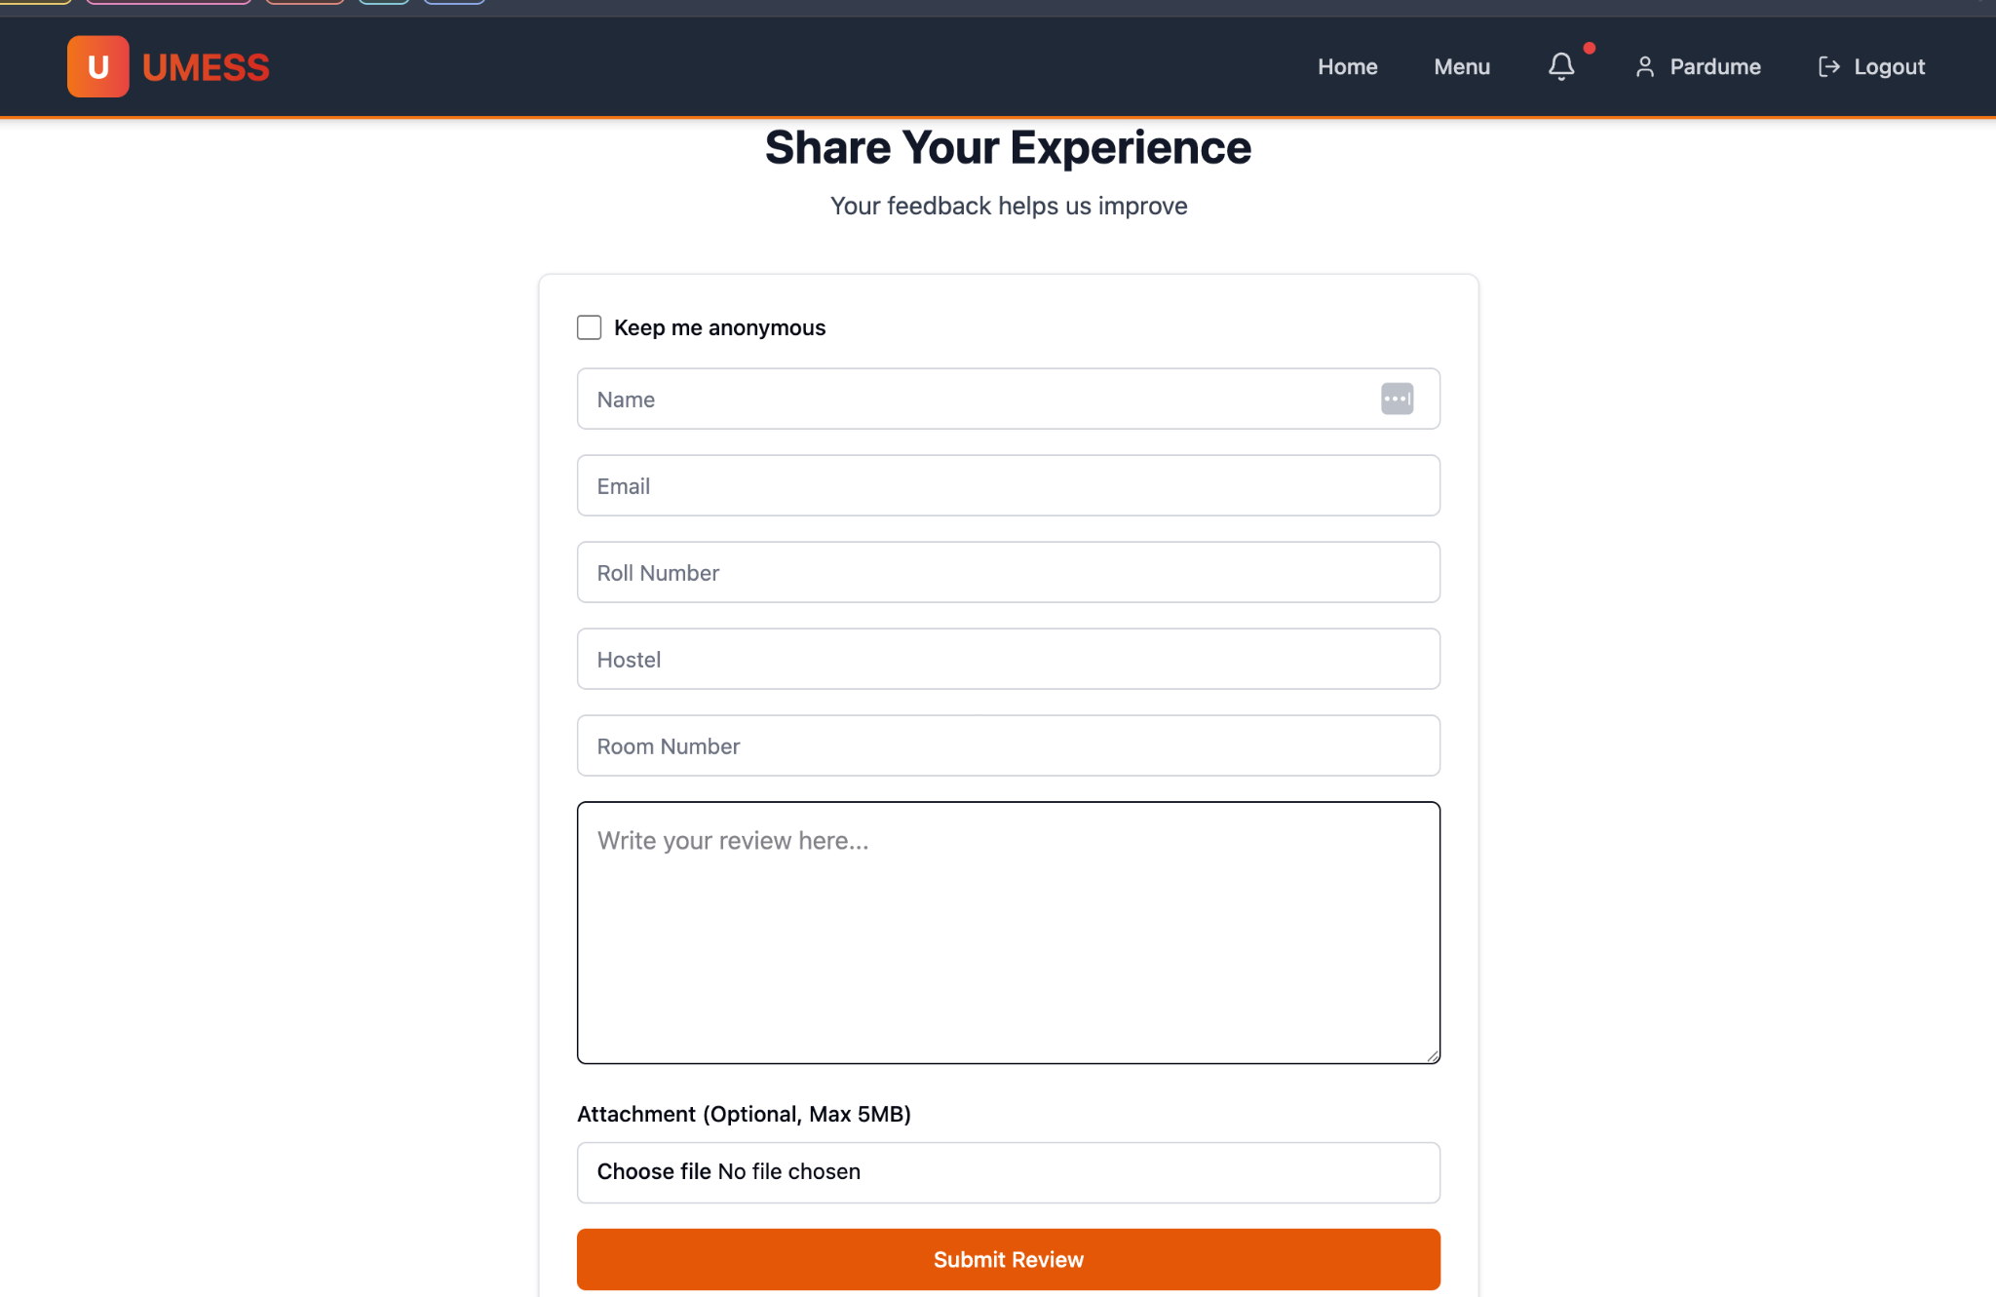



2. Admin

Role-Based Access
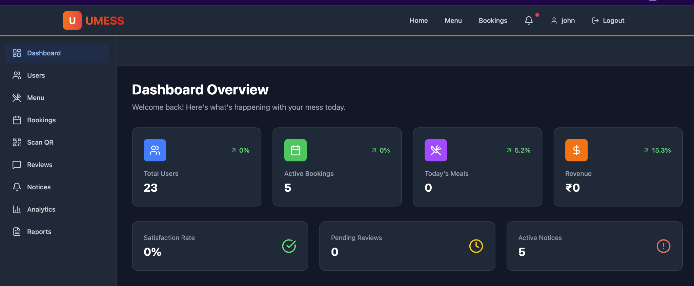
- Different roles (Director, Warden, Staff) have specific permissions.



- Admin Dashboard: Allows admins to monitor food availability, update menus, and manage notices.
- Reviews can be viewed by the admins.
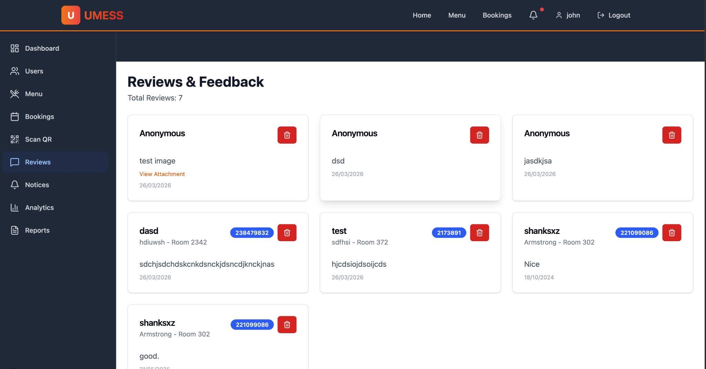

Food Wastage Analytics
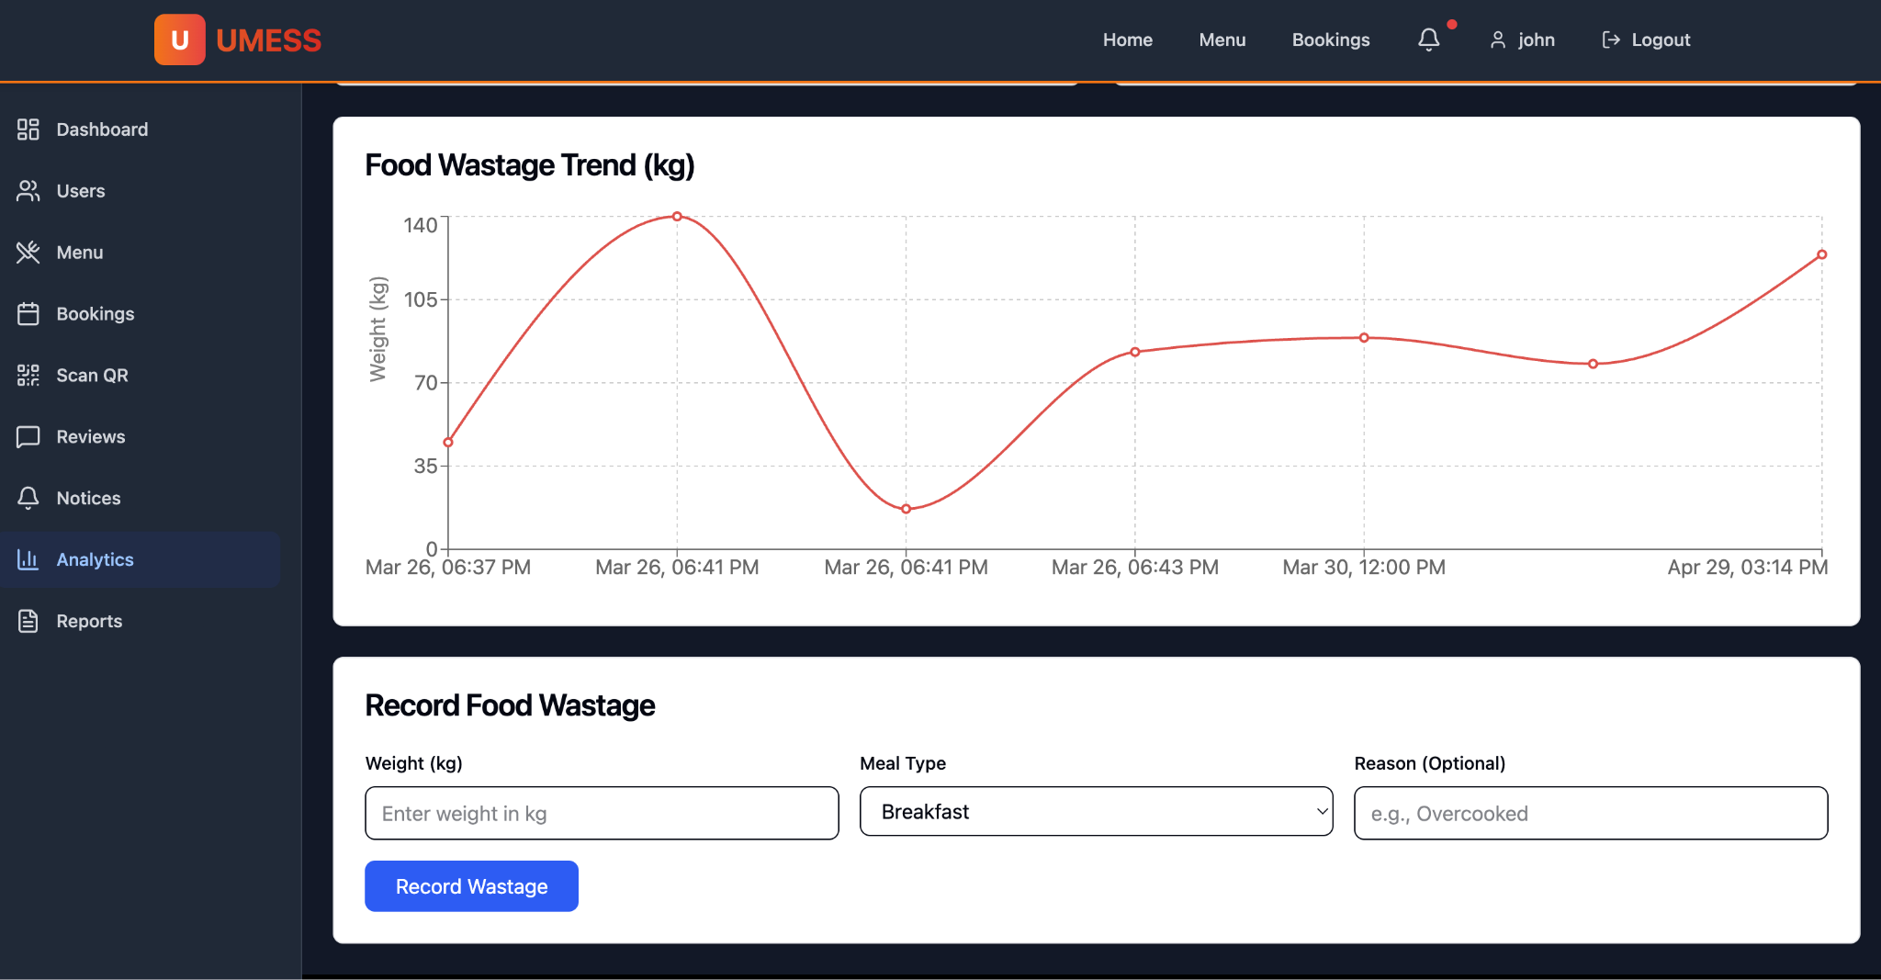
- Reports and Graphs: Admins receive data-driven reports on food wastage, helping them optimize meal planning and reduce waste.



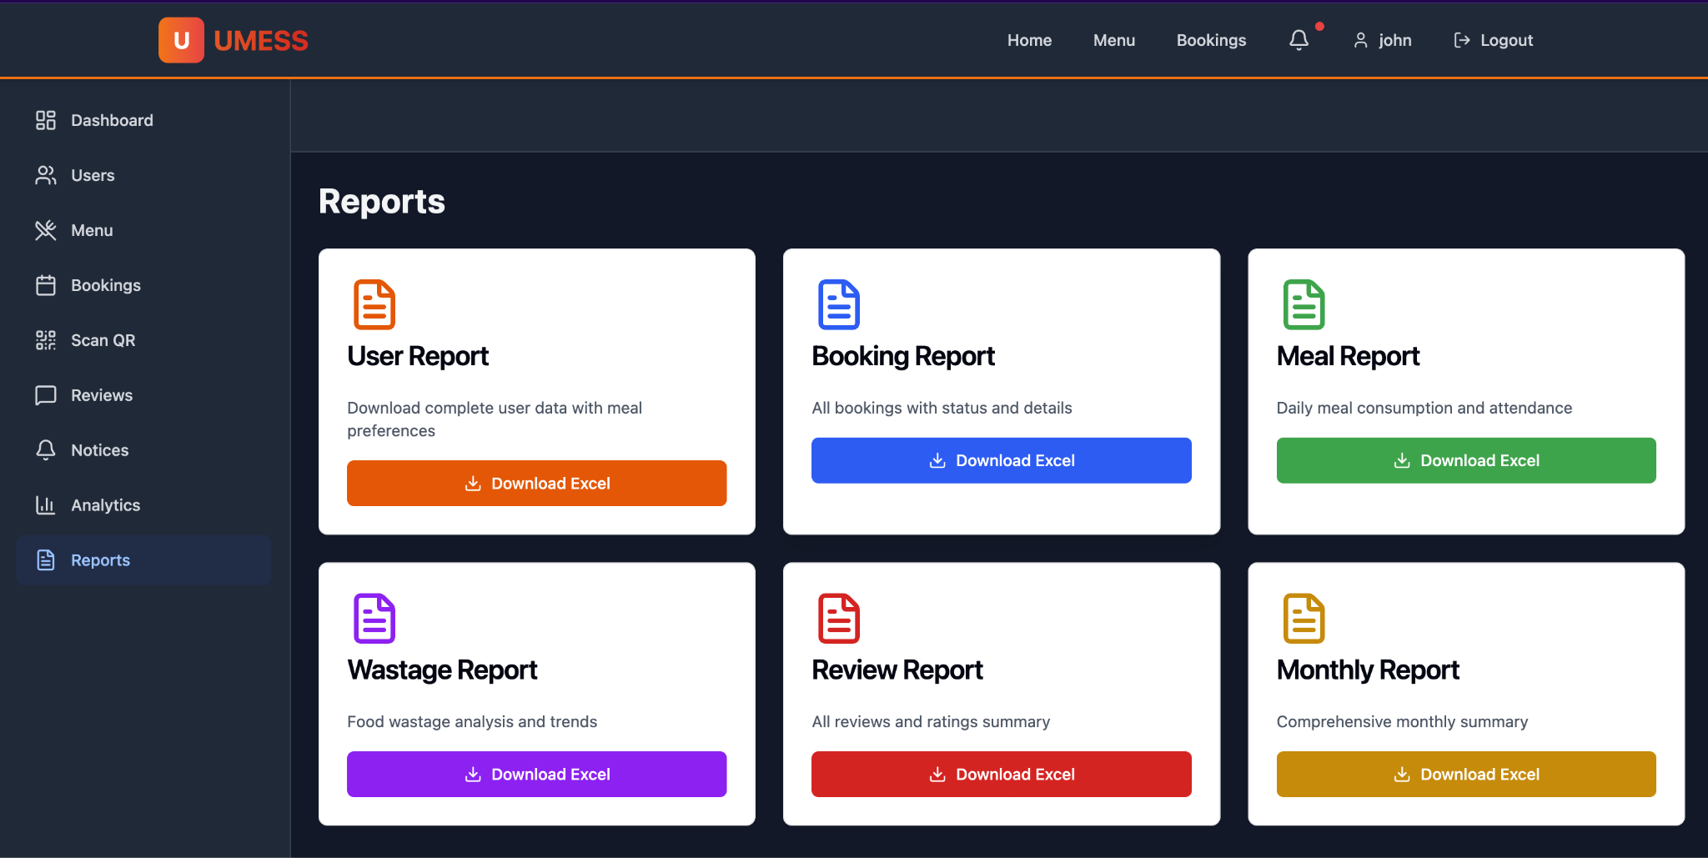

CRUD Operations for Menus and Notices
- CRUD for Menus: Admins can create, read, update, and delete menu items in real-time.
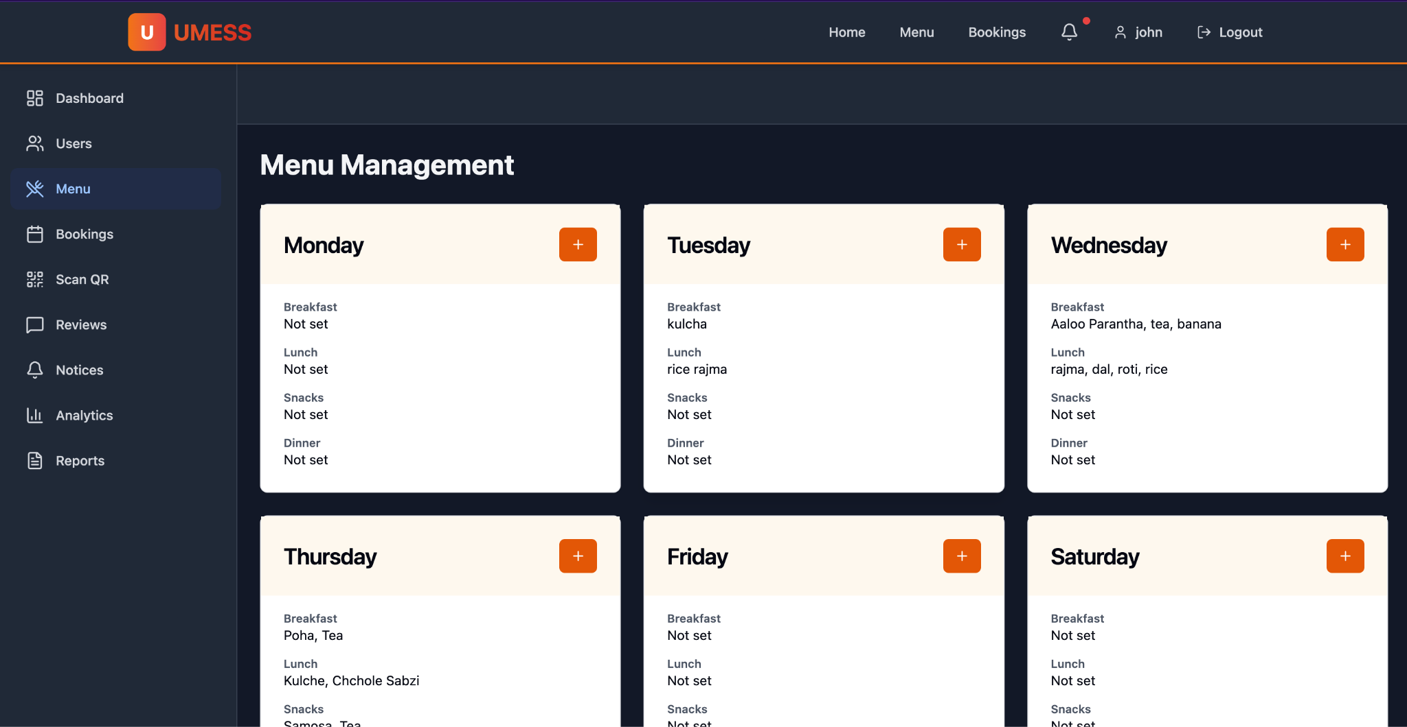
- CRUD for Notices: Critical notices can be easily posted and updated to ensure students are informed immediately.


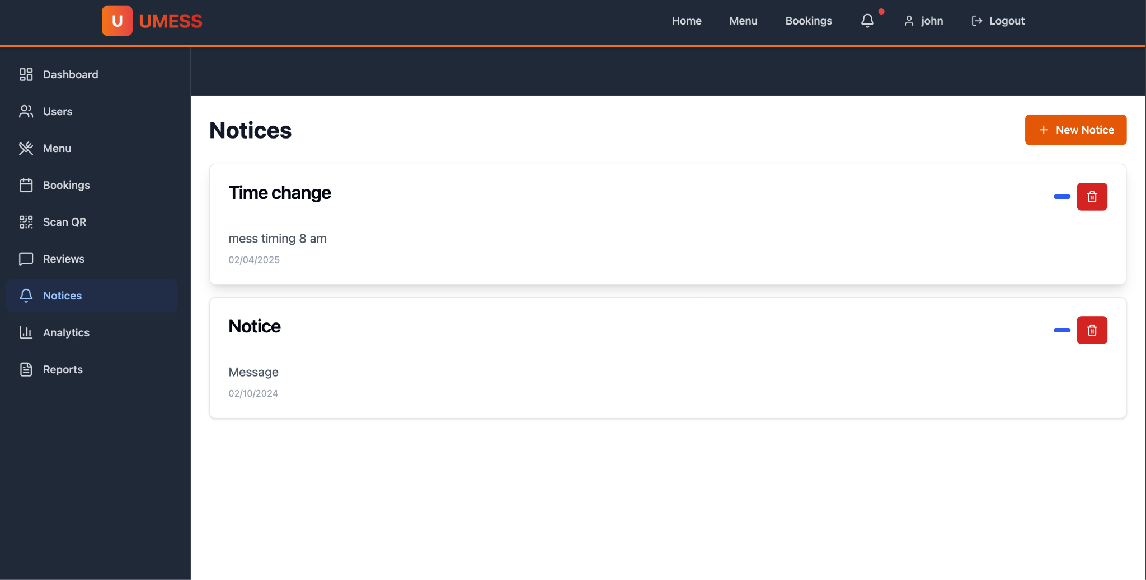
- Faculties can also do the booking of the venues as per their choice.
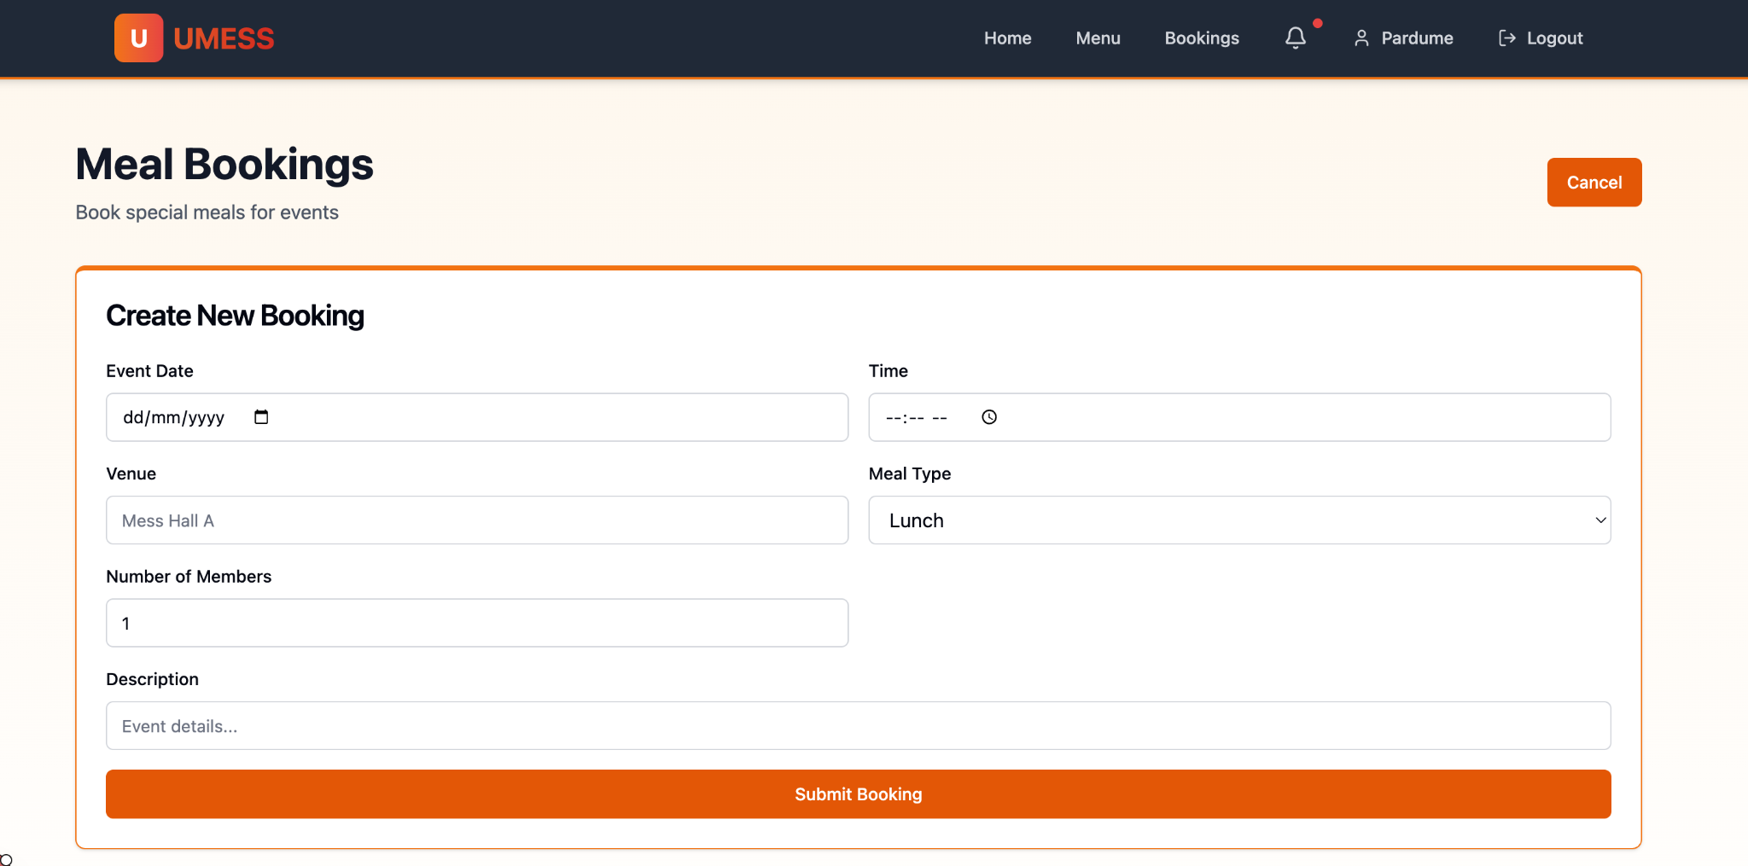

\

Flow of the system

Step 1: Student Authentication
- Student log-in using their school email and password.
- A unique QR code is generated and stored in Cloudinary.

Step 2: Food Availment
- Student scans the QR code at the mess counter.
- The system logs the transaction and confirms the student’s identity.

Step 3: Real-Time Updates
- Admins update the menu and notices via the dashboard.
- Changes are instantly visible to all students.

Step 4: Feedback Submission
- Students leave anonymous feedback on food quality and service.
- Feedback is processed and reviewed by administrators.

Conclusion
The Mess Management System provides a comprehensive solution to address inefficiencies in traditional mess operations. By replacing paper-based mess cards with QR codes, enabling real-time menu updates, and collecting anonymous feedback, the system ensures a more transparent, efficient, and user-friendly experience for both students and administrators. With the added benefit of food wastage tracking and role-based access control, this system sets a new standard for modern, digital mess management in educational institutions.

\

References
- MERN Stack Documentation: How To Use MERN Stack: A Complete Guide
- Cloudinary Documentation: Cloudinary Image & Video Management - Documentation Home
- Vercel Documentation: Vercel Documentation
- Render Documentation: Docs + Quickstarts - Render
- QR-Based Canteen Management System Research: QR-based Canteen Management System - ResearchGate
- Anonymous Feedback in Education Research: Using Anonymous Feedback to Increase Student Engagement
- Food Waste Tracking in Dining Halls Study: Reducing Food Waste in Campus Dining: A Data-Driven Approach
- Cloudinary Integration Guide: Developer Resources for Using Images and Videos in Your Apps
- Vercel Deployment Guides: Guides - Vercel
- Render Deployment Guide: Render Deployment Guide | The Full-Stack Blog

