**If you want to remove previous installs please go to step 5**

Deploying for the first time,

1. If you (or any other developer) have any databases changes, they should have them all in the same location.
2. Now export the application
   1. Using Microsoft edge, log into apex workspace used for the development. Use the following information:

*(Dev Environment)*

<https://apex.oracle.com/pls/apex/f?p=4550:1:103678365519150>**:**

*(Dev Environment)*

WORKSPACE: CODETRAINING

USERNAME: your email address

PASSWORD: your password

* 1. 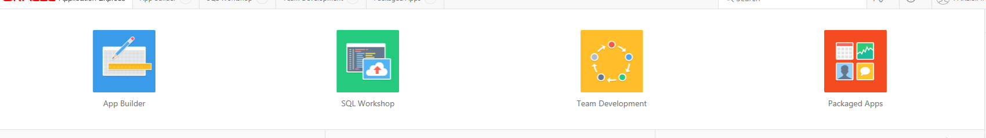Once logged in, go to ‘App Builder’ then click on Great ideas (app no: 87886)

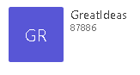

* 1. Once in the great ideas application, you first need to change the version number. The versions will be in this format- release 1 (prod1). Another release be 1.2, 1.3 etc

To change the version number, click on

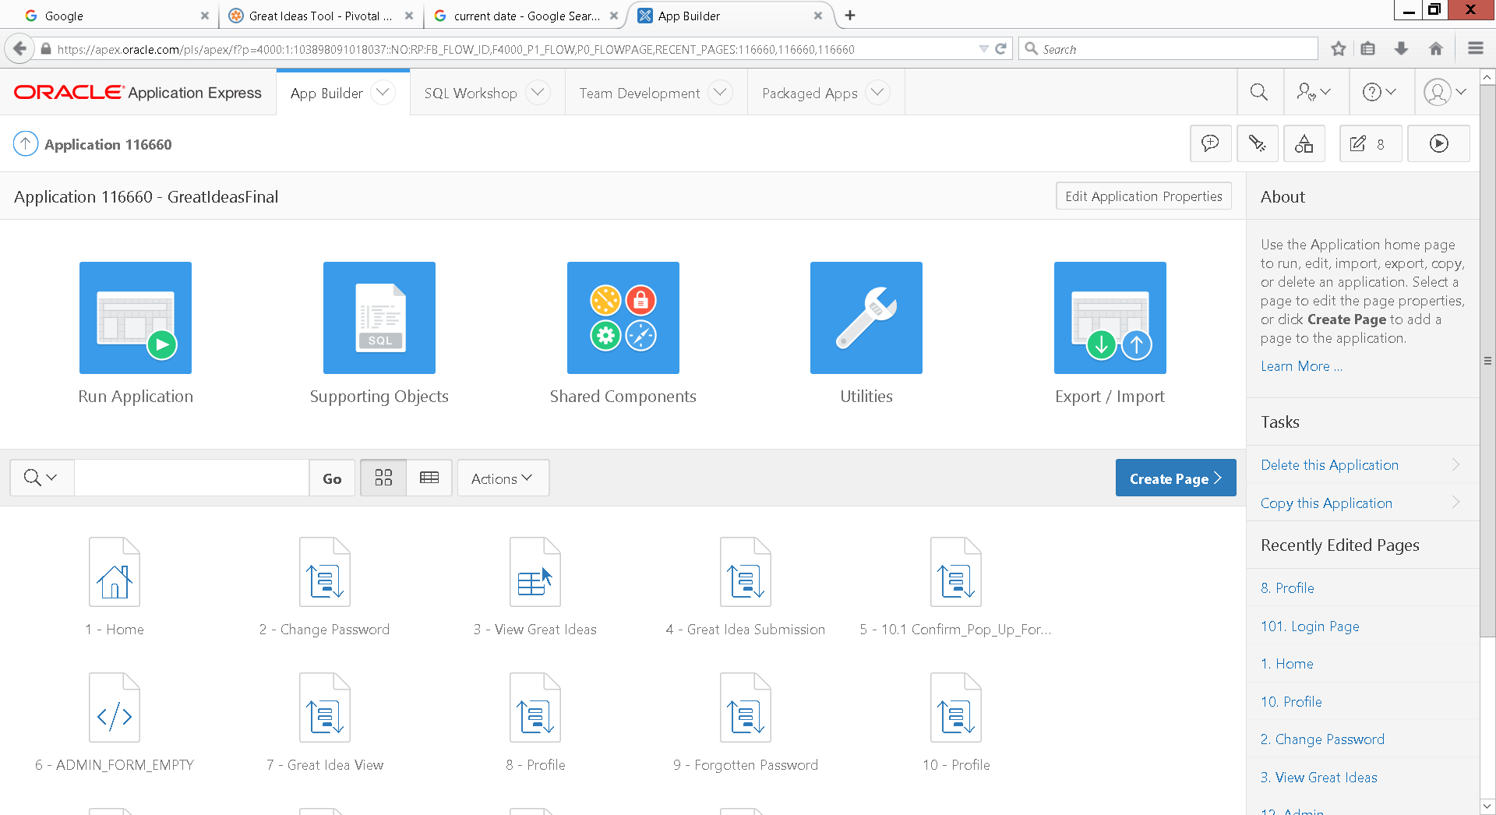

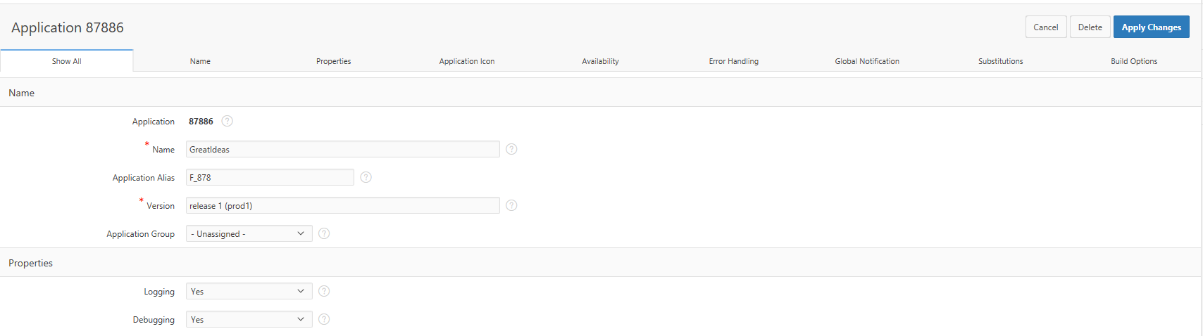Then you will see the following:

In the version field, this is where you ned to change the version number.

Once changed, click on ‘Apply Changes’ and you will be redirected back to the App Builder page.

1. Once in application builder, go back to Great Ideas Application 87886.
   1. Click on Export/ Import.



* 1. You will be prompted by a pop asking “What task would you like to perform”, click on export.
  2. 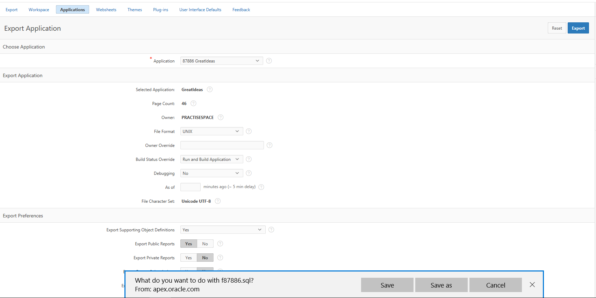Click export and then you will be asked to save a .sql file to your machine.
  3. Once saved, log out.

1. Go log back into apex but this time in the UAT environment.
   1. To success the UAT environment, click on this link with the following credentials.

<https://apex.oracle.com/pls/apex/f?p=4500:1000:107755541602326>:::::

WORKSPACE: GI_UAT

USERNAME: your email address

PASSWORD: your password

* 1. 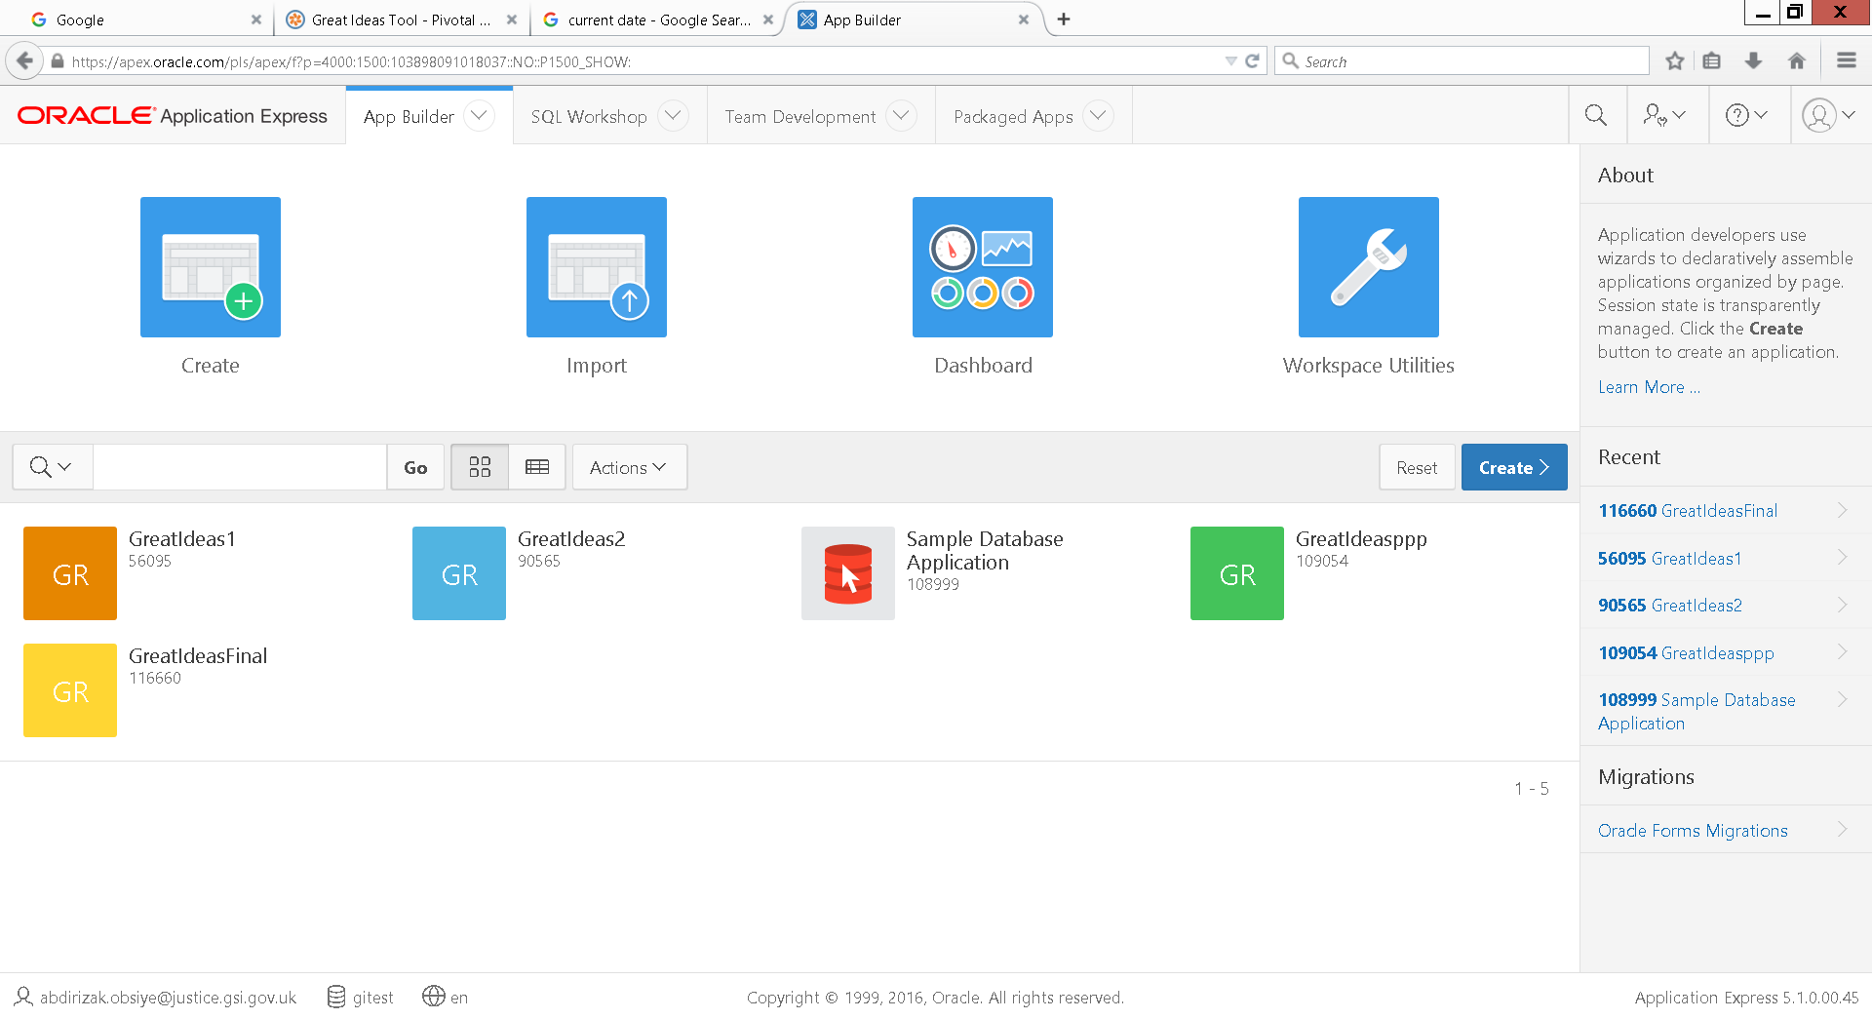Once logged in, click on ‘App Builder’ and then import.
  2. 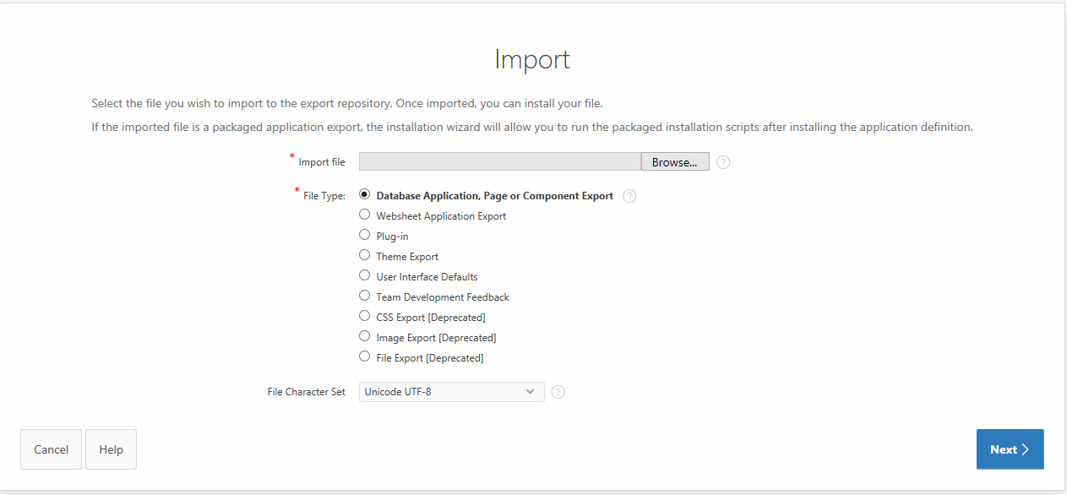Click on browse where is says import file and select the .SQL file you have saved then click next.
  3. 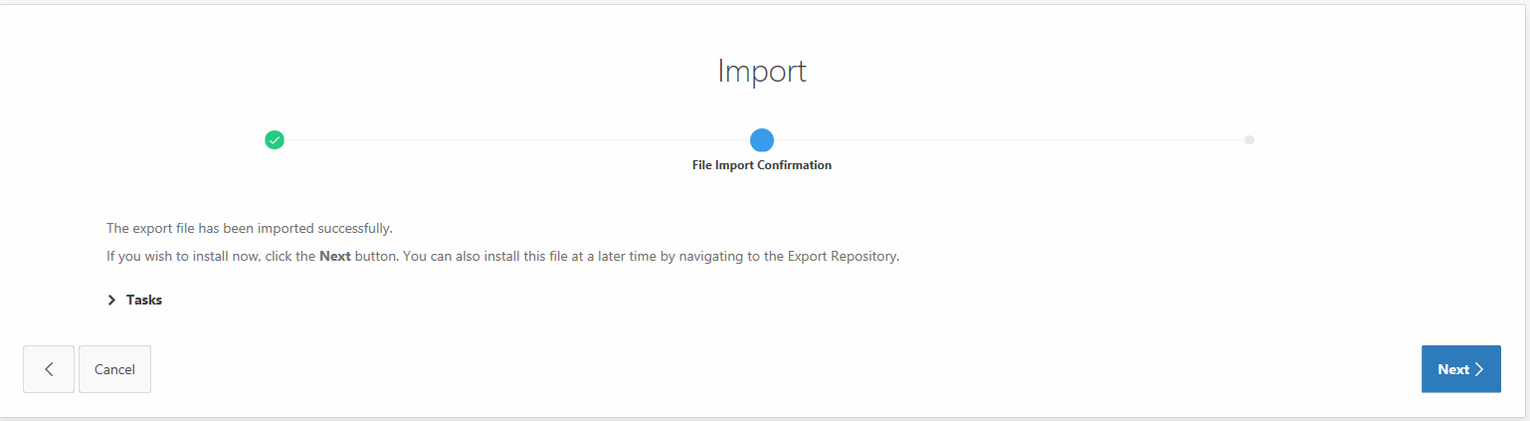in the next page, click next to confirm.
  4. 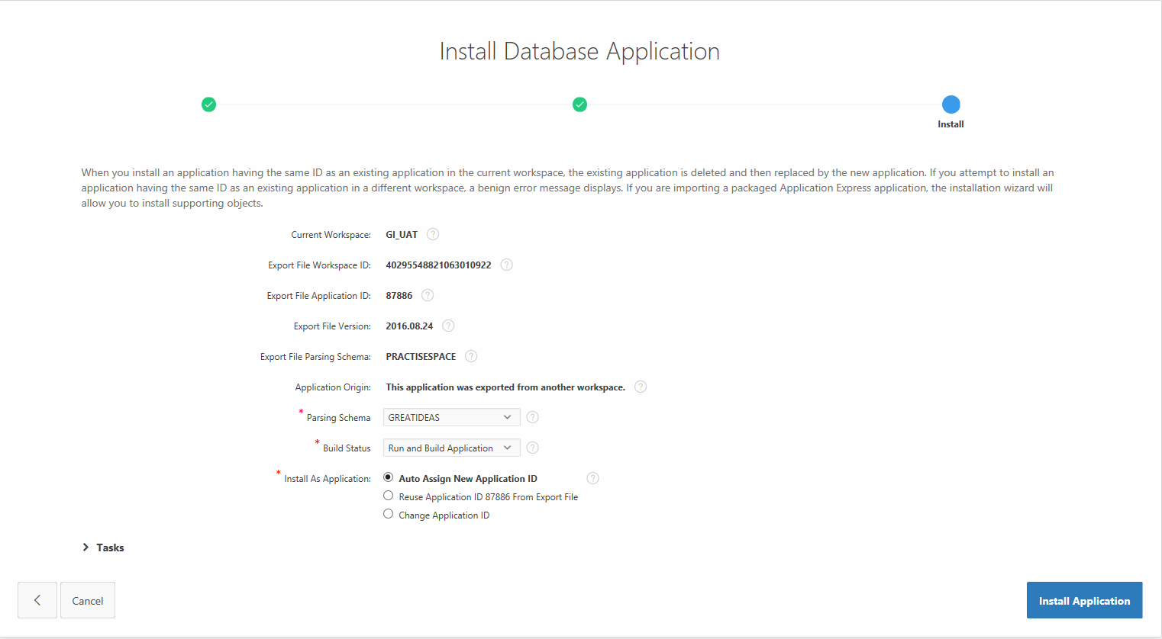One last check, please leave the Parsing Schema as it is.
  5. 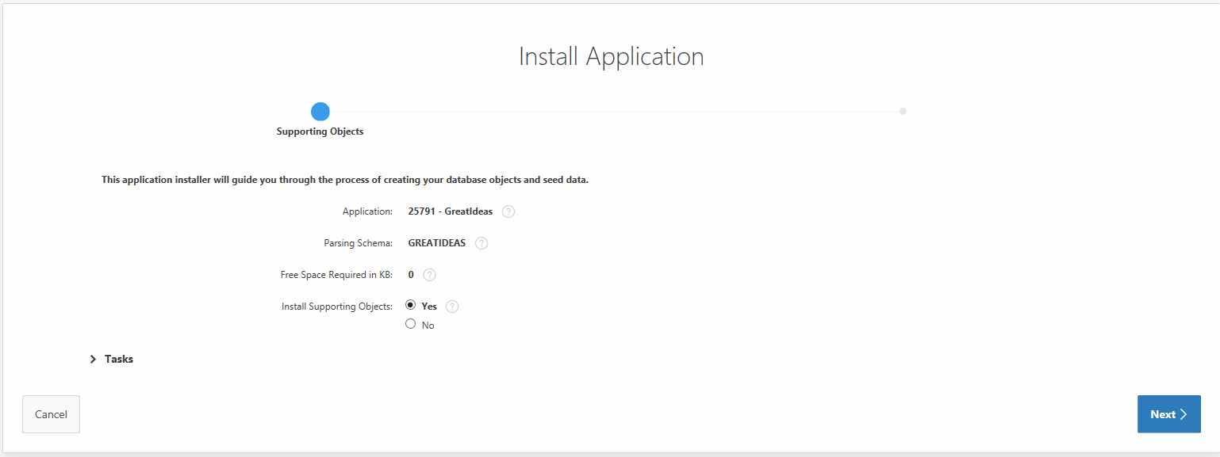After clicking on ‘Install Application’, click next.
  6. 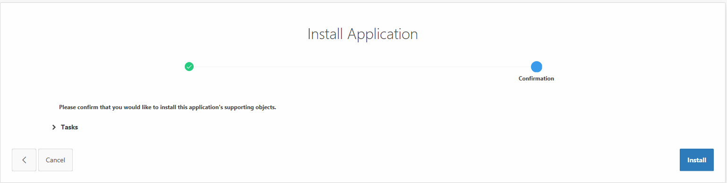Next again.

* 1. 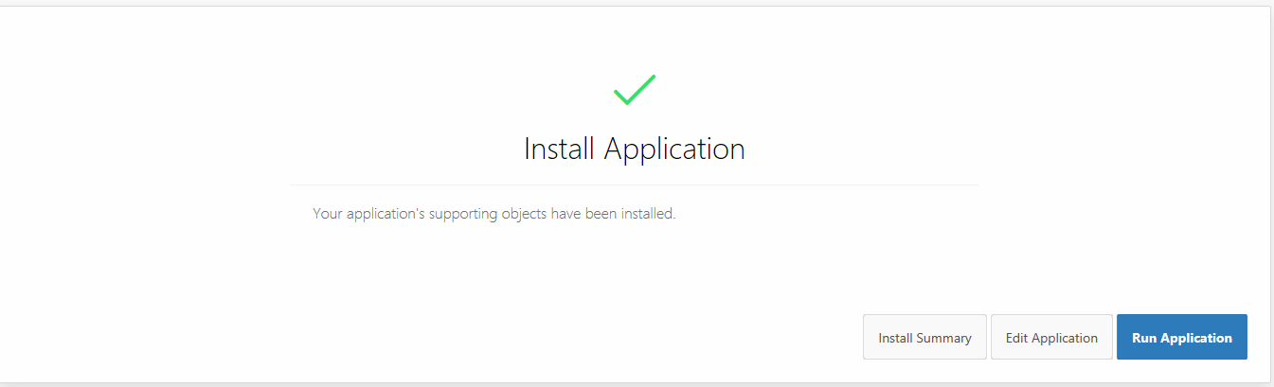The application is now installed.

1. If you want to re- release, delete the previous application and replace it with the new import following the steps above. *Be sure to update the version number from the development environment before exporting to UAT and Prod*
   1. 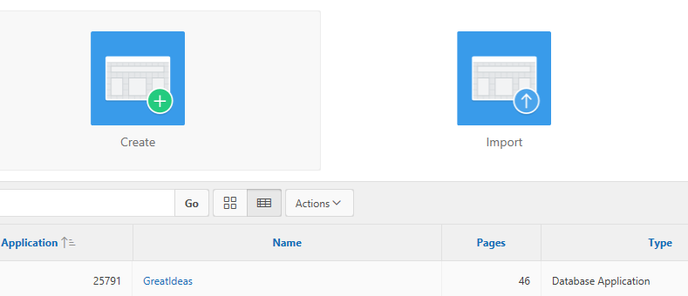Click on the application on application builder.
   2. Click on application properties.

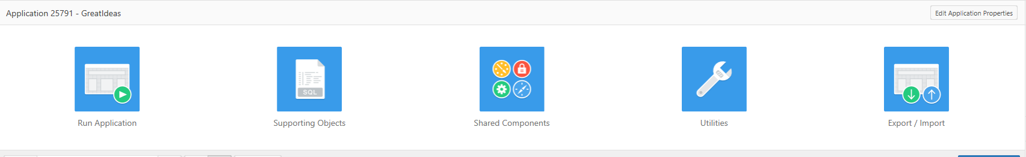

* 1. Click delete.
  2. 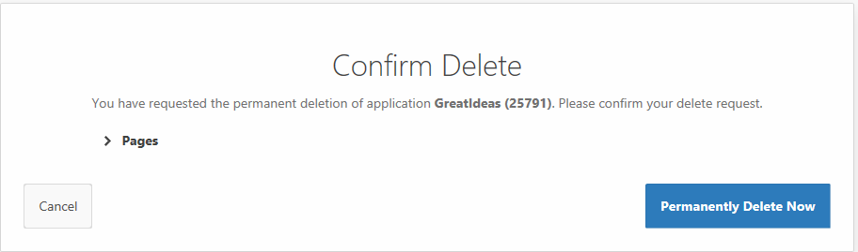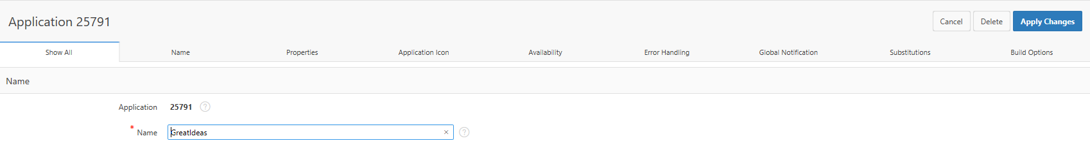confirm delete by clicking on Permanently Delete Now
  3. You will then be redirected back to application install where you can import and install the new version of the application.