|  |
| --- |
| Customer Segmentation Using  K-Means Clustering |
| PAREKH KATHAN CHIRAGKUMAR |

# 1. Abstract

Effective decisions are mandatory for any company to generate good revenue. In these days competition is huge and all companies are moving forward with their own different strategies. We should use data and take a proper decision. Every person is different from one another and we don’t know what he/she buys or what their likes are. But, with the help of machine learning technique one can sort out the data and can find the target group by applying several algorithms to the dataset. Without this, It will be very difficult and no better techniques are available to find the group of people with similar character and interests in a large dataset. Here, The customer segmentation using K-Means clustering helps to group the data with same attributes which exactly helps to business the best. We are going to use elbow method to find the number of clusters and at last we visualize the data.

**2. Keywords**

Clustering, Elbow Method, K-Means Algorithm, Customer Segmentation, Visualization.

**3. Introduction**

**3.1 Introduction**

Nowadays the competition is vast and lot of technologies came into account for effective growth and revenue generation. For every business the most important component is data. With the help of grouped or ungrouped data, we can perform some operations to find customer interests.

Data mining helpful to extract data from the database in a human readable format. But, we may not known the actual beneficiaries in the whole dataset. Customer Segmentation is useful to divide the large data from dataset into several groups based on their age, demographics, spent, income, gender, etc. These groups are also known as clusters. By this, we can get to know that, which product got huge number of sales and which age group are purchasing etc. And, we can supply that product much for better revenue generation.

Initially we are going to take the old data. As we know that old is gold so, by using the old data we are going to apply K-means clustering algorithm and we have to find the number of clusters first. So, at lastly, we have to visualize the data. One can easily find the potential group of data while observing that visualization.

The goal of this paper is to identify customer segments using the data mining approach, using the   
partitioning algorithm called as K-means clustering algorithm. The elbow method determines the optimal   
clusters.

**3.2 Problem Statement**

Customer Segmentation is the best application of unsupervised learning. Using clustering, identify segments of customers in the dataset to target the potential user base. They divide customers into various groups according to common characteristics like gender, age, interest, and spending habits so they can market to each group effectively. Use K-Means Clustering and also visualize the gender and age distributions. Then analyze their annual income and spending scores. As it describes about how we can divide the customers based on their similar characteristics according to their needs by using k-means clustering which is a classification of unsupervised machine learning.

**4. Existing System**

The existing method is storing customer data through paperwork and computer software (digital data) is increasing day by day. At end of the day they will analyse their data as how many things are sold or actual customer count etc. By analysing the collected data they got to know who is beneficial to their business and increase their sales. It requires more time and more paperwork. Also, it is not much effective solution to find the desired customers data.

**5. Proposed System**

**5.1 Proposed Method**

To overcome the traditional method i.e paper work and computerized digital data this new method will play vital role. As we collect a vast data day by day which requires more paperwork and time to do. As new technologies were emerging in today’s world. Machine Learning which is powerful innovation which is used to predict the final outcome which has many algorithms. So for our problem statement we will use K-Means Clustering which groups the data into different clusters based on their similar characteristics. And then we will visualize the data.

**5.2 System Architecture**

Initially we will see the dataset and then we will perform exploratory data analysis which deals with the missing data, duplicates values and null values. And then we will deploy our algorithm k-means clustering which is unsupervised learning in machine learning.

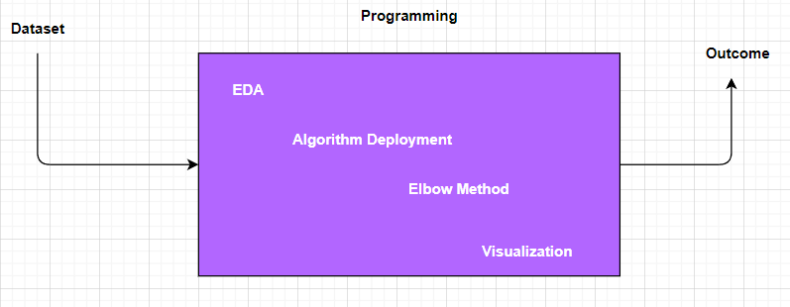

As in order to find the no of clusters we use elbow method where distance will be calculate through randomly chosen centres and repeat it until there is no change in cluster centres. Thereafter we will analyse the data through data visualization. Finally we will get the outcome.

**5.3 Algorithm**

**5.3.1 K-Means Clustering**

* K Means algorithm in an iterative algorithm that tries to partition the dataset into K predefined distinct non overlapping sub groups which are called as cluster.
* Here K is the total no of clusters.
* Every point belongs to only one cluster.
* Clusters cannot overlap.

**5.3.2 Steps of Algorithm**

* Arbitrarily choose k objects from D as the initial cluster centers.
* Repeat.
* Assign each object to the cluster to which the object is the most similar, based on the mean value of the objects in the cluster.
* Update the cluster means, i.e. calculate the mean value of the objects for each cluster.
* Until no change.

**6. Methodology**

**1.** First of all we will import all the necessary libraries or modules (pandas, numpy, seaborn).

**2.** Then we will read dataset and anyalse whether it contains any null values, missing values and duplicate values. So we will fix them by dropping or fixing the value with their means, medians etc which is technically named as Data Preprocessing.

3. We will deploy our model algorithm K-Means Clustering, which divides the data into group of clusters based on similar characteristics. To find no.of clusters we will use elbow method.

4. Finally, we will visualize our data using matplot, which concludes the customers divided into groups who are similar to each other on their group.

**7. Implementation And Analysis**

**7.1 Overview of a Dataset**

This is a mall customer segmentation data which contains 5 columns and 200 rows.

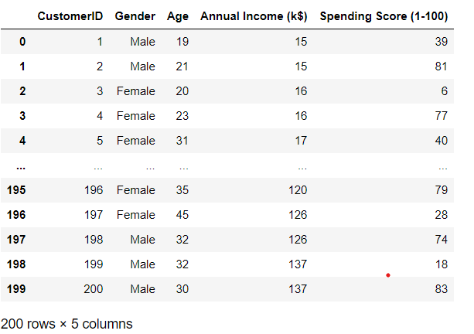

**7.2 Exploratory Data Analysis**

It deals with the data preprocessing, whether it contains any missing values or null values. There after we will see the information and description of the dataset.

**7.2.1 Information of the dataset**

#df.info()

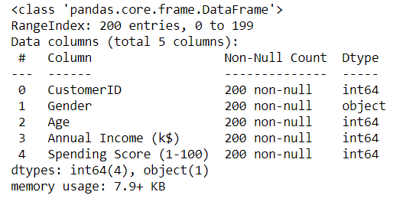

As here it overview the information of the data. And it gives it doesn’t contain any null values.

As we will remove the irrelevant data which is customer id.

df.drop(["CustomerID"], axis=1, inplace=True)

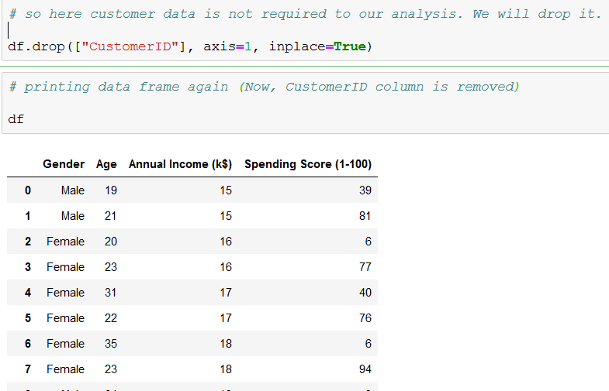

**7.2.2 Description of the data**

#df.describe()

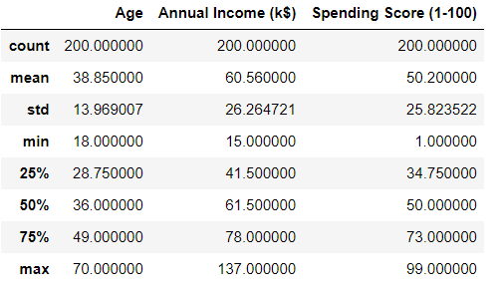

It describes about the count which counts the no of rows in it, mean of the columns, standard deviations, maximum and minimum and percentiles etc.

**7.3 Gender plot Analysis**

Here it overview the gender analysis

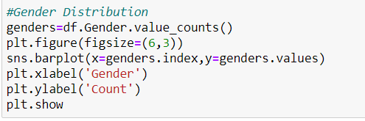

So we label the x-axis as Gender and y-axix as Count and we plot it by using barplot.

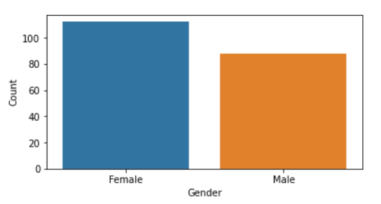

From the plot we will con clued that the there are more female customers than the male customers i.e female customers are more than 100 whereas male customers are nearly 80.

**7.4 Age plot**

We will use distplot for the distribution of age of the customers. 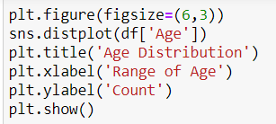

So we label X-axis as range of age and y-axis as count.

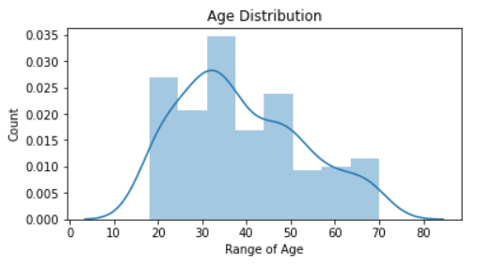

From the plot, it varies the age from nearly 20 to 70. it is evident that the age of the customers between 30 - 40 are more, then after 20-30 etc.

**7.5 Annual Income vs Spending Score**

As we will use scatterplot and labelled x-axis as Annual Income(k$) and y-axis as Spending Score(1-100)

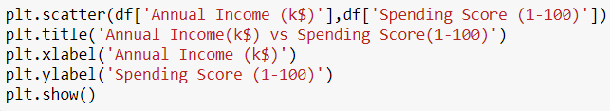

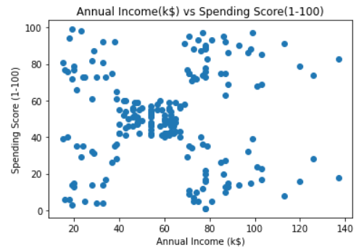

From the plot we observed that it varies from low annual income with low expenditure or spending money to high annual income with high expenditure.

**7.6 Elbow Method**

The elbow method is based on the observation that increasing the number of clusters can help to reduce   
the sum of within-cluster variance of each cluster. This is because having more clusters allows one to capture   
finer groups of data objects that are more similar to each other.   
To define the optimal clusters, Firstly, we use the clustering algorithm for various values of k. This is   
done by ranging k from 1 to 10 clusters. Then we calculate the total intra-cluster sum of square. Then,   
we proceed to plot intra-cluster sum of square based on the number of clusters. The plot denotes the   
approximate number of clusters required in our model. The optimum clusters can be found from the graph   
where there is a bend in thegraph.

First we will consider the data X which as only two columns they are annual income and spending score.

X=df[['Annual Income (k$)','Spending Score (1-100)']]

X.head()

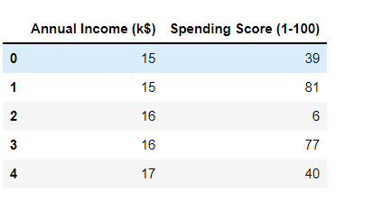

*wcss=[]*

*for i in range(1,11):*

*km=KMeans(n_clusters=i)*

*km.fit(X)*

*wcss.append(km.inertia_)*

*plt.figure(figsize=(6,3))*

*plt.plot(range(1,11),wcss)*

*plt.title('Elbow Curve')*

*plt.xlabel('k value')*

*plt.xticks(np.arange(1,11,1))*

*plt.ylabel('wcss')*

*plt.show()*

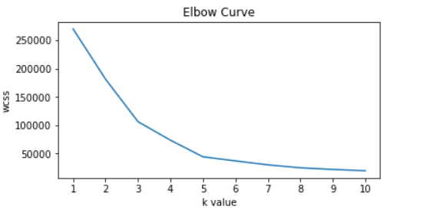

So from the graph we observed that the at 5 there is bend and it can be considered as k which is no of clusters.

Therefore, k=5 i.e no of clusters are equal to 5.

**7.7 Fitting the Algorithm**

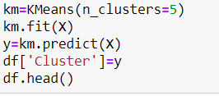

As here we initialized the kmeans as km with 5 clusters and we will fit it. There after we will predict the data and store it in y. And then we will add new column named as Cluster and data as y.

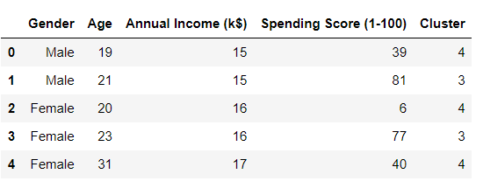

So from the figure we observed that each customer is labelled with cluster which is based on their characteristics.

**7.8 Visualization the clusters**

Visualizing the clusters based on Annual Income and Spending Score of the customers. As here we plot a graph named as Clusters of Customers to visualize the data in terms of groups or cluster.

plt.figure(figsize=(15,7))

plt.scatter(df["Annual Income (k$)"][df.Cluster == 0], df["Spending Score (1-100)"][df.Cluster == 0], c='blue', s=60,label='Cluster 0')

plt.scatter(df["Annual Income (k$)"][df.Cluster == 1], df["Spending Score (1-100)"][df.Cluster == 1], c='red', s=60,label="Cluster 1")

plt.scatter(df["Annual Income (k$)"][df.Cluster == 2], df["Spending Score (1-100)"][df.Cluster == 2], c='green', s=60,label='Cluster 2')

plt.scatter(df["Annual Income (k$)"][df.Cluster == 3], df["Spending Score (1-100)"][df.Cluster == 3], c='yellow', s=60,label='Cluster 3')

plt.scatter(df["Annual Income (k$)"][df.Cluster == 4], df["Spending Score (1-100)"][df.Cluster == 4], c='black', s=60,label='Cluster 4')

plt.title('Clusters of Customers')

plt.legend()

plt.xlabel('Annual Income (k$)')

plt.ylabel('Spending Score (1-100)')

plt.show()

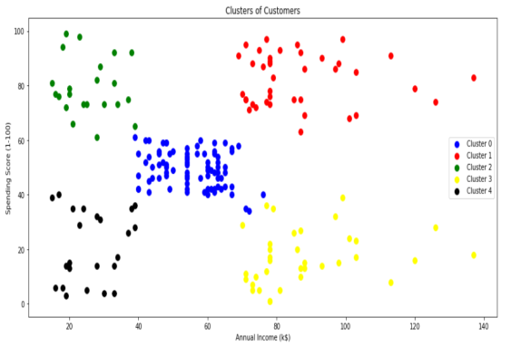

So from the above one we observed that the there are 5 clusters which are named as 0, 1, 2, 3, 4.

* Cluster 0 which is at centre, average annual income with average spending score.
* Cluster 1 which is at top right, highest annual income with highest spending score.
* Cluster 2 which is at top left, lowest annual income with highest spending score.
* Cluster 3 which is at bottom right, high annual income with low spending score.
* Cluster 4 which is at bottom left, lowest annual income with lowest spending score.

**8. Conclusion**

So we concluded that the ,

* The Highest income , high spending can be target these type of customers as they earn more money and spend as much as they want.
* Highest income, low spending can be target these type of customers by asking feedback and advertising the product in a better way.
* Average income, Average spending may or may not be beneficial to the mall owners of this type of customers.
* Low income, High spending can be target these type of customers by providing them with low-cost EMI’s etc.
* Low income, Low spending don’t target these type of customers because they earn a bit and spend some amount of money.

So high income, high spending are the most beneficial ones to the mall owners which increases the owner’s business. (Cluster 1)

**9. References**

[1] Cooil, B., Aksoy, L. & Keiningham, T. L. (2008), ‘Approaches to customer segmentation’, Journal of Relationship Marketing 6(3-4), 9–39.

[2] D. Aloise, A. Deshpande, P. Hansen, and P. Popat, “The Basis Of Market Segmentation” Euclidean sum-of-squares clustering,” Machine Learning, vol. 75, pp. 245-249, 2009.

[3] T. Kanungo, D. M. Mount, N. S. Netanyahu, C. D. Piatko, R.Silverman, and A. Y. Wu, “An efficient K-means clustering   
algorithm,” IEEE Trans. Pattern Analysis and Machine Intelligence,   
vol. 24, pp. 881-892, 2002.

[4] Bhatnagar, Amit,Ghose, S. (2004), ‘A latent class segmentation analysis of e-shoppers’, Journal of Business Research 57, 758–767.

[5] Marcus, C. (1998), ‘A practical yet meaningful approach to customer segmentation approach to customer segmentation’, Journal of Consumer Marketing15, 494–504.