Analíse de dados - boxplots

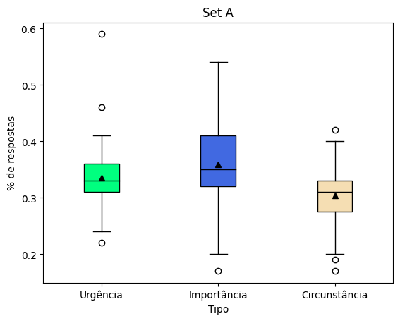

|  |  |  |
| --- | --- | --- |
| **Francisco Alysson Alves Costa** | **22%** | **Inferior** |
| **Michael Moraes** | **46%** | **Superior** |
| **Monica Marques Soares Pereira** | **59%** | **Superior** |
| **Michael Moraes** | **17%** | **Inferior** |
| **Leandro Coelho de Mendonça** | **19%** | **Inferior** |
| **Leandro Giometti** | **17%** | **Inferior** |
| **Leonardo Cury Rovai** | **42%** | **Superior** |

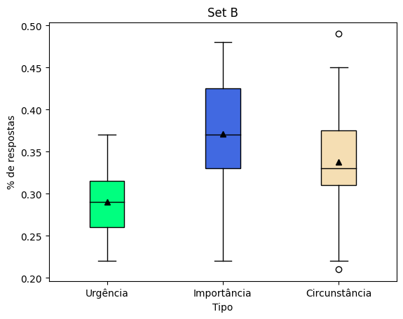

|  |  |  |
| --- | --- | --- |
| **Francisco Alysson Alves Costa** | **21%** | **Inferior** |
| **Thamires Silva de Oliveira** | **49%** | **Superior** |