Customer Segmentation Using K-Means Clustering

Table of Contents
1. Introduction
2. Dataset Description
3. Methodology
4. Clustering Results
5. Visualizations
6. Conclusions

1. Introduction
This project applies K-Means clustering to segment customers into meaningful groups based on Age, Annual Income, and Spending Score. Customer segmentation helps businesses understand different consumer groups and tailor strategies accordingly.

2. Dataset Description
A synthetic dataset resembling the Mall Customers Dataset is used. It contains the following features:
• Age
• Annual Income
• Spending Score

3. Methodology
The workflow followed:
1. Data generation and preprocessing
2. Applying K-Means clustering with k=3
3. Visualizing clusters using scatter plots
4. Interpreting clusters as low, medium, and high spenders

4. Clustering Results
The model successfully grouped customers into 3 clusters:
• Cluster 0: 63 customers
• Cluster 1: 60 customers
• Cluster 2: 77 customers

5. Visualizations
Chart 1: Income vs Spending Score
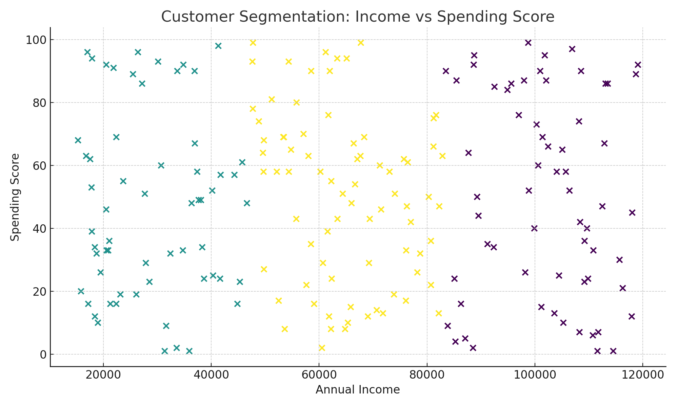
Chart 2: Age vs Spending Score
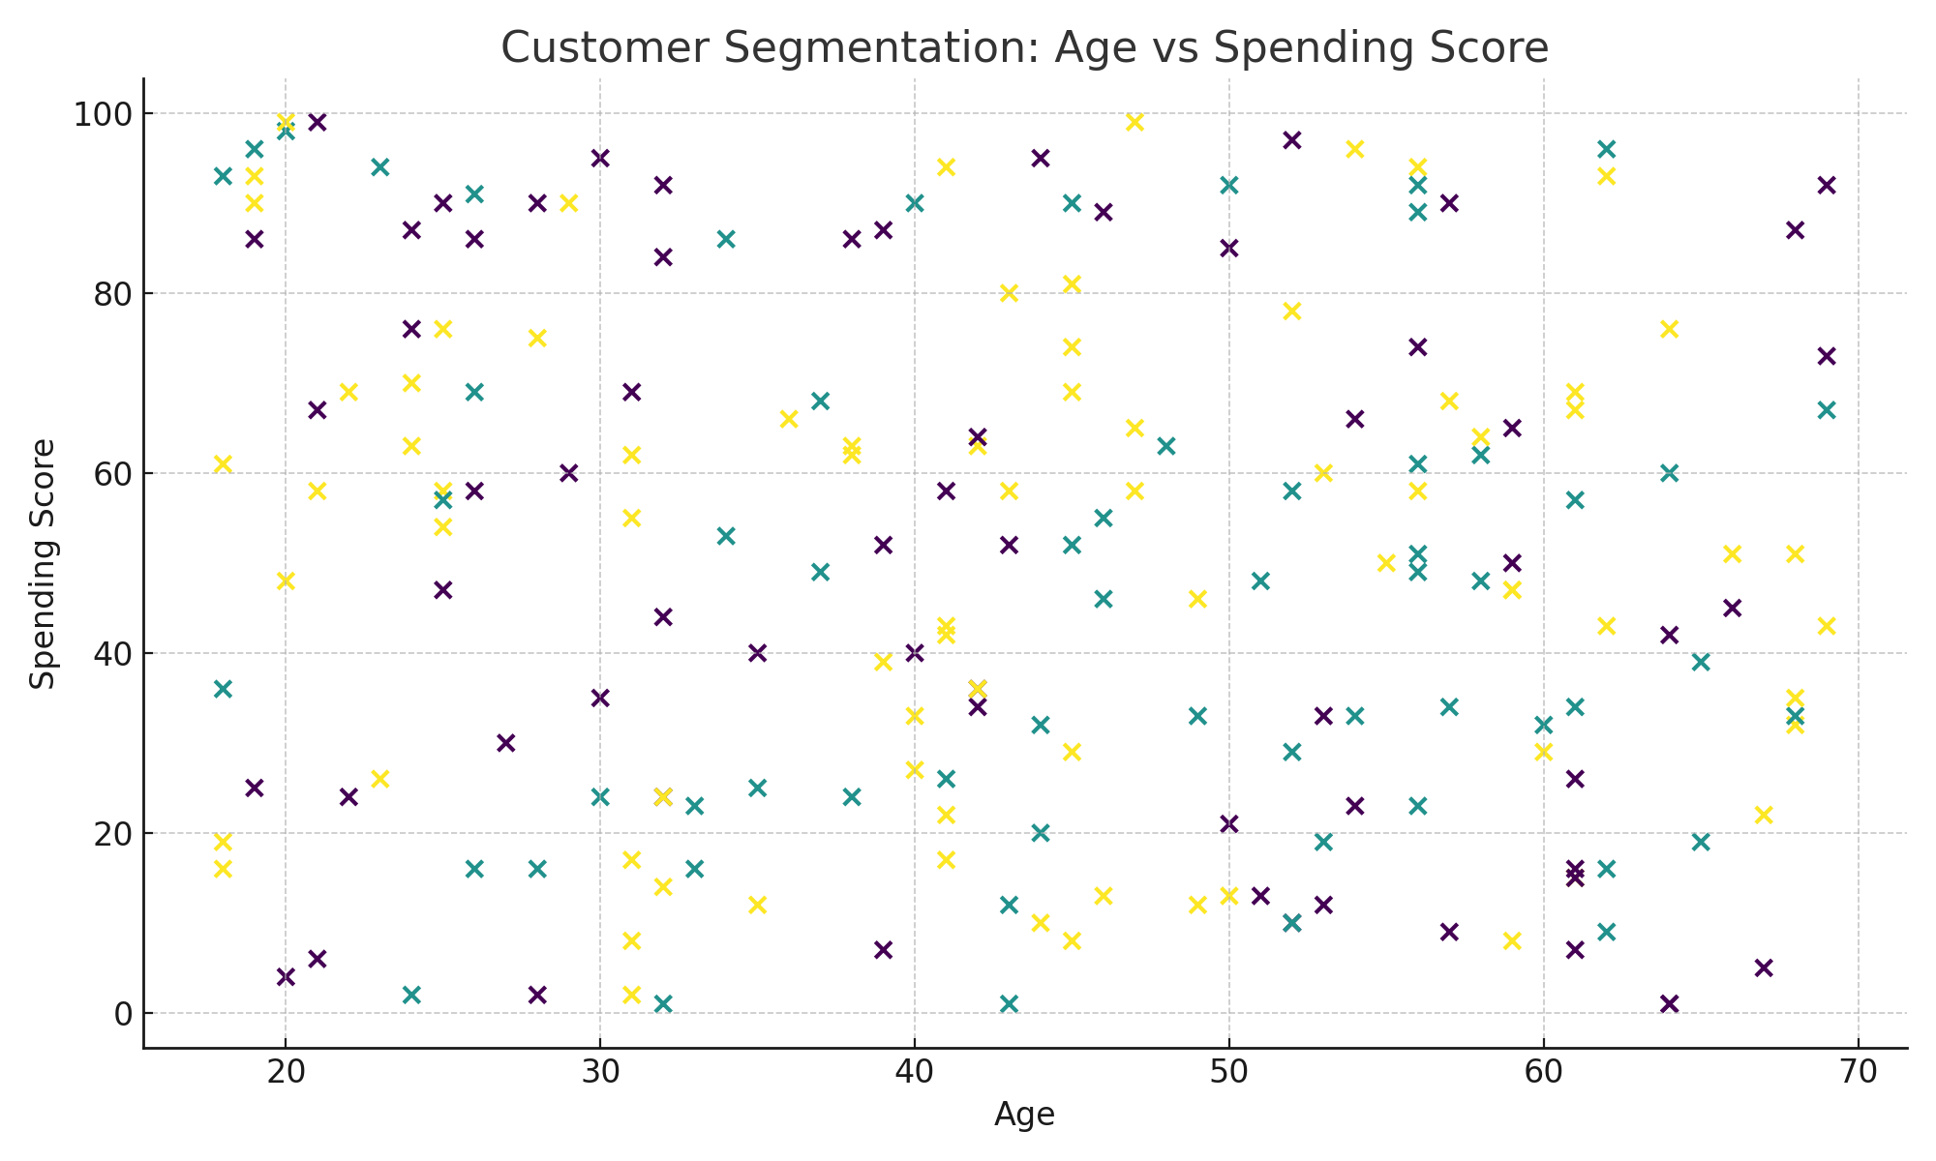
Chart 3: Age vs Income
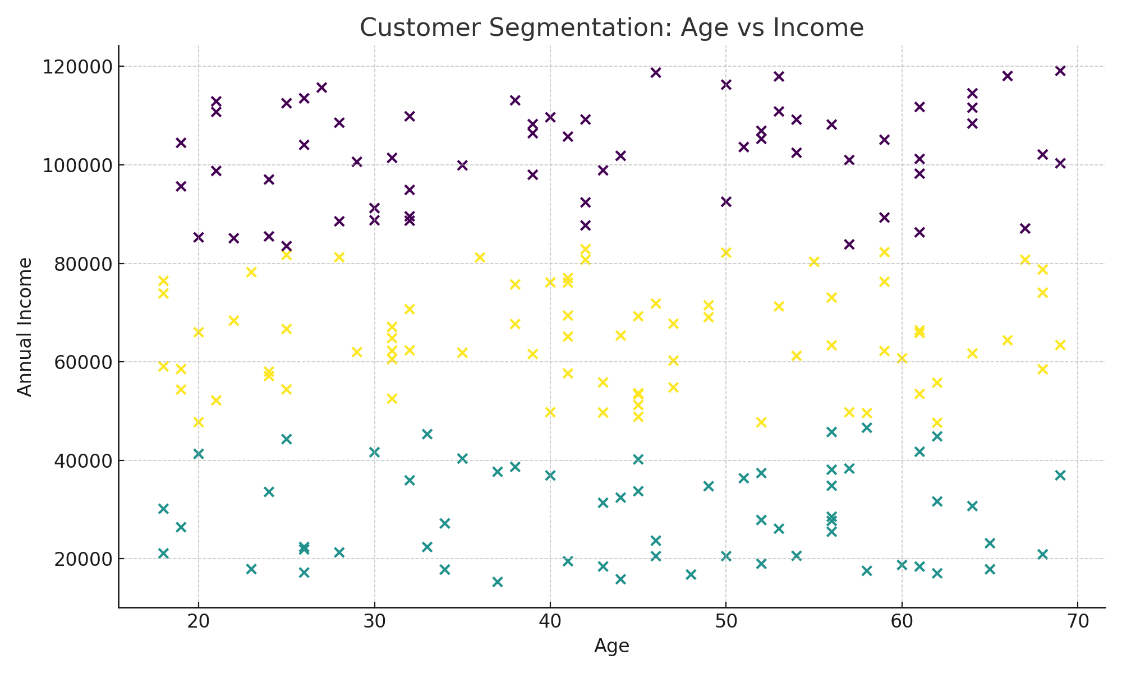

6. Conclusion
The analysis reveals three distinct customer segments. These clusters can be used for targeted marketing, personalized offers, and improved customer retention strategies.

