**Semester: V Name of Student: Paresh Gupta**

**Academic Year: 2022-23 Student ID:22104089**

**Class / Branch: TE IT**

**Subject: Advanced Devops Lab (ADL)**

**Name of Instructor: Prof. Sonal Jain**

**EXPERIMENT NO. 06**

**Aim: To Build, change, and destroy AWS infrastructure Using Terraform.**

**Pre-requistes:**

**1. Install the AWS CLI version 2 on Linux**

Follow these steps from the command line to install the AWS CLI on Linux.

**Install curl on linux**

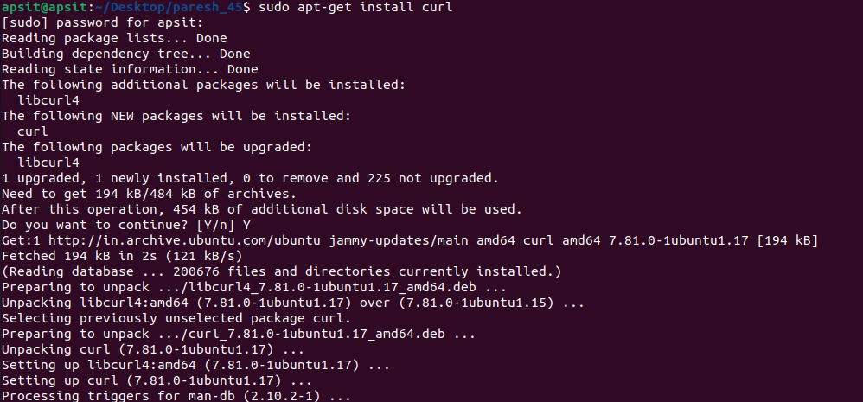

**vishal@apsit:~$ curl "https://awscli.amazonaws.com/awscli-exe-linux-x86_64.zip" -o "awscliv2.zip"**



**vishal@apsit:~$ sudo apt install unzip**

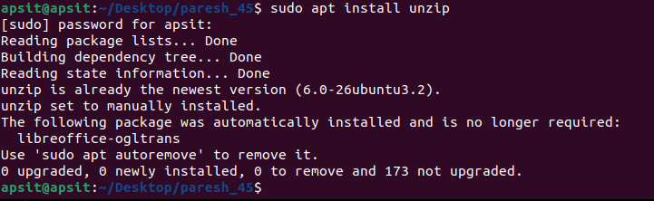

**vishal@apsit:~$ sudo unzip awscliv2.zip**

**vishal@apsit:~$ sudo ./aws/install**

**vishal@apsit:~$ aws --version**

it should display the below outout.

**aws-cli/2.1.29 Python/3.8.8 Linux/5.4.0-1038-aws exe/x86_64.ubuntu.18 prompt/off**

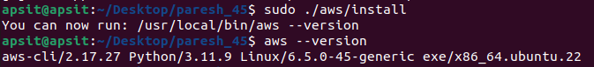

**2. Create a new access key if you don't have one. Make sure you download the keys in your local machine.**

Login to AWS console, click on username and go to My security credentials.

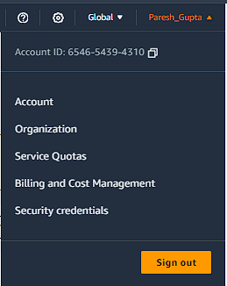

Continue on security credentials, click on access keys  
  
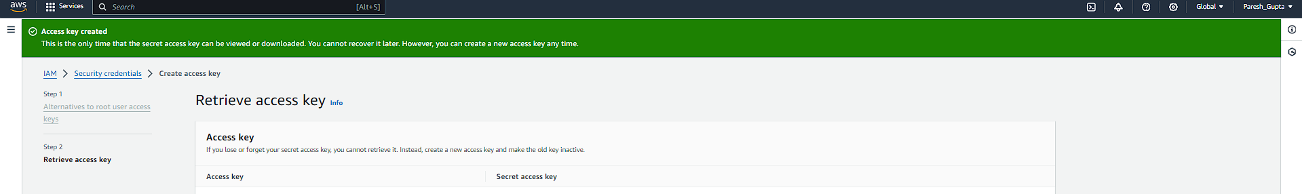

**Perform below commands in Linux where you have installed Terraform**

First setup your access keys, secret keys and region code locally.

**vishal@apsit:~$aws configure**

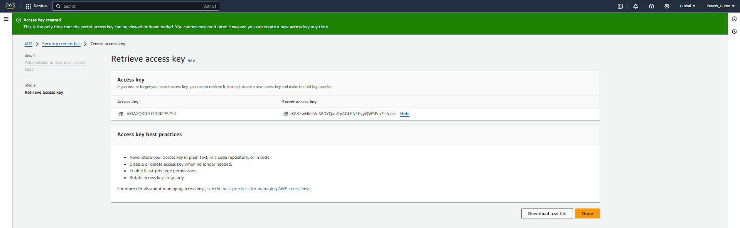

You can check region as shown in below image :

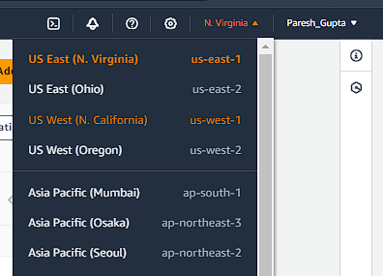

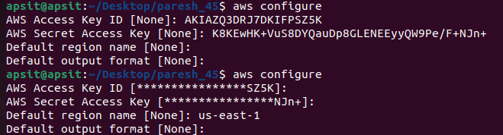

Create one Directory for Terraform project in which all files of terraform we can save

**vishal@apsit:~$ cd ~**

**vishal@apsit:~$ mkdir project-terraform**

**vishal@apsit:~$ cd project-terraform**

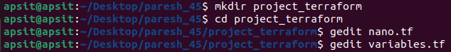

**Create Terraform Files**

**vishal@apsit****:~$ sudo nano variables.tf**

In order to provide key name in variables first create key pair as shown:

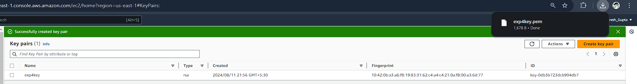



Give name to key pair file as **terraform**

Key pair is generated

Use your Region and Key name in variable.tf as shown and provide instance type which you want to create.

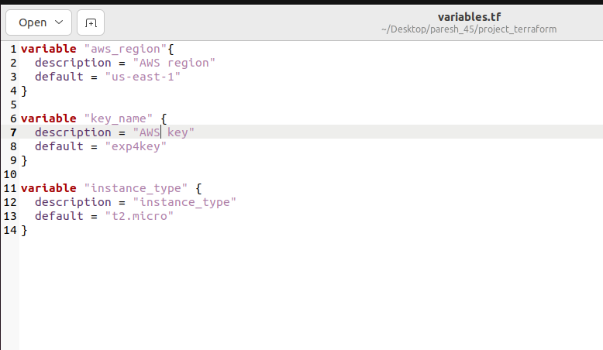

After creating variable terraform file note down the AMI ID of instance which u want to create which we will use to configure our instance in main.tf file.

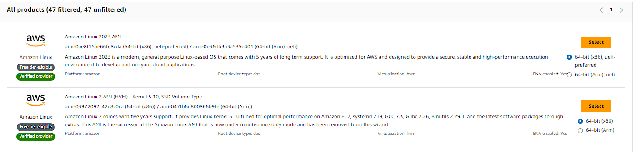

**Now create main.tf file:**



provider "aws" {

region = var.aws_region

}

# Create security group with firewall rules

resource "aws_security_group" "security_jenkins_port" {

name = "security_jenkins_port"

description = "security group for jenkins"

ingress {

from_port = 8080

to_port = 8080

protocol = "tcp"

cidr_blocks = ["0.0.0.0/0"]

}

ingress {

from_port = 22

to_port = 22

protocol = "tcp"

cidr_blocks = ["0.0.0.0/0"]

}

# Outbound from Jenkins server

egress {

from_port = 0

to_port = 65535

protocol = "tcp"

cidr_blocks = ["0.0.0.0/0"]

}

tags = {

Name = "security_jenkins_port"

}

}

resource "aws_instance" "myFirstInstance" {

ami = "ami-0ae8f15ae66fe8cda"

key_name = var.key_name

instance_type = var.instance_type

vpc_security_group_ids = [aws_security_group.security_jenkins_port.id] #changed here

tags = {

Name = "jenkins_instance"

}

}

# Create Elastic IP address

resource "aws_eip" "myFirstInstance" {

instance = aws_instance.myFirstInstance.id

domain = "vpc"

tags = {

Name = "jenkins_elstic_ip"

}

}

Put AMI-ID in above highlighted space and Now execute the below command:

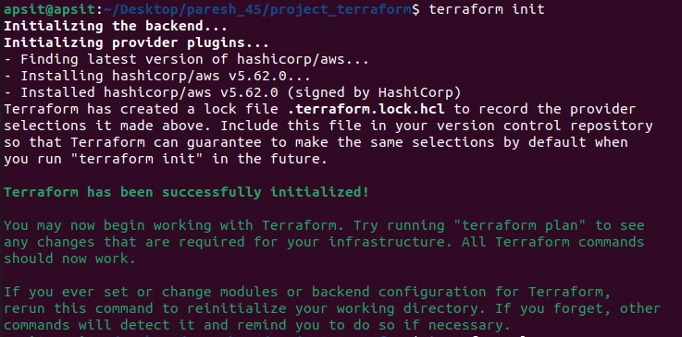

you should see like below screenshot.

**Execute the below command**

the above command will show how many resources will be added.

Plan: 3 to add, 0 to change, 0 to destroy.

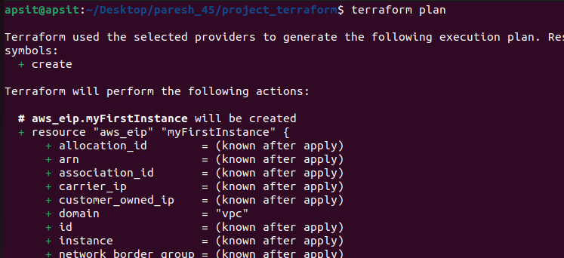

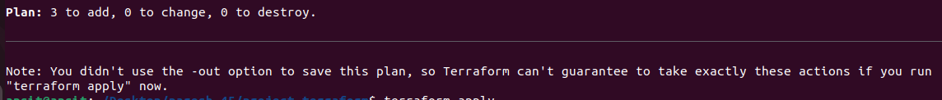

**Execute the below command**

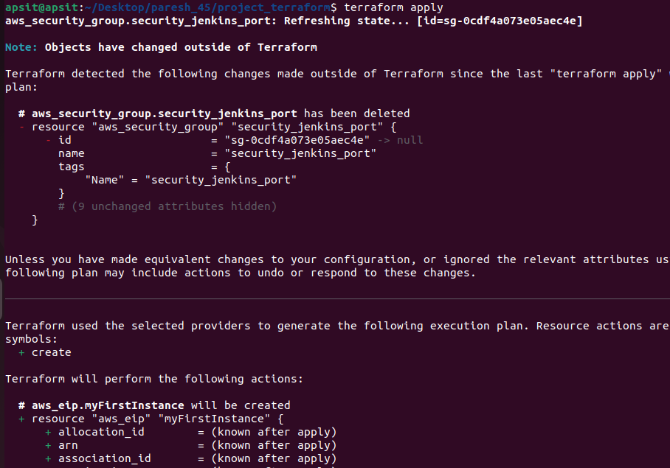

Provide the value as Yes for applying terraform

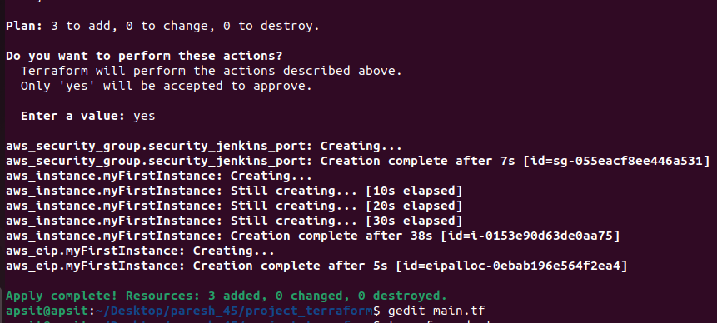

Plan: 3 to add, 0 to change, 0 to destroy.  
  
Do you want to perform these actions?  
Terraform will perform the actions described above.  
Only 'yes' will be accepted to approve.  
  
Enter a value: yes

Apply complete! Resources: 3 added, 0 changed, 0 destroyed.

Now login to EC2 console, to see the new instances up and running, you can see Jenkins_instance is up and running which we deploy from terraform.

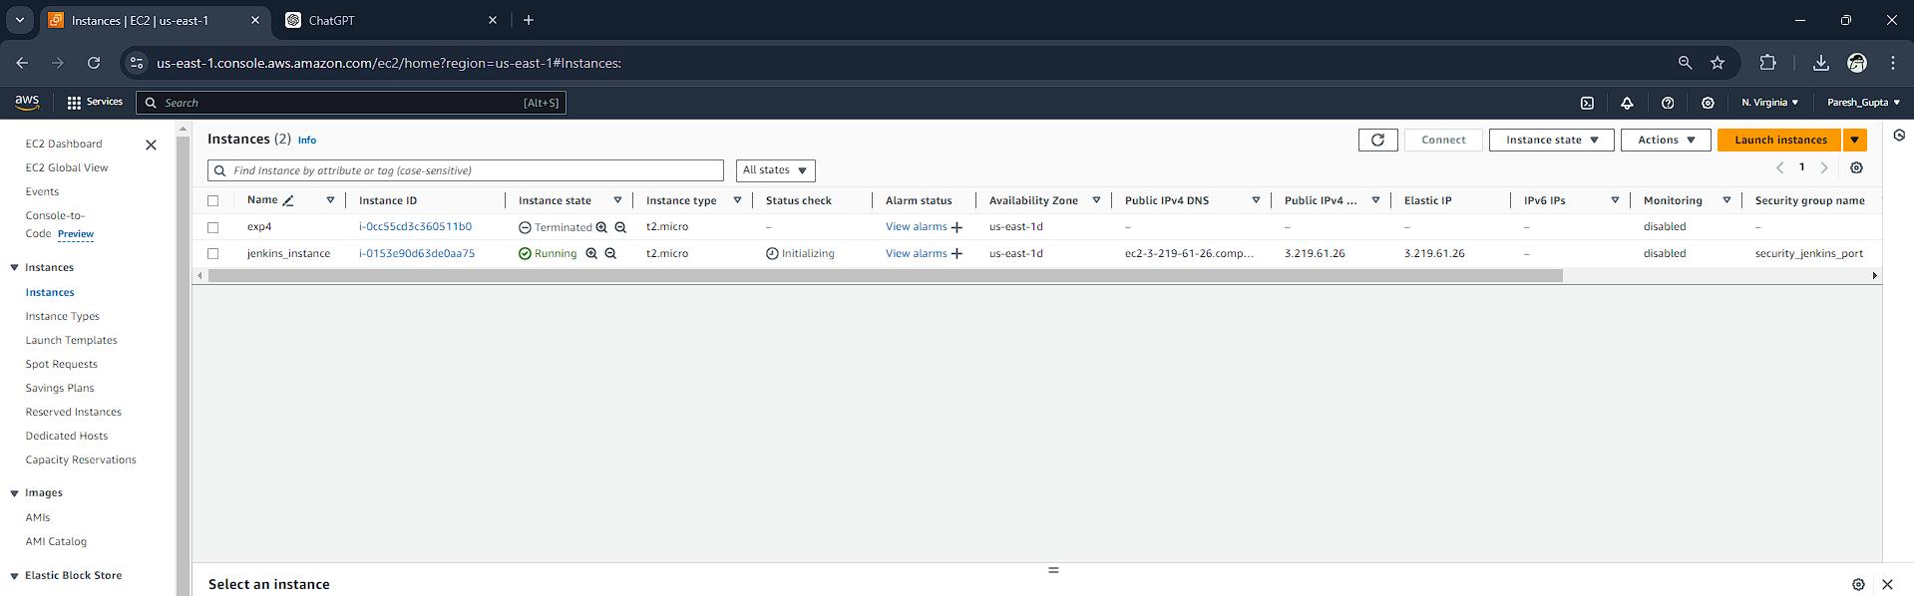



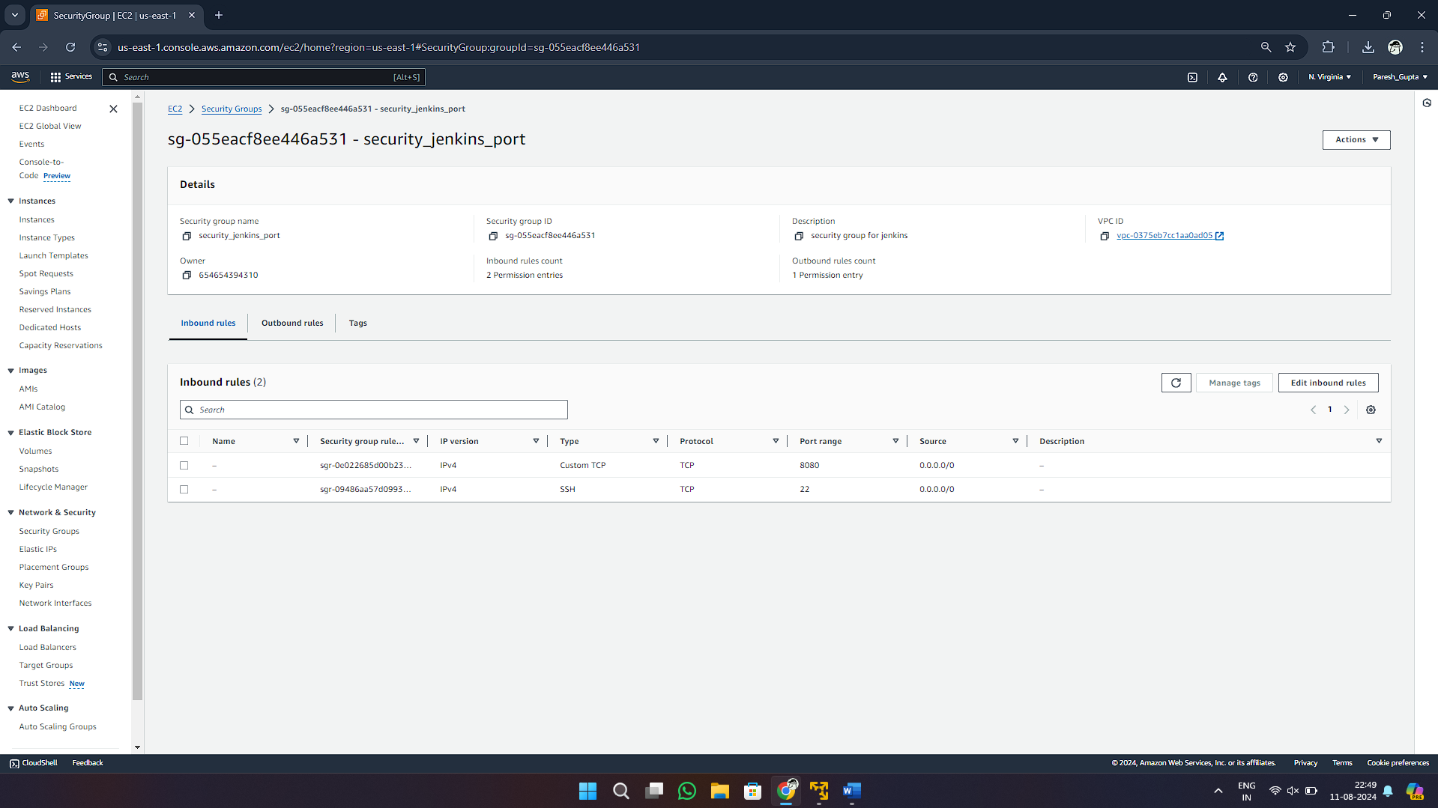

You can also check the security group resource details which you created from terraform :

**Terraform destroy**

you can also destroy or delete your instance by using terraform destroy command :

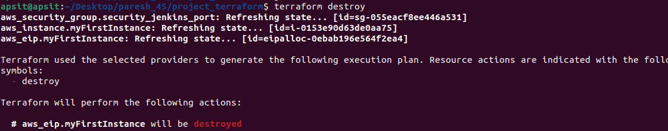

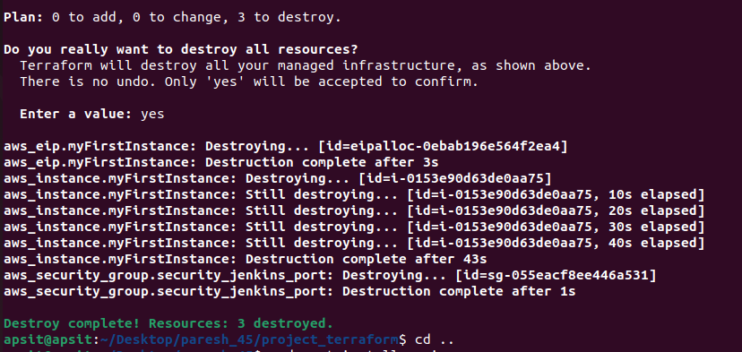

Now you can see instance which you created by using terraform is deleted successfully from aws console also you can check it will removed successfully:

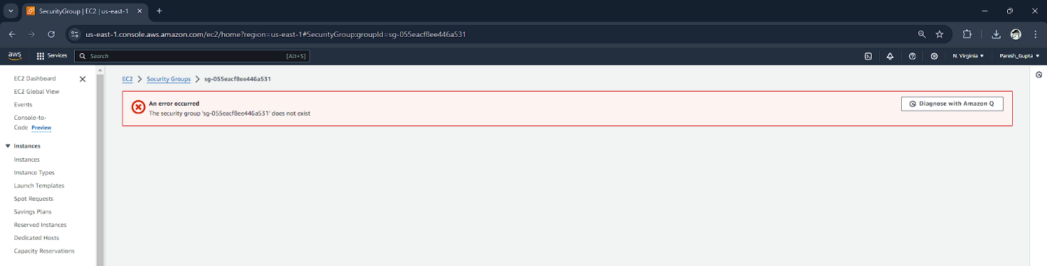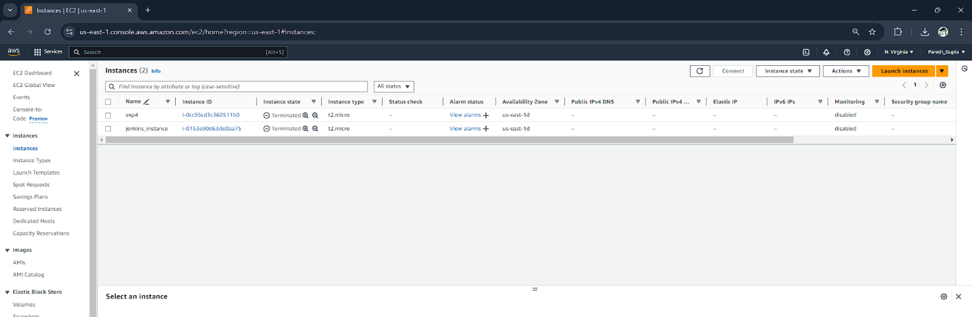

All the Resources including Security groups, EC2 instances using terraform will be deleted. In this way we can automate infrastructure set up using terrform in aws cloud.

**Conclusion: Hence we had successfully created EC2 Instance and Security Group without AWS GUI using Terraform through Linux Terminal.**