|  |  |
| --- | --- |
| **Paresh Korani / 758158** |  |
| Programmer Analyst Trainee | 6+ Months |
| Pune | [paresh.korani@cognizant.com](mailto:paresh.korani@cognizant.com) |
|  |  |

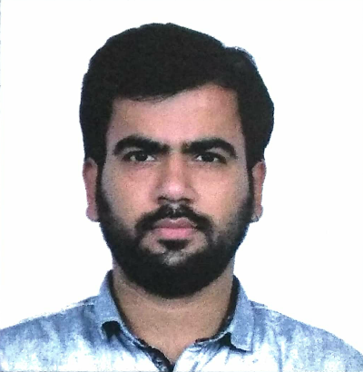

|  |  |
| --- | --- |
| **Summary :** | I have skills in designing web application using **HTML/CSS, HTML5/CSS3** and **JS**  **and JQuery, Bootstrap, Angular.** |
| **Skills and Expertise :** |  |
|  | **[LANGUAGES]** HTML/CSS, HTML5/CSS3, JavaScript, JQUERY, Bootstrap, Angular  **[Tools]** Visual Studio Code, Notepad++, Photoshop |
| **Experience :** | **1.Project :- HTML and CSS** |
|  | **Project description:**  As part of my project I have created web page in HTML5/CSS3 according given PSD.  **Role and Responsibilities**   * Create and modify web pages using new tags of HTML5, * Used CSS for styling that page  1. **Project :- JavaScript Project description:**   As part of my project I have created form as per design and apply validation on it as per given requirement.  **Role and Responsibilities**   * + Create form using HTML and CSS,   + Create validation for form using functionalities of JavaScript, Also use regular expression for same. |

# Project :- Bootstrap

**Project description:**

As part of my project I have created web page as per given documents using inbuilt classes of bootstrap and make it responsive for all devices and browsers.

# Role and Responsibilities

* + Create web page using classes of bootstrap,
  + Used media query to make design responsive,
  + Used JQuery to implement form validation.

# Project :- Angular Project description:

As part of my project I have created web application using angular in which I fetch data from JSON object and display it in our page.

# Role and Responsibilities

* + Create web application using angular 4 functionality,
  + Used routing to route between pages,
  + Fetch data from JSON object,
  + Used forms to display information of each user.

**Education:** B.E (Bachelor of Engineering) in COMPUTER ENGINEERING 2014-17 from K.K Wagh College of Engineering,Nashik (Savitribai Phule Pune University).

**Personal Info:** Name : Paresh Narendra Korani.

Address: Near ICICI Bank,New Plot,,Amalner

Dist-Jalgaon Maharashtra

Pin-425401

Email : [paresh.korani@cognizant.com](mailto:paresh.korani@cognizant.com) Contact No: +91 8975103979

+91 8459705362