Vehicle Registration No: |  | Store:
Odometer Reading: |  | Date:
Employee Name

- Inspection Checklist

Motor Vehicle Inspection Form
1. Inspection Details
OK? | Tyres | OK? | Electrical
□ | Tyres (tread depth) | □ | Both tail lights
□ | Wheel nuts | □ | Headlights (low beam)
 | Outside | □ | Headlights (high beam)
□ | Cleanliness | □ | Reverse lights
□ | Body damage: scratches/dents  etc. (circle on diagram below) | □ | Brake lights
□ | Mirrors & Windows | Cab
□ | Signage (if applicable) | □ | Windscreen & wipers
 | Mechanical | □ | Horn
□ | Engine – oil & water | □ | Indicators
□ | Brakes | □ | Seat belts
□ | Transmission | □ | Cleanliness
□ |  |  | Service log book available

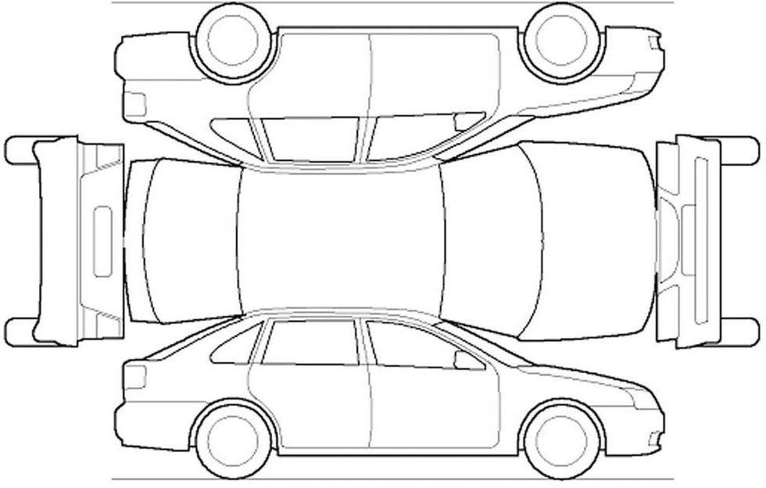
Circle any areas with existing damage.

□ | Spare keys available in store
- Corrective Actions/notes/issues

- Sign- off
I hereby declare that the above information is true and correct at the time of inspection.
Employee Signature |  | Manager Signature
Date |  | Date

