**CO4. Apply the knowledge of green chemistry and nanotechnology for solving the problems of society in sustainable and greener way.**

**Name: Pargat Singh**

**Batch: A2**

**Roll No. : 16010121045**

**Date: 17/11/2021**

**Experiment No. 4**

**Title: To determine the chemical pollutants in water samples using advanced analytical techniques.**

**Aim:**

To determine chemical parameters such as chemical oxygen demand (COD) of water samples.

**Theory:**

It is needless to emphasize the importance of water in our life. Without water, there is  no life on our planet.  We need water for different purposes. We need water for drinking, for industries, for irrigation, for swimming and fishing, etc.

Water for different purposes has its own requirements for composition and purity. Each body of water needs to be analysed on a regular basis to confirm to suitability. The types of analysis could vary from simple field testing for a single analyte to laboratory based multi-component instrumental analysis. The measurement of water quality is a very exacting and time consuming process, and a large number of quantitative analytical methods are used for this purpose.

### **Chemical Oxygen Demand (COD):**

### **Theory:**

COD is used as a measure of oxygen equivalent to organic matter content of a sample that is susceptible to oxidation by a strong chemical oxidant. For samples from a specific source, COD can be related empirically to BOD. COD determination has advantage over BOD determination in that the result can be obtained in about 5 hours as compared to 5 days required for BOD test.

The organic matter gets oxidized completely by K2Cr2O7 in the presence of H2SO4 to produce CO2 and H2O. The excess of K2Cr2O7 remained after the reaction is titrated with ferrous ammonium sulphate. The dichromate consumed gives the O2 required for oxidation of organic matter.



### 

### DRINKING WATER QUALITY STANDARDS:

|  |  |  |  |  |
| --- | --- | --- | --- | --- |
| **Sl. No.** | **Characteristic/Parameter** | **BIS** | **ICMR** | **WHO** |
| 1 | Colour | 5 | 2.5 | - |
| 2 | Odour | Agreeable | Unobjectionable | Unobjectionable |
| 3 | Turbidity | 10 NTU | 5 NTU | 2.5 NTU |
| 4 | pH | 6.5-8.5 | 7.0-85 | 7.0-8.5 |
| 5 | TDS | 500 mgl | 500 mgl | 500 mgl |
| 6 | Hardness | 300 mgl | 300 mgl | 200 mgl |
| 7 | Ca | 75 mgl | 75 mgl | 75 mgl |
| 8 | Mg | 30 mgl | 50 mgl | 30 mgl |
| 9 | CL | 250 mgl | 200 mgl | 200 mgl |
| 10 | Sulphate | 200 mgl | 200 mgl | 200 mgl |
| 11 | Fe | 0.3 mgl | 0.1 mgl | 0.1 mgl |
| 12 | Nitrate | 45 mgl | 20 mgl | 45 mgl |
| 13 | Phenolic compounds | 0.001 mgl | 0.001 mgl | 0.001 mgl |
| 14 | Cd, Sc | 0.01 mgl | - | 0.01 mgl |
| 15 | Cu, As | 0.05 mgl | 0.05 mgl | 0.01 mgl |
| 16 | Cyanides | 0.05 mgl | - | 0.01 mgl |
| 17 | Pb | 0.1 mgl | - | 0.01 mgl |
| 18 | Anionic detergents | 0.2 mgl | - | - |
| 19 | PAH | - | - | - |
| 20 | Residual Chlorine | 0.2 mgl | - | - |
| 21 | Pesticides | Absent | - | - |

BIS- Beaurau of Indian Standards.

ICMR- Indian Council for Medical Research.

WHO- World Health Organization.

# **Self-Evaluation:**

## 

## Assignments:

1. **A 50 ml of sample contains 840 ppm dissolved oxygen. After 5 days the dissolve oxygen value becomes 230 ppm after the sample has been diluted to 80 ml. Calculate the BOD of sample.**

Given: (DO)blank = 840 ppm

(DO)incubated = 230 ppm

Volume of sample before dilution = 50 ml

Volume of sample after dilution = 80 ml

To Find : BOD

Formula:

BOD = [(DO)Blank – (DO)Incubated ] x Dilution Factor

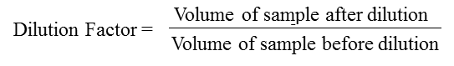

Solution:

Using given formula,

BOD = (840-230)*80/50

= 816 ppm

1. **A 25 ml of sewage water sample was refluxed with 10 ml of 0.25 N K2Cr2O7 solution of dil. H2SO4 . The unreacted dichromate required 6.5 ml of 0.1 N ferrous ammonium sulphate. 10ml of the same K2Cr2O7 solution and 25 ml of distilled water under the same conditions as the sample required 27ml of 0.1 N FAS . Calculate the COD of sewage sample.**

Given**:** Volume of FAS required for blank titration = 27 ml

Volume of FAS required for reaction after mass time = 6.5

Normality of FAS= 0.1 N

Volume of waste water sample taken = 25 ml

To find: COD of sewage sample

Formula:

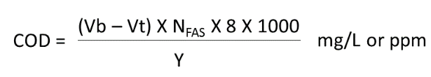

Solution:

Using the given formula,

COD of sewage water = (25 – 6.5) * 0.1*8*1000

25

=656 mg/L

**Observation:**

**Part-1: Blank Water**

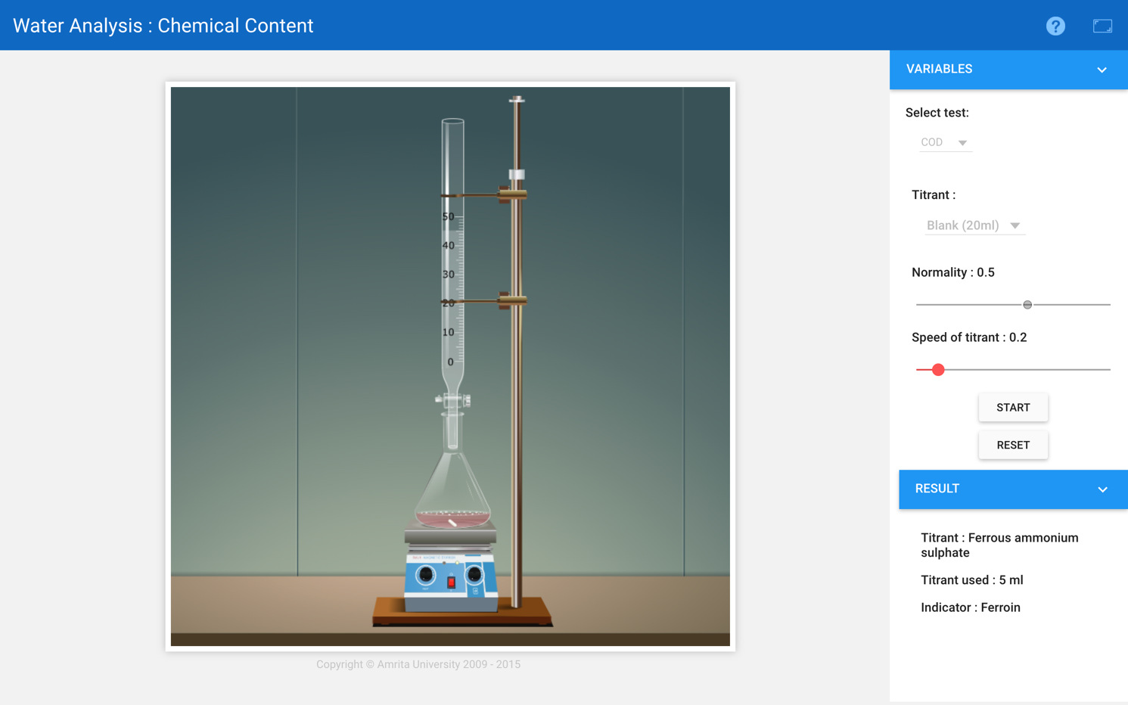

Burette : 0.5 N FAS solution

Conical flask : 20 mL of blank + Indicator

Indicator : Ferroin

End point : Blue to Wine red

Reaction:

CxHyOz + (X + Y/4 – Z/2) O2 → XCO2 + Y/2H2O

Cr2O7-2 + 14H+ + 6e-_ → 2Cr+3 + 7H2O

[Fe+2 → Fe+3 + e-] x 6

Cr2O7-2 + 14H+ + 6Fe+2 → 2Cr+3 + 6Fe+3 + 7H2O

Pilot Reading : 4.0 (mL) to 5.0 (mL)

|  |  |  |  |  |
| --- | --- | --- | --- | --- |
| Reading | I (mL) | II (mL) | III (mL) | Constant (mL) |
| Initial | 0.0 | 0.0 | 0.0 | 5.0  V1 |
| Final | 4.9 | 5.0 | 5.0 |
| Difference | 4.9 | 5.0 | 5.0 |

**Part-2: Tap Water**

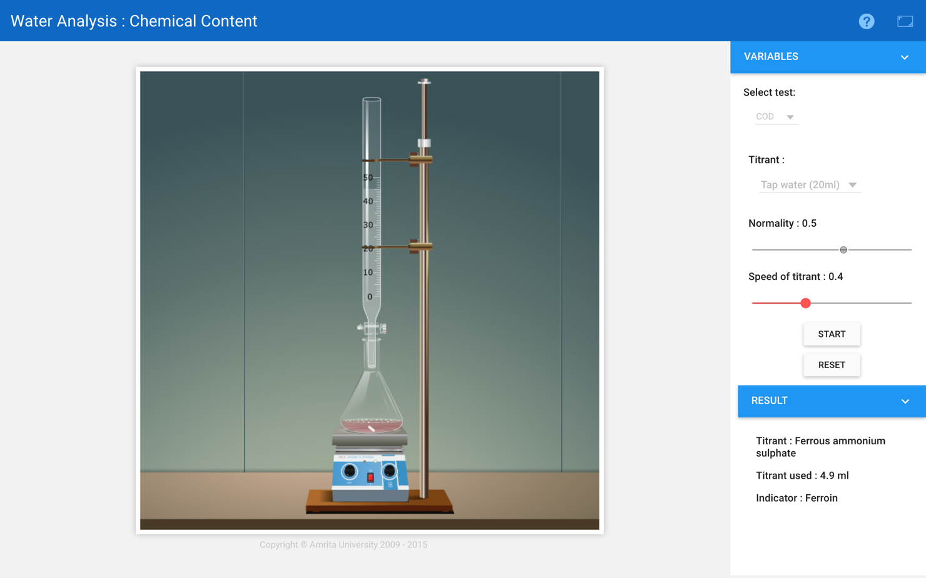

Burette : 0.5 N FAS solution

Conical flask : 20ml of Tap Water + Indicator

Indicator : Ferroin

End point : Blue to Wine red

Reaction:

CxHyOz + (X + Y/4 – Z/2) O2 → XCO2 + Y/2H2O

Cr2O7-2 + 14H+ + 6e-_ → 2Cr+3 + 7H2O

[Fe+2 → Fe+3 + e-] x 6

Cr2O7-2 + 14H+ + 6Fe+2 → 2Cr+3 + 6Fe+3 + 7H2O

# Pilot Reading : 4.0 (mL) to 5.0 (mL)

|  |  |  |  |  |
| --- | --- | --- | --- | --- |
| Reading | I (mL) | II (mL) | III (mL) | Constant (mL) |
| Initial | 0.0 | 0.0 | 0.0 | 4.9  V2 |
| Final | 4.9 | 4.9 | 4.9 |
| Difference | 4.9 | 4.9 | 4.9 |

**Part-3: Well Water**

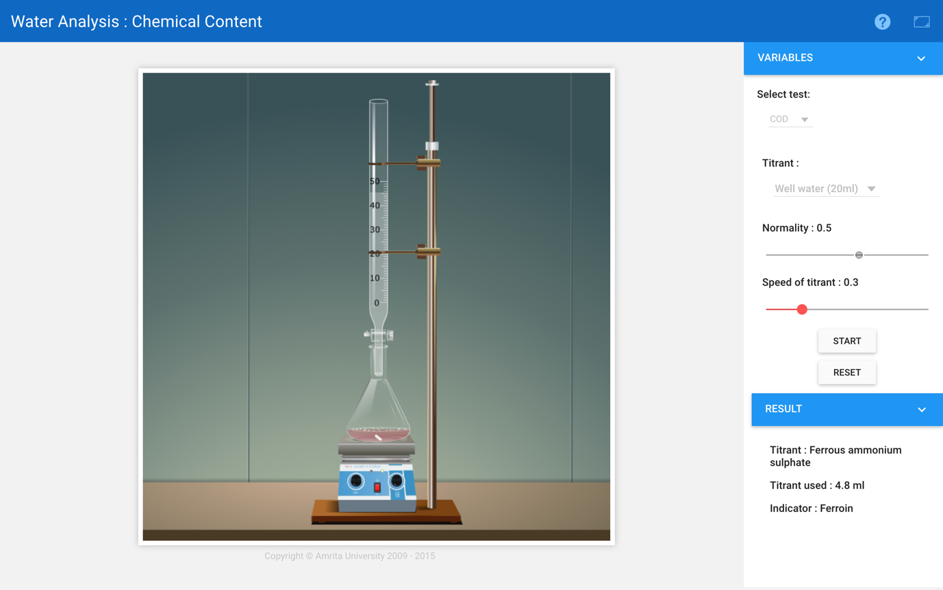

Burette : 0.5 N FAS solution

Conical flask : 20 mL of Well Water + Indicator

Indicator : Ferroin

End point : Blue to Wine red

Reaction:

CxHyOz + (X + Y/4 – Z/2) O2 → XCO2 + Y/2H2O

Cr2O7-2 + 14H+ + 6e-_ → 2Cr+3 + 7H2O

[Fe+2 → Fe+3 + e-] x 6

Cr2O7-2 + 14H+ + 6Fe+2 → 2Cr+3 + 6Fe+3 + 7H2O

# Pilot Reading : 4.0 (mL) to 5.0 (mL)

|  |  |  |  |  |
| --- | --- | --- | --- | --- |
| Reading | I (mL) | II (mL) | III (mL) | Constant (mL) |
| Initial | 0.0 | 0.0 | 0.0 | 4.8  V3 |
| Final | 4.8 | 4.8 | 4.8 |
| Difference | 4.8 | 4.8 | 4.8 |

**Part-4: Domesticated Water**

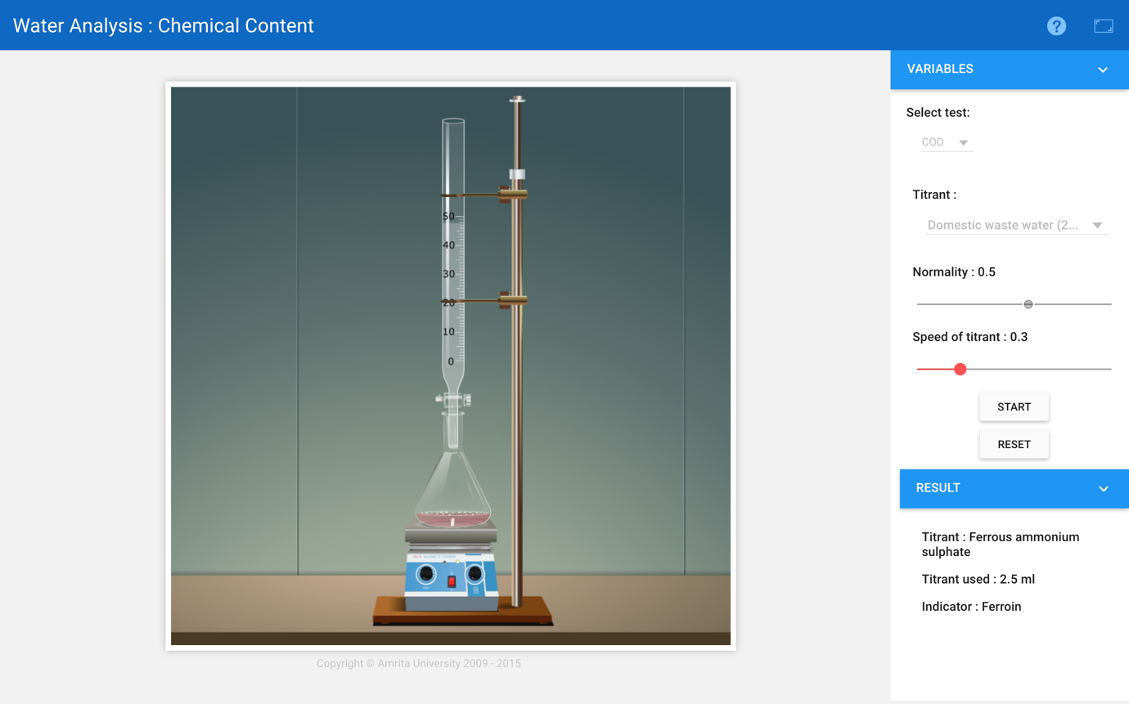

Burette : 0.5 N FAS solution

Conical flask : 20 mL of Domestic Waste Water + Indicator

Indicator : Ferroin

End point : Blue to Wine red

Reaction:

CxHyOz + (X + Y/4 – Z/2) O2 → XCO2 + Y/2H2O

Cr2O7-2 + 14H+ + 6e-_ → 2Cr+3 + 7H2O

[Fe+2 → Fe+3 + e-] x 6

Cr2O7-2 + 14H+ + 6Fe+2 → 2Cr+3 + 6Fe+3 + 7H2O

# Pilot Reading : 2.0 (mL) to 3.0(mL)

|  |  |  |  |  |
| --- | --- | --- | --- | --- |
| Reading | I (mL) | II (mL) | III (mL) | Constant (mL) |
| Initial | 0.0 | 0.0 | 0.0 | 2.5  V4 |
| Final | 2.5 | 2.5 | 2.5 |
| Difference | 2.5 | 2.5 | 2.5 |

**Calculation:**

**Formula:**

COD (ppm)= Vol. of FAS x Normality of FAS x 8000

Vol. of Sample (ml)

**Part-1: Tap water**

Vol of FAS= 5ml - 4.9ml = 0.1 ml

Therefore,

COD =

COD = 20 ppm

**Part-2: Well water**

Vol of FAS= 5ml - 2.5ml = 0.2 ml

Therefore,

COD =

COD = 40 ppm

**Part-3: Domestic Waste water**

Vol of FAS= 5ml - 2.5ml = 2.5 ml

Therefore,

COD =

COD = 500 ppm

**Result:**

1. The COD of tap water= 20 ppm.
2. The COD of well water= 40 ppm.
3. The COD of domesticated water = 500 ppm.

**Conclusion:**

The COD of Well Water is 40.0 ppm , Tap Water is 20.0 ppm and Domesticated Water is 500.0 ppm is observed.