**CO3: Identify and compare the material best suited for the energy production in sustainable and efficient manner.**

**Name: Pargat Singh**

**Batch: A2**

**Roll No. : 16010121045**

**Date: 15/12/2021**

**Experiment No. 8**

**Title: To determine the available nitrogen in the soil sample by Kjeldahl Method.**

**Aim:**

To determine the available nitrogen in the soil sample by Kjeldahl Method.

**Theory:**

## Introduction:

A soil analysis is a process by which elements such as P, K, Ca, Mg, Na, S, Mn, Cu and Zn are chemically extracted from the soil and measured for their “plant available” content within the 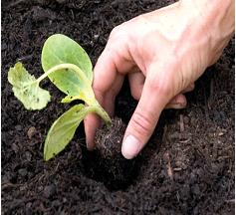soil sample.

### **Significance of Soil Analysis:**

* It increases the knowledge of what nutrients are especially available in our soil.
* It reduces the environmental impacts due to soil amendments.
* It increases the efficiency of resource inputs such as fertilisers and water.
* It helps to predict the nutritional values needed for crop production.
* It helps to evaluate the fertility status of soils of a country or a state or a district.

### **Procedure for Taking Good Soil Samples:**

* Determine the soil unit (or plot).
* Make a traverse over the soil unit (or plot).
* Clean the site (with spade) from where soil sample is to be collected.
* Insert the spade into soil.
* Standing on the opposite side, again insert the spade into soil.
* A lump of soil is removed.
* A pit of ‘V’ shape is formed. Its depth should be 0-6" or 0-9" or 0-12" (i.e., Depth of tillage).
* Take out the soil-slice (like a bread slice) of ½ inch thick from both the exposed surface of the pit from top to bottom. This slice is also termed furrow-slice. To collect the soil-slice spade may be used. Collect the soil samples in a polyethylene bucket.
* Collect furrow-slices from 8-10 or sometimes 20-30 sites. Select the sites at random in a zigzag (or criss-cross) manner. Distribute the sites throughout the entire soil unit (plot). In lieu of spade auger may be used. Do not take the prohibited samples and local problem soils.
* Furnish the following information in two sheets of thick paper with the sample. One sheet is folded and kept inside the bag. Another sheet is folded and attached to the bag.

## Available Nitrogen Content in Soil:

Nitrogen is one of the major elements required for life. It will stimulate above ground growth, and produces the rich green colour that is the characteristic of healthy plants, because of this Nitrogen is essential for plant life. 78% of the atmosphere is covered by molecular Nitrogen (N2); this form of Nitrogen cannot be used by animals. This molecular Nitrogen must first combine with Oxygen or Hydrogen to produce compounds such as Ammonia or Nitrate, or some other organic form of Nitrogen. This is called Nitrogen Fixation. Some Nitrogen Fixation occurs by lightning and some other by blue green algae. However, the bulk of Nitrogen Fixation is preferred by bacteria living in the soil. Some of the Nitrogen Fixation bacteria were living free in the soil, while the others were living within the root nodules of some plants such as soya bean, peanut, beans, clover, alfalfa, etc. Because of Ammonia or Ammonium is produced by the decomposition process, the decomposition of materials in the forest is also a source of Nitrogen. The movement of Nitrogen from the atmosphere into inorganic forms, followed by the incorporation of Nitrogen into plant matter is represented as the **Nitrogen Cycle**, which is shown in the figure given below.

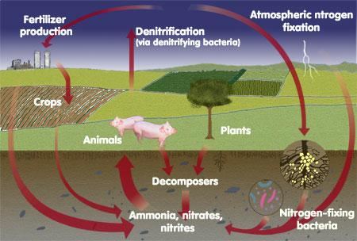

The rate of plant growth is proportional to the rate of nitrogen supply. If the soil is deficient in Nitrogen, the plants become stunted and pale. However, an excess of Nitrogen can damage the plants just as over-fertilizing the lawn can burn and damage the grass.

### **Apparatus:**

Kjeldahl Digestion Assembly, Ammonia Distillation Assembly.

### **Principle:**

The Kjeldahl method permits the available nitrogen to be precisely determined in the plant and in the soil. The method of determination involves three successive phases which are,

1. Digestion of the organic material to convert nitrogen into HNO3.
2. Distillation of the released Ammonia into an absorbing surface or medium.
3. Volumetric analysis of the Ammonia formed during the digestion process.

### **Digestion:**

Digestion of the organic material is carried out by digesting the sample with Con. H2SO4 in the presence of CuSO4.H2O as a catalyst and K2SO4 which raise the digestion temperature. The organic material decomposes into several components i.e.,

C → CO2, O → H2O and N → NH3

In the organic matter, some nitrates are present, most of which are lost during the digestion. The loss may be disregarded for most soils. Since the amount of NO3- - N is far lesser than the Organic Nitrogen.

2 C6H3 (OH) NH2COO + 26 H2SO4 → (NH4) 2SO4 + 25 SO2 + 14 CO2 + 28H2O

### **Distillation:**

The Ammonia content of the digest is determined by distillation with excess NaOH and absorption of the evolved NH3 is in standard HCl.

(NH4)2SO4 + 2 NaOH → Na2SO4 + 2 NH3 + 2 H2O

NH3 +HCl → NH4Cl

### **Volumetric Analysis:**

The excess of standard HCl is titrated against standard NaOH using Methyl Red as an indicator. The decrease in the multi equivalence of acid as determined by acid-base titration, which gives a measure of the N content of the sample. The end point is determined by a change of colour from pink to yellow.

2 HCl + 2 NaOH → 2 NaCl + H2O

### **Significance:**

The chemical analysis of the soil for nitrogen is less precise when the requirement for this element needs to be forecast over a longer period of time, as they vary not only with species, but with the phase of growth and season as well. Therefore the chemical test for NO3- and NH4+ signifies the momentary status when the sample is taken and measures must be taken instantaneously. The analysis of the extractable Nitrogen content of the soil using a given extractable method.

In reaction to crop response study provides a basis of Nitrogen fertility levels, which will rationalize the use efficiency of Nitrogen fertilizer content of the soil are also needed for the evaluation of C-N ratios of soils which give an indication of the process of transformation of organic Nitrogen to available Nitrogen like ammoniated nitrate Nitrogen.

**Procedure:**

## Determination of Available Nitrogen Content in Soil:

* Weigh 50 g of processed soil sample in 500 mL Kjeldahl flask.
* Add 1 g CuSO4, 10 g K2SO4 and 30 mL Con. H2SO4.
* Shake the contents of the flask until through mixing and allowing to stand for at least 30 minutes with frequent shaking or until complete solution results.
* Digest the content until greenish colour appears. K2SO4 raises the boiling point of the acid. So that the loss of acid volatile solution is prevented. CuSO4 5H2O is digestion accelerator which catalyses the speed of digestion process.
* The reagents sometimes contain impurities so run a blank with the same quantities of reagents and subtract the blank value from the value of the soil digest.
* Digestion is effected on the Kjeldahl digestion rack with low flame for the first 10 – 30 min until the frothing stops and then gradually more strongly until the sample is completely charred. The heat is gradually raised until the acid reaches approximately one third the way up the digestion-flask. The flame is not allowed to touch the flask above the part occurred by the liquid. Excessive boiling may cause volatilization of the acid before the organic matter is oxidized.
* Cool the content and dilute to about 100 mL with distilled water. Swirl the flask for about 2 minutes and transfer the fluid part to a 1000 mL distillation flask.
* Wash the residue left in the Kjeldahl flask with 4 or 5 lots of 50 – 60 mL distilled water, decanting the washings into the distillation flask.
* Add a few, glass bead to prevent bumping.
* Fit the flask with two neck joints to one neck dropping funnel is connected for adding 40 % NaOH while to the other neck Kjeldahl trap, which is used to trap the NaOH coming with the distillate. The trap is connected to the condenser with a delivery tube which dips into 50 mL of 0.1 N HCl contained in a conical flask, with one or two drops of methyl red indicator.
* Add about 125 mL (or 100 ml if bumping is a problem) of 40 % NaOH solution till the content are alkaline in reaction (about 5 times the volume of Con. H2SO4 used during the digestion). Heat the RB flask.
* Allow the ammonia formed to be absorbed in standard HCl. Wash down the end of the tube. 150 mL distilled water is added to the conical flask. When no more ammonia is received (test with a red litmus paper turning blue) stop the distillation.
* Titrate the excess of the acid with 0.1 N NaOH solution till the pink colour changes to yellow.
* From the titre value calculate the multi equivalence of the acid participating in the process of ammonia absorbing during digestion.

**a) Calculation:**

**i. Blank:**

Volume of HCl taken for blank = a mL

Volume of NaOH used = b mL

Volume of HCl consumed by liberated NH3 present in blank = a – b = z mL

**ii. Sample:**

Volume of HCl taken for sample = v mL

Volume of NaOH used = u mL

Volume of HCl consumed by liberated NH3 present in sample = v – u = w mL

Volume of HCl consumed for NH3 liberated by sample only = w – z = y mL

1000 mL 1N HCl = 1000 mL 1 N NH3 = 17 g NH3 = 14 g N

1 mL 1N HCl = 1 mL 1 N NH3 = 0.014 g N

1 mL 0.1 N HCl = 1 mL 0.1 N NH3 = 0.0014 g N

Weight of Nitrogen in 5 g of Sample = y x 0.0014 g N = q g N

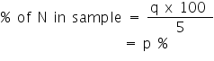

## 

## Points to Remember while Performing the Experiment in a Real Laboratory:

1. Always wear lab coat and gloves when you are in the lab. When you enter the lab, switch on the exhaust fan and make sure that all the chemicals and reagents required for the experiment are available. If it is not available, prepare the reagents using the components for reagent preparation.
2. Properly adjust the flame of the Bunsen burner. The proper flame is a small blue cone; it is not a large plume, nor is it orange.
3. Make sure to clean all your working apparatus with chromic acid and distilled water and ensure that all the apparatus are free from water droplets while performing the experiment.
4. Make sure to calibrate the electronic weigh balance before taking the measurements.
5. Ensure that the desiccator  has sufficient amount of desiccant; Silica gel
6. Use chromic acid to clean the crucible, then heat it and make sure to cool it and before placing in the desiccators. Ensure that you are handling the crucible, with cleaned tongs or with tissue paper .Never touch it with your hand.
7. Switch on the oven and adjust the temperature to 1300 C. Make sure to use a cotton glove while working with a hot air oven.
8. Make sure to clean the Kipp's apparatus tube with water and ensure that it has sufficient solid material; iron sulfinide and acid, H2SO4for producing H2S gas.
9. Clean all glass wares with soap and distilled water. Once the experiment completed recap the reagent bottles. Switch off the light, exhaust fan, hot air oven and Gas cylinder before leaving the lab.
10. Discard the used gloves in a waste bin.

# **Self-Evaluation:**

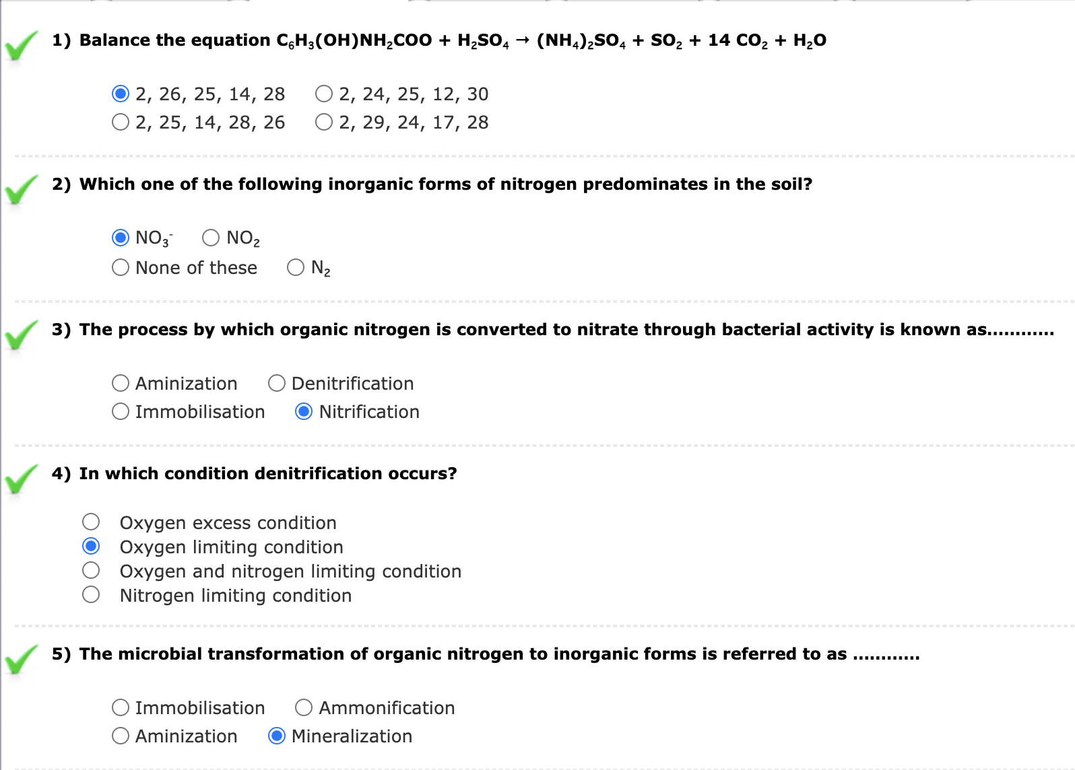

**Assignments:**

1. **Discuss the method of determination of nitrate by selective ion electrode.**

An ion-selective electrode was used to determine nitrate in vegetables after extraction with 0.01 M CuS04. The method proved to be sufficiently accurate and precise for assay of carrot, wild endive, chicory, spinach, parsley, and celery. The use of 2 M (NH4)2SO4 as an ionic strength adjustor was found to be unnecessary. The mean of recoveries was 104% and within sample the coefficients of variation ranged from 2.2 to 6.7%. Results obtained from different samples collected in the Veneto region of Italy indicated that nitrate content of vegetables is relatively low in the area. Nitrate content of vegetables decreased significantly after cooking.

1. **What form of nitrogen in the soil is determined by Kjeldahl method?**

Nitrogen determination has a long history in the area of analytical chemistry. Johan Kjeldahl first introduced the **Kjeldahl method** in 1883 at a meeting of the Danish Chemical Society.Johan Kjeldahl, at that time Carlsberg laboratory manager, was assigned to scientifically observe the processes involved in beer production.  
While studying proteins during malt production, he developed a method of determining **nitrogen content** that was faster and more accurate than any method available at the time. The Kjeldahl analysis is extremely versatile, as it can handle a very wide range of samples from food & feed (grain, meat, fish, milk, dairy, fruit, vegetables), beverages, environmental (agriculture, oilseeds, soil, fertilizers, water, wastewater, sludge) to chemical and pharmaceutical industries (paper, textiles, rubber, plastic, polymer).

1. **Why nitrogen is essential in the soil? Discuss about its deficiency symptons.**

Nitrogen also governs the utilization of phosphorus, potassium and other essential elements. It is a very mobile element. Nitrogen deficiency causes **drastic reduction in vegetative growth**. It causes poor root growth and young plants give spindly appearance. As the soil fertility page explains, nitrogen is really important for plant growth (structure), plant food processing (metabolism), and the creation of chlorophyll. Without enough nitrogen in the plant, the plant cannot grow taller, or produce enough food (usually yellow). But too much nitrogen is just as dangerous.Nitrogen deficiency in plants can occur when organic matter with high carbon content, such as sawdust, is added to soil. Nitrogen deficiency can be prevented in the short term by using grass mowing as a much, or foliar feeding with manure, and in the longer term by building up levels of organic matter in the soil.

1. **How we can determine the organic plus ammonium nitrogen from soil? Explain.**

Nitrogen loss from cropping systems has interested [agronomists](https://www.sciencedirect.com/topics/agricultural-and-biological-sciences/agronomists) since the early recognition by Liebig and others that most crops are nitrogen limited. The widespread early adoption of crop rotations that include legumes provides historical acknowledgment of the importance of nitrogen gains and losses to cropping system success. It is now recognized that even in [semiarid regions](https://www.sciencedirect.com/topics/earth-and-planetary-sciences/semiarid-region) nitrogen is usually the principal resource limiting crop production. There is also an off-farm, environmental cost to fertilizer use, however, and the emerging recognition of this cost has renewed interest in finding ways to minimize nitrogen loss from fertilized cropping systems. Moreover, in some developing regions where fertilizer remains unavailable because of economic constraints, and elsewhere where there is interest in reducing farm chemical use , the conservation of endogenous nitrogen remains an important management goal. Regardless of the magnitude of fertilizer use, the effective containment of cropping system nitrogen requires a greater nitrogen use efficiency at the ecosystem scale. This is a difficult management goal despite decades of research that have provided substantial insights into process-level details of the nitrogen cycle in many different types of ecosystems.

1. **Discuss about the method determination of potentially active nitrogen in the soil.**

All of the active N in surface soils is present in the form of organic compounds that cannot be used directly by plants and also are not susceptible to loss through leaching. The amount of N converted from organic to mineral forms (mineralization) on an annual basis varies, depending on the past management history, annual climatic variation and inherent soil properties. This capacity of the soil to supply plant-available N is an important indicator of soil quality and many chemical and biological methods have been developed in an effort to provide a simple, reliable indicator of potentially mineralizable N the use of N mineralization potential as an indicator of soil quality and the advantages and disadvantages of the various methods available. We then recommend and describe two biologically-based laboratory methods of determining N mineralization potential.

**Observation:**

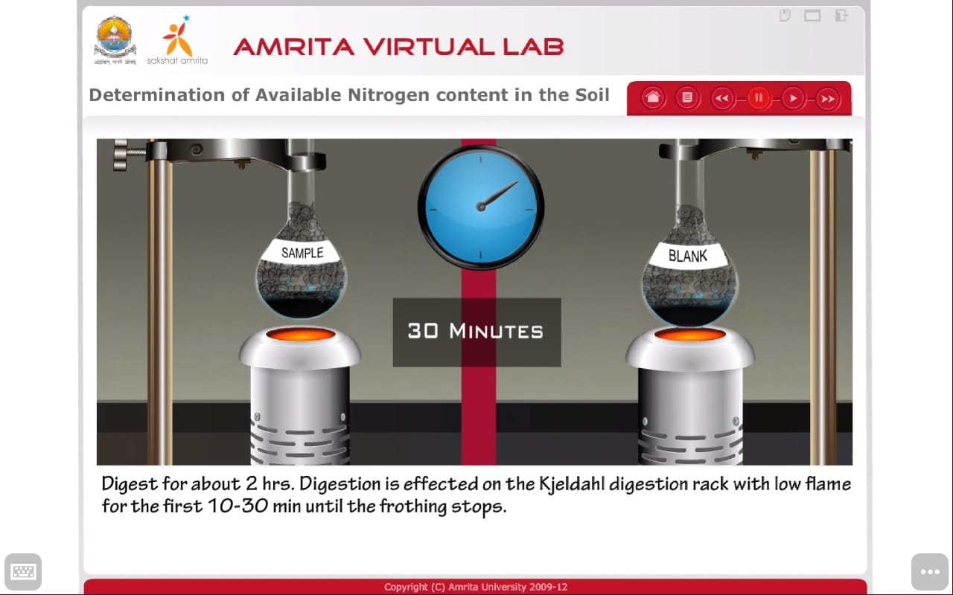

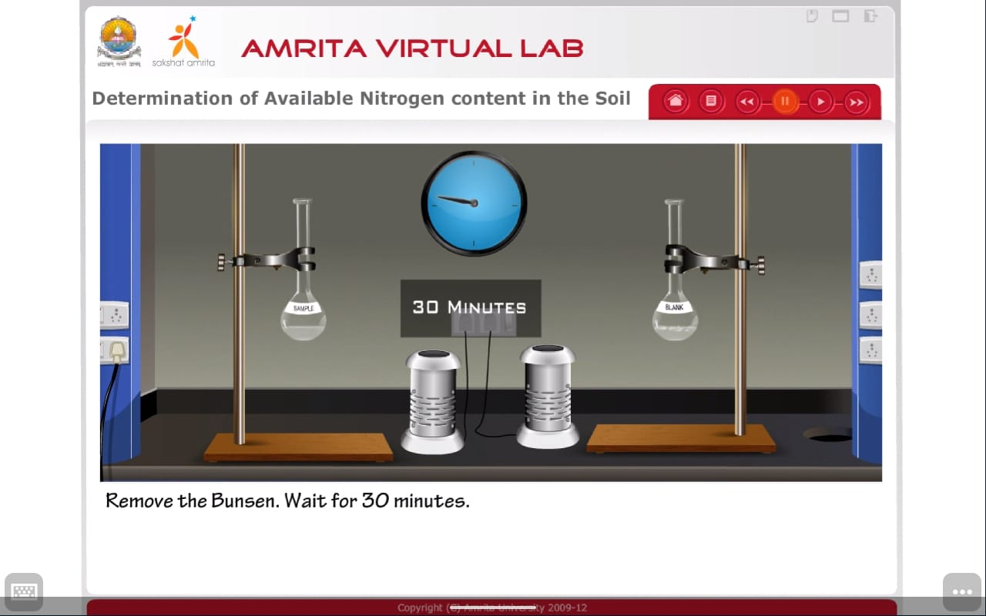

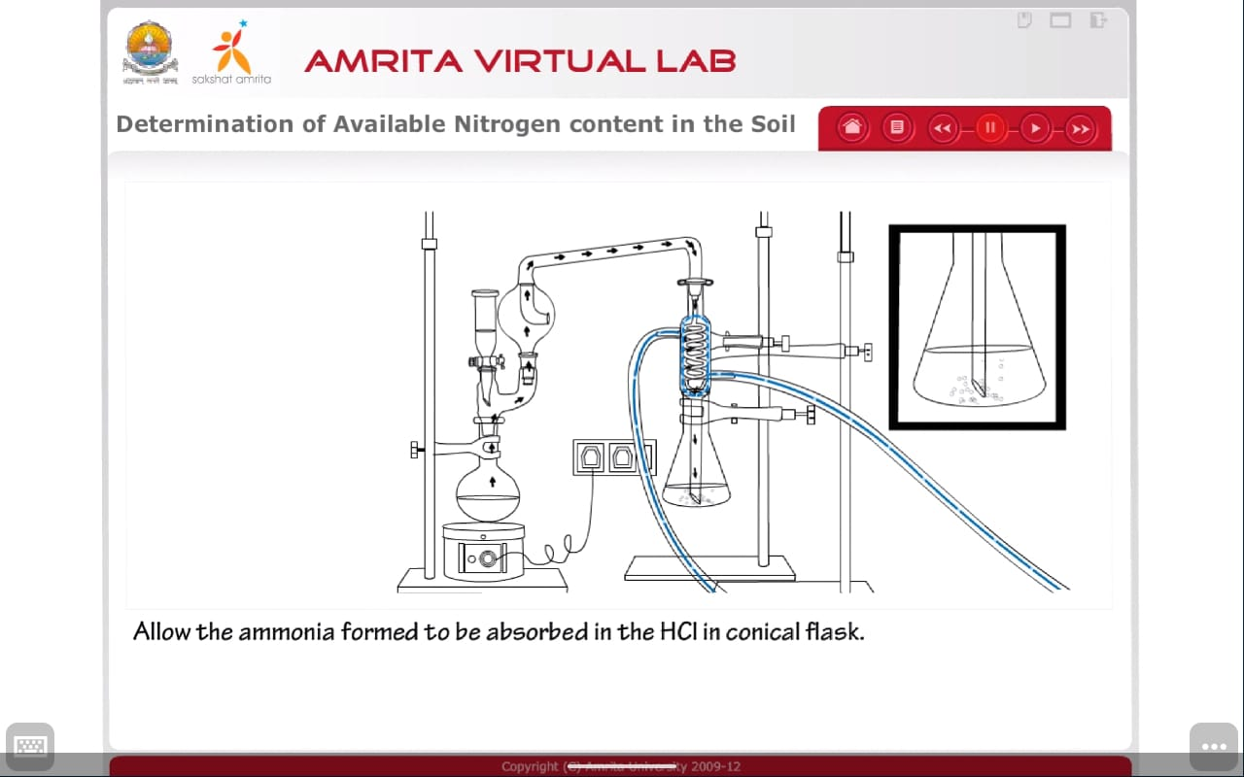

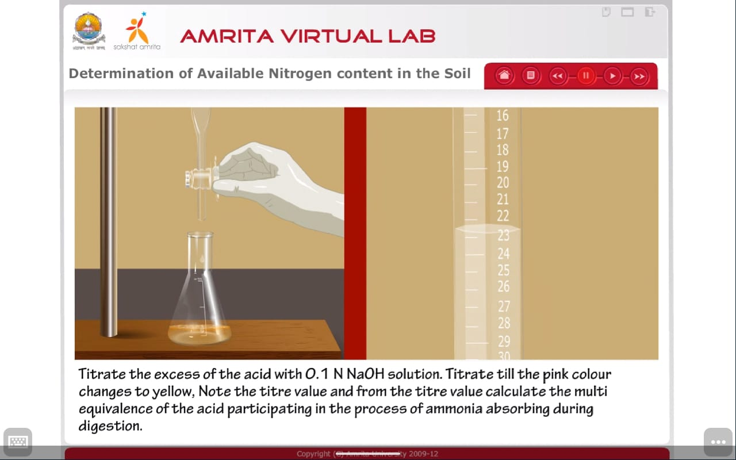

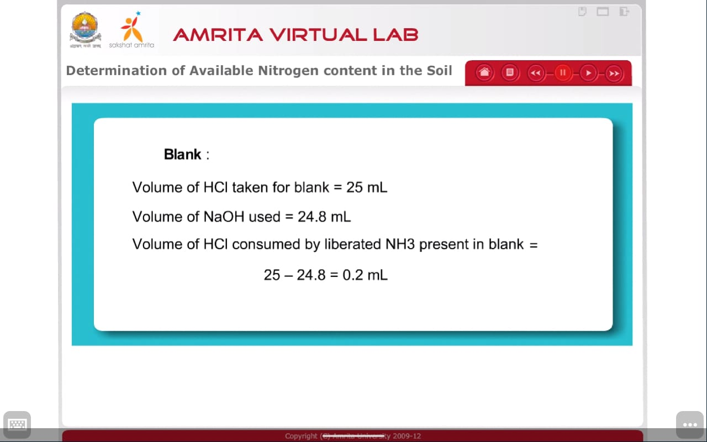

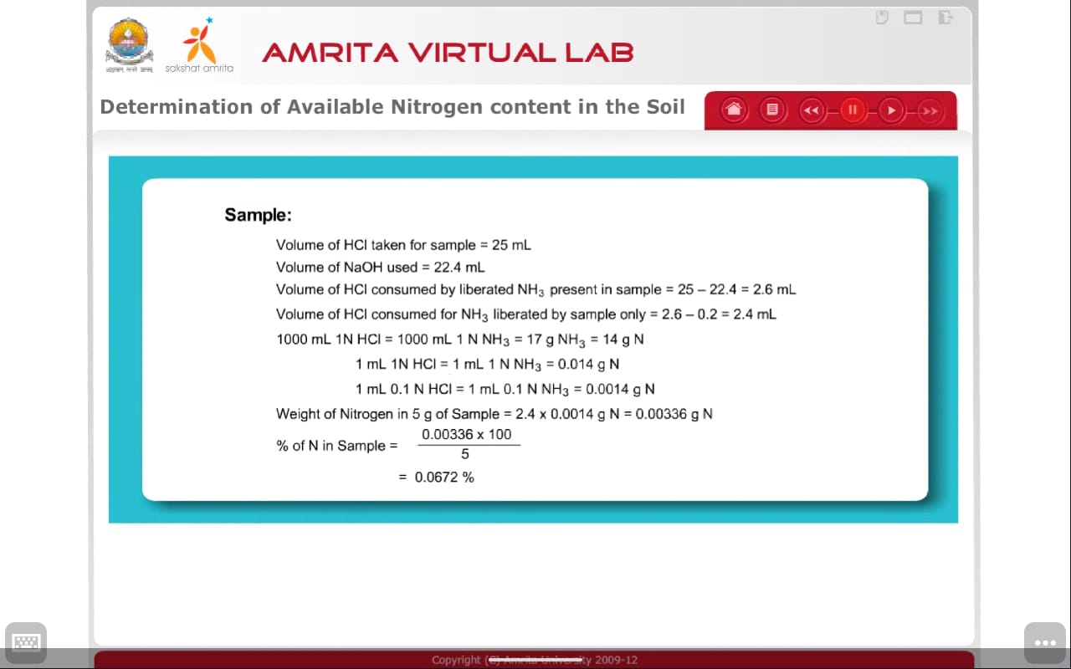

**Conclusion**

Hence we can conclude the availability of nitrogen in the soil sample by Kjeldahl Method.