**Batch: A1 Roll No.: 16010121045**

**Experiment / assignment / tutorial No**

**Grade: AA / AB / BB / BC / CC / CD /DD**

**Signature of the Staff In-charge with date**

|  |
| --- |
| **TITLE :** Follow design process for designing a B2C application. |

**AIM :** To implement different stages of Design Thinking.

**___________________________________________________________**

**Expected OUTCOME of Experiment:**

**CO 3**: Apply the concepts of Design thinking for development of product/ service.

**_____________________________________________________________________**

**Books/ Journals/ Websites referred:**

1 “Design Thinking”, Gavin Ambrose Design Paul Harris

**_____________________________________________________________________**

**Theory:**

* The design process engages a high degree of creativity but in a way that is controlled and directed by the process so that it is channeled towards producing a viable, practical solution to the design problem, meeting or excelling the stated aims of the brief.
* While creativity in design is important, design is an activity that serves economic as well as creative goals.
* Within the design process, seven steps can be identified:
  + Define
  + Research
  + Ideate
  + Prototype
  + Select
  + Implement
  + And learn
* First, the design problem and the target audience needs to be defined.
* The research stage reviews information such as the history of the design problem, end-user research and opinion-led interviews, and identifies potential obstacles.
* Ideate is the stage where end-user motivations and needs are identified and ideas are generated to meet these, perhaps through brainstorming.
* Prototyping sees the resolve or working-up of these ideas, which are presented for user-group and stakeholder review, prior to being presented to the client.
* Selection sees the proposed solutions reviewed against the design brief objective. Some solutions might be practical but may not be the best ones.
* Implementation sees design development and its final delivery to the client.
* Learning helps designers improve their performance and, for this reason, designers should seek client and target audience feedback and determine if the solution met the goals of the brief.

**Title of Application:** Zomato - Food Delivery and Restaurant Discovery Platform

**Abstract of Application:** Zomato is a B2C application that connects consumers with restaurants, offering food delivery services, restaurant discovery, and user reviews. It aims to simplify the process of finding and ordering food from local restaurants while providing a platform for users to share their dining experiences.

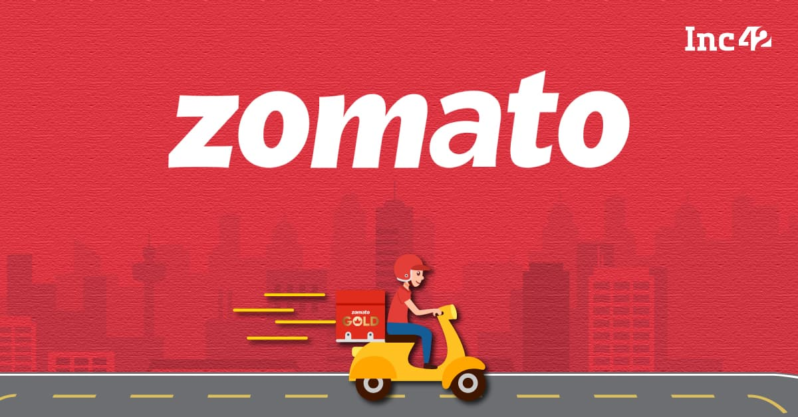

**Explanation of the Application wrt following stages of Design Process:**

1. **Define - Objectives**

The primary objective of Zomato is to transform the food industry by making food discovery and delivery more convenient, reliable, and enjoyable for consumers while providing restaurants with a robust platform to reach and engage with customers digitally. The platform seeks to address the needs of modern consumers who desire quick access to a variety of dining options and seamless ordering experiences.

Key Objectives:

* Develop an Intuitive and User-Friendly Interface: Ensure that users can effortlessly navigate the platform, search for restaurants, and place orders with minimal steps.
* Provide Reliable Restaurant Information: Offer detailed menus, high-quality photos, verified user reviews, and ratings to help customers make informed dining decisions.
* Ensure Fast Food Delivery: Establish efficient logistics to minimize delivery times, maintain food quality, and provide real-time tracking of orders.
* Build Trust: Maintain high service standards, ensure data privacy, and foster transparency in pricing, reviews, and delivery processes.
* Enhance Customer Engagement and Loyalty: Implement personalized recommendations, loyalty programs, and exclusive promotions to increase customer retention.
* Support Restaurant Partners: Provide tools and analytics for restaurants to manage orders, optimize menus, and understand customer preferences.

1. **Research - Collecting background information.**

In the research phase, Zomato conducts an extensive analysis to understand market dynamics, consumer behavior, technological trends, and the competitive landscape. This research informs the platform’s development strategy and feature set.

Market Analysis:

* Global and Local Market Trends: Study the growth of online food delivery markets, consumer demographics, and potential areas for expansion.
* Consumer Behavior Studies: Analyze how customers search for food options, factors influencing their choices, and expectations from an online food platform.
* Pain Point Identification: Identify common issues such as long delivery times, limited payment options, and concerns about food quality.
* Technological Trends: Explore advancements in mobile technology, payment systems, AI, and data analytics.

Barriers:

* Intense Competition: Established players like Swiggy, Uber Eats, and new entrants intensifying market competition.
* Operational Challenges: Ensuring timely deliveries while maintaining food quality.
* Cost Management: Balancing competitive pricing with sustainable profit margins.
* Regulatory Compliance: Navigating different food safety regulations and legal requirements.

Competitive Analysis:

* Evaluate competitors’ strengths and weaknesses.
* Understand their business models, market strategies, and customer feedback.

User Feedback:

* Conduct surveys and focus groups to gather direct insights.
* Identify user needs and expectations for innovation opportunities.

Ideate – Creating Potential Solutions

Based on research insights, Zomato brainstorms innovative solutions to meet user needs and overcome identified challenges.

1. **Ideate – creating Potential Solutions**

Brainstorming potential solutions to meet user needs and solve challenges identified during research:

* Improve delivery speed and tracking: Real-time order tracking with estimated delivery times.
* Personalized recommendations: Machine learning algorithms to suggest restaurants based on user preferences.
* Enhanced customer service: 24/7 customer support for any issues or queries.
* Loyalty programs: Reward users for frequent orders to increase customer retention.

1. **Prototype – Resolving Solutions**

Zomato would develop a prototype of the app with basic functionality:

* A homepage featuring restaurant listings based on user location.
* An order placement flow where users can select a restaurant, browse the menu, and place an order.
* A delivery tracking interface where users can see the status of their order in real-time.

Here is the flow Diagram of the product:

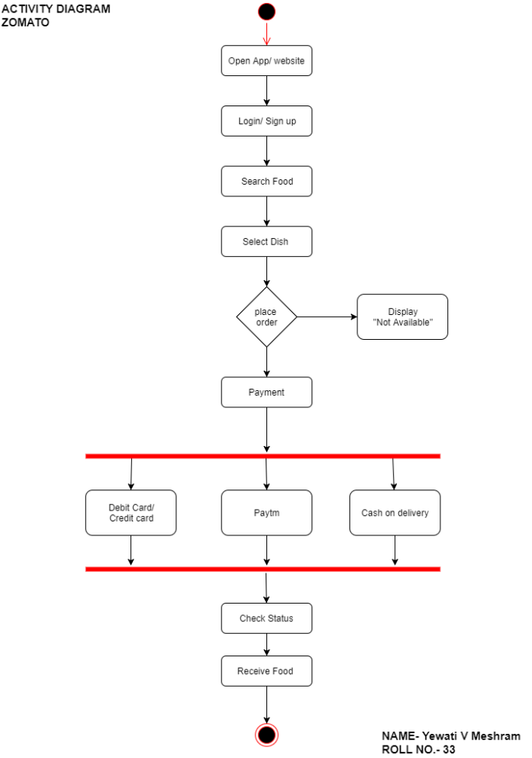

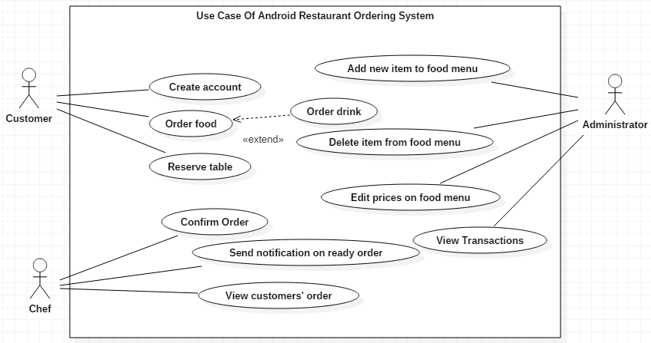

1. **Select – Making Choices**

After reviewing user feedback on the prototypes, Zomato would decide on the best features and interface designs that meet user expectations. Key decisions could include:

* Choosing the most user-friendly UI for browsing restaurants.
* Prioritizing features like delivery tracking, reviews, and recommendations based on user demand.
* Dropping features that didn’t resonate well with users or that increased complexity.

1. **Implement – Delivering the solutions**

At this stage, Zomato would finalize the development of the platform and launch the application for its users. This would involve:

* Developing the backend systems for order management and delivery coordination.
* Scaling the app to handle high volumes of users and restaurant partners.
* Integrating payment gateways for smooth transactions.
* Partnering with restaurants and delivery services to ensure coverage.

Zomato would also run marketing campaigns to promote the app and attract new users and restaurant partners.

1. **Learn - Obtain Feedback**

Potential stakeholders for feedback:

* End users (food orderers)
* Restaurant owners and managers
* Delivery partners
* Food critics and bloggers

**Questionnaire to take feedback:**

**For Users:**

1. How easy is it to find and order from your preferred restaurants?
2. How would you rate the accuracy and helpfulness of user reviews?
3. What additional features would improve your experience with Zomato?
4. How satisfied are you with the order tracking and delivery process?
5. How likely are you to recommend Zomato to friends and family?

**For Restaurant Partners:**

1. How has partnering with Zomato impacted your business?
2. How user-friendly is the restaurant dashboard for managing orders and information?
3. What additional tools or features would help you better serve customers through Zomato?
4. How satisfied are you with the support provided by Zomato?
5. How fair do you find Zomato's commission structure and policies?

**For Delivery Partners:**

1. How intuitive is the delivery app to use during your shifts?
2. What challenges do you face during the delivery process?
3. How can Zomato improve the routing and order assignment system?
4. How satisfied are you with the earnings and incentive structure?
5. What additional support or features would help you perform your job better?

**Post Lab Descriptive Questions**

1. **Describe the Research stage in detail with respect to drivers and barriers.**

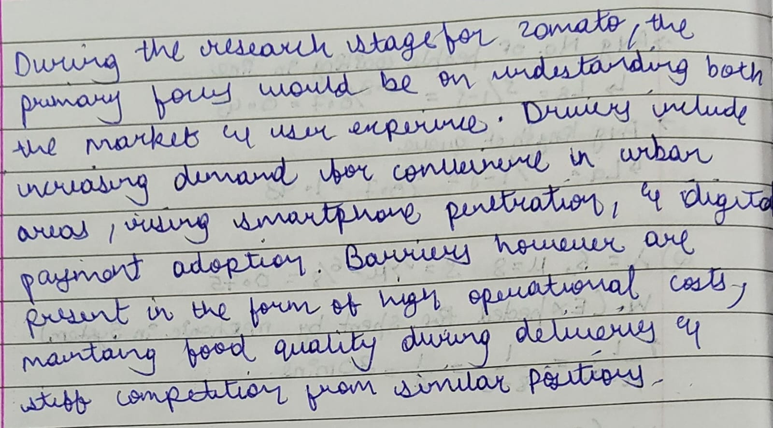

**Date: _____________ Signature of faculty in-charge**