**Batch: A1 Roll No.: 16010121045**

**Experiment / assignment / tutorial No**

**Grade: AA / AB / BB / BC / CC / CD /DD**

**Signature of the Staff In-charge with date**

|  |
| --- |
| **TITLE :** Designing B2C application’s interface |

**AIM :** To design B2C application’s interface.

**___________________________________________________________**

**Expected OUTCOME of Experiment:**

**CO 4**: Refinement, Prototyping, Implementation of product/ service. **_____________________________________________________________________**

**Books/ Journals/ Websites referred:**

1 “Design Thinking”, Gavin Ambrose Design Paul Harris

**_____________________________________________________________________**

**Theory:**

* The design process engages a high degree of creativity but in a way that is controlled and directed by the process so that it is channeled towards producing a viable, practical solution to the design problem, meeting or excelling the stated aims of the brief.
* While creativity in design is important, design is an activity that serves economic as well as creative goals.
* Within the design process, seven steps can be identified:
  + Define
  + Research
  + Ideate
  + Prototype
  + Select
  + Implement
  + And learn
* First, the design problem and the target audience needs to be defined.
* The research stage reviews information such as the history of the design problem, end-user research and opinion-led interviews, and identifies potential obstacles.
* Ideate is the stage where end-user motivations and needs are identified and ideas are generated to meet these, perhaps through brainstorming.
* Prototyping sees the resolve or working-up of these ideas, which are presented for user-group and stakeholder review, prior to being presented to the client.
* Selection sees the proposed solutions reviewed against the design brief objective. Some solutions might be practical but may not be the best ones.
* Implementation sees design development and its final delivery to the client.
* Learning helps designers improve their performance and, for this reason, designers should seek client and target audience feedback and determine if the solution met the goals of the brief.

**Introduction to B2C application:**

A **B2C (Business-to-Consumer)** application connects businesses directly with individual customers, enabling streamlined communication, transactions, and services. In the digital banking sector, B2C apps are essential for providing end users with easy access to their accounts, financial products, and services through mobile or web interfaces.

The B2C application featured here is an example of a **banking app** for **HDFC Bank** that allows users to:

• **Access account information** such as balances and recent transactions.

• **Manage payments** for credit and debit cards.

• **Make UPI transactions** with QR code scanning for seamless money transfers.

• **View profile and contact details** for user personalization and data accuracy.

• **Download monthly statements** for savings accounts.

• **Handle bill payments** for credit cards.

B2C banking applications aim to simplify everyday financial tasks for customers while maintaining robust security features, such as **biometric login** and **password protection**, ensuring sensitive data is protected.

**Design of B2C application’s interface (coloured):**

The design focuses on simplicity, usability, and brand consistency. Each screen is crafted to meet the specific needs of the end user while maintaining a familiar and comfortable user experience

**Key Design Elements:**

1. **Splash Screen**:

* **Branding** is prominent with the HDFC logo, along with the tagline: “We understand your world.”
* **Minimal design** reinforces a clear, recognizable identity.\

1. **Login Screen**:

* **Biometric options** (Face ID) are highlighted for ease of access.
* A **numeric keypad** is used for PIN entry, promoting simplicity.
* The ability to switch between **password login** and biometric login enhances flexibility.

1. **Home Page**:

* Shows **account balances** at a glance, providing key information upfront.
* **Quick actions** like Funds Transfer, Payments, and more are easily accessible.
* The design ensures that **recent transactions** are displayed clearly with iconography representing each transaction type.

1. **Payments Screen**:

* Displays **credit and debit card** balances.
* Offers detailed card management with **outstanding amounts**, **rewards points**, and **bill payment options**.
* Clear hierarchy is maintained with **color differentiation** (red for pending payments and blue for RuPay card).

1. **UPI Screen**:

* Focuses on quick transactions with **QR code scanning** for instant payments.
* **Secure and efficient** transfer experience, in line with user expectations for mobile payments.

1. **Profile and Contact Details**:

* Displays personal and **contact information** in a clean and easy-to-navigate format.
* **Editable fields** like phone numbers and email addresses make updates seamless.

1. **Navigation Bar**:

* Consistent across all screens, with **icons** representing Home, Payments, UPI, and Profile, ensuring ease of navigation.
* The color scheme adheres to the bank’s **blue and white branding**, maintaining a professional look while ensuring good readability.

**Implementation:**

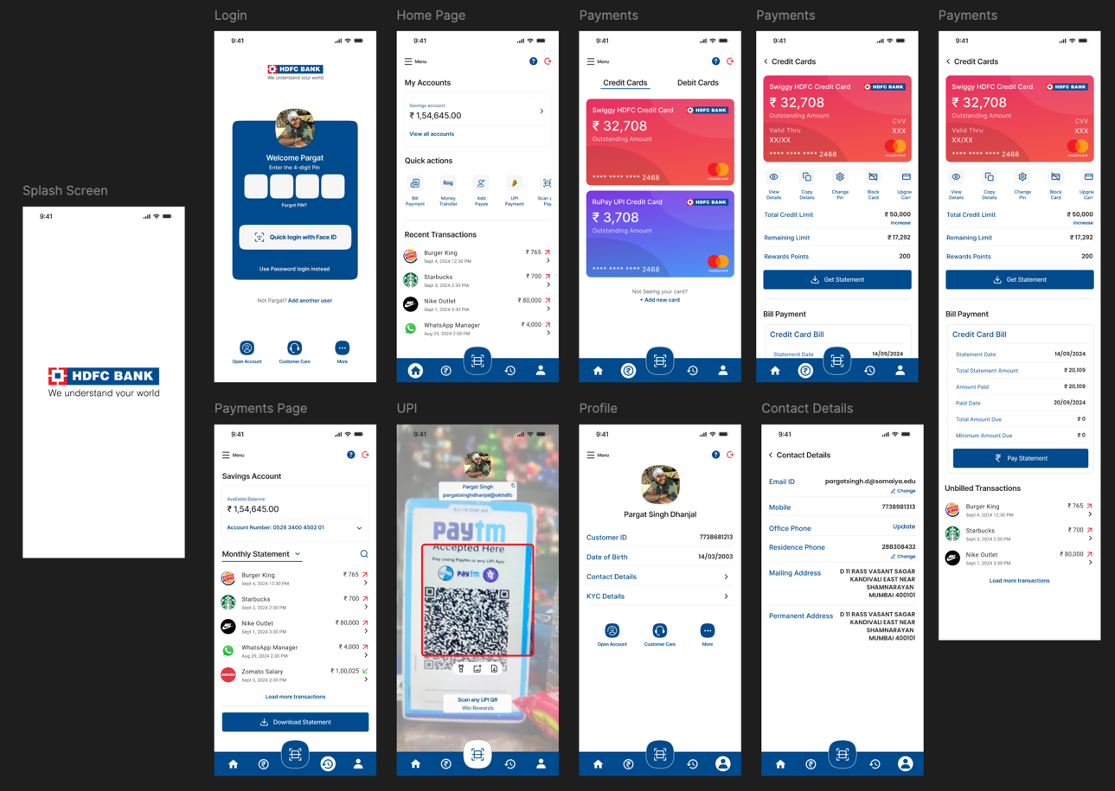

**Post Lab Descriptive Questions**

**1. Specify the role of design thinking principles.**

**Date: _____________ Signature of faculty in-charge**