**Batch: A1 Roll No.: 16010121045**

**Experiment / assignment / tutorial No**

**Grade: AA / AB / BB / BC / CC / CD /DD**

**Signature of the Staff In-charge with date**

|  |
| --- |
| **TITLE :** Refinement of the interface of B2C application. |

**AIM :** To implement refinement process for the interface of B2C application.

**___________________________________________________________**

**Expected OUTCOME of Experiment:**

**CO 4**: Refinement, Prototyping, Implementation of product/ service.

**_____________________________________________________________________**

**Books/ Journals/ Websites referred:**

1 “Design Thinking”, Gavin Ambrose Design Paul Harris

**_____________________________________________________________________**

**Theory:**

* Designing is an iterative process
* With every iteration; appearance, performance of the system may change
* Working up a design idea involves the continued refinement of the artwork and the message it communicates.
* Refinement sees small yet significant changes made to a design in order to enhance the idea and increase the effectiveness of its ability to communicate.
* Refinement can be done in :
  + Thinking in images and signs
  + Appropriation
  + Modification
  + Thinking in shapes and colours

**Implementation:**

**Abstract about B2C application:**

This mobile banking application, developed by HDFC Bank, is designed to provide customers with convenient access to their financial services. The app offers a comprehensive suite of features that allow users to manage their accounts, make payments, and access various banking services directly from their smartphones.

**Existing Interface: Low Fidelity**

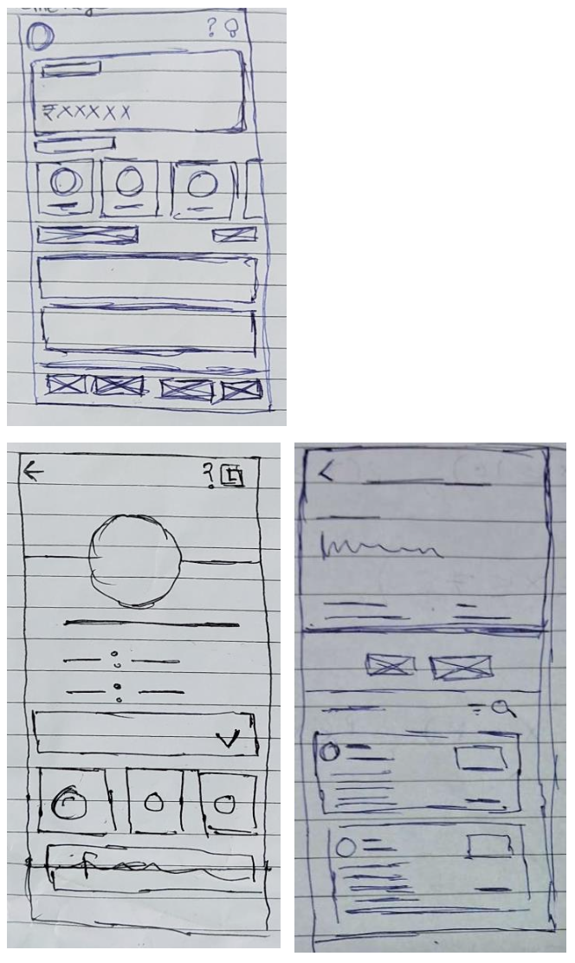

**Refinement with respect to:**

* + Thinking in images and signs
  + Appropriation
  + Modification
  + Thinking in shapes and colours

**Refined Interface:**

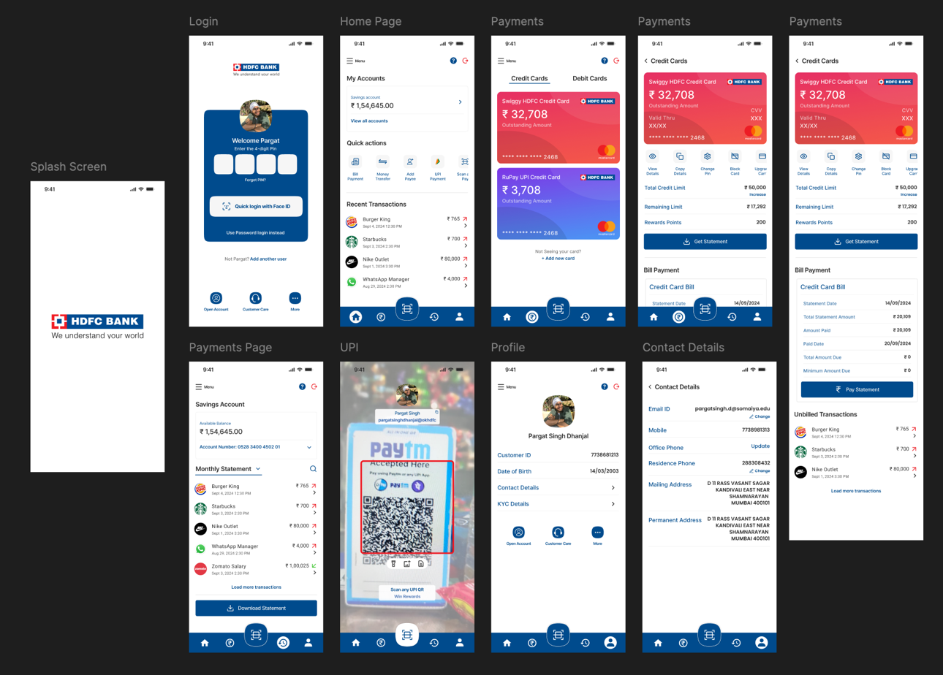

**Post Lab Descriptive Questions**

**1. Explain the concept of appropriation in Refinement.**

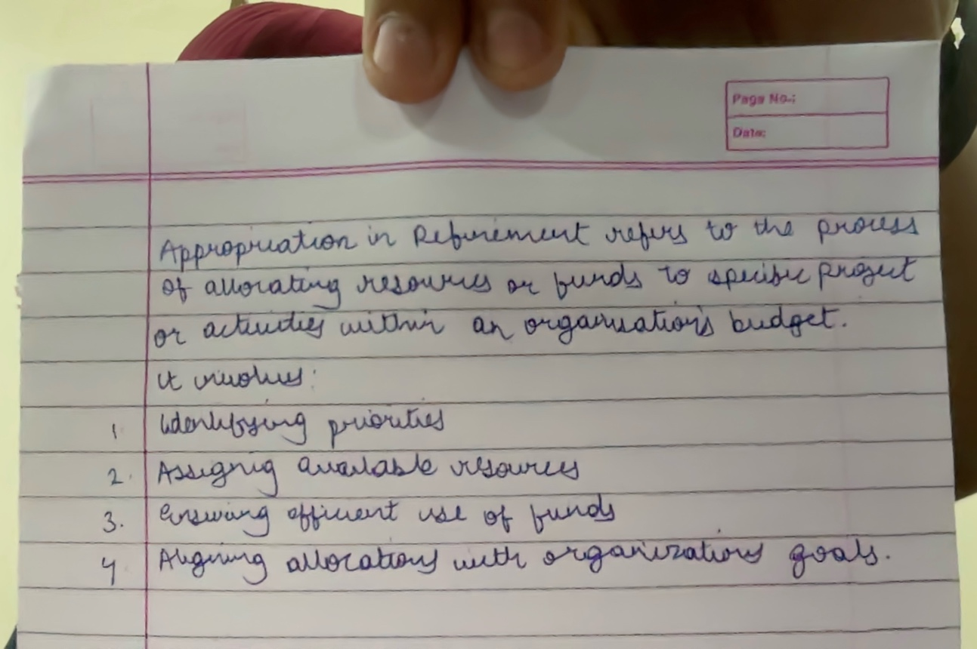

**Date: _____________ Signature of faculty in-charge**