

**Batch: Roll No.:**

**Experiment / assignment / tutorial No. 1**

**Grade: AA / AB / BB / BC / CC / CD /DD**

**Signature of the Staff In-charge with date**

|  |
| --- |
| **Title:** To understand the trouble of interacting with product/machines in day-to-day activity. |

**______________________________________________________________________Objective:** To understand and analyse the potential flaws in design of device/product/application under consideration.

**______________________________________________________________________**

**Expected Outcome of Experiment:**

|  |  |
| --- | --- |
| **Course Outcome** | **After successful completion of the course students should be able to** |
|  |  |

**______________________________________________________________________**

**Books/ Journals/ Websites referred:**

[**https://play.google.com/store/apps/details?id=com.snapwork.hdfc&hl=en_IN&pli=1**](https://play.google.com/store/apps/details?id=com.snapwork.hdfc&hl=en_IN&pli=1)

**______________________________________________________________________**

**Pre Lab/ Prior Concepts:**

**______________________________________________________________________**

**New Concepts to be learned:**

* + Constructive criticism of existing device/product/application for better designs and usability.

**_____________________________________________________________________**

**Selected Device / Product / Application –**

HDFC Mobile Banking Application

**Features/Characteristics OS selected Device / Product / Application**

* **User Interface (UI):** Clean and user-friendly design, intuitive navigation.
* **Security:** Multi-layered authentication, including biometrics (fingerprint, face ID).
* **Account Management:** Easy access to account details, transaction history, and statements.
* **Payments:** Seamless UPI integration, bill payments, and fund transfers.
* **Investment Management:** Access to mutual funds, fixed deposits, and other investment options.
* **Customer Support:** In-app chat support, FAQs, and help resources.
* **Additional Services:** Credit card management, loan details, and insurance services.

**Things that work well:**

* **Security Features:** Strong security protocols like biometric authentication ensure user data safety.
* **App Performance:** The app is well optimised and face negligible lags and bugs.
* **Investment Options:** The app provides comprehensive investment options directly accessible from the platform.
* **Timely Updates:** Regular updates to improve performance and add new features.
* **Login:** Users can easily initiate the login process with biometric authentication.

**Things that doesn’t work well:**

* **Ease of Use:** The app is hard to navigate with a poorly designed interface.
* **Payment Integration:** UPI payments and other fund transfers are not as easy to use as some other well reputed apps like Google Pay.
* **Customer Support:** In-app customer support may sometimes be slow to respond, leading to user frustration.
* **Notification System:** Frequent notifications are easy to miss as there is no proper notification system.

**Design flaws with justifications:**

1. **Lack of Key Feature Accessibility**:
   1. **Issue**: Important features and functionalities are not easily reachable within the app.
   2. **Impact**: Users struggle to find and use key banking features quickly, leading to a frustrating experience.
2. **Inconvenient Notification System**:
   1. **Issue**: There is no dedicated section to view/interact with important bank updates.
   2. **Impact**: Users cannot view, manage, interact with important bank updates like salary notifications causing them to miss out on critical updates.
3. **Confusing UPI and Net Banking Integration**:
   1. **Issue**: UPI and Net Banking are combined in one section without clear differentiation.
   2. **Impact**: Users find it challenging to navigate and use these features effectively due to the lack of clear separation, leading to confusion and potential errors.
4. **Poor Visual Alignment and Aesthetics**:
   1. **Issue**: The interface has misaligned text and lacks overall visual appeal.
   2. **Impact**: This disregard for design principles results in a cluttered and unprofessional look, diminishing user confidence and satisfaction.
5. **Outdated Design**:
   1. **Issue**: The app's design appears outdated and does not reflect modern design standards.
   2. **Impact**: Users may perceive the app as old-fashioned and less reliable, reducing their engagement and overall satisfaction with the app.

**Images of existing Device / Product / Application:**

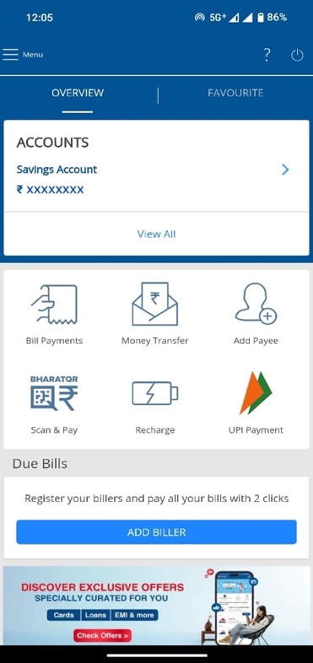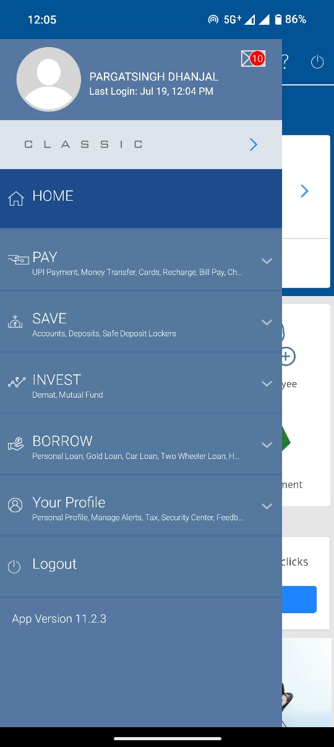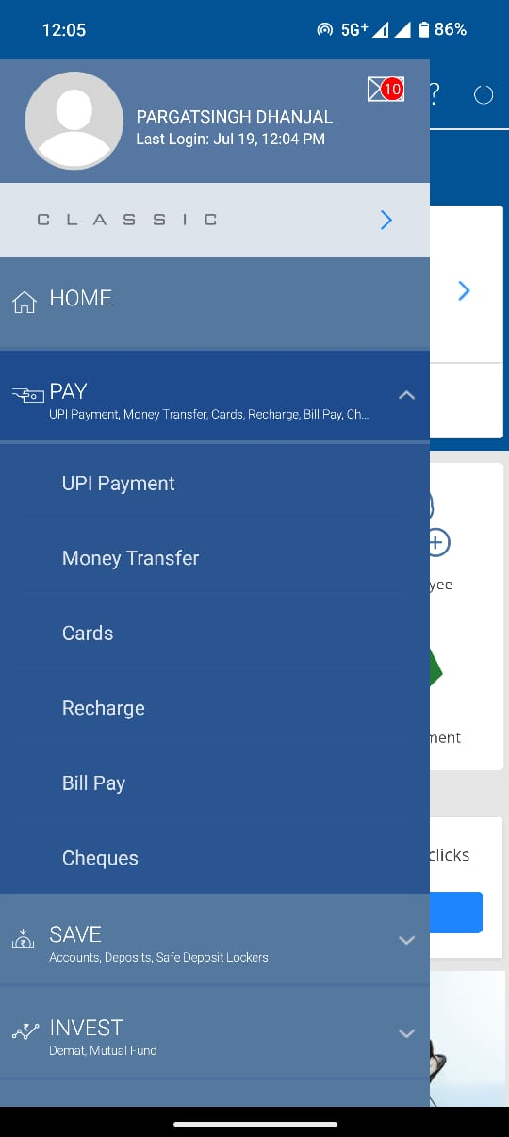

**Suggestions for a better design:**

**Low Fidelity Design Solution:** Home Page

**Activity:**

1. **Critical evaluation of device/product/application.**

• **Objective Analysis:** Evaluate the performance, usability, and features of the device/product/application. This includes identifying strengths, weaknesses, and any inconsistencies in functionality.

• **User Experience:** Assess the overall user experience, focusing on how intuitive and accessible the interface is for users.

• **Performance Issues:** Identify any lag, crashes, or bugs that affect the usability or reliability of the product.

• **Security Concerns:** Evaluate the security measures in place to protect user data and privacy.

• **Comparative Analysis:** Compare the product with similar products in the market to identify areas where it excels or falls short.

1. **Suggestive measures for optimization of design.**

• **Streamline User Interface:** Simplify the design to make navigation more intuitive, reducing the learning curve for new users.

• **Enhance Performance:** Optimize the codebase to improve app speed, reduce crashes, and ensure smooth performance across all devices.

• **Improve Security Protocols:** Implement additional security features, such as two-factor authentication, to protect user data.

• **User Feedback Integration:** Regularly incorporate user feedback into updates to ensure the product continues to meet user needs.

• **Reduce Notification Overload:** Allow users to customize notification settings to avoid overwhelming them with too many alerts.

• **Accessibility Enhancements:** Ensure the product is accessible to users with disabilities by incorporating features like screen readers, high-contrast modes, and easy-to-navigate interfaces.

1. **Benefits of critical evaluation of existing device/product/application.**

• **Improved User Satisfaction:** By addressing issues and enhancing features, the product becomes more user-friendly, leading to higher customer satisfaction.

• **Competitive Edge:** Regular critical evaluations help the product stay ahead of competitors by continuously improving and adapting to market demands.

• **Increased Reliability:** Identifying and fixing bugs or performance issues increases the reliability and trustworthiness of the product.

• **Cost Efficiency:** Early identification of potential problems can save costs in the long run by avoiding major redesigns or fixes.

• **Innovation:** Critical evaluation encourages innovation by identifying areas where new features or improvements can add value to the product.

• **Enhanced Security:** Regularly evaluating security features helps protect against new threats and ensures user data remains secure.

**Team Members:**

**1. Pargat Singh Dhanjal**

**2. Vishrut Deshmukh**

**3. Meet Gala**

**Conclusion:** We have successfully completed the given experiment.