

**Batch: A1 Roll No.: 16010121045**

**Experiment / assignment / tutorial No**

|  |
| --- |
| **TITLE:** Introduction to UI/UX Design principles. |

**Objective:** To understand the application development/design process using the concept of design principles.

___________________________________________________________

**Expected OUTCOME of Experiment:**

**CO 1:** Understand the fundamentals of human-computer interaction and its impact on UX design.

**__________________________________________________________________**

**Books/ Journals/ Websites referred:**

<https://ieeexplore.ieee.org.library.somaiya.edu/stamp/stamp.jsp?tp=&arnumber=10030059>

<https://bootcamp.uxdesign.cc/basic-introduction-to-user-experience-and-user-interface-design-f0aae08a2b44>

**______________________________________________________________________**

**New Concepts to be learned:**

1. Stages of design thinking process.
2. User Research.
3. Experimental product design for mobile / web based applications.

**Background Theory:**

UI/UX design revolves around creating products that are visually appealing and easy to use, ensuring a seamless and satisfying user experience. UI (User Interface) focuses on the aesthetics, including layout, typography, and colors, while UX (User Experience) emphasizes the overall interaction and journey of the user. Key principles include user-centered design, consistency, feedback, accessibility, and affordance, all aimed at making the interface intuitive and accessible. By understanding and applying these principles, designers can create products that meet users' needs effectively and efficiently.

**Introduction to UI/UX:**

User Experience Design: it’s the process of creating a product that is easy to use, easy to interact with, and accessible for the users while putting their feelings first, based on a long-term and short-term scale.

User Interface Design: is the design of user interfaces for machines and software, such as computers, home appliances, mobile devices, and other electronic devices, with the focus on maximizing usability and the user experience.

Most of the time these two roles get misinterpreted meanwhile they are different but both work together to build a usable product for the user. What could be the difference? Let’s find out.

A typical illustration to explain the difference is the human body, separating the skeleton from the flesh, the skeleton refers to the UX design showing the architectural blueprint of the product while the Flesh refers to the UI design which relates to how the product looks and feel to the outer eye of a user.

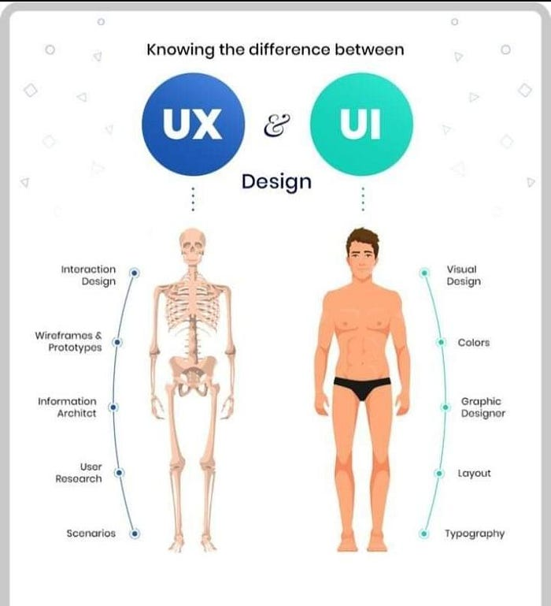

A UX designer considers the user’s entire journey to solve a particular problem; what steps do they take? What tasks do they need to complete? How straightforward is the experience? Much of their work focuses on finding out what kinds of problems and pain-points users come up against, and how a certain product might solve them.

UI designer focuses on all the details that make this journey possible. That’s not to say that UI design is all about looks; UI designers have a huge impact on whether or not a product is accessible and inclusive.

**Heuristic Design Principles:**

Heuristic design principles are a set of general guidelines that inform the design process, helping to ensure that user interfaces are intuitive, efficient, and user-friendly. These principles are based on years of research and practical experience in human-computer interaction and usability engineering. They are not strict rules but rather flexible guidelines that can be applied across various contexts and design challenges. The most widely recognized set of heuristics was developed by Jakob Nielsen, known as Nielsen's 10 Usability Heuristics. These heuristics cover key aspects of usability, such as visibility of system status, match between system and the real world, user control and freedom, consistency and standards, error prevention, and more.

By adhering to heuristic design principles, designers can create interfaces that are more likely to meet users' needs and expectations, reduce the likelihood of user error, and enhance the overall user experience. These principles are especially useful during the early stages of design when concrete user testing may not yet be feasible. They provide a framework for evaluating and improving a design before it is tested with actual users.

**Importance of Usability principles:**

Usability principles are fundamental to creating products that are easy to use, efficient, and satisfying for users. These principles focus on ensuring that a product meets the needs of its users in a way that minimizes frustration and maximizes productivity. Usability is not just about making a product look good; it's about making sure that it works well for the people who are using it.

The importance of usability principles lies in their ability to improve user satisfaction, reduce errors, and increase the effectiveness of a product. A usable product is one that users can learn quickly, remember how to use, and perform tasks with minimal effort. When usability principles are applied, users are more likely to have a positive experience, which can lead to increased adoption rates, fewer support requests, and a stronger overall reputation for the product.

Moreover, in today's competitive market, usability can be a significant differentiator. Products that are easy to use are more likely to retain users and foster brand loyalty. By focusing on usability principles, designers and developers can ensure that their products not only meet functional requirements but also provide a smooth and enjoyable user experience.

**Design Thinking:**

Design thinking is an iterative process in which we seek to understand the user, challenge assumptions, and redefine problems in an attempt to identify alternative strategies and solutions that might not be instantly apparent with our initial level of understanding. At the same time, design thinking provides a solution-based approach to solving problems. It is a way of thinking and working as well as a collection of hands-on methods

Design thinking revolves around a deep interest in developing an understanding of the people for whom we’re designing the products or services. It helps us observe and develop empathy with the target user. Design thinking helps us in the process of questioning: questioning the problem, questioning the assumptions, and questioning the implications. Design thinking is extremely useful in tackling problems that are ill defined or unknown, by re-framing the problem in human-centric ways, creating many ideas in brainstorming sessions, and adopting a hands-on approach in prototyping and testing. Design thinking also involves ongoing experimentation: sketching, prototyping, testing, and trying out concepts and ideas.

**Elements of Design Thinking process:**

The 5 essential elements of Design Thinking play a crucial role in crafting exceptional products. By delving into these stages, we gain a deeper understanding of the design thinking process and its transformative power in problem-solving and innovation.

**Empathise:** Understand your users’ needs through research and observation.

**Define:** Clearly articulate the needs and problems of your users.

**Ideate:** Challenge assumptions and generate innovative ideas.

**Prototype:** Begin creating tangible solutions.

**Test:** Experiment and gather feedback on your solutions.

**User Research:**

1. **Qualitative.**

Qualitative research focuses on understanding the deeper motivations, emotions, and behaviors of users. It involves gathering rich, detailed data that can provide context and meaning to user actions. Qualitative research methods include:

**User Interviews:** One-on-one conversations with users to gather in-depth insights about their experiences, preferences, and pain points.

**Focus Groups**: Group discussions where participants share their thoughts and opinions on a specific topic or product.

**Contextual Inquiry:** Observing users in their natural environment while they interact with a product or perform tasks.

**User Testing with Think-Aloud**: Users interact with a prototype while verbally expressing their thoughts, helping researchers understand their decision-making process.

**Ethnographic Studies:** Immersing oneself in the user's environment to gain a deep understanding of their daily routines, behaviors, and challenges.

**Diary Studies:** Users keep a diary or record of their interactions with a product over time, providing insights into their experiences over the course of days or weeks.

Qualitative research is valuable for uncovering insights that quantitative data might miss, such as the "why" behind user behaviors and the emotional aspects of their experiences.

1. **Quantitative.**

Quantitative research involves collecting numerical data that can be analyzed statistically. It provides a broader view of user behaviors and allows for measuring trends and patterns. Quantitative research methods include:

**Surveys:** Structured questionnaires distributed to a large number of participants to gather data on user preferences, demographics, and opinions.

**Analytics:** Tracking user interactions and behaviors within a digital product using tools like Google Analytics or user behavior tracking software.

**A/B Testing:** Comparing two or more variations of a design or feature to determine which performs better based on metrics such as click-through rates or conversion rates.

**Heatmaps**: Visual representations of where users interact the most within a UI, helping identify popular and neglected areas.

**Usability Testing Metrics:** Measuring metrics like task completion rates, time on task, and error rates to assess the usability of a product.

Quantitative research provides data-driven insights and allows designers to make informed decisions based on concrete numbers and measurements.

**Experimental product design for mobile-based application:**

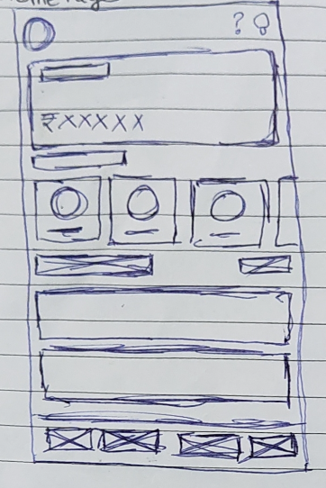

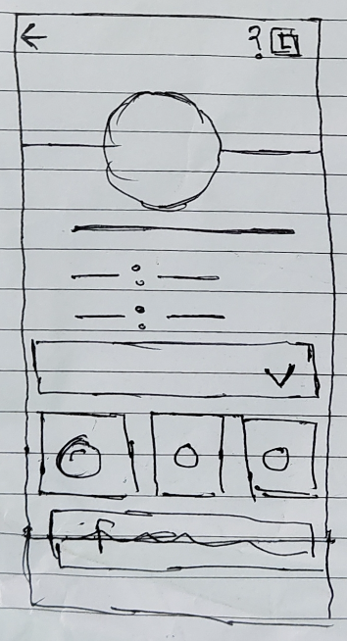 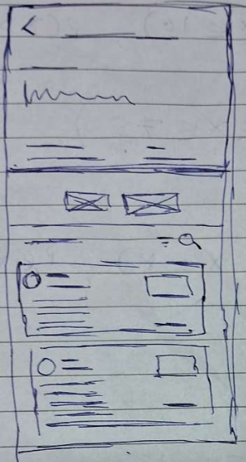

**Activity:**

Creation of wireframes (hand-drawn) for the proposed applications.

Design principles adhered to with proper justification.

**Laboratory Work**:

Complete the given activity for the same.

**Team Members:**

**1. Pargat Singh 16010121045**

**2. Vishrut Deshmukh 16010121043**

**3. Meet Gala 16010121051**

**Conclusion:**

Hence, we explored UI/UX, Design Thinking and its elements. We have also explored the probable mobile view of the application.