

**Batch: A1 Roll No.: 16010121045**

**Experiment / Assignment / Tutorial No:**

|  |
| --- |
| **TITLE:** Implementation of Wireframing models. |

**Objective:** To understand the role of wireframe models for UI/UX design.

______________________________________________________________________

**Expected OUTCOME of Experiment:**

**CO3: Illustrate the working of UX design process.**

**______________________________________________________________________**

**Books/ Journals/ Websites referred:**

[**https://www.figma.com/**](https://www.figma.com/)

**______________________________________________________________________**

**New Concepts to be learned:**

1. Structure of application/product under consideration.
2. Skeleton of application/product under consideration.
3. Tools for wireframe models.

**Background Theory:**

Understanding the structure and skeleton of an application/product is fundamental to building effective and user-friendly software. This involves defining how an application is organized and how different components interact with each other. The skeleton refers to the basic framework or layout that supports the app, often visualized through wireframe models.

**Introduction to Wireframe models:**

Wireframe models are basic visual guides used to suggest the structure of an interface and the relationships between its components. They help designers and developers focus on functionality and layout without being distracted by design details like colors or typography. Wireframes serve as blueprints for the final design, ensuring that the user experience is well thought out before actual development begins.

**UI/UX design process:**

The UI/UX design process typically involves several stages:

1. **Research**: Understanding the target audience, their needs, and the market landscape.
2. **Planning**: Outlining the app's structure, user flows, and key features.
3. **Wireframing**: Creating low-fidelity sketches that map out the user interface and interactions.
4. **Prototyping**: Building interactive models to simulate the user experience.
5. **Testing**: Gathering feedback from users to refine the design.
6. **Final Design**: Applying visual elements like colors, typography, and branding.

**Structure of UI/UX:**

The structure of UI/UX involves organizing content and features in a way that makes sense to users. This includes defining the information architecture, navigation, and hierarchy of elements. A well-structured UI/UX ensures that users can easily find what they need and complete their tasks efficiently.

**Skeleton of UI/UX:**

The skeleton of UI/UX refers to the wireframe or the basic layout that outlines where different elements like buttons, images, text, and forms will be placed on the screen. It provides a visual map of the user interface, showing the placement of key components without getting into the finer details of design.

**Brief description of topic selected for Wireframe model:**

The HDFC mobile banking app is a platform that allows users to manage their banking needs on the go. It includes features like checking account balances, transferring money, paying bills, and accessing various banking services. The wireframe model will focus on creating a user-friendly interface that facilitates these activities.

**Scope and Functionality**

The scope of the wireframe model includes the following functionalities:

**Login and Authentication**: Secure access to the user's banking information.

**Home Dashboard**: Display of account balances, recent transactions, and financial summaries.

**Fund Transfers**: Easy transfer of funds between accounts or to other users.

**Bill Payments**: Quick and secure payment of utility bills, credit card bills, etc.

**Customer Support**: Access to help and support services within the app.

**Selected Tool - Title and Features:**

The tool selected for creating the wireframe model is **Figma**, a popular web-based design tool. Figma offers features like:

* **Real-time Collaboration**: Multiple users can work on the same design simultaneously.
* **Component Libraries**: Reusable design elements that speed up the design process.
* **Prototyping**: Tools to create interactive prototypes to test user flows.
* **Cross-Platform Support**: Accessible from any device with an internet connection.

This overview provides a foundational understanding of wireframe models and how they can be applied to designing the HDFC mobile banking app.

**Lab Activity / Results with brief description of each Wireframe:**

**1. Login Screen:**

* **Purpose**: This screen allows users to securely log in to the HDFC Bank app using their 4-digit PIN or Face ID for quick access.
* **Key Features**:
* Quick login with Face ID for faster access.
* Alternative login using a password if the user prefers.
* Option to add another user for easy switching between accounts.
* Clear and simple UI with a welcoming message personalized for the user.

**2. Home Page:**

* **Purpose**: The main dashboard offers a comprehensive view of the user's financial status, including savings account balance and recent transactions.
* **Key Features**:
* Overview of the user’s savings account with a “View all accounts” option for more details.
* Quick actions section allowing users to perform frequent tasks like bill payments, money transfers, and UPI payments.
* Display of recent transactions with logos of merchants for visual clarity.
* Easy navigation through the menu and access to important features like statements and transactions.

**3. Payments:**

* **Purpose**: Manage credit and debit cards, track outstanding balances, and make payments.
* **Key Features**:
* Displays a list of both credit and debit cards, showing outstanding amounts for each.
* Attractive card design with easy-to-read amounts and expiration dates.
* Option to add new cards seamlessly from this section.

**4. UPI Payment:**

* **Purpose**: Simplifies UPI payments using QR codes for quick and seamless transactions.
* **Key Features**:
* Integration with Paytm for QR-based payments.
* Ability to scan any UPI QR code to make payments instantly.
* Shows user details at the top, ensuring correct identification during payments.
* Functional buttons to either scan a new UPI code or participate in rewards and offers.

**5. Profile:**

* **Purpose**: Displays the user's personal and KYC (Know Your Customer) details.
* **Key Features**:
* Shows essential personal information like Customer ID, Date of Birth, and KYC status.
* Direct access to Contact Details for updates and review.
* Users can explore more detailed sections, such as account opening or customer care assistance.
* Clean layout focusing on user identification and customization.

**6. Contact Details:**

* **Purpose**: Allows users to view and update their contact and mailing information.
* **Key Features**:
* Editable fields for Email ID, Mobile, Office Phone, Residence Phone, and Mailing Address.
* Keeps both mailing and permanent address visible for easy updates.
* Ensures that all personal contact information is centrally located and accessible.

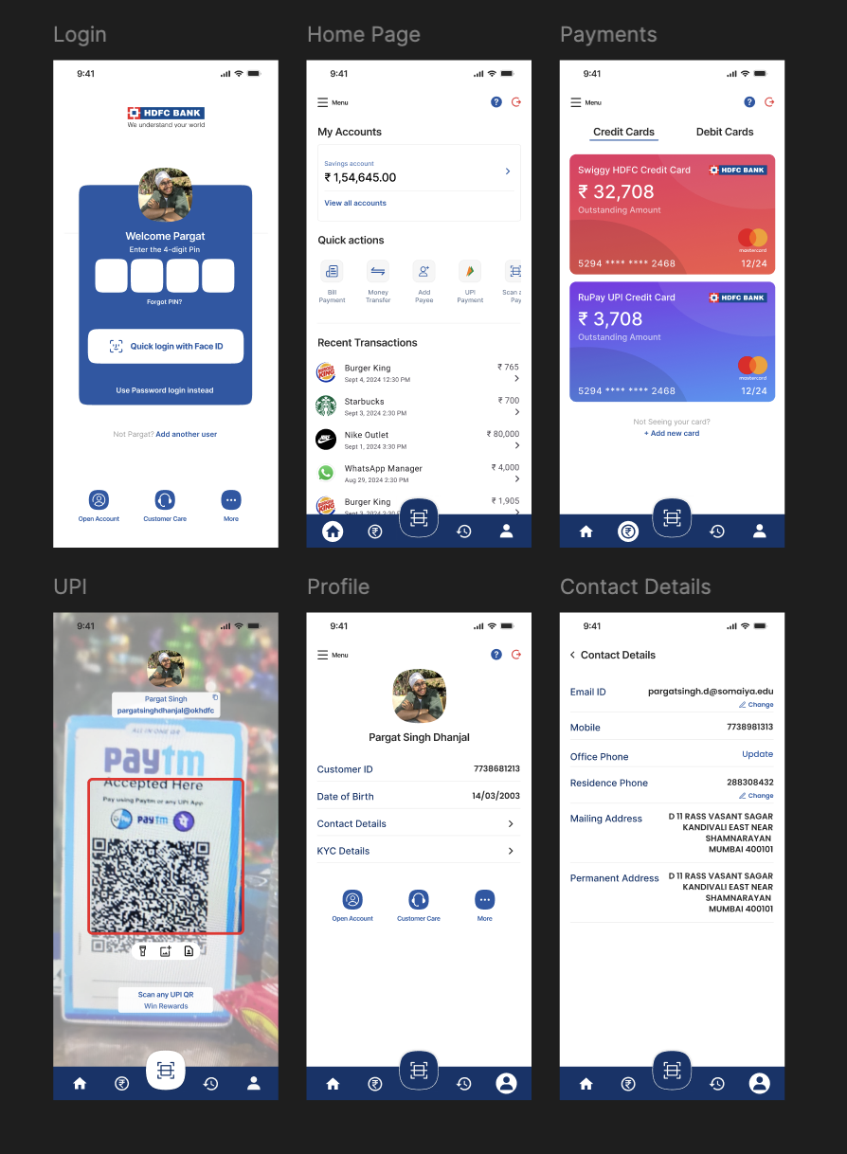

**Team Members:**

**1. Pargat Singh Dhanjal – 16010121045**

**2. Vishrut Deshmukh - 16010121043**

**3. Meet Gala - 16010121051**

**Conclusion:**

In conclusion, the redesigned HDFC mobile banking app successfully improves user experience by offering a streamlined and intuitive interface. Key features like quick login, clear financial overviews, seamless UPI payments, and easy access to personal details enhance usability and convenience. The focus on personalization, security, and efficient navigation ensures that users can manage their banking needs more effectively, making the app more user-centric and efficient for daily banking activities.

Top of Form

Bottom of Form