

**Batch: A1 Roll No.: 16010121045**

**Experiment / Assignment / Tutorial No:**

|  |
| --- |
| **TITLE:** Implementation of storyboarding in UI/UX design process. |

**Objective:** To study and understand the role of storyboarding process in UI/UX design. ______________________________________________________________________

**Expected OUTCOME of Experiment:**

**CO3: Implementation of storyboarding in UI/UX design process.**

**______________________________________________________________________**

**Books/ Journals/ Websites referred:**

<https://www.uxdesigninstitute.com/blog/ux-storyboard/#:~:text=In%20UX%20and%20product%20design,a%20specific%20context%20or%20scenario>.

**______________________________________________________________________**

**New Concepts to be learned:**

1. Storyboards.

**Introduction to storyboards in UX design:**

**Role of Storyboards in UX.**

Storyboards play a crucial role in User Experience (UX) design by:

1. **Visualizing user journeys**: They help designers and stakeholders understand how users interact with a product or service over time.
2. **Identifying pain points**: Storyboards can highlight potential issues in the user experience, allowing designers to address them early in the process.
3. **Communicating concepts**: They provide a visual narrative that's often easier to understand than written descriptions or technical diagrams.
4. **Encouraging empathy**: By depicting users in context, storyboards help teams empathize with user needs and motivations.
5. **Facilitating collaboration**: They serve as a common reference point for discussions among team members and stakeholders.

**List of tools and its features for storyboard creation:**

• **Adobe XD**

* Integrated with other Adobe products
* Vector drawing tools
* Collaboration features

• **Sketch**

* Mac-only software popular among UX designers
* Extensive plugin ecosystem
* Powerful vector editing tools

• **Figma**

* Web-based collaborative design tool
* Real-time collaboration
* Cross-platform compatibility

• **Miro**

* Online whiteboard platform
* Templates for various UX methods including storyboarding
* Collaborative features for remote teams

**Storyboarding (Results) for the application/product under consideration:**

**User Journey**

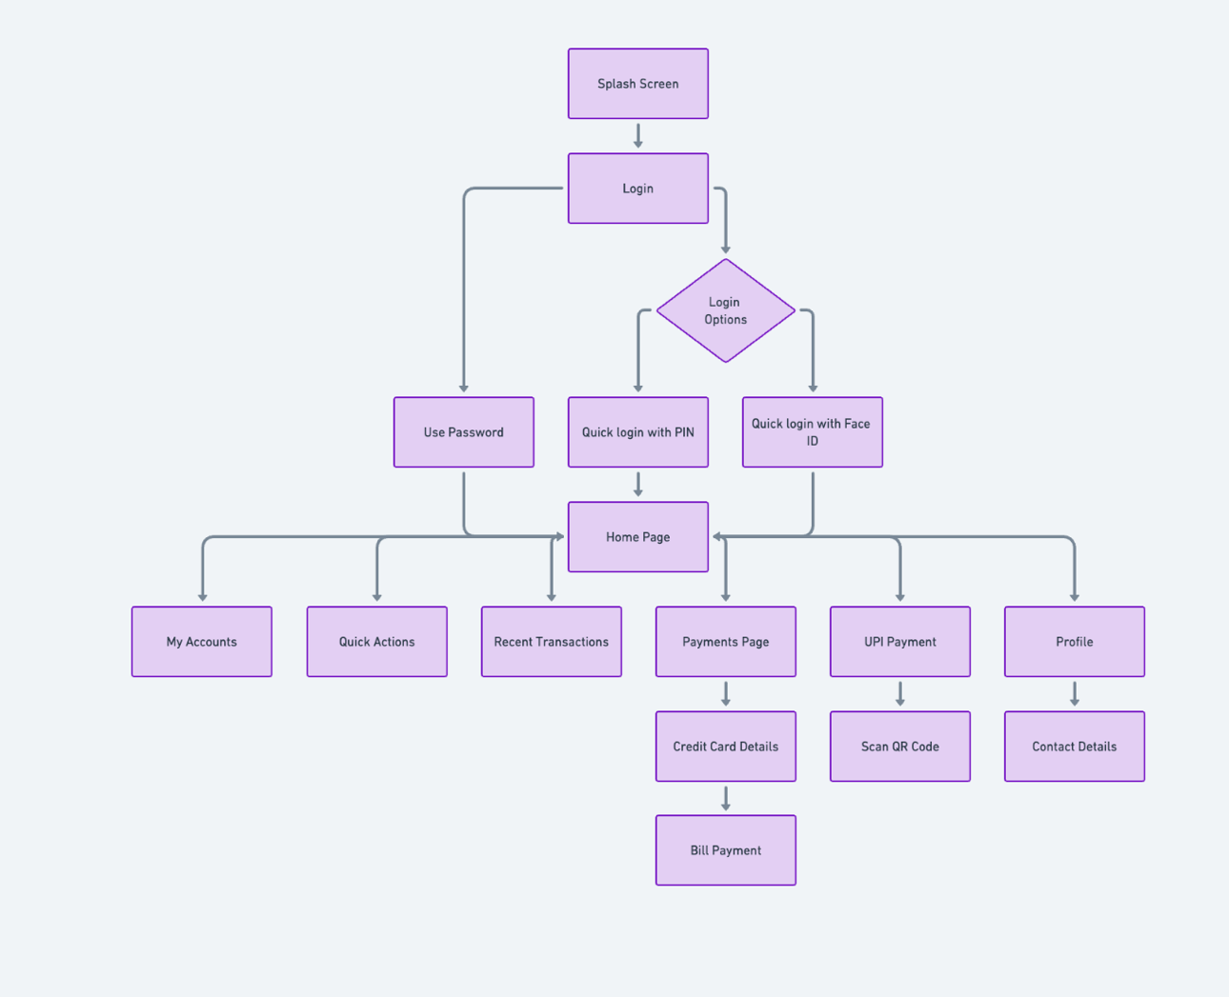

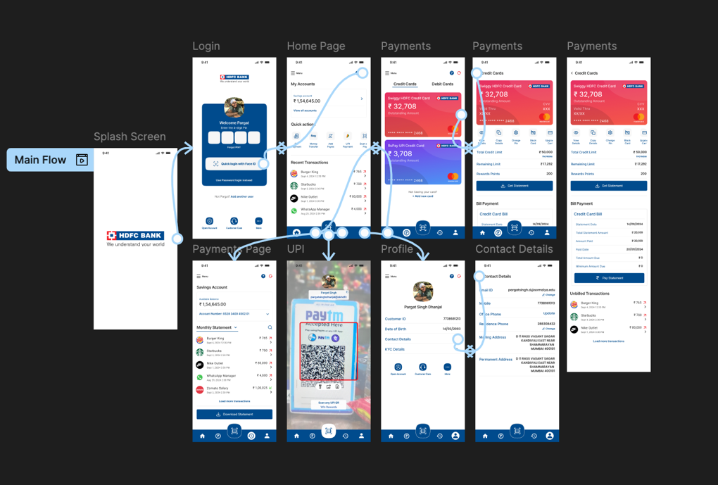

**Conclusion:**

Storyboards are a powerful tool in UX design, helping to visualize the user journey and identify opportunities for improvement. They bridge the gap between raw ideas and final designs, ensuring that the user's needs and experiences remain at the forefront of the design process. By using storyboards, UX designers can create more empathetic, user centered products that truly meet the needs of their target audience.